How did literary and artistic depictions of the Three Living and the Three Dead reflect medieval attitudes towards death?
The Legend of The Three Living and The Three Dead is known to have been recorded in medieval English within MS Douce 302 kept at the Bodleian Library. The manuscript was composed by John Audelay in the fifteenth century and some attribute the poem to him also. It is the only example of the poem having been recorded in English. However earlier versions of the tale appear in many languages and Dubruck states it to have been around ‘in the Orient as early as the third century, and it penetrated to the West in about the eleventh century’ alluding to very early origins. Dubruck also notes the ‘central motif is the warning of the dead men addressed to the living: “Quod fuimus, estis. Quod sumus, eritis”, a motto found in early Arabian, Greek and Roman epitaphs’. This is not necessarily surprising, for death reaches all and to reflect on what you do in this life and whether there is life after death is something philosophised since classical times. The tale is part of a common momento mori (Latin for “remember that you have to die”) culture that was present in Latin Christian countries. Especially during and after the period of the Black Death in the mid fourteenth century, people became more obsessed with what came after death. Throughout medieval literature and art this legend and the later “Danse Macabre” show how the medieval mind contemplated their earthly life with their trivial pursuits and self-indulgent pleasures. There are many depictions of the Legend throughout literature such as in Psalters and Books of Hours (it became a popular image within the Office of the Dead). Often these depictions had the poetic verse or other literary accompaniment to the images of the Three Living and Three Dead. It also became popular imagery for murals within churches, an ever-present reminder for the devout. Whilst some show slightly altered behaviour most depict the living in shock, horror and disgust at the dead varying from scenes where the two groups stand and stare at one another to scenes of movement where the dead are hunting the living.
John Audeley was an English priest and poet who died in the first half of the fifteenth century. Situated at Haughmond Abbey in Shropshire he is attributed to having compiled a manuscript now known as MS Douce 302 which resides within the Bodleian library at Oxford. The manuscript contains many poems including Christmas carols although most of Audeley’s poetry is associated with repentance. One of the more famous poems in this work is the tale of The Three Dead Kings which records a variant of the Legend of the Three Living and the Three Dead. As stated above, it is the only currently known version in English as most occur in French amongst other languages. Some scholars attribute the poem to Audeley due to its dialect belonging to the Shropshire and Staffordshire area (although some disagree on this, claiming it has a more northerly dialect) and of its alliterative style with thirteen-line stanza form as is common with his poems. The tale recounts how three kings within a boar hunt are separated from their retainers and come upon three animated corpses who claim to be their forefathers and admonish them for not taking care for their dead father’s souls. They afterwards warn them against earthly pleasures revealing their own suffering because of it before leaving again. The Kings have various reactions ranging from wanting to escape the terrors before them or facing them. The poem reflects the natural “fight or flight” situation when presented with death. A common theme within literature post-Black Death in being concerned with living well to assure your soul’s wellbeing after death. This theme was already common within Europe. One of the most famous versions of the Legend is Li troi vif et li troi mors written by Baudouin de Condé, a minstrel at the court of Margaret II, Countess of Flanders. His poem recounts the typical meeting between three living men and three dead and after one flees the first of the dead states:
‘Tel seres vous et tel comme ore
Estes, fumes, ja fu li ore
(What you are, we were, and what we are, you will be.)’
which conveys the entire message and warning of the scene. It displays the wisdom of recognising that no matter what you gain in life all end up as they now are: dead.
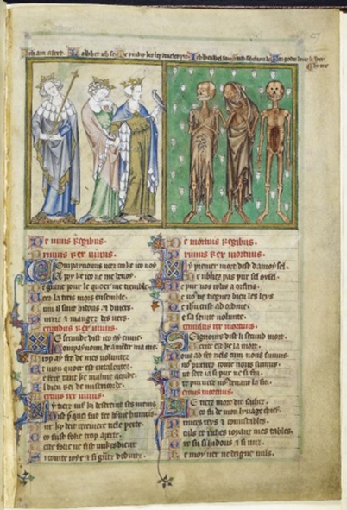
The Howard Psalter is a fourteenth century illuminated prayer book and contains the remains of the De Lisle Psalter bound within it. Surviving from the De Lisle Psalter are the calendar and the Speculum theologiae which have been attributed to a thirteenth century Franciscan friar John of Metz. The page concerning the Legend of the Three Living and the Three Dead consists of a large depiction of the Living and Dead with the French verse below embellished with Latin rubrics. Above the depiction are phrases in the English vernacular of what each figure is seemingly exclaiming. The French verse recounts a version of the legend which in comparison with others seems tame in the Living’s reactions to the dead. The dead themselves are there merely to advise the living on what is to come if you continue in the way you live. They comprise a group of individuals having a mere conversation. The artistic depiction above illustrates this. The living figures are shown as crowned Kings, all equal in status presumably they show slightly different reactions. The left most King shows to be leaning away from the corpses before him and is flush against the frame of the image with a gap between himself and his more curious companions. He shows more caution or a willingness to escape as his body seems turned towards the frame also with his right foot pointed towards it and his head leaning away from the rest of the figures. However, his face looks towards the figure and could be interpreted to be conveying disgust or suspicion of these devil-like figures with the positioning of his eyebrows. The other two Kings, whilst closer to the dead figures are portrayed with their torsos leaning away from the dead although the right-most King grasps the hand of the King behind him as though in fear wanting the assurance of a companion whilst he faces this fearful sight. He holds on his left hand a falcon, evidence of the original purpose of the party. It seems important to note the position of the heads of the three Kings, whilst the first figure mentioned has his head turned away from the dead and the right-most figure has his looking straight on, the middle figure looks down as though not quite mustering the confidence to face death and yet has his hand to his chin as though either in deep thought about what he is experiencing or is perhaps in the process of bringing up his hand to cover his nose from the stench of the decaying corpses. The English phrases above them exclaim what each is feeling flowing from left to right: “I am afraid”, “Lo, what I see”, “Methinks these be devils three”. The middle King looks the most afraid of what he sees whilst the other two appear more outraged and suspicious of what is before them. The phrases reveal common feelings to such scenes, suspicion of some ruse or fear of the unknown. However, the three expressions do not show the Kings to be confrontational to death, rather suspicious of it. The dead are portrayed in varying states of decay as gruesomely grinning skeletal figures with decreasing amounts of rotting flesh and raggedy attire. The middle figure seems more unsettling as he appears to be enjoying a private joke and is the only dead figure that appears in motion as he points to the living with his hand on chest, again adding to the sense of some private hilarity. The expressions above the dead are as follows: “I was well fair”, “Such shall you be”, “For God’s love, beware by me”. As the middle figure’s expression could be interpreted as a mockery of the living, his accompanying phrase suits well. The artistic depictions together with their accompanying phrases reflect how the composer or patron perhaps feared what comes after death, although the dead’s first two phrases depict a fear of the physicality of death. The phrases refer to fear of what will happen to the physical body. The representations of the fair faced Kings in fine brightly coloured raiment contrasted with the gruesome decayed bodies of their forefathers in dark half-present garments in which worms have made their home convey this difference helps convey the difference in emotional spirit between the two groups – the weariness of the dead with the strong emotional response to the dead in shock and fear. The materiality of life means little after death and so part of the warning is conveyed that material possessions do not matter in the grand scheme of life.
Figure 1: The Three Living and the Three Dead, The British Library, Arundel 83, f. 127
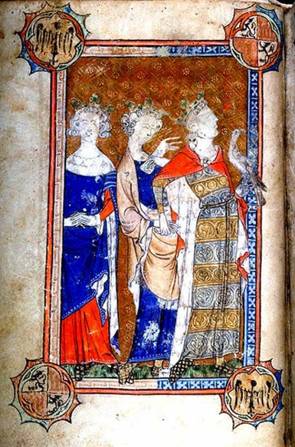
Not many years after the De Lisle Psalter was compiled; a book of hours was made for Robert De Lisle’s wife Margaret de Beauchamp. Seemingly incomplete only the Three Living are portrayed. The positioning of the figures is very similar although not exactly like that of the figures previously discussed. The figures appear squashed closer together although again the left-most King is partially edged out of the frame persisting in trying to escape the situation whilst his two companions seem focused on something outside of the frame we know to be the Three Dead. Again, the right-most King supports his falcon whilst clasping the hand of his companion. The falcon again looks to the dead as though also entranced. The middle King this time appears braver with his head lowered only slightly and appears to be gesturing towards the Dead out of frame. The figures are brightly and richly dressed topped with golden crowns displaying the materiality of high society. The expressions reflect much the same emotions and reactions towards the Dead as in the De Lisle Psalter. Whether the hours were by the same artist or merely copied from the Psalter itself they show how the opinion of this legend was much the same. On being confronted with death the Kings are fearful and yet willing to face it alluding to the idea of the time to not having to be fearful of death but be willing to face it if having lived a life devoid of earthly pleasure and vanity.
The Hours of Mary of Burgundy were made in the late fifteenth century by the yet unidentified but influential Master of Mary of Burgundy. In the fifteenth century, it became more popular to place images of the Three Living and the Three Dead in the Office of the Dead within Books of Hours. They sometimes reflect a more violent take on depictions of the Legend and this is true of these particular Hours. It is interesting to note she died in 1482 at the age of 25 years from a riding accident whilst out hunting. The manuscript is from around 1480 and as the depiction of the Three Dead shows them violently attacking a woman (Mary of Burgundy herself?) on horseback it is safe to assume the depiction may be a representation of the death of Mary. The dangers of daily life causing unexpected death rather than plague played on the minds of the people of Flanders. This time .the three living are depicted on horseback and whilst normally the three living are depicted as male members of society, these hours show a woman centralised to show her importance. The shrouded corpses hold weapons and the scene appears “mid-chase” with the men fleeing in front whilst the woman looks back upon death chasing them. The dead figures are gruesomely depicted with expressions showing how they have lost the visage of the living. The colours used for the living and then for the dead mark the contrast between their states with lighter colours given to their clothing and to the world around them whilst the corpses of the dead depict the colour of rotting flesh. The bottom right corner shows two dogs. Whether intended the dogs are also shown in contrast as though the darker dog is the living animal whilst the white outlined dog appears to be its deathly counterpart like the owners in the image. On the other hand, they may simply be two live animals scarpering away from death like their owners as is more likely due to their appearance in the following Hours example. The overall feeling sensed from the image is one of fear in trying to escape death. The hunters have become the hunted, the predators the prey. The living figures appear young enjoying the pursuits of the young whilst death is trying to snatch them away. It conveys a sense of approaching death and that time is short and may come at any moment.
Figure 2: The Three Living, The Morgan Library and Museum, MS G.50, F. 6v
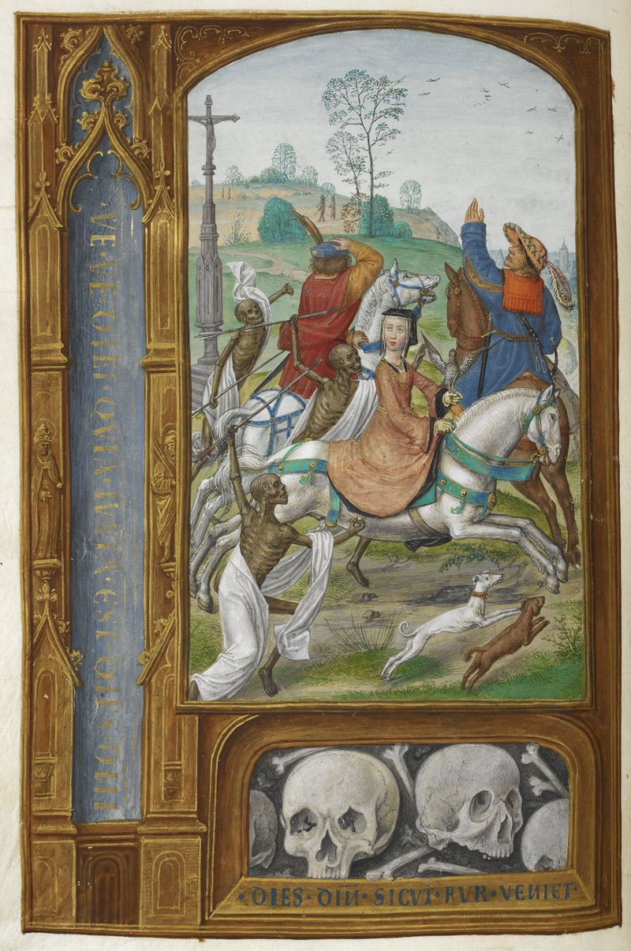
The Hours of Joanna I of Castille were likely made in Ghent during the sixteenth century due to their authorship being of Gerard Horenbout and Sanders Bening. Like the Hours of Mary of Burgundy, they reflect the unusual depiction of a female amongst the Living of the legend and due to the similar position of the figures including the light and dark coloured dogs it is likely the idea was either directly copied or highly inspired by Mary’s Hours with only a few alterations perhaps by preference of the artist in making the image feel more realistic. These noticeable similarities do not surprise when understanding that these women were related. Joanna I of Castile was married to Mary’s son Philip the Handsome and so similarities in family works were not uncommon, especially when taking into account the illustrator of Mary’s Hours was exceeding influential in his style. Joanna’s Hours appear to each stand out more so than the previous Hours with their pale lightly coloured clothing and more evenly spaced positions. More pleasing to the eye the corpses do not convey such a gruesome appearance and yet still display the hunt upon the living. The lady’s companions appear to be gesturing off into the distance conveying the theme of escaping death. The similar Hours convey a sense of the Dead not being so cautionary with words but more violent in action as though death is upon them and to be aware how you live.
Figure 3: Three Living and the Three Dead at the beginning of the Office of the Dead, British Library, ADD MS 35313
The Legend of the Three Living and the Three Dead also became popular within murals. Again, they display a different example of the actions and visualisations of the Living and Dead. The dead often appear within coffins in three stages of decomposition and can often be found to be young in appearance. To find depictions of the dead encased in open coffins is more usual in murals it seems than within manuscripts. This simple alteration of a more natural placement of the dead almost normalises the story with the warning coming from one (the mediator) who is usually old and soon to be joining the dead. The living are more contemplative as a fourth living figure (a mediator) is usually portrayed in the image warning them and showing the open coffins of the dead. Several examples also show the experience is not confined to the usual three living high society male figures but sometimes include a crowd of spectators. Painted within churches these served as an ever-present reminder to the devout of death ever present. ‘Pavel Chihaia has convincingly argued that the Legend of the Three Living and Three Dead evolved in Italy through Franciscan institutions as a specific by-product of a Franciscan polemic against the power of secular lords’ and perhaps accounts for the many Italian mural examples. They could certainly serve a strong political purpose as the Church was often looking for power within the realms of the Christian Kings. Rather than store and spend their wealth on their own pleasures it could become another ploy to encourage donations to the church in order to save the nobles’ immortal souls.
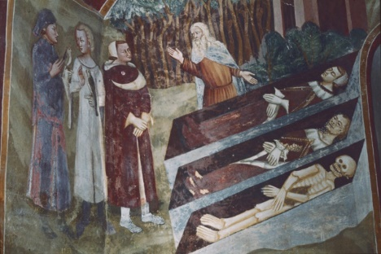
The Sacro Speco is a sacred grotto within St. Benedict’s Abbey in the town of Subiaco, Rome. Within are many murals from various painting schools from many time periods. One such mural depicts an old man gesturing between three Living men and three Dead in various stages of decomposition on display in open caskets. The scene is seamless in contrast to how the Living and Dead are kept separate in textual artistic sources. Unlike in manuscript form, these Living do not appear afraid but rather more contemplative. The frescoes are recorded as being made by the Sienese painting school who worked there in the fourteenth century. Interesting to note is that a mural on the opposite wall to this depicts the Triumph of Death where Death is depicted blind as a reminder that death slays without attention to age, wealth or virtue and is in keeping with the conscious medieval mind that you must be ever-ready for death.
Figure 4: Three Living and the Three Dead, Sacro Speco, Rome. Source online.
The Legend of the Three Living and the Three Dead conveys a popular theme present in the medieval mind. Through literary and artistic depictions, the emotions conveyed stay the same and only alter in intensity. All depictions provide the warning and subsequent fear felt by the living. The depictions that show the living on horseback seem to provide a stronger sense of fear and often of violence as though the Dead were chasing the Living of the scene. The Legend in all depictions therefore provides a strong reminder of the momento mori culture that was strong particularly in England, France, Italy, Germany and Holland. This reflects how death was imminent and would take anyone regardless of age or status within society. This is evident from the often youthful depictions of the Living from different walks of life. Due to the Living often representing men of high society perhaps shows this warning was for the higher classes who were too attached to their pleasure led life and therefore was more reflective of the thoughts of higher ranked society than the common people.

Bibliography
Biggs, Sarah, The Three Living And The Three Dead, Blogs.Bl.Uk, 2014. Available from: http://blogs.bl.uk/digitisedmanuscripts/2014/01/the-three-living-and-the-three-dead.html [Accessed 8 January 2018]
British Library, The Three Living And The Three Dead, Bl.Uk, 2018 Available from: http://www.bl.uk/catalogues/illuminatedmanuscripts/ILLUMIN.ASP?Size=mid&IllID=7109 [Accessed 9 January 2018]
British Library, Book of Hours. 2018. Available from: http://www.bl.uk/manuscripts/FullDisplay.aspx?ref=Add_MS_35313 [Accessed 10 January 2018]
Caciola, N, Wraiths, Revenants and Ritual in Medieval Culture. Past & Present, Vol. 152, August (1996), pp.3-45.
Carleton Williams, E, Mural Paintings of the Three Living and the Three Dead in England. (London: British Archaeological Association, 1942).
D'Emilio, James, Subiaco, Sacro Speco, Scala Santa, The Three Living And The Three Dead Available: http://etc.usf.edu/clippix/picture/subiaco-sacro-speco-scala-santa-the-three-living-and-the-three-dead.html [Accessed 11 January 2018]
Dubruck, E. The Theme of Death in French Poetry of the Middle Ages and the Renaissance. (Netherlands: Mouton & Co, 1964).
Gertsman, Elina, ‘The Gap of Death: Passive Violence in the Encounter Between the Three Dead and the Three Living’, in Beholding Violence in Medieval and Early Modern Europe, ed. by Alice Terry-Fritsch and Erin Felicia Labbie (Farnham, UK: Ashgate, 2012), pp.85-104
Kinch, A, Image, Ideology, and Form: The Middle English “Three Dead Kings” in its Iconographic Context. The Chaucer Review, Vol. 43, Issue 1 (2008), pp 48-81.
Morgan Library, Medieval & Renaissance Manuscripts Online - Book Of Hours, Ica.Themorgan.Org, Available from: http://ica.themorgan.org/manuscript/thumbs/76993 [Accessed 10 January 2018]
Tristram, P. Figures of Life and Death in Medieval English Literature. (London: Elek Books, 1976).
The Monastery Of St. Benedict, Monasteri Subiaco, 2014. Available from: http://monasteri-subiaco.it/en/monastery-st-benedict [Accessed 11 January 2018]

E, Dubruck. The Theme of Death in French Poetry of the Middle Ages and the Renaissance. (Netherlands: Mouton & Co, 1964).
E, Dubruck. The Theme of Death in French Poetry of the Middle Ages and the Renaissance. (Netherlands: Mouton & Co, 1964).
E, Carleton Williams, Mural Paintings of the Three Living and the Three Dead in England. (London: British Archaeological Association, 1942).
E, Gertsman, ‘The Gap of Death: Passive Violence in the Encounter Between the Three Dead and the Three Living’, in Beholding Violence in Medieval and Early Modern Europe, ed. by Alice Terry-Fritsch and Erin Felicia Labbie (Farnham, UK: Ashgate, 2012), pp.85-104
P, Tristram. Figures of Life and Death in Medieval English Literature. (London: Elek Books, 1976).
A, Kinch, Image, Ideology, and Form: The Middle English “Three Dead Kings” in its Iconographic Context. The Chaucer Review, Vol. 43, Issue 1 (2008), pp 48-81.
"The Monastery Of St. Benedict", Monasteri Subiaco, 2014. Available from: http://monasteri-subiaco.it/en/monastery-st-benedict [Accessed 11 January 2018]

