Part 1
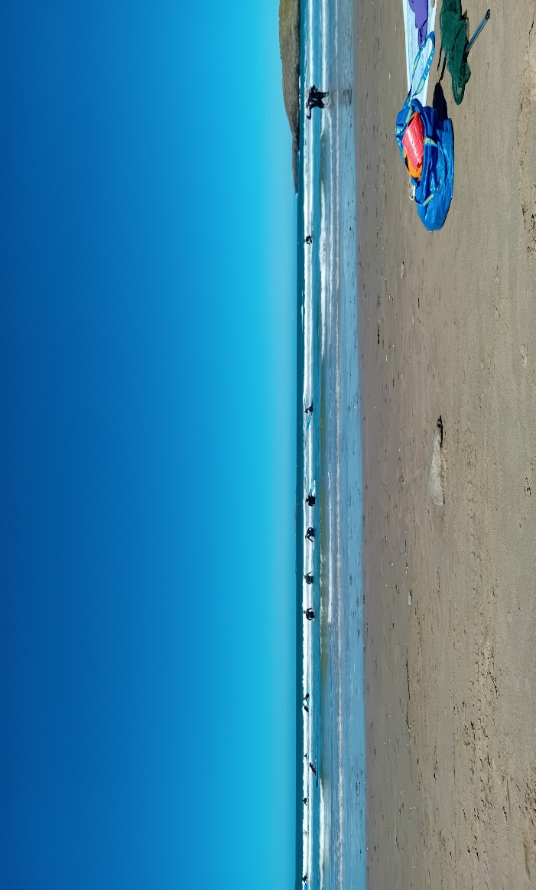
(Image of Whitesands Beach, Thomas 2024)
Part 2 (1356 words)
From the Picture above the beach offers a rich and engaging environment for young children to explore and develop scientific and mathematical concepts. By incorporating elements of guided instruction and open-ended exploration, practitioners can harness the beach's natural resources to foster valuable learning experiences. For instance, as children line up pebbles and count them, they can discover fundamental mathematical principles such as one-to-one correspondence. (Gelman,2009). For example, children can observe tidal patterns, study the characteristics of different shells, rocks, pebbles or count the number of waves crashing against the shore - all of which cultivate their understanding of scientific principles and mathematical relationships. (Matias, et al., 2020).
Additionally, Li (2023) mentions that the beach offers a multitude of opportunities for children to engage in estimation and measurement activities. By comparing the sizes of seashells, rocks, pebbles or the distance between their own footprints and those of other people, children can develop a more intuitive and hands-on understanding of fundamental measurement concepts like length, area, and volume. These activities encourage children to make predictions, assess their assumptions, and refine their grasp of quantitative relationships in a tangible, real-world setting.
Furthermore, Bell, et al., (2009) mentions that the beach environment presents a wealth of scientific experience that children can explore and investigate. By observing the behaviour of waves, such as how they crash and recede, the properties of sand, like how it feels and moves, or the diversity of marine life, including shells, crabs, and other organisms, children can develop important scientific skills like observation, hypothesis testing, and data collection. These hands-on experiences allow young learners to engage in the scientific process and deepen their understanding of the natural world around them.

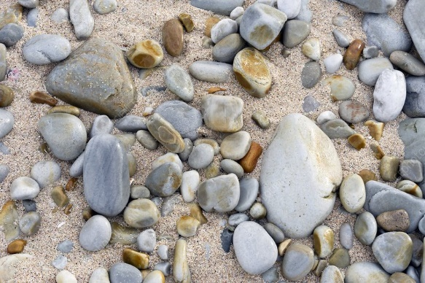
(Science photo library, 2024)
The beach can serve as an invaluable resource for fostering young children's scientific and mathematical development. By leveraging the multisensory and interactive nature of the beach environment, practitioners can design engaging, play-based activities that help children build foundational concepts and skills in Science, Technology, Engineering, and Mathematics (STEM) (Aslan, et al., 2022). Nite, et al., (2014) says that these activities can encourage children to explore, experiment, and discover natural phenomena, promoting hands-on learning and a deeper understanding of scientific principles and mathematical relationships. Additionally, the beach’s diverse and ever-changing landscape provides endless opportunities for children to make observations, formulate hypotheses, and test their ideas, all while developing critical thinking and problem-solving abilities essential for future success in STEM.

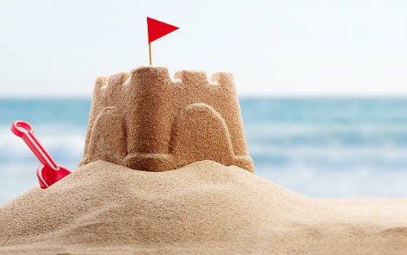
(iStockphoto, 2024)
While the beach can provide a rich and engaging environment for young children to explore scientific and mathematical concepts, there are potential drawbacks to relying too heavily on this setting that educators must carefully consider. Foremost, the beach environment can be unpredictable and present various safety risks for young children, particularly with regards to the water and uneven terrain. Practitioners must vigilantly supervise children’s activities and take robust measures to ensure their wellbeing and mitigate potential hazards. Additionally, the beach may not offer the level of structure and consistency that some young learners require to effectively grasp complex STEM concepts, as the distractions and variability of the beach setting could potentially hinder children’s focus and make it more challenging for them to develop a deep, sustained understanding of the principles being taught. Furthermore, access to beaches may be limited, especially for children in urban or inland areas, reducing equitable opportunities for all young learners to benefit from this educational approach. While the beach can serve as a valuable resource for hands-on, experiential learning, it is crucial for adults to carefully design and implement beach-based learning activities to maximize their educational benefits while prioritizing child safety and ensuring that all children have the support, they need to successfully develop key scientific and mathematical skills and understandings. (Koon, et al., 2022).
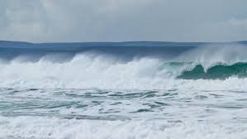
(Williams, no date)

According to Goldenberg and Carter (2021) the curriculum for Wales highlights the importance of 'Mathematics and Numeracy', focusing on the development of problem-solving skills and the application of mathematical concepts in real-world contexts. For instance, the Mathematics and Numeracy, areas of learning progression step 1 “I can group and sharing with objects and quantities” and “I can group or share small quantities into equal-sized group, investigate, collect and record data found within the environment”. (Welsh Government, 2020)
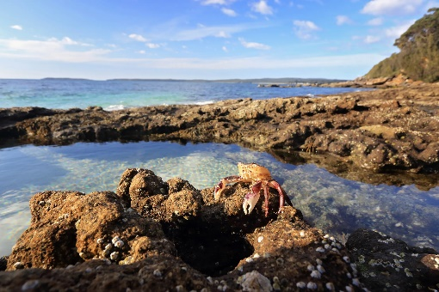
(RNLI, no date)
However, Jordan and Chawla (2019) mention that by providing young children with hands-on, open-ended learning opportunities in the natural beach environment, practitioners can support their development of specific scientific and mathematical concepts in alignment with the curriculum for Wales and various educational frameworks. For instance, Science and Technology, areas of learning within the Welsh Curriculum mention that with the progression step 1, “I can show curiosity and question how things work”, “I can explore the environment, make observations and communicate my ideas” and “I can recognise that plants and animals are living things which grow”. Whitlock, Eivers and Walker (2023) says that the curriculum for Wales places a strong emphasis on 'Expressive Arts', which encourages children to use their senses to explore and respond to the world around them. This focus on sensory engagement and creative expression aligns seamlessly with the beach environment, which provides a rich, multifaceted setting for young children to investigate scientific and mathematical concepts through open-ended, arts-based activities. By immersing children in the natural wonders of the beach and empowering them to observe, interact with, and create artistic representations of the elements they encounter, educators can foster a deeper, more holistic understanding of patterns, shapes, textures, and other fundamental scientific principles. This approach not only nurtures children's expressive and creative capacities but also helps them make meaningful connections between the arts, science, and mathematics, supporting their overall cognitive and academic development. Furthermore, Ward (2008) mention that the curriculum for Wales highlights the importance of 'Health and Well-being', recognizing the vital role that the natural environment plays in supporting children's physical, mental, and emotional well-being. The beach setting, with its opportunities for physical activity, sensory exploration, and connection with nature, can serve as a powerful medium for children to develop a positive relationship with the natural world, which in turn can foster a sense of environmental awareness.
In the context of non-maintained settings, such as early years setting or community-based settings, the beach can serve as an invaluable resource for promoting scientific and mathematical learning. These settings often have more flexibility in their curriculum and can more readily incorporate trips and outdoor learning experiences that leverage the unique features of the beach environment. By taking advantage of this flexibility, non-maintained settings can design engaging, hands-on learning activities that allow young children to directly interact with and observe the natural phenomena found at the beach. This can include collecting and analysing data on tidal patterns, marine life, and weather conditions, as well as using the beach's diverse features to explore concepts of measurement, geometry, and problem-solving as mentioned by Bell et al (2009). Additionally, the beach environment can foster a sense of environmental stewardship and connection to the natural world, which are important 21st century skills that can be nurtured in young children through purposeful educational programming. (Burke and Crocker, 2020)
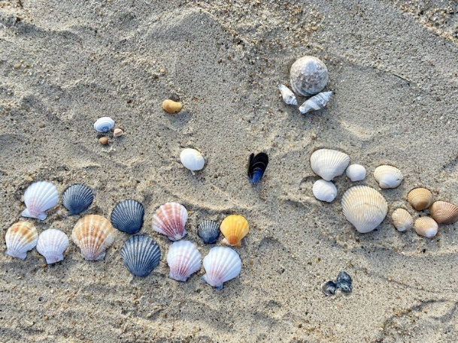
(Learning with outdoors (no date)
The versatility and multifaceted nature of the beach as a learning environment make it an exceptionally well-suited setting for young children to develop a diverse array of scientific and mathematical skills. The beach's rich and dynamic natural features provide boundless opportunities for hands-on, experiential learning that aligns seamlessly with the educational frameworks and curricula of Wales. This is particularly beneficial in non-maintained settings, such as early years settings and community-based settings, where there is greater flexibility to incorporate engaging outdoor learning experiences that leverage the beach's unique potential. By integrating the beach into their educational programming, these non-maintained settings can foster young children's natural curiosity, wonder, and enthusiasm for exploring the physical world around them, while also cultivating essential 21st century skills like critical thinking, problem-solving, and collaboration. The beach's diverse natural experience from fluctuating tides to a variety of marine life, offer endless possibilities for children to directly observe, measure, and analyse real-world scientific and mathematical concepts, laying a durable foundation for their cognitive, social, and emotional development. (Welsh Government, 2022)

Part 3 (600-1000 words)
RISK BENEFIT ASSESSMENT

Location / Activity: | Whitesands Beach St Davids | Date: | 2nd Sep 2024
Assessor: | Claire Thomas | Review date:

Experience exploring outdoor space in photograph | How will young people BENEFIT from this activity? | Hazards and associated risks | Who is at risk? | PRECAUTIONS in place to reduce the risk of injury | Overall risk after precautions  RATING: L/M/H
Sand | Imagination, Creativity, Gross and fine motor skills | Sand holes, Jelly fish, Animal Faces, Dust from the sand and Glass | Children and Adults | Talk to the children before regarding throwing sand and the importance of washing hands. Always supervise children. Sun cream, hats, Water bottles | L
Rock Pools | Imagination, learning about sea animals and their habitats, Exploration | Slips, trips and falls over rocks, leading to Impact injuries, drowning  broken bones, concussion, Crabs and other rockpool life, biting or stinging children. | Children | Always supervise that child when visiting low level rock pools. Check the designated area which the rock pooling will take place to ensure it is safe with no hidden litter. Children know boundaries. Check the ground conditions and ensure it is not too slippery underfoot. Appropriate footwear. First Aid Kit and regular head count | L
Pebbles | Creativity, Mark making, counting the pebbles, pattern making, language skills, Gross motor skills | Uneven surfaces. Slip, trips and falls. | Children and adults | Carry out a visual check before children get on the beach. Regular head count. First Aid Kit | L
Tide times | Counting and comparing the Waves. Learning about gravitational forces between the Earth, the moon, and the sun – Low and High Tides | Tide times, heights, range and whether it is rising or falling, and potential impact on group activities. | Children and Adults | Daily tide check undertaken prior to visit. Set boundaries before going to the Beach | M
Shells | Counting and comparing Sizes, Colours and chapes | Sharp shells, trip. | Children and Adults | Ensure children have the correct footwear beforehand, pair children up, carry out visual check on area that is being used. Regular head count | L
Dogs off leads | Interaction with Dogs, Sensory – feel, smell | Children might be frightened by Dogs | Children and Adults | Talk to the children before going to the beach on how they should respond if they see a dog or other animals. First Aid Kit | M
Strangers | Not to go with Strangers | Children are taken away. Children can be frightened | Children | Regular head counts, check registered, staff to supervise children. Talking to the children beforehand about strangers. | M

Part 4 (1926 words)
The outdoor environment has been shown to offer a wealth of unique and diverse opportunities for young children to engage with mathematical and scientific concepts in authentic, meaningful, and hands-on ways. This natural setting allows children to freely explore, investigate, and discover a myriad of mathematical patterns, relationships, and experiences, as well as actively engage in scientific inquiry through direct observation, experimentation, and problem-solving. The outdoor environment provides a dynamic, stimulating, and enriching environment that fosters children's natural curiosity and desire to make sense of the world around them. By providing a rich and varied outdoor environment, children can immerse themselves in experiences that promote the development of mathematical thinking, scientific reasoning, and a deeper understanding of the natural world. The flexibility and openness of the outdoor space encourages children to freely manipulate, observe, and experiment with a diverse array of materials, objects, and phenomena, allowing them to construct their own knowledge and discover concepts through active, hands-on learning. This holistic, experiential approach helps children build strong foundations in mathematics and science, while also nurturing their overall cognitive, social, and physical development. (Marshall, 2017a)
By immersing children in the outdoor environment, adults can effectively support and encourage their engagement with mathematical and scientific concepts in a variety of ways. First, the physical and sensory elements of the outdoor space, such as natural materials, textures, shapes, and quantities, can serve as a catalyst for children's mathematical and scientific explorations. Children may observe, compare, and categorize these elements, laying the foundation for early mathematical and scientific understanding. Additionally, the openness and flexibility of the outdoor setting allows children to freely move, manipulate, and experiment with these materials, promoting active, kinaesthetic learning. (Kelly, et al., 2022)
Second, the outdoor environment provides abundant opportunities for children to engage in more complex, open-ended problem-solving and scientific investigations. Children may construct their own structures, such as dens, habitats, or simple machines, which requires them to consider and apply a variety of mathematical and scientific concepts, including spatial relationships, measurement, geometry, and engineering principles. (Acar, 2014a) This hands-on, experiential approach allows children to actively explore, experiment, and discover how the physical world works, honing their critical thinking and problem-solving skills in the process. By manipulating materials, testing hypotheses, and observing the results, children develop a deeper understanding of mathematical patterns and scientific experience, laying a durable foundation for future learning in these domains. (Chen and Jin, 2023)
Speldewinde (2022) agrees with Kelly, et al (2002), that the role of the adult in supporting and encouraging children's engagement with mathematical and scientific concepts in the outdoor environment is crucial.
When working with early years children in the outdoor environment, adults play a crucial role in supporting and encouraging this engagement with mathematical and scientific concepts. Attentive and responsive adults can leverage the affordances of the outdoor space to foster children's curiosity, facilitate their learning, and scaffold their development in these domains. By intentionally designing the outdoor environment to provide a wealth of natural elements, loose parts, and open-ended materials, adults can create rich opportunities for children to explore and investigate mathematical patterns, relationships, and experiences, as well as engage in scientific inquiry through hands-on experimentation and problem-solving. Additionally, adults can actively observe, interact with, and pose thoughtful questions to children, guiding their explorations and discoveries and helping them make connections to their prior knowledge and experiences. In this way, adults can play a vital role in nurturing children's natural inclination towards mathematical and scientific understanding, supporting their learning and development in these critical domains. (Cheeseman, 2019)
Much like Cheeseman (2019), Bento and Costa (2018) also mention that one key aspect of adult’s support is the way in which the outdoor environment is designed and structured to promote engagement with mathematical and scientific ideas. The outdoor environment should be intentionally curated to provide a variety of natural elements, loose parts, and open-ended materials that can be used by children to explore concepts such as number, shape, measurement, classification, and causation. For example, the outdoor space may include a variety of natural objects (e.g., rocks, sticks, leaves, seeds) that children can use to count, sort, and compare, as well as a variety of tools and materials that can be used for experimentation and investigation, such as ropes, pulleys, mirrors, magnifying glasses, and more. Vesenlinovska, Petrovska and Zivanovic (2010) say that by providing these rich and diverse resources, adults can create an environment that sparks children's curiosity and encourages them to actively engage in mathematical and scientific exploration and discovery. According to Play Scotland (no date), says that the term ‘loose parts’ came into widespread from Simon Nicholson’s article The Theory of Loose Parts: How NOT to Cheat Children and that Nicholson described loose parts as ‘variables’ and provided examples such as “materials and shapes; smells and other physical phenomena, such as electricity, magnetism and gravity; media such as gases and fluids; sounds, music, motion; chemical interactions, cooking and fire; and other humans, and animals, plants, words, concepts and ideas. With all these things all children love to play, experiment, discover and invent and have fun”
In addition to the physical design of the outdoor environment, the role of the adult in actively scaffolding and supporting children's learning is also crucial. As children engage in open-ended play and exploration, adults can observe and listen closely, asking thoughtful questions, such as “‘Why does that happen?”, “What animal can you see at the beach”, “What can you hear at the beach”, making connections, and providing guidance and support that helps children deepen their understanding and push the boundaries of their learning. For example, adults may notice a child exploring the properties of water and may ask questions that help the child to make connections between their observations and scientific concepts such as buoyancy, evaporation, or the water cycle. In this way, the adult acts as a knowledgeable and supportive partner, helping children to make sense of their experiences and build upon their existing knowledge and understanding. By engaging in this responsive and interactive approach, adults can foster children's natural curiosity, encourage their critical thinking, and guide them towards a deeper comprehension of mathematical and scientific principles. Through this collaborative learning process, children are empowered to actively investigate, experiment, and discover the wonders of the natural world around them. Through this collaborative learning process, children are empowered to actively investigate, experiment, and discover the wonders of the natural world around them. (National Academies, 2023)
Sarama et al. (2018) also says much like Cheeseman (2019) Bento and Costa (2018) that the role of the adult in supporting and encouraging young children's engagement with mathematical and scientific concepts in the outdoor environment is multifaceted and crucial. By intentionally designing the outdoor space to provide engaging and enriching learning opportunities, and by actively scaffolding and supporting children's explorations and discoveries, adults can play a vital role in nurturing children's natural inclination towards mathematical and scientific understanding, and in fostering a lifelong love of learning in these critical domains. Through thoughtful guidance, strategic questioning, and a deep understanding of child development, adults can unlock the full potential of the outdoor environment as a dynamic and transformative learning space, where children are empowered to investigate, experiment, and discover the wonders of the natural world around them.
Friedrich Froebel and Maria Montessori, two influential figures in early childhood education, both recognized the value of outdoor learning and its potential to support children's development. (Solly, 2018)
Acar (2014b) mentions that Froebel, the founder of the kindergarten movement, believed that children learn best through play and hands-on experiences in the natural world. He emphasized the importance of allowing children to freely explore and interact with their environment, as he believed this approach would foster their innate curiosity and facilitate their understanding of mathematical and scientific concepts.
According to Kuo and Jordan, (2019) Froebel encouraged the use of natural materials, such as sticks, leaves, and seeds, in children's play, as he believed these materials could be used to explore a variety of mathematical and scientific concepts, including patterns, shapes, textures, growth, and the properties of natural objects. Also, Froebel recognized that hands-on engagement with these natural elements would foster children's curiosity, problem-solving skills, and deeper understanding of the world around them. Specifically, Froebel believed that interacting with natural materials would allow children to discover geometric shapes, observe changes over time, and investigate the physical characteristics of the objects. This hands-on, exploratory approach, he argued, would spark children's innate wonder and lead to more meaningful learning about the natural world.
Similarly, Montessori, of early childhood education, recognized the importance of outdoor learning environments for supporting and nurturing children's mathematical and scientific understanding. Montessori believed that children learn best through active, hands-on engagement with their senses, and that the rich, multisensory experiences offered by outdoor environments provide invaluable opportunities for sensory exploration, discovery, and meaningful learning. She emphasized that by interacting with the natural elements and experience found in outdoor spaces, children can develop a deeper understanding of mathematical concepts like patterns, shapes, and spatial relationships, as well as scientific principles related to the physical and biological world around them. Montessori's approach encouraged practitioners to carefully assist and provide access to a variety of natural materials for children to freely investigate, manipulate, and draw conclusions from, fostering their innate curiosity and problem-solving skills. (Marshell (2017b)
Jordan and Chawla (2019) say that in the Montessori approach, children are encouraged to engage with a variety of natural materials, such as leaves, stones, insects, and other elements from the outdoor environment, to investigate the physical properties and experience of the world around them. Montessori emphasized the crucial role of the adult in guiding and supporting children's exploration, by carefully selecting and providing appropriate materials and opportunities for children to freely experiment, observe, manipulate, and draw their own conclusions about the natural world. Through these hands-on, sensory-rich experiences, children can develop a deeper understanding of scientific concepts related to the natural environment, as well as mathematical skills such as measurement, patterns, shapes, and spatial relationships.
Through these hands-on experiences in outdoor learning environments, children can develop a deeper understanding of a wide range of mathematical concepts, such as measurement, patterns, shapes, and spatial relationships, as well as scientific concepts related to the natural world, including growth, life cycles, properties of matter, and cause-and-effect experience. Both Froebel and Montessori recognized the immense value of providing children with opportunities to freely explore and engage with the natural world, as these experiences foster their instinctive curiosity, problem-solving skills, and holistic understanding of the physical and biological aspects of the environment. This, in turn, supports children's development of a sturdy foundation in mathematical and scientific reasoning that can be built upon throughout their educational progress. (Children, et al, 2015)
Conclusion
In conclusion the outdoors environment becomes an active environment on which children to engage with mathematical and scientific concepts in authentic, meaningful, and hands-on ways. As Kelly et al (2022) stated by immersing children in the outdoor environment, adults can effectively support and encourage their engagement with mathematical and scientific concepts in a variety of ways. Adults can actively observe, interact with, and pose thoughtful questions to children, guiding their explorations and discoveries and helping them make connections to their prior knowledge and experiences as mentioned by Cheeseman (2017). As from both Froebel and Montessori approaches the outdoor environment will provide children with opportunities to freely explore and engage with the natural world, as these experiences foster their instinctive curiosity, problem-solving skills, and holistic understanding of the physical and biological aspects of the environment. This, in turn, supports children's development of a sturdy foundation in mathematical and scientific reasoning that can be built upon throughout their educational progress.

References
Acar, H. (2014) "Learning Environments for Children in Outdoor Spaces," Elsevier BV, 141, p. 846-853. Available at: https://doi.org/10.1016/j.sbspro.2014.05.147.
Aslan, S. et al. (2022) Exploring Kid Space in the wild: a preliminary study of multimodal and immersive collaborative play-based learning experiences, Springer Science Business Media, 70(1), p. 205-230. Available at: https://doi.org/10.1007/s11423-021-10072-x.
Bento, G. and Costa, A, J. (2018) "Outdoor play as a mean to achieve educational goals - a case study in a Portuguese day-care group," Taylor & Francis, 18(4), p. 289-302. Available at: https://doi.org/10.1080/14729679.2018.1443483.
Bell, P., Lewenstein, B., Shouse, A.W and Feder, M.A (2009) Learning Science in Informal Environments: People, Places, and Pursuits Washington, D.C: The National Academies Press Available at: https://nap.nationalacademies.org/read/12190/chapter/2#1.
Burke, A. and Crocker, A. (2020) "“Making” Waves: How Young Learners Connect to Their Natural World through Third Space," Multidisciplinary Digital Publishing Institute, 10(8), p. 203-203. Available at: https://doi.org/10.3390/educsci10080203.
Chen, H., Wen, Y. and Jin, H, J. (2023) "Computer-aided teaching and learning of basic elementary functions," Elsevier BV, 9(5), p. e15987-e15987. Available at: https://doi.org/10.1016/j.heliyon.2023.e15987.
Children, o, B, Y. et al. (2015) Transforming the Workforce for Children Birth Through Age 8: A Unifying Foundation. Available at: https://iom.nationalacademies.org/~/media/Files/Activity%20Files/Children/BirthToEight/April-2015/Birth%20through%208%20Public%20Release%20Presentation.pdf.
Gelman, A, S. (2009) "Learning from Others: Children's Construction of Concepts," Annual Reviews, 60(1), p. 115-140. Available at: https://doi.org/10.1146/annurev.psych.59.103006.093659.
Goldenberg, P, E. and Carter, J, C. (2021) "Programming as a language for young children to express and explore mathematics in school," Wiley, 52(3), p. 969-985. Available at: https://doi.org/10.1111/bjet.13080.
Gray, T. (2018) "Outdoor learning: not new, just newly important," Springer Science Business Media, 38(2), p. 145-149. Available at: https://doi.org/10.1007/s41297-018-0054-x.
Istockphoto (2024) Sandcastle. Available at: https://www.istockphoto.com/photo/holiday-concept-gm478454142-67360255 (Accessed: 9 September 2024)
Jordan, C. and Chawla, L. (2019) "A Coordinated Research Agenda for Nature-Based Learning," Frontiers Media, 10. Available at: https://doi.org/10.3389/fpsyg.2019.00766.
Jordan, C. and Chawla, L. (2019) "A Coordinated Research Agenda for Nature-Based Learning," Frontiers Media, 10. Available at: https://doi.org/10.3389/fpsyg.2019.00766.
Kelly, Ó. et al. (2022) "Universal Design for Learning - A framework for inclusion in Outdoor Learning," Springer Science Business Media, 25(1), p. 75-89. Available at: https://doi.org/10.1007/s42322-022-00096-z.
Koon, W. et al. (2022) "Lessons learned from co‐designing a high school beach safety education program with lifeguards and students," Wiley, 34(1), p. 222-231. Available at: https://doi.org/10.1002/hpja.664
Kuo, M. and Jordan, C. (2019) "Editorial: The Natural World as a Resource for Learning and Development: From Schoolyards to Wilderness," Frontiers Media, 10. Available at: https://doi.org/10.3389/fpsyg.2019.01763.
Li, X. (2023) “Research on Training Strategies of Quantity Sense of Primary School Students under the Background of New Curriculum Criteria,” EDP Sciences, 157, p. 01008-01008. Available at: https://doi.org/10.1051/shsconf/202315701008.
Learning with outdoors (no date) Seashells Available at: https://learningwithoutdoors.com/learningactivities/seashells (Accessed: 9 September 2024)
Marshall, C. (2017) "Montessori education: a review of the evidence base," Nature Portfolio, 2(1). Available at: https://doi.org/10.1038/s41539-017-0012-7.
Matias, A., Carrasco, A. R., Ramos, A. A., and Borges, R.: Engaging children in geosciences through storytelling and creative dance, Geosmin. Commun., 3, 167–177, https://doi.org/10.5194/gc-3-167-2020,
Nite, B, S. (2014) Science, technology, engineering, and mathematics (STEM) education: A longitudinal examination of secondary school intervention. Available at: https://doi.org/10.1109/fie.2014.7044214.
National Academies of Sciences, Engineering, and Medicine. (2022). Science and Engineering in Preschool Through Elementary Grades: The Brilliance of Children and the Strengths of Educators. Washington, DC: The National Academies Press. https://doi.org/10.17226/26215.
Play Scotland (no date) Loose Parts. Available at:https://www.playscotland.org/wp-content/uploads/1-Loose-Parts-Play.pdf (Accessed: 9 September 2024)
RSPB (no date) Image Rock pools Available at: https://www.rspb.org.uk/helping-nature/what-you-can-do/activities/rock-pooling. (Accessed: 9 September 2024)
Sciencephoto library (2024) Pebbles in a beach. Available at: https://www.sciencephoto.com/media/479683/view/pebbles-on-a-beach (Accessed: 9 September 2024)
Solly, K. (2018) "In the natural world is where children belong," Mark Allen Group, 20(2), p. 25-27. Available at: https://doi.org/10.12968/eyed.2018.20.2.25.
Speldewinde, C. (2022) "STEM Teaching and Learning in Bush Kinders," Springer Science Business Media, 22(2), p. 444-461. Available at: https://doi.org/10.1007/s42330-022-00207-4.
Thomas, C. (2024) Whitesands Beach (Photograph)
Veselinovska, S, S., Petrovska, S. and Zivanovic, J. (2010) "How to help children understand and respect nature?" Elsevier BV, 2(2),p. 2244-2247. Available at: https://doi.org/10.1016/j.sbspro.2010.03.316.
Ward, K. (2008) "Enhancing Environmental Awareness through the Arts," SAGE Publishing, 33(3), p. 19-26. Available at: https://doi.org/10.1177/183693910803300304.
Welsh Government (2022) A curriculum for funded non-maintained nursery settings. Available at: https://hwb.gov.wales/api/storage/b1801d78-38c3-4320-9818-d9996c21aef8/220914-a-curriculum-for-funded-non-maintained-nursery-settings.pdf.
Whitlock, B., Eivers, A. and Walker, S. (2023) "The state of play-based learning in Queensland schools," SAGE Publishing, 48(3), p. 247-262. Available at: https://doi.org/10.1177/18369391231159672.
Williams, N (no date) Waves Available at:https://rnli.org/safety/know-the-risks/waves. (Accessed: 9 September 2024)

