Professional Career Development

Student name: Marin – Adrian Mirancea
Student ID: 1811973

Contents
Introduction 3
Self- evaluation review, Self-motivation, learning styles 4
Analysis of personal strengths, weaknesses, and tools to support professional development planning 8
Review of my understanding and expectations of the world of employment 13
Career ambitions and aspirations 14
Personal development plan to enable me to achieve my ambitions 16
Conclusion 17
References 18
Appendixes 19

Introduction
Career development is the process by which a person's work identity is formed. It is a significant part of human development and spreads throughout a person's lifetime when the first person becomes aware of how people live. For example, when a child sees that some people are doctors, others are firefighters, and some are carpenters, this signals the beginning of the process. It continues that the person begins to explore the occupations and eventually decides how my career will proceed- or me. Career development does not end there. After I choose a career, I will then receive the necessary education and training, apply for and receive employment, and ultimately progress in my career. For most people, this will change jobs and workplaces at least once in their workplace, but perhaps more than that.

Self- evaluation review, Self-motivation, learning styles
Concepts of self-awareness
Every people have some personal characteristics which may help get success or may cause the problem. So self-awareness is that an individual knows about himself and can make the proper decision and also can try to develop his skills. The awareness must about both physical and mental. An individual has to aware of his physical ability and mental ability to do a task. Self-awareness helps an individual to cope up with any situation in real life.
Various approaches to self-awareness and learning
Assess readiness to learn: The main source of knowledge is books, articles, journals and so many written things. So to learn everybody has to read from several sources. So an individual has to assess his readiness to understand his learning ability.
I have to assess my readiness to understand the learning ability (MirosÅ, 2012). It can be done through reading a passage in a specific time such as 30 minutes or 1 hour and make an answer to the question about the passage. Through this process, I can understand my ability to read and understand. If I got a weakness, I will make a plan and implement it to overcome the problem.
Set learning goals: Every task or project should have a time frame and specific goals and objectives also. The activities, efforts, and performance are depended on the goal and objective. Like that, I have to set a goal and objective to learn. Specific goals and objectives will increase learning efforts and achieve success. At the time of setting goals and objectives of learning, I must consider my ability to take the challenge and also the reality of the goal.
Engage in the learning process: the Setting goal is just a primary activity of the task. By making the plan of learning, I have to engage in the learning process and must do the activities to increase knowledge both theoretical and practical tasks (McLean, 2012). In the organization, I have to engage all activities which need to be learned. Without proper engagement in learning activities, I cannot increase my knowledge properly.
Evaluate learning: An individual can learn a topic only primary knowledge or depth of the knowledge. Now, it is a competitive world of specialization. Just knowing the basic knowledge is not enough. It should know the subject very deeply. So I should understand how much I acquired the knowledge through learning. And I have to learn from my mistakes properly.
Identify personal preferences
Visual: It is the process of learning from diagrams, charts, graphics, and video animation also. Learning by this process is effective and the knowledge can be stored a long time because of a visual diagram. It will help a learner to understand a critical topic easily. And it also increases to present a topic through visual diagrams.
Auditory: It is another effective process of learning by which a learner can learn formally. In this way, a teacher delivers his knowledge though giving a lecture and the students or audience listen to the lecture and acquires the knowledge by it. The process is popular and effective because it is a faster way of learning. The students can ask any question to the teacher in the class and get the answer immediately and can understand the topic properly.
Reading and writing preference: In this way, a learner, read a topic and write done some words as notes to better understand and store the knowledge for future revision or any other purpose (Lussier and Achua, 2012). It is a very effective way to learn a topic properly. The learner can mark or write down the critical and important issues for future reading or understand.
Kinesthetic: It is the method of learning with the practical work that means learning by doing. It is a very effective method of learning because the learner can learn practically and he or she can remember the knowledge for a long time with high skills and efficiency. For example, I joint in an organization as a trainee and learning by practically doing the given job. Through this process, an individual can learn a topic properly and very deeply. And the process is also easy to understand the matter easily than the theoretical learning process.
Kolb's learning styles
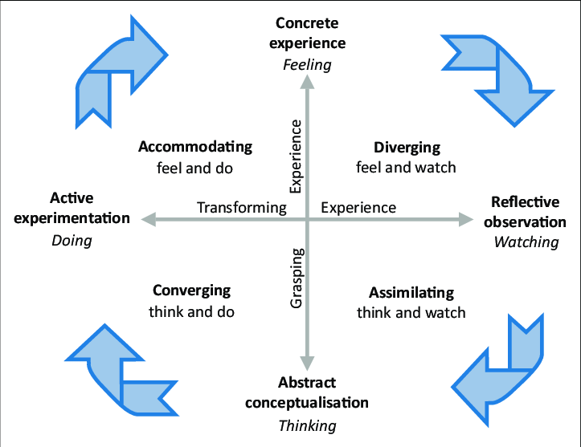
Figure 01: Kolb's learning styles (Henning, Myers and John, 2015)
Concrete Experience: It's the kind of experience I can imagine myself doing. Through these types of learning styles, I value the experiences I have had with myself. Apart from this, I am currently doing some work and the experiences there are also in this learning style.
Reflective Observation of the New Experience: This type of learning refers to an experience that I can be influenced by. This kind of experience has not happened to me so I can't feel it. But from this kind of experience, I can see that there are many essential things to learn that can reflect on my career formation.
Active Experimentation: I am directly involved in these types of learning styles. That is, these experiences are happening to me constantly through my activities. I think about the things that are happening to me and try to learn.
Abstract Conceptualization: It is completely a conceptual learning style whose functionality is expressed through thought. I feel comfortable in thinking about having important experience in various important learning areas.
Honey and Mumford learning style
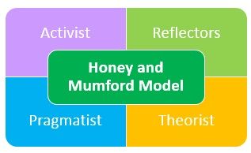
Figure 02: Honey and Mumford learning style (Gale, 2018)
Activist: This learning style involves brainstorming all kinds of important information. Here too the issue of problem-solving is considered very seriously. Learners are divided into groups to achieve problem-solving skills. Role-playing encourages the learning of others.
Theorists: This learning style emphasizes logic in solving any problem. Particularly established theories and models are followed to learn anything. This shows a kind of regularity among the learners that nobody breaks easily.
Pragmatists: Practical work is highly supported in this type of learning style (Moyles, 2010). Typically, these types of learning activities are carried out through Dissection. Different types of case studies are solved, which makes it possible to do health analysis very well. This learning style is also very effective in solving problems.
Reflectors: This type of learning is done through learning by learners. Generally, it can be effective in learning about another event or one's experience. Through coaching and feedback, many new things are learned and learned.
Questionnaire and result
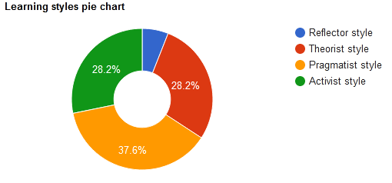
Figure 03: Learning style pie chart
The pragmatist style may be the most effective for me as shown here in the pie chart. I think the best way I can do this is through Practical Learning. By doing this I can get a good idea of ​​the contents and it is suitable for solving health-related problems. Reflector style adoption of my learning is not very effective. Adding something to my own learning from another experience makes it difficult for me to work.
For learning, I like to use different types of logical models and theories. Especially through the Theorist style, I can achieve the learning needed to solve problems and make important decisions. Besides, learning becomes much easier through group discussion and discussion. Usually, in this learning style, I have to face all kinds of new experiences that are challenging for me. I like to take on any type of challenge and it is very helpful for learning.

Analysis of personal strengths, weaknesses, and tools to support professional development planning
Nobody is 100% fulfilled by having all the good things. Every person has some weaknesses and unique strength so everybody has to find an economic scale of efficiency to utilize the strength and reduce the weakness (Gabbar, 2017). When an individual finds his weakness then he can take steps to overcome the weakness and can convert it strength. He also can find his potentialities by identifying his strengths. Here I mention my strength and weakness below-
Individual strengths
- I am physically fit and healthy enough because of my regular physical exercise so I can continue hard work for a long time without getting any physical pressure.
- I am dedicated to my given job and love to take a challenge. It increases my work efficiency.
- I can cope up with any environment or situation in a very short time and can make a good relationship with others.
- I can do work properly even if high mental pressure and can cool in any situation.
- I am skilled enough in mathematics and can solve any mathematical problem very easily.
- I have strength in critical evaluation of any case or study.
Individual weaknesses
- I do not like to do work for a long time project and it irritates me to wait for getting the result of any task.
- I have less interest to learn by reading and love to learn by doing practically. So most of the time I feel bore to learn articles or books.
- I am very slow at reading and writing. It kills my time to complete the learning task.
- I have less IT-based knowledge like coding, programming, and others which are very important in this current world.
- I spend more time to complete a task perfectly and cannot be satisfied by doing a task in a shortly.
Opportunities
- Get things done quickly through practice
- Maintain time by working fast
- Skills that have weaknesses are an opportunity to recover
- Opportunity to manage new skills
Threats
- In many learning styles, choosing the right one is quite a challenge
- Learning content can be very difficult to manage
- Properly developing a Personal Development Plan
The SMART objective of Professional development planning
Skill or ability area | Specific task (what is the task or objective? attach details if appropriate) | Measures (standards and parameters) | Agreed (is it?) | Realistic (is it?) | Timings (start/finish dates)
Time management | One has to be most aware of the time. Do not let any kind of work end after the stipulated time. | Working on health issues must make everyone's time valuable. You should perform the assigned duties by completing the work at the right time. | I can try to get my daily tasks done within the stipulated time in order to achieve this skill within the stipulated time. | To accomplish this, the most positive style for me is to follow the various learning styles and do more of the preclinical work. | It will take me about 4 months to achieve this learning school.
Long term attention | The skill of working for a long period of time has to be achieved and through it, the work is performed successfully. | While working at a health club, you have to work long hours. In this case, patience and mental effort are required. | In the workplace, I have to make the habit of practicing longer periods of work so that I can concentrate longer. | In addition to the learning style, I can do some project work on my own initiative that I can set a long time to complete. | It will take 5 months to fulfill this objective.
Communication skill | Communication skills need to be increased in order to maintain good communication and communication with everyone. | The health club has to work with many types of customers and colleagues and maintain fair communication with everyone. | Basically, communication is very important for relationship buildup and my own skill development. This skill needs to be developed for other skill development as well. | With those around me, I can easily practice this skill for growth. There is an opportunity to receive learning style support to enhance communication skills. | This skill requires 3 months to develop.
Table 01: My Professional development planning
Johari Window Model
The Johari window model has envisioned a house for practice and understanding that has four equally sized rooms. They describe the individual's personal and unknown personal information, such as guilt, qualities, feelings, etc., from four points of view. Its two cells indicate all the known information about themselves, and the other two indicate unknown information about themselves, but others know it.
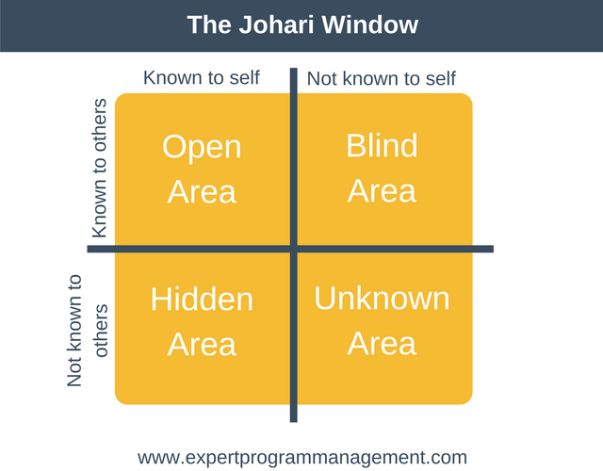
Figure 04: Johari Window Model (FLORES, 2018)
Open or Arena: Usually, we get to know each other in the middle of a day's work together. This section contains all the information related to the person, both to colleagues and to the person himself. The more you know each other, the less the amount of unknown information within yourself will decrease. The relationship with colleagues will be even more effective and dynamic.
Blind: It indicates all information about the person that his or her colleagues know but is unknown to him. I don't know much about what others know about me. Naturally, others may have different ideas about me than I could ever imagine. To reduce blind spots, you need to know about yourself from colleagues.
Hidden or Façade: There are many of us who keep to ourselves. They know a lot but just restrict themselves, don't let others know. This cell contains seascape information. For example, secrets, past experiences, etc., we hide because of fear, shame or hesitation which has a huge impact in the workplace, even in everyday life. To minimize this cell, unknown data will need to be moved to an open area.
Unknown: This section contains all the information that is unknown to the person himself as well as to others (Eilam, 2012). For example, hidden abilities or talents that remain unknown for a lifetime may remain unknown. All these hidden qualities and abilities remain unknown to themselves or to everyone until they are discovered by the observation of themselves or others. And hidden talent can also be revealed in an instant when something unexpected happens.
Concept of personal confidence, studying and thinking independently
Confidence is needed to ensure our success in various tasks. Self-confidence helps us in our lives, whether it is an office or personal life. After graduation, almost everyone has less and less confidence. I may not feel confident enough before making a presentation at the office, returning to class after a holiday, or going to Reunion. However, sometimes it is easier to work with just a little time to prepare.
I have to challenge myself constantly to be fully confident. By doing this, it seemed impossible in the beginning, I could do it. It will increase my confidence but not decrease. Not everything that will always succeed, but I have to know to accept the loss. Besides, challenging work must be done with confidence to achieve customer satisfaction at any health club. If I am not successful in anything, I will have to learn from it without wasting time.
I will not hesitate to ask for help from a friend or relative to regain my confidence. I need to open up the issue to close friends or contact them if there is a known support group. There they will teach me some simple and simple techniques to improve their social communication skills. I can also practice them in support groups or with my close friends. This will build my confidence easily and easily mix with people.

Review of my understanding and expectations of the world of employment
Strategies for exploring employment options acquiring, selecting and collating information
Self-Exploration: Self-Exploration is a process I find myself in. This is a very important component of employment (Blackstone, 2009). I need to have a clear idea about my needs, desires, interests, desires and so on. I can mix with everyone very easily and work diligently. It can give me an idea of ​​some of the many skills I have about myself. These skills can increase my acceptance of employment. But in this case, I also have several lacking that can back me up in selection. That is why I can quickly fix the skills that are lacking in Self-Exploration.
Explore my academic and career options: It is very important to have the right idea about my academic qualification and its demands. Since my academic education is related to health issues, my area of ​​employment may be this affiliated health club or any other institution. That's why when I think about my career, I focus more on health organizations. My academic background can be quite useful for hiring these organizations. But above all else, my motive and desire are to work at such an institution.
Considering the work environment: Not only do I want to be realistic in pursuing my own and my academic education and career. That's why the working environment can become an important factor in my thinking. In the workplace, I expect a number of things that I can be interested in working on when I meet. I always think about things like proper procedures, workplace discipline, behavior, etc. I hope health clubs help people who are employed to create careers.
Strategies for career advancement
Staff recruitment: Advertising for staff recruitment is provided in various media. Candidates have to apply after mentioning eligibility for recruitment (Rouse, 2010). If the organization wants, the staff can also complete the recruitment process from internal sources.
Person specifications: In the advertisement for the recruitment of the staff, there are several specifications that candidates are asked to fill. Some of the specifications are mentioned somewhere in this specification. Especially in health clubs, the age, height, weight, etc. of the candidate are considered very carefully.
Job specifications: Candidates must have several specifications for the job. The organization seeks to recruit candidates with some of these required skills. Those who do not have the specifications mentioned in the candidates will not be able to apply.
Interviewing: After considering the CV of the candidates, a small number of candidates were selected for the interview. The candidates were then interviewed. Interviews are mainly asked about various health questions. Information about the organization is also sought.
Induction: Through the interview, the organization can know enough information about the candidate's status. In this, the candidate who is most qualified is selected for the post (Balandin, Dunaytsev and Koucheryavy, 2010). The candidate is informed by letter to join the post.
Mentoring: Once the recruitment is completed, the selected staff will have to provide training as needed. Such training is needed to adapt to the work of the organization. Moreover, proper mentoring is needed to increase work performance and fulfill the goals of the organization.

Career ambitions and aspirations
Dominate the new skill: I have some good and useful skills that I can use in my work. But there are some new skills that I think will enhance my skills. There are several skills that I want to master in terms of customer satisfaction and employee control when it comes to health clubs. My ambition is to develop new skills all the time. I am trying to develop these skills through a personal development plan. If I can develop these skills on a regular basis, then there is no problem with working in the workplace.
Provide lead to employees: If I think of myself as a manager of a health club, I should give the staff they lead. In this case, I have to be sure of the goals and objectives of the organization. The goal of the organization is to provide employees with leads. The employees complete the tasks they will do for the organization on purpose. I have to think about the desires, aspirations, and needs of the employees and give them motivation accordingly. The culture and needs of a single worker are the same, but they have to get work done through them. If I have the skills to lead, I will be able to reach a better position.
Becoming an expert in my field: I want to work at a health club or any such institution. In this case, I always want to have a good idea for my sector. The more I know about my own field of work, the more I will be able to Dominate. Especially in the field of health, it is very important to have an idea about physical exercise, how to stay healthy, and various exercises. I'm trying to gain a better understanding of these things. In addition to following the learning styles, I am pursuing a personal development plan to achieve this type of knowledge. By learning this way I hope to be able to fulfill my ambition.
The desire for security: Safety will always be a factor no matter where I work. There may be a few types of security. But my desire is that I get all kinds of security from the organization properly (Appannaiah, Narayana Reddy and Ramanath, 2010). Financial, social, and physical securities are very important in working in an organization. I am very interested in any health-related organization and these organizations are very aware of safety. No need to deal with any kind of stress and worry when the desire for security is met. This will allow me to think more about my career.
The desire for better pay and benefits: Adapting to the workload is a positive aspect, even if the stress is high. However, one aspect of the organization should also be taken into account that the salary and other benefits of the worker should be paid properly. In the same way, I would like to join an organization so that I can get my salary. There are many benefits to working in an organization. Nowadays benefits like salary, bonus, tours, etc. are offered in all kinds of establishments. My desire is to work in an organization where these benefits are readily available.

Personal development plan to enable me to achieve my ambitions
I was never very aware of the time before and I was late for every task. However, following the Personal Development Plan, I am currently able to complete my daily tasks in a timely manner. I'm getting enough time to develop a new skill. I think this is quite effective in meeting my ambition.
My communication skills have grown enormously in the wake of the Personal Development Plan. My ambition is to provide employees with the right leads. Communication skills are very important for giving employees the lead. With the help of this Personal Development Plan, I was able to resolve this incident of my Communication Skill very quickly. At the same time, I will be able to move forward with my career by maintaining good communication with other colleagues in the organization.
Be that as it may, through the advancement plan, I have had the option to perceive all the wellbeing related issues and find out about their utilization. Moreover, I have had the option to find out about the issues that can emerge in these issues in an opportune way. There are numerous kinds of answers for potential issues and I have defeated them. Regardless of what the issue might be, I would like to have the option to understand it rapidly. Through this, I trust I will have the option to accomplish my objectives and be extremely compelling in building a vocation.

Conclusion
It is important to note that, for most people, career development happens without the intervention of other people. There is no specific age when it starts - some people will start thinking about career choices early in life, while others will not worry too much about it until they make more money than they decide. Although many individuals run this process independently, almost everyone can benefit greatly from seeking specialist career guidance. By consulting a career counselor or other similarly trained expert, or taking a class school that helps with career development, I can build a more satisfying and successful career.

References
Appannaiah, H., Narayana Reddy, P. and Ramanath, H. (2010). Business research methods. Mumbai [India]: Himalaya Pub. House.
Balandin, S., Dunaytsev, R. and Koucheryavy, Y. (2010). Smart spaces and next-generation wired/wireless networking. Berlin: Springer.
Blackstone, W. (2009). Commentaries on the laws of England. Clark, NJ: The Lawbook Exchange.
Eilam, B. (2012). Teaching, learning, and visual literacy. Cambridge [England]: Cambridge University Press.
FLORES, R. (2018). BACKROADS PRAGMATISTS. [Place of publication not identified]: UNIV OF PENNSYLVANIA PR.
Gabbar, H. (2017). Smart energy grid engineering. London: Academic Press.
Gale, C. (2018). Gale Researcher Guide for. Farmington Hills: Cengage Gale.
Henning, B., Myers, W. and John, J. (2015). Thinking with Whitehead and the American pragmatists. Lanham, Maryland: Lexington Books.
Lussier, R. and Achua, C. (2012). Leadership. Mason, Ohio: South-Western.
McLean, P. (2012). The handbook of coaching. San Francisco, Calif.: Jossey-Bass.
MirosÅ, a. (2012). Production-oriented and Comprehension-based Grammar Teaching in the Foreign Language Classroom. Springer Berlin Heidelberg.
Moyles, J. (2010). Thinking about the play. Maidenhead: Open University Press/McGraw-Hill Education.
Rouse, K. (2010). Personal development. South Melbourne, Vic.: Oxford University Press.

Appendixes
Questionnaire


