

Master of Business Administration
Student Name: Akashkumar Darji
Student ID: 2432866
Prof: Tushara Balendran
LCMB7034 - International Marketing: Principles and Practices
Title: Analysis and comparison of India and UK marketing strategies for BMW
Student ID: 2432866
Student Name : Akashkumar Darji Word Count:5000

Table of Contents

1. Introduction 4
2. Brand overview: BMW 4
3. Comparison of the socio-cultural context of India and the UK 5
3.1 Comparing and contrasting macroenvironmental factors 5
3.1.1 PESTLE analysis on the UK and India automotive industry 5
3.2 Comparing the UK and India microenvironment impact on BMW 12
4. Comparison of Brand’s STP strategies in Country A and Country B 13
4.1 STP strategies in the UK 13
4.2 STP strategies in India 14
4.3 Comparison between India and the UK for targeting and segmentation and position 16
5.1 7P marketing mix strategies 17
5.1.1 BMW in the UK 17
5.1.2 BMW in India 20
5.1.3 Comparison of the UK and India marketing mix 23
6. Evaluation of the performance of marketing strategies 24
6.1 Evaluating whether BMW’s marketing strategies are successful in countries, i.e, India and the UK 24
7. Evaluation of marketing ethics practice 25
7.1 Marketing ethics followed by BMW in the country India 25
7.2 Ethical issues faced by BMW in the UK 26
8. Recommendation & Conclusion 26
8.1 Recommendations 26
8.2 Conclusion 27
9. Reference List 28

1. Introduction
The international marketing practices of the organisations in the contemporary business landscape involve the process towards promoting and selling products. This aspect of the business leverages the distribution of products that fit diverse environments and cultures. In this context, the report will analyse the marketing strategies of BMW. In this report, the chosen organisation is BMW, to analyse the marketing strategies of the company in two different countries, which are the UK and India. The study will offer an in-depth understanding of the sociocultural context in both countries. Further, it will also compare the STP strategies and marketing mix strategies of BMW in the chosen countries. Besides, the performance of marketing strategies will be evaluated, in addition to marketing ethics practice.

2. Brand overview: BMW
Bayerische Motoren Werke (BMW), a German luxury automaker, was founded in 1916 with its official headquarters in Munich, Germany. The company operates in 140 countries, including the UK and India, offering premium vehicles through local production in the UK and a widespread dealership network in India (Bmwgroup.com, 2025). The company specialises in the development, manufacturing, and selling of automobiles and motorcycles, including accessories and engines. The company has the presence of major production and assembly facilities, including a sales network in different parts of the globe (Global Data, 2025). The company is ranked among the top ten leading brands across the global automobile domain with respect to its investment in fleet electrification by leveraging artificial intelligence in the process of vehicle manufacturing (Carlier, 2025).
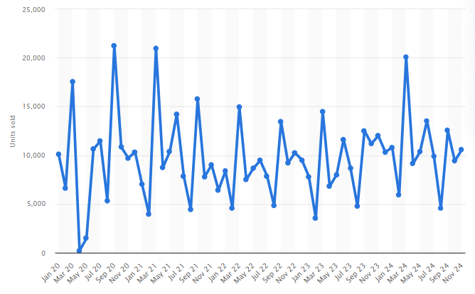
Figure 1: BMW passenger cars sold
(Source: Carlier, 2024)
According to the statistical report, the sales of BMW pertaining to passenger cars in the financial year of 2025 have engrossed a growth of $103 billion. This highlights the annual growth rate for the company between 2025 to 2029, with the projected market volume of $105 billion during the specific year (Statista, 2025).

3. Comparison of the socio-cultural context of India and the UK

3.1 Comparing and contrasting macroenvironmental factors

3.1.1 PESTLE analysis on the UK and India automotive industry
Macroenvironmental factors involve external forces that impact and influence the operations of brands and businesses. In the wider sense, it determines the analysis of economic, political, social, technological, environmental, and legal factors (Gini and Agala, 2023).
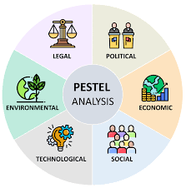
Figure 2: PESTLE factors
(Source: Segura et al., 2023)
Political
Brexit uncertainty in the UK has imposed a significant shift in the automobile market due to new tariffs and the reduction in production, posing a supply chain disruption (Zhang, 2020). The UK government is supporting incentives for EVs, where vehicles are eligible for up to £3,750 discount (Mistry, 2025).
The “Make in India” initiative of India is transforming the automobile sector into a global manufacturing powerhouse (Singh et al., 2025). The government of India is committed towards the electrification mission to gain electric mobility of 30% by 2030 (IBEF, 2024).
Both countries favour BMW in response to government incentives for EVs towards teh promotion of electric models and favouring brand positioning.

Economic
The economy of the UK has expanded with the rise of GDP by 0.1% in 2025, eventually influencing its position in the international market (Inman, 2025). The recent inflation rate of the UK is highlighted to be 3.8%, posing a higher impact on the aspects of consumer prices (Clark, 2025).
India highlights the presence of economic volatility in terms of gaining a position as a faster-growing major economy with a GDP growth of 6.5% between 2024 to 2025 (Gov.in, 2025). The current inflation rate of India has declined to 1.54% a down from 2.07% (Ferreira, 2025).
Economic volatility and GDP growth fluctuation is unfavourable, impacting consumer spending and demand for premium vehicles. Changing inflation impacts the pricing and profitability of BMW.
Social
In the UK 9.7% of customers demonstrate a strong preference towards sustainable products and the willingness to pay more for sustainable products or services (Barabas, 2024). Growing environmental awareness is influencing customers to become increasingly ecologically minded, which has become a major driver of changing customer behaviour (Consultancy UK, 2022; Deloitte, 2024).
In India, urbanisation is the major driver for transforming the spending capacity of Indian customers (Eastspring, 2024). 50% of the Indian younger population opts for a hybrid technology while purchasing a vehicle (Deloitte, 2024).
Urbanisation and changing customer behaviour of Indian and UK is unfavirable as this will require BMW to adapt its products and services to local needs.
Social environment of India and the UK through Hofstede’s dimensions
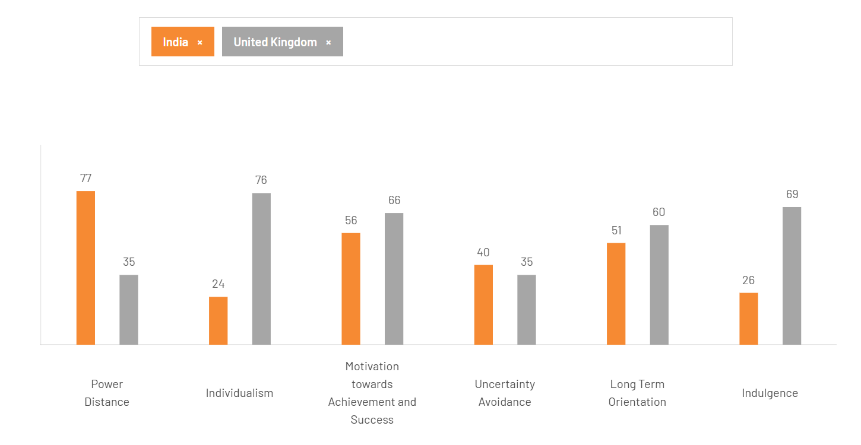
Figure 6: Country comparison of UK and India
(Source: Hofstede Insights, 2025)
The power distance score of India indicates a strong acceptance towards unequal power, whereas the lower score of the UK represents a greater emphasis on factors such as equality and decentralisation. The UK is determined to be highly individualistic as the greater emphasis is placed towards personal autonomy; in comparison, India tends to be collectivist, where major priority is given towards group harmony. With a higher focus towards masculinity, the UK tends to prefer competition and achievement, whereas the culture of India is represented to be assertiveness with a higher preference to nurture qualities. The lower uncertainty avoidance of the UK represents higher tolerance, with a moderate score; India reflects a preference towards uncertainty avoidance. The long-term orientation determines a higher dominance of philosophical thought, whereas the UK tends to believe in the truth of the situation. India tends to be culturally resistant; in comparison, the UK exhibits a greater willingness towards desires (Hofstede Insights, 2025). Thus, the cultural dimension tool of Hofstede highlights that the UK and India differ in terms of power distance, uncertainty avoidance, individualism, and long-term orientation.
Hofstede advantage
- The model enables understanding of diverse culture
- Fosters appreciation for diversity
- Promotes global collaboration
- Reduce misunderstanding and conflicts with the optimisation of feasible communication and collaboration (Escandon-Barbosa et al., 2021)
Hofstede disadvantages
- The aspects of model, such as power distance index, masculinity/ femininity and others does not fully capture the intricacies of various social cultures
- The model only focuses on cultural perspective with no emphasise on individual based social context
- Higher reliance of model can hinder accurate determination of subcultural and individual differences
- The model fails to reflect on current cultural values (Williamson, 2002)
Socio-cultural factors' impact on two countries on BMW
Similarities:
- Both in the UK and India BMW positions itself as a luxury brand by emphasising high-quality products and services
- BMW ensures customer-centric approach by prioritising customer satisfaction to meet local preferences (Hyatt, 2020)
- It uses digital marketing strategies, including social media and online advertising, to engage with customers in both the UK and India
- It has integrated relevant innovation and technology to develop products and services by fulfilling commitment to quality and performance (Afaqs, 2025)
Differences:
- The marketing strategies of BMW reflect difference in terms of culture, where in the UK, it focuses on individualistic culture, while in India, it prioritises collectivist culture (Hyatt, 2020)
- In the UK, BMW uses personalised marketing, on the other hand in India it emphasises social benefits and family-oriented marketing
- Product offering of BMW differs in two markets, with a greater emphasis on luxury and performance in the UK, and technology in India
- In the UK, BMW prioritises personalization, while in India, it focuses on trust and loyalty (Afaqs, 2025)
Technological
The UK is seeking a technological grant scheme in support of new EV charging points (Dempsey and Hinson, 2024). The UK is accelerating autonomous vehicle deployment, whereby by 2035, 40% of new cars will gain self-driving capabilities (Gov.UK, 2025).
The electric mobility of India is rapidly growing with investment in V technology due to the $100 billion share that the Indian automotive market will acquire in the global sphere (Gov.in, 2019). The Indian automotive sector transformation is driven by advancements concerning sustainable mobility and opportunities pertaining to EV manufacturing and battery production (Gov.in, 2019).
Favourable for enhancing premium quality and performance, leveraging technological advancements to improve customer experience and loyalty.
Legal
Stringent emission regulation, such as the UK Emissions Trading Scheme (UK ETS), prohibits greenhouse gas emissions (Gov.UK, 2021). Mandatory annual safety inspections (MOTs) ensure that the legal standards pertaining to vehicle development are met (GOV.UK, 2025).
The Indian cabinet has approved a $1.3 billion scheme for EVs in support of pollution emission and cleaner fuel usage (Mehta, 2024). Bharat Stage VI (BS-VI) norms prohibit emissions through stringent standards (Gajbhiye et al., 2023).
Unfavourable as it can impact market reputation and brand image if BMW fails to align with legal guidelines. Moreover, this also makes brands susceptible to increased compliance costs.
Environmental
The 2008 Climate Change Act of the UK emphasises climate action and environmental sustainability (Stiftung, 2024). The UK is committed to a 2050 net-zero carbon emission target (Dempsey and Hinson, 2024).
In India emphasis towards the sustainable target is being made towards the sustainable target of reducing carbon emissions by 35 to 40% by 2030 (Tillu et al., 2024). Coordinated action is being taken to reduce Scope 1 and Scope 2 emissions by 2050 (Arora et al., 2025).
Unfavourable if the marketing strategy of BMW fails to align with its commitment pertaining to sustainability and environmental responsibility, giving rise to unethical behaviour and greenwashing accusations.
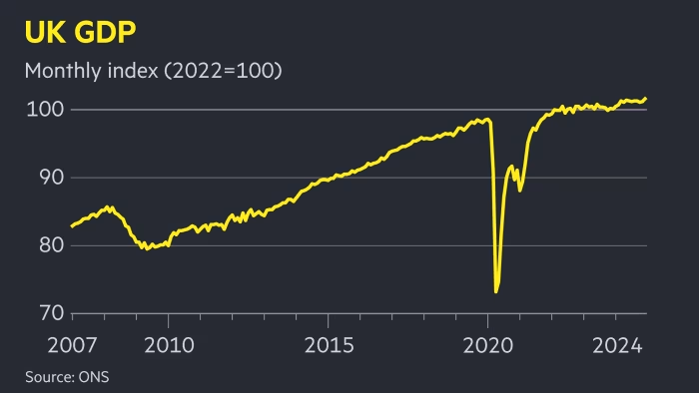
Figure 3: UK GDP
(Source: Fleming, 2025)
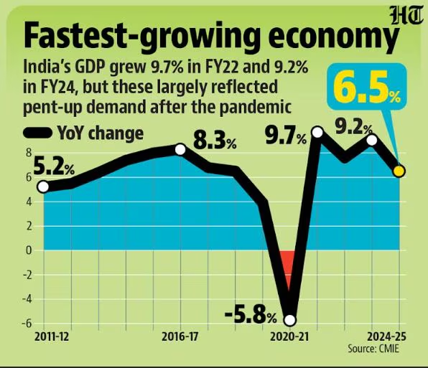
Figure 4: India GDP growth
(Source: Kishore and Jayaswal, 2025)
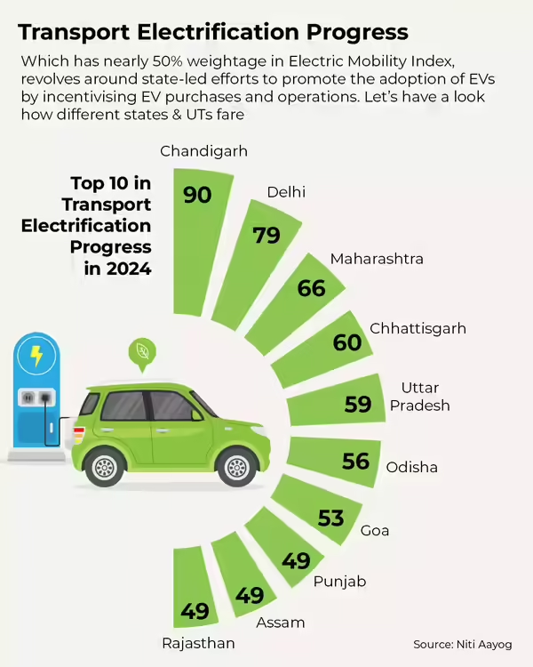
Figure 5: Electric mobility growth in India
(Source: Times of India, 2025)

3.2 Comparing the UK and India microenvironment impact on BMW
In response to the above PESTLE analysis conducted in terms of the UK and India, it can be determined that both nations have a present comparatively different environment for the operation of automobile ventures, such as BMW. For instance, the Brexit uncertainty and stringent emission regulations highlight threats to the operation of BMW, whereas the economic growth of India highlights opportunities in gaining support from the political environment to align with the process of electrification (Zhang, 2020; IBEF, 2024). Regardless, the key similarities of both countries illustrate an emphasis on sustainability and emission reduction, including preferences of customers towards eco-friendly products and services. Nevertheless, factors pertaining to economic growth, inflation and EV incentives are deterrents to elaborating a major difference between the UK and India. Therefore, in both nations, for BMW, it is essential to leverage opportunities, significantly coping with critical concerns.

4. Comparison of Brand’s STP strategies in Country A and Country B

4.1 STP strategies in the UK
Segmentation
Demographic
Age: 50-64 years
As per Statista, the UK population aged between 50 to 64 years has the highest weekly expenditure on automobiles in 2022 (Statista, 2022).
Gender: Male and Female
The premium car market has historically had a higher percentage of male drivers.
However, professional women who like fashion, technology, and concern for the environment have also been the focus of contemporary marketing initiatives, including the BMW iX and i4 promotions.
Income: High income ($70,000 a year).
These people understand the long-term worth and environmental advantages of luxury cars, and they can afford them.
Occupation: Professional leaders, IT specialists, business owners, and managers are drawn to the company because they view BMW as an emblem of social standing as well as an operational advantage.
Psychographic
Need: Sustainable luxury EV with modern features and advanced battery charging technology.
Lifestyle: BMW appeals to contemporary, tech-savvy, environmentally conscious customers who respect quality and innovation.
Values: Customers of BMW UK show a strong interest in sustainability and are increasingly choosing hybrid and all-electric cars.
V.A.L.S personality types
Values: Targets customers with higher desire for performance, quality, and innovation.
Attitudes: In need of confidence and sophistication, including lend of performance and practicality
Lifestyles: Value over style and performance, in addition to leisure activities and passionate about driving and automotive technology (BMW, 2021)
The target audience of the company in the UK is the eco-conscious automobile buyers falling in the age group, 50-64 years (Statista, 2022). Wealthy individuals who value efficiency, luxury, and distinction are drawn to BMW. This demographic responds positively to features like cutting-edge driver aid systems and opulent interior choices. In its varied product portfolio, which includes cars, motorbikes, and electric cars, BMW provides an equilibrium of history and contemporary that these experts value. Additionally, a significant portion of BMW's target market consists of driving fanatics who seek out outstanding handling and potent power. People who enjoy the rush of driving are drawn to models such as the BMW 3 Series, which has been renowned for its dynamic qualities since its debut in 1975.
Positioning statement and perceptual map
“BMW provides premium, highly sophisticated, and ecologically friendly transportation options that blend enjoyable driving with ethical development, compared to other luxury vehicle manufacturers who strike a balance between effectiveness and thrills for sophisticated and environmentally aware consumers in the United Kingdom who want performance and status.”
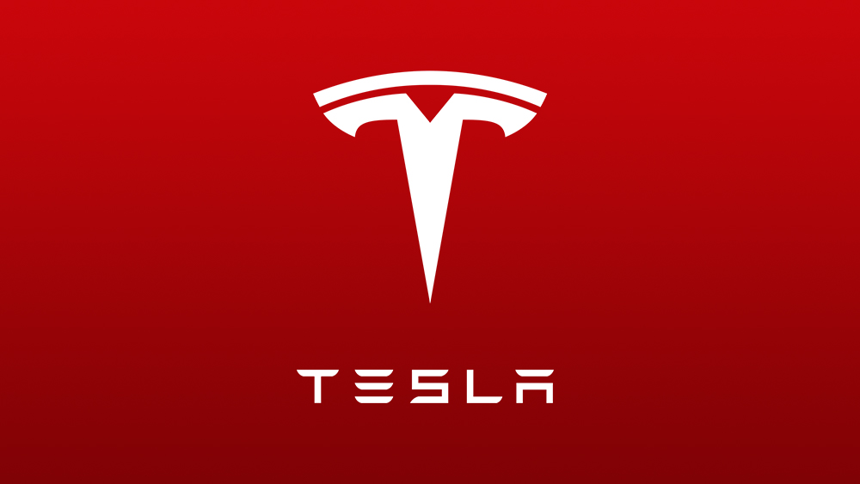

High Price
Low Price
High Sustainability
Low Sustainability
Figure 7: Perpetual Map of BMW in the UK
Source: (Self-created)

4.2 STP strategies in India
Segmentation
Demographic
Age: 55 years and above
TOI reported that Millennials and middle-aged people (above 55 years) are highly fond of purchasing EVs in India (Gupta, 2024).
Gender: Male and Female
Customers of both sexes are targeted, especially retirees, professionals, and business owners who value high-end brands and technological competence.
The emphasis is on wealthy individuals who have extra cash to spend on luxury cars that provide sustainability, comfort, and status.
Income: High Income Groups
Psychographic
Need: Value-based EVs with a high range and long durability of battery durability
Lifestyle: People with a modern, forward-thinking lifestyle who are aware of the effects on the natural world but are unwilling to give up luxury, style, or the enjoyment of driving.
V.A.L.S personality types
Values: Greater emphasis on driving experience and BMW's engineering excellence, with the focus on technology and sustainability
Attitudes: Reflecting success through premium brand, confidence and sophistication, in addition to contradicts with requirements of family and social status
Lifestyles: Fits with luxury and exclusivity, career growth and status and passionate towards driving and automotive technology (BMW, 2024)
Target audience
Eco-conscious automobile buyers aged above 55 years in India (Gupta, 2024). “These customers are financially stable, have a good education, and want to make sustainable and innovative purchases. They favour companies that stand for distinction, dependability, and environmental consciousness.”
Positioning statement and perceptual map
“BMW provides luxurious electric car models that combine German engineering superiority with sustainable creativity, providing an unmatched driving pleasure that demonstrates both elegance and accountability to wealthy and environmentally conscious Indian consumers seeking elegance, performance, and environmental responsibility.”
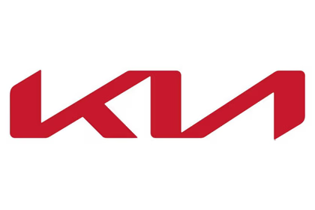

High-Value product
Low-Value product
Highly sustainable
Low sustainable
Figure 8: Perpetual Map of BMW in India
Source: (Self-created)

4.3 Comparison between India and the UK for targeting and segmentation and position
In India, BMW segmentation, targeting and positioning strategy focuses on value creation, whereas BMW in the UK prioritises sustainability over pricing. “Although BMW's STP initiatives in India and the UK both target wealthy, environmentally aware buyers, their approaches vary in terms of focus and market maturity. BMW positions itself as a pioneer in luxury green mobility in the UK by focusing on professionals between the ages of 50 and 64 who value sustainability, innovation, and driving excellence. BMW, on the other hand, targets Indian clients 55 years of age and above who are looking for affordable electric cars that blend comfort, performance, and status. India's approach places a higher priority on affordability within luxury, dependability, and long-term value than the UK, which emphasises environmental responsibility and cutting-edge technology. This is in line with the nation's developing EV infrastructure and changing consumer understanding.”
5. Comparison of Marketing Mix Strategies in Country A and Country B

5.1 7P marketing mix strategies
The approach of marketing mix strategies is significant in terms of effectively placing products or services. The approach supports alignment with marketing efforts in response to marketing needs and customer relationships.

5.1.1 BMW in the UK
Product: High-end, luxury two- and four-wheel drive vehicles for international markets are the main emphasis of the BMW Group. Depending on the particular requirements of each market group, these products are produced at particular locations worldwide. While many of the goods available are the same throughout continents, others allow for a great degree of customisation for their consumers.
Price: As a leading competitor in the industry, BMW Group has long produced luxury cars that are seen as status symbols. BMW's pricing approach is also communicated by its affiliated brands, such as Mini Cooper and Rolls-Royce. The cost of these brands is slightly greater than that of the typical BMW product line. In order to place itself in the "desirable" market sector, BMW sets a premium price. In the marketing mix it employs, this price approach also makes sure that the company's name doesn't become watered down or its place in the market becomes ambiguous. The price tag of BMW car spare parts and post-purchase servicing is another example of this marketing tactic. The new BMW i4 electric sedan's on-the-road (OTR) pricing in the UK starts at £50,365 for the base eDrive35 Sport model. At £69,995 OTR, the i4 M60, a high-end model, is listed (BMW, 2021).
Promotion: Merchandise and other offers have been effectively promoted by the company. In order to continuously build awareness of the brand, its promotional approach, which is a component of its marketing mix, emphasises strong marketing through media outlets such as TV, the internet, billboards, print, etc. Numerous rallying competitions, as well as other sporting events, have BMW as a close supporter. The business also supports a number of well-known sports teams and rally drivers (BMW Group, 2023).
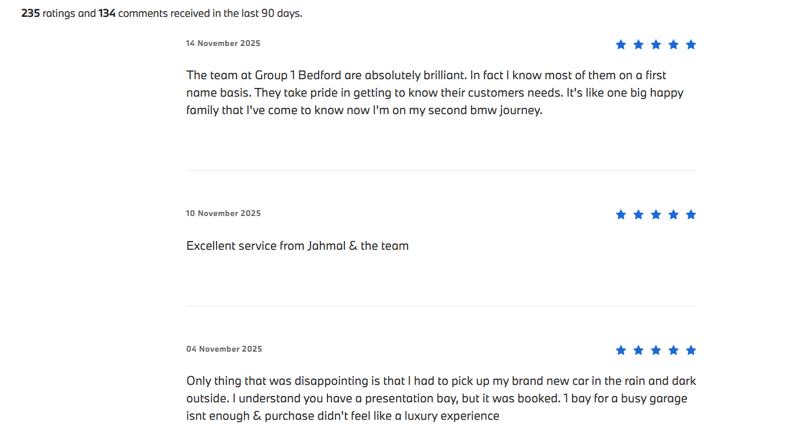
Figure 9: BMW customer reviews UK
(Source: BMW uk, 2025)
Place: As a well-known automaker, BMW has expanded its production sites across numerous locations. Munich, Bavaria, was home to the first facility. However, the business has already established enormous production facilities to handle such enormous volumes as a result of acquiring fresh clients worldwide. BMW's worldwide distribution for business showrooms, as well as other high-end auto sellers, is covered by its marketing mix placement approach in addition to its production. As of February 1, 2024, there are 150 BMW shops in the UK. With 124 dealerships, or almost 83% of all BMW dealers in the UK, England has the most BMW facilities in the whole nation (Scrapehero, 2025).
People: BMW has emphasised on Customer Experience Centre in terms of offering customer experience and satisfaction, with the presence of 154,950 employees (BMW, 2024). It has ensured the engagement of trained and knowledgeable sales staff, who support in building long-term relationships with customers (BMW, 2024).
Process: Focus towards online configurators and booking systems to streamline processes concerning sales. Depiction of efficient servicing and maintenance procedures, including sustainability and environmental responsibility (BMW UK, 2025).
Physical evidence: Presence of luxury dealerships and showrooms. In addition to managing the website to effectively cater requirements of the UK customers (BMW UK, 2025).
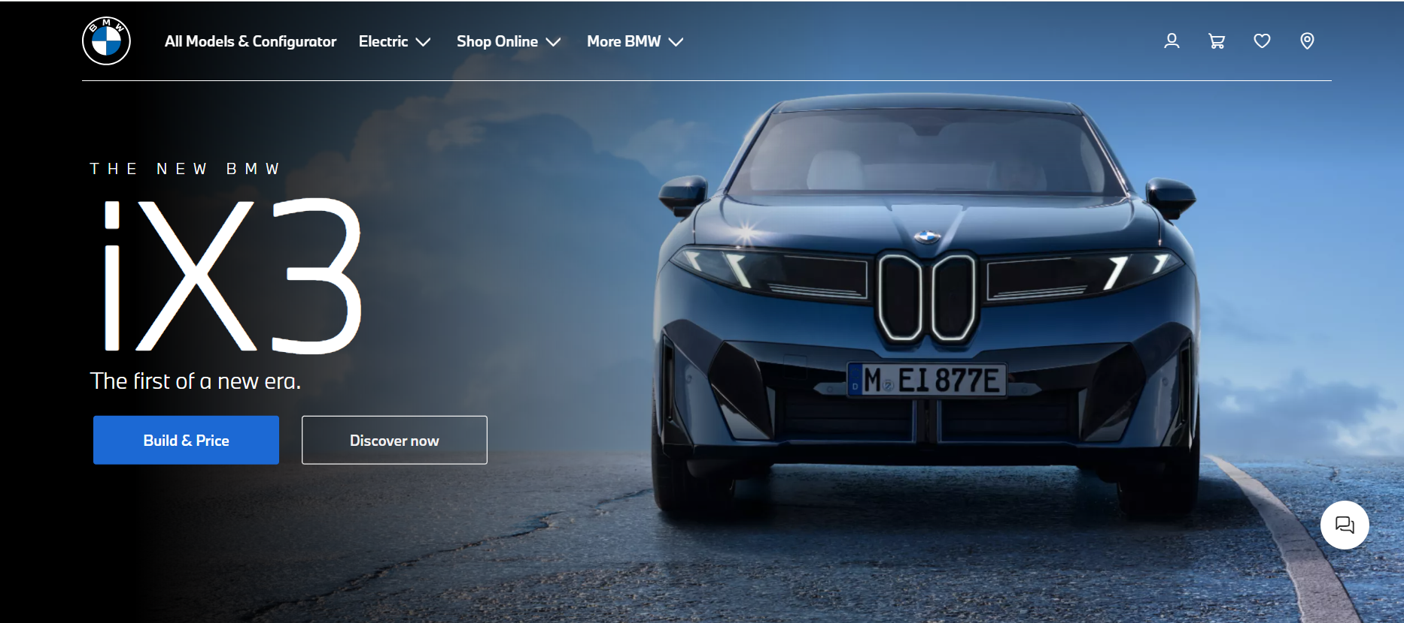
Figure 10: BMW UK website
(Source: BMW UK, 2025)
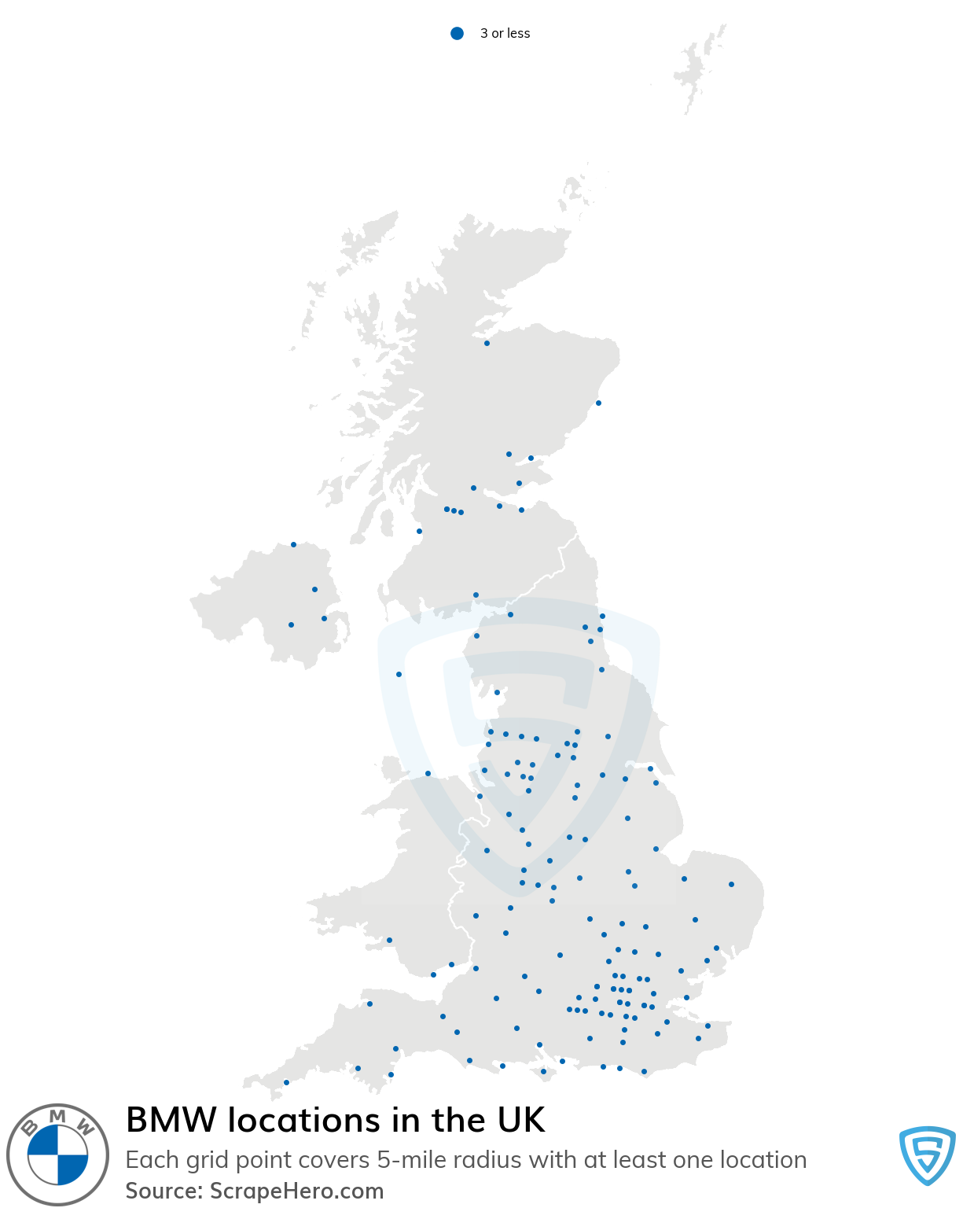
Figure 11: BMW Locations in the UK
Source: Scrapehero (2025).
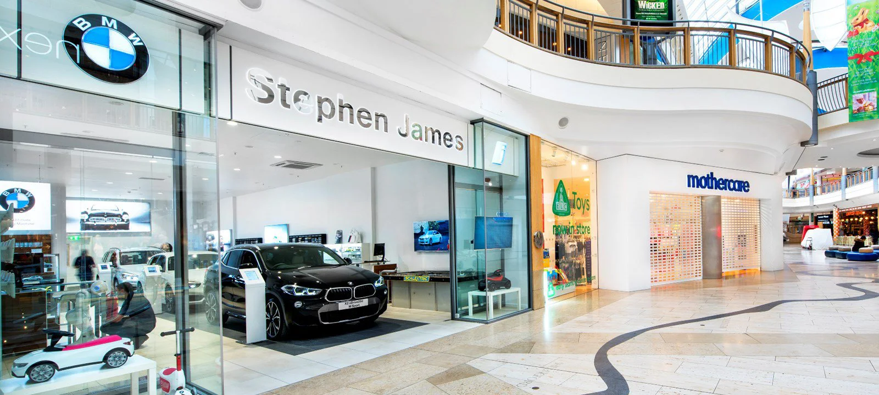
Figure 12: BMW Store in UK
Source: (luxuryretail, 2018)

5.1.2 BMW in India
Product: Under the BMW, Mini, and Rolls-Royce brands, BMW has produced more than 80 models of high-end automobiles. Additionally, BMW Motorrad has developed more than 15 motorcycle models. Among contests and titles such as Touring Car Racing, Formula 1, Sports Car Racing, and the Isle of Man TT or Tourist Trophy Races, the business's automobiles and motorcycles have made history. They have produced cars that meet the needs of every class, from entry-level to upper-level, notwithstanding the high pricing. advancing engineering from its most fundamental model. Each thing has unique qualities and attributes.
Price: Customers seek and pay far greater rates for such perceived excellence because BMW's pricing mix is undoubtedly premium due to its premium equipment and style. Items that stand separately in the BMW product range, such as Rolls-Royce and Mini John Cooper, have higher costs than competitors (Arya, 2025).
Promotion: “A company's ability to effectively implement promotional and advertising techniques determines its level of success. BMW uses aggressive advertising on TV, billboards, print ads, social media (Facebook, Instagram, Twitter, Snapchat), and at various sporting events to build ongoing brand awareness. However, they oppose the general public having access to cars. As a result, the TV commercials are more polished and of better quality. At the time of purchase, they give their consumers memorable experiences and concentrate on their luxury. Slogans such as "Sheer Driving Pleasure" and "The Ultimate Driving Machine" imply to consumers and others that driving a BMW may provide a driving experience that no other vehicle can match. Additionally, the corporation has well-known brand advocates like Sachin Tendulkar.” BMW has 2M followers on the Instagram page, communicates product updates through Instagram to customers (Instagram, 2025).
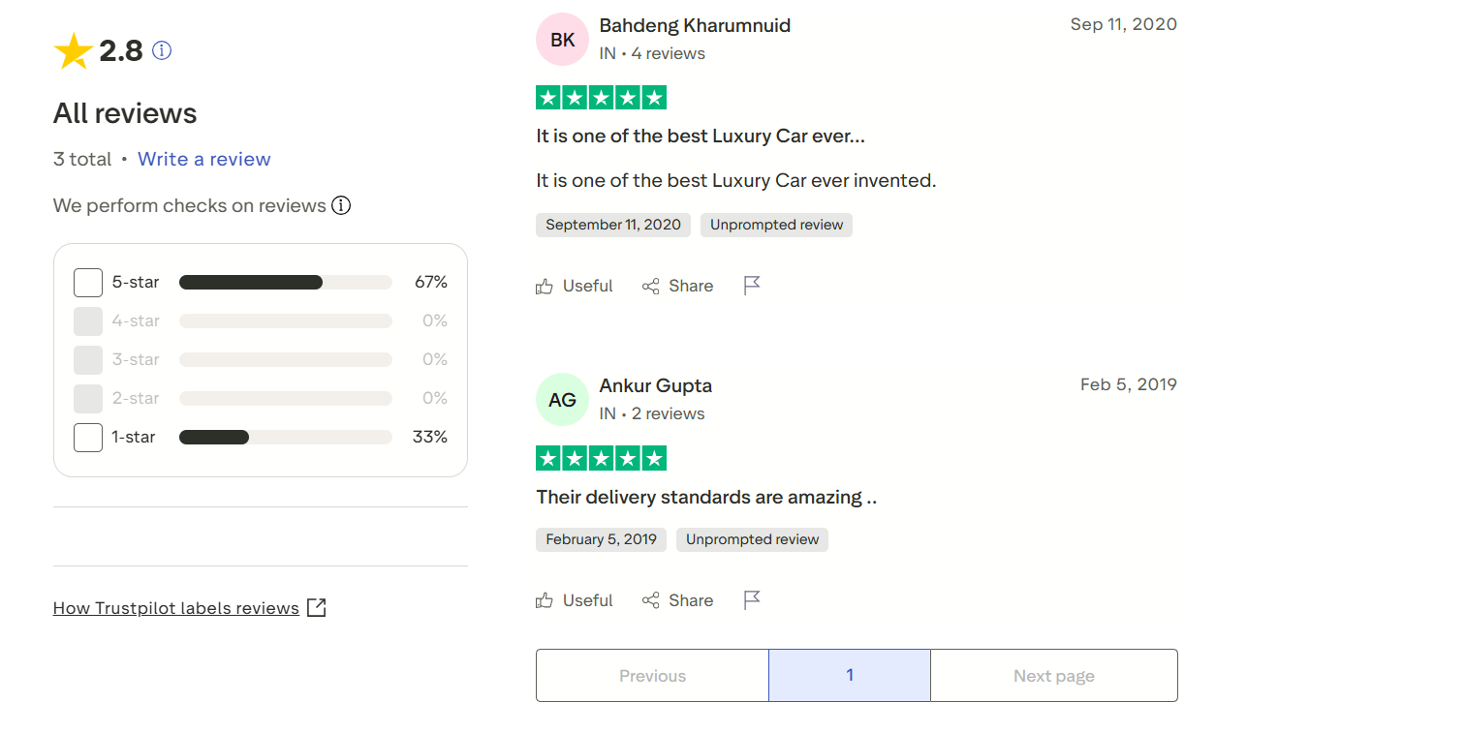
Figure 13: BMW customer reviews in India
(Source: BMW.in, 2024)

Place: BMW India has established a significant physical footprint; as of July 2025, it had about 520 authorised dealer locations throughout the country. “The business sold 15,721 cars in India in 2024, setting a new record. These sites are spread across both large metropolises and up-and-coming cities; for example, Maharashtra alone has about 89 dealer shops, or about 17% of the nationwide network. BMW's distribution network covers the luxury mobility market in India by catering to both ultra-premium and urban affluent consumers (Amulya Raj Srinet, 2025).
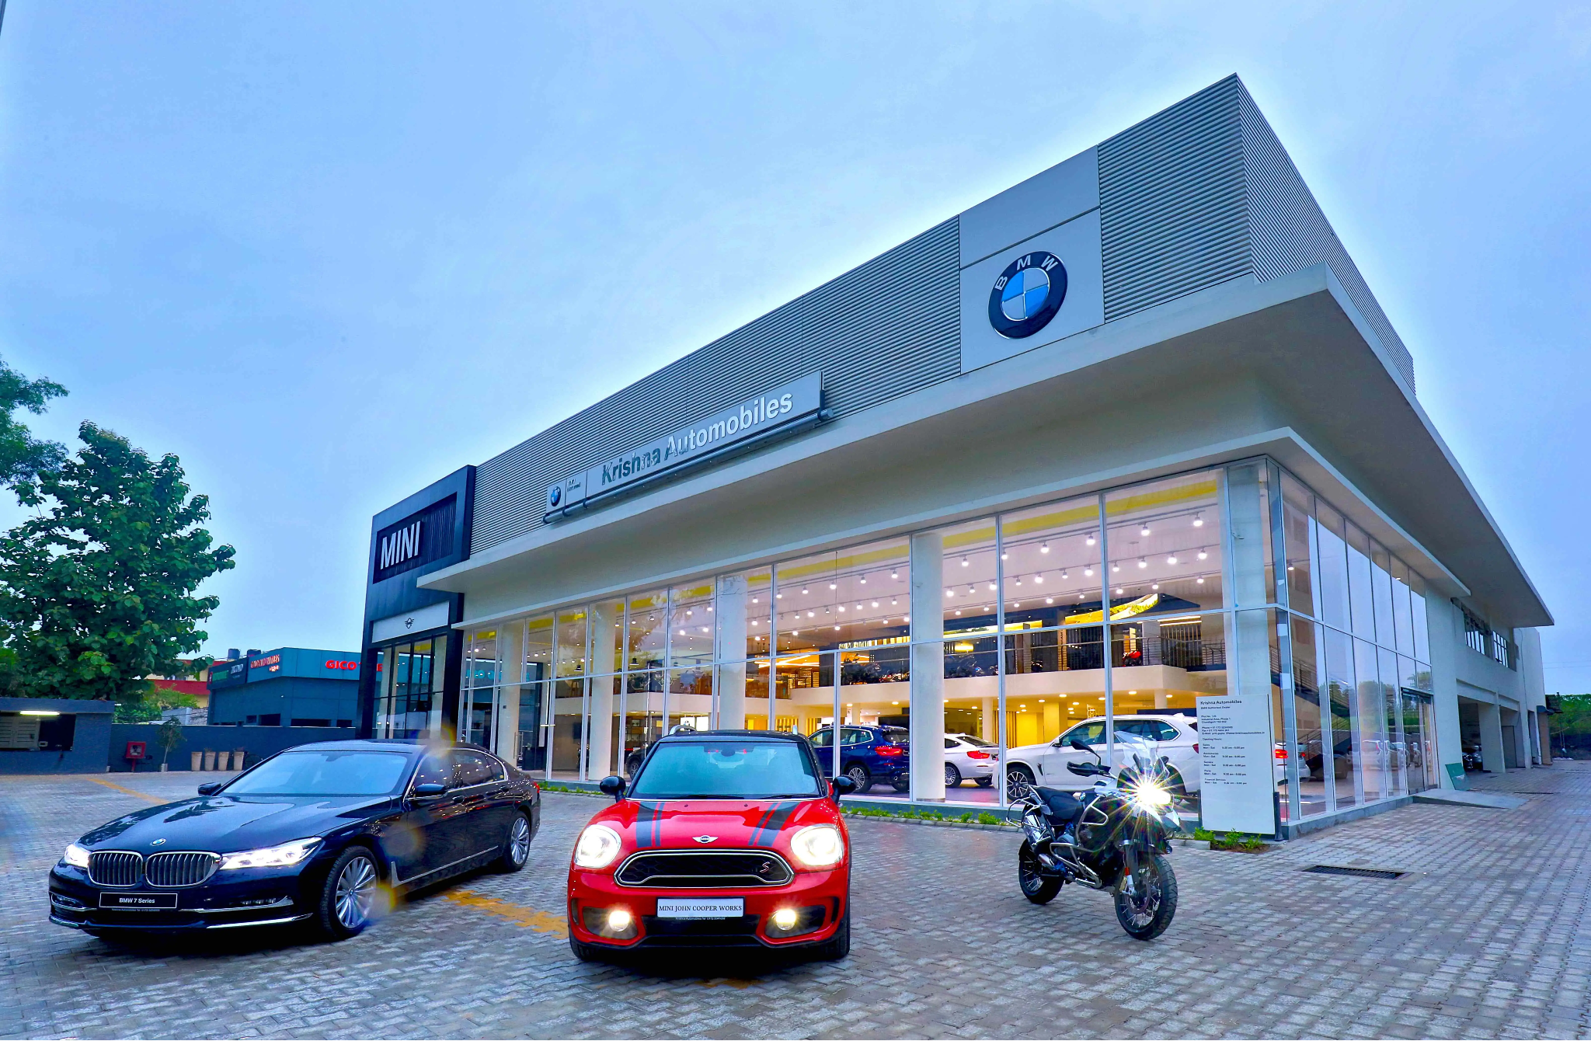
Figure 14: BMW Store in India
Source: (ET Auto, 2018)
People: BMW in India focuses on customer experience and satisfaction, with the assurance of relevant support and guidance with the engagement of 149,475 employees (BMW India, 2025). Trained and knowledgeable sales staff are responsible for handling customer service centres (BMW.ind, 2025).
Process: Emphasise towards dealerships offering same-day repairs and flexible scheduling. It also emphasises reducing waste and emissions by leveraging the Sustainable Materials team (BMW, 2024).
Physical evidence: Depiction of iconic BMW roundel and slogan "The Ultimate Driving Machine”. Driving growth and brand experience by means of a supportive website (BMW India, 2025).
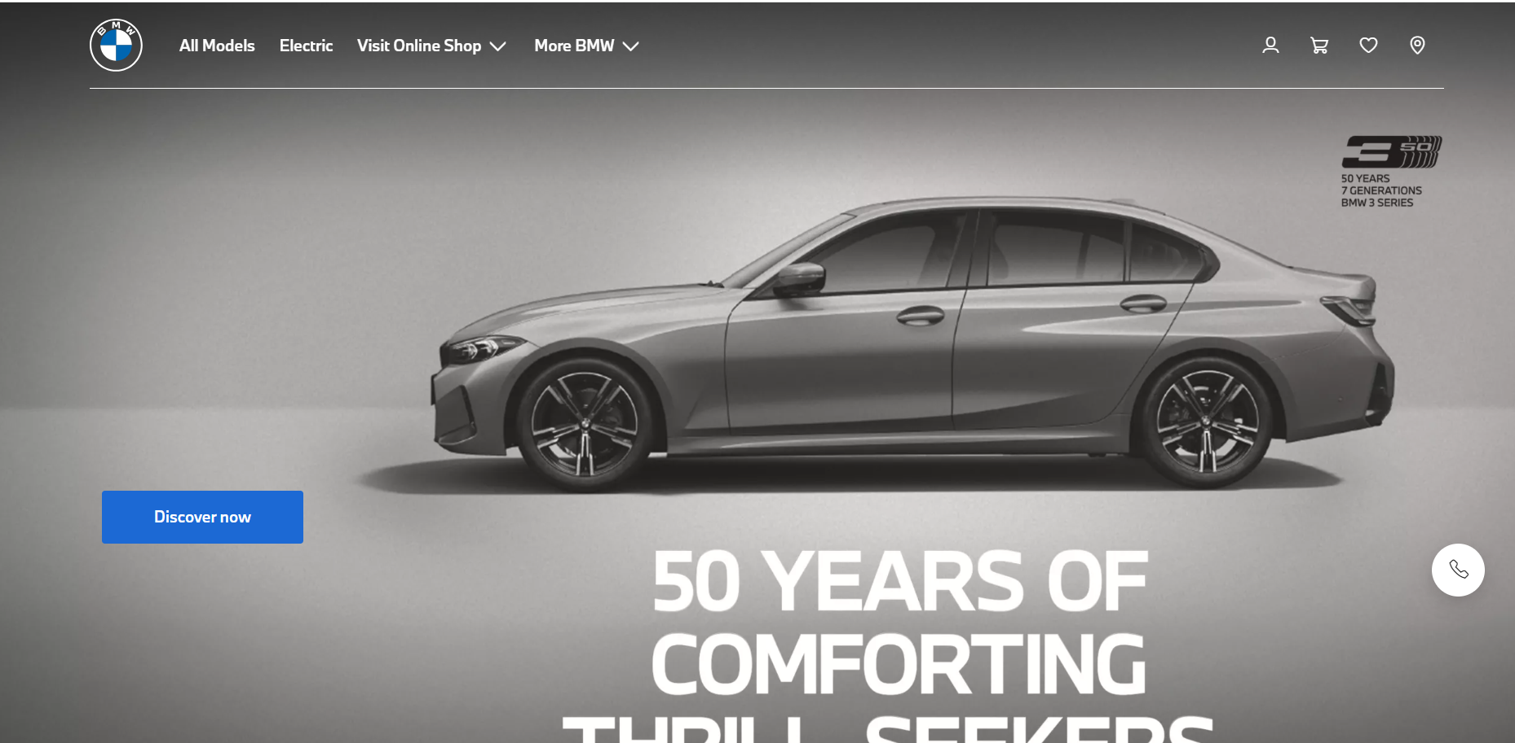
Figure 15: BMW India website
(Source: BMW India, 2025)

5.1.3 Comparison of the UK and India marketing mix
In the UK BMW's four-wheeler vehicles have long been linked to the luxury and premium product market. The organisation has always worked to earn the reputation of "Premium" among its clientele. BMW's products consist of high-end sedans, SUVs, and sports cars that provide effectiveness, style, and an image. Product innovation and R&D investment contributed to the highest share of BMW i4 Gran Coupe in the UK’s EV market (Li, 2025). With 172,240 total registrations in 2024, BMW Group UK led the premium market; more than 25% of those registrants were all-electric (BMW Group, 2024). This demonstrates that the UK marketplace is benefiting from BMW's product shift to powered premium cars. For many years, BMW has consistently competed in a number of global rally competitions. On many occasions, they have emerged as an effective team at Formula One races (BMW Group, 2023). “BMW's sponsorship of branded events is particularly noticeable: the BMW PGA Championship, which has been the title partner since 2005, attracts sizable live audiences (about 114,000 in 2024), extensive TV coverage on Sky Sports, and BBC highlights, providing BMW with ongoing premium exposure to affluent customers.”
Whereas in India, BMW occasionally creates novel and fresh models in response to the shifting demands of their clientele. BMW sold around 2,509 electric cars in India during the period, “January 2025 to September 2025” (ET, 2025). The top EV model of BMW sold in India is the iX1 (TIMES OF INDIA, 2025). Addressing the elite class, they are the priciest cars, with a sleek appearance and a ton of technology. Additionally, these cost more to maintain and fix. BMW introduced more economical automobiles, with its cheaper versions at reasonable prices. In India, the base price of the BMW 2 Series Gran Coupe is Rs 38.88 lakh (Arya, 2025). The BMW X1 and G 310 R are the brand's most reasonably priced vehicles. BMW guarantees availability, brand experience, and first-rate after-sales assistance that complements its upmarket positioning in India by carefully placing showrooms and service facilities.” (Amulya Raj Srinet, 2025).

6. Evaluation of the performance of marketing strategies

6.1 Evaluating whether BMW’s marketing strategies are successful in countries, i.e, India and the UK
The marketing strategies adopted by BMW in the Indian market helped it boost its sales and ensure it was the highest car-selling brand in 2024, where the company sold 15,721 cars (15,721 BMW cars and 709 MINI cars) (Srinet, 2025). In the UK, the total sales of BMW passenger cars were around 10558 units in November 2024, which were 3571 units in February 2023 (Carlier, 2024). Effective marketing approaches of BMW helped it increase its sales in the UK market.
BMW India (2025) mentioned that their primary motivation to sell their products is to have customer data and personalise communication. Globally, they sell over 2.45 million vehicles as of 2025. In recent years, they have also made significant achievements in areas such as electric and autonomous vehicles, innovation, sustainability, and performance. BMW India (2025) also states that their target market refers to the affluent class, who always seek luxury and comfort even in their daily lives. However, in the UK, the company always focuses on higher sales and fame. They also implement an effective marketing strategy via social media to create a long-lasting brand marketing plan. The social media marketing of the company is said to be outstanding, as they initiate a product-focused and messaging-based strategy (Arica, 2020). On platforms such as Instagram, YouTube, and TikTok, the company uses high-quality graphic visuals to grab the attention of its customers. BMW in the UK also focuses on emotional appeal as it engages with customers on an emotional level.
The primary focus of the company in both countries is to achieve innovation. Therefore, the company uses a robust product strategy to achieve innovation and introduce new models (Yu, Zhang, and Ju, 2023). The authors also emphasise the distribution channels of the company, based on the marketing strategies. The company has a significant focus on customer segmentation, as it implements marketing strategies based on it. The company is known for its global reach, thus it uses the networks to not only ensure dealership for brand experience, but also to create a proper brand identity to communicate with its customers. Studies show that BMW is known to have a Hostile strategy to expand its reach in India, to make its products available in more than 50 cities. It can be said that in both countries, the marketing strategies for selling products are efficient as in both countries, BMW has a larger market value. Therefore, the company can be evaluated to be successful in market strategy in both the UK and India.

7. Evaluation of marketing ethics practice

7.1 Marketing ethics followed by BMW in the country India
In terms of marketing ethics in the Indian market, BMW focuses on social responsibility, cultural sensitivity and compliance with laws and regulations, reflecting local values and norms (Bmwgroup.com, 2025). In the automobile landscape of India, the company is working towards the enhancement of environmental sustainability concerning the restoration of biodiversity. In this aspect, BMW India Foundation is facilitating a progressive step towards the restoration of a healthier ecosystem. The company understands the need for preserving a sustainable future in response to the longevity of the Indian community (BMW, 2025).
BMW in India is determined to be a period sustainable mobility partners in the 2024 Raisina Dialogue scheduled. In the Indian domain, the company is highlighted to be a dedicated leader of the automobile industry as it has pioneered in aspects such as sustainability and circular economy by ethically optimising resources and offering exceptional and premium travel experiences to Indian customers. This reflects on the marketing commitment of the company in response to determining the needs of minimalistic design towards offering of comfortable ride with a credible focus towards cutting-edge fleet with the emphasis on offering electric driving pleasure (BMW, 2024).
Apart from this, in determining the interest of Indian customers and maintenance of business transparency, the venture emphasises personalised communication with the collection of data pertaining to customer behaviour and preferences. In this aspect, BMW India effectively adheres to the privacy policy in terms of promoting promotional campaigns based on customer interests (BMW, 2025). Thus, in India, BMW understands the pursuit of ethical marketing efforts.

7.2 Ethical issues faced by BMW in the UK
In the UK market of the UK the “Advertising Standards Authority” (ASA) of the UK has banned the advertisement of BMW for its electric car due to its unsubstantiated claims regarding “clean car” (Gerretsen, 2022). Especially, pertaining to its advertisement across social media platforms, such as Facebook, BMW faced a serious concern in terms of its marketing efforts by misleading customers concerning zero emissions, particularly in response to its i3 electric car model (Glenday, 2020). This has highlighted the pursuit of the company to greenwash customer perception by means of advertising efforts across social media platforms.

8. Recommendation & Conclusion

8.1 Recommendations
Adoption of an accurate and transparent messaging approach in the UK:
The adoption of an accurate and transparent messaging approach can help BMW mitigate its misleading advertisement issues in the UK. In terms of navigating the claims of greenwashing customers through social media advertising, for BMW, it is essential to align and understand customer protection law, such as the Advertising Standards Authority (ASA), in terms of marketing green speaking with confidence. This also infers the design and delivery of sustainability initiatives towards the minimisation of potential challenges concerning misleading adverts. In the automobile landscape of the UK for BMW, it is essential to emphasise an accurate and transparent messaging approach with a focus on accuracy and security of information that is delivered pertaining to its product or services (Rimell, 2023). Thus, the company needs to brush off green claims in order to safeguard its business ethics and cultural integrity.
Strengthening of after-sales support in India:
In order to survive in the automobile landscape of India, for BMW, it is imperative to navigate the claim of selling defective vehicles through relevant marketing efforts, such as after-sales services. Ensuring this, the company will be able to highlight its effort towards the maintenance of customer satisfaction, align with parameters of performance compliance and the cultivation of long-term customer engagement. Through this, the company will be able to align with avenues of customer feedback, displaying its enriching marketing effort to foster customer experience in the Indian automotive domain (Grüntges et al., 2021). Thus, this implies enhancement of the BMW brand reputation with the integration of after-sales marketing efforts.

8.2 Conclusion
Based on the above analysis, it can be inferred that the marketing approaches incorporated by BMW in the UK and India enabled it to strengthen its performance. The microenvironment of both India and the UK is illustrated to offer a comparatively different landscape for BMW. In addition, the cultural dimension of both nations tends to vary in several aspects, procuring a massive impact on the preferences and behaviour of customers to opt for products and services of BMW. Moreover, in both nations, BMW is emphasising the marketing effort in relevance to the preferences and interests of local customers.

9. Reference List
Afaqs (2025). BMW India drives innovation with VDO.AI’s immersive CTV campaigns. [online] afaqs! Available at: https://www.afaqs.com/news/advertising/bmw-india-drives-innovation-with-vdoais-immersive-ctv-campaigns-10536856 [Accessed 27 Oct. 2025].
Amulya Raj Srinet (2025). BMW India Registers Highest Sales With 15,721 Cars In 2024. [online] www.ndtv.com. Available at: https://www.ndtv.com/auto/bmw-india-registers-highest-sales-with-15-721-cars-in-2024-7425345.
Arica, A. (2020). 6 Key Points About The Digital Marketing Strategy Of BMW. [online] Digital Agency Network. Available at: https://digitalagencynetwork.com/6-key-points-about-the-digital-marketing-strategy-of-bmw/.
Arora, C., Chaturvedi, V. and Das, P. (2025). What is India’s Strategy for Net-zero Transport & Automobile Sector? [online] CEEW. Available at: https://www.ceew.in/publications/net-zero-strategy-for-low-carbon-automobile-sector-and-transport-decarbonisation [Accessed 27 Oct. 2025].
Arya, A. (2025). New GST Price Cut: BMW Cars And SUVs Get Cheaper By Up To Rs 9 Lakh. [online] Times Now. Available at: https://www.timesnownews.com/auto/car-news/new-gst-price-cut-bmw-cars-suvs-cheaper-new-price-article-152702571 [Accessed 27 Oct. 2025].
Barabas, D. (2024). Consumers willing to pay 9.7% sustainability premium, even as cost-of-living and inflationary concerns weigh: PwC 2024 voice of the consumer survey. [online] PwC. Available at: https://www.pwc.com/gx/en/news-room/press-releases/2024/pwc-2024-voice-of-consumer-survey.html.
BMW (2019). BMW (UK) Limited Corporate Governance Statement. [online] Available at: https://www.bmw.co.uk/content/dam/bmw/marketGB/bmw_co_uk/footer/legal/legal-notice/BMW_UK_Ltd_Corporate_Governance_Statement_2019.pdf.asset.1597310331240.pdf.
BMW (2021). BMW Service Inclusive | Personalised Service Plan | BMW UK. [online] Bmw.co.uk. Available at: https://www.bmw.co.uk/en/topics/owners/service-workshop/servicing/service-inclusive.html.
BMW (2024). BMW Customer Support. [online] Bmw.co.uk. Available at: https://www.bmw.co.uk/en/more-bmw/customer-support.html.
BMW (2024). BMW Group UK Leads the Premium Segment in 2024 with Strong Electric Growth. [online] BMW Group PressClub. Available at: https://www.press.bmwgroup.com/united-kingdom/article/detail/T0447261EN_GB/bmw-group-uk-leads-the-premium-segment-in-2024-with-strong-electric-growth?language=en_GB.
BMW (2024). BMW India proud to be the Sustainable Mobility Partner of Raisina Dialogue 2024. [online] BMW Group PressClub. Available at: https://www.press.bmwgroup.com/india/article/detail/T0439839EN/bmw-india-proud-to-be-the-sustainable-mobility-partner-of-raisina-dialogue-2024?language=en [Accessed 27 Oct. 2025].
BMW (2024). BMW India proud to be the Sustainable Mobility Partner of Raisina Dialogue 2024. [online] BMW Group PressClub. Available at: https://www.press.bmwgroup.com/india/article/detail/T0439839EN/bmw-india-proud-to-be-the-sustainable-mobility-partner-of-raisina-dialogue-2024?language=en.
BMW (2025). Leading the Way: BMW India Foundation Environmental Efforts. [online] Www.bmw.in. Available at: https://www.bmw.in/en/topics/bmw-india-foundation/environment.html.
BMW (2025). Marketing Policy. [online] Www.bmw.in. Available at: https://www.bmw.in/en/topics/marketing-policy.html.
BMW (2025). Welcome To Zscaler Directory Authentication. [online] Bmw.co.uk. Available at: https://www.bmw.co.uk/en/footer/experience-bmw/about-us.html#tabs-4f12d31290-item-8f1008c075-tab [Accessed 27 Oct. 2025].
BMW Group (2023). BMW continues run of success, taking top spot in numerous international competitions once again in 2023. [online] BMW Group PressClub. Available at: https://www.press.bmwgroup.com/global/article/detail/T0439708EN/bmw-continues-run-of-success-taking-top-spot-in-numerous-international-competitions-once-again-in-2023.
BMW Group (2024). BMW Group UK Leads the Premium Segment in 2024 with Strong Electric Growth. [online] BMW Group PressClub. Available at: https://www.press.bmwgroup.com/united-kingdom/article/detail/T0447261EN_GB/bmw-group-uk-leads-the-premium-segment-in-2024-with-strong-electric-growth.
BMW India (2025). Home. [online] Www.bmw.in. Available at: https://www.bmw.in/en/index.html.
BMW India (2025). The BMW Group. [online] www.bmw.in. Available at: https://www.bmw.in/en/topics/Fascination-BMW/the-corporation-original/the-bmw-group.html.
BMW India. (2025). Marketing Policy. [online] Available at: https://www.bmw.in/en/topics/marketing-policy.html.
BMW uk (2025). About Your Local BMW Retailer | Group 1 Bedford. [online] Group1bedfordbmw.co.uk. Available at: https://www.group1bedfordbmw.co.uk/about-us/customer-reviews/.
BMW UK (2025). The BMW Official Website | BMW UK. [online] Bmw.co.uk. Available at: https://www.bmw.co.uk/en/index.html.
BMW.in (2024). BMW India is rated ‘Average’ with 2.8 / 5 on Trustpilot. [online] Trustpilot. Available at: https://www.trustpilot.com/review/www.bmw.in [Accessed 8 Dec. 2025].
BMW.ind (2025). Contact us. [online] Www.bmw.in. Available at: https://www.bmw.in/en/topics/owners/contact-us.html [Accessed 8 Dec. 2025].
Bmwgroup.com, (2025). BMW Group Locations worldwide. Available at: https://www.bmwgroup.com/en/company/locations.html#where-to-find-us-worldwide
Bmwgroup.com, (2025). Responsibility & Sustainability at BMW Group. Available at: https://www.bmwgroup.com/en/sustainability.html
Carlier, M. (2024). Monthly sales volume of BMW passenger cars in the United Kingdom (UK) from January 2020 to November 2024. [online] Statista. Available at: https://www.statista.com/statistics/300405/bmw-car-sales-in-the-united-kingdom/.
Carlier, M. (2025). Topic: BMW Group. [online] Statista. Available at: https://www.statista.com/topics/5551/bmw/?srsltid=AfmBOoqo8nAFQoz6gZKZdHg9p_6XS4CPplJGhlkbefSK7zpoMCaRFU2C#topicOverview [Accessed 27 Oct. 2025].
Clark, D. (2025). Inflation rate for the Consumer Price Index (CPI) in the United Kingdom from January 2000 to January 2025. [online] Statista. Available at: https://www.statista.com/statistics/306648/inflation-rate-consumer-price-index-cpi-united-kingdom-uk/.
Consultancy UK (2022). UK consumers embracing more sustainable behaviour. [online] Available at: https://www.consultancy.uk/news/30077/uk-consumers-embracing-more-sustainable-behaviour.
Deloitte (2024). Almost 50% of Indian consumers opt out of ICE to embrace environment conscious hybrid tech: Deloitte 2024 Global Automotive Consumer Study. [online] Deloitte. Available at: https://www.deloitte.com/in/en/about/press-room/almost-50-percent-of-Indian-consumers-opt-out-of-ice-to-embrace-environment-conscious-hybrid-tech-deloitte-2024-global-automotive-consumer-study.html.
Deloitte (2024). The Sustainable Consumer. [online] Deloitte United Kingdom. Available at: https://www.deloitte.com/uk/en/Industries/consumer/perspectives/the-sustainable-consumer.html.
Dempsey, N. and Hinson, S. (2024). Electric vehicles and infrastructure. commonslibrary.parliament.uk. [online] Available at: https://commonslibrary.parliament.uk/research-briefings/cbp-7480/.
Eastspring (2024). Why India’s consumer boom may be the next big thing for investors. [online] www.eastspring.com. Available at: https://www.eastspring.com/insights/thought-leadership/why-indias-consumer-boom-may-be-the-next-big-thing-for-investors.
Escandon-Barbosa, D., Salas-Paramo, J. and Rialp-Criado, J. (2021). Hofstede’s Cultural Dimensions as a Moderator of the Relationship between Ambidextrous Learning and Corporate Sustainability in Born Global Firms. Sustainability, [online] 13(13), p.7344. doi:https://doi.org/10.3390/su13137344.
ET (2025) BMW drives past 20% EV sales in India; first-time luxury buyers fuel demand, Economictimes.com. Available at: https://m.economictimes.com/industry/auto/auto-news/bmw-drives-past-20-ev-sales-in-india-first-time-luxury-buyers-fuel-demand/articleshow/124461074.cms (Accessed: 17 October 2025).
ET Auto (2018). BMW Group launches first integrated dealership facility in India. [online] ETAuto.com. Available at: https://auto.economictimes.indiatimes.com/news/aftermarket/bmw-group-launches-first-integrated-dealership-facility-in-india/65341116 [Accessed 19 Dec. 2025].
Ferreira, J. (2025). India Inflation Rate Below Forecasts. [online] Tradingeconomics.com. Available at: https://tradingeconomics.com/india/inflation-cpi.
Fleming, S. (2025). UK economy unexpectedly grew 0.1% in fourth quarter. [online] @FinancialTimes. Available at: https://www.ft.com/content/6eb3451d-348e-4752-a033-05503bc213ce.
Gajbhiye, M.D., Lakshmanan, S., Kumar, N., Bhattacharya, S. and Nishad, S. (2023). Effectiveness of India’s Bharat Stage mitigation measures in reducing vehicular emissions. Transportation Research Part D: Transport and Environment, [online] 115, p.103603. doi:https://doi.org/10.1016/j.trd.2022.103603.
Gerretsen, I. (2022). The adverts banned for misleading climate claims. [online] www.bbc.com. Available at: https://www.bbc.com/future/article/20220302-the-adverts-that-were-banned-for-misleading-climate-claims.
Gini, K.B. and Agala, H.O. (2023). The Impact of Macro-Environmental Factors on Business Performance. International journal of research and innovation in social science, 7(11), pp.1837–1843. doi:https://doi.org/10.47772/ijriss.2023.7011145.
Glenday, J. (2020). BMW Facebook ad banned over ‘zero emissions’ claim. [online] The Drum. Available at: https://www.thedrum.com/news/2017/12/06/bmw-facebook-ad-banned-over-zero-emissions-claim [Accessed 27 Oct. 2025].
Global Data (2025). Bayerische Motoren Werke AG Company Profile - Overview. [online] www.linkedin.com. Available at: https://www.globaldata.com/company-profile/bayerische-motoren-werke-ag/.
Gov.in (2019a). Invest India. [online] Investindia.gov.in. Available at: https://www.investindia.gov.in/sector/electric-mobility.
Gov.in (2019b). Invest India. [online] Investindia.gov.in. Available at: https://www.investindia.gov.in/india-opportunity.
Gov.in (2025). India’s economic growth stands out amid global volatility. [online] Ddnews.gov.in. Available at: https://ddnews.gov.in/en/indias-economic-growth-stands-out-amid-global-volatility/ [Accessed 27 Oct. 2025].
Gov.UK (2021). UK Emissions Trading Scheme (UK ETS): technical guidance and tools. [online] GOV.UK. Available at: https://www.gov.uk/government/collections/uk-emissions-trading-scheme-uk-ets-technical-guidance-and-tools.
Gov.UK (2025). Connected & Automated Mobility 2025: Realising the benefits of self-driving vehicles in the UK. [online] Available at: https://assets.publishing.service.gov.uk/media/62ff438c8fa8f504cdec92df/cam-2025-realising-benefits-self-driving-vehicles.pdf.
GOV.UK (2025). Getting an MOT. [online] GOV.UK. Available at: https://www.gov.uk/getting-an-mot/the-mot-test.
Grüntges, V., Matthey, A., Peter, F. and Stöber, J. (2021). The new key to automotive success: Put customer experience in the driver’s seat. [online] McKinsey & Company. Available at: https://www.mckinsey.com/capabilities/growth-marketing-and-sales/our-insights/the-new-key-to-automotive-success-put-customer-experience-in-the-drivers-seat.
Gupta, N.S. (2024) Middle-aged and millennials drive EV demand, says Deloitte study, The Times of India. Times Of India. Available at: https://timesofindia.indiatimes.com/city/chennai/middle-aged-and-millennials-drive-ev-demand-in-india-reveals-deloitte-study/articleshow/108598926.cms (Accessed: 24 January 2025).
Hofstede Insights (2025). Country Comparison Tool. [online] Theculturefactor.com. Available at: https://www.theculturefactor.com/country-comparison-tool?countries=india%2Cunited+kingdom.
Hyatt, K. (2020). BMW UK uses vehicle detection tech to personalize warranty ads. [online] CNET. Available at: https://www.cnet.com/roadshow/news/bmw-uk-public-warranty-personalized-marketing/ [Accessed 27 Oct. 2025].
IBEF (2024). Electric Vehicles: Electric Vehicle Industry in India and its Growth. [online] India Brand Equity Foundation. Available at: https://ibef.org/industry/electric-vehicle.
Inman, P. (2025). UK economy expands as GDP rises by 0.1% in August ahead of crucial budget. [online] the Guardian. Available at: https://www.theguardian.com/business/2025/oct/16/uk-economy-expands-as-gdp-rises-by-01-in-august-ahead-of-crucial-budget.
Instagram (2025) BMW India (@bmwindia_official) • Instagram photos and videos, Instagram.com. Available at: https://www.instagram.com/bmwindia_official/?hl=en (Accessed: 17 October 2025).
Jain, D. (2024). Supreme Court Directs BMW To Pay Rs 50 Lakhs Compensation To Customer For Defective Car. [online] Livelaw.in. Available at: https://www.livelaw.in/top-stories/supreme-court-cheating-case-against-bmw-for-supply-of-defective-car-closed-263271 [Accessed 27 Oct. 2025].
Kishore, R. and Jayaswal, R. (2025). Indian economy grew 6.5% in 2024-25, beating forecasts. [online] Hindustan Times. Available at: https://www.hindustantimes.com/india-news/india-economy-grew-6-5-in-fy25-beating-forecasts-101748630179174.html.
Li, S. (2025) ‘BMW Electric Vehicles Transition and Future Market’, Advances in Economics, Business and Management Research, pp. 723–733. Available at: https://doi.org/10.2991/978-94-6463-770-0_81.
luxuryretail (2018). BMW Urban Store - Luxury Retail. [online] Luxury Retail. Available at: https://luxuryretail.co.uk/bmw-urban-store/.
Market.us (2025). BMW AG Statistics and Facts. [online] Market.us. Available at: https://market.us/statistics/automotive-companies/bmw-ag/.
Mechanical Engineering, B. (2023). Issue 11 IJSDR2311058 www. ijsdr.org International Journal of Scientific Development and Research, [online] 8, p.401. Available at: https://ijsdr.org/papers/IJSDR2311058.pdf.
Mehta, T. (2024). India approves $1.3 billion incentive scheme for electric vehicles. [online] Reuters. Available at: https://www.reuters.com/business/autos-transportation/india-allots-109-bln-rupees-scheme-promote-electric-vehicles-2024-09-11/.
Mistry, P. (2025). Electric cars eligible for £3,750 discount announced. [online] 28 Aug. Available at: https://www.bbc.com/news/articles/cvgvywyev1do.
PTI (2024). Supreme Court asks BMW to pay Rs 50 lakh as compensation to customer for defective car. [online] The Economic Times. Available at: https://m.economictimes.com/industry/auto/auto-news/supreme-court-asks-bmw-to-pay-rs-50-lakh-as-compensation-to-customer-for-defective-car/articleshow/111733047.cms.
Rimell, W. (2023). Why Greenwashing is a worry for automotive - CAT Magazine. [online] www.catmag.co.uk. Available at: https://www.catmag.co.uk/features/why-greenwashing-is-a-worry-for-automotive/.
Scrapehero (2025). Number of BMW locations in the UK in 2023. [online] ScrapeHero. Available at: https://www.scrapehero.com/location-reports/BMW-UK/.
Segura, E., Belmonte, L.M., Herrera, R.M. and Somolinos, J.A. (2023). A Strategic Analysis of Photovoltaic Energy Projects: the Case Study of Spain. Sustainability, 15(16), pp.12316–12316. https://www.mdpi.com/2071-1050/15/16/12316
Singh, S., Naseer, D.S. and Shah, A. (2025). International Journal of Research Publication and Reviews IMPACT OF GOVERNMENT POLICIES ON INDIAN AUTOMOBILE INDUSTRY Introduction. International Journal of Research Publication and Reviews, [online] (6). Available at: https://ijrpr.com/uploads/V6ISSUE6/IJRPR48816.pdf.
Srinet, A.R. (2025). BMW India Registers Highest Sales With 15,721 Cars In 2024. [online] www.ndtv.com. Available at: https://www.ndtv.com/auto/bmw-india-registers-highest-sales-with-15-721-cars-in-2024-7425345.
Statista (2022) Car and vehicle purchases expenditure by age UK 2022| Statista, Statista. Available at: https://www.statista.com/statistics/285626/car-and-vehicle-purchases-weekly-uk-household-expenditure-by-age/?srsltid=AfmBOoogy99b__X2g-IgOtiYpqCFSnFBdspRMQoR-Ooje_XZSMaxiChg (Accessed: 17 October 2025).
Statista (2025). BMW (Passenger Cars) - Worldwide. [online] Available at: https://www.statista.com/outlook/mmo/passenger-cars/bmw/worldwide?srsltid=AfmBOorr0yUnCZD0vS8hLrBdGtRRTj2NWbLp7-pzEPzcnjvE70aT2lx-.
Stiftung, B. (2024). SGI 2024 | United Kingdom | Environmental Sustainability. [online] Sgi-network.org. Available at: https://www.sgi-network.org/2024/United_Kingdom/Environmental_Sustainability.
Theculturefactor.com, (2025). Country comparison tool. Available at: https://www.theculturefactor.com/country-comparison-tool?countries=india%2Cunited+kingdom
Tillu, P.G., Digalwar, A.K., Singh, S.R. and Reosekar, R.S. (2024). Towards sustainable automobile ecosystem in India: Integrated analysis of technical, economic, and ESG dimensions. Cleaner Environmental Systems, [online] 14, pp.100210–100210. doi:https://doi.org/10.1016/j.cesys.2024.100210.
TIMES OF INDIA (2025) BMW India achieves best-ever sales with GST 2.0 boost: iX1 top EV model, The Times of India. The Times Of India. Available at: https://timesofindia.indiatimes.com/auto/news/bmw-india-achieves-best-ever-sales-with-gst-2-0-boost-ix1-top-ev-model/articleshow/124454200.cms.
Times of India (2025). India’s EV Push: States Race Ahead in Electrification, Charging & Adoption. [online] The Times of India. Available at: https://timesofindia.indiatimes.com/india/indias-ev-push-states-race-ahead-in-electrification-charging-adoption/articleshow/124086069.cms
Williamson, D. (2002). Forward from a Critique of Hofstede’s Model of National Culture. Human Relations, 55(11), pp.1373–1395. doi:https://doi.org/10.1177/00187267025511006.
Yu, Q., Zhang, M. and Ju, Y. (2023). BMW’s International Marketing Strategy Analysis. Advances in Economics Management and Political Sciences, 42(1), pp.89–96. doi:https://doi.org/10.54254/2754-1169/42/20232084.
Zhang, A. (2020). THE IMPACT OF BREXIT ON MOTOR INDUSTRY IN UK. [online] Available at: https://www.atlantis-press.com/article/25885071.pdf.

