Growth of Muscle Tissue via Hypertrophy and Hyperplasia in Trained, De-trained and Untrained Athletes

Abstract
This paper will cover the different ways in which muscle is built. The first being Hypertrophy which is a direct increase in muscle mass size and the cross-sectional area of the muscle tissue. However this is not the growth of new muscle fibres. The increase in size is due to an increase in density opposed to an increase in muscle fibre length or an increase in fibre volume. The second of which will be hyperplasia; ‘Similarly to hypertrophy it does result in a direct increase in muscle size; however the process of hyperplasia is the increase in cell volume/number of muscle fibres. Where as seen above hypertrophy is the increase in muscle fibre size.’ [5] I will then go on to talk about Muscle Protein synthesis, its function in muscle building and how we can optimise it by altering our diet. I will then talk about progressive overload a useful tool we can use in our programming to inhibit all of the above to optimize muscle building in terms of training. Finally I will summarise why all these factors above are essential for creating an adequate muscle building environment that allows the trainee no matter of training level to maximise the amount of muscle gained in the shortest period of time.
Contents
Introduction 1
What is Hypertrophy 1
Growth of New Muscle Fibres (Hyperplasia) 3
Muscle Protein Synthesis 5
Progressive Overload 6
Summary 7
Bibliography 8

Introduction
When we talk about hypertrophy in both enhanced and natural athletes we are referring to the process of increasing the size of muscle tissues in the human body. Hypertrophy covers the basis of muscular size gained from completing exercise; the most efficient way to achieve hypertrophy is through weight lifting directly. When looking at progressive overload which is the stimulus directly related to hypertrophy. I will cover the process of the human body being forced to adapt to new stimulus. By this I mean the body being forced to adapt a tension (weight) that it has not previously experienced. This new tension therefore forces the body to adapt in order to handle the new strain that it has experienced by undergoing hypertrophy and increasing muscle density and strength.

What is Hypertrophy
Hypertrophy is a direct increase in muscle mass size and the cross-sectional area of the muscle tissue. However this is not the growth of new muscle fibres. The increase in size is due to an increase in density opposed to an increase in muscle fibre length or an increase in fibre volume. Despite what is presumed about muscle gain both cardiac tissue and skeletal tissue respond to an increased workload via hypertrophy. As stated by Richard Henandez and Len Kravitz ‘With cardiac muscle, the heart becomes more effective at squeezing blood out of its chambers, whereas skeletal muscle becomes more efficient at transmitting forces through tendonous attachments to bones ‘ [1]. In this paper however we will be looking at increasing muscular size and density on the skeletal of natural athletes.
In order to inhibit hypertrophy and gain muscle mass two things need two occur, stimulation of the muscle tissue and repair of the damaged tissue. The stimulation of the muscle would occur during the period of time of which it is being trained through resistance training or when the muscle is experiencing some kind of stress. The repair portion of muscular growth occurs after the muscle tissue has been stimulated causing damage and the athlete is in a state of rest, this allowing the body to repair and the damaged muscle fibres.
As seen on Mens Health by Dr Rachel Tavel ‘Dormant cells called satellite cells, which exist between the outer and basement membranes of a muscle fiber become activated by trauma, damage or injury — all possible responses to the stress of weight training. An immune system response is triggered, leading to inflammation, the natural clean up and repair process that occurs on a cellular level.’ [2] When referring to muscular repair through satellite cells this is not the process of growing new muscle fibre. In fact this is the process of a direct increase in size of the muscle fibres. This is because the original satellite cells divide and the daughter cells are drawn to the damaged tissues, before sharing their nuclei with the damaged tissue stimulating repair increasing fibre size.
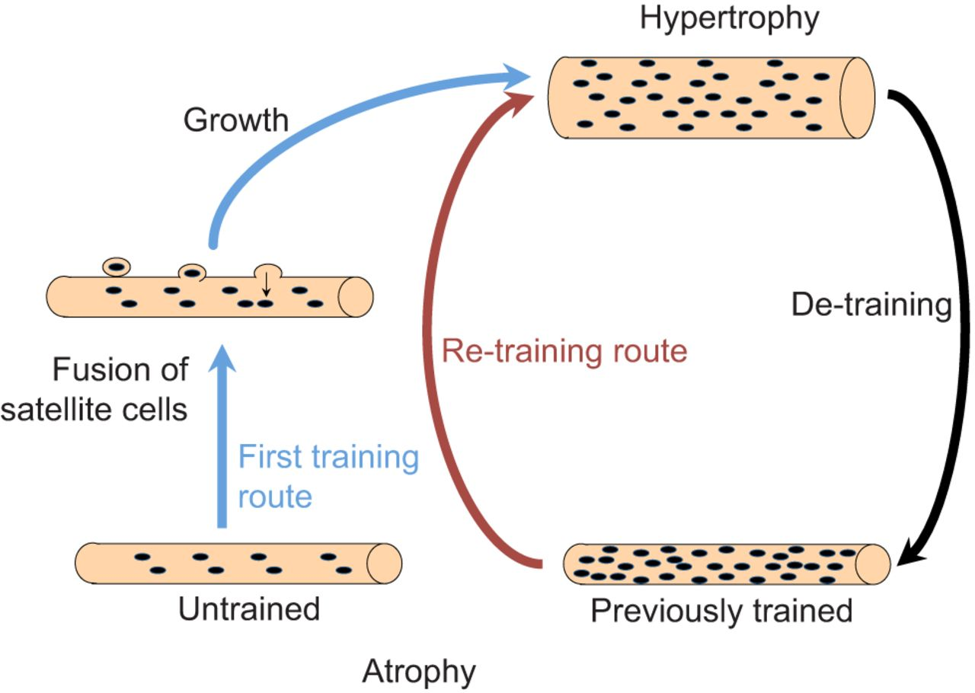
As seen from what I have paraphrased from a study from New Mexico University ‘Usually these cells are dormant, however they come to be activated when the muscle fibre receives any form of trauma, damage or injury, such as from resistance training overload. The satellite cells then multiply, and the daughter cells are drawn to the broken muscle site. They then fuse to the existing muscle fibre, donating their nuclei to the fibre, which helps to regenerate the muscle fibre. It is necessary to emphasize the factor that this manner is not developing greater skeletal muscle fibres (in humans), but growing the dimension and quantity of contractile proteins (actin and myosin) within the muscle fiber.’ [1].
Figure 1 - [3]

Figure 1, dictates the cycle of cellular hypertrophy. Focussing on the untrained part of the diagram we can gain a clear image of what is happening during the process of muscle growth. Starting from an untrained muscle fibre we can see that it is not very dense has minimal nuclei. Once we stimulate this atrophied tissue and hypertrophy begins we move round to the growth section of the diagram where satellite cells in the basal membrane multiply, fuse and add more myonuclei to the muscle tissue resulting in muscular hypertrophy and an increase in muscle size. Once nuclei have been added to the muscle tissue it is a permanent adaptation meaning that if the muscle were to atrophy due to detraining. When the trainee begins to train again, they would gain muscle far faster due to the nuclei being already available in the tissue opposed to having to create new nuclei. We see this rapid growth in detrained athletes usually when they are returning from injury in both natural and enhanced athletes. There are diminishing returns however they athlete will only be able to quickly rebuild size to what they previously reached. After this point they would then need to recruit new nuclei referring back to the untrained part of the diagram. Known as muscle memory ‘The term muscle memory has also been used for the ability to rebuild muscle mass and strength, as previous strength exercise seems to make it easier to regain muscle mass later in life even after long intervening periods of inactivity and mass loss’ [4]

Growth of New Muscle Fibres (Hyperplasia)
‘When we look at growing new muscle fibres all together we refer to this as hyperplasia (Hyperplasia does not only take part in muscle tissue). Similarly to hypertrophy it does result in a direct increase in muscle size; however the process of hyperplasia is the increase in cell volume/number of muscle fibres. Where as seen above hypertrophy is the increase in muscle fibre size.’ [5] We tend to see Hyperplasia take a back seat when we talk about muscular gain because generally it is rare we will gain new muscle fibres as mass majority of growth with come from muscular hypertrophy in both natural and enhanced athletes. In saying that when we do see hyperplasia take place we do tend to see it mainly in enhanced athletes this is likely due to them having super physiological levels of testosterone and being protein synthesis being elevated far longer than in natural athletes. Something I will cover further on in the report.
Similarly to hypertrophy in order for muscle fibres to grow we again need to undergo the same process of stimulation and repair. When this occurs unlike hypertrophy we are looking at complete formation of new fibres. Again this process relies heavily on the satellite cells that can go from dormant to active and convert to muscle fibre. ‘Skeletal muscles are key in muscle building process and are located between the sarcolemma and basement membrane of the of the muscle fibres. They act as a reserve population of cells able to activate in response to injury of muscle tissue. This allows them to change and alter their proteins to adapt and repair the damaged parts of muscular tissue’ [6]
So form this we can take away then these cells are able to adapt and change into muscle fibres which inhibits the conclusion that they are responsible for not just hypertrophy but hyperplasia.
This begs the question how hyperplasia takes place. ‘There are two methods upon which we can see hyperplasia take place, when a muscle fibre is spit forming 2 separate fibres or when the Satellite cells undergo cell division and mitosis and form new fibres.’ [7] This generally being after the muscle has been stimulated and damaged and the body gives out an inflammation response resulting in muscular growth. We can see an example of this in a study where a cat was forced to use one paw to access food. ‘This took place over a 46 week period just using the same paw which resulted in a larger number of muscle fibres compared to the unused paw. This was determined to be due to muscle fibre splitting taking place.’ [8] by the splitting of these fibres it would then allow for hypertrophy to take place across my fibres in the long run.
Figure 2 - [9]
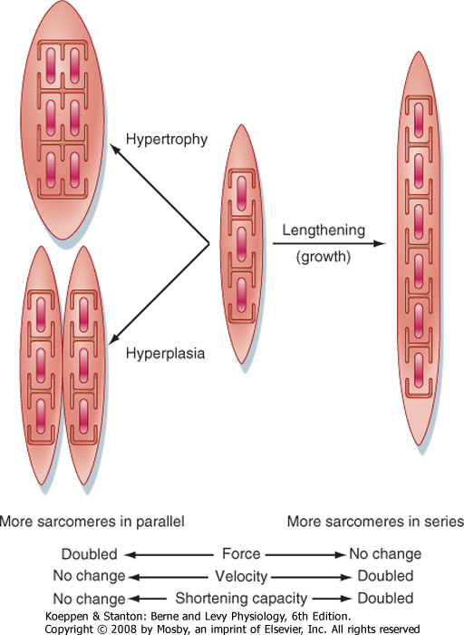

I have inserted figure 2 to dictate the key difference between the different types of muscle growth. Here we can clearly see that during the process of hyperplasia we are creating new muscle tissue cells. Whilst during hypertrophy we are directly increasing muscle size through Myonuclei overload ‘The process of untrained muscles acquire newly formed nuclei by fusion of satellite cells preceding the hypertrophy.’ [10]

Muscle Protein Synthesis
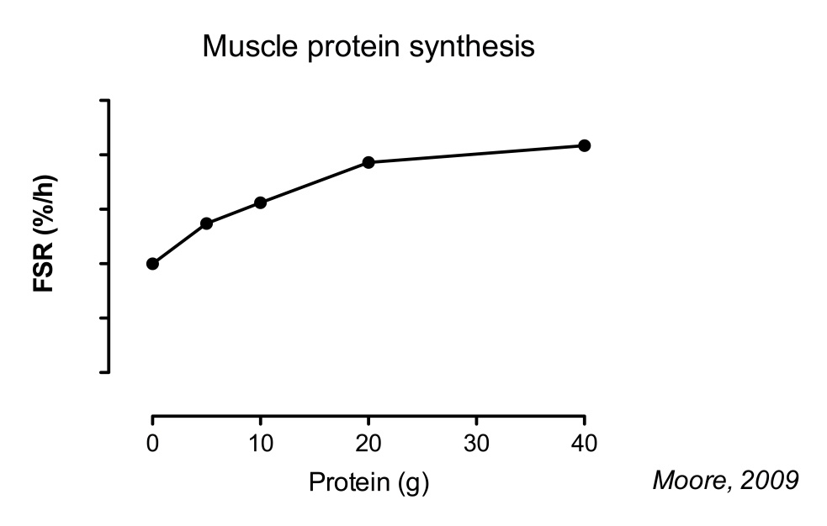
Protein synthesis is the process of creating specific proteins to be used in the body. We will be looking specifically at muscle protein synthesis;’ protein synthesis is a naturally occurring process in which protein is produced to repair muscle damage caused by intense exercise. It is an opposing force to muscle protein breakdown (MPB) in which protein is lost as a result of exercise.’ [11]
So the take away from this is that when we exercise we are damaging muscle tissue therefore breaking down proteins. We then need to undergo protein synthesis to replace these lost proteins and build new muscle tissue.
In order to undergo protein synthesis however we first need to consume enough food and protein to facilitate the creation of new proteins. ‘When data of several studies was combined and the amount of protein was expressed per bodyweight, it was found that on average 0.25 g/kg would optimize muscle protein synthesis.’ [12] The take away from this would be that in order to benefit from protein synthesis athletes would need to eat at least 0.25g of protein per kg of bodyweight.
Figure 3 - [13]

Figure 3 is a graph showing the increase in muscle protein synthesis correlated to amount of protein consumed. As we can see from the graph the more protein we consume the higher the protein synthesis level up to a certain point of diminishing returns where we start to level off. Which shows despite common belief the more protein we consume doesn’t always mean better results.
Muscle protein synthesis (MPS) directly inhibits hypertrophy/hyperplasia; this means if we aren’t under-going MPS then we aren’t undergoing hypertrophy/hyperplasia either. This study suggests that ‘After a heavy training session MPS is doubled for 24hours and slowly returns to baseline after the 36hr mark’ [14] Suggesting that after a muscle group is trained a muscle group is able to develop muscle tissue for up to 36hrs later. We also know that without the aid of protein synthesis we would not be gain muscle and is extremely diet related as you need a higher protein and calorie intake as ‘muscle growth can only occur if muscle protein synthesis exceeds muscle protein breakdown; there must be a positive muscle protein balance.’ [15] Suggesting we need to consume enough protein and calories to gain muscle

Progressive Overload
Progressive Overload, ‘this is the principle of placing planned stress on the body that exceeds stress that has been placed on the body previously during any physical activity including resistance training.’ [16] This principle forces the body to adapt to new stimulus which directly inhibits Hypertrophy/Hyperplasia, without this principle we cannot gain muscle. ‘There are 4 key ways of inducing progressive overload 1)Increasing intensity – lifting heavier weight in your next session 2)Increasing Volume – increasing/decreasing volume – the process of either increasing repetitions at a lower weight or decreasing repetitions at a heavier weight 3)Increasing Frequency – Training more often in a week 4)Increasing Tension- Time under tension rule keeping a muscle under tension for longer periods of time.’- [17] In order to optimise training all these factors should be taken into account to inhibit Hypertrophy/Hyperplasia. However seeing as Hyperplasia is hard to inhibit there have been studies that show there should be a focus on time under tension to maximise the potential for hyperplasia.
‘Muscles examined over a 28-d stretching period of the ALD muscle. Demonstrated results that progressive stretch overload, produces effects unlike chronic stretch overload in that longitudinal fibre splitting which may contribute significantly to an increase in fibre number.’ [18] This would suggest that in order to optimize training to achieve both Hypertrophy/Hyperplasia we should look to have an emphasis on time under tension and weighted stretching to allow us to create new muscle fibres. Despite all this evidence we do know that, ‘The use of anabolic steroids when combined with strength training induces a far greater gain in muscle size and new muscle fibre formation.’ [19] suggesting that there are limitations to these principles and even when optimised cannot match results achieved by an anabolic steroid user.

Summary
To conclude in order for all types of athlete to grow more muscle it is important to take into account an adequate diet with enough protein 0.25g/kg of bodyweight to facilitate MPS. In addition to this it is key, that athletes of all levels maximise the progressive overload principle in order to place new stress on the skeletal muscle. This in combination of an adequate diet will allow them to maximise MPS which with proper training will allow for Hypertrophy/Hyperplasia optimization allowing for the maximising muscle building potential over a shorter period of time. It is also very important to take into account when writing an optimized muscle building program, that MPS is elevated for 36hrs meaning any athletes looking to gain muscle mass should organise training of different muscle groups around his 36hr window. A good program should ensure to retrain the muscle at the end of this window to keep the body constantly undergoing MPS.

Bibliography

[1] | R. J. H. a. L. Kravitz, “The Mystery of Skeletal Muscle Hypertrophy,” New Mexico University, 22 July 2003. [Online]. Available: https://www.unm.edu/~lkravitz/Article%20folder/hypertrophy.html. [Accessed 21 Novemeber 2019].
[2] | D. R. Tavel, “How you can use hypertrophy to grow muscle,” 21 November 2018. [Online]. Available: https://www.menshealth.com/fitness/a25252586/muscle-hypertrophy/. [Accessed 21 Novemeber 2019].
[3] | K. Gundersun, “Muscle memory and a new cellular model for muscle atrophy and hypertrophy,” Journal of Experemental Biology, 19 February 2016. [Online]. Available: https://jeb.biologists.org/content/219/2/235. [Accessed 21 November 2019].
[4] | D. Taaffe and R. Marcus, “Dynamic muscle strength alterations to detraining and retraining in elderly men.,” PubMed.gov, 17 May 1997. [Online]. Available: https://www.ncbi.nlm.nih.gov/pubmed/9171971?dopt=Abstract. [Accessed 21 Novemeber 2019].
[5] | Lylemcd, “Hyperplasia vs. Hypertrophy in Skeletal Muscle,” Body Recomposition, 18 August 2016. [Online]. Available: https://bodyrecomposition.com/training/hypetrophy-hyperplasia-skeletal-muscle.html/. [Accessed 21 November 2019].
[6] | M. JE and P. TA, “Muscle satellite cells,” PubMed.gov, 31 August 2003. [Online]. Available: https://www.ncbi.nlm.nih.gov/pubmed/12757751. [Accessed 21 November 2019].
[7] | J. A. PHD, “Muscle Fiber Hypertrophy vs Hyperplasia: Has the debate been settled?,” Stephen Seilier, 2001.
[8] | G. W, E. GC and B.-P. F, “Skeletal muscle fiber splitting induced by weight-lifting exercise in cats.,” PubMed.gov, January 1977. [Online]. Available: https://www.ncbi.nlm.nih.gov/pubmed/139079. [Accessed 21 November 2019].
[9] | Koeppen and Stanton, Artists, Effects of Growth on Mechanical Output of Muscle Cell. [Art]. Berne and Levey Physiology 6th Eddition, 2008.
[10] | J. C. Bruusgaard, I. B. Johansen, I. M. Egner, Z. A. Rana and K. Gundersen, “Myonuclei acquired by overload exercise precede hypertrophy and are not lost on detraining,” PNAS, 24 August 2010. [Online]. Available: https://www.pnas.org/content/107/34/15111. [Accessed 21 November 2019].
[11] | D. Leal, “Is Muscle Protein Synthesis the Same as Growth?,” VerWellFit, 08 Novemeber 2019. [Online]. Available: https://www.verywellfit.com/muscle-protein-synthesis-and-muscle-growth-4148337. [Accessed 21 November 2019].
[12] | J. Trommelen, “The Ultimate Guide to Muscle Protein Synthesi,” Nutrition Tactics, 17 August 2016. [Online]. Available: https://www.nutritiontactics.com/measure-muscle-protein-synthesis/#5_Advantages_of_muscle_protein_synthesis_measurements_over_muscle_mass_measurements. [Accessed 21 Novemeber 2019].
[13] | Moore, Artist, Muscle protein synthesis. [Art]. 2009.
[14] | M. JD, G. MJ, T. MA, M. JR, I. SA and Y. KE, “The time course for elevated muscle protein synthesis following heavy resistance exercise.,” PubMed.gov, 20 December 1995. [Online]. Available: https://www.ncbi.nlm.nih.gov/pubmed/8563679. [Accessed 21 November 2019].
[15] | T. KD and W. RR, “Exercise, protein metabolism, and muscle growth.,” PubMed.giv, 11 March 2001. [Online]. Available: https://www.ncbi.nlm.nih.gov/pubmed/11255140. [Accessed 21 November 2019].
[16] | W. J. Kraemer and S. J. Fleck, “Progressive Overload,” in Optimisng Strength Training, Human Kinetics, 2007, pp. 33-34.
[17] | Seana, “The Principle of Progressive Overload,” Freeletics, December 2018. [Online]. Available: https://www.freeletics.com/en/blog/posts/the-principle-of-progressive-overload/. [Accessed 21 November 2019].
[18] | A. J and G. WJ, “Muscle fiber splitting in stretch-enlarged avian muscle.,” PubMed.gov, 26 August 1994. [Online]. Available: https://www.ncbi.nlm.nih.gov/pubmed/7968431. [Accessed 21 November 2019].
[19] | F. Kadi, A. Eriksson, S. Holmner and L. Thornell, “Effects of anabolic steroids on the muscle cells of strength-trained athletes,” Pub Med.gov, 31 November 1999. [Online]. Available: https://www.ncbi.nlm.nih.gov/pubmed/10589853. [Accessed 21 Novemeber 2019].

