Discuss how the evolution of Human Resources Management (HRM) facilitates the strategic development of an international hotel brand through workforce planning, recruitment and
selection.

Student Name: Ana Maria Stoica
Module title: Personnel Resourcing and Development Level 5 Spring Term 2024
Module code: BMIH5005
Student ID:2245028
Module Leader: Scott James
Word count: 2000

Introduction
According to Ivancevich and Konopaske (2013), human resource management involves the efficient coordination, organization, and administration of a company's existing staff to accomplish its mission, vision, and objectives. These encompass employee motivation, recruitment, employment, training, remuneration, and retention. In addition, HRM personnel are responsible for developing and executing policies and procedures that enhance employee safety. Further, in the essay HR practices of Hotel Primer Inn will be discussed in detail. The essay sheds light on the recruitment and selection process and further strategies of HR that support management in achieving business goals.
Hotel Premier Inn mainly focuses on the experience of customers so they provide great value and tasty food, and for that management is working in teams. The management does consider the choices of customers and offers them flexibility in rates and services so they can get the desired facilities. The company is located in more than 800 locations in the UK and beyond to satisfy its customers globally. Leaders believe that the world is a community, and they are part of it. The management wants to enhance the experience of their customer at each stage, and for that, they are promoting business innovation and training employees accordingly. Strategic HR practices support the firm leaders to achieve goals as they are providing skillful people according to the needs of the business (Premier Inn, 2024).

Discussion
According to Thite, Kavanagh, and Johnson (2012), the role of HRM has evolved since World War II as changes have been needed at each stage of the business. HR is focusing on training personnel, and they are also playing in recruitment and selection. Strategic human resource management (SHRM), sometimes known as 'people strategy', involves creating a cohesive framework for the hiring, training, and supervision of staff in a way that promotes the long-term goals of a company. It facilitates the synchronization of various elements of personnel management as it helps to achieve organizational goals (CIPD, 2024). Hotel Premier Inn leaders have taken different strategic actions for the firm’s development. The firm management is focusing on investing in human capital.
It is part of the strategic action as Hotel Premier Inn invested £1 billion in employee training to refine the operation, which increase profitability. Leaders of Hotel Premier
Inn invested in workplace planning, and for that, they are hiring diverse people (Whitbread PLC, 2023).

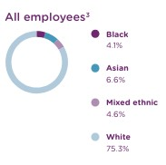
Figure 1: Ethnicity of Employees (Source: Whitbread PLC, 2023).)

The management has planned different strategies for employee management, and if they do face challenges, and to eliminate problems, strategic actions are taken. The job market in the United Kingdom has experienced a substantial tightening this year, resulting in increased challenges in recruitment. In response, the management has made investments and implemented a restructuring of our UK Operations Resourcing Model. Through establishing a centralized team, the company has successfully reduced the time required for engagement by 50% and had a 60% growth in the number of applications received for each vacancy. The implementation of the transformation has primarily improved procedures to better the application experience for potential
Whitbread employees and streamline the work environment for our recruiting managers. Over the past year, the main goal has been to provide job opportunities that have a beneficial influence on the communities that the entity serves. The collaborations of the company include the following:
- Sustaining collaborations with the Department for Work and Pensions and Jobcentre Plus;
- Restarting the execution of sector-based work academy programs in association with NGOs like Shaw Trust. Through this collaboration, the HR leader has successfully hired and employed over fifty individuals who were previously unemployed for a significant duration.
In addition, HR has forged a robust partnership with local authorities, placing special emphasis on recruiting individuals from the areas themselves. Collaborating with the local borough hotel to support the reintegration of working parents into the workforce at the newly established Premier Inn in Canary Wharf.
The leader took a strategic move to form partnerships with educational institutions, such as secondary schools and colleges, in each of the regions. These partnerships will facilitate work experience opportunities and part-time employment alongside academic pursuits, helping to develop transferable skills. Additionally, the entity will be piloting collaborations with other organizations. The leaders partnered with the municipality in Nottinghamshire to offer caretakers the opportunity to gain job experience and enhance their employability skills (Whitbread PLC, 2023).
On the other hand, as per the opinion of Shafique (2012), internal recruitment is a cost-effective method that promotes employee happiness and morale. Prioritize allocating time towards hiring or promoting existing employees before seeking external talent. It is extremely disheartening for the employee, who has exerted significant effort to earn a promotion, to witness a newcomer taking the position that rightfully earned or aspired to. Internal promotion within the organization requires less training and transfer. From the analysis, it has been observed that Premier Inn Hotel adopted a similar approach to recruitment. The company is focusing on the expansion of operations and enhancing quality. This creates job opportunities for existing employees, which contributes to personnel growth and the firm’s development.
On the other hand, HR leaders are planning recruiting activities according to business requirements as the Premier Inn portfolio demonstrates the highest number of business travels in its City Centre, Central London, and Inner London establishments. The elevated mean number of business trips in these particular locations, in contrast to other regions, indicates that this is likely attributable to the increased concentration of offices and enterprises in more urban areas. HR leaders consider the needs of the customers, and according to that, they recruit people to stay competitive in the industry and offer standard services to their consumers. However, the action is mainly taken to forecast the demand for labor and, according to that management, people supply personnel in the needed departments (Premier Inn Hotels Report, 2024).
The Top Employers Institute has acknowledged Premier Inn as one of the top workplaces in the United Kingdom. This is a significant achievement of the company, as this recognition is exclusively given to firms that offer the most attractive work environments for their employees. It does indicate that HR leaders are doing strategic planning to provide a better working environment for employees, and their working practices are evolving as per market needs. HR leaders focus on working culture, manage talent at the time of recruitment and selection, and further focus on career development. The Top Employers Institute conducted a thorough evaluation of support centers, hotels, and restaurants, leading to the issuance of compliance certification. Their investigation included various areas, such as talent management, organizational culture, and career development. Essentially, it was a thorough evaluation of our organization. The Top Employers Institute provides benchmarking services in several areas to help firms assess their position compared to other companies, as well as get valuable insights into their strengths. Hotel Premier Inn is quite pleased that our exceptional working practices have been recognized and evaluated with great precision according to their rigorous standards (Premier Inn News, 2022).

Furthermore, HR plays a strategic role in managing the functions of the business, and leaders set goals for strategic planning.
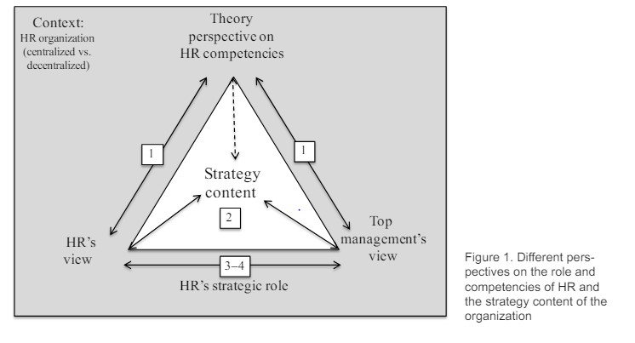
Figure 2: Strategic Role and Its Functions (Source: Laine, Stenvall, Tuominen, 2017).
For strategic planning and goal setting, leaders of Premier Inn Hotel considered the personalities of the individuals to work together in a better way. The management evaluated employees on the psychological scale and further gained knowledge regarding the personality of their human capital, which supports in setting goals and designing further strategies. Such as there are micromanagers, grafters, big talkers, chatterboxes, delegators, workaholics, charmers, jugglers, comedians, and wallflowers. The action also helps the leaders how to communicate with which employees. It is crucial to remember that every person is distinct. Individuals exhibit diverse personalities and motivations, impacting their reactions to circumstances in their professional and personal lives. Especially in the workplace, HR leaders must recognize and value these individual differences since it can enhance our professional achievements if we have the skill to anticipate others' responses and efficiently handle their diverse personalities.
Although there is no generally applicable set of instructions for managing the workplace, there are specific tactics and approaches that can be beneficial for all individuals (Cropanzano, 2012; Premier Inn News, 2017).

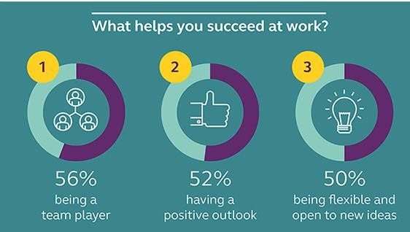
Figure 3: What Helps to Succeed At Work (Source: Premier Inn News, 2017).
According to the above statistical analysis, HR leaders are designing strategic goals, which are helping leaders achieve the desired results on time (Premier Inn News, 2017).
HRM may be traced back to the early 20th century when its major goals were to maintain records and ensure compliance with labor laws. The function of HRM has evolved throughout time to become more proactive and strategic in its endeavors to align human resources with the goals and objectives of the company (Gray, 2011). It can be observed that Premier Inn's HR manager also evolved as leaders shifted towards digitalized training for their employees as it is cost-effective and further allows management to fulfill personnel needs systematically. Premier Inn HR Leaders partnered with Premier in Univesity as it is an e-learning platform.
The platform utilizes video lessons, interactive examinations and challenges, and e-books to educate over 22,000 employees on various areas such as health and safety, sales, and customer service. Since the introduction of the technology, Premier Inn has noticed a decrease in worker turnover and a rise in employee engagement. The site allows Hotel proprietors and managers to grant their employees access to the latest industry trends, optimal methods, and research. Moreover, it provides a user-friendly interface that allows trainers to track the real-time advancement of employees, enabling them to adapt training programs according to individual performance levels. This training platform can be extremely beneficial for hotel owners and managers as they strive to stay ahead in the ever-changing landscape of technology (Preno, 2024).
For recruitment and selection of employees, business leaders focus on the digital platform as they share information regarding jobs on different platforms such as Linked In, Indeed, and their website platform for recruiting employees. The leader shortlists candidates and interviews further the selection process. The management focuses on general knowledge questions, and some psychological aspects are tested on employees, along with job-related technical questions. Once the employee clears all tests and becomes part of the organization, the management offers them training. On-the-job training is provided by HR leaders to employees according to their job requirements and the future goals of the company (Indeed, 2024; Hotel
Premier Inn, 2024a).

Conclusion
The essay mainly focuses on Premier Inn Hotel's business practices and how HR is planning a role in managing employees. It can be observed that the role of HR is evolving as it prioritizes employee development and satisfaction. Hotel Premier Inn invested in the human capital to retain them in the long run. The management is focusing on training and development of personnel and strategic practices so, the company can grow and retain its position in the market.

Leaders of HR did partnership as it is a strategic move to enhance employees' capabilities.
It is observed that diversity is promoted in the business and the management is nurturing talent. The company got recognition as the top workplace in the UK regarding effectiveness and good working environment. However, it is concluded that HR takes strategic actions so a business can achieve its goal. The management forecasts the needs of people and hires them in advance to fulfill the requirements of the business. Also, digital training programs are designed so the firm can achieve its business goals. Technological advancement in training programs enhances overall learning and increases the engagement of personnel.

References

CIPD. 2024. Strategic human resource management. [Online] Available at
<https://www.cipd.org/en/knowledge/factsheets/strategic-hrmfactsheet/#:~:text=Strategic%20HRM%2C%20or%20'people%20strategy,climate%20to %20meet%20performance%20targets.> [Accessed on 27th April 2024].
Cropanzano, R., 2012. Justice in the Workplace: From Theory To Practice, Volume 2. Psychology
Press.
Gary, D., 2011. Human resource management. Pearson Education India.
Indeed. 2024. Premier Inn jobs and careers. [Online] Available at
<https://uk.indeed.com/cmp/Premier-Inn/jobs> [Accessed on 29th April 2024].
Ivancevich, J.M. and Konopaske, R., 2013. Human resource management. McGraw-Hill.
Laine, P., Stenvall, J. and Tuominen, H., 2017. A strategic role for HR: Is it a competence issue? Nordic Journal of Business, 66(1), pp.29-48.
Premier Inn Hotels Report. 2024. The Economic Impact of Premier Inn Hotels. [Online] Available at <https://cdn.whitbread.co.uk/media/2023/08/The-Economic-Impact-of-Premier-Innhotels_2022-study_final.pdf> [Accessed on 27th April 2024].

Premier Inn News. 2017. 23/10/2017 | The most common office personalities, and how to work
better together. [Online] Available at
<https://www.premierinn.com/gb/en/news/2017/office-personalities.html> [Accessed on 28th May 2024]
Premier Inn News. 2022. Premier Inn named Top Employer. [Online] Available at https://www.premierinn.com/gb/en/news/2022/top-employer.html [Accessed on 28th April 2024]
Premier Inn. 2024. About us. [Online] Available at
<https://www.premierinn.com/gb/en/why.html> [Accessed on 25th April 2024].
Premier Inn. 2024a. Job Search. [Online] Available at
<https://www.whitbreadcareers.com/search-and-apply/>[Accessed on 25th April 2024].
Preno. 2024. Hotel Management Training: How To Upskill Your UK Employees[Online] Available at <https://prenohq.com/blog/hotel-management-training-how-to-upskill-youruk-employees/>
Shafique, O., 2012. Recruitment in the 21st Century. Interdisciplinary Journal of Contemporary Research in Business, 4(2), pp.887-901.
Thite, M.O.H.A.N., Kavanagh, M.J. and Johnson, R.D., 2012. Evolution of human resource management and human resource information systems. Introduction To Human Resource Management, pp.2-34.
Whitbread PLC. 2023. Investigate to Win. [Online] Available at <
https://www.annualreports.com/HostedData/AnnualReports/PDF/LSE_WTB_2023.pdf>
[Accessed on 27th April 2024].

