An Exploratory Case Study of Teachers and Year 1 Learners Perceptions of Wellbeing Check-ins on Their Readiness to Learn

by

Jada Lynch

Module Code: ECAD7004
Module Title: Professional and Pedagogic Studies: Researching the Learning: What, How and Why am I Teaching?
Student Number: 1901096

 | Targed/Target | Yr hyn yr wyf wedi'i wneud yn yr aseiniad hwn  What I have done in this assignment...
Targed/Target 1
Targed/Target 2
Targed/Target 3

- Introduction

The purpose of this research project is to explore the use of a wellbeing check-in on pupils' readiness to learn, to develop a critical understanding of the use and implementation of this intervention. Thus, enabling me to develop as a transformative, reflective and research-informed practitioner – through conducting close-to-practice research - enhancing my own practice to positively impact learners. To achieve this, I will engage in ‘wider research and findings’ in line with the QTS professional standards for teaching and leadership (PSFTL) (Welsh Government, 2019). Additionally, I will design, conduct and critically evaluate close-to-practice research in line with the ‘professional networks and communities’ QTS PSFTL which involves engaging in small scale action research (Welsh Government, 2019).

According to Stirling and Emery (2016) the wellbeing of pupils has been linked to their readiness to learn. The aim of this research project is to develop an understanding of the use of a wellbeing check-in as an intervention to support the wellbeing of pupils and promote their readiness to learn, through a critical exploration of theory and research findings. In addition to the collection of primary data to obtain first-hand perspectives of teachers and year 1 pupils regarding this intervention on pupil's readiness to learn.

According to a study carried out by Einhorn et al (2024) - which analysed the self-reported data of 36,951 primary school aged children (8-11 years old), across 500 primary schools in Wales – the mental health and wellbeing of primary school children is concerning with the percentage of children reporting ‘emotional difficulties’ increasing from 13% in 2017 to 29% in 2022, highlighting a downward trend.

Welsh Government’s (2021) guidance on embedding a whole school approach to emotional and mental wellbeing, also revealed that around 1 in 10 children aged 5-16 have mental health issues, with 50% of individuals with long-term mental health issues experiencing symptoms by the age of 14. However, the guidance also states that most emotional and mental health issues are non-clinical and do not require specialist interventions, highlighting the significance of poor mental health among children and young people, reiterating the findings of Einhorn et al (2024). Research suggests that education and mental wellbeing are intimately related, according to a number of studies, supporting learners' health and wellbeing in schools can have a significant impact on engagement with learning (Welsh Government, 2021).

This research topic was chosen due to my understanding of the responsibility I have as an educational practitioner – in line with the Social Services and Wellbeing (Wales) Act 2014 – to promote the wellbeing of all children and young people whom I encounter (Social Care Wales, 2023). Additionally, it was felt that I was best placed to carry out research on this intervention as the school I am currently placed in on the PGCE - within the South Wales Area - already implemented a wellbeing check-in as part of a wellbeing welcome, which I take responsibility in running. The wellbeing welcome consists of a wellbeing check-in alongside a range of calming activities which pupils engage in including drawing, colouring and yoga.

Additionally, I recognise the link between children and young peoples’ wellbeing and their engagement with learning (Welsh Government, 2021). Thus, providing the rationale for this research project to explore the use of a wellbeing check-in on pupils' readiness to learn.

To achieve this, the research question being explored is ‘What are teachers and year 1 learners' perceptions of a wellbeing check-in on pupils readiness to learn’.

1.2 Defining Key Terms

Wellbeing

The definition of wellbeing is highly debated among research due to its multifaceted nature (Deci and Ryan, 2008; Ryff, 1989; Thomas, 2009; Dodge et al, 2012; Forgeard et al, 2011). To provide clarity the term wellbeing is defined as meaning when “a person is happy, healthy and is comfortable with their life and what they do” (Welsh Government, 2015, p.4).

Readiness to Learn

According to Chorrojprasert (2020) and for the purpose of this research, readiness to learn describes a state whereby learners feel positive towards and happy to engage in learning, demonstrating commitment and resilience to achieve learning, particularly where learning is challenging.

- Literature Review

2.1 How does wellbeing impact learning?

According to Robinson (2014) poor wellbeing can hinder children’s learning and cause them to become withdrawn, disruptive and reluctant to ask for help from adults. Wider research supports this indicating a correlation between a child’s social, emotional and behavioural wellbeing and their engagement with learning and educational outcomes (Gutman and Vorhaus, 2012; Evans-Whipp et al, 2017). School wellbeing including learners' enjoyment towards school, stimulation of learning and relationships with peers and teachers has also been linked to a child's engagement with learning (Gutman and Vorhaus, 2012; Evans-Whipp et al, 2017).

Maslow's (1943) Hierarchy of Needs theorizes that individuals have a hierarchy of needs organized from their basic physiological and safety needs up through their psychological needs for love and belonging, self-esteem and self-actualisation. The theory explains that lower needs must be met before an individual can reach self-actualisation needs which is when learning will occur (Maslow, 1943; Mcleod, 2024; Burleson and Thoron, 2017). Burleson and Thoron (2017) argue that an individual’s behaviour is motivated by their most concerning needs, so for children with deficient basic, safety, love and belonging or self-esteem needs, engagement with learning is deferred until those more fundamental needs are achieved. One all deficiency needs are satisfied, individuals become motivated to self-actualize enabling then to engage with learning and reach their fullest potential (Mcleod, 2024; Maslow, 1943). However, it has been argued that individuals do not necessarily fulfil their needs in the rigid order suggested by Maslow's hierarchy, as multiple categories of needs can be fulfilled simultaneously (Mcleod, 2024; Maltby, Day and Macaskill, 2017). Additionally, there have been criticisms surrounding the lack of empirical validity and generalisability of Maslow's (1943) Hierarchy of Needs (Mcleod, 2024).

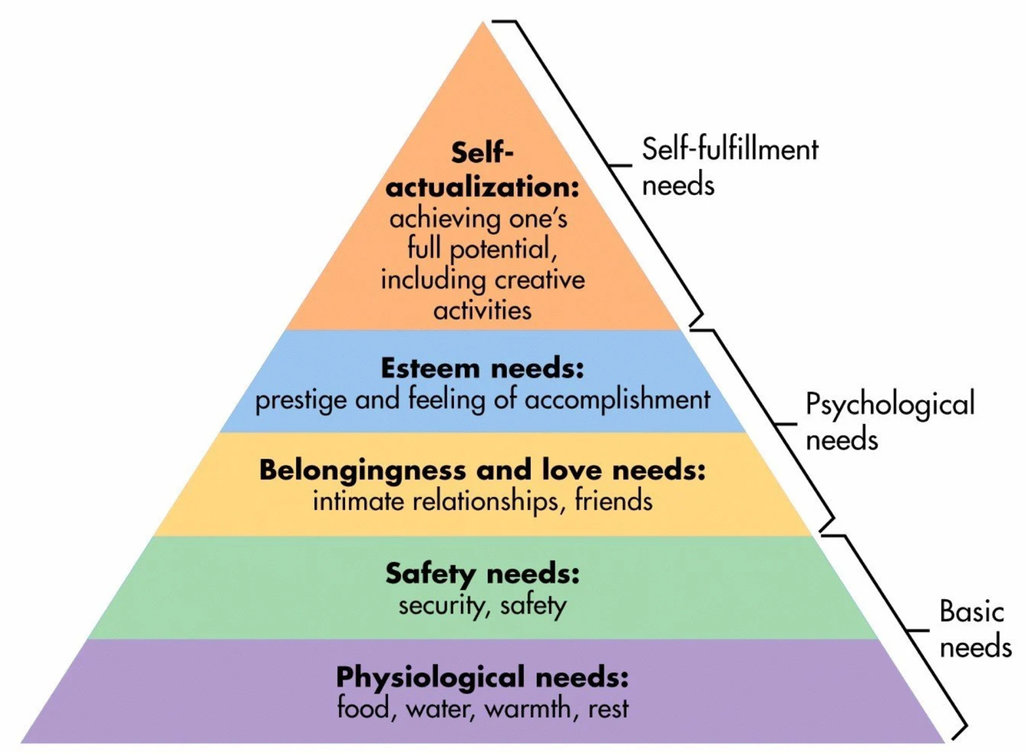Figure 1: Maslow’s Hierarchy of Needs
(Mcleod, 2024)

Therefore, Maslow’s (1943) Hierarchy of Needs suggests that an individual’s wellbeing and readiness to learn is determined by the meeting of their physiological, safety, love and belonging, self-esteem and self-actualisation needs (Maltby, Day and Macaskill, 2017). Thus, emphasising the importance of teachers developing wellbeing interventions which address these needs to promote pupils readiness and ability to learn (Burleson and Thoron, 2017).

2.2 What is a wellbeing check-in?

An extensive search of literature revealed only one study which directly linked to the use of a wellbeing check-in, conducted by Flack et al (2022) in Australia and New Zealand, highlighting a clear gap in research and further rationale for this project. The study, which included 52 schools and over 30,000 responses – supporting its validity – provides valuable insights into the features of a wellbeing check-in and the perceptions of educational practitioners regarding its implementation. The wellbeing check-in within this study is an online survey administered weekly by teachers to monitor pupil’s general wellbeing and their wellbeing in relation to domain specific elements (resilience, safety and belonging) and protective factors (family relationships, friendships, extra-curricular activities, attitudes towards schoolwork, academic stress, health and sleep) (Flack et al, 2022).

Findings from Flack et al’s (2022) study suggest that the implementation of a wellbeing check-in provides valuable opportunities for staff to identify issues impacting pupils wellbeing and to implement timely support which meets the needs of pupils and promotes their wellbeing (Flack et al, 2022). This is particularly important given the findings of Aldrup, Carstensen and Klusmann (2022) linking teachers ability to effectively respond to pupil's emotional needs with positive pupil-teacher relationships, improved pupil wellbeing and readiness to learn. Additionally, the findings suggest that effective implementation of a wellbeing check-in supports pupils to identify a teacher as a trusted adult who they can approach for wellbeing support. This is significant as having a trusted adult has been linked to improved outcomes in children’s health, wellbeing and education (YoungMinds, n.d.). Thus, highlighting the critical role of teachers and the support they provide within a wellbeing check-in and the impact this can have on pupils wellbeing and therefore readiness to learn (Flack et al, 2022; Young Minds, n.d.).

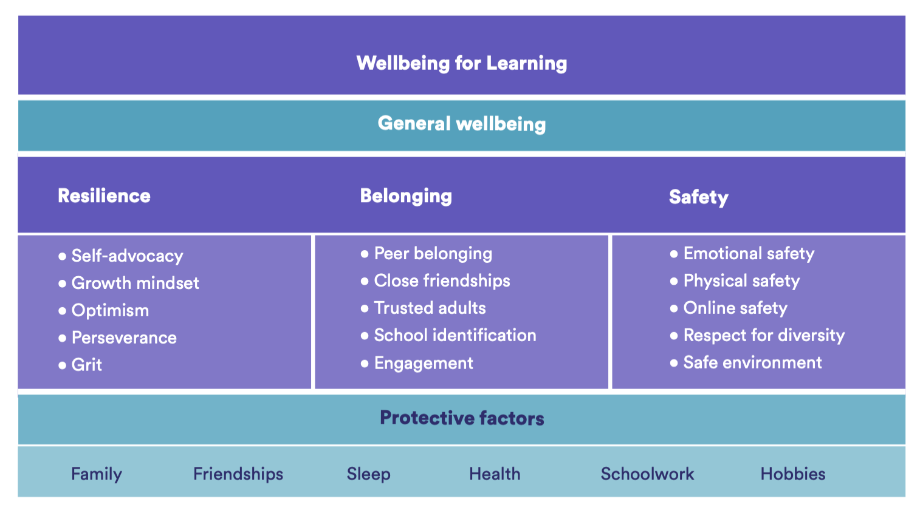Figure 2:”The Wellbeing for Learning Framework”
(Flack et al, 2022, pp. 10)

Furthermore, Maslow’s Hierarchy of Needs was highly influential in the design of the wellbeing check-in Flack et al’s (2022) study, taking into consideration the influence of pupils' assets and needs and the impact these have on pupil wellbeing and their readiness to learn. This is apparent in Figure 2 which illustrates the different assets and needs that a child or young person has in a hierarchal order similar to Maslow’s (1943) Hierarchy.

Despite its usefulness, the generalisability of this research must be addressed as it may be limited due to the different educational policies and approaches to wellbeing across Australia, New Zealand, Southwest Asia, and Wales (Flack et al, 2022; Aldrup, Carstensen and Klusmann, 2022).

However, the findings of Flack et al’s (2022) study aligns with the Welsh Government’s “Framework on embedding a whole-school approach to emotional and mental wellbeing”, which increases its generalisability and relevance in relation to this research project (Welsh Government, 2021). In corroboration with the Welsh Governments framework, the study suggests that the implementation of a wellbeing check-in can provide schools with a consistent opportunity for pupils to have supportive conversations with staff, ensuring they are safe and protected (Flack et al, 2022; Welsh Government, 2021). Thus, allowing pupils to feel able to express their feelings and understand that their concerns will be heard and valued (Welsh Government, 2021). Alignment with the Welsh Government’s framework enhances the applicability of the study’s findings to the current research which explores the use of a wellbeing check-in to support pupil wellbeing and promote pupil’s readiness to learn within a Welsh context.

Whilst the wellbeing check-in within Flack et al’s (2022) study was conducted weekly, it is worth noting that wellbeing check-ins can occur more frequently (Clarke, 2022). Whilst the literature does not explicitly state the optimal frequency of a wellbeing check-in, the related Check-In/Check-Out (CICO) behavioural intervention used in schools could provide some insight (Schaper, 2024). The CICO intervention aims to support positive behaviour among pupils exhibiting behavioural issues through daily check-ins and check-outs with a designated adult, consistent feedback from teachers and effective communication between the school and home (Schaper, 2024; Bundock et al, 2019; Klingbeil, Dart and Schramm, 2019). The intervention is conducted daily to provide regular and routine feedback, to support pupils to meet their goals and achieve the desired outcomes regarding their behaviour (Schaper, 2024). Therefore, this could suggest that the frequency of a wellbeing check-in should be determined based on the needs and level of support required by pupils regarding their wellbeing.

3.0 Explanation of a Case Study

3.1 What is a Case Study?

A case study is a qualitative research method used to investigate a specific case or multiple interrelated cases to gain a deeper contextualised understanding of real-life phenomena (Punch, 2009; Schoch, 2019; Wilson, 2009; Denscombe, 2014; Crowe et al, 2011). Cases can be complex and difficult to define as they can vary extensively to include any phenomenon which involves an individual or group of individuals, interactions between and actions of individuals or settings, behaviours, policies and processes, events and incidents which exists within a “time- and space- bounded" (Alpi and Evans, 2019) context (Punch, 2009; Cohen, Manion and Morrison, 2018).

The real-life context is crucial for providing research with a “nuanced perspective of reality” (Flyvbjerg, 2006) and increasing credibility. However, the context-specific nature and complexity of case study research has been criticized for its lack of generalisability limited to similar contexts (Cohen, Manion and Morrison, 2018). However, a major benefit of conducting research within a real-life context ensures minimal influence on the phenomena being explored (Denscombe, 2014).

According to Hancock et al (2021) there are several case study designs, the three significant designs being explanatory, descriptive and exploratory. Descriptive case studies aim to explain the main characteristic of a phenomenon, while explanatory case studies investigate “cause-and-effect” linkages to answer “why/how questions” (Hancock, et al, 2021). The exploratory case study design, adopted in this research project, aims to provide in-depth contextual information regarding identified phenomena, allowing for greater understanding and insight into current issues, to provide the basis for future research (Denscombe, 2014; Mohan, 2021; Hancock et al, 2021). However, the qualitative and interpretative nature of data collection methods associated with case study research can reduce the validity and reliability of findings (Denscombe, 2014). In response to this weakness it is suggested that more than one group of participants and method of data collection are used to support the corroboration of data and the credibility and validity of findings (Creswell, 2014; Wilson, 2009; Yin, 2018).

3.2 Sampling Methods

The participants involved in this case study included a year 1 teacher and five year 1 pupils selected from a primary school within the South Wales area, using both opportunity and random sampling.

Sampling methods are pertinent to all research, as they enable researchers to identify participants in a study (Punch, 2009). Opportunity sampling – also referred to as convenience sampling – is a non-probabilistic technique where the researcher selects the most accessible participants (Cohen, Manion and Morrison, 2018; Wilson, 2009; Palaiologou, Needham and Male, 2016). Opportunity sampling was chosen as I am currently placed in a year 1 class within a school in the South Wales area on a professional teaching experience, which provides access to both teachers and year 1 pupils who engage in a wellbeing check-in as part of their daily routine. However, it is important to mention that it has been argued that findings generated from research which uses opportunity sampling lacks generalisability outside of the sample to the wider population. That being said, as this is an exploratory case study generalisability would already be restricted to the specific phenomenon being explored and individuals being studied (Cohen, Manion and Morrison, 2018).

The sample size for this study included five year 1 pupils and one year 1 teacher who is also my class mentor. As there are 35 pupils within the year 1 class, random sampling – a probability technique (Wilson, 2009) – was also used when more than five pupils returned consent forms to participate within the study, to ensure all participants available to participate had an equal chance of being selected to ensure fairness and eliminate any concerns regarding researcher bias (Cohen, Manion and Morrison, 2018; Wilson, 2009; Palaiologou, Needham and Male, 2016; Denscombe, 2014). To do this, all available participants were entered into a random name generator – whilst ensuring anonymity and confidentiality using participant references explained in the ethical considerations section – to select five participants at random.

Whilst it could be argued that both sample sizes are small, they were chosen to ensure there would be sufficient time to collect and effectively analyse data within the time limitations of the research project. Additionally, the busy schedule and commitments of the teacher, as well as the need to minimise the impact on pupils’ learning was also considered. However, despite the sample sizes, the inclusion of different perspectives and data collection methods increases the credibility of the findings generated (Creswell, 2014; Wilson, 2009; Yin, 2018).

4.0 Research Methods

Due to the qualitative design of exploratory case study research, qualitative data collection methods (QDCM) were chosen – due to their ability to obtain the rich textual data collected – to effectively explore the perceptions of teachers and year 1 pupils on the use of a wellbeing check-in on pupils readiness to learn (Teherani et al, 2015; Denscombe, 2010; Blaxter, 2010; Bell and Waters, 2018). However, there are several criticisms of QDCM methods which were considered, relating to their time-consuming and complex nature regarding the collection and analysis of data, in addition to the potential bias as a result of their subjective and interpretative nature which could reduce the validity and reliability of research findings (Bell and Waters, 2018). Despite this the QDCM adopted in this study included a focus group conducted with the five Year 1 pupils and a semi-structured interview conducted with a year 1 teacher.

4.1 Focus Group
The literature reveals contrasting views regarding the competence and ability of children and young people to engage with research (Groundwater-Smith, Dockett and Bottrell, 2015). Nevertheless, what appears to be more paramount when conducting research with children and young people is the design of data collection methods and their ability to retrieve the perceptions and experiences of children and young people, by meeting their learning needs and abilities, to promote their competence to engage in research (Groundwater-Smith, Dockett and Bottrell, 2015). To achieve this the Literacy Framework within the Curriculum for Wales, was used to develop an understanding of the literacy abilities of the year 1 (children aged between 5 and 6 years old) pupils participating in this research (Welsh Government, n.d.). A focus group was chosen as the most appropriate research method for data collection with the pupil participants due to its reliance on listening to questions posed by the interviewer and the viewpoints of others within the focus group and providing verbal responses through collaborative discussion, with no reading or writing required, which better aligned with the pupils’ stronger listening and speaking abilities compared to their reading and writing skills (Brinkmannn and Kvale, 2015; Welsh Government, n.d.).

According to Brinkmann and Kvale (2015) focus groups provide a less directive method of interviewing which encourages participants to express their opinions and experiences surrounding the research topic being explored. To facilitate this open-ended questions were developed – refer to Appendix A – to encourage participants to contribute freely whilst also providing structure to keep the focus group on track (Manion, Cohen and Morrison, 2018; Creswell, 2014). Brinkmann and Kvale (2015) emphasize the importance of designing questions that are age-appropriate and understandable for children to promote the competence of children to engage in research. To achieve this, I ensured to use age-appropriate vocabulary when developing focus group questions and provide clear explanations of key terms related to the research topic, including ‘wellbeing’ and ‘readiness to learn’.

Focus groups have been criticized for the power dynamics that can occur between participants leading to some participants becoming more overpowering than others dominating the focus group and the potential for conflict as a result of disagreements, which could lead to findings becoming reflective of one or few participants rather than all reducing the validity and generalisability of results (Cohen, Manion and Morrison, 2018). To overcome this, I ensured to create a positive and trusting atmosphere whereby participants felt comfortable to express their views and respect the views of others.

Furthermore, focus groups are often criticised for their lack of empirical evidence, which can reduce the validity and generalisability of findings. However, the purpose of a focus group is not to provide clear solutions but to present different viewpoints to better understand research issues which corresponds with the purpose of an exploratory case study (Brinkmann and Kvale, 2015; Cohen, Manion and Morrison, 2018; Punch, 2009; Denscombe, 2014).

Finally, another challenge considered when conducting the focus group was the recording of data, as research highlights difficulties with using transcription alone due to its inability to distinguish the contributions made by each participant (Brinkmann and Kvale, 2015; Creswell, 2014). However, this was overcome by transcribing and audio recording the focus group to support the identification of the contributions of each participant (Brinkmann and Kvale, 2015; Creswell, 2014).

4.2 Semi-Structured Interview

To collect the perspectives of the teacher a semi-structed interview was adopted due to its ability to collect in-depth and detailed information, as well as its effectiveness in exploring participants’ views and experiences. Furthermore, several open-ended question were developed as part of an interview schedule for the semi-structured interview – refer to Appendix B – to ensure the discussion which took place focused on the research topic and that data collected was relevant and useful (Bell and Waters, 2018). Additionally, unlike other data collection methods, interviews provide the opportunity to develop and clarify responses, which allowed for the introduction of new insights that pre-determined questions would not have addressed (Bell and Waters, 2018).

Critics of semi-structured interviews argue that they are subjective due to the interpretative nature of data analysis, potentially leading to researcher bias (Brinkmann and Kvale, 2015). Nevertheless, interpretation of data is required when collecting and analysing qualitative data, so in response to this I ensured that I was aware of my own views and hypothesis when conducting the research to minimise interviewer/researcher bias in the design of the interview schedule and data analysis, thereby promoting the validity and credibility of the findings (Brinkmann and Kvale, 2015; Creswell, 2014; Sheehan, 2014). Audio and transcript recordings of the interview and the focus group was pertinent to this as it provided the opportunity to refer back to the data when identifying themes and interpreting meanings to ensure that they reflected the data collected. Furthermore, the literature suggests that the interviewer’s views can also influence questioning and responses to participant responses. I ensured I was aware of this when asking probing questions to encourage participants to elaborate on their responses whilst ensuring I did not lead participants to answer in a way they perceived I wanted, in both the semi-structured interview and the focus group (Brinkmann and Kvale, 2015)

Finally, critics argue that semi-structured interviews are time time-consuming and may not provide generalisable findings due to their often small scale nature. However, in this case study, semi-structured interviews were found to be suitable due to their ability to produce the rich data regarding teachers’ and year 1 pupils’ perceptions of a wellbeing check-in on pupils readiness to learn. As a result, this information has provided insights for future research – which corresponds with the purpose of an exploratory case study –suggesting a need for further studies which explore the use and effectiveness of wellbeing check-ins in enhancing pupils readiness to learn (Brinkmannn and Kvale, 2015; (Punch, 2009; Denscombe, 2014; Cohen, Manion and Morrison, 2018).

5.0 Data Presentation and Analysis Methods

According to Denscombe (2014) the purpose of data analysis is to provide a thorough understanding of research topics being explored.

Qualitative data analysis involves collating, summarising and sorting data according to the identification of codes which provide the “building blocks” (Braun and Clarke, 2016) of themes which emerge, this process is also referred to as data reduction. Data reduction is crucial in the process of qualitative data analysis, as it helps to condense the significant amount of textual data which is often produced to support the recognition of themes and patterns (Palaiologou, Needham and Male, 2016). The role of the researcher is critical in qualitative data analysis as following the identification of themes, the researcher needs to select the pieces of data which they believe best demonstrate their existence. Following this, the researcher interprets the selected data to produce meanings, concepts or ideas to provide an insight or understanding of the research topic being explored, in this case the teacher’s and year 1 pupils’ perceptions on the use of a wellbeing check-in on pupil’s readiness to learn (Creswell, 2014; Wellington, 2020; Wilson, 2009; Denscombe, 2014; Punch, 2009).

The method of data analysis adopted in this study is thematic analysis which aims to provide meanings of the data in relation to identified themes (Braun and Clarke, 2016). According to Braun and Clarke (2016) thematic analysis is particularly useful when conducting exploratory research to understand the views and experiences of participants in relation to the research topic being explored. However, an identified weakness of thematic analysis is the potential for bias due to its interpretative nature, which could impact the validity and usefulness of the study’s findings (Palaiologou, Needham and Male, 2016).

6.0 Ethical Considerations

Prior to starting any research activity an ethics form was submitted to the University of Wales Trinity St David’s (UWTSD) Ethics Committee. The receival of ethical approval from the Ethics Committee, outlines that the research project met the necessary ethical standards as outlined in the UWTSD Research Ethics and Integrity Code of Practice (REICP) (UWTSD, 2020). Additionally, in line with both the UWTSD REICP (UWTSD, 2020) and the BERA Ethical Guidelines for Educational Research (BERA, 2018) several ethical considerations were made to ensure the ethical integrity of the research being conducted.

When conducting research with children and young people (CYP) under the age of 16 years old, “voluntary informed consent” (BERA, 2018, pp.8) should be obtained from the child or young person’s parent or legal guardian (NSPCC, 2024; BERA, 2018). However, according to the United Nations Convention of the Rights of the Child (UNCRC), CYP must also have the capacity to make their own choices regarding their involvement to ensure their rights are being respect. This form of consent is known as assent (UNICEF, 2019; UNICEF, 2021; National Centre for Research Methods, 2023; BERA, 2018; NSPCC, 2024). Regardless of the consent obtained, if a child or young person has not provided involuntary and informed assent, they must not be involved in the research activity (UNICEF, 2021; National Centre for Research Methods, 2023).

To obtain voluntary and informed consent parents/legal guardians of the pupil participants and the teacher participant involved in the research were provided with a letter of participation explaining the purpose of the research activity, and how data collected would be recorded and used. Thus, ensuring full transparency. Additionally, a consent form was attached to the letter of participation to evidence that informed consent was provided for or on behalf of all participants involved. Alternatively, informed assent was obtained verbally from pupil participants involved in the research, following a verbal explanation of the purpose of the research and how the information they provided would be recorded and used.

The positionality of the researcher must also be considered as this can lead to pressure among participants to consent due to the fear of negative consequences, meaning that consent is not provided voluntarily (BERA, 2018). Within this research my positionality would refer to me being the teacher’s mentee and pupil participants’ student teacher.
In response to this, when obtaining both consent and assent it was made clear in both the letter of participation and the verbal explanation that participants have the right to withdraw themselves and their data from the research at any point without any negative consequences (UWTSD, 2020; NSPCC, 2024; UNICEF, 2021).

Furthermore, the confidentiality and anonymity of participants was ensured (BERA, 2018) through secure storage of personal data collected. Paper consent forms were kept under lock and key and non-identifiable references were used to distinguish participants (PP = pupil participant and TP = teacher participant, followed by a letter in brackets (i.e., PP(A), PP(b)). Additionally, all audio and transcript recordings were uploaded to a personal password protected one drive to maximise security. Participants and parents/legal guardians were informed that all personal data would be securely disposed of by the end date of the research of 31/07/24. This ensured the privacy and confidentiality of all participants involved in the research (BERA, 2018).

6.0 Analysis of Results

6.1 Theme One: Teacher Support
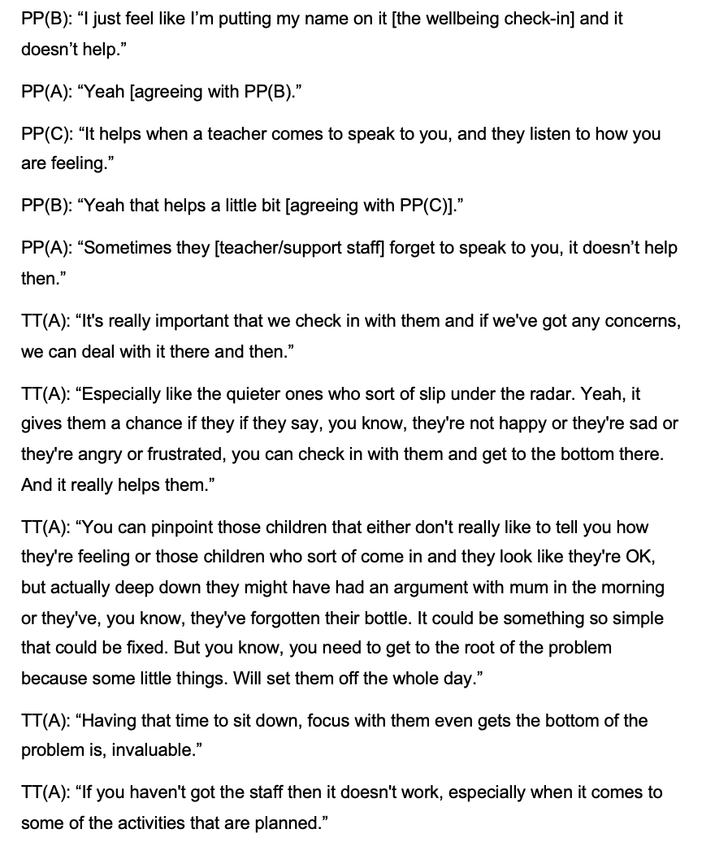

Meaning

The data indicates that emotional support from teachers or school staff is the most important aspect of a wellbeing check-in, highlighting the teacher’s crucial role in supporting pupil wellbeing, which supports the findings of Flack et al’s (2022) study. Furthermore, it was expressed that the wellbeing check-in was appreciated by pupil participants as it helped teachers and school staff to understand the emotional state of pupils without the need for verbal expression. This correlates with data collected from the interview with the teacher participant, which suggested that the wellbeing check-in allows teachers to pinpoint those children who may be experiencing poor wellbeing - particularly those children who aren’t forthcoming and often “slip under the radar” - in order to identify and deal with any concerns at the most immediate opportunity. However, the data suggests that staffing issues could potentially impact the quality of teacher support and therefore the success of a wellbeing check-in on pupils’ readiness to learn. As limited staff may make it difficult to reach all pupils, which is crucial. Without the provision of teacher support the value and impact of the wellbeing check-in may be reduced, as it would simply involve pupils identifying how they are feeling, reducing its effectiveness in promoting pupil wellbeing and readiness to learn. Additionally, the data suggests that when using a wellbeing check-in chart within a wellbeing check-in to gauge pupils feelings, it should include various emotions to aid pupils’ understanding, especially for younger ones with limited emotional knowledge, to allow them to express their feelings and provide a true reflection of their emotions.

6.2 Theme Two: Consistency

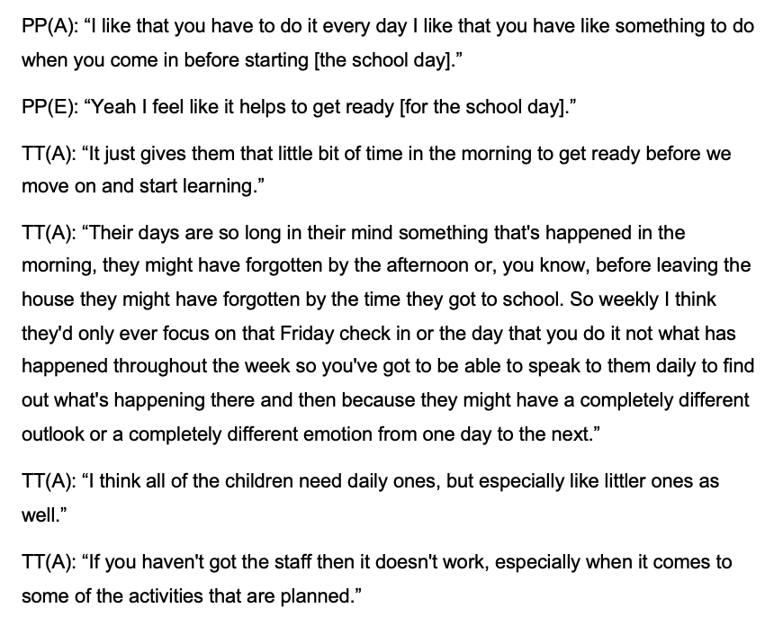

Meaning

Consistency of the wellbeing check-in was another theme which emerged within the data. Pupil participants expressed that they like doing the wellbeing check-in every morning before they begin their learning as it helps them to feel ready. However, this applies to all of the activities within the wellbeing welcome not solely the wellbeing check-in. The teacher participant interview confirmed that the wellbeing welcome, including the wellbeing check-in, provides pupils with time to settle and prepare for the day before engaging in learning, which has been found to be beneficial. Additionally, the interview data highlighted the significance of daily wellbeing check-ins, especially for younger children, as they may struggle to recall feelings or issues that affected their wellbeing. Emphasising the cruciality of discussing these issues with children daily to address them “then and there”. Thus, challenging the frequency of the wellbeing check-in Flack et al’s (2022) study, suggesting that a weekly wellbeing check-in would be insufficient in supporting pupils wellbeing and readiness to learn, particularly for younger pupils.

6.3 Theme Three: Emotional Understanding
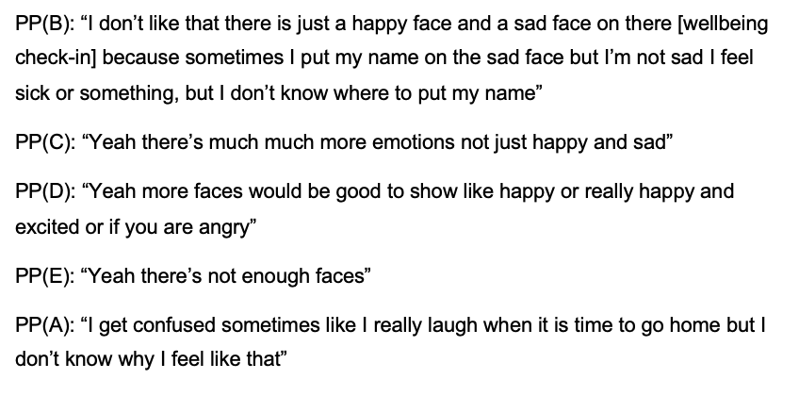

Meaning
Pupils understanding of their emotions was another theme which emerged. Pupil participants expressed the various emotions felt when indicating their wellbeing on the wellbeing check-in chart, leading to discussion about the absence of ‘faces’ to illustrate the various emotions they may experience. Thus, limiting pupils' ability to express how they are feeling due and inaccurate reflections of their true feelings. This could reduce the impact and usefulness of a wellbeing check-in as pupils may not associate their issues with the emotions available and as a result teachers may be unaware of a child experiencing poor wellbeing due to inaccurate placement of pupils names on the wellbeing check-in chart. Therefore, reducing its ability to support pupil wellbeing and promote readiness to learn. Additionally, pupil participants also expressed that they do not always understand why they are feeling certain emotions and would like to be given opportunities to engage in activities to support their emotional understanding.

6.4 Theme Four: Peer Support

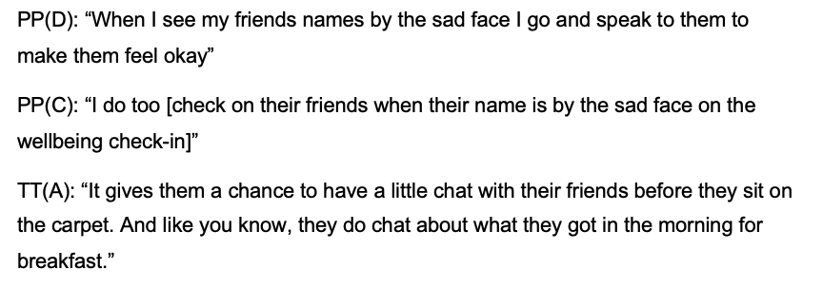

Meaning
Peer support was another theme which emerged. Pupil participants expressed that the visibility of the wellbeing check-in chart within the classroom means that they can see when their peers are feeling ‘sad’ which has led to opportunities whereby peers would support each other’s wellbeing, an element which participants were particularly positive about. This was corroborated and confirmed by data collected in the teacher interview, increasing the validity of this finding.

6.5 Theme Five: Readiness to Learn
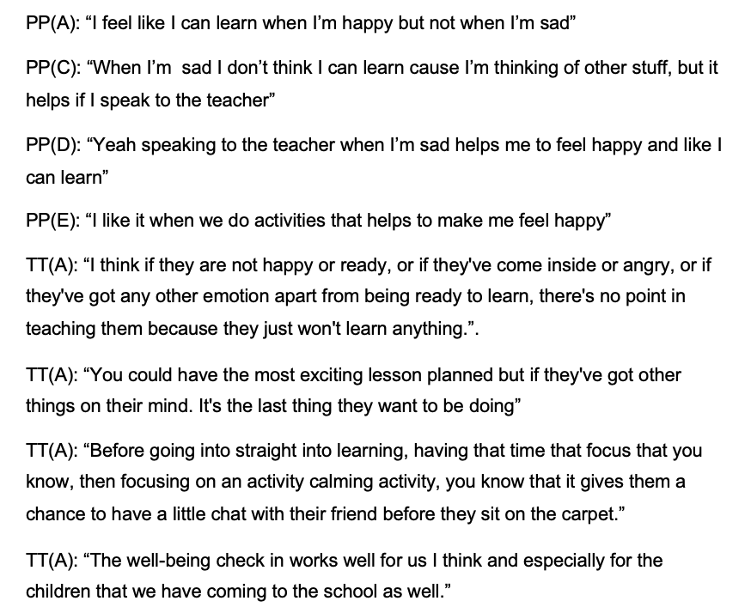

Meaning
Pupils expressed that when they feel happy that they feel more able and ready to learn and persevere with challenging tasks and activities. However, their readiness to learn is reduced when they experience poor wellbeing as it has a negative effect on their ability to concentrate on and preserver through learning, which supports the findings of Stirling and Emery (2016) previously discussed. The teacher interview data supports the notion that it’s ineffective to expect pupils to engage in teaching and learning when they’re not in a receptive emotional state, as this can hinder their ability to focus and retain learning effectively. Additionally, the data suggests that in addition to the calming activities and the wellbeing check-in already provided within the wellbeing welcome, the creation of an area for pupils experiencing negative feelings or emotions, would significantly enhance their wellbeing, as indicated on the wellbeing check-in chart. Furthermore, the data also suggests that the teacher advocates for having a wellbeing check-in but as part of a wellbeing welcome which includes a range of calming activities to support pupils to settle in by giving them time to process their emotions and get into a positive mindset, promoting their wellbeing and supporting them to feel ready to learn.

7.0 Conclusions and Recommendations

In response to the research question the research findings reveal that pupils’ wellbeing significantly impacts their readiness to learn, which supports the findings of Stirling and Emery (2016). However, a wellbeing check-in alone is not sufficient to support pupils wellbeing. Instead, a wellbeing welcome is proposed which allows pupils to settle in to class and engage in calming activities like colouring, drawing, or yoga while the wellbeing check-in is conducted. However, a wellbeing check-in is crucial for teachers to identify pupils experiencing poor wellbeing and provide timely support which meets their needs, supporting the findings of Flack et al (2022). Consistency of teacher and staff interactions was also found to be key to the success of the wellbeing check-in and its ability to support pupils readiness to learn. Furthermore, the research also highlights the potential of a wellbeing check-in to encourage peer support and the importance of designing a wellbeing check-in chart or tool that allows pupils to express a wide range of emotions. The new insights and findings of this research provide the basis for future research to test and potentially increase the validity and generalisability of the implementation of a whole-school wellbeing check-in to support pupils’ wellbeing and readiness to learn.

However, this study has several limitations. The validity of the findings is reduced due to the lack of prior research on wellbeing check-ins and their impact on pupil’s readiness to learn. Additionally, concerns exist regarding the validity and generalizability of the research findings due to the subjective and interpretative nature of the data collection methods used, though their inclusion was necessary and justified given the exploratory nature of the case study approach (Brinkmann and Kvale, 2015; Cohen, Manion and Morrison, 2018; Punch, 2009; Denscombe, 2014). Whilst some findings correlated with the limited existing research (Flack et al, 2022) increasing their validity, others provide new insights in the use and implementation of wellbeing check-ins and their impact on pupils’ readiness to learn. Despite issues with validity and generalisability, I would argue that these findings make useful contribution to an identified gap in the research.

Furthermore, in light of this research I will be taking these findings forward, particularly the adaption of the wellbeing check-in chart to incorporate a wider range of emotions and the inclusion of activities which support pupils emotional understanding within the wellbeing welcome in my current placement. In regard, to future research I would like to explore the frequency and design of a wellbeing check-in further to understand the necessary components of a wellbeing check-in to promote the wellbeing and readiness to learn of all pupils across the primary age phase as current findings are potentially limited to year 1 pupils. Additionally, going forward as I begin my own career as a teacher, this research has provided valuable insight regarding the importance of pupils wellbeing and the impact this has on their readiness to learn, as well as an intervention I can implement within my own classroom to support this.

8.0 References

Aldrup, K., Carstensen, B. and Klusmann, U. (2022) “Is Empathy the Key to Effective Teaching? A Systematic Review of Its Association with Teacher-Student Interaction and Student Outcomes”, Educational Psychology Review, 34, pp. 1177-1216.
Alpi, E. and Evans, J.J. (2019) “Distinguishing Case Study as a Research Method From Case Reports as a Publication Type”, Journal of the Medical Library Association, 107(1), pp. 1 – 5. Available at: https://www.ncbi.nlm.nih.gov/pmc/articles/PMC6300237/ [Accessed: 28 April 2024].
Australian Research Alliance for Children and Youth (2024) What do we mean when we say ‘wellbeing’? Available at: https://www.aracy.org.au/blog/what-do-we-mean-when-we-say-wellbeing#:~:text=Too%20frequently%20it%20is%20used,or%20young%20person%20to%20thrive. [Accessed: 28 March 2024].
Bell, J. and Waters, S. (2018) Doing Your Research Project: A Guide for First-Time Researchers. 7th Edn. McGraw-Hill Education, Open University Press.
Blaxter, L., Hughes, C. and Tight, M. (2010) How to Research. 4th Edn. Open University Press.
Brinkmannn, S. and Kvale, S. (2015) InterViews. 3rd Edn. SAGE
British Educational Research Association [BERA] (2018) Ethical Guidelines for Educational Research. 4th Edn. London. Available at: https://www.bera.ac.uk/publication/ethical-guidelines-for-educational-research-2018 [Accessed: 29 April 2024]
Bundock, K., Hawken, L.S., Kladis, K. and Breen, K. (2019) “Innovating the Check-In, Check-Out Intervention: A Process for Creating Adaptations”, Intervention in School and Clinic, 55(3), 169-177.
Burleson, E. and Thoron, A. (2017) Maslow’s Hierarchy of Needs and It’s Relation to Learning and Achievement. Available at: http://knowen-production.s3.amazonaws.com/uploads/attachment/file/2007/Maslow_E2_80_99s%2BHierarchy%2Bof%2BNeeds%2Band%2BIts%2BRelation%2Bto%2BLearning.pdf [Accessed: 22 April 2024].
Chorrojprasert, L. (2020) “Learner Readiness – Why and How Should They Be Ready?”, LEARN Journal: Language Education and Acquisition Research Network Journal, 13(1), pp. 268 – 274. Available at: https://files.eric.ed.gov/fulltext/EJ1242968.pdf [Accessed: 26 March 2024].
Clark, A. (2022) Student daily or weekly check-in sheets (with a template). Available at: https://www.classcraft.com/blog/daily-weekly-check-in-sheets-pbis/ [Accessed: 28 April 2024].
Clarke, V. and Braun, V. (2016) “Thematic Analysis”, The Journal of Positive Psychology, 12(3), pp.297-298.
Cohen, L., Manion, L. and Morrison, K. (2018) Research Methods in Education. 8th edn. Routledge: London and New York.
Creswell, J.W. (2014) Educational Research: Planning, Conducting and Evaluating Quantitative and Qualitative Research. 4th Edn. Pearson.
Crowe, S., Creswell, K., Robertson, A., Huby, G., Avery, A. and Sheikh, A. (2011) “The Case Study Approach”, BMC Medical Research Methodology, 11(100). Available at: https://bmcmedresmethodol.biomedcentral.com/articles/10.1186/1471-2288-11-100 [Accessed: 28 April 2024].
Deci, E.L. and Ryan, R.M. (2008) “Hedonia, eudaimonia, and well-being: an introduction,” Journal of happiness studies, 9(1), pp. 1–11. Available at: https://doi.org/10.1007/s10902-006-9018-1.
Denscombe, M. (2010) The Good Research Guide: For Small-Scale Social Research Projects. 4th edn. McGraw-Hill, Open University Press.
Denscombe, M. (2014) The Good Research Guide: For Small-Scale Social Research Projects. 5th edn. Open University Press.
Diener, E. (1984) “Subjective Well-being", Psychological Bulletin, 95, pp. 542-575. Available at: https://doi.org/10.1037/0033-2909.95.3.542 [Accessed: 28 March 2024].
Dodge, R., Daly, A., Huyton, J. and Saunders, L. (2012) “The Challenge of Defining Wellbeing”, International Journal of Wellbeing, 2(3), pp. 222-235. Available at:
Einhorn, J., Brophy, S., James, M., Kennedy, N. and Marchant, E. (2024) “Changes in self-reported health and wellbeing outcomes in 36,951 primary school children from 2014 to 2022 in Wales: An analysis using survey data,” Frontiers in public health. Available at: https://www.frontiersin.org/journals/public-health/articles/10.3389/fpubh.2024.1285687/full?utm_source=Email_to_authors_&utm_medium=Email&utm_content=T1_11.5e1_author&utm_campaign=Email_publication&field&journalName=Frontiers_in_Public_Health&id=1285687 [Accessed: 26 March 2024]
Evans-Whipp, T., Mundy, L., Canterford, L. and Patton, G. (2017) Student Wellbeing, Engagement and Learning Across the Middle Years. Available at: https://files.eric.ed.gov/fulltext/ED592582.pdf [Accessed: 22 April 2024].
Farimani, Z. and Shari, N. (2020) “Reaching Self-actualization in Education: Construction and Validation of a Hierarchical Scale”, Journal of Language Teaching and Research, 11(4), pp. 623 – 634. Available at: https://www.academypublication.com/issues2/jltr/vol11/04/14.pdf [Accessed: 21 April 2024].
Flack, C. B., Schoeffel, S., Walker, L. and Bickerstaff, A. (2022) Wellbeing for Learning: Evidence Brief on Student Wellbeing From a Pilot in Schools. Available at: https://s3.ap-southeast-2.amazonaws.com/docs.pivotpl.com/resources/Research/Pivot_Wellbeing_for_Learning_Evidence_Brief_2022.pdf [Accessed: 28 April 2024].
Flyvbjerg, B. (2006) “Five Misunderstandings About Case-Study Research”, Qualitative Inquiry, 12(2), pp. 219 – 245. Available at: https://journals.sagepub.com/doi/10.1177/1077800405284363 [Accessed: 28 April 2024].
Forgeard, M. J. C., Jayawickreme, E., Kern, M. and Seligman, M. E. P. (2011) “Doing the Right Thing: Measuring Well-Being for Public Policy,” International journal of wellbeing, 1(1). Available at: https://doi.org/10.5502/ijw.v1i1.15.
Groundwater-Smith, S., Docket, S. and Bottrell, D. (2015) Participatory Research with Children and Young People. SAGE
Gutman, L. and Vorhaus, John. (2012) The Impact of Pupil Behaviour and Wellbeing on Educational Outcomes. Available at: https://assets.publishing.service.gov.uk/media/5a747ef340f0b604dd7ae609/DFE-RR253.pdf [Accessed: 22 April 2024].
Hancock, D.R., Algozzine, B. and Lim, J.H. (2021) Doing Case Study Research: A Practical Guide for Beginning Researchers. 4th edn. Teachers College Press.
Klingbeil, D.A., Dart, E.H. and Schramm, A.L. (2019) “A Systematic Review of Function-Modified Check-In/Check-Out”, Journal of Positive Behaviour Interventions, 21(2), pp. 77 – 92.
Maltby, J., Day, L. and Macaskill, A. (2017) Personality, Individual Differences and Intelligence. 4th Edition, Pearson.
Maslow, A.H. (1943) “A Theory of Human Motivation”, Psychological Review, 50(4), pp. 430-437.
Mcleod, S. (2024) Maslow’s Hierarchy of Needs. Available at: https://www.simplypsychology.org/maslow.html [Accessed: 21 April 2024].
Mohan, R. (2021) What is a Case Study? Available at: https://venngage.com/blog/what-is-a-case-study/#:~:text=Exploratory%20case%20reports,-An%20explanatory%20report&text=This%20is%20usually%20conducted%20as,could%20have%20found%20inconclusive%20results. [Accessed: 28 April 2024]
National Centre for Research Methods (2023) Guidance Paper 2: Obtaining Consent in Research Involving Children – Understanding the Legal and Ethical Framework. Available at: https://eprints.ncrm.ac.uk/id/eprint/4917/1/Obtaining%20Consent%20in%20Research%20involving%20Children%20–%20Understanding%20the%20Legal%20and%20Ethical%20Framework.pdf [Accessed: 29 April 2024].
NSPCC (2024) Research with Children: Ethics, Safety and Promoting Inclusion. Available at: https://learning.nspcc.org.uk/research-resources/briefings/research-with-children-ethics-safety-promoting-inclusion#:~:text=specifically%20for%20children.-,Informed%20consent,participating%20in%20the%20research%20are [Accessed: 29 April 2024]
Palaiologou, I., Needham, D. and Male, T. (2016) Doing Research in Education: Theory and Practice. SAGE.
Punch, K. (2009) Introduction to Research Methods in Education. London: SAGE
Rahmani, K., Gnoth, J. and Mather, D. (2018) “Hedonic and Eudaimonic Well-being: A Psycholinguistic View”, Tourism and Management, 69, pp. 155-168. Available at: https://www.sciencedirect.com/science/article/pii/S0261517718301195 [Accessed: 28 March 2024].
Robinson, M. (2014) The Feeling Child: Laying the Foundations of Confidence and Resilience. 1st Edition, Routledge.
Ruggeri, K., Garcia-Garzon, E., Maguire, A., Matz, S. and Huppert, F. A. (2020) “Well-being is More Than Happiness and Life Satisfaction: A Multidimensional Analysis of 21 Countries”, Health and Quality of Life Outcomes, 18. Available at: https://hqlo.biomedcentral.com/articles/10.1186/s12955-020-01423-y#citeas [Accessed: 28 March 2024].
Ryff, C.D. (1989) “Happiness Is Everything, or Is It? Explorations on the Meaning of Psychological Well-Being,” Journal of personality and social psychology, 57(6), pp. 1069–1081. Available at: https://doi.org/10.1037/0022-3514.57.6.1069.
Schaper, A. (2024) Check-In/Check-Out (CICO): Intervention Tips and Guidance. Available at: https://www.panoramaed.com/blog/check-in-check-out-cico-intervention#:~:text=Description%3A%20CICO%20is%20a%20strategy,increased%20positive%20adult%20attention%20daily. [Accessed: 28 April 2024].
Schoch, K. (2019) ‘Chapter 16: Case Study Research’, in Burkholder, G.J., Cox, K.A., Crawford, L.M. and Hitchcock, J.H. (ed.) Research Design and Methods: An Applied Guide for the Scholar-Practitioner. SAGE Publications Inc.
Seligman, M. (2018) “PERMA and the building blocks of well-being,” The journal of positive psychology, 13(4), pp. 333–335. Available at: https://doi.org/10.1080/17439760.2018.1437466.
Social Care Wales (2023) Overview: Social Services and Well-being (Wales) Act 2014. Available at: https://socialcare.wales/resources-guidance/information-and-learning-hub/sswbact/overview [Accessed: 26 March 2024].
Social Services and Well-being (Wales) Act 2014. Available at: https://www.legislation.gov.uk/anaw/2014/4/section/2 [Accessed: 28 March 2024].
Stirling, S. and Emery, H. (2016) A whole school framework for emotional well-being and mental health: Supporting resources for school leaders. Available at: https://www.ncb.org.uk/sites/default/files/uploads/files/NCB%20School%20Well%20Being%20Framework%20Leaders%20Resources_0.pdf [Accessed: 26 March 2024]
Su, L., Tang, B. and Nawijn, J. (2020) “Eudaimonic and Hedonic Well-being Pattern Changes: Intensity and Activity”, Annals of Tourism Reseach, 84. Available at: https://www.sciencedirect.com/science/article/pii/S0160738320301523#:~:text=Actually%2C%20well%2Dbeing%20consists%20of,2001%3B%20Ryff%2C%201989). [Accessed: 28 March 2024].
Teherani, A., Martimianakis, T., Stenfors-Hayes, T., Wadhwa, A. and Varpio, L. (2015) “Choosing a Qualitative Research Approach”, Journal of Graduate Medical Education, 7(4), pp. 669-670. Available at: https://www.ncbi.nlm.nih.gov/pmc/articles/PMC4675428/#:~:text=Qualitative%20research%20is%20the%20systematic,and%20how%20interactions%20shape%20relationships. [Accessed: 29 April 2024]
Thomas, J. (2009) ‘Working Paper: Current Measures and Challenges of Measuring Children’s Wellbeing’, Household, Labour Market and Social Wellbeing. Newport: Office for National Statistics.
UNICEF (2019) A Summary of The UN Convention on The Rights of The Child. Available at: https://www.unicef.org.uk/wp-content/uploads/2019/10/UNCRC_summary-1_1.pdf [Accessed: 29 April 2024]
UNICEF (2021) UNICEF Procedure on Ethical Standards in Research, Evaluation, Data Collection and Analysis (2021). Available at: https://www.unicef-irc.org/files/documents/d-4165-Final%20Procedure%20Ethical%20Standards%20Evidence%2004%202021.pdf [Accessed: 29 April 2024]
University of Newcastle (2024) Research Methods: What are Research Methods? Available at: https://libguides.newcastle.edu.au/researchmethods#:~:text=Research%20methods%20are%20the%20strategies,better%20understanding%20of%20a%20topic. [Accessed: 29 April 2024]
University of Wales Trinity Saint David [UWTSD] (2020) Research Ethics and Integrity Code of Practice. Available at: https://www.uwtsd.ac.uk/research/research-integrity-and-ethics [Accessed: 29 April]
Wellington, J.J. (2020) Educational Research: Contemporary Issues and Practical Approaches. 2nd Edn. Bloomsbury Academic.
Welsh Government (2015) Social Servies and Well-being (Wales) Act 2014: The Essentials. Available at: https://www.gov.wales/sites/default/files/publications/2019-05/social-services-and-well-being-wales-act-2014-the-essentials.pdf [Accessed: 28 March 2024].
Welsh Government (2019) Professional standards for teaching and leadership. Available at: https://hwb.gov.wales/api/storage/19bc948b-8a3f-41e0-944a-7bf2cadf7d18/professional-standards-for-teaching-and-leadership-interactive-pdf-for-pc.pdf [Accessed: 26 March 2024]
Welsh Government (2021) Framework on embedding a whole-school approach to emotional and mental well-being. Available at: https://www.gov.wales/sites/default/files/publications/2021-03/framework-on-embedding-a-whole-school-approach-to-emotional-and-mental-well-being.pdf [Accessed: 26 March 2024]
Welsh Government (n.d.) Literacy and Numeracy Framework. Available at: https://hwb.gov.wales/curriculum-for-wales/cross-curricular-skills-frameworks/literacy-and-numeracy-framework [Accessed: 29 April 2024]
Wilson, E. (2009) School-Based Research: A Guide for Education Students. London: SAGE
Yin, R.K. (2018) Case Study Research and Applications: Design and Methods. 6th Edn. SAGE
Young Minds (n.d.) Someone to Turn To: Being a Trusted Adult for Young People. Available at: https://www.youngminds.org.uk/media/by3o0aru/someone-to-turn-to-report.pdf [Accessed: 28 April 2024]

