
Applied Computing

Wales Institute of Science and Art (WISA)

Networks and Cybersecurity Essentials (ACCA4024)

Lab 7: Tools to check on Threats and Vulnerabilities



n.kaliyamurthy@uwtsd.ac.uk 1

Objectives
Using Packet Capturing tools and network monitoring tools.
Tasks
1. Use Nmap to scan 2.
Required Resources
- PC with Ubuntu 16.0.4 LTS installed in a VirtualBox or VMware virtual machine. (Alternatively, Any Linux Platform)
- Internet Connection to refer the outcomes o References: https://nmap.org/

Task 1
- Login as User Cisco.
- Go to Terminal and Type the following commands and examine o To do that we are using Nmap.
▪ Network Mapper, or Nmap, is an open source utility used for network discovery and security auditing. Administrators also use Nmap for monitoring hosts or managing service upgrade schedules. ▪ Nmap determines
        - what hosts are available on a network,
        - what services are running,
        - what operating systems are running, • What packet filters or firewalls are running?
o So, basically if you could get all the above details using Nmap, you could get few information which could be used later in performing attacks or mitigating attacks.

- Commands to execute o Step 1:
▪ nmap localhost
(This is a scan performed to get information about the services that are bound to the localhost)

o Step 2:
▪ Replace the above command with your IP Address and other hosts (if connected/ else ignore) in your network to check the outcomes.
Type the command you used to find out your host IP Address
ifconfig
Type the command you used to scan after finding your host IP Address
Nmap localhost in order to indetify more information
Record the outcomes of the above command here
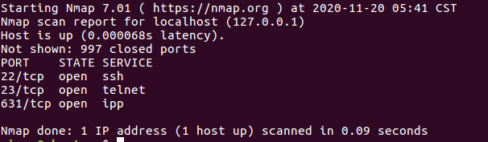

o Step 3: Analyse the outputs/outcomes from Step 1 and 2 and record your reflections. (Hint: Analyse what is the difference between local host and ip address of the host, If ports displayed are different, Why is it different? etc (not limited to the hints))
- Step 4: Why is the nmap scan only scans the first 1000 ports? What will be the command to scan all the ports?
Because it is limited to the local network, which would usually be reduced down 1000 sports for the maintenance and speed issues, it would be nmap -p to be able to see all of the commands, and all of the visible ports or use nmap -p0-65535 192.168.122.1

- Step 5: Scan the UDP Ports
    - nmap –sU localhost
(This is a scan performed to get information about the UDP ports and to execute this command you need root privileges. So, try)
    - sudo nmap –sU localhost
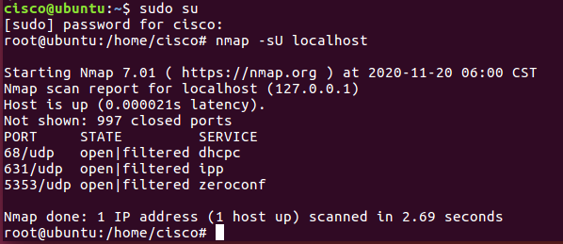
- Step 6: From the above outcomes select any ports which is open
▪ sudo nmap –p137 localhost
(Change the port number 137 to any port which you found as open in the previous step (5).)
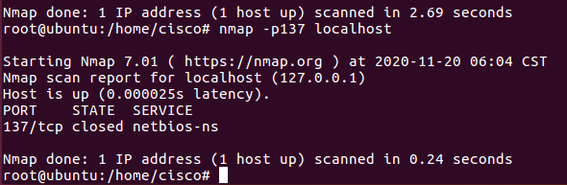

- Step 7: Try other port related commands and record its purpose.
    - sudo nmap –pportnumber host_ip
    - sudo nmap –pportnumber_startrange-portnumber_endrange host_ip
    - sudo nmap –pportnumber,portnumber host_ip
    - not limited to the above (Do a google search, refine your search and find out other port related commands, Hint:nmap.org)
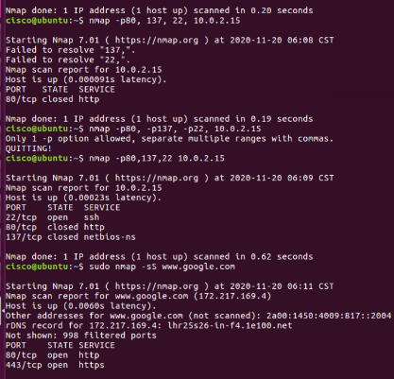
- Step 8: Detecting the version is a very important part of information gathering. Try to find out the version. ▪ nmap –sV localhost

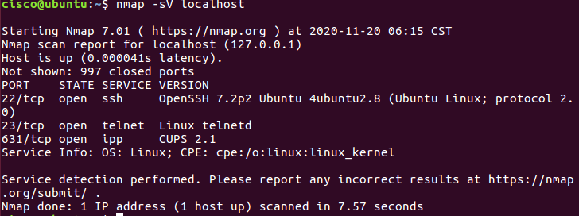

- Step 9: Try other commands to detect other versions and record its purpose.
      - Command to identify the Operating System version

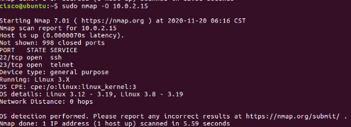

      - Command to identify the Service Version

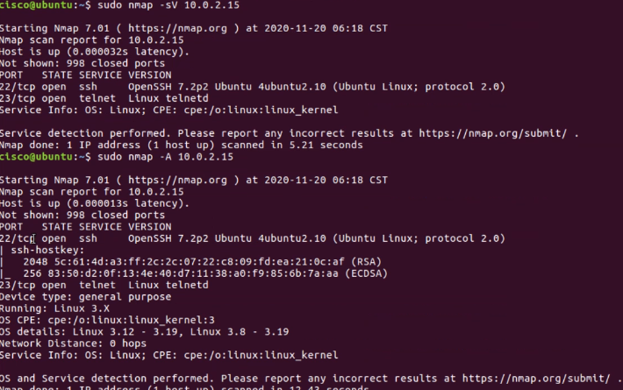

Learnings from tutorials so far:
Part 1 (Packet Tracer, Host Machines)
  - Build a home Network
  - Understand and configure IP Address
  - Use Ping/ Trace route Utility to check the connection status
  - Use ipconfig /all command to determine the MAC address of a Windows computer on an Ethernet network.
  - Analyze a MAC address to determine the manufacturer.
  - Analyze the Wired and Wireless Network connection.
  - Analyze Address Resolution Protocol (ARP).
  - Connect to a Wireless Router and configure the basic settings in a wireless router and add security features.
  - Use nslookup command to understand the url to ip conversion.
  - Configure basic connectivity settings in Intermediate devices (Switch/ Router).
  - Work with SBA Packet Tracer Files/ environment
  - Configure ftp, web, email, dns, ntp and aaa Servers Part 2
  - Set up a virtual lab environment
  - Troubleshooting the virtual lab environment
  - Working with virtual machines
  - Authentication, Authorization and Accounting
  - Threats and Vulnerabilities – Using NMAP

