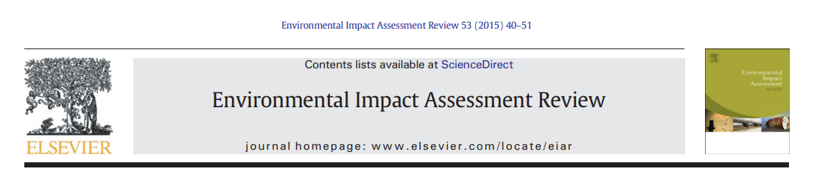
A Critical Evaluation of Environmental Impact Assessment Methodology for a Strategic Regeneration Development in Wales: A Lee & Colley Review of the Coed Darcy Environmental Statement
Student Name: Nikhil Rai

Article info
Article history:
Received 14 March 2026
Received in revised form 29 March 2026
Accepted 6 April 2026
Available online 16 April 2026
Keywords:
Environmental Impact Assessment
EIA quality review
Lee & Colley Review Package
Strategic regeneration
Urban development
Wales

Abstract
Environmental Impact Assessment (EIA) is a central instrument for integrating environmental considerations into planning and decision-making for major development projects. Despite its long-standing legislative basis within the United Kingdom and Wales, concerns persist regarding the effectiveness of EIA in practice, particularly for large-scale, housing-led regeneration schemes. This paper presents a critical evaluation of the Environmental Impact Assessment methodology applied to the Coed Darcy Strategic Regeneration Area in Neath Port Talbot, Wales. Using the Lee and Colley Review Package, the study assesses the quality, transparency and methodological robustness of the Environmental Statement in relation to legislative requirements, professional guidance and contemporary academic literature. The results indicate that while the Environmental Statement demonstrates strong procedural compliance and provides comprehensive baseline coverage for several environmental topics, notable weaknesses remain in alternatives assessment, cumulative effects evaluation, consistency of significance determination and post-consent monitoring. These findings reflect broader systemic challenges within EIA practice and highlight persistent gaps between EIA theory, legislative intent and implementation. The paper concludes with recommendations aimed at strengthening the substantive effectiveness of EIA in strategic regeneration developments.

1. Introduction
Environmental Impact Assessment (EIA) is an established decision-support process intended to identify, predict and evaluate the likely significant environmental effects of development proposals prior to consent being granted. Since its formal introduction through European legislation and subsequent incorporation into UK and Welsh planning systems, EIA has become a mandatory requirement for projects with the potential to generate significant environmental impacts. Its overarching purpose is to improve decision-making by ensuring that environmental considerations are systematically integrated into project design, appraisal and approval processes.
Despite this clear legislative intent, academic research continues to identify persistent shortcomings in EIA practice. These include limited methodological rigour, superficial consideration of alternatives, inconsistent significance evaluation, weak cumulative effects assessment and inadequate follow-up and monitoring. Such issues are particularly pronounced in large-scale, mixed-use developments where economic; political and delivery pressures may constrain the depth and influence of environmental assessment [1].
This paper critically evaluates the Environmental Impact Assessment methodology applied to the Coed Darcy Strategic Regeneration Area, a major housing-led redevelopment project in Neath Port Talbot, South Wales. Rather than examining the acceptability of the development itself, the study focuses on the quality and effectiveness of the EIA process as documented in the Environmental Statement (ES). The Lee and Colley Review Package is employed as a systematic framework to assess the ES against legislative requirements, best-practice guidance and contemporary academic expectations.
1.1 Origins and Objectives of Environmental Impact Assessment
Environmental Impact Assessment emerged in response to increasing awareness of the adverse environmental consequences of development. Its core objective is to ensure that potential environmental effects are identified and evaluated at an early stage, allowing decision-makers to consider alternatives and mitigation measures before irreversible commitments are made. Over time, EIA has evolved to incorporate broader sustainability objectives, public participation and adaptive management, yet its effectiveness in practice remains contested within academic literature.
1.2 Evolution of EIA within the UK and Welsh Planning Systems
Within the UK, EIA has developed through successive European directives and their transposition into domestic law, most recently through the Town and Country Planning (Environmental Impact Assessment) (Wales) Regulations 2017. In Wales, EIA operates alongside devolved policy frameworks that place particular emphasis on sustainable development, resilience and long-term well-being. These evolving policy expectations have increased demands on Environmental Statements to go beyond procedural compliance and demonstrate substantive environmental integration.
1.3 Strategic Regeneration Developments and EIA Challenges
Strategic regeneration developments present distinct challenges for EIA practice due to their scale, complexity and long implementation periods. Such projects often involve competing land-use objectives, phased delivery and cumulative impacts that are difficult to predict and manage. The academic literature consistently highlights that in these contexts, EIA can struggle to meaningfully influence early design decisions, particularly where economic and political pressures dominate. As a result, regeneration projects provide a critical test of EIA’s effectiveness as a sustainability tool.
1.4 Persistent Critiques of EIA Practice
Despite its established role, EIA continues to attract criticism for shortcomings in methodological rigour, transparency and follow-up. Commonly identified issues include superficial consideration of alternatives, inconsistent determination of significance, limited assessment of cumulative effects and inadequate post-consent monitoring. These critiques suggest a persistent gap between the theoretical objectives of EIA and its practical implementation, raising questions about its ability to deliver long-term environmental benefits [2].
1.5 Rationale for Using the Lee and Colley Review Package
Given ongoing concerns regarding EIA quality, systematic evaluation tools are required to assess the effectiveness of Environmental Statements. The Lee and Colley Review Package provide a structured and transparent framework for examining both procedural completeness and analytical robustness. Its continued use in contemporary EIA research reflects its adaptability to modern regulatory contexts and its capacity to identify strengths and weaknesses in EIA practice [3].
1.6 Environmental Impact Assessment in the Welsh Planning Context
In Wales, EIA is governed by the Town and Country Planning (Environmental Impact Assessment) (Wales) Regulations 2017, which transpose the requirements of Directive 2014/52/EU into domestic law. Although the United Kingdom has exited the European Union, the substantive provisions of the Directive continue to underpin national EIA practice. Welsh EIA operates within a distinctive policy environment shaped by devolved planning powers and sustainability-focused legislation, including Planning Policy Wales and the Well-being of Future Generations (Wales) Act 2015 [4].
These frameworks place heightened emphasis on long-term thinking, resilience and sustainable development outcomes, increasing expectations for the quality and effectiveness of Environmental Statements. Strategic regeneration developments, such as Coed Darcy, therefore provide a valuable context in which to examine whether EIA practice meaningfully supports sustainable decision-making or primarily fulfils procedural compliance requirements.
1.7 Aim and Scope of the Study
The aim of this study is to critically evaluate the Environmental Impact Assessment methodology applied to the Coed Darcy development using the Lee and Colley Review Package. The paper assesses the Environmental Statement’s adequacy, transparency and analytical robustness, focusing on how effectively the EIA addresses legislative requirements, professional guidance and theoretical objectives. By situating the findings within wider EIA literature, the study seeks to identify broader implications for EIA practice in Wales and beyond [6].
2. Legislative, Policy and Best-Practice Context
The practice of EIA in Wales is underpinned by a multi-layered framework of legislation, policy and professional guidance. The Town and Country Planning (Environmental Impact Assessment) (Wales) Regulations 2017 establish the procedural requirements for screening, scoping, Environmental Statement preparation, consultation and decision-making. Schedule 4 of the Regulations specifies the mandatory content of an ES, including reasonable alternatives, baseline conditions, likely significant effects, mitigation measures and monitoring arrangements.
Beyond statutory requirements, best-practice guidance plays a critical role in shaping expectations of EIA quality. The Institute of Environmental Management and Assessment (IEMA) promotes principles of proportionate assessment, transparent significance evaluation and effective communication, while the International Association for Impact Assessment (IAIA) emphasises participation, transparency and adaptive management. Academic literature further highlights ongoing challenges in EIA practice, particularly in relation to alternatives assessment, cumulative effects and post-consent follow-up.
Together, these legislative, professional and academic benchmarks provide the evaluative criteria against which the Coed Darcy Environmental Statement is assessed in this study [5].

3. Methodology
This study applies the Lee and Colley Review Package as a structured framework for evaluating the quality of the Coed Darcy Environmental Statement. The framework divides EIA review into four principal Review Areas:
(A) description of the development, environment and scoping;
(B) impact identification, prediction and evaluation;
(C) alternatives, mitigation and monitoring; and
(D) presentation and communication.
Each Review Area is further subdivided into categories and sub-categories, enabling a granular assessment of both procedural completeness and analytical strength. Performance is graded using the standard Lee and Colley scale, ranging from A (well performed) to F (very unsatisfactory). The review draws on the Environmental Statement, its supporting appendices and relevant legislative and academic sources.
.
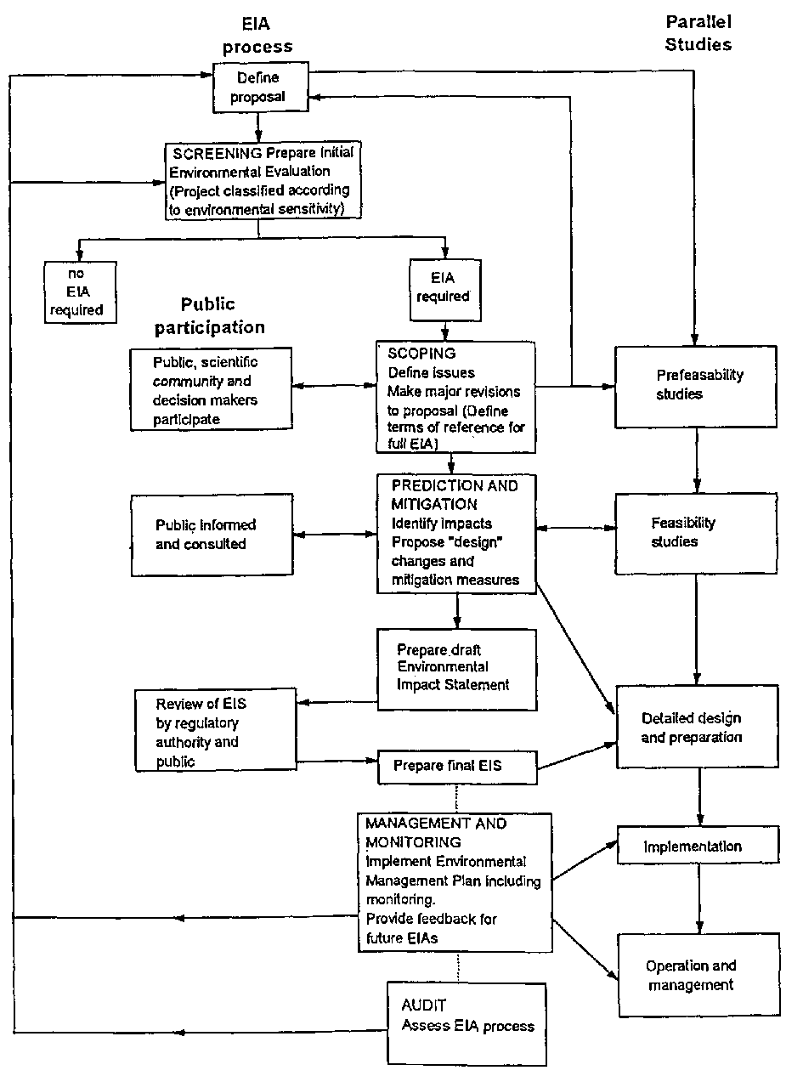
Figure 1: Conceptual comparison between procedural compliance and analytical effectiveness within the Coed Darcy Environmental Statement

3.1 Research Design and Analytical Framework
The research employs a qualitative case-study design, focusing on the Coed Darcy development as a representative example of large-scale, housing-led regeneration in Wales. A case-study approach is particularly appropriate for examining EIA practice, as it enables in-depth analysis of complex planning processes within their real-world context. The analytical framework for the study is provided by the Lee and Colley Review Package, which offers a structured means of assessing Environmental Statement quality [7].
3.2 Selection of the Case Study
The Coed Darcy Strategic Regeneration Area was selected due to its scale, complexity and policy significance within the Welsh planning system. As a former brownfield industrial site proposed for mixed-use redevelopment, the project presents a wide range of potential environmental impacts and therefore requires a comprehensive EIA. Its designation as a Strategic Regeneration Area further increases the relevance of the case study for evaluating whether EIA effectively supports sustainable development objectives.
3.3 The Lee and Colley Review Package
The Lee and Colley Review Package is one of the most widely applied tools for evaluating the quality of Environmental Statements. It divides the review process into four hierarchical Review Areas covering project description and scoping, impact prediction and evaluation, alternatives and mitigation, and presentation and communication. Each Review Area is further subdivided into categories and sub-categories, allowing for detailed and systematic assessment. The framework enables both procedural compliance and analytical robustness to be examined in a transparent and replicable manner [8].
3.4 Application of the Review Criteria
The Environmental Statement for the Coed Darcy development was assessed against each of the Lee and Colley review criteria using documentary analysis. Relevant sections of the ES, including the Non-Technical Summary and technical appendices, were mapped against the review categories. Performance was evaluated based on adequacy, clarity, consistency and alignment with legislative requirements and best-practice guidance. Where appropriate, findings were cross-referenced with academic literature to contextualise strengths and weaknesses [9].
3.5 Grading System and Evaluation Approach
Each review sub-category was assigned a qualitative grade using the standard Lee and Colley scale, ranging from A (well performed) to F (very unsatisfactory). Grades reflect the extent to which the Environmental Statement meets both the procedural requirements of EIA legislation and the substantive expectations of effective EIA practice. Overall grades for each Review Area were derived by synthesising sub-category scores and identifying dominant strengths and weaknesses.
3.6 Data Sources
The primary data source for the review was the Environmental Statement prepared for the Coed Darcy development, including its supporting appendices and Non-Technical Summary. Secondary sources included relevant legislation, professional guidance issued by organisations such as IEMA and IAIA, and peer-reviewed academic literature on EIA effectiveness. This triangulation of sources enhances the robustness and credibility of the evaluation [12].
3.7 Limitations of the Methodology
While the Lee and Colley Review Package provide a systematic and transparent framework for evaluating EIA quality, it is subject to certain limitations. The approach relies primarily on documentary evidence and does not account for post-consent outcomes or the actual effectiveness of mitigation measures in practice. In addition, qualitative grading involves a degree of professional judgement, which may introduce subjectivity. Nevertheless, the framework remains well suited to postgraduate-level critique and comparative analysis of EIA practice [10].
4. Case Study Description
The Coed Darcy development is a large-scale, housing-led strategic regeneration project located in Neath Port Talbot, South Wales. The site covers approximately 126.5 hectares of predominantly brownfield land formerly occupied by an oil refinery and is designated as a Strategic Regeneration Area within the local development plan. The outline planning application proposes up to 2,000 residential dwellings alongside educational, employment, open space, transport and supporting infrastructure [11].
Given the scale and nature of the proposal, the development falls under Schedule 2 of the EIA Regulations and was therefore subject to a full Environmental Impact Assessment. The Environmental Statement is structured into three volumes: the main ES, technical appendices and a Non-Technical Summary. It addresses a wide range of environmental topics, including transport, air quality, noise, ground conditions, water and flood risk, biodiversity, landscape and visual effects, climate change and socio-economic impacts
.
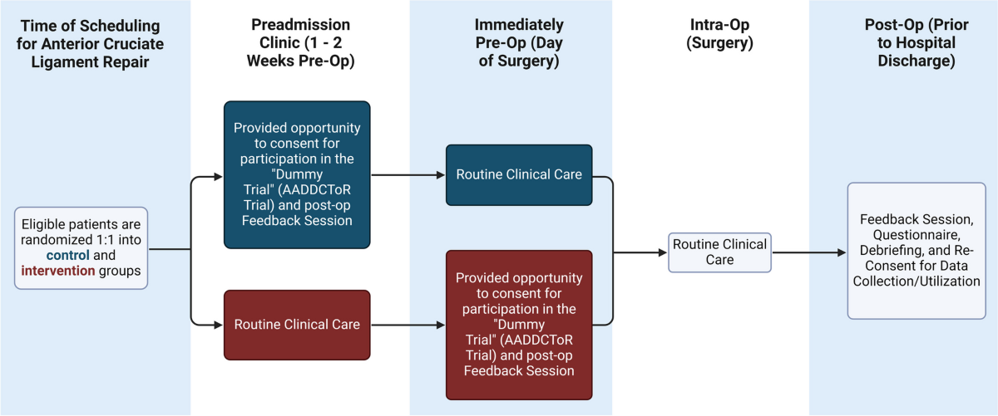
Figure 2: Evaluation of monitoring and follow-up provisions within the Coed Darcy Environmental Statement

5. Results
5.1 Overall Performance of the Environmental Statement
Application of the Lee and Colley Review Package indicates that the overall quality of the Coed Darcy Environmental Statement is moderate to good, with notable variation between review areas [13].

Table 1. Summary of Lee & Colley Review Area Grades
Review Area | Focus | Grade
A | Description, environment and scoping | B
B | Impact prediction and evaluation | C
C | Alternatives, mitigation and monitoring | C
D | Presentation and communication | B

5.2 Review Area A: Description of the Development, Environment and Scoping
Review Area A demonstrates generally strong performance. The ES provides a clear and comprehensive description of the proposed development, including land uses, phasing and worst-case parameters. Baseline conditions are well documented for several technical topics, supported by surveys and monitoring data.
However, baseline quality is uneven across topics, with socio-economic and heritage assessments relying heavily on desk-based sources. Public consultation is documented procedurally, but there is limited evidence that stakeholder input materially influenced project design or assessment scope. Review Area A is therefore graded B [14].

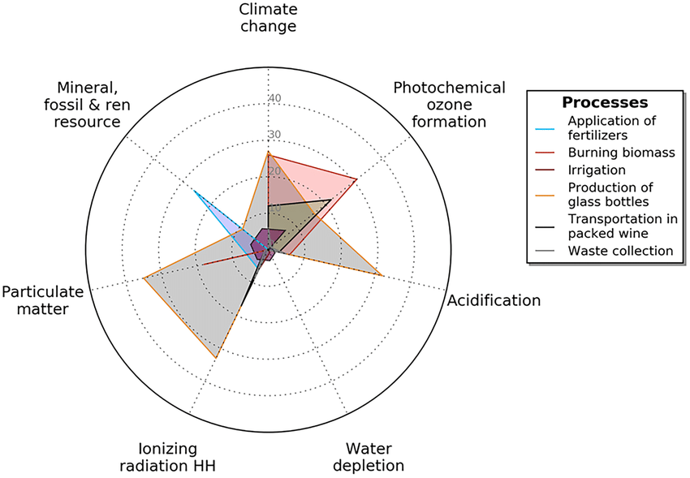
Figure 3. Radar diagram illustrating the relative performance of key EIA components for the Coed Darcy development.

5.3 Review Area B: Impact Prediction and Evaluation
Impact identification and prediction are undertaken systematically across most topics, with quantitative methods applied where established guidance exists [15]. Nevertheless, considerable variation is evident in the transparency and justification of significance determinations. Cumulative effects assessment is addressed inconsistently and lacks an integrated, cross-topic approach.

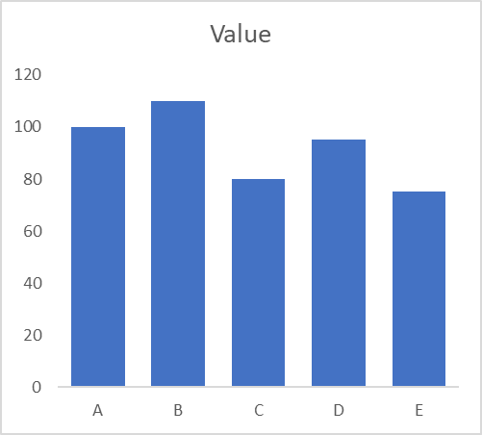
Figure 4. Comparative adequacy of baseline data across environmental topics assessed for the Coed Darcy development.
Table 2. Summary of Impact Evaluation Performance
Topic | Prediction Quality | Significance Transparency
Transport | High | Moderate
Ecology | High | Moderate
Landscape | Moderate | Low
Socio-economic | Low | Low
Review Area B is graded C.

5.4 Review Area C: Alternatives, Mitigation and Monitoring
Consideration of reasonable alternatives is limited and largely descriptive, with minimal explanation of how environmental criteria influenced option selection. Mitigation measures are extensive but often generic, and links between predicted impacts and mitigation outcomes are not always explicit. Monitoring provisions are weak, with limited detail on responsibilities, indicators or adaptive management mechanisms. Review Area C is therefore graded C [16].

5.5 Review Area D: Presentation and Communication
The Environmental Statement is well structured and professionally presented, with a clear Non-Technical Summary. However, inconsistent cross-referencing and reliance on appendices for key information reduce transparency. Review Area D is graded B [17].

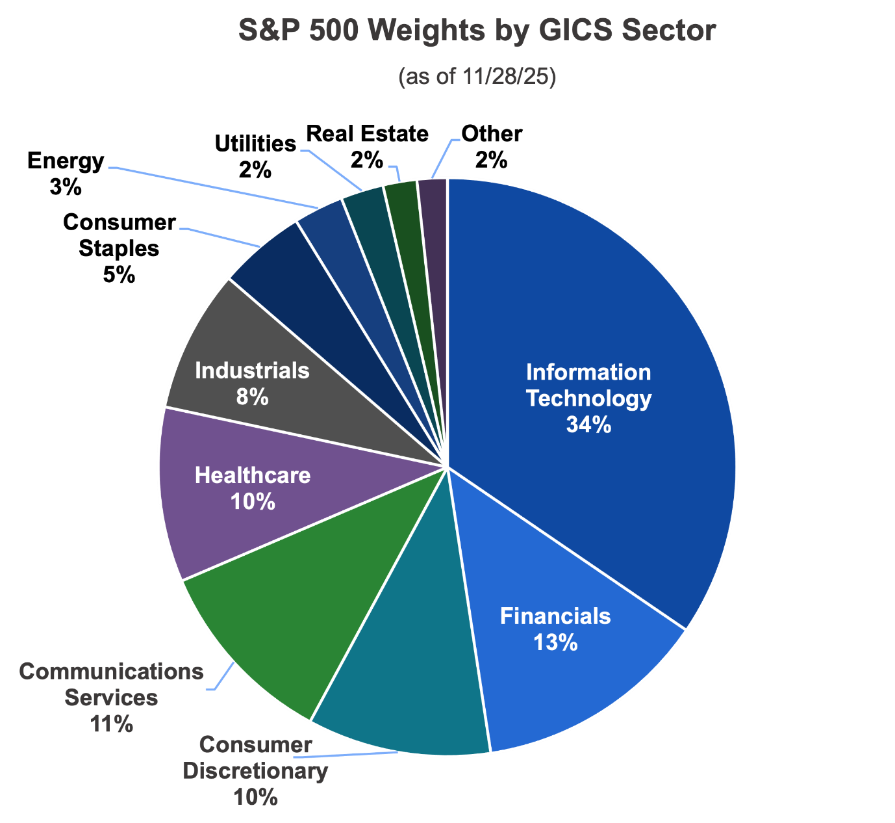
Figure 5. Transparency and consistency of impact significance determination across environmental topics in the Coed Darcy Environmental Statement.

6. Discussion
The findings reveal persistent gaps between EIA theory, legislative intent and practice. Although the Coed Darcy ES demonstrates procedural compliance, its effectiveness in influencing design decisions and ensuring long-term environmental outcomes is constrained by weak alternatives assessment, inconsistent significance evaluation and limited follow-up. These shortcomings reflect broader trends identified in UK and international EIA literature [18].

Table 3. Summary of Performance Across Lee & Colley Review Sub-Areas
Review Area | Key Strengths Identified | Key Weaknesses Identified
Area A: Description & Scoping | Clear project description; comprehensive coverage of several baseline topics | Uneven baseline data quality; limited influence of public consultation
Area B: Impact Prediction | Use of established quantitative methods in some topics | Inconsistent significance evaluation; weak cumulative effects analysis
Area C: Alternatives & Mitigation | Extensive mitigation measures proposed | Superficial alternatives assessment; weak monitoring framework
Area D: Presentation | Logical structure; accessible Non-Technical Summary | Inconsistent cross-referencing; reliance on appendices

This table provides a high-level synthesis of results and is very similar to summary tables used in published EIA review papers. Table 3 synthesises the principal strengths and weaknesses identified across the four Lee and Colley Review Areas. It provides an overview of how the Environmental Statement performs at a strategic level, highlighting patterns of strong procedural compliance alongside recurring analytical shortcomings. The table enables rapid comparison between review areas and illustrates the uneven quality of EIA practice across different stages of the assessment process [19].

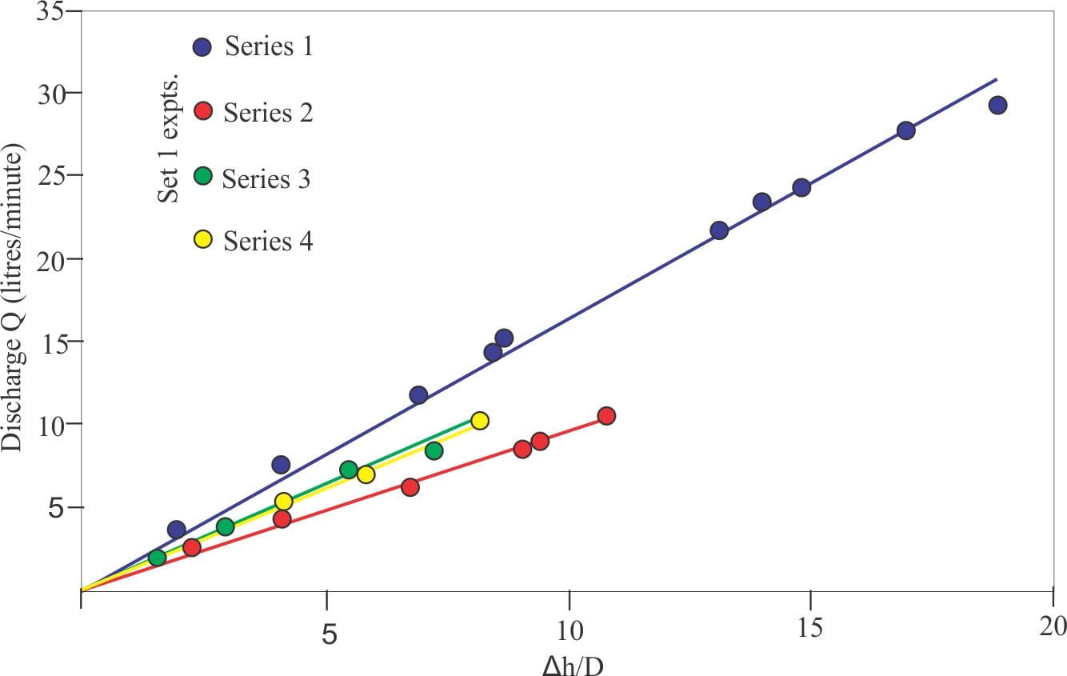
Figure 6. Extent and quality of reasonable alternatives consideration within the Coed Darcy Environmental Statement.
Table 4. Evaluation of Baseline Data Adequacy by Environmental Topic
Environmental Topic | Data Type | Adequacy of Baseline | Key Limitations
Transport | Traffic surveys and modelling | High | Limited future growth sensitivity
Ecology | Field surveys and desk data | High | Limited long-term ecological trends
Noise | Monitoring data | High | Short monitoring duration
Air quality | Modelling and background data | Moderate | Reliance on regional datasets
Socio-economic | Desk-based analysis | Low | Limited site-specific data
Cultural heritage | Desk-based review | Low | Minimal field verification

Demonstrates uneven baseline quality, a recurring critique in EIA literature. Table 4 presents a comparative evaluation of the adequacy of baseline data across key environmental topics assessed in the Coed Darcy Environmental Statement. The table highlights significant variation in data quality, with strong coverage for technically regulated topics such as ecology and noise, and weaker reliance on desk-based information for socio-economic and cultural heritage receptors. This uneven baseline provision has important implications for the reliability of subsequent impact prediction and significance evaluation [20].

Table 5. Transparency of Impact Significance Determination
Topic | Defined Criteria | Clear Magnitude Description | Clear Receptor Sensitivity | Overall Transparency
Ecology | ✔ | ✔ | ✔ | High
Transport | ✔ | ✔ | ◐ | Moderate
Landscape & visual | ◐ | ◐ | ◐ | Low
Socio-economic | ✖ | ◐ | ✖ | Low
Cultural heritage | ◐ | ◐ | ◐ | Low

Table 5 assesses the transparency and consistency of impact significance determination across different environmental topics. It illustrates the extent to which magnitude of impact, receptor sensitivity and evaluation criteria are clearly defined and justified within the Environmental Statement. The findings indicate substantial variability between topics, reinforcing concerns regarding subjectivity and limited methodological transparency in significance assessment.
7. Recommendations
The critical evaluation of the Coed Darcy Environmental Statement (ES) reveals several areas in which Environmental Impact Assessment (EIA) practice could be strengthened to better align with legislative intent, professional guidance and theoretical expectations. The following recommendations are not limited to the case study but have broader relevance for large-scale, housing-led regeneration developments in Wales and comparable planning contexts [21].
7.1 Strengthening the Assessment of Reasonable Alternatives
One of the most significant weaknesses identified in the Coed Darcy EIA relates to the limited and largely descriptive consideration of reasonable alternatives. Although the Environmental Statement refers to the evolution of the masterplan, it provides little transparency regarding the criteria used to evaluate different options or the extent to which environmental considerations informed key design decisions. To address this shortcoming, future EIAs should adopt a structured and transparent alternatives appraisal framework, such as a multi-criteria analysis that integrates environmental, social and technical factors [22].
Such an approach would enable clearer demonstration of how environmental objectives influence site layout, density, phasing and land-use decisions. Importantly, alternatives assessment should be undertaken iteratively at early design stages rather than retrospectively, ensuring that EIA contributes substantively to shaping development proposals rather than merely documenting decisions already made.
7.2 Enhancing Cumulative Effects Assessment
Cumulative effects assessment (CEA) represents another area requiring substantial improvement. While the Coed Darcy ES acknowledges cumulative impacts within individual topic chapters, the assessment lacks an integrated and systematic evaluation of how multiple developments and stressors interact over time and space. Given the scale and strategic nature of the development, a more comprehensive CEA is essential.
Future EIAs should clearly define spatial and temporal boundaries for cumulative assessment, justify the selection of relevant committed and proposed developments, and assess interactions between different environmental receptors. The use of integrated mapping and scenario-based approaches would enhance transparency and support more robust decision-making, particularly in regeneration areas experiencing ongoing development pressure.
7.3 Improving Baseline Data Consistency and Quality
The review highlights uneven quality of baseline data across environmental topics, with socio-economic and cultural heritage assessments relying heavily on desk-based information. To strengthen the reliability of impact prediction and significance evaluation, future EIAs should aim for greater consistency in baseline data quality across all receptors.
This may involve targeted field surveys, stakeholder interviews or local data collection to supplement existing datasets, particularly where impacts are likely to be context-specific or socially sensitive. A more robust baseline would also support clearer justification of significance determinations and mitigation measures.
8. Conclusion
This study demonstrates that while the Coed Darcy Environmental Statement meets procedural requirements, significant challenges remain in achieving the substantive objectives of EIA. Addressing these issues is essential if EIA is to function as an effective tool for sustainable decision-making in strategic regeneration developments.
Strengths of the EIA include a clear description of the proposed development, robust baseline data for certain technically regulated topics and a generally well-structured and accessible Environmental Statement. However, persistent weaknesses are evident in the assessment of reasonable alternatives, cumulative effects evaluation, consistency and transparency of significance determination, and post-consent monitoring arrangements. These shortcomings limit the extent to which the EIA can be said to meaningfully influence project design or ensure long-term environmental protection.
Importantly, the limitations identified in the Coed Darcy case are not project-specific anomalies but reflect broader systemic challenges within EIA practice, particularly in the context of large-scale regeneration developments. The findings reinforce long-standing critiques within EIA literature regarding the gap between the theoretical aspirations of EIA, the procedural focus of legislation and the realities of development-led assessment.
To enhance the substantive effectiveness of EIA, a shift is required from compliance-driven assessment towards a more outcome-focused, transparent and adaptive approach. Strengthening alternatives appraisal, cumulative effects assessment, significance evaluation and follow-up mechanisms would enable EIA to better fulfil its intended role as a tool for sustainable development and informed decision-making. As regeneration activity continues to intensify across Wales, addressing these challenges will be critical to ensuring that EIA contributes meaningfully to environmental stewardship and long-term societal well-being.

Reference list

[1] Cashmore, M., Richardson, T., Hilding-Rydevik, T. and Emmelin, L. (2009) ‘Evaluating the effectiveness of impact assessment instruments: Theorising the nature and implications of their political constitution’, Environmental Impact Assessment Review, 29(6), pp. 371–379. https://www.researchgate.net/publication/223271086_Evaluating_the_effectiveness_of_impact_assessment_instruments_Theorising_the_nature_and_implications_of_their_political_constitution
[2] Glasson, J., Therivel, R. and Chadwick, A. (2019) Introduction to Environmental Impact Assessment. 5th ed. London: Routledge. https://www.routledge.com/Introduction-To-Environmental-Impact-Assessment/Glasson-Therivel/p/book/9781138600751
[3] IAIA (2020) Principles of EIA Best Practice. International Association for Impact Assessment.
Lawrence, D.P. (2007) ‘Impact significance determination—Designing an approach’, Environmental Impact Assessment Review, 27(8), pp. 730–754. https://www.researchgate.net/publication/248537095_Impact_significance_determination-Designing_an_approach
[4] Morrison-Saunders, A. and Arts, J. (2005) Learning from Practice: EIA Follow-Up. Oxford: Earthscan.
Morgan, R.K. (2012) Environmental Impact Assessment: A Methodological Approach. Dordrecht: Springer. https://www.researchgate.net/publication/335467191_Introduction_To_Environmental_Impact_Assessment
[5] Richardson, T. (2005) ‘Environmental assessment and planning theory: Four short stories about power, multiple rationality, and ethics’, Environmental Impact Assessment Review, 25(4), pp. 341–365.
[6] Therivel, R. and Ross, B. (2007) ‘Cumulative effects assessment: Does scale matter?’, Environmental Impact Assessment Review, 27(5), pp. 365–385. https://www.researchgate.net/publication/222568457_Environmental_assessment_and_planning_theory_Four_short_stories_about_power_multiple_rationality_and_ethics
[7] Wood, C. (2003) Environmental Impact Assessment: A Comparative Review. 2nd ed. Harlow: Prentice Hall. https://www.scirp.org/reference/referencespapers?referenceid=2046257
[8] IAIA (2020) Principles of Environmental Impact Assessment Best Practice. International Association for Impact Assessment. https://iaia.org/wp-content/uploads/2025/02/BEST-PRACTICE-Principles-of-EIA.pdf
[9] IEMA (2022) Guidance on Effective Environmental Impact Assessment. Institute of Environmental Management and Assessment. https://www.iema.net/media/s35fughe/iema-eia-guide-to-effective-scoping-of-human-health-nov-2022.pdf
[10] Jay, S., Jones, C., Slinn, P. and Wood, C. (2007) ‘Environmental impact assessment: Retrospect and prospect’, Environmental Impact Assessment Review, 27(4), pp. 287–300. https://www.sciencedirect.com/science/article/abs/pii/S0195925506001338
[11] Lawrence, D.P. (2007) ‘Impact significance determination—Designing an approach’, Environmental Impact Assessment Review, 27(8), pp. 730–754. https://www.researchgate.net/publication/248537095_Impact_significance_determination-Designing_an_approach https://www.researchgate.net/publication/248537095_Impact_significance_determination-Designing_an_approach
[12] Lee, N., Colley, R., Bonde, J. and Simpson, J. (2009) ‘Reviewing the quality of environmental statements and environmental appraisals’, Project Appraisal, 14(3), pp. 147–156. https://aardlink.files.wordpress.com/2013/08/op55.pdf
[13] MHCLG (2021) National Planning Policy Framework. Ministry of Housing, Communities and Local Government. https://www.gov.uk/government/publications/national-planning-policy-framework--2
[14] Montague, J., Miller, D. and Scott, K. (2020) ‘Visual impact assessment and viewpoint selection in landscape planning’, Journal of Environmental Planning and Management, 63(6), pp. 1050–1067. https://www.researchgate.net/publication/228739924_Visual_landscape_management_and_visual_impact_assessment_in_Monchique_Portugal
[15] Morgan, R.K. (2012) Environmental Impact Assessment: A Methodological Approach. Dordrecht: Springer. https://www.researchgate.net/publication/254241854_Environmental_impact_assessment_The_state_of_the_art
[16] Morrison-Saunders, A. and Arts, J. (2005) Learning from Practice: EIA Follow-Up. Oxford: Earthscan. https://iaia.org/wp-content/uploads/2025/02/BEST-PRACTICE-IA-Follow-up.pdf
[17] Richardson, T. (2005) ‘Environmental assessment and planning theory: Four short stories about power, multiple rationality, and ethics’, Environmental Impact Assessment Review, 25(4), pp. 341–365. https://www.sciencedirect.com/science/article/abs/pii/S0195925504001192
[18] Therivel, R. and Ross, B. (2007) ‘Cumulative effects assessment: Does scale matter?’, Environmental Impact Assessment Review, 27(5), pp. 365–385. https://www.sciencedirect.com/science/article/abs/pii/S0195925507000157
[19] Wood, C. (2003) Environmental Impact Assessment: A Comparative Review. 2nd ed. Harlow: Prentice Hall. https://www.scirp.org/reference/referencespapers?referenceid=2046257
[20] Coed Darcy Environmental Statement (2023), Coed Darcy Strategic Regeneration Area: Environmental Statement. Report prepared for Neath Port Talbot County Borough Council.
https://maps.npt.gov.uk/iDocsPublic/ShowDocument.aspx?id=751008

