DISSERTATION PROPOSAL
Analyzing the culture of improvement and the role of innovation within the healthcare sector. Strategies for homecare settings.

Student Name: Mihaela Sandu Rizea
Student ID: 2126225
Module code: LCBB6000_BIRM
Dissertation
Assignment section: Component 1: Coursework
1: A written research proposal
Lecturer’s name: Dr Seyed Navid Nasirpourosgoei

TABLE OF CONTENT
1. INTRODUCTION ............................................................................................................3
1.1 Background of the Research ……..............................................................................3
1.2 Research Aim ..........................................................................................................4
1.3 Research Objectives ..............................................................................................5
CHAPTER 2: LITERATURE REVIEW ……....................................................................5
CHAPTER 3: METHODOLOGY …..………………………………………………………7
CONCLUSION …………………………………………………………………….…..……..8
REFERENCES ………………………………………………………………………………….9

1.INTRODUCTION
The healthcare sector has been under pressure over the years having to find new solutions due to such problems as: population growth and ageing, increasing costs, staffing shortages, or a more newish problems such as telehealth, data security and cybersecurity (Doyel, et. all,2013), as well as Brexit and Covid-19 pandemic. Withall, the challenges faced, for the care settings, was even more mandatory to find modern and effective solutions. Overall, stands the need to improve their services, in order to improve patient experience (Millella, Minelli, Strozzi and Croce, 2021).
Aspects including values, principles, behaviors, environments makes the culture of an organization (Schein, 2010) and a culture of improvement appears to be the driven factor for adopting innovative solutions for the progress of the any organizations, as well within healthcare sector (Apekey, et.all, 2011).

1.1 THE BACKGROUND OF THE RESEARCH
The increased attention for improving within health and social care sector, it was proved by the many and significant studies, clinical trials, secondary data, administrative data, and a reach specialized literature, which have demonstrate the necessity of change, replacing traditional models of care with more efficient and modern alternatives (Fitzgerald et al., 2001; Leeman et al, 2007). The specialized literature shown the numerous aspects that need attention, identifying areas where need to improve, coming also, with ideas and solution for such problems.
The challenges faced by this sector and also, the recently COVID – 19 pandemic, proved the necessity of change and implementation of innovative practices (Greenhalgh et al., 2004) and technologies within healthcare, as well as a new managerial approach (CQC, 2020).
According to statistics supported by data offered by the Care Quality Commission (CQC) and the Department of Health and Social Care (DHSC), in 2024 across UK were registered approximately 17,000 care settings, residential care homes and nursing homes, in which are receiving support around 200,000 people just in England.
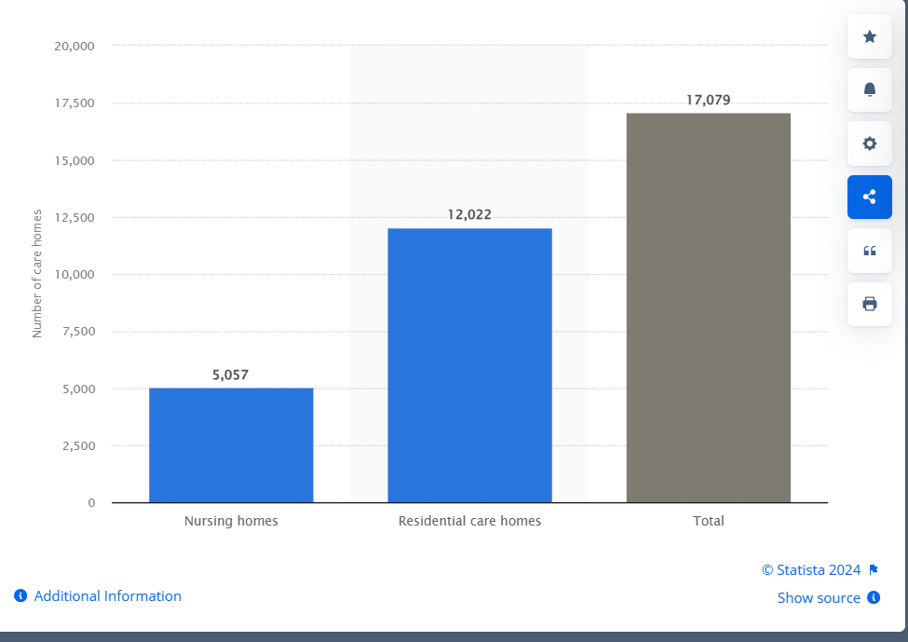
(Statista, 2024)
The statistics shown that even there is a great need for technical improvements and around 60% from these settings adopted Health Electronic Recording (HER) systems, just 12% from these care settings have digital experts and there is a need to build stronger digital leadership and change management within this organizations as there is a lack of clarity in how to access this technologies, the costs and, most important, which are the benefits (Adult Social Care Technology Review, 2022).

1.2 THE AIM OF THE RESEARCH
The present study aims to investigate what are the connections between organizational culture and a culture of improvement, and the understanding of the necessity to transform and modernize by implementing innovative practices and advanced technology.
In order to identify how does a culture of improving influence the sector, and what is the role of innovation in care, the present research aims to assess the current culture in healthcare and care settings with a particular attention on a case study, identifying key innovations which are available to be implemented, or if there any other possibilities (Akenroye, 2012).

1.3 THE OBJECTIVES
The objectives of the present research are:
- To analyse the settings’ culture within healthcare sector for improving patient care.
For this reason, the present research will analyze what is the relation between the understanding of how a culture of improvement will contribute to transformation within healthcare sector, and how implementing innovation will produce a positive impact on the patient care. The study will concentrate on showing how this innovations will results in benefits for the healthcare sector including reducing costs, or increasing adaptability and sustainability, as well as showing which are the barriers in implementing such innovative culture and technologies. The current research explore what the barriers are in implementing a culture of improving, identifying what are the factors that can facilitate innovation.
- To analyse the relationship between the culture of the organization and change improvement process.
The present research will analyse the importance of a culture of improvement, what are the barriers for adopting a different modern approach by the management and which are the implications for the healthcare sector. By evaluating the impact of such innovations on the patient outcomes and the care quality, the present research will examine also new findings which would contribute to the development of the health care sector, with the attention on care settings.
3. To analyse how change of management and the new technologies will impact the staff attractiveness for this sector. As any transformation has positive or negative impacts on the organization, the study will analyse in what way this culture of improvement and the implementation of innovations will contribute to staff attractiveness in the healthcare sector and the care settings.

2. LITERATURE REVIEW
By conducting a literature review, we can identify key concepts, theories and elaborate a framework for this study. The research over the existing literature about the healthcare sector and innovation, enable as to identify what are the problems, what have been cover by the previous research in this area, presenting any positives findings and new possibilities, as well as highlighting any gaps that still need further attention.

Organisational Culture and Quality Improvement according to Mannion and Davies (2018), are those factors that impact service performance, quality, and the attitude towards adopting new practices and technologies. According to them, within the healthcare sector we still find multiple subcultures, which can either contribute to change and quality improvement, or constituting real barriers to innovation. They are presenting how the organizational culture within the healthcare sector and care sectors can influence the approach towards change and the necessity for a cultural reform.
Backhouse and Ogunlayi (2020) explain why Quality Improvement is a principle-based regarding the approach for change and presents its role in problems solving, quality service and better outcomes for those using the services.
Within a review on innovations in healthcare sector, Sounderajah, et al. (2019) refers to disruptive innovations across various domains such as research, diagnostics, digital health, education and techniques criticizing the inconsistent use of this term, they have been suggesting a more appropriate term such as cost-effective innovation.
Speaking about design thinking in healthcare innovation, Oliveira, Zancul and Fleury (2020) focus on the application of this concept in different innovation projects across medical specialties, hospital innovations and healthcare management, and the need to increase focus on the inspiration phase and attract individuals in innovation projects. They are highlighting the fact that even the design thinking might increase the cost and time spent, the concept foster design changes.
The Care Quality Commission (2020) promotes the concept of enabling innovation within health and social care sector within a report, particularly in response to COVID-19 pandemic. The report present the role of the active providers within this sector in identification, management and service delivering, and how by adopting innovation these can improve the outcome for their patience.
These key concepts, theories and frameworks provide as with a profound understanding of how the culture of improving and the innovation can improve the patience care, efficiency, and performance within healthcare and care settings.

3. METHODOLOGY
For this study, a qualitative research paradigm is appropriate, because this allows us to explore in-depth specific aspects, experiences, and attitudes of the management approach within healthcare sector and care home settings. Qualitative research is appropriate for understanding complex social phenomena and gaining insights into the "how" and "why" some projects have been initiated and completed (Bell, Bryman and Harley, 2022).
The research will focus on analysing – thematic analyse - a case study of a care home adopting a new electronic recording systems. The thematic analyse is a widely used method which allow as to identify, analyse and present any patterns discover.
The understanding of the concepts, as well as the implication of such innovation ideas will be supported by a case study, conducting an interview with the manager of a care setting, which allows as to collect data about this subject ensuring the key topics are covered. The interview with a care setting’s manager will be conducted face to face and will include a preset it questioner of 10 opened questions.

4. CONCLUSION
By conducting this research, collecting and analysing data, the study aim to prove the conditional relation between a culture of improvement, highlighting the role of the management, and the developing within the healthcare sector. The study’s objectives are to present the findings of this research, analysing and comparing with other cases presented by other studies, in order to show if there is a real connection between this three factors: culture of improvement, innovation and transformation in healthcare sector. The main intention is to highlight the importance of a management innovative orientated, which understand the importance of new and modern practices and technologies, and which does not avoid adopting and implementing innovation within their organizations and change for the future.

References
- Amalberti, R., Staines, A., and Vincent, C. (2022). Embracing multiple aims in healthcare improvement and innovation. International Journal for Quality in Health Care, 34(1), mzac006.
- Anderson-Wallace, M., and Downham, N., (2024). Improving Quality in Healthcare: Questioning the work for Effective Change., p.210.
- Barrett, D., and Twycross, A. (2018). Data collection in qualitative research. Evidence-Based Nursing, 21(3), 63.
- Bell, E., Bryman, A. and Harley, B., (2022). Business Research Methods. Sixth Edition., Oxford. p.647.
- Deutsch, E.S., Perry, S.J., and Gurnaney, H.G., (2021). Comprehensive Healthcare Simulation: Improving Healthcare Systems, p.240.
- Flick, U. (2018). The SAGE Handbook of Qualitative Data Analysis.
- Gaglio, B., Henton, M., Barbeau, A., Evans, E., Hickam, D., Newhouse, R., & Zickmund, S. (2020). Methodological standards for qualitative and mixed methods patient-centred outcomes research. BMJ, 371, m4435.
- Greenhalgh, T., and Papoutsi, C. (2019). Spreading and scaling up innovation and improvement. BMJ, 365, l2068.
- King's Fund. (2016). Understanding quality in district nursing services.
- Mannion, R., and Davies, H. (2018). Understanding organisational culture for healthcare quality improvement. BMJ, 363, k4907.
- Marjanovic, S., Altenhofer, M., Hocking, L., Chataway, J., & Ling, T. (2020). Innovating for improved healthcare: Sociotechnical and innovation systems perspectives and lessons from the NHS. Science and Public Policy, 47(2), 283-297.
- NHS England. (2017). Building and nurturing an improvement culture. Improvement Leaders’ Guide.
- Neves, A. L., Freise, L., Laranjo, L., Carter, A. W., Darzi, A., and Mayer, E. K. (2018). Impact of providing patients access to electronic health records on quality and safety of care: a systematic review and meta-analysis. BMJ Quality & Safety, 29(12), 1019-1030.
- Neves, A. L., Carter, A. W., Freise, L., Laranjo, L., Darzi, A., & Mayer, E. K. (2018). Impact of sharing electronic health records with patients on the quality and safety of care: a systematic review and narrative synthesis protocol. BMJ Open, 8(8), e020387.
- Priestman, W., Sridharan, S., Vigne, H., Collins, R., Seamer, L., & Sebire, N. J. (2018). What to expect from electronic patient record system implementation: lessons learned from published evidence. BMJ Health & Care Informatics, 25(2), 92-102.
- Oliveira, M., Zancul, E., and Fleury, A. L. (2020). Design thinking in healthcare innovation: A systematic review. BMJ Open, 10(1), e034445.
- Roberts – Turner, R., and Shah, R., (2021). Pocket Guide to Quality Improvement in Healthcare., p.348.
- Saunders, M., Lewis, P., and Thornhill, A., (2023). Research Methods for Business Students, p. 860.
- Schein, Edgar H., 2010. Organizational Culture and Leadership. Fourth Edition, p.436.
- Statista, available on www.statista.com and UK: Number of care homes 2022 | Statista).
- Williams, S.J., and Caley, L., (2020). Improving the Healthcare Service., p.192.
- Adult Social Care Technology Review, available on 8 March 2022 - Adult Social Care Technology Review - Future Care Capital

