MARKETING PLAN WRITTEN FOR HOLIDAY INN
Student’s name: Andrea Bardoczi
Student’s identity:2209718
Marketing Essentials BMIH4005
Lecturer Gayathri Mudiyanselage

Table of Contents
Introduction 3
The marketing mix 4
Micro marketing environment (SWOT analysis) 5
Macro marketing environment (PESTLE analysis) 6
Creating customer value and engagement 7
Effective use of digital marketing 8
Work breakdown structure 9
Gantt chart 11
Conclusion 12
Reference list 13

Introduction
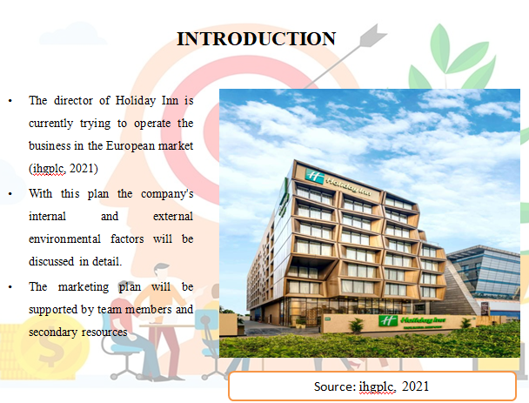
- The director of Holiday Inn is currently trying to operate the business in the European market (ihgplc, 2021)
- With this plan the company's internal and external environmental factors will be discussed in detail.
- The marketing plan will be supported by team members and secondary resources
The current presentation aims to analyse the marketing plan and strategies of Holiday Inn’s to expand hospitality business to the European market. Apart from developing the business in the UK and US markets, the company is currently operating in the Asia Pacific area. Currently the company is targeting the other European markets (many areas of Britain’s) to increase the target market and customer base. During this presentation the company's marketing mix strategy, internal environment analysis and external environment analysis will be discussed in detail.

The marketing mix
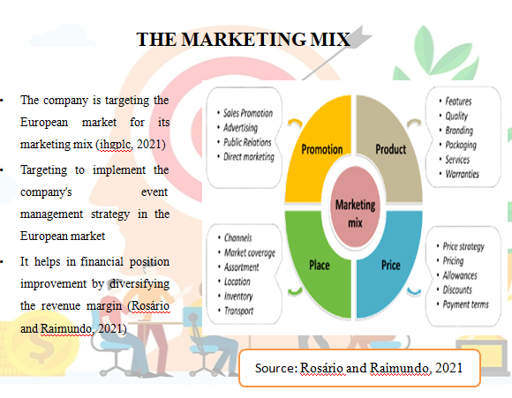
- The company is targeting the European market for its marketing mix (ihgplc, 2021)
- Targeting to implement the company's event management strategy in the European market
- It helps in financial position improvement by diversifying the revenue margin (Rosário and Raimundo, 2021)
In terms of product or service development, Holiday Inn's marketing team is looking to develop hospitality services related to event management. Developing event management in the UK market can be very profitable. Due to the fact that the UK market has a lot of big business events due to which the revenue margin for the company can improve a lot. As noted by Dieguez et al., (2021), providing hospitality services makes it much easier for companies to diversify their revenue margins.
Marketing Mix In terms of target marketing, the company will target various business or financial companies. In the case of event management, if you target the company, the target market is very limited, but targeting financial companies has a much higher revenue potential for event management companies (Fonseca and Carnicelli, 2021). For this reason, the company's managers are communicating directly with event managers of various companies in the field of marketing. Targeting the company's online and offline marketing makes this marketing approach much richer.

Micro marketing environment (SWOT analysis)
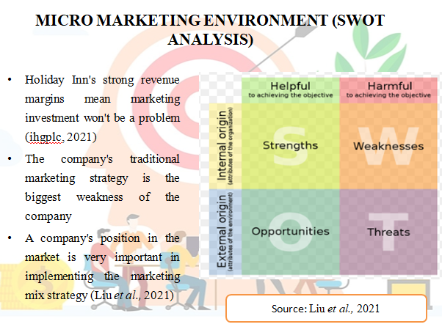
- Holiday Inn's strong revenue margins mean marketing investment won't be a problem (ihgplc, 2021)
- The company's traditional marketing strategy is the biggest weakness of the company
- A company's position in the market is very important in implementing the marketing mix strategy (Liu et al., 2021)
The company's revenue margin in the global market has exceeded $6.5 billion, and that's why it's not too much of a problem to invest in a new business operating in the UK market these days. As stated by Jones (2022), implementing a marketing mix strategy makes the company more likely to increase costs, therefore, having a strong financial position is a positive for any company in implementing its marketing strategy well.
However, due to the company's traditional marketing system, there will be many problems for the company to provide event management services. Human resource support is very important in event management marketing (Thaha et al., 2021). The fact that Holiday Inn's marketing managers do not have much human resources is problematic for the company. However, since the revenue margin is high, it will not be much of a problem for the company to develop human resources. However, the threat for the company to compete with its competitors (such as Marriott International) in the UK market may increase.

Macro marketing environment (PESTLE analysis)
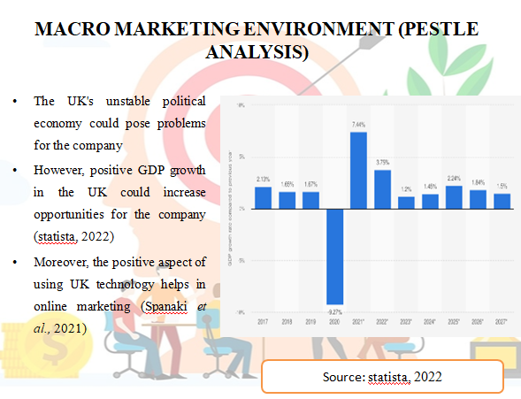
- The UK's unstable political economy could pose problems for the company
- However, positive GDP growth in the UK could increase opportunities for the company (statista, 2022)
- Moreover, the positive aspect of using UK technology helps in online marketing (Spanaki et al., 2021)
The political group in the UK is currently in a very unstable position due to which it may be problematic to expand business into this market. However, due to the positive GDP growth (3.25%, 2.71 Lakh Crore) in the UK, the opportunity to improve the hospitality business in this market is increasing. Socially, many UK companies organise their business meetings in luxury hotels, and in this field more importance is being given to organising domestic business events as well as international business events.
Due to the advanced technical infrastructure of the UK, the company will not have too many problems in operating the business. Due to advanced technical infrastructure the company will not have much problem in following online marketing, and at the same time, it is more convenient to communicate with domestic and international clients through various online marketing methods. Moreover, expanding into the UK legal and environmental law business market is becoming increasingly advantageous.
The UK's Employment Rights Act 1996 will make it much easier for companies to advance their human resources. Also the UK Environment Protection Act 2020 will help the company to promote a sustainable approach.

Creating customer value and engagement
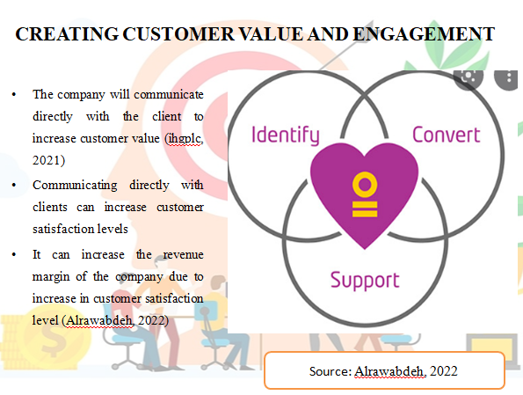
- The company will communicate directly with the client to increase customer value (ihgplc, 2021)
- Communicating directly with clients can increase customer satisfaction levels
- It can increase the revenue margin of the company due to increase in customer satisfaction level (Alrawabdeh, 2022)
In order to maintain customer value, the company's marketing team wants to analyse the demand trends of European market clients. At the same time, certain team members from the company are trying to communicate with other clean companies.
As a result, more companies will show interest in using Holiday Inn for office meetings or other events in the future. This can greatly increase the company's revenue margin and popularity in the corporate world which will help in the company's revenue margin improvement. Moreover, due to the diversification of income sources, it will be more convenient for the company to increase its revenue margin.
In order to improve visitor engagement, the company will arrange special halls or rooms where business meetings can be held well. Moreover, Holiday Inn's marketing team wants to target both online and offline channels for this marketing because selecting two marketing sources will help the company to reduce the communication gap with customers or clients.

Effective use of digital marketing
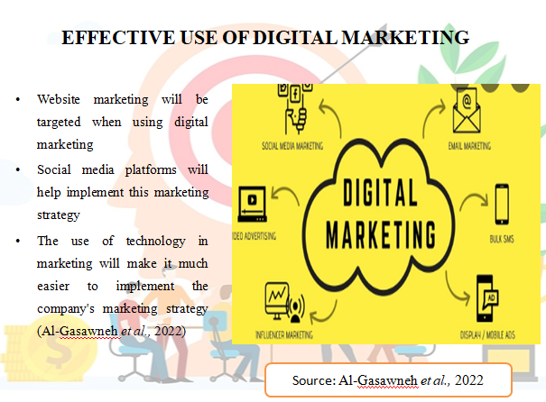
- Website marketing will be targeted when using digital marketing
- Social media platforms will help implement this marketing strategy
- The use of technology in marketing will make it much easier to implement the company's marketing strategy (Al-Gasawneh et al., 2022)
Website development and social media marketing will be given more importance in making the digital marketing strategy effective. In terms of website development, Holiday Inn's official website will be greatly advanced, so that other companies can better understand the activities of this company in the field of event management services. At the same time, social media will be used in advertising as it will be convenient to target a large number of users and professional areas. The marketing team is increasingly targeting development for website development and marketing, and in this field it is planned to employ those employees whose technical skills are more advanced.
The company also wants to stay ahead in server development while implementing the marketing strategy well. This server development process will be more effective by improving the advanced technology infrastructure as well as maintaining cyber security. As a result, it will be much easier for the company to advance their marketing plan in the future, and at the same time it will be more convenient for the company to face competitive advantage.

Work breakdown structure
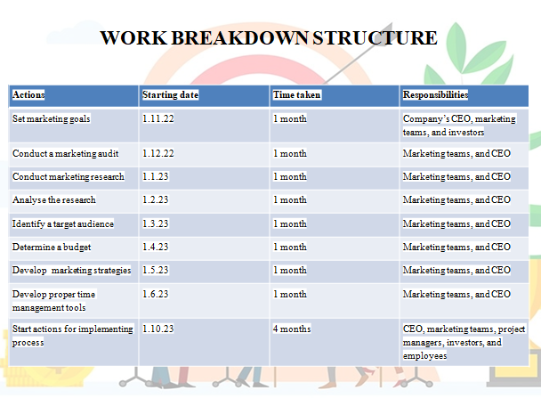
Actions | Starting date | Time taken | Responsibilities
Set marketing goals | 1.11.22 | 1 month | Company’s CEO, marketing teams, and investors
Conduct a marketing audit | 1.12.22 | 1 month | Marketing teams, and CEO
Conduct marketing research | 1.1.23 | 1 month | Marketing teams, and CEO
Analyse the research | 1.2.23 | 1 month | Marketing teams, and CEO
Identify a target audience | 1.3.23 | 1 month | Marketing teams, and CEO
Determine a budget | 1.4.23 | 1 month | Marketing teams, and CEO
Develop marketing strategies | 1.5.23 | 1 month | Marketing teams, and CEO
Develop proper time management tools | 1.6.23 | 1 month | Marketing teams, and CEO
Start actions for implementing process | 1.10.23 | 4 months | CEO, marketing teams, project managers, investors, and employees

It may take up to a year for Holiday Inn's marketing managers to implement this marketing plan, and the skills of the company's CEO, marketing team, and employees are especially important in developing and implementing this marketing plan.

Gantt chart
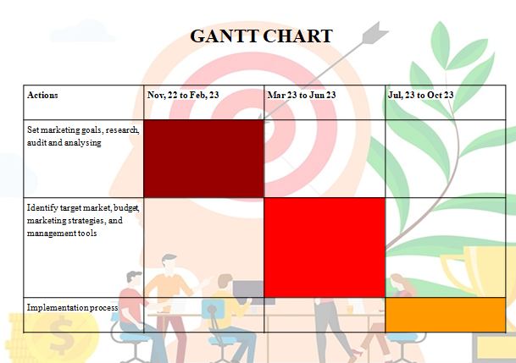
Actions | Nov, 22 to Feb, 23 | Mar 23 to Jun 23 | Jul, 23 to Oct 23
Set marketing goals, research, audit and analysing
Identify target market, budget, marketing strategies, and management tools
Implementation process

Conclusion
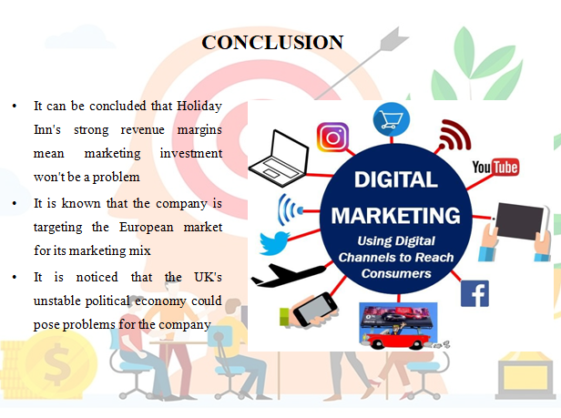
- It can be concluded that Holiday Inn's strong revenue margins mean marketing investment won't be a problem
- It is known that the company is targeting the European market for its marketing mix
- It is noticed that the UK's unstable political economy could pose problems for the company
After discussing the above entire presentation, it can be concluded that the company's revenue margin in the global market has exceeded $6.5 billion, and that's why it's not too much of a problem to invest in a new business operating in the UK market these days.

Reference list
Al-Gasawneh, J. A., AlZubi, K. N., Anuar, M. M., Padlee, S. F., ul-Haque, A., and Saputra, J. (2022). Marketing Performance Sustainability in the Jordanian Hospitality Industry: The Roles of Customer Relationship Management and Service Quality. Sustainability, 14(2), 803.
Alrawabdeh, W. (2022). Seasonal balancing of revenue and demand in hotel industry: The case of Dubai City. Journal of Revenue and Pricing Management, 21(1), 36-49.
Dieguez, T., Ly, N. T., Ferreira, L. P., and Silva, F. J. G. D. (2021, June). Digital customer network strategy influences on Hotel Business. In International Conference Innovation in Engineering (pp. 420-431). Springer, Cham.
Fonseca, A. P., and Carnicelli, S. (2021). Corporate social responsibility and sustainability in a hospitality family business. Sustainability, 13(13), 7091.
ihgplc (2021). Annual report. Available at https://www.ihgplc.com/en/investors/annual-report Accessed on 17.10.2022
Jones, P. (2022). A review of the UK’s tourism recovery plans post COVID-19. Athens Journal of Tourism, 9(1), 9-18.
Liu, C. H., Jiang, J. F., and Gan, B. (2021). The antecedent and consequence behaviour of sustainable tourism: integrating the concepts of marketing strategy and destination image. Asia Pacific Journal of Tourism Research, 26(8), 829-848.
Rosário, A., and Raimundo, R. (2021). Consumer Marketing Strategy and E-Commerce in the Last Decade: A Literature Review. Journal of Theoretical and Applied Electronic Commerce Research, 16(7), 3003-3024.
Spanaki, M. Z., Papatheodorou, A., and Pappas, N. (2021). Tourism in the post COVID-19 era: evidence from hotels in the North East of England. Worldwide Hospitality and Tourism Themes, 13(3), 357-368.
statista (2022). United Kingdom: Real gross domestic product (GDP) growth rate from 2017 to 2027. Available at https://www.statista.com/statistics/263613/gross-domestic-product-gdp-growth-rate-in-the-united-kingdom/ Accessed on 17.10.2022
Thaha, A. R., Maulina, E., Muftiadi, R. A., and Alexandri, M. B. (2021). Digital marketing and SMEs: a systematic mapping study. Library Philosophy and Practice (e-journal), 5113.

