Extraction, Processing, and Failure Mechanisms of Titanium and its Alloys
Iriney Georgiev
Iriney Georgiev, MSc Motorcycle Engineering, University of Wales Trinity Saint David, Swansea, SA1 8PH

Abstract –Titanium has become a popular material in modern manufacturing due to its various material properties. A few of its characteristics include its ability to resist corrosion, its strength, its lightweight nature, and its heat resistance. However, the extraction process for titanium and subsequent machining and fabrication of its alloys can be challenging and complex [1]. The purpose of this report is to evaluate the benefits and limitations of titanium alloys, with a special focus on the mechanisms of their failure. To provide practical insight into the challenges associated with working with titanium, a failure report on titanium engine valves is presented in the second part of this study.
1. Introduction
Titanium (Ti) is a naturally occurring element in the earth's crust. There are several remarkable properties of this metal, including its high strength-to-weight ratio as well as its exceptional corrosion resistance and biocompatibility. Despite these advantages, titanium is considered a 'rare metal' due to its lower production volume compared to other structural metals such as iron (Fe), aluminum (Al), and copper (Cu). The Kroll process, which was developed 70 years ago, is the primary method for commercial titanium production. However, this extraction process is still in its early developmental stages, and further technological innovations are necessary to scale up production and reduce costs [1]. Additionally, titanium can be alloyed with other materials, including palladium, vanadium, aluminum, iron, molybdenum, and tin. This will create materials that offer high tensile strength, toughness, and corrosion resistance while exhibiting low density. These alloys find applications in various industries, such as aerospace, transportation, power generation, chemical, utilities, automotive, and healthcare [2].
In an internal combustion engine (ICE), valves are crucial components that allow intake and exhaust gases to circulate. Furthermore, they provide a seal between the working space inside the cylinder and the manifold during the compression and power phases of a 4-stroke engine to increase combustion efficiency. As a result of the high temperature and pressure generated by the combustion process, these valves are subjected to thermal stress. Although all valves are subjected to these extreme conditions, exhaust valves are more vulnerable to failure due to the extreme heat generated by flue gases. In contrast, the inlet valve is cooled by fresh charge entering the cylinder, resulting in a lower failure rate [3].
The aim of this study was to enhance the comprehension of the impact of microstructure and heat treatment on the chemical and mechanical characteristics of titanium alloys. Titanium Nitrite-coated or fully-constructed valves are utilized in high-level motorsport racing to improve engine performance. The study acknowledged the various techniques of titanium alloy production/heat treatment and the usage of different forms of cast and wrought titanium alloys to produce a failure report for a potential customer on titanium valves for ICE.
2. Literature Review
Depending on the temperature, titanium's crystal structure undergoes significant changes. It exhibits a hexagonal close-packed (HCP) structure below 882.5°C. Above this temperature, titanium's crystal structure transitions to a body-centered cubic (BCC) structure. As a result of this allotropic transformation, the metal's mechanical properties and processing methods are influenced [4].
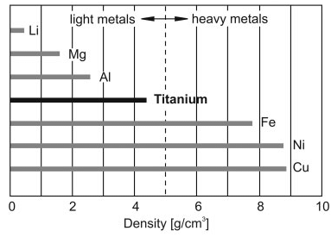
With an atomic diameter of 0.320 nm, titanium has a relatively large atomic size, which contributes to its strength and low density [5]. As shown in figure 1, titanium has a density of 4.54 g/${\text{m}}^{3}$. It significantly lower than that of other metals used in advanced applications, such as steel, making titanium an attractive choice for industries such as aerospace and automotive.
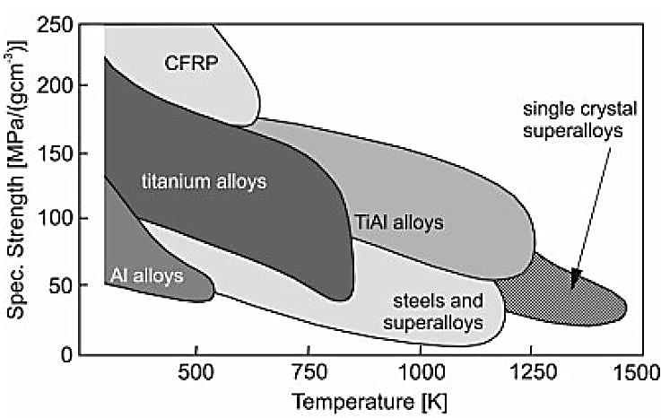
Figure 1: Specific Strength vs Temperature Comparison of Different Metals, [5]

Figure 2 illustrates titanium's melting point of around 1667°C. Combined with titanium's excellent strength and toughness, this property makes it an ideal candidate for parts used in jet engines, gas turbines, and other heat-intensive applications. Moreover, titanium is highly reactive with oxygen, nitrogen, carbon, and hydrogen, which can result in the formation of interstitial and surface compounds. Due to its reactivity, the metal has both strength and weakness. It is capable of forming a protective oxide layer that imparts excellent corrosion resistance, but it may also complicate the processing of the metal and hence, require special handling procedures.
2.1 Extraction Processes
Since the 1940s, the Kroll process has been the predominant method for extracting titanium by reducing titanium tetrachloride (TiCl4) with magnesium (Mg). A number of stages are involved in the process, including the extraction of titanium from the ore, the production of TiCl4, and its subsequent reduction with Mg. However, the Kroll process is labor-intensive and has a low yield, which adds to the complexity and cost of producing titanium [6].
Figure 2: Density Comparison of Different Metals, [5]
Scientists have been exploring alternative methods and improvements for extracting titanium due to its complexity and limitations. For instance, I. Kaldre et. al proposed enhancements to the Kroll process, such as continuous reduction of TiCl4 or alternative reducing agents like sodium or calcium, to improve efficiencies and yields and reduce operating costs [7]. Moreover, the FFC Cambridge process, which uses electrolysis, has the potential to reduce energy consumption and complexity in titanium extraction, according to S. Oosthuizen [8].
The formation of titanium alloys, after the extraction process, is determined by a combination of factors. These include the desired properties of the final product and the intended industry for its application. The extraction process typically produces pure titanium in the form of sponge, which is then converted into ingots or billets. Therefore, different alloying and processing stages are designed to achieve specific alloy compositions and microstructures [9].
2.2 Alloying Compositions

Microstructure and alloying elements of titanium alloys are what determine their classification into alpha, near-alpha, alpha-beta, and beta alloys.

Alpha phase alloys are characterized by hexagonal close-packed (HCP) crystal structures and use alpha-stabilizing elements such as aluminum, tin, and zirconium to increase strength, ductility, and corrosion resistance. As a contrast, beta phase alloys are characterized by a body-centered cubic (BCC) crystal structure, which enhance performance at high temperatures, formability, and hardenability [10].
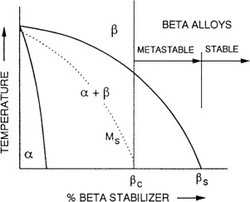
Figure 3: Phase Diagram of Titanium Alloys [10]

As shown in figure 3, the alloying elements chosen and their concentrations determine the properties and performance of titanium alloys, which are suitable for a wide range of applications. For example, alpha titanium alloys have good strength, ductility, and corrosion resistance, which makes them ideal for low to moderate temperature applications in aerospace, automotive, chemical, marine, and biomedical fields. Meanwhile, beta titanium alloys are known for their outstanding shapeability, hardenability, and strength-to-weight ratio.
2.4 Melting Processes
Due to titanium's reactive nature, it requires careful handling during melting to prevent contamination and ensure the desired microstructure and properties of the final product [7].
- Electroslag Refining (ESR) involves striking an electric arc between an electrode and a workpiece containing molten slag to remove impurities from the metal. The ESR process is capable of refining large quantities of titanium for industrial production, however certain impurities may remain in the metal, resulting in weaker mechanical properties.
- Vacuum Arc Remelting (VAR) involves melting a metal electrode within a vacuum chamber, which eliminates impurities such as oxygen and nitrogen, to produce large ingots of titanium. The system is suitable for industrial production.
- A relatively new technology called Electron Beam Melting (EBM) uses high-energy electron beams to melt and fuse titanium powder. Among its advantages, it is capable of producing dense, uniform structures, creating complex geometries with high precision, and producing lightweight parts. However, there are limitations to this process, such as the size of the parts that can be produced.
- With Plasma Arc Melting (PAM), titanium is melted and refined using a plasma torch, producing a high-quality material with minimal contamination. It can be used to refine a wide range of titanium alloys.
- An induction coil is used in the Induction Skull Melting process to melt titanium before it is cast into a copper mold that is water-cooled. The process enables the production of high-quality titanium alloys with a uniform structure, as well as the refinement of a wide range of titanium alloys for industrial production. The process has several limitations, including the high cost of equipment required, the limited size of parts that can be produced, and the time required for melting and cooling in batches.
2.5 Heat Treatment
The two main classes of titanium alloys, alpha and beta, have different microstructures that influence their heat treatment processes.
The alpha titanium alloys are typically heat-treated in the alpha-beta range, where they undergo phase transformations from a single-phase alpha structure to a dual-phase alpha-beta structure. As part of the heat treatment process, the material is heated to a temperature between 700°C and 900°C, held at that temperature for a specified period of time, then cooled rapidly to room temperature. Thus, the final product is stronger, more ductile, and more fatigue resistant [10].
On the other hand, beta titanium alloys are heat-treated between 800°C and 1000°C, where they undergo a phase transformation from a single-phase beta structure to a dual-phase alpha-beta structure. Moreover, the rate at which beta alloys are cooled is crucial, as slow cooling can lead to the formation of undesirable microstructures, resulting in a reduction in mechanical properties. Beta alloys exhibit high strength-to-weight ratios, excellent corrosion resistance, and good welding properties [11].
2.6 Machining Processes

Due to their high cutting forces, temperatures, and tendency to work harden, titanium components can be challenging to machine. The most common machining processes for titanium alloys include turning, milling, drilling, grinding, and electrical discharge machining (EDM). There are advantages and disadvantages to each of these processes, with factors such as alloy type, part geometry, desired surface finish, and required tolerances influencing the selection of the most appropriate process. In order to prevent tool wear, deformation, and thermal damage to the workpiece, proper cooling and chip evacuation are crucial [12].

2.6 Casting Processes
Among the most common methods for casting alpha and beta titanium alloys is investment casting, also called Lost-Wax Casting. The process involves creating a wax pattern of the desired component and coating it in a ceramic shell. After the shell has hardened, the wax is melted out, leaving a cavity for the mold to fill with molten titanium. Once the titanium is solidified, the ceramic shell is removed, revealing the completed component [13]. With a tight tolerance and excellent surface finish, investment casting is well known for its ability to produce complex geometries. Nevertheless, the process of creating wax patterns and ceramic molds can be time-consuming and expensive.
As another casting method, Vacuum Arc Remelting (VAR) involves melting an electrode in a water-cooled copper crucible while it is under vacuum. As the molten titanium alloy solidifies in a controlled manner, a refined microstructure is produced, resulting in a high-quality ingot. VAR produces clean, uniform, and defect-free ingots, which are crucial for high-performance applications such as aerospace [14]. The process is, however, energy-intensive and requires specialized equipment, making it less cost-effective for production on a smaller scale.
The last but not least method is Cold Crucible Induction Melting (CCIM). Utilizing an electromagnetic field, it levitates and melts titanium alloy using a water-cooled copper crucible [15]. In this method, the final product is of high purity and uniformity, making it suitable for applications requiring superior material properties, such as aerospace and biomedical components. In spite of this, the high cost of the equipment and the complexity of the process may limit its widespread use.
3 Failure Analysis of ICE Valves
The valve and valve seat insert play a vital role in the valve train, which is one of the most crucial systems in an ICE. As both the engine's gas flow and timing are controlled by this system, it is essential for the engine's performance. In general, the primary goal of ICE design is to increase specific power output, which, however, can lead to higher temperatures in the combustion chamber. Increasing temperatures can cause premature failure of exhaust valves, in particular [3]. Furthermore, the engine industry has placed a greater emphasis on lightweight designs in order to comply with strict emission laws and fuel efficiency standards. New materials and designs have been developed for engine valves to reduce their weight. Despite their heat-resistant properties, conventional heat-resistant steel, nickel-based alloys, and cobalt-based alloys have been unable to offer substantial weight savings. This has resulted in TiAl alloy gaining popularity due to its low density and excellent mechanical properties at high temperatures, despite its high raw material and manufacturing costs [16].
3.1 Processing

A high degree of precision is achieved in the production of engine valves in mass production. In general, valves made from heat-resistant steel are manufactured by hot forming and machining. It is, however, not easy to fabricate TiAl valves by hot forming due to its low ductility and poor formability. As has already been demonstrated [17], different manufacturing processes can produce a TiAl valve at a low cost and with a high level of production efficiency. There have also been reports that centrifugal casting combined with mechanical machining is a viable method. Additionally, TiAl valves can also be manufactured using powder metallurgy technology [18].

3.2 Fabrication

While valves make up a small percentage of an internal combustion engine's total mass, they represent a significant portion of the moving mass in the valve train system. It has been shown that reducing valve mass can reduce the stiffness of valve springs, thereby reducing noise and impact seating forces, as well as reducing severe contact conditions between valves and seat inserts. Reduced valve inertia could also improve the dynamic characteristics of the valve train system, resulting in improved fuel economy.
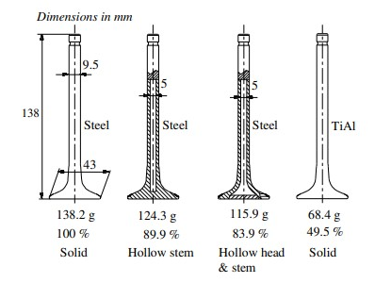
Figure 4: Different Material and Design Configuration Comparison of ICE Valves, [18]

Figure 1 illustrates the mass of valves in a medium-duty natural gas engine with a variety of materials and configurations. In comparison with the steel valve, H. Dengyun developed two hollow valve configurations that reduced mass by 83.9%. In addition, a TiAl valve would reduce mass by another 49.5% [19].
Modern engines typically utilize martensitic steels like X85 or X65 for intake valves and austenitic alloys for exhaust valves. At 700 °C, the Young's modulus of X60 is lower than that of X85 at 400 °C, with values of 136 GPa and 197 GPa, respectively. As previously outlined, TiAl alloys possess excellent mechanical properties even when exposed to high temperatures. As an example, the tensile strength of TiAl alloy remains similar at 400 °C and 700 °C, while its Young's modulus is slightly decreased from 160 to 151 °C, and its hardness is reduced from 280 to 270 °C. However, at temperatures below 700 °C, the elongation of TiAl alloy remains low, indicating that it is difficult to form [12]. In most cases, TiAl valves are manufactured using centrifugal casting and mechanical machining techniques.
Figure 5: Exhaust Valve After 2 Million Impact Cycles, [17]
Additionally, Finite Element Analysis (FEA) was used to investigate the performance of TiN-coated and uncoated IC engine exhaust valves [20]. This study focused on the exhaust valve of a four-stroke two-wheeler engine and simulated its behavior under high temperatures. It was determined that the TiAI-coated valve had 4 times longer life cycle as a result of its minimal heat absorption.
3.3 Areas of Concern and Defects

As combustion pressure builds in the cylinder, it places a load on the valve head, causing micro sliding at the interface between the valve seating face and the seat insert. As a result of Forsberg et al. research, sliding in the sealing interface has been identified as one of the leading causes of engine valve and seat insert wear. Identifying the wear of a valve requires determining how sliding length relates to valve and seat geometry since intake and exhaust valve materials, test temperatures, initial contact widths, and seating face angles differ [21].
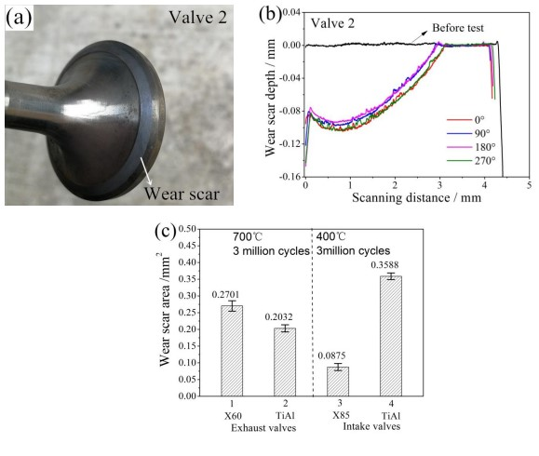

A different study involved conducting bench-top wear tests on both heat-resistant steel and titanium engine valves for two million impact cycles, as shown in figure 5. When compared to austenitic exhaust valves tested at 700°C, the TiAl valve demonstrated superior wear resistance with a 24.8% reduction in wear loss. Oxidative wear and adhesive wear were found to be the primary causes in this case. However, when compared to martensitic intake valves tested at 400°C, the TiAl valve showed four times greater wear loss than the martensitic valves [17].
Titanium valves are subject to several types of defects during the manufacturing process, which may adversely affect their function and performance. In many materials, there is a defect known as porosity, which is characterized by small voids or pockets of air within them. As a result, the valve's structure may be weakened and it may become more prone to cracks and failures. Improper machining can also cause uneven surfaces or incorrect dimensions, which can adversely affect the fit and operation of the valve. Furthermore, insufficient heat treatment or improper alloying can cause internal stresses within the material, which can lead to fatigue and cracking.
4. Conclusions

The objective of this study was to identify the critical processing steps involved in the production of titanium and its alloys, including the machining and fabrication processes. The ultimate aim was to showcase the potential benefits of using titanium alloys in ICE applications. However, it was equally important to identify potential weaknesses in titanium components. Therefore, help customers who desire titanium-based or coated valves to make informed decisions by making them aware of the associated risks.
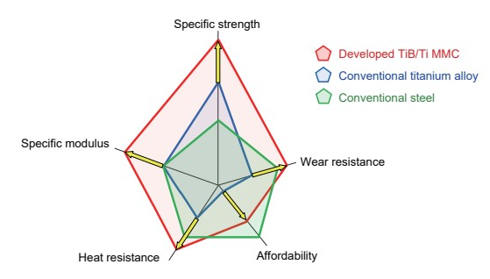
Figure 6: Radar Chart Comparing Titanium Alloy vs Conventional Steel, [3]

The prototype engine parts made from TiB/Ti-MMCs are illustrated in the figure above, and their feasibility was assessed. The study focused on a range of engine components such as spur gears, connecting rods, valve lifters, valve retainers, and hollow valves. The graph demonstrates that titanium alloys offer significant benefits over other metals. It is noteworthy that automobile and motorcycle manufacturers are increasingly utilizing titanium in their manufacturing processes. A major factor in this trend is the advancement in the recycling process, specifically the use of vacuum arc remelting, which is capable of reusing the same material [22]. Although 2-3% of titanium can be lost in the recycling process, advanced techniques and precise control can significantly reduce this loss, increase titanium recycling efficiency, and reduce cost.

References

[1] | IMARC, "Titanium Alloy Market: Global Industry Trends, Share, Size, Growth, Opportunity and Forecast 2023-2028," IMARC, 2023.
[2] | O. Takeda, T. Ouchi and T. Okabe, "Recent Progress in Titanium Extraction," METALLURGICAL AND MATERIALS TRANSACTIONS, vol. 51B, pp. 1315-1328, 2020.
[3] | T. Saito, "Affordable High-performance Ti/TiB Metal Matrix Composites Tailored for Automotive Engine Components: Design, Manufacturering, Process, and Remaining Issues," R&D Review of Toyota CRDL, vol. 51, pp. 1-30, 2020.
[4] | O. Ezugwu and A. Machado, "Sustainable Built Environment & Sustainable Manufacturing," Encyclopedia of Sustainable Technologies, pp. 487-506, 2017.
[5] | D. Lunt, "The effect of macrozones in Ti-6Al-4V on the strain localisation behaviour," School of Materials, 2014.
[6] | J. Zhang, H. Matsuura and F. Tsukihashi, Treatise on Process Metallurgy, vol. 3, 2014, pp. 1507-1561.
[7] | I. Kaldre, E. Blimbergs and L. Goldsteins, Optimization of electroslag melting towards to titanium morphology improvement in combined Kroll process, COMPEL, 2019.
[8] | "In search of low cost titanium: the Fray Farthing Chen (FFC) Cambridge process," The Journal of The Southern African Institute of Mining and Metallurgy, vol. 111, pp. 119-202, 2021.
[9] | L Yuan, X. Chen, H. Zhang and M. Cen, "Inclusions in melting process of titanium and titanium alloys," Tsinghua University, 2019.
[10] | B. Khidhir, Y. Ahmed, K. Sahari and M. Ishak, "Titanium and its Alloy," IJSR, 2014.
[11] | S. Semiatin, T. Lehner, J. Miller and D. Furrer, "Alpha/Beta Heat Treatment of a Titanium Alloy with a Nonuniform Microstructure," Metallurgical and Materials Transaction, 2017.
[12] | Kennametal, "Titanium Machining Guide," Kennametal, 2023.
[13] | U. Klotz, C. Legner, F. Bulling, L. Freitag, C. Fabauer, S. Schaffoner and C. Aneziris, "Investment casting of titanium alloys with calcium zirconate moulds and crucibles," The International Journal of Advanced Manufacturing Technology, vol. 103, pp. 343-353, 2019.
[14] | E. Sabaki, A. Kharicha, A. Ludwig and J. Bohacek, "A Parametric Study of the Vacuum Arc Remelting (VAR) Process: Effects of Arc Radius, Side-Arcing, and Gas Cooling," Metallurgical and Materials Transactions , vol. 51, pp. 222-235, 2020.
[15] | S. Fashu and M. Lototskyy, "A review on crucibles for induction melting of titanium alloys," University of the Western Cape, 2019.
[16] | V. Mamilla, "Failure Analysis of Internal Combustion Engine Valves by using ANSYS," Department of Mechanical Engineering, 2014.
[17] | F. Lai, S. Qu, H. Qin, R. Lewis, T. Slatter, X. Li and H. Luo, "A comparison of wear behaviour of heat resistant steel engine valves," The University of Sheffield, 2020.
[18] | ".The study of exhaust valve of Tilanium-aluminium alloy in diesel engine," Journal of Hunan university, vol. 28, pp. 32-34, 2001.
[19] | H. Dengyun, "A forming technology for hollow head & sodium filled engine valve which based on cross wedge rolling to produce workblank". China Patent ZL 201510236950.9, 27 10 2017.
[20] | R. Rao, K. Reddy and C. Kumar, "Simulation of composite Titanium Nitrite (TiN) coated Internal Combustion engine exhaust valve using ANSYS," IJRTE, vol. 8, pp. 2277-3878, 2019.
[21] | P. Forsberg, D. Debord and S. Jacobson, "Quantification of combustion valve sealing interface," – A novel experimental technique and simulations, vol. 69, pp. 150-155, 2014.
[22] | O. Takeda, T. Oucho and T. Okabe, "Recent Progress in Titanium Extraction and Recycling," Metallurgical and Materials Transaction, 2020.
[23] | K. Kelkar, S. Patankar, A, Mitchell, O. Kanou, N. Fukada and K. Suzuki, "Computational Modeling of the Vacuum Arc Remelting (VAR) Process Used for the Production of Ingots of Titanium Alloys," Japan Institute of Metals, 2017.

