

LCBB5013 - Entrepreneurship

Task 1

Student Name: Mariana-Janeta Cucu
Student ID: 2238838
Coursework: Portfolio

Table of Contents
Introduction 3
Element 1 4
Element 2 7
Element 3 10
Element 4 14
Conclusion 18
References 19

Introduction
Business plan refers to the document for planning objectives of the business and how achieve them, using the available resources for the business (Sahlman, W. A. (2008). The main aim of this task is to provide a business plan based on 4 different elements, namely: Element 1 – Business idea, product, objectives and USP, Element 2 – Business environment and competitor analysis, Element 3 – 4Ps, market segmentation and marketing strategies, Element 4 – Legal, management, and financial planning. A detailed marketing mix for the new entrepreneurship idea of La Mama’s bakery will also be done. A presentation of the business plan will also be presented in this portfolio, which will highlight the idea of the new entrepreneurship plan.

Element 1
Business Idea
Ratten (2023) explained that entrepreneurship helps in identifying several business-related opportunities as well as exploiting them through the creation of new products or the recombination of the existing resources, as well as commercialisation of new services and products. The market size of the bread and bakery industry is worth £10.3bn (Mintel, 2025). In 2022, the artisanal bakery products market size worldwide was valued at USD 95.13 billion, which is projected to rise by 5.7% to 2030 from 2023 (Grand View Research, 2025). Sustainability is also recognised to be the driving force in the country’s bakery market as consumers are highly conscious of the environmental impact of their food choices (Mondelez, 2025). Hence, the bakery market was chosen due to high consumer demand for artisanal, sustainable, and premium bakery goods.
La Mama's Bakery is envisioned as a future business which will follow a simple structure at the start and then gradually grow large enough to expand and own multiple locations. Within the context of Effectuation theory, which aligns with the simple organisational structure of La Mama's Bakery to start the new business based on an effectual approach of managing uncertainty, the prospective risks will be identified, particularly from the competition. The bakery will most likely transition from simple to functional, and finally to a divisional structure to expand and achieve long-term success. The business will focus on locally sourced and high-quality ingredients while also striving to maximise customer experience, creativity, and maintain freshness. Further, it will also offer a unique blend of innovative flavours and traditional recipes to emerge as the most beloved bakery in the community.
As discussed by Peng (2023), Schumpeter's Innovation Theory outlines the five types of innovation, such as new products, new methods, new markets, new supply sources, and new industries. The theory also proposes that entrepreneurs are expected to update their ideas prior to innovation. Based on the theory, the entrepreneur is considered to be an innovator aiming to disrupt the local market by introducing a new combination to secure a competitive advantage, which aligns with the innovative mindset of the new business. La Mama's Bakery will also emphasise positively influencing the community by aligning with the sustainability demands. While expanding in the country, the bakery will also operate as a retail outlet, encouraging takeaway, dine-in, as well as online delivery options.
Mission Statement
To bake high-quality, innovative goods, delighting customers while committing to local sourcing and sustainability.
Vision Statement
To become the community's most beloved premium bakery brand with multiple locations recognised for creative flavour.
Overview of the products or services
The main products of La Mama's Bakery will include cakes, pastries, breads, rolls, cookies, sweets, desserts, and so on. Some other products will most likely include custom and celebration products, dietary and speciality items, innovative signature items, limited edition treats, and others. The main service offered is the sale of these baked goods in a physical shop environment, although the bakery will also accept and deliver online orders on time.
Business Objectives
Short-term objectives
- To establish the single bakery as the community's most beloved local spot.
- To implement 100% locally-sourced primary ingredients to ensure quality and freshness.
- To achieve high customer experience scores and strong repeat business rates.
- To successfully launch signature products blending traditional and innovative flavours.
- To ensure all single-use packaging is sustainable, compostable, or recyclable.
- To develop an efficient system to minimise food waste and optimise inventory.
Long-term objectives (3 years to 5 years)
- To transition to a functional and then to divisional structure to improve specialised efficiency and output.
- To establish autonomous regional divisions to maximise market responsiveness nationally.
- To achieve strong brand recognition for product creativity and flavour innovation.
- To successfully expand the business model to own and operate multiple retail locations.
- To become a recognised industry leader in high-quality, ethical, and sustainable baking.
- To integrate and maximise revenue from online delivery and omnichannel sales options.
Unique Selling Point (USP)
A USP helps in making brands much better compared to the competition, which helps to stand out and create an impression (Deland, 2022). It not only helps in differentiating the brand but also justifies the price points to build brand identity by communicating the benefits. It also helps brands to search for prospective buyers and convert them to loyal brand advocates. The core USP of La Mama's Bakery is to emerge as a premium bakery brand that scales high-quality, innovative flavour combinations with a fundamental commitment to environmental sustainability and local sourcing. The three integrated elements of the bakery include quality sourcing, creative and traditional recipes, and omnichannel customer experience.

Element 2
Porter’s Five Forces
Competitive Rivalry
As of 2025, the country records 3,096 businesses within the Bread and Bakery Goods Production sector, which has surged by 3.1% from 2020 (Mintel, 2025). Aran Bakery, Bake Shop, Bakers Yard Bakery, Beefcake Café, and Bostock Bakery North Berwick are some of the leading bakeries in the UK (The Good Food Guide, 2025). In 2024, the country reported a total of 1,759 Bakery Cafes, reporting a steep 1.6% increase from 2023 (IBIS World, 2025). Hence, the rise in bakery cafes and the leading bakers demonstrates intense competition for La Mama's Bakery. This, in turn, depicts a high threat for the new business in the UK.
The Threat of New Entrants
Starting a small, local bakery with a simple organisational structure does not require the massive capital investment of a national chain. Hence, this might impose a low threat on La Mama's Bakery, helping it to attract prospective customers to strengthen brand loyalty. On the contrary, the frozen bakery products market in the country is experiencing a notable shift towards artisanal and premium offerings. The market is projected to rise by 5.74% between 2023 and 2032 to reach USD 2188.15 million (Credence Research, 2025). This might pose a high threat to La Mama's Bakery as the growth of the market provides opportunities for the growth and expansion of new businesses alongside the existing ones. This might make it quite challenging for the bakery to achieve a competitive position in the sector.
The Bargaining Power of Buyers
In 2025, especially in the bakery market, consumer spending is projected to rise, with average transaction values increasing by approximately 6% (Mintel, 2025). On the other hand, in Q2 2025, the household disposable income surged to 443916 GBP Million from 442635 GBP Million in Q1 2025 (Trading Economics, 2025). Thus, an increase in disposable incomes and consumer spending results in a growth in overall consumption. In such a situation, La Mama's Bakery will experience a high bargaining power of customers, for which the bakery will have to provide personalisation and differentiated value to prevent them from exploring alternatives.
The Bargaining Power of Suppliers
Core ingredients like wheat flour and energy are subject to global commodity markets, resulting in cost pressures and price volatility for bakeries. Over the last five years through 2020-2025, the revenue of the bread and bakery goods production market is projected to decrease at an annual rate of 1.6% to £10.3 billion, which is driven by the surging price of bread as well as other baked products (Mintel, 2025). Moreover, in case of any supply chain disruption, as a new and small business, the bakery will also not have enough suppliers to switch, which in turn, would pose a significant threat. Thus, the bargaining power of suppliers is high for small bakeries, such as La Mama's in the country.
The Threat of Substitution
The direct substitutes of La Mama's Bakery include products from in-store supermarket bakeries, accounting for a larger portion of the country’s grocery sales. The UK supermarkets use a range of methods for in-store bakery options, wherein some of the leading retailers are Asda, Lidl, M&S, Morrisons, Sainsbury’s, and Tesco (North and Smail, 2021). Further, the indirect substitutes are home baking and other go-to food options, such as salads and sandwiches. Compared to the previous years in 2020, the country reported a 157% increase in home baking businesses (Simply Business, 2025). On the other hand, based on the concerns of ultra-processed food and the rising cost of living crisis, Brits are making more loaves and cakes at home. Hence, this will most likely pose a high threat to La Mama's Bakery. In such a situation, focusing on premium and innovative products and a unique experience will help the new business to establish itself as a destination for high-quality indulgences, which cannot be replicated by its competitors.
Thus, based on the above analysis, competitive rivalry, customers, new entrants, suppliers, and substitutes poses the greatest challenge for La Mama's Bakery. However, a focus on premium, innovative products offer a key opportunity to attract prospective customers.
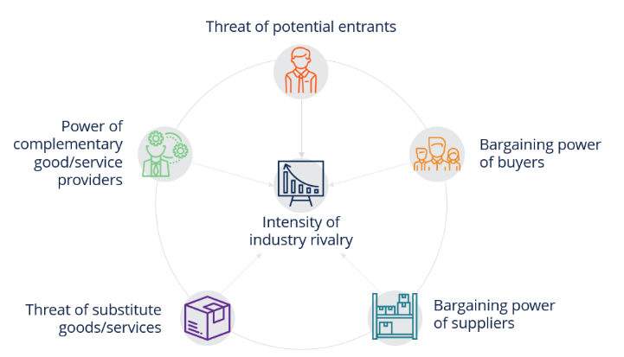
Figure 1: Porter's Five Forces
(Source: CFI, 2025)

Element 3
Market Segmentation and Target Customers
Segmentation
La Mama’s bakery will segment its market on the basis of the preference for mode of shopping and another on the basis of whether the customers directly buy from the available option presented by La Mama’s bakery or will personalise it according to their preferences and needs. The segmentation of customers is mainly done on the basis of age, income, gender, and lifestyle (Vargas et al., 2021).
Targeting
A report of 2023 has highlighted that 45% of the young people in the UK and Europe from the age group of 18 to 34 buy bakery products every single day (British Baker, 2025). This highlights that the main target of the enterprise should be on the young people, and from the age group of 18 to 34. This will help La Mama’s bakery to reach the correct audience and turn them into customers. A data has also highlighted that men have increased their purchases of bakery products and buy more than the women (Bakery & Snacks, 2024).
Positioning
The enterprise will position its brand in such a way that it will attract customers and turn them into its loyal customers. The organisation should focus on creating a technologically savvy and user-friendly website for their business, which will not only highlight all the information and data but will also encourage the customers to make their purchase.
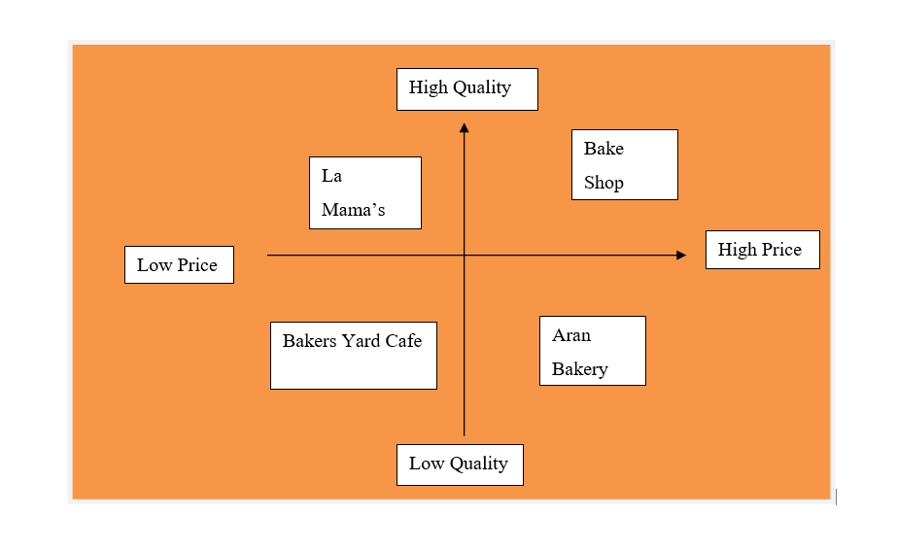
Figure 2: Positioning Map
(Source: Created by the Author)
4 Ps of Marketing
The 4 Ps of marketing is also widely known as the marketing mix. This allows the organisation to determine the best possible method and strategy for achieving its business objectives and aims. The four factors of the marketing mix are product, price, location and promotion (Darmawan and Grenier, 2021).
Product
The enterprise will be a bakery which will operate its business in the food and beverages industry. La Mama’s Bakery should prioritise specialising in their cakes, pastries, cookies and other bakery products. A study has highlighted that one of the most emerging trends in the bakery market is sugar-free desserts (Barry Callebaut, 2025). La Mama’s bakery should focus on introducing several bakery products and desserts which will be sugar-free. Modifying their product range according to this will help them in targeting more buyers and also increase their sales and brand value.
Price
In the year 2024, the bakery market of the UK recorded the highest sales, and between the time frame of 2019 to 2024, the industry their AGBP was recorded to be 1,238.75 million. In the year 2024, the market grew by 5.3% (Global Data, 2025). This highlights that La Mama’s bakery will have huge competition in the industry, and to make the enterprise successful, competitive pricing strategies should be applied by the entrepreneur. Competitive pricing helps the organisation in attracting customers and motivating them to make a purchase from the brand.
Place
La Mama’s bakery should focus on both physical stores and creating an online platform for their customers, through which they can also get orders online. The physical store will not only be the place where the customers can make their purchase, but it will also act as a landmark for the brand. This will also enable the enterprise to bake its bakery products and store its raw materials effectively. In the year 2024, it was predicted that the online food delivery market of the UK would reach 31,120.2 million US Dollars (Spherical Insights, 2025). This highlights the importance of online food delivery options for the growth and visibility of the enterprise. La Mama’s bakery should create its own website where it will provide its online customers with the option to make their purchase and customise their products.
Promotion
The enterprise should focus on social media marketing and post daily content on them for attracting customers and building a personal relationship with them so that La Mama’s bakery can turn them into a loyal customer base. Social media marketing helps the companies to share their thoughts, products, stories and other details on different social media platforms (Mishnick and Wise, 2023). In the UK, 79% of the total population as of January were actively using social media (Data Reportal, 2025). It can be said from this data that focusing on social media marketing will help La Mama’s bakery to gain a loyal customer base and also increase its brand visibility.
People
The employees of La Mama’s bakery will be the most crucial people of the enterprise as they will be managing the operations, delivery and other activities. The customers of the organisation also fall under people, and they impact the sales of the enterprise.
Online Marketing Strategies
In today's modern day business world, where all the operations and activities are digitalised, it is extremely important for all the new entrepreneurs to prioritise to market their brand, products or services online using the different approaches for targeting more customers and increase the brand visibility. One of the most important aspects of online marketing is social media marketing. Social media marketing is defined as the steps taken by the organisation for marketing their brand and products over different social media platforms such as Instagram, Facebook and X (Mishnick and Wise, 2023). Social media marketing will help La Mama’s Bakery in boosting the awareness of the brand among its targeted customers using different specified features of social media. Social media allows the businesses to select their audience category and show their advertisement specifically to that group for increasing their engagement and reach. As of January 2025, 79% of the total population of the UK used social media, which amounts to be 54.8 million people (Data Reportal, 2025).
This highlights that prioritising social media marketing will help La Mama’s bakery to increase its visibility among the people of the UK and also spread awareness among its target customer range. The organisation should also focus on email marketing. Email marketing helps the brands to send personalised emails to their customers according to their needs and preferences (Paulo et al., 2025). This will help La Mama’s bakery in tailoring personalised messages and offers for their target customers and build a positive relationship with them, so that they can motivate their target customers to make a purchase from their bakery brand. On the contrary, email marketing has one biggest setback, which is the target customers not opening their emails, and emails directly going to the spam folder. This will impact the online marketing procedure of La Mama’s bakery negatively.

Element 4
Limited Company
A limited liability company refers to a business structure for private organisations, which combines both corporations and partnerships (CFI, 2025). In a limited company, the owners are legally responsible for the debts to which they have invested.
Sole Trader
A sole trader refers to the business type with the simplest business structure to establish and maintain records for (Gov.uk, 2025). It is an individual who is responsible for owning and running a business, without any legal distinction between the business and the owner.
Partnerships
A partnership is generally described as an endeavour in which two or multiple people come together to strive toward common goals (Sirkin, 2022). In this business structure, the co-owners agree to share the business losses and profits.
Legal structure of La Mama's Bakery
A sole trader is the most suitable legal structure for the new bakery business. As described by Yli-Huumo (2023), sole trading is generally selected as the starting the entrepreneurship journey for small business entrepreneurs. A sole trader is immensely important for economic benefits, and it guides the owners to decide and adapt efficiently to the dynamic market. Further, the low start-up costs and the simplicity of the design make it the most suited option for La Mama's Bakery compared to other legal structures. Operating as a sole trader will also help the bakery to retain all its profits, enjoy complete autonomy, tax simplicity, and foster strong customer relations.
Organisational chart
At the beginning, La Mama's Bakery will follow a simple organisational structure. A simple structure is often described as a flat organisational structure. A flat structure is described by some hierarchical levels relative to the size of the organisation. It is considered to be a standard approach which is used by various firms for its direct communication, simplicity, and flexibility between employees and managers (O'Reilly, 2025). This particular structure also offers higher autonomy to staff by allowing them to take part in decision-making, encouraging control in work, and helping them to foster better connections.
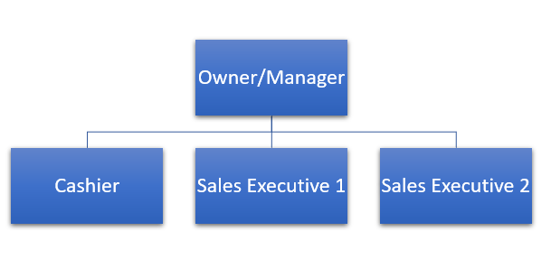
Figure 3: Flat or simple organisational structure
(Source: 4 Simple Organizational Structure | Download Scientific Diagram)
Start-up funding requirements and funding sources
Start-up funding
Category | Estimated Cost (£)
Premises Lease and Deposit | 10,000
Renovation and Interior Setup | 8,000
Bakery Equipment | 20,000
Furniture and Fixtures | 4,000
Licences and permits | 1,000
Initial Inventory and Ingredients | 3,500
Technology Setup | 2,500
Marketing and Branding | 3,000
Staff Recruitment and Training | 6,000
Utilities and Overheads (Initial) | 2,000
Delivery Equipment | 1,000
Contingency Fund | 5,000
Total | 66,000
Table 1: Start-up funding
(Source: Created by the learner)
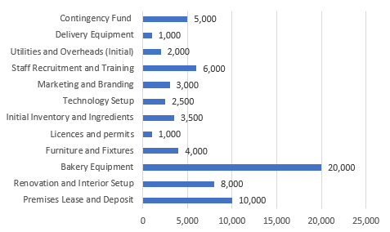
Figure 4: Funding Breakdown
(Source: Created by the learner)

Potential funding sources
Government-Backed Schemes and Grants
The Start Up Loans scheme provides personal loans up to £25,000 with access to free mentoring and business support and a 6% interest rate (British Business Bank, 2025).
Crowdfunding
Crowdfunding helps access to capital, acts as an alternative finance option, faster way to raise funds without upfront costs, encourages crowdsourcing about £30,000, and also helps introduce to loyal customers (NiBusinessinfo.co.uk, 2025). This will help La Mama's Bakery with a powerful marketing channel to raise money from a larger population upon validating the ideas.
Self-financing
Self-financing helps to gain more control over business finances as it helps to retain full ownership and prioritise business expenditure (NiBusinessinfo.co.uk, 2025). This is also the cheapest and easiest method which will help La Mama's Bakery to cover some of the funding needed. It is estimated that, £15,000 could raised from this source for this business.
Risk and mitigation strategies
Risks
- The Global Supply Chain Pressure Index (GSCPI) increased to 0.03 in September 2025 from -0.04 in August (Federal Reserve Bank of New York, 2025). Hence, supplier cost fluctuations might pose a risk due to volatile prices for core ingredients like wheat flour and energy, shrinking the business's revenue margin.
- Recruitment issues for the new bakery, La Mama's, could involve difficulty in hiring and retaining staff in a competitive job market.
Mitigation Strategies
- It is recommended that La Mama's Bakery establish strong relationships with local suppliers for more stable, long-term pricing. Reliable supply chain relations are important for ensuring customer satisfaction and consistent quality (Forbes, 2024).
- It is recommended that the bakery also develops a repeatable talent acquisition strategy focusing om quality rather than quantity. Appropriate talent acquisition strategy will help La Mama’s Bakery to set hiring goals, identify future needs, create repeatable systems, and develop talent pipelines (Simonson and Williams, 2025).

Conclusion
Concluding this portfolio, it can be said that the concept of entrepreneurship is effectively mentioned. This portfolio has highlighted the new enterprise idea, which is La Mama’s Bakery. A detailed marketing mix has been done in this portfolio for understanding the target audience and determining the most effective pricing and promotion approaches. The unique selling proposition of the new enterprise will also be discussed. To analyse the competition present for La Mama’s bakery, Porter’s Five Forces Analysis has also been done. A detailed management, financial and legal planning of the new enterprise will also be discussed in this portfolio. For the future perspective, La Mama’s bakery will be able to use this study for improving their operations and online marketing activities more effectively.

References
Bakery & Snacks (2024) What would make Brits buy more bakery products?. Available at: What would make Brits buy more bakery products? Consumer survey reveals all (Accessed: 13 October 2025).
Barry Callebaut (2025) Top 6 Trends to Watch in Bakery. Available at: Top 6 Trends to Watch in Bakery | Barry Callebaut (Accessed: 11 October 2025).
British Baker (2025) Nearly half of young adults buy baked goods daily, research finds. Available at: Nearly half of young adults buy baked goods daily, research finds | News | British Baker (Accessed: 13 October 2025).
British Business Bank (2025) Government grants for start-ups. Available at: Government grants for start-ups | Start Up Loans (Accessed: 13 October 2025).
Fig.1 CFI (2025) Competitive Forces Model. Available at: Competitive Forces Model - Definition, Template (Accessed: 14 October 2025).
CFI (2025) Limited Liability Company (LLC). Available at: Limited Liability Company (LLC) - Definition, Advantages, & Disadvantages (Accessed: 13 October 2025).
Credence Research (2025) UK Frozen Bakery Products Market By Product Type (Bread, Cakes and Pastries, Morning Goods, Pizza Crust, Other Product Types); By Distribution Channel (Hypermarkets/Supermarkets, Specialty Stores, Online Retailing, Other Distribution Channels) – Growth, Share, Opportunities & Competitive Analysis, 2024 – 2032. Available at: Frozen Bakery Products Market Size, Growth and Forecast 2032(Accessed: 13 October 2025).
Darmawan, D. and Grenier, E. (2021) ‘Competitive advantage and service marketing mix’, Journal of Social Science Studies (JOS3), 1(2), pp. 75-80.
Data Reportal (2025) Digital 2025: The United Kingdom. Available at: Digital 2025: The United Kingdom — DataReportal – Global Digital Insights (Accessed: 11 October 2025).
Deland, A. (2022) Unique Selling Propositions: What It Is, Why You Need One And How To Write Your Own. Available at: Unique Selling Propositions: What It Is, Why You Need One And How To Write Your Own (Accessed: 13 October 2025).
Federal Reserve Bank of New York (2025) Global Supply Chain Pressure Index (GSCPI). Available at: Global Supply Chain Pressure Index (GSCPI) - FEDERAL RESERVE BANK of NEW YORK (Accessed: 14 October 2025).
Forbes (2024) Supply Chain Relationships: 20 Tips To Enhance Quality And Service. Available at :Supply Chain Relationships: 20 Tips To Enhance Quality And Service (Accessed: 14 October 2025).
Global Data (2025) United Kingdom (UK) Morning Goods (Bakery and Cereals) Market Size, Growth and Forecast Analytics to 2029. Available at: United Kingdom (UK) Morning Goods (Bakery and Cereals) Market Size, Growth and Forecast Analytics to 2029 (Accessed: 13 October 2025).
Gov.uk (2025) What a sole trader is. Available at: Become a sole trader: What a sole trader is - GOV.UK (Accessed: 13 October 2025).
Grand View Research (2025) Artisanal Bakery Products Market (2023 - 2030). Available at: Artisanal Bakery Products Market Size & Share Report, 2030 (Accessed: 14 October 2025).
IBIS World (2025) Bakery Cafes in the UK - Number of Businesses (2013–2031). Available at: Bakery Cafes in the UK Number of Businesses Statistics | IBISWorld (Accessed: 13 October 2025).
Klenner, N.F., Gemser, G. and Karpen, I.O. (2022) ‘Entrepreneurial ways of designing and designerly ways of entrepreneuring: Exploring the relationship between design thinking and effectuation theory’, Journal of Product Innovation Management, 39(1), pp. 66-94. Available at: Design Thinking and Innovation Management: Matches, Mismatches and Future Avenues (Part 2): Journal of Product Innovation Management: Vol 39, No 1 Accessed 15 October 2025
Lewis, S.M. (2024) Why Franchising Is A Smart Business Strategy. Available at: Why Franchising Is A Smart Business Strategy (Accessed: 13 October 2025).
Mintel (2025) Bread & Bakery Goods Production in the UK - Market Research Report (2015-2030). Available at: Bread & Bakery Goods Production in the UK Industry Analysis, 2025 (Accessed: 13 October 2025).
Mintel (2025) UK Bakeries and Pastry Shops Market Report 2025. Available at: UK Bakeries and Pastry Shops Market Report 2025 | Mintel (Accessed: 13 October 2025).
Mishnick, N. and Wise, D. (2024) ‘Social Media Engagement: An Analysis of the Impact of Social Media Campaigns on Facebook, Instagram, and LinkedIn’, International Journal of Technology in Education, 7(3), pp. 535-549. Available at: EJ1438393.pdf (Accessed: 11 October 2025).
Mondelez (2025) The Biggest Trends in Baking for 2025. Available at: Bakery Trends 2025 | Mondelez Away From Home (Accessed: 14 October 2025).
NiBusinessinfo.co.uk (2025) Choose the right finance when starting a business. Available at: Advantages and disadvantages of using your own money to start a business | nibusinessinfo.co.uk (Accessed: 13 October 2025).
NiBusinessinfo.co.uk (2025) Crowdfunding. Available at: Advantages and disadvantages of crowdfunding | nibusinessinfo.co.uk (Accessed: 13 October 2025).
North, A. and Smail, J. (2021) How do UK supermarkets operate their in-store bakeries? Available at: How do UK supermarkets operate their in-store bakeries? | Analysis | British Baker (Accessed: 13 October 2025).
O'Reilly, D. (2025) 7 Organizational Structure Types (With Examples). Available at: 7 Organizational Structure Types (With Examples) – Forbes Advisor (Accessed: 13 October 2025).
Paulo, M., Miguéis, V.L. and Pereira, I. (2022) ‘Leveraging email marketing: Using the subject line to anticipate the open rate’, Expert systems with applications, 207, p. 117974. Available at: Leveraging email marketing: : Using the subject line to anticipate the open rate: Expert Systems with Applications: An International Journal: Vol 207, No C
Peng, Y. (2023) ‘An analysis of entrepreneurial leadership based on Schumpeter’s theory of innovation’, Academic Journal of Business & Management, 5(8), pp. 34-37. Available at: An Analysis of Entrepreneurial Leadership Based on Schumpeter's Theory of Innovation | Francis Academic Press
Popov, I. (2023) Why Digital Presence Is Not A Matter Of 'If' But 'When' For Businesses. Available at: Why Digital Presence Is Not A Matter Of 'If' But 'When' For Businesses (Accessed: 13 October 2025).
Ratten, V. (2023) ‘Entrepreneurship: Definitions, opportunities, challenges, and future directions’, Global Business and Organizational Excellence, 42(5), pp. 79-90.
Sahlman, W. A. (2008). How to write a great business plan. Harvard Business Press.
Sharma, F.C. and Gupta, S. (2022) Business Organsiation And Management. SBPD Publications. Available at:Business Organsiation And Management - Dr. F.C. Sharma, Sanjay Gupta - Google Books (Accessed: 13 October 2025).
Simonson, J. and Williams, R. (2025) 11 Effective Recruitment Strategies. Available at: 11 Effective Recruitment Strategies – Forbes Advisor (Accessed: 14 October 2025).
Simply Business (2025) The success of Great British Bake Off sees a surge in home baking businesses. Available at: Success sees surge in home baking businesses (Accessed: 13 October 2025).
Sirkin, M. (2022) Creating Lasting Partnerships. Available at: Creating Lasting Partnerships (Accessed: 13 October 2025).
Spherical Insights (2025) United Kingdom Online Food Delivery Services Market. Available at: United Kingdom Online Food Delivery Services Market Size, Share (Accessed: 13 October 2025).
The Good Food Guide (2025) Britain’s Best Bakeries 2025. Available at: Britain's Best Bakeries 2025 | The Good Food Guide (Accessed: 13 October 2025).
Trading Economics (2025) United Kingdom Households Disposable Income. Available at: United Kingdom Households Disposable Income (Accessed: 13 October 2025).
Tykkyläinen, S. and Ritala, P. (2021) ‘Business model innovation in social enterprises: An activity system perspective’, Journal of Business Research, 125, pp. 684-697. Available at: Journal of Business Research | Vol 132, Pages 1-918 (August 2021) | ScienceDirect.com by Elsevier (Accessed: 16 October 2025)
Vargas, E.P., de-Juan-Ripoll, C., Panadero, M.B. and Alcañiz, M. (2021) ‘Lifestyle segmentation of tourists: the role of personality’, Heliyon, 7(7). Available at: Lifestyle segmentation of tourists: the role of personality: Heliyon (Accessed:26 October 2025)

Yli-Huumo, R. (2023) ‘Business plan for the event industry as a sole trader’, Available at: Template file for long reports and theses (Accessed: 13 October 2025).

