Introduction to Programming – Assignment 1 – Programming in Python

A1)
Variables are, in essence, things used to store data. These can be classified as strings, integers and floats, which deal with letters, whole numbers and decimal numbers, respectively.
When a variable is created, space in the computer’s memory is reserved and, depending on the type and size of the data, more or less space will be allocated. For example, a variable might be labelled: “myNumber” (Note the camel casing, it improves legibility in the code). This variable is then assigned the integer “8”. For this, a small amount of memory will be reserved. Comparatively, another variable could be created; “myNumber2”. This variable is assigned the float “1.337”. Even though mathematically, 8 is greater than 1.337, more space will be reserved for the latter variable, as there is more data to store. Conversely, strings tend to reserve the most space, again as there is more data to store.
Notable, Python is what is known as a “weak typed language”; when a variable is created, Python infers the type based on the input – if a whole number is assigned for example, the variable assumes integer storage. However, a developer can force the language to assume a specific type through the input. For example:
print(“What is the answer to 3+4?”)
userAnswer = int(input())

This assumes the user will input a whole number and will reserve space accordingly. However, this also means the code will crash if anything other than an integer is inputted.
Variables are used mainly for efficiency, both in reading and writing code. For example, a developer might need to make use of a long and complex float, which changes often in accordance with other pieces of code in a project. Rather than copy/pasting the original float, or writing out every decimal manually, a variable could instead be assigned, which would be referenced instead. This would improve the legibility, specifically by making it more recognisable, as well as reduce the potential for future errors. This is especially notable when using formulae, as individual variables could be created for each algebraic symbol used in, for instance, the quadratic formula. In short, the code becomes much more intuitive, both to use and to edit.
It should be noted however, that for a variable to be more recognisable, it should be self-describing. It relies on the individual developer.

A2)
If/else statements are used to make decisions in Python, according to certain criterion set out by the developer. It follows a kind of decision tree – “if” being the first choice, and “else” being the second – which makes decisions based on true/false Booleans. For example:
myName = “Rose”
if myName == “Rose”:
print(“Heya Rosie!”)
else:
print(“Hello strange and mysterious person!”)

In this example, the “if” statement is true (criteria are satisfied), and thus the program follows everything indented, printing the string “Heya Rosie!” to the console, exiting the statement. However, if the “if” statement were false (i.e. the myName variable does not equal “Rose”), it would read as:
myName = “June”
if myName == “Rose”:
print(“Heya Rosie!”)
else:
print(“Hello strange and mysterious person!”)

…And would print “Hello strange and mysterious person!” to the console!
If/else statements are used when there are decisions to be made. When code is run, sometimes different operations need to be performed depending on inputs or data. In this case, if/else statements are used. Notably however, even though Booleans are used to make these decisions, they don’t have to be restricted to two decisions. Python also includes the “elif” statement, a portmanteau of “else if”. When used, it offers a third path, and can be used multiple times. In the previous examples, this would read as:
myName = “June”
if myName == “Rose”:
print(“Heya Rosie!”)
elif myName == “June”:
print(“Hey, Junebug :3”)
elif myName == “Dave”:
print(“It keeps happening”)
else:
print(“Hello strange and mysterious person!”)

According to the code, the first “if” statement returns as false, while the “elif” statement returns as true, meaning everything following the indent is run.
Also of note, while the given examples make use of str-class variables, ints and floats could also be used.

A3)
Loops in any program, let alone Python, are used to automate tasks. On top of making code slightly more organised (for example, not having to copy and paste the same operation potentially hundreds of times), it will also save space in terms of project size. It is simply more efficient.
Specifically, loops will repeat certain sections of code. How many times the code repeats depends on the type of loop used. For instance, the “while” loop is used when the number of iterations (times the code is repeated) is not known in advance. Much like if/else statements above, they function on Booleans. Everything depends on the criteria set by the developer. Notably, “while” loops are most often used whenever user input is involved:
userPIN = 9001
print(“Please enter your PIN code.”)
codeInput = int(input())
while codeInput != userPIN:
print(“Incorrect PIN. Please try again.”)
codeInput = int(input())
else:
print(“Welcome to your account!”)

In the example above, a user is required to enter 9001 into the console to proceed. Whatever number is input, it is stored in the “codeInput” variable, which is then compared to the pre-existing “userPIN” variable. If they do not match, the “while” loop criteria are satisfied, and any operations following the indent are performed. Otherwise, if they match, the user is let into their account.
Additionally, there are “for” loops. Much like “while” loops, they are designed to repeat iterations many times over, but these are most often used when the range of iterations is known in advance. In an example:
for counter in range (0, 11, 2):
print(counter)

The code above functions as a counter, hence the variable name. It counts upwards, starting at 0, exiting at 11, printing in increments of 2, which results in this being printed to the console:
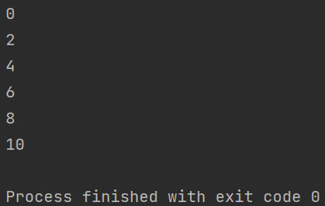
“for” loops are also useful for lists, or arrays in other programming languages.

B1)
Initial Analysis:
This exercise requires four variables that require different classes of data. The first and second variables, “userName” and “userNIN”, require strings (mixing letters and numbers). The third variable, “userAge”, requires an integer. A float could technically work but would be inappropriate. And the last variable, “userPPM”, involves currency, meaning a float would be most suitable.
At each stage, I’ll want to prompt the user to input the required data, testing by checking the class. This will be easiest with a “while” loop. While I could forgo this in favour of letting the program crash, the user would then have to start the process anew, which would not be ideal in a real-world scenario. The “while” loop allows me to re-prompt the user, letting them try again at the same stage.
Once all variables have data, I’ll want to print them all to the console.
Code:
print("What is your name?") # Prompts the user to enter their name.
userName = input() # Takes user input, assigning it to the "userName" variable.
while userName.isalpha() is False: # While loop to test for valid name.
# .isalpha() with is False Boolean checks for only alphabetical input.
print("A name must only contain letters. Please try again.") # Prompts the user to try again.
userName = input() # Allows the user to try again.
inputCheckNIN = "n" # This variable lets the while loop start for NIN verification.
while inputCheckNIN == "n":
print("Please enter the first two characters of your National Insurance Number.")
firstNIN = input()
# Going two letters at a time.
# Originally I wanted to use string methods like .isalnum() to do NIN input all at once.
# But, I couldn't find a string method that includes only A-Z, a-z, 0-9 and " "...
# ...While also excluding decimals.
# Thus, verification relies on checking one or two characters at a time, according to the user.
while firstNIN.isalnum() is False: # Checks for alphanumeric characters.
print("Only alphanumeric characters are valid.")
print("Please re-enter the first two characters of your National Insurance Number.")
firstNIN = input() # Allows for re-input.
print("Please enter the second two characters of your National Insurance Number.")
secondNIN = input()
while secondNIN.isalnum() is False:
print("Only alphanumeric characters are valid.")
print("Please re-enter the second two characters of your National Insurance Number.")
secondNIN = input()
print("Please enter the third two characters of your National Insurance Number.")
thirdNIN = input()
while thirdNIN.isalnum() is False:
print("Only alphanumeric characters are valid.")
print("Please re-enter the third two characters of your National Insurance Number.")
thirdNIN = input()
print("Please enter the fourth two characters of your National Insurance Number.")
fourthNIN = input()
while fourthNIN.isalnum() is False:
print("Only alphanumeric characters are valid.")
print("Please re-enter the fourth two characters of your National Insurance Number.")
fourthNIN = input()
print("Please enter the final character of your National Insurance Number.")
finalNIN = input()
while finalNIN.isalnum() is False:
print("Only alphanumeric characters are valid.")
print("Please re-enter the final character of your National Insurance Number.")
finalNIN = input()
print("Your National Insurance Number reads as:", firstNIN, secondNIN, thirdNIN, fourthNIN, finalNIN)
print("Is this correct? (y/n)") # Final user prompt for checking NIN details.
inputCheckNIN = input() # If == "n", the while loop restarts. Otherwise, it continues.
# Technically the loop would also continue as long as anything other than "n" is input.
print("How old are you?") # prompt for user age.
userAge = int(input())
if userAge < 18: # Checks user age is above 18 years old.
print("You must be 18 or over to use this program.")
exit()
# Does not contain opportunity to re-input by design.
# User must be 18 or over to continue using the program.
print("What is your current take home pay per month?")
print("Please input your answer to two decimal places (e.g.: 1234.56).")
payPerMonth = float(input()) # float(input()) forces input to be cast as float.
# So, even if a user input "50000", the program would convert this to "50000.0".
PPM_2DP = "{:.2f}".format(payPerMonth) # Formats the payPerMonth float to two decimal places.
print("Your details are as follows:") # Everything here and below lists all recorded details.
print("Name: ", userName)
print("National Insurance Number: ", firstNIN, secondNIN, thirdNIN, fourthNIN, finalNIN)
print("Age: ", userAge)
print("Take home pay per month:", "£"+str(PPM_2DP)) # Note concatenation of "£" to formatted float.

Testing:
Tests: Special characters, numbers, “happy path”
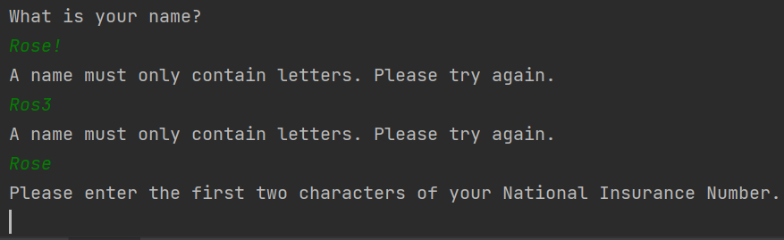

Tests: Special characters, “happy paths”
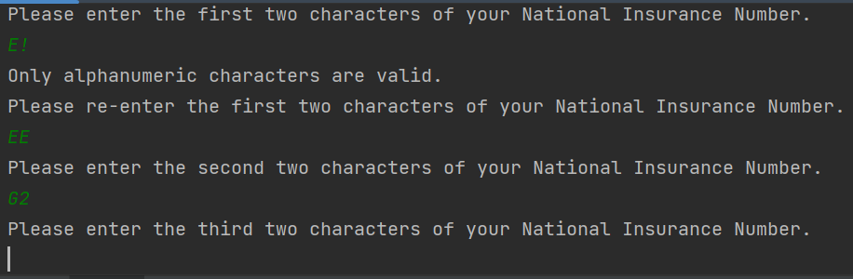
Tests: Further variations on “happy path”, another special character test
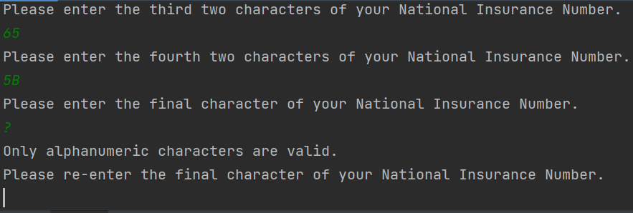
Test: National Insurance Number re-input loop functionality
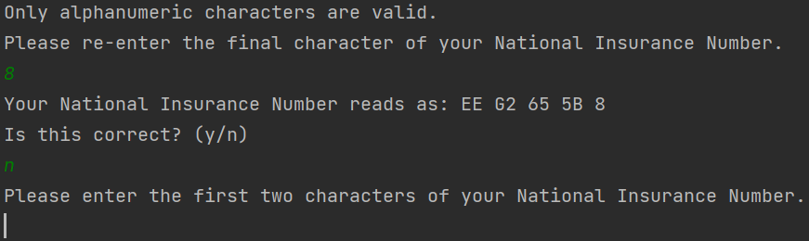
Test: Exiting the loop (“happy path”)
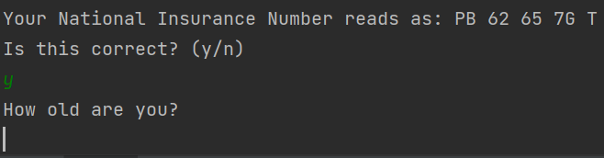

Test: String where whole number expected
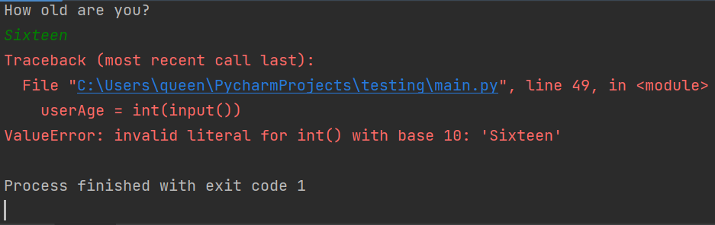
Test: Float where whole number expected
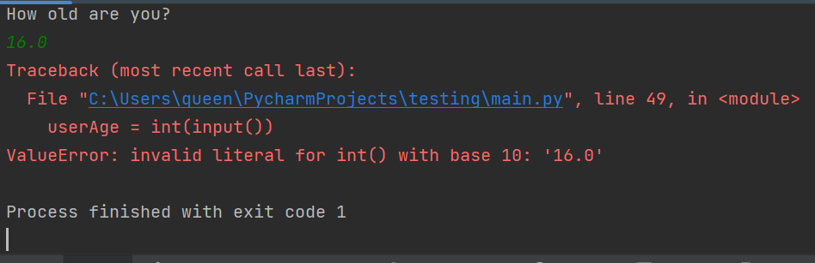
Test: “Happy path”, less than 18 input
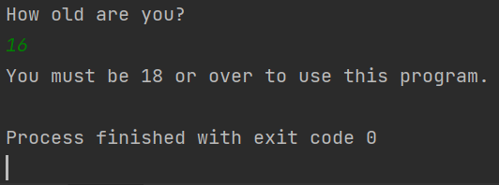
Test: “Happy path”, over 18
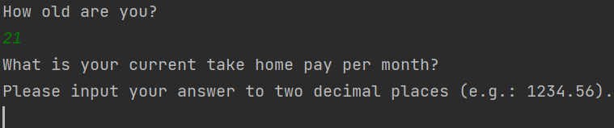

Test: String where float expected
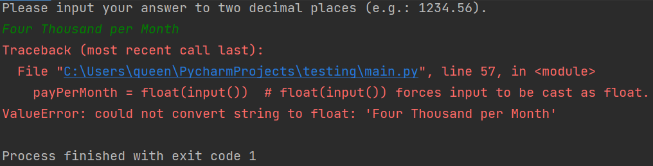
Test: Integer where float expected (still performs as expected):
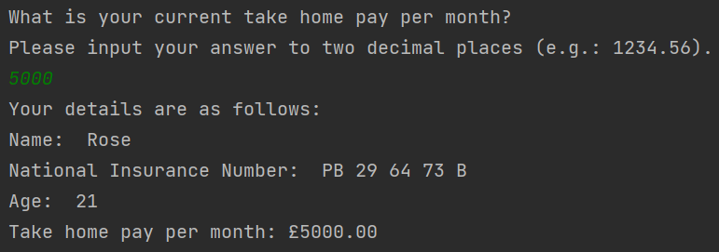
Test: User enters more than 2 decimal places
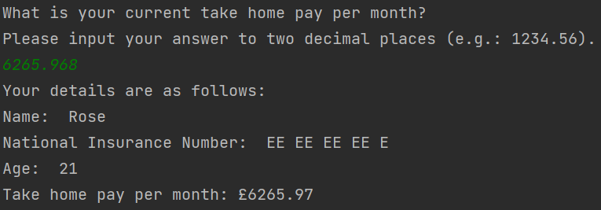

B2)
Initial Analysis:
Need a minimum of two variables, but three might be more appropriate. Above diagram lists “h” and “b”, but the area of a square is just either “h” or “b” squared. Regardless, will allow for input of length and width (b for base?). Will also need a variable for radius. Using the formula $A=πr^{2}$, area of the circle can be calculated. Finally, blue shaded part can be calculated by subtracting the area of the square from the area of the circle. At each stage, I’ll want to prompt the user for necessary re-input, for example:
print(“The area of your square is: “, squareArea)
print(“Is this correct? (y/n)”)

For the extra part, I’ll just need an if/else to check that the square area isn’t more than the circle area. Though the exercise specifies not more than circle dimensions (i.e. does not grow past the circumference). Maybe check that length or width is not more than the radius?
Might also be fun to graph this, even just for validation purposes, but that’s not necessary.
Code:
import math # Imports math library. Allows for future use of pi.
squareAreaCorrect = "n" # Allows while loop on line 3 to begin.
while squareAreaCorrect == "n":
print("Please enter the length of your parallelogram.")
squareLength = float(input()) # Prompts user for length. Will convert whole numbers to decimals.
print("Please enter the width of your parallelogram.")
squareWidth = float(input()) # Prompts user for width.
squareArea = squareLength * squareWidth # Area = Length * Width.
print("The area of your parallelogram is: ", squareArea)
print("Is this correct? (y/n)")
squareAreaCorrect = input() # Gives opportunity to confirm and exit the while loop.
while squareAreaCorrect != "n" and squareAreaCorrect != "y": # Checks for anything that isn't y/n.
print("Input not recognised. Please re-input confirmation:")
print("Is the area of your parallelogram", str(squareArea)+"? (y/n)")
# Concatenation requires temporary conversion to string class.
squareAreaCorrect = input()
circleAreaCorrect = "n" # Allows for loop beginning.
while circleAreaCorrect == "n":
print("Please enter the radius of your circle.")
circleRadius = float(input())
circleArea = math.pi * circleRadius ** 2 # Area = pi * radius(squared).
print("Your circle area is: ", circleArea)
formattedCircleArea = "{:.2f}".format(circleArea)
# Formats to 2dp. Otherwise, decimal is uncomfortably long.
print("To two decimal places, this reads as: ", formattedCircleArea)
print("Is this correct? (y/n)")
circleAreaCorrect = input() # Allows for loop exit.
while circleAreaCorrect != "n" and circleAreaCorrect != "y":
print("Input not recognised. Please re-input confirmation.")
print("Is the area of your circle", str(formattedCircleArea)+"? (y/n)")
circleAreaCorrect = input()
shadedArea = circleArea - squareArea
formattedShadedArea = "{:.2f}".format(shadedArea)
if squareWidth > (circleRadius * 2) or squareLength > (circleRadius * 2):
# Checks that the square remains within the bounds of the circle.
# Granted, this also assumes the square subtracts area from the dead center every time.
print("Caution: Given parallelogram dimensions exceed circle diameter.")
print("Proceed? (y/n)")
breachException = input()
if breachException == "n":
print("Understood - program will now exit.")
exit() # Program exits by design.
# Not sure how I'd go about making callbacks to edit previous variables.
# Maybe with custom functions?
elif breachException == "y":
print("The shaded area remaining is: ", shadedArea)
print("To two decimal places, this reads as: ", formattedShadedArea)
exit() # if the exit() weren't here, this message would print twice.
else:
print("Input not recognised - program will now exit.")
exit()
# See above notes in if statement.
print("The shaded area remaining is: ", shadedArea)
print("To two decimal places, this reads as: ", formattedShadedArea)

Testing:
Test: String input where float expected
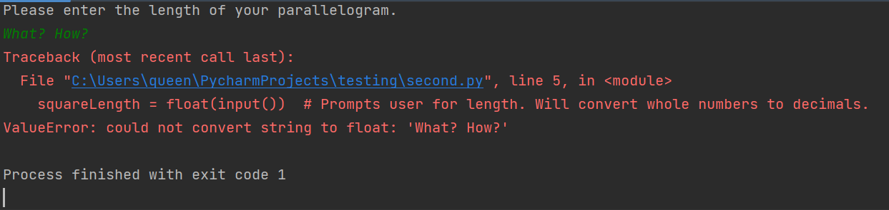
Test: Integer and float input
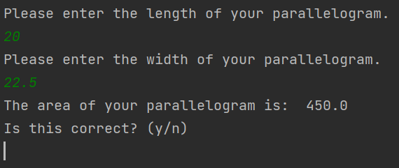
Test: Loop functionality
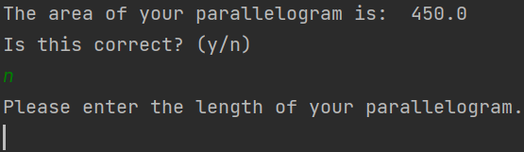

Test: Loop exit functionality
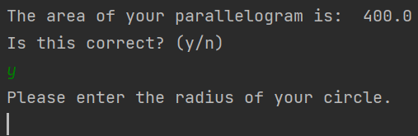
Test: String input for radius where float expected
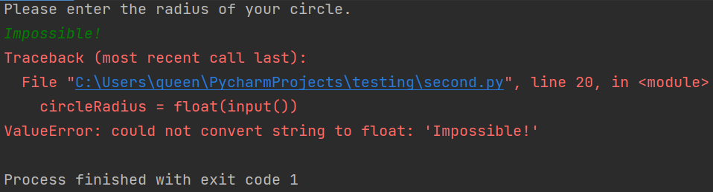
Test: Radius input “happy path” and loop functionality
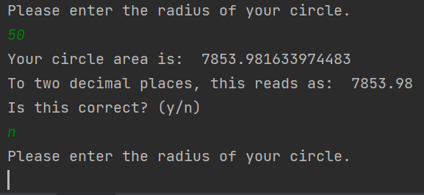
Test: Loop exit and final results “happy path”
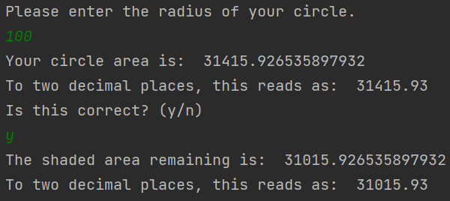

Test: “Out of bounds” message functionality
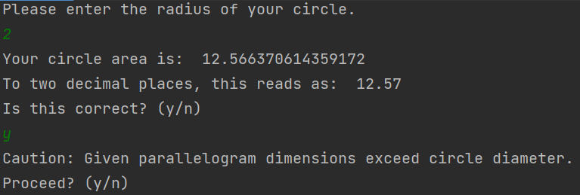
Test: “Out of bounds” exception functionality (functions as expected – square area was 10000.00, circle area was 12.57, both given here to 2d.p.)
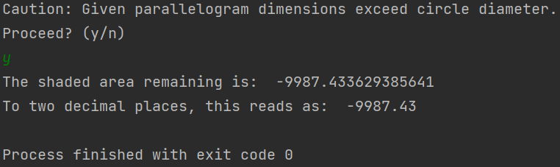
Test: Out of bounds non-exception functionality
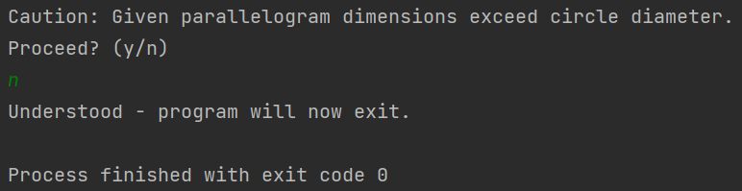

B3)
Initial Analysis:
Program needs two separate lists minimum, something like shoppingList = [] and itemPrices = []. Will need to append each list in alternating order, first the item, then the price. The example lists at least five items, but I think it’d be more fun to make a loop that allows the user to append as many items as they need to both lists, whether that be more or less than 5 items. Making a custom function might be necessary, but we’ll see.
As for the discount percentage, will need to generate a random number between 10 and 40, inclusive. Will need to import random. After that, will need to make a formula whereby the itemPrices total are multiplied by (1 – [random number generated, divided by 100]). E.g.: itemPricesTotal * (1 – (25/100)). Of course, this discount total will also need to be printed.

Code:
import random # Imports random library for lottery ticket generation.
shoppingList = []
listPrices = []
# Technically I can mix data types in lists...
# But I want to be able to add everything together more easily.
# Making two separate lists seems ideal for that.
def list_addition(): # Function lets me add to each list indefinitely.
print("Please enter the name of your item.")
shoppingList.append(input()) # Appends the first list.
print("Please enter the price of your item.")
listPrices.append(float(input())) # Appends the second list. Will crash if not int or float.
list_addition() # Function in action baybeeee
listAddChoice = "y" # Lets the while loop begin.
print("Would you like to add another item to your list? (y/n)")
listAddChoice = input() # At this point, at least one item has been added to both lists.
# This acts as a potential stopping point, assuming the user is only buying one item.
while listAddChoice == "y":
list_addition()
print("Would you like to add another item to your list? (y/n)")
listAddChoice = input() # Allows for loop exit.
priceTotal = sum(listPrices) # sum() is the reason I made two lists at all. Simplifies the process.
print("Here is your shopping basket:")
for nextItem in shoppingList:
print(nextItem) # for loop usually used when range is known beforehand...
# But in this case, I already know the range will be however entries the user makes.
# Technically a while loop might be better as I don't know the precise range...
# But if it ain't broke...
print("And their respective prices:")
for nextPrice in listPrices:
print("£"+str("{:.2f}".format(nextPrice))) # Same as above, only formatted to 2dp...
# ...And concatenated with "£".
print("This totals to:", "£"+str("{:.2f}".format(priceTotal))) # PriceTotal also gets formatted.
print("Drawing lottery ticket...")
lotteryNumber = random.randint(10, 40) # Generates a random number between 10 and 40 inclusive.
print("Your lottery number is", str(lotteryNumber)+", which nets you a", str(lotteryNumber)+"% discount!")
if lotteryNumber == 40:
print("That's the highest possible discount - lucky you!") # Just for fun :3
discountMaker1 = lotteryNumber / 100 # Divides the generated number by 100...
discountMaker2 = 1 - discountMaker1 # Then subtracts that from 1.
# Yes, there are better ways to do this, but this is the method I prefer.
discountTotal = priceTotal * discountMaker2 # Gets you the total discounted price.
print("With discount, this brings your grand total to:", "£"+str("{:.2f}".format(discountTotal)))
# Formatted and concatenated, of course.

Testing:
Test: Letters and symbols input to shoppingList
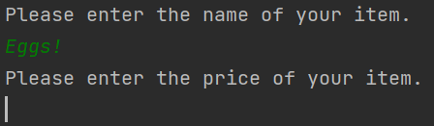
Test: Number input to shoppingList
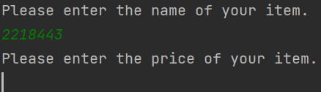
Test: Non-integer or float input to listPrices
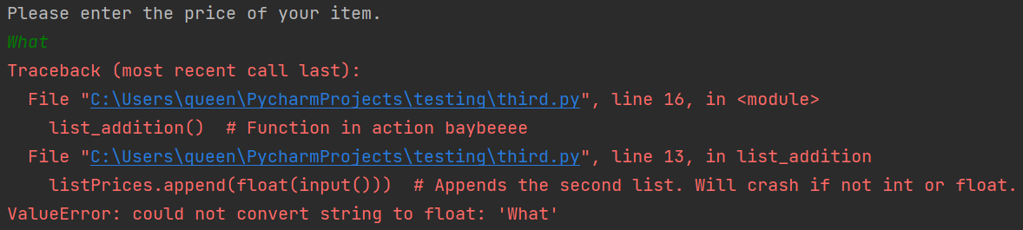
Test: while loop functionality
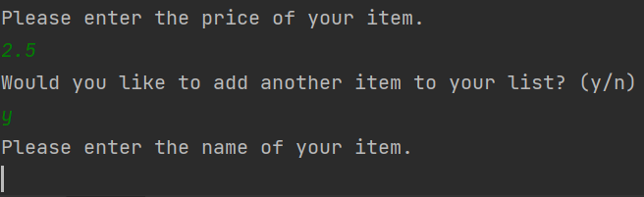

Test: Loop exit functionality, followed by sum(listPrices) functionality and formatting, random number generation, and discount application.
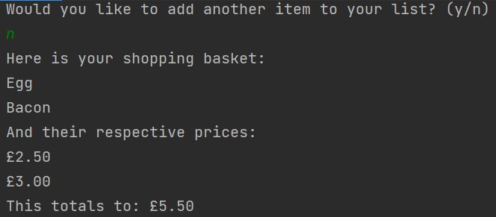
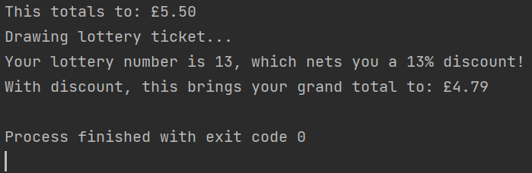

B4)
Initial Analysis:
We’re making a graphic, so we’ll need to import turtle. The “Z” doesn’t need any looping, so I’ll do that by hand. The “O”s might. Could make a function to draw an “O”, complete with the smaller “o” in the middle (gives the illusion of line thickness, as shown in assignment example). This would then be looped twice. Then again, as I’m only doing 2 “O”s, a function is probably overkill. We’ll see as we make it.
As for width and height, I can only do that by ear, as far as I’m aware. Will need some trial and error.
Code:
import turtle # Imports from the turtle library.
laCreatura = turtle.Turtle() # Spawns the turtle.
laCreatura.shape("turtle") # Changes cursor to an actual turtle, for fun :3
laCreatura.penup() # While getting in position, makes sure no line is drawn.
laCreatura.left(180) # Turn left 180 degrees
laCreatura.forward(200) # Move forward 200 pixels
laCreatura.right(90) # Turn right 90 degrees
laCreatura.forward(100)
laCreatura.right(90)
laCreatura.pendown() # Turtle in position, pen is down. Subsequent movement commands will draw.
# Everything from lines 4 to 10 gets the turtle into position.
# I realise now I could've used .goto() instead of doing all this aaaa
def draw_z(): # Custom function for drawing a "Z".
laCreatura.forward(100)
laCreatura.right(90)
laCreatura.forward(20)
laCreatura.right(45)
laCreatura.forward(110)
laCreatura.left(135)
laCreatura.forward(80)
laCreatura.right(90)
laCreatura.forward(20)
laCreatura.right(90)
laCreatura.forward(100)
laCreatura.right(90)
laCreatura.forward(20)
laCreatura.right(45)
laCreatura.forward(110)
laCreatura.left(135)
laCreatura.forward(80)
laCreatura.right(90)
laCreatura.forward(20)
laCreatura.right(90)
laCreatura.penup() # Line 16 to 36 draws a "Z".
def draw_o(): # Custom function for drawing an "O".
laCreatura.pendown()
laCreatura.circle(60)
laCreatura.penup()
laCreatura.left(90)
laCreatura.forward(20)
laCreatura.right(90)
laCreatura.pendown()
laCreatura.circle(40)
laCreatura.penup() # Line 40 to 48 draws an "O".
draw_z() # Draws a "Z".
laCreatura.forward(200)
laCreatura.right(90)
laCreatura.forward(118)
laCreatura.left(90) # Lines 52 to 55 get the turtle into position for "O".
draw_o() # Draws an "O".
laCreatura.right(90)
laCreatura.forward(20)
laCreatura.left(90)
laCreatura.forward(155) # Lines 57 to 60 get the turtle into position for the next "O".
draw_o()
turtle.done() # Keeps the graphic from closing.

Testing:


