End of Project Report

Student’s Name: Anastasiya Petrova
Student Number: 1816952
Module title: Project Management (LCBB5005)
Assignment title: Assignment 2
Module Lecture’s Name: Dr Molly Jack

Table of Contents:
1.Introduction …………………………………………………………………………………………………… 3
2.Monitor and Control the Project ……………………………………………………….............................. 3
3.End of Project Report……………………………………………………………………………………........ 7
- The objectives of the project and whether they were achieved………………….………………….... 8
- Whether the project stayed within its original scope…………………………………………………… 8
- Changes made during the project…………………………………………………………………….... 10
- Lessons learned during the project ……………………………………………………………………. 10
- Risks which could have been identified earlier on in the project ……………………………………. 11
4.Conclusion …………………………………………………………………………………………………. 12
5.References.……………………………………………………………………………………………….…. 13

Introduction
During the work in Assignment 1, the initiation, planning, and execution of a Project Plan were considered. In this paper, the mechanism of monitoring and control, End of Project (EOP) report, Lessons Learned during the project, and reflections will be considered.

Monitor and Control the Project
Summary of the Project
The Broadgreen Hospital was planning to come up with an integrated patient information system that would be used to store all the necessary data about their patients. The system would be an electronic care record. Some of the data that was to be stored include the patients’ names, addresses, contacts, age, medical history, their date of birth, and the treatment they receive from the hospital. This system was necessary for the hospital, as it would permanently solve the problem of patient data management that the hospital was currently facing. Through it, all the authorized staff in the hospital would be able to record, share, and access all the necessary information they require about the patients who receive services from the hospital. The system would also improve the quality of services offered to the patients, as their previous medical history are necessary for informing their current medical needs. For the implementation of the project to develop an integrated information system for the needs of Broadgreen Hospital, a budget of £ 50,000 and a duration of 6 months was set.
In order to meet the needs and goals of the hospital, in planning and developing the project, I adhered to the definition of the Project Process.
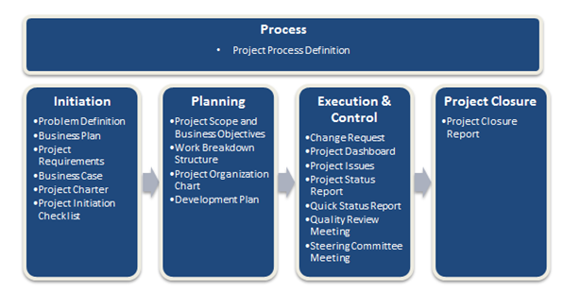
Source: Chan, W., (2011), [online].
According to the Prince2 project management methodology, each project is divided into stages, each of which is managed individually. The individual processes are defined with separate key inputs and results, as well as the goals and activities to be achieved. This can be illustrated as follows:
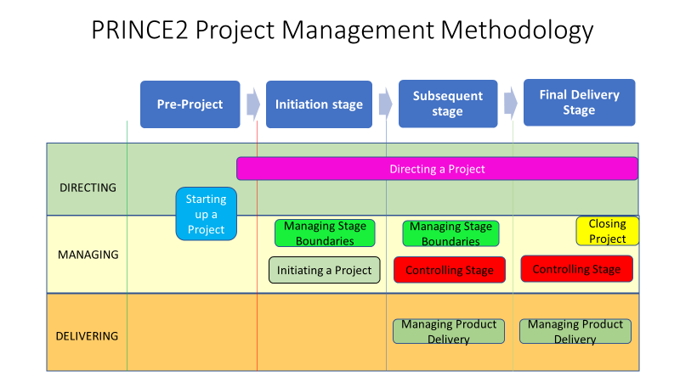
Source: Autor’s work
Process Key activities
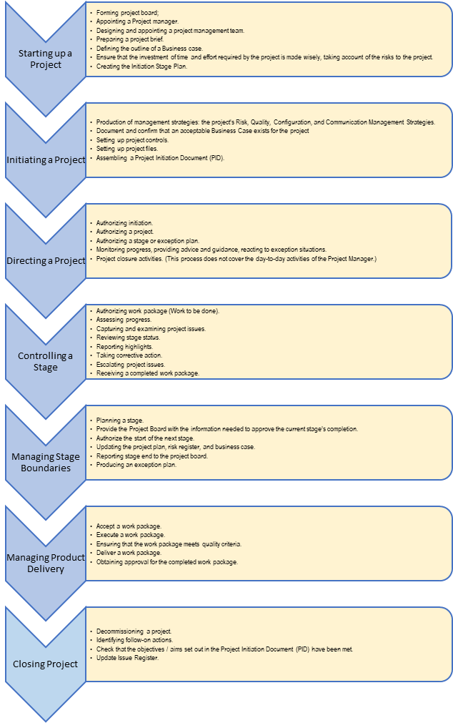
Source: Autor’s work
The use of the project monitoring and control system is crucial to ensure that the project objectives are achieved, even in the presence of some uncertainties. This system helps to identify all threats associated with the implementation plan, as well as to minimize it. After identifying the deviations and reporting the status of the project, a comparison is made with the plan, analyses are made, and then corrective actions are taken. All this is properly documented. To ensure the effectiveness of the system, monitoring policy as well as intervention and control policy were clearly defined. It was clearly defined in the monitoring policy what, who, where, when and by whom to monitor, and in the intervention and control policy what, who, where, when and by whom to prevent intervention and correct (Hazır, Ö, 2015).
Monitoring and Control Project Work: Tools & Techniques, and Outputs
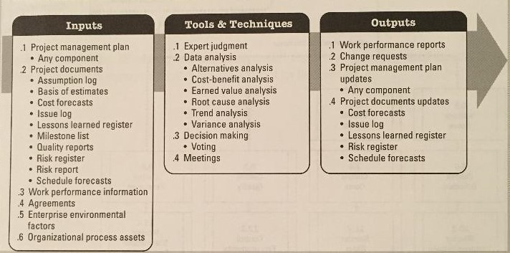
Source: PMBOK® CUIDE (2017)
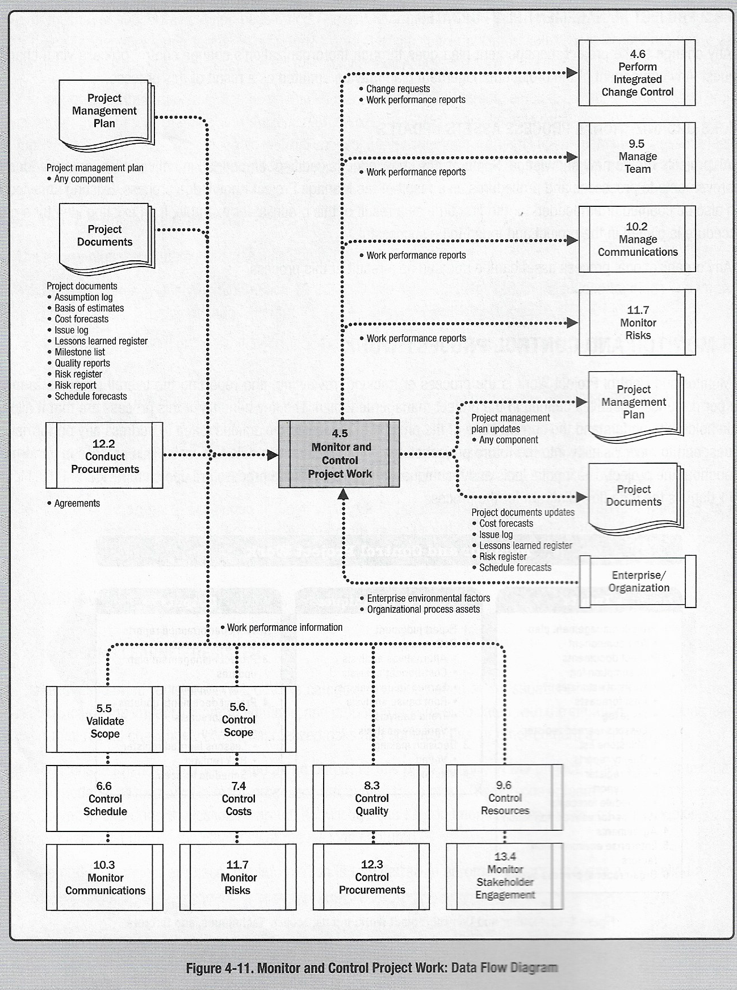
Source: PMBOK® CUIDE (2017)
The main aspects that are taken into account in this control include quality, cost and time. Below are some of the approaches used as control mechanisms for the project described in Assignment 1.
Planning. This is the most basic control practice that has been adopted for this project, as all participants in the project are planned before their implementation. In this regard, each activity that had to be carried out was identified in the breakdown structure of the project work, and the duration in which it was to be carried out was determined. This facilitated easy tracking of project activities to ensure that the project remained within expected limits. In addition, planning also facilitated project implementation.
Documentation is also another reliable mechanism. In this regard, all decisions and discussions taken regarding the project are officially documented, which is a reliable reference point during the project implementation. As well, this documentation will be useful to help resolve problems with non-communications and misunderstandings that may arise among the project team.
In addition, a proactive approach was adopted to solve issues and problems that could arise during the project. Some of these issues could relate to scope, budget, quality, human resources, and time (Dahlgren and Söderlund, 2010). The project manager also ensures that the key project deliverables and project performance are periodically reviewed. This helps in ensuring that any emerging errors are rectified early enough before they compromise the success of the project. Different Tools and Techniques were used for control and monitoring at each stage.

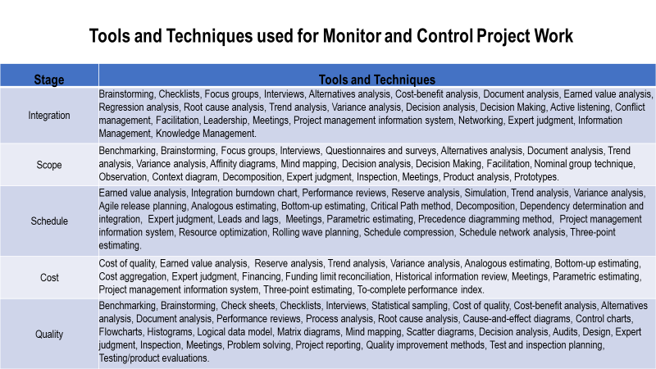
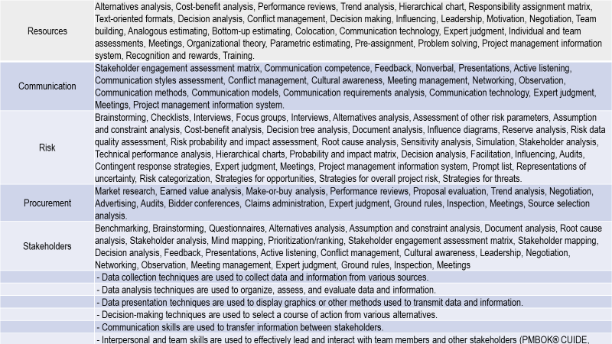
Autor’s work
End of Project
The end of the project is the last phase of the project cycle. To close the project, it is necessary to follow a procedural checklist, which includes an overview of what has been learned, the things that could change, the methods used, successful for the project. All this would lead to the avoidance of mistakes in future projects, on the one hand, and on the other hand, to the increased use of good techniques and practices (Meredith et al., 2018).
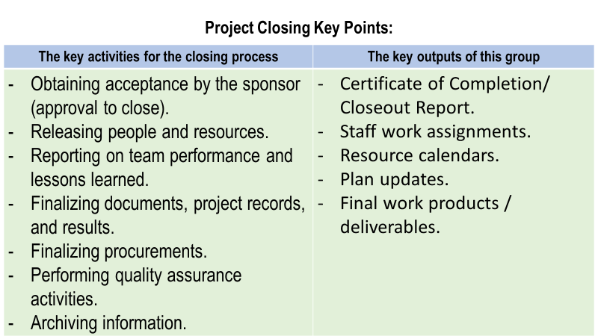
Autor’s work
If the project is not closed properly, the organization may be liable for incomplete payments under contracts due to incomplete coverage or may be liable for incompatible practices by regulators.
The objectives of the project and whether they were achieved.
The main aim of the project was to develop an electronic integrated patient information system for Broadgreen Hospital. The system was urgently needed in the hospital to help in better patient data management for the hospital, which would also help improve the general efficiency of the services it offers. This objective was achieved at the end of the project, and with the anticipated efficiency.
One major aspect which could be associated with the success of the project was the planning which was carried out before the project was initiated. During the planning, all the major components of the project such as the resources needed, the stakeholders and risks were identified. This made it possible for the project team to plan on how each project task was to be carried out to ensure that it facilitated the completion of the system. After this, the project manager worked together with all the concerned stakeholders to ensure that the project plan was adhered to. This kind of coordination ensured that the project was completed within the expected duration.
Whether the project remained in its original scope
It is worth noting that the project remained within the initial scope set during the planning. For example, the project was expected to last six months. The project was completed on time, which clearly proves compliance with the project schedule, where each project task was set a specific duration within when to be completed. Fortunately, all stakeholders completed their activities on time, which helped to meet the deadlines.
As well, the project budget was adhered to. The project had been assigned a budget of £50,000 that was to facilitate all the project activities from its planning to the implementation. Below is the project breakdown of the expenditure.

Description |  | Original Budget (£) | Actual costs (£)
Project supplies  Software and hardware  Stationery  Subtotal |  | 12,000  140  12,140 | 12,000  140  12,140
Project team human resources  Direct cost  - Staff salaries  - Consultants salaries  Indirect costs – travel cost  Sub-total |  | 29,760  900  2,000  32,660 | 29,760  900  1,850  32,510
Administrative |  | 5,200 | 5,000
Total expenditure for the project |  | £ 50, 000 | £ 49, 650

Based on the above component breakdown, there was a positive variance of £350 between the original budget and the actual costs that were incurred during the project. The elements which resulted in these costs include the project team's indirect costs and administrative costs. This was mainly because most of the meetings among the project team were held online due to the COVID-19 control measures which restrict social gathering. This reduced the allowance costs, and especially on transport expenditures which were to be paid to the project team. As a result of this, the project’s total expenditure was £ 49, 650 against the planned £ 50, 000.

Changes made during the project
A key change that was made during the project was on the reporting framework. Previously, it had been planned that the team members were to hold physical meetings to discuss the progress of the project. However, after consultations among the members, it was agreed that the meetings would be held online. This change was approved by the project manager and the project sponsor. This was mainly due to the COVID-19 control measures that had been put in place, which restricted social gatherings. Hence, it was considered wise that the members carry out their meetings online.
Effects of the changes to the project
Although this was a new approach for the members, it ended up being effective and convenient for the team members. This is because the meeting saved on time as members did not have to travel to their meeting venues. As well, it was through the online meetings that the project was able to cut on some of the indirect costs which had been allocated for the project team allowances.
Lessons learned during the project
Any project is an avenue for any participant to learn. There are many opportunities for learning in a project, such as through the factors that facilitated the success of a project, as well as failures incurred. Being a project manager, I took part in most of the project stages, from the planning time to the closure of the project. During my participation, there are different lessons that I learned, and which I will be able to apply during similar involvements in the future. In this section, I will discuss some of these lessons.
One of the major ones was the role of inclusivity and diversity in decision-making. During the planning of the project, the project sponsor emphasized the need for the involvement of all the major project team members in making decisions regarding every project task. Following this, the project team was identified early enough to ensure that each category of the project team, both internal and external were represented. Due to this, the decision-making team was composed of individuals from different backgrounds and experiences in project management. Following this inclusivity and diversity, most of the decisions made regarding the project were informed and reliable, which can largely be attributed to the success of the project.
An additional lesson learned was the role of planning in project management. Planning is quite essential in any project as it helps the project team identify their desired objectives, avoid missed deadlines reduce risks, and deliver on the required services. This was quite evident during the project. As a result of the planning, the project team was able to identify the objectives which the Broadgreen Hospital, who were the project clients needed to achieve. Out of this, a plan was developed on how the project team would work as a team to ensure that these goals were achieved in the end.
In addition to this, the planning also helped in the identification of most of the risks that the project was exposed to. This was possible because of the involvement of a diverse project team who had been involved in similar projects before. Hence, they shared their experiences and the risks which they encountered, which was useful in developing our risk register. After these risks were identified, it was now possible to identify mitigation actions. Out of this, the team members were adequately prepared on how to prevent these risks from happening, which reduced their chances of happening.
However, the communication channels which were adopted seemed to be ineffective. Due to the fact, that most of the communication was online, some of the key information was not adequately shared with the relevant stakeholders. According to the communication plan which had been set, after the meetings, the project secretary was to compile the meeting minutes and share it with the stakeholders within 24 after the meeting. However, this did not work as planned, as the minutes were not share within this duration. In some instances, this delayed the implementation of some of the important tasks, which had to be attended to immediately after the meeting. Although this did not affect the overall performance of the project, in the future I would ensure the development of a more comprehensive communications plan. As a project manager, I also noted that developing the communication plan alone was not quite reliable. Hence, I will ensure to involve the project team in order to come up with a plan that takes into consideration the communication needs of all the stakeholders.
Lastly, an additional aspect that I learned during the project is the role of time management in the success of a project. Sahu, K, and Sahu, M (2014) define time management as the ability to plan and organize time spend on activities. In this regard, during the project planning, as the project manager, I guided the project team in developing a work breakdown structure. The structure comprised of all the project activities and the timescale within which they were supposed to be carried out. Although some of the activities seemed to have a prolonged duration, I ensured that each activity was started at its planned start-date. This guaranteed that each task was carried out under ample time, which prevented rushing to finish the activities to beat the deadlines. It was through this approach that all the project activities were accomplished in time, which resulted in the timely delivery of the project.
Risks which could have been identified earlier on in the project
Complex or simple, any form of the project is exposed to some risks. Hence, in order for a project to be successful, it is vital that planners know these risks and identifies suitable measures on how to deal with them efficiently. Our project was also had certain risks that were identified during the planning phase. All the identified risks were accompanied by mitigation actions, which limited the chances of the risks from occurring. However, despite the planning, there were also some risks that were not identified. Below are some of the risks that needed to be identified earlier on in the project.
Unclear specifications. Based on the clients’ needs, they only needed an electronic integrated patients’ information system. However, they did not give precise details of what specifications they would have preferred for their system. As well, the project team did not realize this risk during the project planning stage. Hence, the system developers were not served with these fine details. Being external stakeholders in the project, the external developers had to request for a meeting with the project team to come up with specifications of the fine details required in the project. Although this had to destruct the project schedule, it was fortunate that it did not affect the entire timescale as tasks were still run within the required time. Had this risk been identified earlier, it would not have occurred during the project.
Unforeseen circumstances were also some of the major risks which should have been identified earlier. This was most necessary due to the fact that the project was carried out during the COVID-19 pandemic. Being a global pandemic, every stakeholder was exposed to the pandemic. Hence, it was vital for the risk to be identified early enough and planned for. This was essential as, during the project, some of the project team members were infected with the disease, which limited their participation in their assigned responsibilities. Despite this, their colleagues were able to make up for them and the project was completed as planned. In the future, it will be necessary to pan for such uncertainties and identify substitute team members to take up positions of stakeholders who are unable to attend to their responsibilities due to unavoidable occurrences.
Conclusion
This report assessed how the project performed from its initial states when the project was completed. It is worth noting that the project was successful and that the project team was capable of delivering the final services of an electronic integrated patient system to the hospital. Although the project was successful, it encountered some challenges that we were able to solve in time in that they did not affect the outcome of the project. By participating in the project as the project manager, I was able to learn many lessons that I will apply in similar undertakings in the future to guarantee better performance.

References:
- Chan, W., (2011), ‘Introducing the New MindManager Project Jetpack‘. [online]
Available at: https://blog.mindmanager.com/blog/2011/02/managing-projects-with-mindmanager-just-got-easier/
(Accessed: 21.08.2020)
- Dahlgren and Söderlund, (2010), ‘Modes and mechanisms of control in Multi-Project Organisations: The R&D case’, International Journal of Information Technology Project Management (IJITPM), 5(3), 39-66.
Available at: https://www.researchgate.net/profile/Jonas_Soederlund/publication/247832713_Modes_and_mechanisms_of_control_in_Multi-Project_Organisations_the_RD_case/links/00b495253cf6e8346e000000/Modes-and-mechanisms-of-control-in-Multi-Project-Organisations-the-R-D-case.pdf
(Accessed: 22.08.2020)
- Hazır, Ö, (2015), ‘A review of analytical models, approaches and decision support tools in project monitoring and control’, International Journal of Project Management, Volume 33, Issue 4, p. 808-815.
Available at: https://www.sciencedirect.com/science/article/abs/pii/S0263786314001422
(Accessed: 22.08.2020)
- Kendrick, T., (2015), Identifying and managing project risk: essential tools for failure-proofing your project, 3rd ed, AMACOM.
- Meredith et al, (2018), ‘Project Management, A Strategic Managerial Approach’, 10th ed, WILEY, p.497-502.
- PMBOK® CUIDE, (2017), 6th edition, p.105 - 113
- Sahu, K., Sahu, M. (2014), ‘Cost & Time and Also Minimum Project Duration Using Alternative Method’, International Review of Applied Engineering Research.
- ISSN 2248-9967 Volume 4, Number 5 (2014), pp. 403-412.
Available at: http://www.ripublication.com/iraer-spl/iraerv4n5spl_03.pdf
(Accessed: 24.08.2020)
- Vaníčková, R., (2017), ‘Application of PRINCE2 project management methodology’, Studia commercialia Bratislavensia, Volume 10; Number 38 (2/2017); pp. 227-238, DOI: 10.1515/stcb-2017-0021 ISSN 1339-3081
Available at : https://content.sciendo.com/configurable/contentpage/journals$002fstcb$002f10$002f38$002farticle-p227.xml
(Accessed: 22.08.2020)

