Brett Thomas (1807835)
University of Wales - Trinity Saint David
ACBA6000 – Construction Management

Contents
1 Gantt Chart 2
2 Site Specific Reports 4
3 5 Week Delay Scenario 10
4 Bibliography 12

Gantt Chart
The following Gantt Chart has been produced using Microsoft Project. This will be the main application used to plan the project in SA1. The Gantt Chart will show the critical tasks and timeline which has been developed as part of the project. The critical path is highlighted.

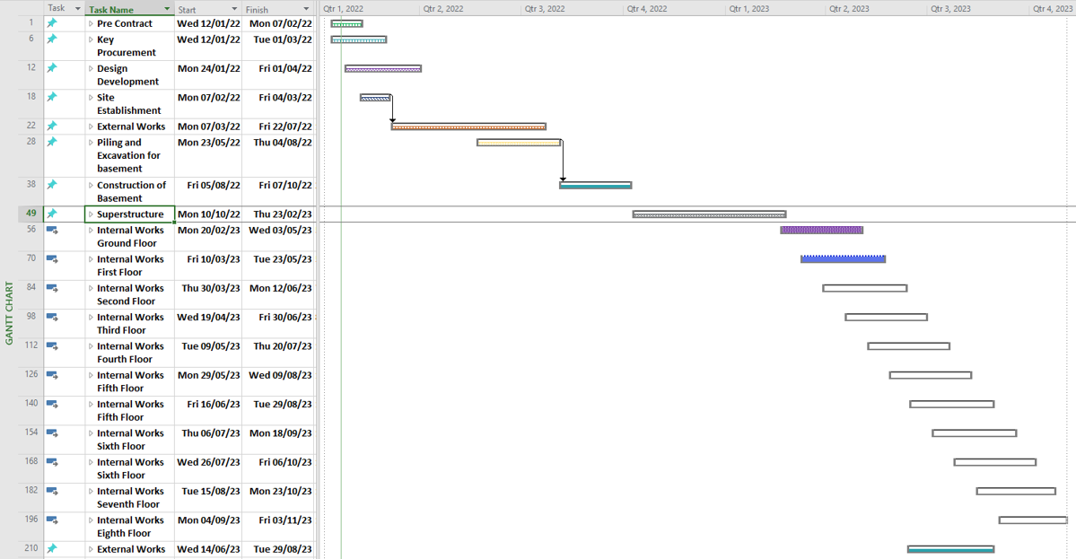
Figure 1: Gantt Chart showing main tasks of project.

The gantt chart was produced showing the overall tasks of the project and shows the multiple different phases to the project.
This can also be expanded in project and look into each element showing more detailed information. I have done this for the excavation work and the completion of the basement. The gantt chart below shows a more detailed step by step guide for this.

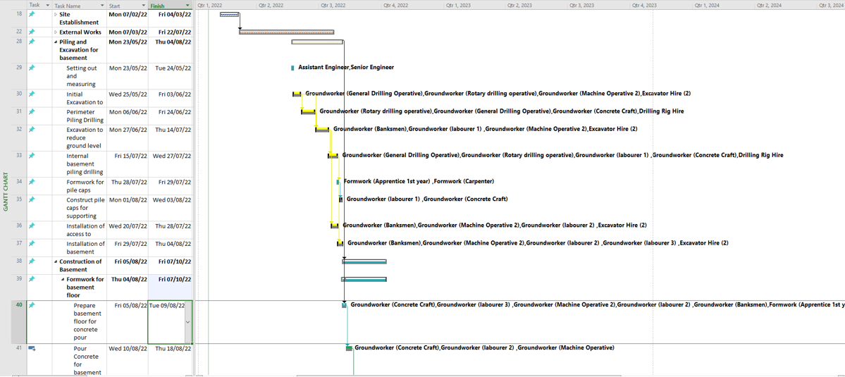
Figure 2: Gantt Chart showing detailed breakdown of tasks with element of works

The gantt chart and development of using applications like Microsoft Project allows the project manager to develop a master programme. Following this programme can help to project manager tract performance, weekly and monthly progress reports, assess any deviations from the original plan and determine if any actions need to be taken for any issues that arise. This will also highlight the critical tasks to the project and which tasks have float. This means they should not affect the critical path if there are any delays.
Not only time but budgets and resources can also be managed through these applications. Using the application like project allows you to develop, evaluate and produce reports for all aspects of tasks, time, budget and resource.
The master programme will usually be developed by the client and contractor and agreed as part of the contract process.

Site Specific Reports

There are many reports you can extract via projects.
When I look at the SA1 project I am able to extract reports and graphs which allow me to visualise the project and the tasks associated. For example the first report I have extracted below shows the baseline estimated duration of each of the main headed tasks.
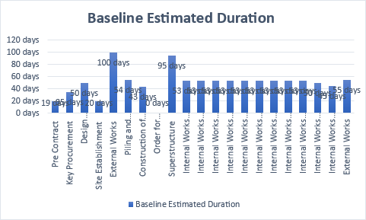
Figure 3: Baseline Estimated duration for each of the headed tasks

This can visually highlight the proposed durations of each task.
We can also show a report to highlight the hours of each task, the remaining work, the work completed and the compare to the actual duration. The below graph/report only has hours input for the External works, Piling and Excavation and Construction of basement as these are my chosen tasks.
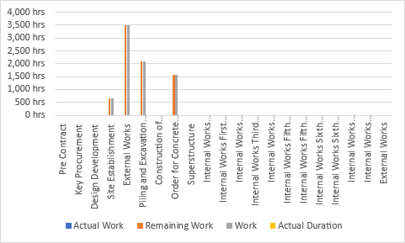
Figure 4: report showing the hourly working figures for each task

This detail can be looked more in depth for each of the headed tasks also. For example below I have looked at the Pre Contract works. Following the timeline some of these jobs are either completed or part completed. By assigning the amount of work complete in project I can then pull off the report at a high level to see if there is any work outstanding that shouldn’t be or if the durations are being well managed.

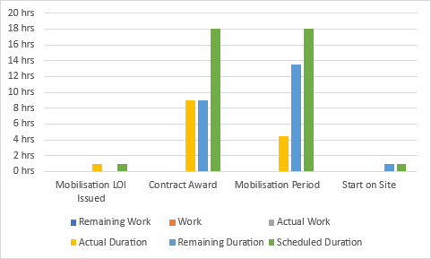
Figure 5: report showing the scheduled duration, actual and remanding duration on the Pre contract work

Regular and accurate reports from site can mean an up-to-date tracking of the project and any early indications of issues that may delay the project can be highlighted and addressed at the earliest opportunity.

Other reports that can be compiled from the application can relate to resource and costs. Below is a resource overview chart which highlights the name of each resource and the committed hours to their tasks they have been allocated.

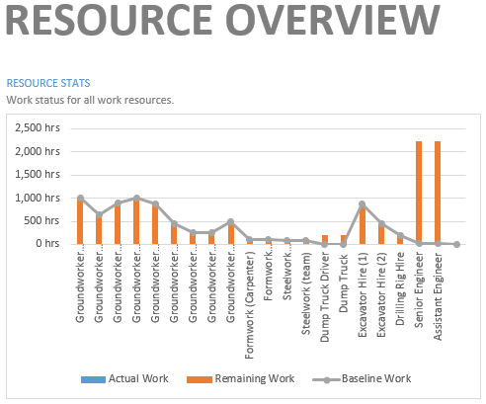
Figure 7: Resource overview showing the allocated hours to each of the workers

As each task is completed you can assign the task to show how much of the work has been completed. This can then be compared to the amount of work is proposed to be completed. I have added in some tasks completions to evident this.

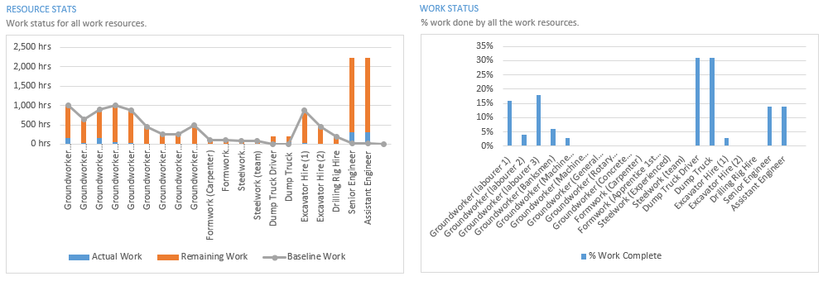
Figure 8: proposed work v work completed

Another good tool to use and report to use is the resource allocation. This can show if there is an over allocation of resources for a specific task. For example, if there are 3 tasks which overlap each other in the proposed project plan, and each task needs a dump truck driver involved, then his time would overlap which means a decision can be made to make the tasks follow on from each other to utilize the one dump truck driver, or if time is an issue, then a second dump truck driver to be hired may be the solution. This will be highlighted in the application and in a report that can be run.

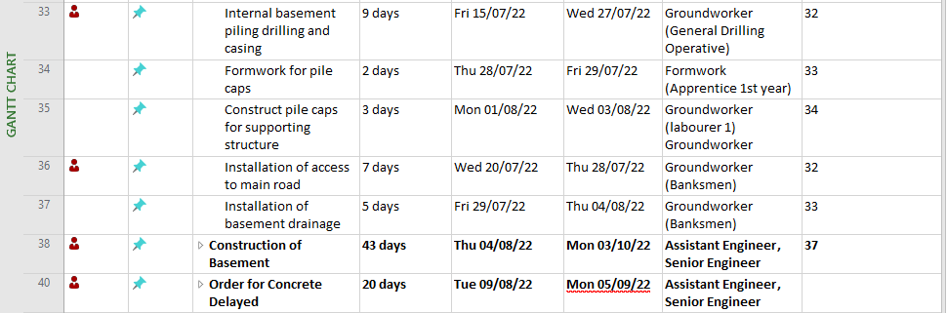

Figure 9: Indicators showing an overallocation of resource

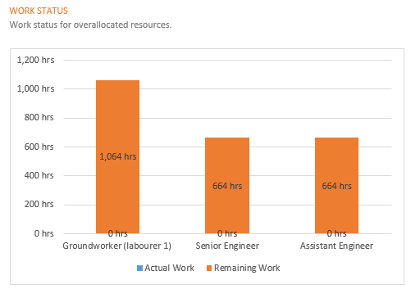
Figure 10: Overallocated Resource

Costs for the project can also be allocated and tracked using the project application. This can be input for resource, fixed costs, or the granular detail of the individual costings of each material and so on. Resource and plant hire can be input and followed. The way you input your costs for the project may depend on how the funds are available throughout the project life.
Funds may be allocated in one lump sum at the beginning of the project which means you can plan for the fixed costs for each task which will show on plans as a lump sum payment for each task.
If funds are released on a month-by-month basis then the costings for the project will need to be broken down further and allocated across the individual steps of the project.
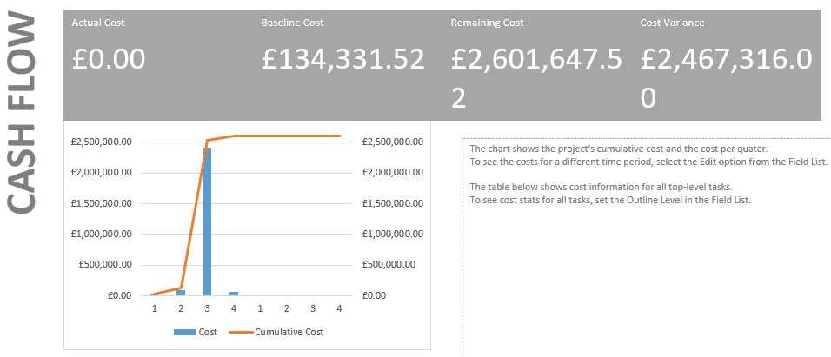
Figure 11: Cashflow for the project – with only the detailed tasks input

The resource and plant can be input to the resource tab and again this information allocated to their specific tasks.
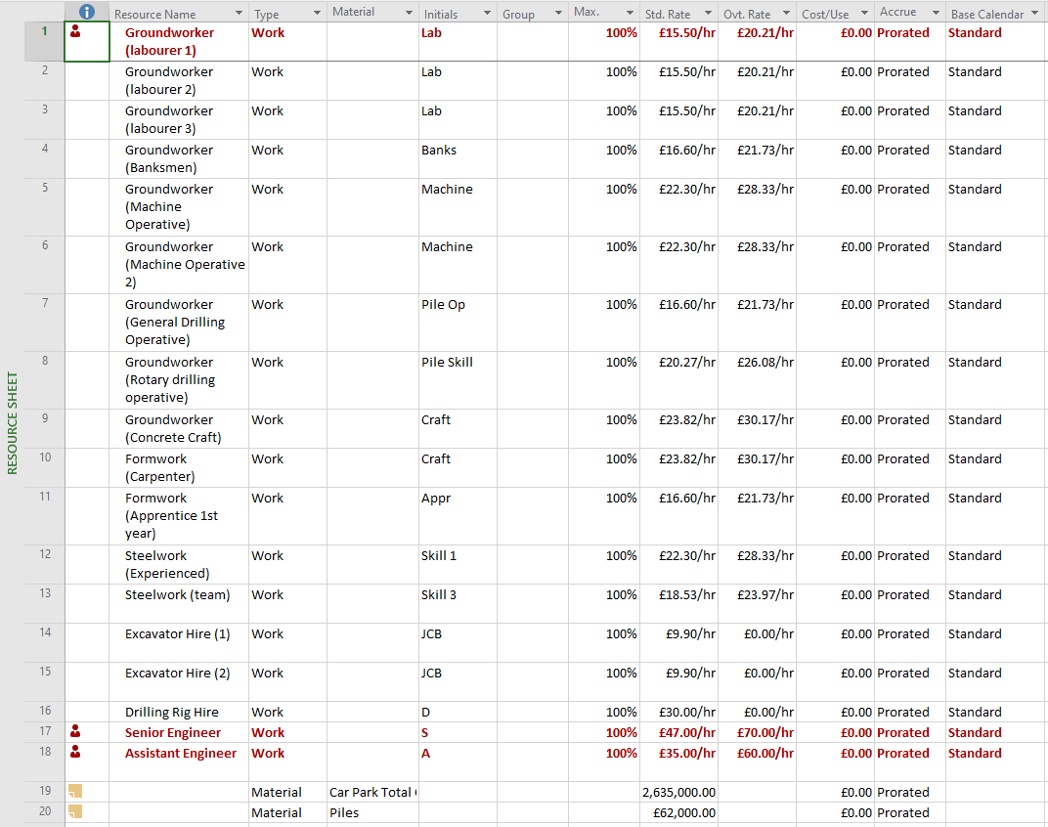
Figure 12: Allocated staff, plant and material total costs

The figures used above are all utilized from the Spons Civil Engineering and Highway works price book 2020.
The material costs for the car park and piles are a total cost which has been calculated using the Spons handbook for costs of full construction of an underground car park per m2. The piles costs has also been used from the same handbook.
This gives the ballpark figures required and shows how the total project costs may look. This could also be broken down and individual costs such as costs of concrete per m2 to be delivered to site, formwork carpentry, steelwork per m2 and so on. These figures would usually be derived by the Quantity surveyor and again either the total amount added to the tracker or the individual costs.

Further analysis can be looked at into the resource cost and how this is distributed between the different resources. This can give you an overall proposed budget for the development and again as costs are input and tasks complete you can compare the proposed costs vs actual costs.

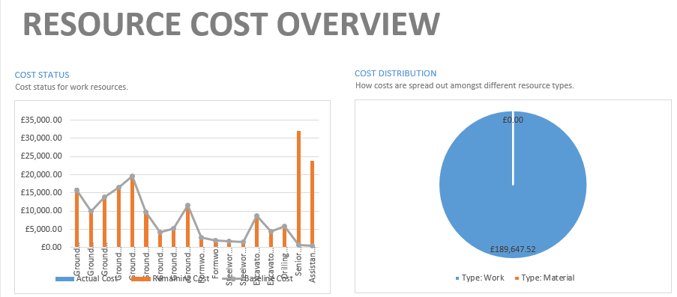
Figure 13: Resource cost overview for each resource

All these tools and reports allow the project manager to constantly evaluate and update the progress of the project.
Using the reports available allows you to track and manage the performance of the teams, using this can help you to decide as the project manager if additional measures will need to be taken to make sure the project stays on track within its planned progress.

5 Week Delay Scenario

In scenario 1, we have a delay of the project due to a strike by the local concrete company for 5 weeks. Using the project application, we can add in a delay to the project to allow us to manage the delay and ascertain how long this may delay the project. I have input this into project as a separate task.

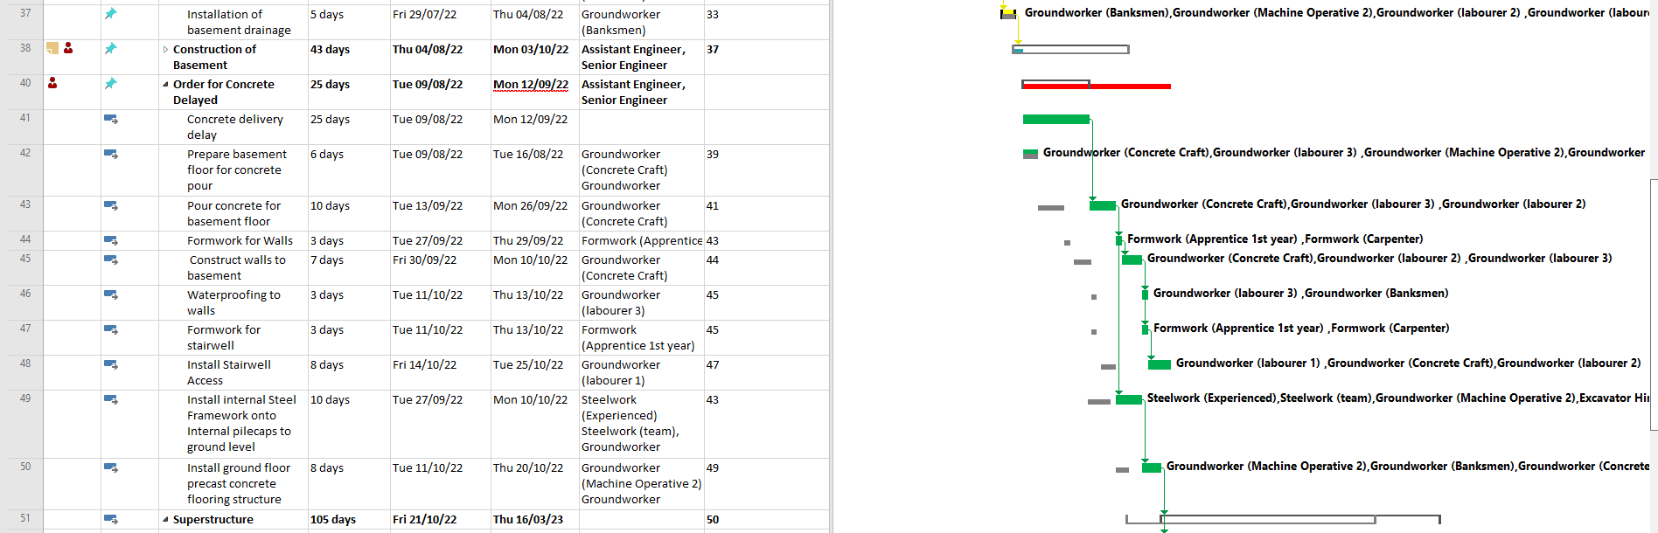
Figure 14: Task (left) showing the delay of 5 weeks for concrete and (right) showing the delay to our baseline of the project

The current works shows a clear delay from the set baseline throughout the whole of the remaining project. The reason for the delay will be looked at initially and dependent on the type of delay can depend on if there are any penalties or charges assigned to the client or contractor. The types of delays should be in the original contract and will be discussed following the issue arising.

An event that causes delay to the project can be known as a delay event. This may be and employer risk event of a contractor risk.
The different typed of delay can be a contractor delay. This may be due to resource issues, errors on site (work having to have to be redone) etc. this type of delay would usually come at a cost the contractor themselves. This would be where they either must pay damages to the client if there is a delay on completion, or the cost may be to bring in more resource in order to complete the project on time to prevent further damages costs.

An event caused by the client may be due to changes in design, material or giving the contractor possession of the site in the first place. These type delays will come at a cost to the client and would make them liable for the contractor to claim a direct loss expense. This could be because the delay in completion prevents the contractor beginning their next job on time and so on.

A neutral event which will not be the fault of either the contractor or the client. This could be from exceptionally adverse weather conditions, national strikes or changes in statutory requirements. These types of events may allow the contractor to an extension of time and but not necessarily allow them to claim a loss and expense due to this.

It would be expected that if there was a concern of a delay then an early warning indication would be submitted to the contract admin and identification would be required on the delay event.

In this case the delay may be considered a neutral delay due to a strike by the local company. Though this is not a national strike and discussion would be needed around if this was a foreseen event.

The client can instruct the contractor to accelerate the works regardless of whether the fault is of the contractors or not.

There are several solutions that can be used in this scenario which may rectify the issue. Discussion between the client and contractor would be required to come to the best solution. One solution may be to enquire to a different concrete company which may outside of the framework for the contractor/client.
If the concrete company is outside of the framework, then there may be delays in (dependent on company) in going through a procurement process.
There will more than likely be a higher cost incurred for the concrete as there is no pre agreed fees in place for the project.
The benefit to this though may be the delay to the concrete delivery may be reduced greatly.

These costs could then be compared to an increasing resource or overtime for the staff in order to recover the time lost to the 5-week delivery.
This added incentivization to the resource may be beneficial in reducing the time element to each of the tasks as the working hours will be longer. Again, this would need to be compared to hiring more resource or paying the overtime of the current resource to work the longer hours.
With a significant time, delay of 5 weeks, expecting the current resource pool to regain this time by working extra hours could be seen as a high-risk option. As the resource becomes more worked there may be risk of errors occurring which in turn may delay work on site further.

Again, dependent on the risks of the project and who the delay in costs fall to may depend on the action or route the client/contractor may take to attempt to complete the programme on time. I have completed an overview below on what may be presented to the client in terms of options for the delay and acceleration of the works.

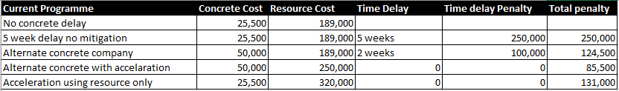
Figure 15: Table produced to show potential cost implications to the different scenarios in the acceleration of the project

The penalty would again depend on the contract in place prior to the construction programme and who the penalty is potentially assigned to. The client or the contractor.

In summary, the contract that’s initially agreed on and the programme, should be as detailed as physically possible and look at a whole host of potential issues. The better the programme is developed by the contractor with accurate costings, plans, resources, and timelines, the less risk there is of parts of the programme going wrong. It is also wise to agree a host of potential issues in advance in the contract so if there are any delays in the project, the costs and issues will fall on the correct party. When a contract has been signed then that is legally binding, and if there are any ambiguous sections missed by either party, then this will potentially go into court proceedings if there is dispute.

Bibliography

Society of Construction Law Delay and Disruption Protocol, 2nd edition, 2017

Incentivizing project performance in the construction of new facilities, Bryde and Joby 2007

Construction Contract incentivization schemes: lessons from experience, CIRIA, D Richmond-Coggan, London 2001

Construction contracts: law and management (3rd edition). E & F N Spon, London, pp381. ISBN 9780419261704

