PROJECT MANAGEMENT
ASSESSMENT 2
Anca Vasile
Student id:2018716

Executive Summary
Managing a project entail using a set of practises designed to realise a project while keeping to its specifications. Crossrail, which will connect more points of interest, is the city of London's longest active construction project. Some of the factors that led to its early success will be discussed in this report, as will the most essential project management practises and the issues that made it appear like a failure and a nightmare. Other elements that contribute to successful project management have also been discussed, alongside the reasons for failure. A recommendation has been issued describing the necessary steps that, if taken, may prevent the Crossrail project from collapsing.

Table of Contents
1. Introduction ……………………………………………………………………..............4
2.Main Body…………………………………………………………………….…………4
- My opinion about the project and research ..……………………..……………..4
- Problems that made the project collapse…………..…………….………………6
- Project management ……………………………………………….…………….7
3. Conclusion ………………………………………………………………………………9
Reference…………………………………………………………………………..............10

Introduction
The Crossrail project in London will connect several different parts of the city. The length of Crossrail, measured in stations, is 41. The project covers 73 miles. Heathrow, Reading, Shenfield, and Abbey Wood will all be linked by Crossrail. There are a few factors that will have an impact on this endeavour. Crossrail plans to connect 200 million people to major cities every year. This programme is supported by TfL and the government of the United Kingdom. This is the stuff of dreams, what with its innovative design and commitment to environmental sustainability (Crossrail.co.uk, 2022). The success or failure of a project is directly related to how well it is managed. Some difficulties emerged as the project progressed.
Establishing and maintaining criteria for a project is an integral part of project management. Continuous activities and resources, such as people, money, intellectual property (IP), and technology, are managed as part of the project management process. A comprehensive strategy outlining the steps to be taken from the beginning to the end of a project is essential. Different methods of project management are required to deal with the risks and uncertainties inherent in project creation. Crossrail is a massive undertaking fraught with danger. Unlike typical endeavours, this one was handled with care. In this study, I'll analyse its early success, important project management milestones, and problems that led to its failure and nightmare status.

Main body
The Crossrail project has been related to conventional methods of construction management, such as the detailed description of the project's design and the solicitation of construction bids for specific construction packages. The company has successfully managed its contingency budget, which has allowed for better risk assessment and mitigation, and a sharper focus on procurement costs. In addition, the Crossrail project's Responsible Company has set up a number of expert committees, each of which is made up of people with expertise in a certain area. Exception committees oversee tasks including procurement, tunnelling, and railway networks. The equipment and materials needed for the project were accumulated over the course of six months. The "Performance Assurance Framework" is the product of this analysis, and it includes the metrics of drive gathering, measured performance, and knowledge sharing. The health and safety, commercial, quality, community relations, social sustainability, and environmental aspects of the project were prioritised under the framework (Medeossi, 2019). The decision to create a digital model of the project necessitated the examination of not only its construction and design, but also its future operations, as well as the use of conventional methods. The term "digital twin" was used to describe this approach. As part of the rigorous standards and requirements set by Crossrail Ltd. for the aim of ensuring the effective running of the Crossrail project, all contractors working on the Crossrail project are provided access to a suite of Crossrail-specific software and processes.
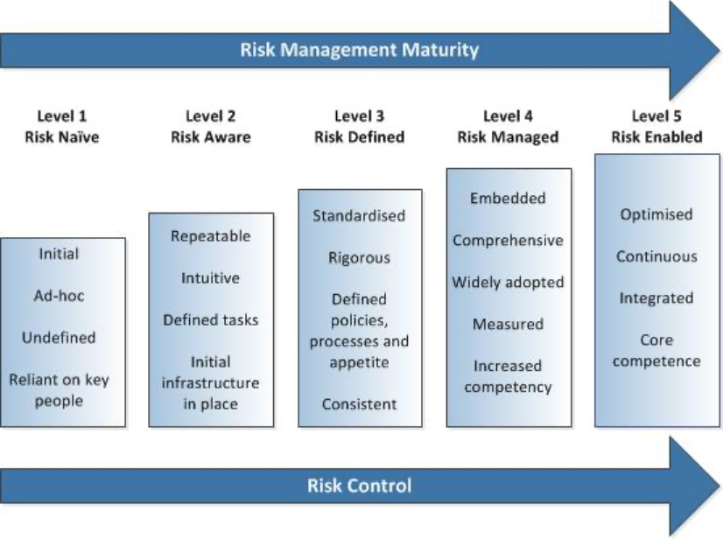
Some of the most important recent developments are the Crossrail-Bentley Information Academy, Innovate 18, and the learning legacy. These methods have been essential in improving the efficiency of many other endeavours. Increased innovation in the operational process may be attributed to the Crossrail-Bentley Information Academy's success in creating a synergy between the physical model and the digital model. To that end, Crossrail Limited and Bentley Systems have formed this partnership. Crossrail is said to have an elaborate strategy for gathering both a real-world and digital picture of the project at the same time. Implementing this vision might help accomplish a number of objectives, including better project delivery. Crossrail included Building Information Modeling (BIM) and the Common Data Environment (CDE) as a consequence of this collaboration (CDE). This has led to an uptick in novel contributions to engineering design, a decrease in waste generation, and lower expenses associated with upkeep of railways in the future. Brentley is in charge of making sure that Crossrail is adopting, developing, and documenting best practises in the field of digital and IT infrastructure (Lobo and Abid, 2020). Further, BIM has been useful for construction review and briefing meetings, as well as for linking together different project bases. Achieving the desired results in the decision-making process was facilitated by using this digital twin.
Without Innovate 18 and Learning Legacy's support, the programme would not be feasible. It has been brought to my notice that the basic objective of Innovate 18 is to make it easier for different groups to share, learn from, and build upon one another's knowledge and ideas. My research indicates that this site successfully bridges the gap between civil engineering professional organisations, construction industry leadership councils, and international business groupings. Health and safety, digital-physical integration, viable solutions, and efficient delivery are just a few examples of how Innovate 18 has helped guide innovators in the right direction. A paper named "Crossline Learning Legacy" has been drafted to distribute the project's lessons learnt (Crossrail.co.uk, 2022). A wide range of details from the project's earlier phases, such as planning and procedures, are included here. Usage of a Toolbox Comprised of Case Studies and Best Practices Documentation
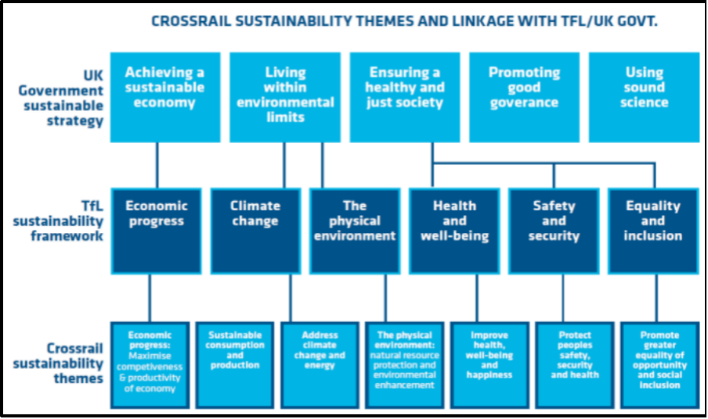
Sustainability is the mark of a job well done from the start. Financial and ecological stability are aided. Over the next 60 years, it is expected to generate £42 billion in revenue. It will add an estimated £10.6 billion to the value of London's real estate. An estimated 55,000 new jobs were generated in the United Kingdom as a result of Crossrail building projects, and hundreds of small businesses were given a chance to expand their operations. Crossrail Ltd. hopes to reuse or recycle 98% of the debris generated by the excavation process by placing it in green spaces and natural areas. Emissions from the project are reduced by filtering out 39% and recycled by another 83%. The initiative's goal was an 8% reduction in carbon emissions; an 18% reduction was actually accomplished. According to research (Nao.org.uk, 2022a), the answer is yes. A device that guides contractors in selecting appropriate tools for the job has made this a reality. As a result of the project, less energy was used. The use of LED lighting decreases energy consumption and carbon emissions over time. There is a 32% drop in carbon dioxide emissions due to building.

The problems which made this project to collapse
The target completion date for the project has been set for 2018. Still, the process took much longer than expected. This has resulted in an updated construction timeline and budget, both of which have been approved by Crossrail Ltd. and the funders. An all-new management group has been sent to the field, and they are starting from square one. From 2019 through 2020, the project allegedly repeatedly missed deadlines. (Ting, 2021). This is because Crossrail Ltd. is finding and identifying new challenges and issues with the current design. Crossrail Ltd. moved on with a new approach to execute plans with higher expected levels of productivity. In August of 2020, the organisation began working on a cost estimate and schedule to complete further sets of jobs. Due to this, progress on the project slowed significantly. The project's completion date has been pushed back and its total cost has increased due to the lockdown.
The total cost of the project has risen by 15%, and this fact has been brought to everyone's notice. In addition, when the lockdown was declared, no construction was permitted for the next nine weeks. The process of coordinating the activities of different systems and resources is yet another newly uncovered element. More than half a million pieces of hardware and software are sitting idle and waiting to be put to good use. The lack of commercial levers between Crossrail Ltd and contractors to prevent cost overruns and timetable slips has been called the project's worst flaw. There will be 19 more contracts for a combined £1.3 billion after 2019. (Nao.org.uk, 2022b). I've mentioned it before: the strength of a project committee depends largely on the quality of its members. With so many key roles along the Elizabeth line unfilled, Crossrail was unable to complete construction on time. It made it more challenging to restore the team's capacity and talents.
Implementing the plan in practise
The complexity of bringing the Elizabeth line into service stems from the fact that it relies on many separate factors, all of which must be functional simultaneously. The Elizabeth line's duties have been split and distributed across many different organisations, such as Network rail, MTRL, and RfLi. There is a specific goal for each duty. I've seen that whenever there's an internal transfer of authority, the service delivery time balloons significantly. Even though Crossrail's test runs have started, the remaining work after the test runs and operation will start to grow more complex, exposing greater risks. The higher costs associated with the risk mitigation strategies will be included into the total project budget. Upward revisions of the original estimate range from 800 million to 1.1 billion pounds (Nao.org.uk, 2022a). There are still steps that need to be taken that might end up adding to the final price. The cost will go up since the operational testing uncovered major problems that need fixing.
achieving a favourable rate of return
Based on my prior investigation, I have determined that the proposed project would provide a positive return and add to the nation's cost advantages. However, the savings were a result of studies undertaken between 2011 and 2015 and rising rail ridership. It has been observed that the normal pattern of travelling and travel to far-flung regions has diminished as a consequence of the pandemic scenario and the most recent statistical data that has been revealed. An annual revenue risk of around 150 million pounds has been attributed to the current trends (Gsd.harvard.edu, 2022). It's possible that further monetary benefits might result from this effort. The development of a readily accessible railway calls for the implementation of strategic measures, such as those that have positive effects on the local ecosystem, the local economy, and the local rehabilitation efforts.

Project Management steps
The process of project management is ongoing from the commencement of a project until its conclusion, and it is intimately connected with the key stages that define the project life cycle. The establishment of the project's deliverables is at the heart of any and all project management, and the project managers play a crucial part in this process. The many stages of the project management life cycle will be emphasised in this presentation. Initiation, planning, execution, maintenance, and closure are the five stages that make up project management. The beginning of the project is both the first and most essential step in the process of determining what will be delivered by the project. At this point, there will be testing as well as research that can be conducted. During this stage, documentation of the project's needs and the starting paperwork is typically completed. According to San Cristóbal et al. (2018), this stage also includes the analysis of stakeholder needs and business requirements in addition to business care. Second, planning a project results in the creation of a road map for the project and ultimately determines how successful the project will be. At this point in the process, the organisation of teams and the consolidation of resources are two of the most significant goals. It's possible that using certain frameworks, like SMART objectives, may assist a project in reaching its most critical objectives. Included in this are things like the project scope, the work breakdown structure, the communication strategy, and the risk assessment.
Thirdly, the execution of the project contributed to the development of the team as well as the competition for deliverables. It includes the assessment of a variety of reports, transitions, and updates that contribute to the performance and monitoring of the project. During this stage, the project will be introduced, the team will be built, resources will be allocated, the project plan will be carried out, the procurement process will be managed, tracking systems will be set up, tasks will be scheduled, and the plan will be altered as required. Monitoring and assessing the progress of a project is an essential step in the process of developing Key Performance Indicators (KPIs). Some of these indicators include the project objectives, the high quality of the deliverables, the monitoring of costs and efficiency, and the performance of the project. The last step of a project is called "closure," and at this stage, meetings assess both the successes and the failures. At this point, it is determined whether or not the project was a success and if there are any areas in which it may be improved. The completed and archived final report for the project has been generated. Because Crossrail Ltd maintains such stringent standards and criteria, each and every contractor who is working on the project has access to a variety of Crossrail and software protocols (Larsson, 2020). It is very evident that Crossrail views the project as simultaneously having a physical and virtual vision. The assistance provided by Innovate 18 has been beneficial to the innovation.
It has been suggested that good project management requires a number of different characteristics. According to the findings of my investigation, a project may be considered a success if it satisfies the requirements of the company, is delivered on time and in accordance with the plan, is delivered and under budget, and achieves the value that was anticipated. It has been emphasised that effective project management is an essential initial step, which is one of the many factors that will determine the level of success achieved by the project. I have placed a focus on a few components that are essential to the successful completion of a project. One of the most important and meticulous things to keep in mind is the need of laying out clear, understandable goals and engaging in exhaustive preparation. The assessment of deliverability using early criteria, meticulously planned implementation, precise technical specifications, realistic estimates, and process scheduling are the primary conditions for any project (Lauer, 2021). Standard software infrastructure as well as the development of a formal system methodology are both necessary components for the effective completion of a project. Personnel, consisting of a qualified team and committee, is the last significant aspect that contributes to success.
In addition, I have identified a few factors that are likely to result in the failure of a project. The primary factors contributing to this issue are incomplete requirements and a lack of interaction from stakeholders. During the development of the project, the project's stakeholders need to have the ability to have a significant influence and access to information about every method that is designed or followed. Inadequate planning and quality assurance or control processes that are not carried out correctly are often to blame for failed projects. Technology plays an important part in the completion of a project successfully. On the other hand, not having enough expertise in the relevant fields, not having enough resources, and having high expectations might lead a project to fail and be related with other aims (Antony, 2018). Uncertain objectives, arbitrary timelines, and the use of technology with little to no track record of success will all contribute significantly to the failure of a project.

Conclusion

One may conclude that appropriate project management is necessary and entails a number of cautious strategies that must be used based on the situation in order to achieve successful projects. This study discusses both the factors that contributed to ineffective project management and those that did not. A project is deemed successful if it fulfils all of the following requirements: it has satisfied all business requirements; it has delivered on time and has been maintained in accordance with schedule; it has delivered on budget and has produced the expected value. The two main reasons are unmet demands and insufficient input from pertinent parties. Both the early successes and related problems of the Crossrail projects have been highlighted. Although it was anticipated that the project would be completed by 2018, it subsequently fell farther behind schedule. It has come to our knowledge that the project's cost has increased by an extra 15%.
It is conceivable to suggest that a strategic approach be taken in order to lower the cost rise, delays, and increased risk of the project similar to HS2, which is a gigantic project designed to provide high-speed train linkages between London and important cities in the Midlands and the North of England. Additionally, it has been noted that there is a necessary lack of communication. The relevant department should have written to the committee and asked them to support more openness and transparency among the delivery organisations. In order to guarantee that the critical programmes are completed on time, the project needed to have given some attention to going back through them. Additionally, updates should be sent on a regular basis to the department in charge of making sure that the crucial development is finished within the authorised time. The agency has often been unable to identify the root causes of issues. An action plan that was more concise and sensitive would have been produced had all project stakeholders taken part in an evaluation of the situation following 2019. The project's overall cost is anticipated to be in the three-billion-dollar range. The project's projected value for money initiative is in peril. Due to this, taxpayers should have received evident priority throughout the time of expense increases. Considering the current situation, different steps must also be implemented, such as looking at various risk variables and doing cost-benefit evaluations.

Reference
Journals
Antony, J. and Gupta, S., 2018. Top ten reasons for process improvement project failures. International Journal of Lean Six Sigma.
Larsson, J. and Larsson, L., 2020. Integration, application and importance of collaboration in sustainable project management. Sustainability, 12(2), p.585.
Lauer, T., 2021. Success factor project management: managing complexity correctly. In Change Management (pp. 185-201). Springer, Berlin, Heidelberg.
Lobo, S. and Abid, A.F., 2020. The role of social media in intrastakeholder strategies to influence decision making in a UK infrastructure megaproject: Crossrail 2. Project Management Journal, 51(1), pp.96-119.
Medeossi, G. and Nash, A., 2020. Reducing Delays on High-Density Railway Lines: London–Shenfield Case Study. Transportation Research Record, 2674(7), pp.193-205.
San Cristóbal, J.R., Carral, L., Diaz, E., Fraguela, J.A. and Iglesias, G., 2018. Complexity and project management: A general overview. Complexity, 2018.
Ting, C., Gilson, B. and Black, M., 2021. Developing the 3D geological model for Crossrail 2, London, UK. Quarterly Journal of Engineering Geology and Hydrogeology, 54(2).
Website
Crossrail.co.uk, 2022 Crossrail Review Available at: https://learninglegacy.crossrail.co.uk [Accessed on 6 August]
Gsd.harvard.edu, 2022 Crossrail -Elizabeth Line London, UK Available at: https://research.gsd.harvard.edu [Accessed on 6 August]
Nao.org.uk, 2022a Crossrail – a progress update (Summary) - National Audit Office Available at: https://www.nao.org.uk [Accessed on 6 August]
Nao.org.uk, 2022b Crossrail - National Audit Office Available at: https://www.nao.org.uk [Accessed on 6 August]

