Leading Digital and Strategic Change BMSW7003
Assignment Guidance Steve Griffiths 28 March 2023.
Last session workshop.
Some general guidance and some examples. Many from my ppts delivered in lectures so do look back and at resources on Moodle.
As you can see I got a little taken up with Sonya’s Morrisons example, but the same can be done for your case company.

- The focus of the assignment. Leading digital change, based on a strategic analysis.

Try to stay relevant to the answers to the task set, NOT the one you would rather answer!
Do the basics:
Definitions
- Your case organisation: structure and culture.
- Markets and competition.
- Strategic goals
- Strategic choices
- Collaborations and servicing with/by other organisations.
- Leadership.
- Managing Change.
- Digital investment/transformation

Apply to examples: products, services, categories, industries, etc.
Evaluate how your case fits in with models and concepts.
Note academics all develop their theories, have disputes with each other and develop rival models. Sometimes there is little difference between them. Therefore the student’s job is to pull out the key common factors and discuss if any variations are important.
There is unlikely to be one perfect answer or application. It is your examples, analysed which will demonstrate your understanding of the concept.
See below for the many influential variables. Most theories and models have to adapt to changes in the environmental influences/variable. No theory is 100% perfect.
- Critical perspective.

Critical perspective is the way in which you use a sceptical (not cynical) perspective to challenge everything.
Definitions. Models/theories. Applications. Conclusions drawn etc.
You need not make up all this. It will be gifted to you in the readings/ research that you do. So long as you quote your sources when you manage the different arguments, you will do well.
Analysis and evaluation, engaging with the literature are keys to success.
- Analysis and Evaluation.

To score higher grades academics pride themselves on their:
Analysis: Having an informed debate using different perspectives to review the evidence. The ability to see more than one perspective.
Evaluation; Making a logical judgement. In this task it would be, what definitions to run with, what examples to illustrate the concepts, what are the implications of the analysis, which marketing strategies would help?.....
Both should be backed up by references to the academic literature, where subject specialists will already have had these discussions. However they frequently disagree, so your task is to disentangle their debate to make it fit your narrative.
Unfortunately many assignment answers simply REPORT what brands are or what the action was. Reporting/describing is a lower order skill, which at your level will not give you marks. See advice on using appendices.
Discussion on converting a description to analysis.

- Referencing styles: APA 7th style conventions (including the reference list).

- Do not use the 1st person (I or We) which is poor academic style.

- Do not waste time and words with overlong clunky referencing. Just stick to Author Name, Date and then let the reader see the full reference in your reference list at the end. There were errors in using naming or sourcing in your text. For example:

(Please note these are made up references!!)
Griffiths (2023) says that starting with a quick Google Search can help you set the scene and identify things you need to look at in more depth.
Or
Always start with a Google search, collect abstracts, which allows a quick way to see who noted authors are, which you can return to when you have set up your report plan. (Griffiths, 2023).
In the reference list:
Griffiths, S.L. (2023) The Lazy Student’s Guide to surviving assignments. Swansea: Knock Off Books.
More than one author:
Griffiths and Porter (2020) Challenge the concept of leadership in an e-Commerce environment in the C21st.
More than two authors:
Griffiths et al. (2019) review branding as a means to reduce consumer perceived high risk purchasing decisions.
However in the reference list:
Griffiths, S.L., Pitson, M. and Johnson, B. (2019) How to tell the truth in change management. Journal of Hazy Storytelling, Vol.2, No.1, pp. 23-26.
- Currency/Up-to-datedness (Not sure this is a real word). It is ok to use the classics or your standard textbook, but try to update. This is particulalry true for internet or e-Commerce discussions.

Try to vary authors. If we see the same author being “overused” it looks lazy. Mullins (2006) says this…..Mullins (2006) says that…….
- Authors with different perspectives. This is your major task and it will show that you have really investigated the topic thoroughly. Helped by a “reader” article.

Back up all examples with articles/sources.
Best if you can get academic articles to back up, if not media or industry magazines. Some source is better than no source.
Commentator site:

Digital Adoption (2023) What Are the 4 Main Areas of Digital Transformation? 21 February. https://www.digital-adoption.com/what-are-the-4-main-areas-of-digital-transformation/ (Accessed 23-03-23).
Academic source:
Hanelt, A., Bohnsack, R., Marz, D., & Antunes Marante, C. (2021). A systematic review of the literature on digital transformation: Insights and implications for strategy and organizational change. Journal of Management Studies, 58(5), 1159-1197. https://doi.org/10.1111/joms.12639
In this article we provide a systematic review of the extensive yet diverse and fragmented literature on digital transformation (DT), with the goal of clarifying boundary conditions to investigate the phenomenon from the perspective of organizational change. On the basis of 279 articles, we provide a multi-dimensional framework synthesizing what is known about DT and discern two important thematical patterns: DT is moving firms to malleable organizational designs that enable continuous adaptation, and this move is embedded in and driven by digital business ecosystems. From these two patterns, we derive four perspectives on the phenomenon of DT: technology impact, compartmentalized adaptation, systemic shift and holistic co-evolution. Linking our findings and interpretations to existing work, we find that the nature of DT is only partially covered by conventional frameworks on organizational change. On the basis of this analysis, we derive a research agenda and provide managerial implications for strategy and organizational change.
- Use of examples.
Examples apply the concepts, can be “interrogated” and show your mastery of the topic. In most cases there will be no agreed answer, but you must still seek alternatives and manage the debate.
Where do you get them?
The class is aware of my use of industry, category, commentator and other media sources. Please make sure however that you build an appreciation that these sources are not academically reliable or valid, since they are not refereed or based on academic primary research.
However……….they do vary in quality….
Academic sources……use the data bases.
Go to sources.
- Word count. University policy ‘deduct marks for going over’.

- Managing your arguments.
Get to the main focus as quickly as possible. Then look for opportunities to revisit the concept of high perceived risk, to make some sort of judgement (evaluation) on whether you example or even the concept is valid.
Plan a structure.
Possible plans.
Themes:
- Strategy in general but upgraded to your case.
- Environmental factors that impact on strategic choices, then evaluate.
- Justify the digital investment.
- Background in Change and Leadership theory, then upgrade to your case.
- Derive logical conclusions and recommendations. (Refer back to underpinning discussions and analysis).

In all cases find academic articles for back up. See my Abstract references.
- What can leaders do?

Many of the solutions involved communications, market & organisational research to get to know consumers/employees better, customisation of products for consumers’ needs, differentiation to make the brand special (essential) in the eyes of the consumer i.e. brand loyalty. However in changing circumstances consumers influential variables will change, some consumers are fickle. Other stakeholders may change their priorities e.g. workers, suppliers, Board of Directors, financiers etc. Some cultures are difficult to change.
Are some barriers to change immovable?
Are some leaders bound to fail, even if they are good?
- How do we tie it all together? Links to the discipline?

Back to Mission and objectives, strategy, choices, implementation and control and the way leaders might react, in order to give advice.

Kotler, P. (2018) Kotler on Marketing: How to Create, Win and Dominate Markets. NY: The Free Press.
There are three kinds of companies: those who make things happen, those who watch things happen, and those who wonder what’s happened. – Anonymous
Customers are increasingly choosing vendors on the basis of long-term value, not long-term history.
There are two kinds of companies: those who change and those who disappear.
1. Win Through Higher Quality
2. Win Through Better Service
3. Win Through Lower Prices
4. Win Through High Market Share
5. Win Through Adaptation and Customization
6. Win Through Continuous Product Improvement
7. Win Through Product Innovation
8. Win Through Entering High-Growth Markets
9. Win Through Exceeding Customer Expectations
https://www.researchgate.net/publication/265069529_Kotler_on_Marketing_How_to_Create_Win_and_Dominate_Markets [accessed 19-03-23)
You can register with Research Gate as a “Researcher” using your University email.

Assignment Tasks
- Conduct a strategic audit for your organisation or an organisation you have studied. Evaluate its strategic environment, strategic opportunities and possible strategic choices. (40%)

Case organisation Mission/Objectives/ Past history.
Most of it is likely to be found on its website, annual reports or policy document.
XXXX's mission is simple: “Develop the Stakeholders, Touch the World, Build a Better Future”.
What are the xxx values?
What is the motto of xxx?
What is the current goal of xxx?
What does xxx believe in?
You might wish to criticise these.
You might like to see how consistent xxx is in applying its mission and values.
Analysis of corporate culture? Example: Microsoft (2023) see appendix 1 below.
Values Accountability
We accept full responsibility for our decisions, actions, and results.

Integrity
We are honest, ethical, and trustworthy.

Respect
We recognize that the thoughts, feelings, and backgrounds of others are as important as our own.
Some objectives e.g. making profit might need to compromise to achieve other objectives e.g. environmental protection (eco environment , rather than business environment).

Business Environment Analysis.
Make sure you have examples and sources for the list of things in these matrices.
SWOT Table x
Strengths  People -high motivated at the beginning. | Weaknesses  People- high turnover
Opportunities | Threats

Morrisons past history in managing change e.g. M&A activity re Safeway.
Toms, Steve, Turnaround at William Morrison Supermarkets PLC, 2004-2007 (December 11, 2015). Leeds University Business School Working Paper No. 16-05, Available at SSRN: https://ssrn.com/abstract=2702265 or http://dx.doi.org/10.2139/ssrn.2702265
Morrisons case of limited liability for damages due to rogue employee and digital data protection

Hordern, Victoria 2020 The vicarious liability of employers for employees in the context of UK data protection law – WM Morrison Supermarkets plc v Various Claimants, 1st April. Journal of Data Protection & Privacy, Volume 3 / Number 4 / Autumn/Fall 2020, pp. 455-459(5).

PESTLE

Political | Economic
Social  New generations care more for the environment. | Technological
Legal  Laws and regulation on environmental standards are getting stronger. | Environmental  Environmental demonstrators are having an impact on real business processes and the image/PR of the company.
Table Y.
From Tables X and Y, the SWOT and PESTLE can be linked together e.g. skilful people are a strength and are attracted to the organisation because it fits the social, cultural, ethical developments in society. However Gen-Z are less likely to stick with organisations if they become disillusioned or frustrated, feeling empowered to move jobs easily, hence danger of high turnover of skilful people.

For Morrisons, poor performance in a static economy
https://www.theguardian.com/business/2023/feb/15/morrisons-credit-rating-downgraded-after-report-of-poor-sales-and-profit#:~:text=The%20downgrade%20was%20triggered%20by,agency's%20expectation%20of%206.5%20times.
Is digital and improving online the solution for them?

Porter’s 5 Forces-
You do not have to talk about all 5 forces. However refer to the diagram and analyse that perhaps for Morrison’s supermarket, existing supermarkets (the big 5) and threat of customers moving online, when Morrison’s online shopping app has been criticised, is the main focus for the company’s strategic choice.
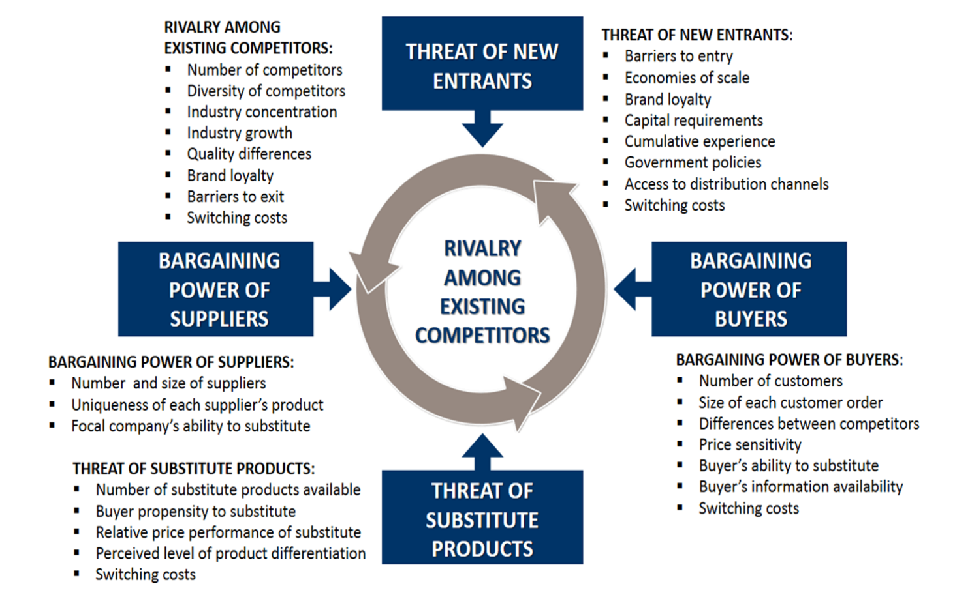
Do back up with sources for back up.
Even if these are media sources e.g.
https://www.dailyrecord.co.uk/lifestyle/morrisons-named-uks-most-complained-26947575
https://www.scotsman.com/lifestyle/food-and-drink/morrisons-issue-apology-after-whisky-price-blunder-offered-a-bottle-of-glenlivet-single-malt-scotch-for-just-ps250-3734560
https://www.campaignlive.co.uk/article/morrisons-lagging-online-shopping-does-fare-social-media/1300760
https://groceries.morrisons.com/content/new-look-morrisons-66795#:~:text=Our%20online%20delivery%20service%20and,from%20your%20local%20Morrisons%20store.
https://www.reuters.com/article/us-morrisons-online-idUSBRE9AK14O20131121
https://www.examinerlive.co.uk/whats-on/shopping/morrisons-issues-urgent-update-customers-21931472
Make sure you quote them properly.

Amazon?
Cheng, T.K., 2022. Buyer Power in the Digital Economy: The Case of Uber and Amazon. NYUJL & Bus., 19, p.1.
The power changes with e-Tailing??
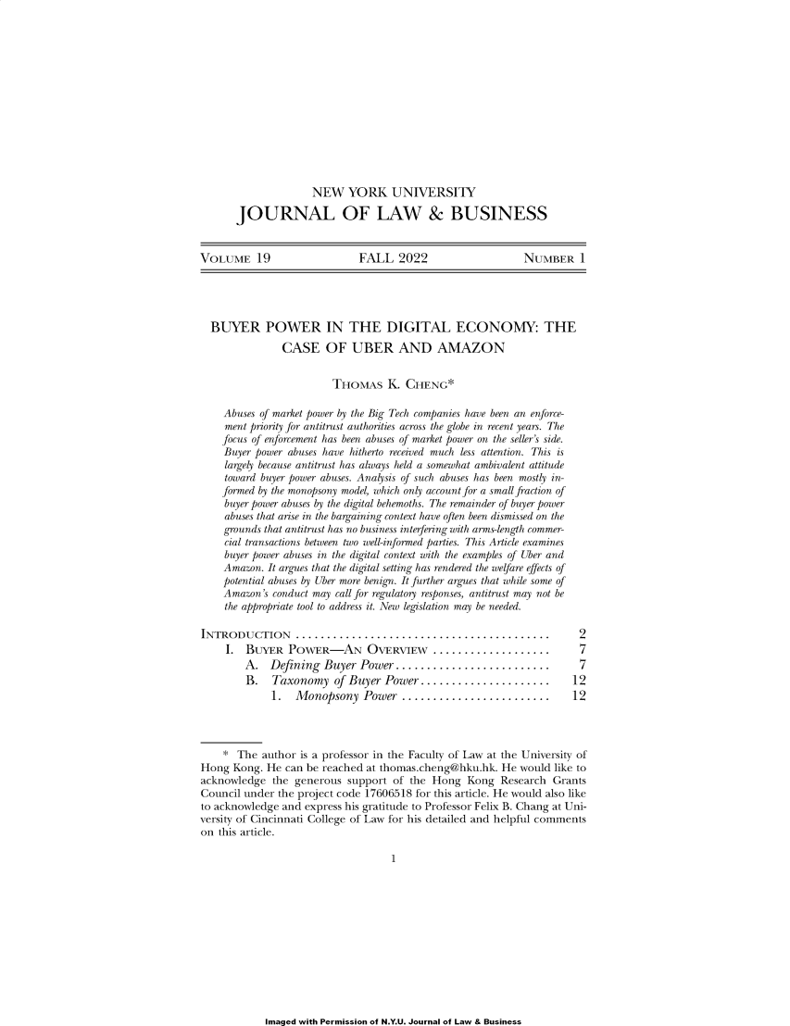
Company/Product/Brand Life cycle: Drucker’s Product Life Cycle (PLC)
(Source: PLC from consulting group briefing paper https://kfknowledgebank.kaplan.co.uk/business-strategy/strategic-analysis/product-lifecycle-analysis )
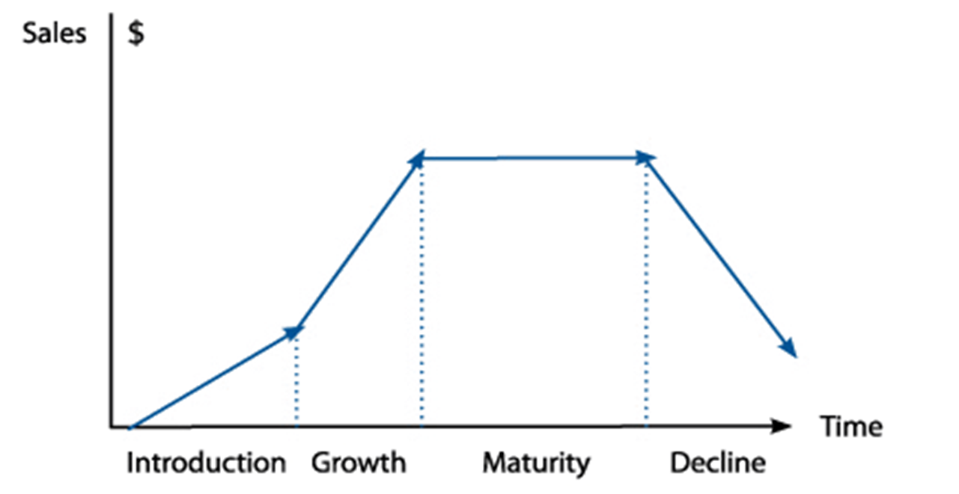

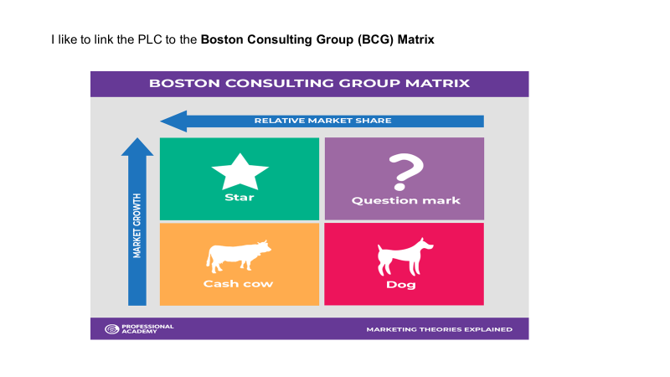
Strategic Choices
Porter’s (2002) Generic Strategies
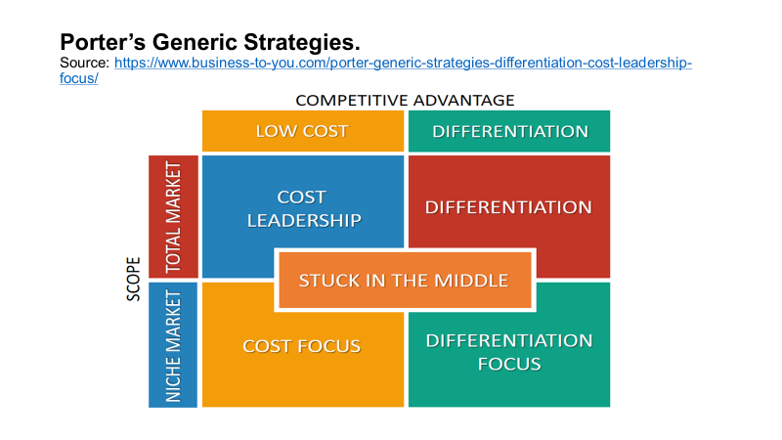

Ansoff’s Matrix:
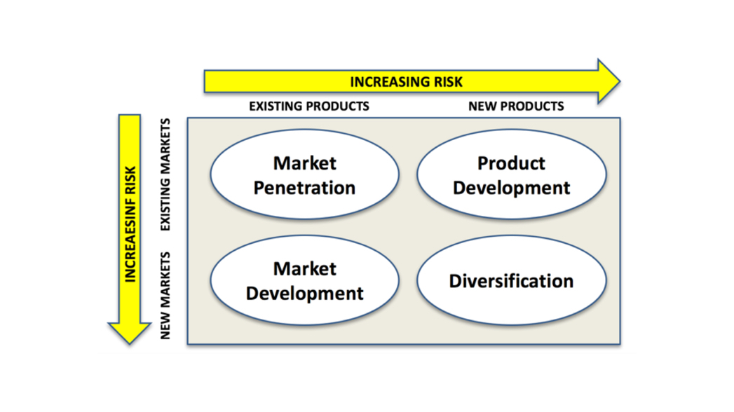
I don’t normally recommend this sort of “buy and essay” site however if it has anything interesting to say use it but be careful. This is for Morrisons and their IT/IS strategy.
https://www.totalassignment.com/free-sample/strategic-information-systems-assignment-business-strategy-for-morrisons

Digital strategy for retail…how does Morrisons fit in? Can you find an update?
https://www.emerald.com/insight/content/doi/10.1108/09590550610660279/full/html?casa_token=fcBdkiQ-ENIAAAAA:4eAcLAgVspw4fSny0ZNhRIqh8Z88Do6puVR6WQqWo7CBHnm3AMuDoiMTD2cKiWfHBmB894DsGSCkO2N0TPQhzvKwi32M8ovr7pEDIYFOIFXemOb_YC_z
Harris, M., 2009. Machine for shopping-[engineering future]. Engineering & Technology, 4(11), pp.18-20.

Your conclusion can map a variety of strategic approaches but must include some digital innovation/investment/ policy adoption, which must follow the underpinning strategic environmental analysis.
Digital transformation
Digital investment
Digital update/improvement.
How does it fit the rest of the analysis?

- Analyse the organisation’s choices in the context of two different leadership theories to evaluate the likelihood of success for each. (20%)

Whatever your digital innovation is, analyse and evaluate the best leadership style, likely to make it a success. Contrast this with an alternative, justifying why one approach might be better than another. However it is open to judge that if the environmental factors were different another leadership approach might be valid.

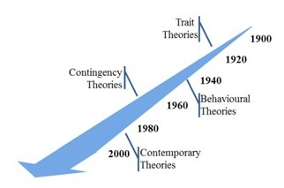
Source: Redmond, J. (Undated) Strategy and the importance of strategic leadership. CPA Ireland. https://www.cpaireland.ie/CPAIreland/media/Education-Training/Study%20Support%20Resources/P2%20Strategy%20and%20Leadership/Relevant%20Articles/cpa-article-strategy-and-leadership-final.pdf (Accessed 12-01-23).

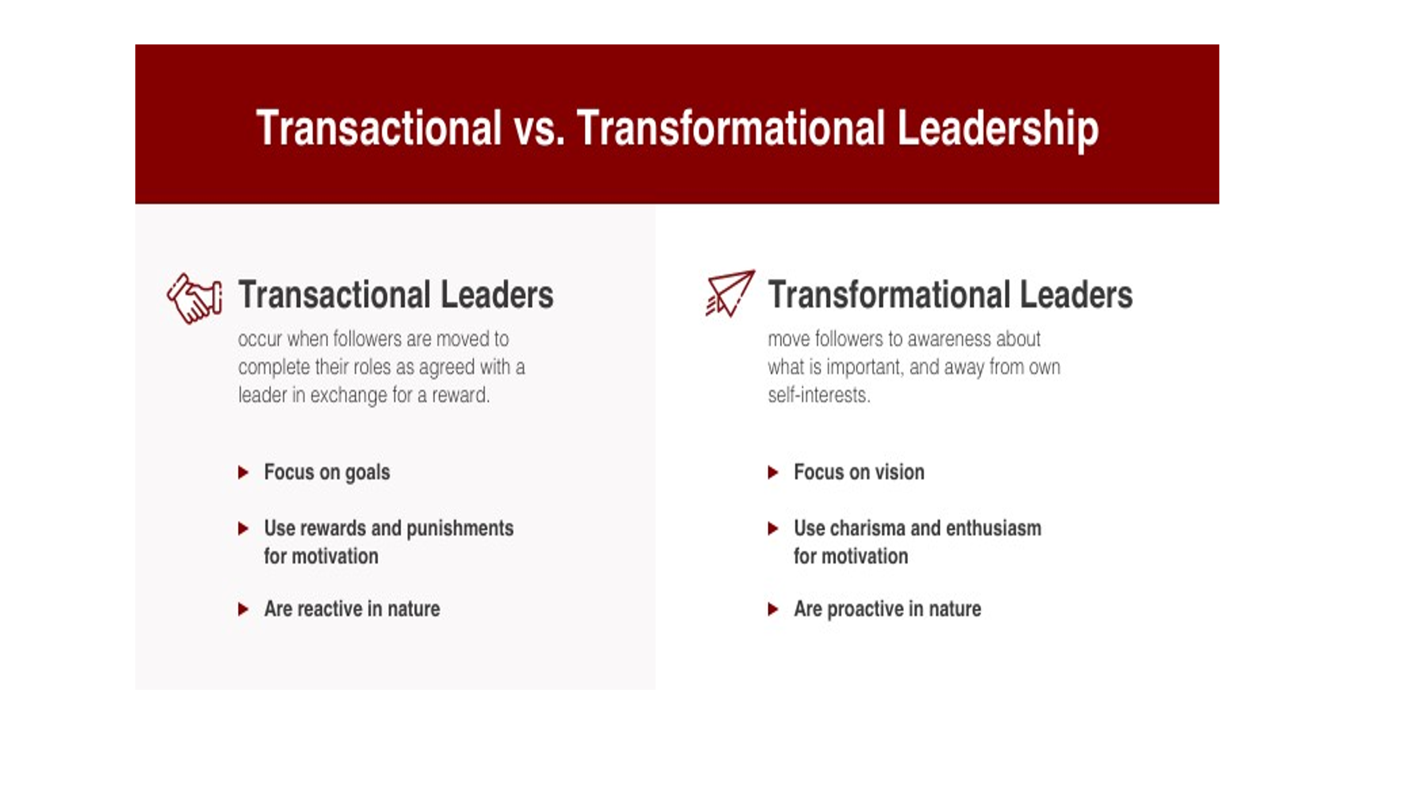

Are there common influential/variable themes/factors?
What environment?
What organisational culture?
What tasks?
What time constraints exist?
What resources are available?
What followers?
What leaders lead the leaders being analysed?
How might they play with the challenge of digital investment/innovation?

- Make logically derived recommendations to the organisation on how to improve its strategic leadership function with special reference to a digital investment/implementation. (40%)

Task 3 requires you to review a digital development, analyse how it can help leaders achieve strategic goals and evaluate some guidance how this might be done. The digital investment/process is your choice, but you will be asked to share what you plan to analyse in session 6.
Link:
- Organisational details
- Management culture
- History/management of change
- Leadership style
- Constraints/barriers to change and how to overcome them.
- Likelihood for success.
- Fall back policy?

Does Morrisons have the Resource Based View (RBV) or Digital Based View (DBV) to take advantage of digital innovation? This article does mention the supermarket. Need to access via the data bases.

Richard W. Cuthbertson ª ^{b}, Peder Inge Furseth ^{c} Digital services and competitive advantage: Strengthening the links between RBV, KBV, and innovation. Journal of Business Research. Volume 152, November 2022, Pages 168-176. https://doi.org/10.1016/j.jbusres.2022.07.030

Note that some of the readings state that a very high percentage of digital investments fail, perhaps there should be a fall-back strategy. What happens if it goes wrong?
Need for organisational resilience.
Jim Boehm, Wolfram Salmanian, and Daniel Wallance (2023) A technology survival guide for resilience. McKinsey & Company. 24 March. https://www.mckinsey.com/~/media/mckinsey/business%20functions/risk/our%20insights/a%20technology%20survival%20guide%20for%20resilience/a-technology-survival-guide-for-resilience.pdf (Accessed 27-03-23).
Technology resilience is the sum of practices and foundations necessary to architect and deploy technology safely across the technology stack Technology resilience prepares organizations to overcome challenges when their technology stack is compromised, reducing the frequency of catastrophic events and enabling them to recover faster in the case of an event.
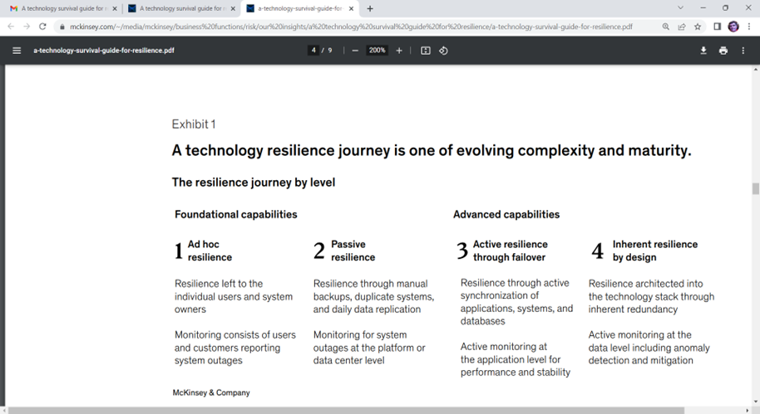

As with all types of protection, it’s not “you get what you pay for” but rather “you get what you prepare for.” It would be easy to throw money at all forms of resilience, but understanding what you possess and then having visibility and transparency into what you have will bring focus, allowing any organization to remain resilient and either stay up and running or get back to a steady state as soon as possible.
Morrisons needed resilience to survive the hostile customer reaction to its new loyalty card, a digital innovation, which didn’t go to plan.
https://www.mylondon.news/whats-on/shopping/shoppers-disgusted-morrisons-new-system-20576913

Cyber risk?

Ida Kristensen Managing a cyber risk event: ‘Be a student of a crisis’.
March 3, 2023 | Interview https://www.mckinsey.com/capabilities/risk-and-resilience/our-insights/cybersecurity/managing-a-cyber-risk-event-be-a-student-of-a-crisis

Five years ago, Equifax Inc., a global credit-reporting agency, was the victim of a 2017 data breach, exposing the personal information of 147 million people. As the crisis unfolded, Julia Houston, the company’s chief strategy and marketing officer, was part of the team managing the fallout.
Her takeaway: “Every executive really needs to be a student of crisis.”
Could there be a case for being a Laggard?

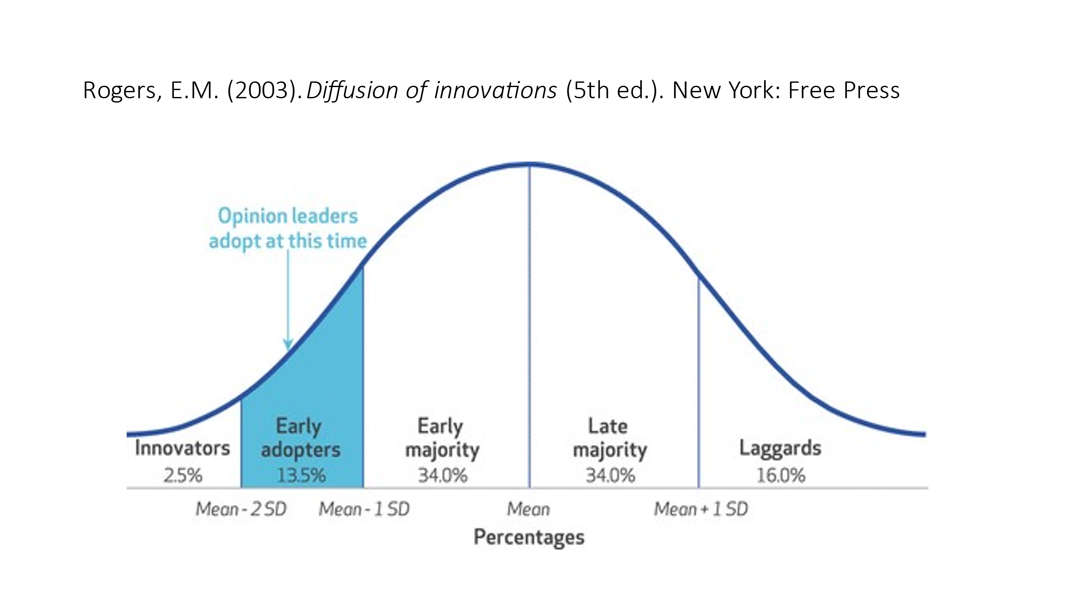
See lecture ppts.

Murat Oturakci ª, Oya H. Yuregir ^{b} New approach to Rogers’ innovation characteristics and comparative implementation study. Journal of Engineering and Technology Management, Volume 47, January–March 2018, Pages 53-67. https://doi.org/10.1016/j.jengtecman.2017.12.004

With this study, gaps in Rogers’ diffusion theory were handled and these research questions were derived: i. “What are the impacts of organizational characteristics such as leadership, strategy, market orientation, organizational learning and communication on Roger’s diffusion theory”, ii. “What are the impacts of employees’ characteristics such as age, gender, department, education and experience on Roger’s diffusion theory?”

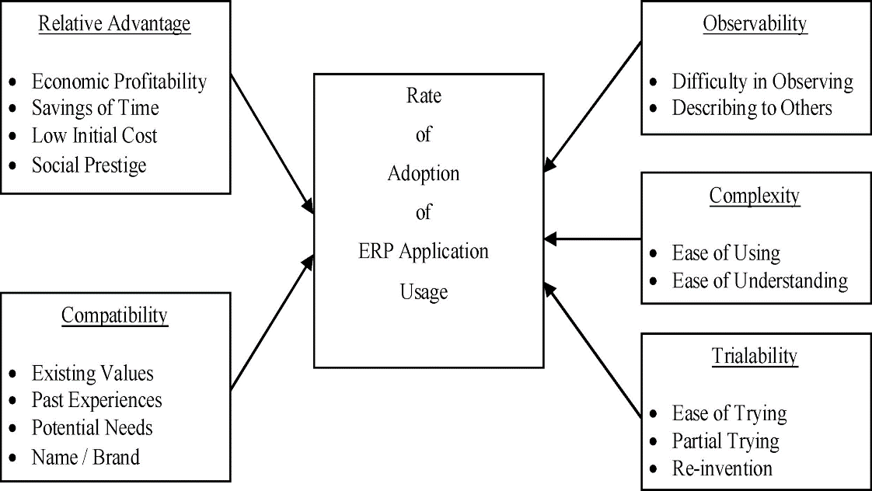

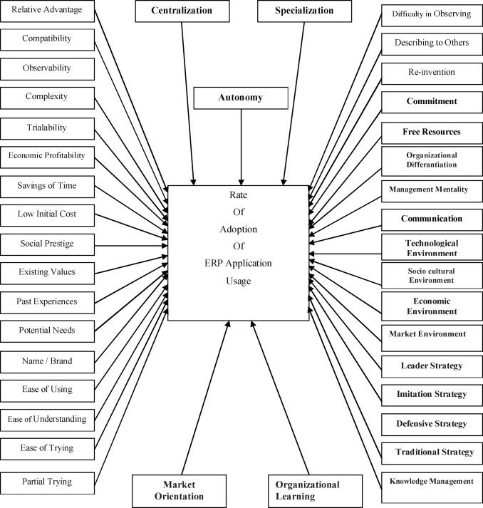

General Presentation Issues
This is about presentation of the arguments as well as referencing style.
Arguments must be:
- Logical
- Applied/illustrated.
- Analysed
- Evaluated

Tables, pictures, figures etc.- All need labels and sources:
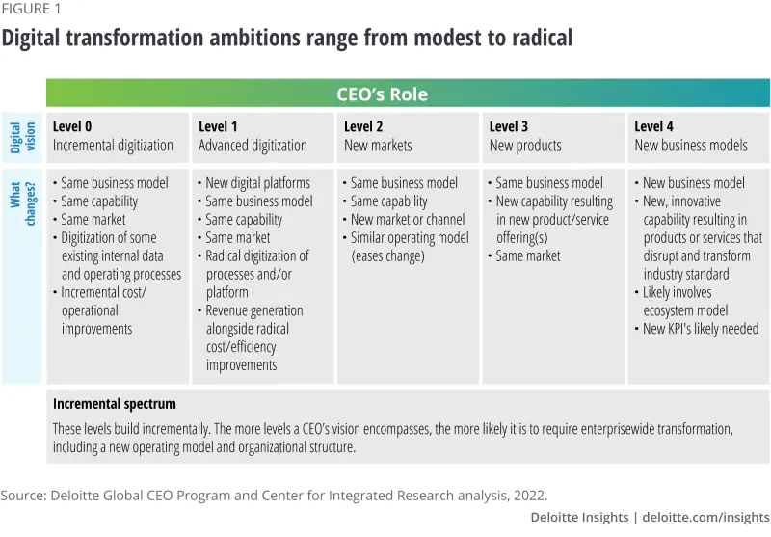Figure 1: Smith et al. (2022) Deloitte Global.
Where are you on this scale?

Reference List:
“Big is beautiful”……25 academic references + commentator sites + example sources + websites……..

Appendices. If you use them, refer to them in your text.
For example:
Appendix 1: Microsoft Organisational chart.
In the text:
“Appendix 1 refers to the organisational structure of Microsoft. It reveals a complex, international, functionally divided approach. Reform and decision making must be processed in several forums before action can be taken. This positively ensures expertise is used to screen viable plans, but inevitably slows the processes of actioning policies that might need more urgency.”
See Appendix below.

Style- be objective, do not use 1st person…”I” or “we”……”it might be argued….” “It might be concluded that….”
Font: Ariel 12.
Referencing: APA, alphabetical order by author family or organisation name.
Websites must have: Full details, date of publication and accession date.

To cite:

Smith, T., Sniderman, B. & Kearns-Manolatos, D. (2022) How to lead digital transformation from the top. A practical guide for leaders facing the challenge of transforming their organizations through digital technology. Deloitte. https://www2.deloitte.com/uk/en/insights/topics/strategy/how-to-lead-digital-transformation.html (Accessed 12-02-23).

Appendix 1: Microsoft Organisational chart. https://theorg.com/org/microsoft

Microsoft
Founded by childhood friends Bill Gates and Paul Allen in Redmond Washington, Microsoft began its operations as a computer software company. They quickly became a household name within the computer operating system market when it was founded in 1975. With their successful IPO a few years later, they went on to acquire several large operations such as LinkedIn and Skype giving them total market dominance. With the shift to a devices and services strategy and under new leadership, Microsoft went on to become the most valuable publicly traded company in the world. In 2019, they made history as the third US public company to reach 1 trillion market cap, and most recently, they have been valued at over 2 trillion.

Today, Microsoft generates revenue by developing, licensing, and supporting a wide range of software products and services, by designing and selling hardware, and by delivering relevant online advertising to a global customer audience. In addition to selling individual products and services, they offer suites of products and services such as consulting to computer system integrators and developers. However, they are mostly known for Microsoft Windows Operating System, Microsoft Office suite, and the Internet Explorer web browser.

More specifically, their products include operating systems for personal computers, servers, phones, and other intelligent devices; server applications for distributed computing environments; productivity applications; business solution applications; desktop and server management tools; software development tools; video games; and online advertising. They also design and sell hardware including the Xbox 360 gaming and entertainment console, Kinect for Xbox 360, Xbox 360 accessories, and Microsoft PC hardware products.

Industries Data, Enterprise Software

Headquarters: Redmond, United States
Stage: Seed
Employees:10,000+

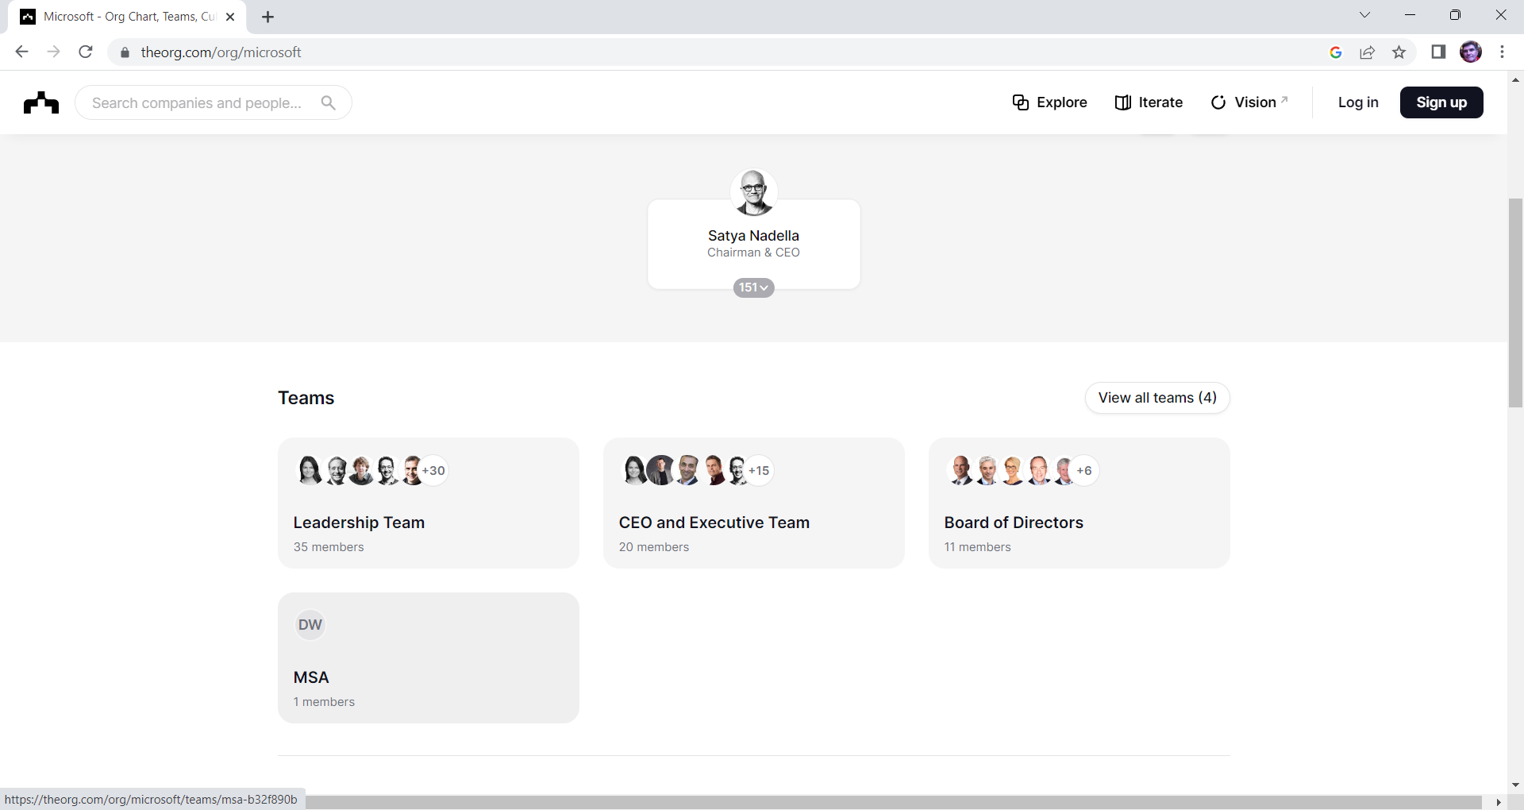

Please note, Alina, this is a very simplified view of Microsoft, I could get a quick diagram in time for the session I am sure that you will.

Steve

