ASSINGMENT 1. e-porfolio EVIDENCE of LEARNING
CHANGEMAKERS: BUILDING YOUR PERSONAL BRAND FOR SUSTAINABLE EMPLOYMENT

NAME--------------- OTISON OSAZUWA EKUNWE.
STUDENT ID--------1921110.
MODULE NAME-------CHANGE MAKER; BUILDING YOUR PERSONAL BRAND FOR SUBSTAINABLE EMPLOYMENT.
MODULE CODE-------- BMHP5015.
LECTURER NAME------MR TAYO KOREDE.

PERSONAL STATEMENT // APPLICATION FOR A POST- GRADUATE DEGREE IN YOUR UNIVERSITY.

TO THE REGISTRY UWTSD.
DEAR SIR/MA.
As a teenager growing up in Africa, our understanding was education is the major contributor to success and knowledge, we saw educational people succeeding and positioned in life, hence my determination started from my earlier days.
My father was educated, and he inspired us for academic pursuit, but his early death became a turbulence prompting my leaving Africa at a young age into a world without much educational opportunity (Spain).
Finally came here 7 years ago and realise there is opportunities here for further studies and had always wanted to continue education and to pursue my long-lost dream.
I started the journey 6 years ago with NVQ level 2 & 3, completed my higher education level 4 in this university and in continuation with level 5 and 6 in health and social care.
My intention is to keep pushing for more education and a masters would bring my goal in sight.
SIR/MA, please wish to apply for a master course in your university, a master's in health and social care would improve my knowledge in a field that I am passionate about, by becoming more productive to myself, family and community, I wish to contribute to the society and having a master would bring me closer to people, a role model, a contributor to development and encouraging people to do the right thing. I learnt a long time ago that it is not what we know that matters, but what we contribute with what we know.
An admission into your reputable university that open doors for people with lost hope for further studies, the teaching and lecturers combined with all staff has inculcated the best morals and value to my development with their good approach and the opportunity to get a second chance and prove myself to be good ambassador of this university, hence my need to continue for masters here.
I visualise every day to see the reality of this childhood goals and dream, as the saying goes “knowledge is power “and this I know would be beneficial to whoever I encounter and possibly extend to my origin as a way of giving back and doing the right thing.

Thank you in advance.
Yours Sincerely,
Otison, O.E.
CURRICULUM VITAE FOR THE POST OF A MANAGER AT MIDWAY CARE GROUP.
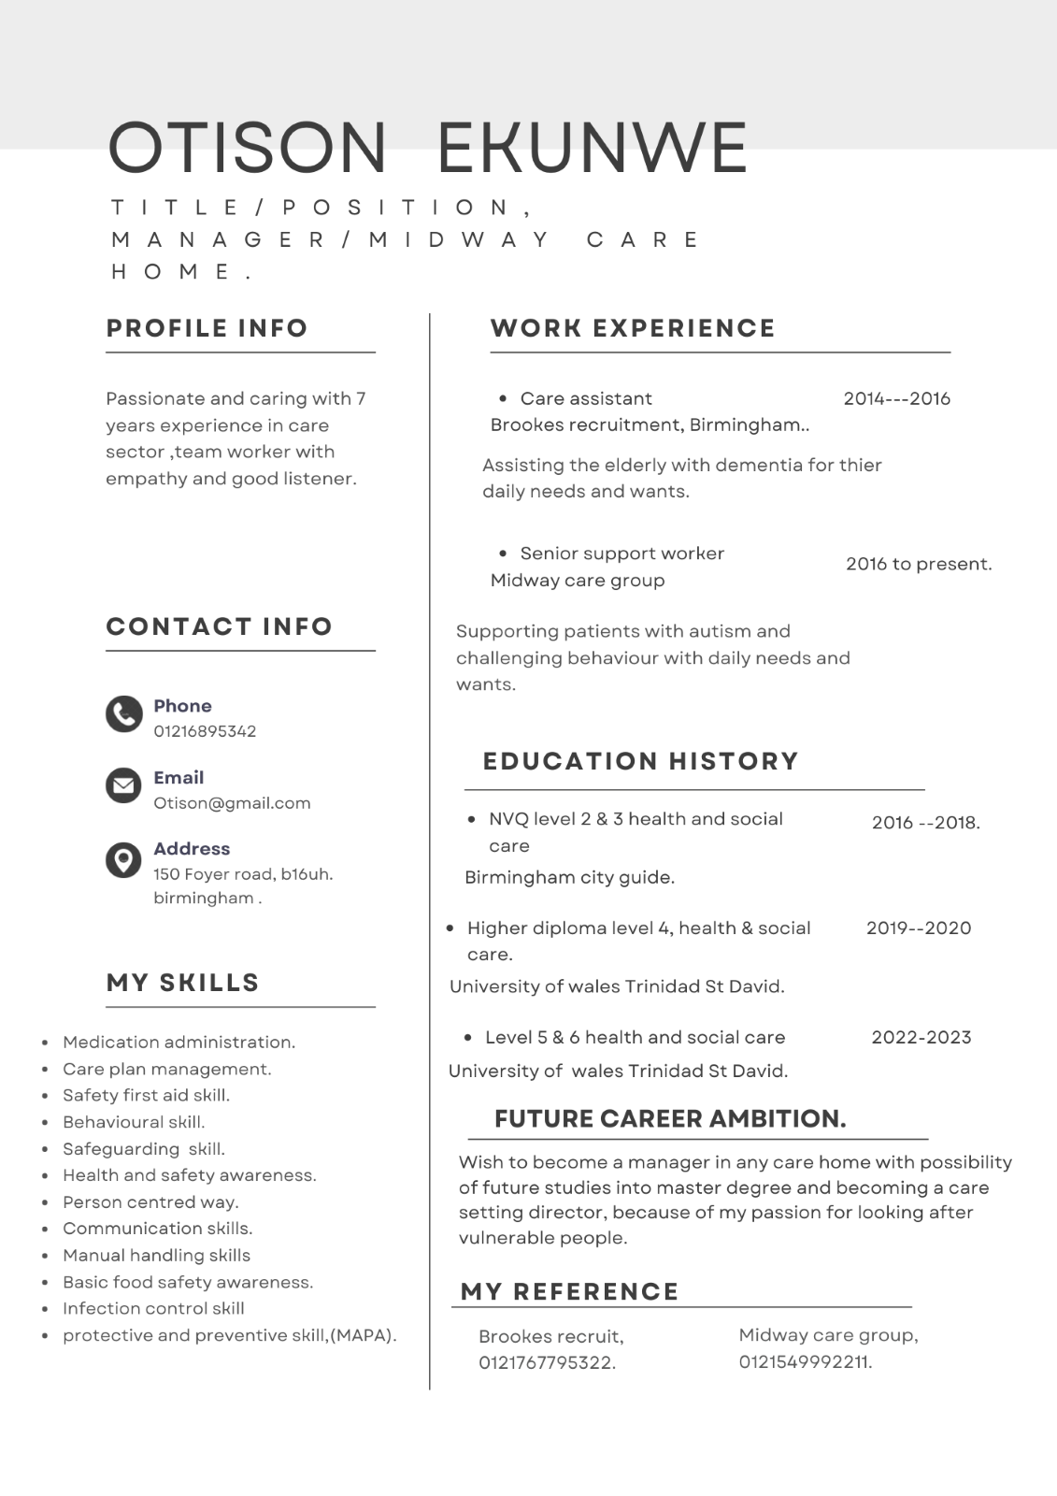

PITCH

RISK OF EPILEPSY ON AUTISM PATIENT.
TO THE PUBLISHING EDITOR, CHANNEL 5 TELEVISION.

PATIENT WITH AUTISM AND EPILEPSY. FIGURE 1.​

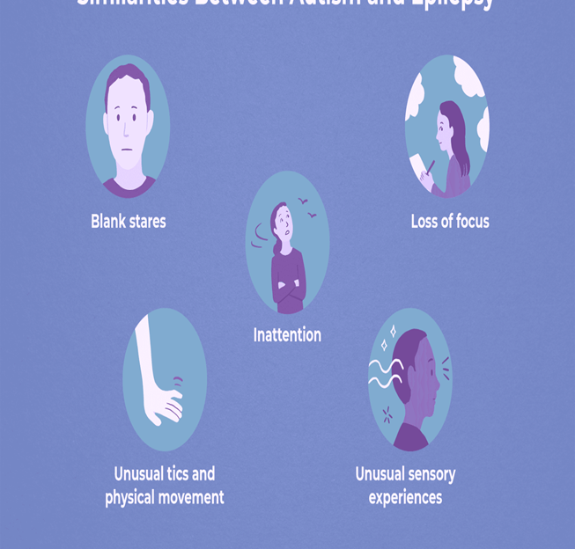

My name is OTISON EKUNWE, a second year student from university of Wales Trinidad St David, studying health and social care, and working fulltime as a support worker that attend to the daily needs and want of young people living with autism, challenging behaviour and epilepsy.
The purpose of writing this for publication is to express my concern and attract the awareness to the high risk and suffering people with autism, epilepsy are going through. Zahra et al (2022)"autism spectrum disorder and epilepsies are heterogeneous human disorder that have miscellaneous etiologies and pathphysiology ,there is considerable risk of frequent epilepsy in autism that facilitates amplified morbidity and mortality". To some there are signs of absentee before seizure, hence preventive measures are put in place to avoid injuries from failing, but others without signs are at risk from failing on hard surface or object leading to injuries or death.​
Recently I was told of a patient that woke up during the night with seizure and fell from the staircase to hitting his head, he came back from hospital and became withdrawn and Traumatised.​
WHO (2006) “ autism as one of the greatest threat to public health, autistic individuals are prone neurological complications such as epilepsy and cerebral Palsy”, .and Woolfenden et al (2012) “ a key reported risk factor is the presence of intellectual disability, which increases epilepsy risk in ASD by three to five times”, Amet (2008) on his meta- analysis report carried between 1963 and 2006 from published reports about relative risk of epilepsy in autism established very clearly that intellectual disability greatly increase the risk of epilepsy in people with autism.

Solution

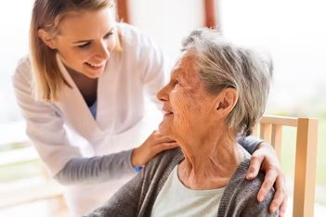
PERSON CENTRED CARE APPROACH, figure 2.

To reduce the risk of injuries or death from falling , it would be a good idea if autistic patient with epilepsy be categories as person centred care. day and night as this would bring easier access for quick intervention when the symptoms arises and prevention from falling on hard surface or object, a patient with autism and epilepsy also need support for direction and guide to toilet at night.temperature could be another effect that triggers epilepsy in people with autism, though it is not generally known about the trigger in different people but temperatures can be moderated with person centred approach to the best degree for them.​

Sudden death in epilepsy (SUDEP) though few, is related to death of people with epilepsy during sleep, person centred approach could help to prevent those death with right approach centred care.

Conclusion
Public awareness to problem of patient living with autism and epilepsy towards preventive measure to eradicate fall that causes brain damage or death as their life is at risk without person centred approach.
Sun et al (2022) significant levels of multi morbidity, polypharmacy and lack of systemised approach to treatment and risk exist, addressing these concerns is essential to reduce premature mortality.​
Thank you for your co-operation in advance as I am aware this publication would be related through your media to the awareness of general public and those responsible towards mankind and using this opportunity to say thank you and continue with your good work’ as your platform is educative. Accurate and popular.​

REFERENCES
Amet, C. Gourfinkel- AN. I. Bouzamondo, A. et al (2008) epilepsy in autism is associated with intellectual disability and gender; evidence from meta-analysis . Biological psychiatry, 64 (7),pp577-582.​

Sun, J.J. Perera, B. Henley , W . Et al (2022) epilepsy related multi morbidity, poly pharmacy and risk in adults with intellectual disability; a national study . J NEUROL 269.2750-2760 2022,https;//Doi.org/10.1007/s00415-021-10938-3.​

World health organisation,(WHO)(2006) neurological disorders ;public health challenges.

Woolfenden S. Sarkozy, V. Ridley , G. et al (2012) systematic review of two outcomes in autism spectrum disorder, -epilepsy and mortality. Dev med child NEUROL,2012 ,54;306-12.​

Zahra, A. Wang, Y. Wang , Q. (2022) shared etiology in autism spectrum disorder and epilepsy with functional disability, Behav. NEUROL. 2022 April . 27;2022; 5893519.Doi 10.1155/2022/5893519. PMID ;35530166;PMCID;PMC 9068331

