ECAD5008 – Leading the learning: what, how and why am I teaching?

A written assignment CRITICALLY EVALUATING how assessment for learning can be utilised in a series of learning opportunities to aid progression across chosen area of learning and experience.

Introduction

This is a written assignment presenting the importance of Assessment for Learning and how it is utilised through the classroom environment throughout several teaching and learning opportunities to widen progression and critical thinking across the different areas of learning. Critical thinking is a key skill for both the learners and teachers, it allows further thinking and understanding of a matter. Allowing children to think critically gives them the opportunity to link different aspects of learning and apply their own knowledge to create their own ideas. (Verna Knight, 2021)

This assignment will include examples of Assessment for Learning strategies and how they will be utilised throughout three learning episodes including three different areas of learning whilst creating meaningful cross curricular links throughout. Cross curricular links carry importance throughout the curriculum to teach children that one subject or topic isn’t individual to itself, and it carries links across to other AoLEs (Areas of Learning and Experience) allowing children to create their own thoughts and understandings whilst thinking critically about different matters and identifying where the links come from. (Chris Rowley, 2009) Cross-curricular links allow children to gain a wide and deeper understanding of what they are learning and allow them to make further connections and transfer their knowledge throughout their future education. (Anon., 2020)

The theme I have chosen for this assignment allows children to create their own links and ideas throughout the AoLEs (Areas of Learning and Experience’s). I have chosen the theme of food as a focus for this assignment. This theme is fascinating and relatable, and it allows children to put things in their own perspective. The theme highlights several areas of learning allowing children to learn through a range of different areas, widening their overall knowledge throughout their educational journey. The three lessons have a main AoLE focus but throughout the lesson there are cross-curricular links. Creating an opportunity for cross-curricular links allows children to think and evaluate their personal experiences, they are able to put things into their own perspectives and allows them to further think critically. (Barnes, 2018)

The lessons will support the children’s learning and allow meaningful, creative, and innovative practice. Innovative and creative practice prepares the children for their future and allows them to use different skills and engage in their learning. Children think critically and imaginatively to reach their goal and full potential. (Anon., 2023)

The three lessons will be targeting those aged 7-8 years old under progression step two. Ages 2-7 are a fundamental time for the development of a child. I chose to focus on children aged 7-8 as this is the time where they start to express their interest in specific areas and apply their knowledge appropriately. The children start to gain more focus and emotion for several different areas at this age and it allows them to gain deeper understandings and absorb information. (Sriram, 2020)

The children will already have prior knowledge regarding the topic and these lessons will aid them throughout further understanding of the smoothie topic. The lessons are relatable and will aid their well-being alongside. The lessons are fun and engaging for all children of different abilities and there is consistent support throughout using pair work which aids and widens their understanding and other vital assessment for learning strategies to support their learning experiences and educational journey.

Assessment for Learning is an evaluation point for children to gather the information that they have learnt and implement it whilst allowing them to reflect on the learning. It allows children to critically think about the learning and make their own links and connections throughout. Teachers can positively impact the children’s knowledge and understanding by using several different Assessment for Learning strategies to identify how to aid them throughout further learning. (C, 2021) Assessment for Learning is an opportunity to support teaching and learning strategies throughout the classroom. Teachers gain an understanding as to how the children use and interpret information. (Berry, 2008)

Literature Review

All teachers teach in their own styles and methods, but all children learn differently, and it is important to ensure children are receiving the effective learning that they deserve. Making teaching relevant to the children increases their interest throughout the subject and allows them to widen and deepen their thinking throughout their educational journey, they will further evaluate and use their knowledge to continually aid them. (Race, 2020) Assessment aims to be relevant and interesting for children, some learning can be difficult to assess, but assessment carries importance throughout learners experiences and should be implemented where possible. (Donaldson, 2015)

Assessment for learning is a type of teaching approach used throughout classrooms to assess children throughout their educations. Teachers put strategies in place to identify how they can aid the children’s progress and performance allowing them to further succeed. (Steele, 2019) The strategies and practices aim to aid children’s progress and allow them to continually achieve. (Gardner, 2012) Assessment for learning encourages children to gain interest and become more engaged within their learning experiences. (Anon., n.d.) Assessment holds a wide importance throughout education and it aims to support the active learning for children and ensure all children are given equal opportunity and understanding through the practice of their teacher. (Bullock, 2017)

Paul Black and Dylan Wiliams conducted research about assessment for learning and identified several different strategies needed to improve teaching and learning through assessment. They shared that children aid by receiving effective feedback during and after a task, children should be actively involved throughout their learning, teachers should take into consideration the results of assessment for following lessons and allowing children to assess themselves and others to gain deeper understandings of tasks. (BroadFoot, et al., 1999)

Assessment for Learning is a teaching strategy that allows continuous progression for children and pupils. Assessment allows children to understand clearly and visually what is asked of them. They are able to improve their work using feedback, communication, or success criteria’s. Assessment for learning turns the focus to the children’s learning and allows the teacher to see clearly what the next stage of learning is for all pupils. (Ofsted, 2011)

Identifying where children are on their learning journey is a key aspect of assessment for learning. It is within the interest of the teacher to acknowledge where the children are and how to aid them in where they should be or what their next step may be. (ELT, 2021)

One of the first elements of assessment for learning is sharing the criteria with the children. Sharing learning outcomes and expectations with the children allows them to gain an insight as to what is expected of them and how they can implement their own thinking to aid their understanding throughout. (Anon., 2020) Learning objectives should include specific statements allowing the children to understand exactly what they should aim to achieve, they should be measurable allowing the children to understand what learning is considered successful, they should be attainable allowing all children to be challenge regardless to their ability but they should also have a sense of reality allowing the children a chance of success, they should be relevant allowing the children to gain interest in their new learning and understanding what is necessary and they should be time-bound allowing the children to see an end point for assessment. (Norman, et al., 2016)

Another element of assessment for learning is the quality of talk and questioning. Assessment for learning is used throughout lessons, there aren’t specific times throughout the lesson where assessment for learning is best implemented. Questioning is a strong strategy used at the beginning of most lesson allowing the children to highlight what they already know in regards to the subject before they actually begin the lesson. (Gardner, 2020) Questioning allows the teacher to understand the abilities of the children at that point of the term and gain an idea as to what can be done to further aid them. The teacher can adjust further steps that they may plan for the class to complete allowing all children equal opportunity to gain understanding fully. Whole class questioning gives teachers within the classroom an opportunity to understand and evaluate the confidence and thinking that the children are developing. (Hawthorne, 2022)

Another one of the four elements of Assessment for Learning is the use and quality of feedback. Feedback is important and essential through many things in life and many people benefit widely from it. Feedback allows children to alter the way they may be thinking or interoperating something. Children should aim to accept feedback and use it to lead them through their next stage of learning. (Spendlove, 2009) This element of assessment for learning allows children to independently use the feedback, they will have the opportunity to implement changes where they feel necessary. (Steele, 2019)

The last element of assessment for learning is peer and self-assessment which is a process allowing children to develop their understanding from one another and working independently. Children are allowed the opportunity to discuss ideas and findings whilst communicating and listening to the views and understandings of others. (Exeter, n.d.) Peer assessment encourages children to listen carefully and ensure they’ve heard the correct information, this is a skill for their educational journey but also a vital skill for their futures. (Muir & Spain, 2016)

There are several people who disagree with assessment for learning and believe that it is a damaging strategy for children at such an early stage in their childhood. They express that assessment for learning has been misunderstood throughout the education system. (Kirby, 2013)

David Didau, a writer who is frustrated by the education system, strongly disagrees that assessment for learning is meaningful and he believes that “you cannot see learning; you can only see performance”. He demonstrates that pupil performance is a weak indicator as to whether the children could further use and transfer skills and knowledge. (Didau, 2014)

Discussion

My three main AoLEs I have chosen for this assignment linking with the main topic of Food are Humanities, Languages, Literacy and Communications and Health and Well-being, whilst considering cross-curricular links widely throughout.

Lesson One – Humanities (See appendices 1)

My first lesson carries a focus on the AoLE of Humanities, this AoLE expands the minds and thinking of the children and opens them to further ideas regarding historical events and the beliefs of others around them whilst understanding the geographical factors worldwide. (Donaldson, 2015)

I chose this AoLE because I think it as inclusive topic for discussion throughout the classroom. It is important for the children to understand that there is a wider and deeper world around them, they will gain understandings as to how other countries produce food and the roles in which people play to transport and collect the items we eat daily. The children have the freedom to explore where their food comes from and identify and create assumptions throughout their decision making.

In this lesson children are given the opportunity to research different countries and gain understanding of the different foods they produce and eat. The children will already have prior knowledge of foodbanks and fairtrade, they will be encouraged to discuss this allowing them to deepen their thinking when moving onto the main task. The children will work in small groups for this task allowing them to continually question one another whilst peer assessing throughout. They will be provided with several pictures and written descriptions of a particular food, they will then be provided with a large map, and they must work together as a group to identify and explain where they believe the particular food is made, produced or eaten. They will then be given the opportunity to openly discuss their reasoning and identify whether there were any obvious patterns presented to them whilst considering the content that they have previously covered.

The assessment for learning strategy used throughout this lesson is peer assessment using think, pair, share. Using this assessment for learning strategy throughout the classroom carries both advantages and disadvantages like other strategies. Using think, pair, share throughout the classroom allows the children to develop several skills at once, they are encouraged to communicate and voice their thoughts and opinions in relation to the topic. The children share different ideas with one another allowing them to develop further meaningful ideas aiding the classroom discussion. (Stokes, n.d.) Children use this strategy by creating, thinking and developing their ideas individually whilst then moving onto the peer assessment access of sharing what they have found with their partner and analysing the information that they share with one another allowing them to further express their thoughts and feelings to the whole class. (Sparling, 2020)

Peer assessment widely aids children’s learning and thinking critically regarding their work. It is the process whereby the children share thoughts and feedback to one another to benefit their learning. The children are allowed the opportunity for open discussion whilst evaluating the thoughts of one another to support them throughout. (Chin, 2016)

This assessment for learning strategy can impact the feedback produced to children negatively, the accuracy and quality of feedback is a crucial aspect to some children, and it is found that peer assessment as an assessment strategy can have that negative effect on some children. Children need clarity and elaboration on feedback and this strategy could influence incorrect ideas and information to some children who don’t have a deep understanding or critical thinking method to the strategy. (Double, et al., 2019)

Lesson Two – Health and Well-Being (See Appendices 2)

My second lesson focuses on the Health and Well-Being AoLE, this AoLE aims to aid children widely. There are several focuses throughout this AoLE and without it the development throughout other AoLEs may not be successful. This AoLE focuses on the holistic development of children and allows them to view their rights throughout life. (Donaldson, 2015)

I chose this AoLE because as a teacher I aim for my lessons and learning experiences to be clearly beneficial long term for the children. I aim for all children to find meaning in what they are doing throughout the classroom. I believe there are many aspects of this AoLE that make it relatable for the children and allow them to create links throughout what they are doing. They are able to discuss the different food that they may eat and see in the supermarket and identify why and how they are nutritional. The children will gain understanding as to how nutritional the foods they currently eat are and understand the nutritional value of other foods.

The meaningful cross curricular link throughout this learning episode is Languages, Literacy and Communication. The children will need to read and communicate throughout this lesson. Remembering the main lesson focus is health and well-being the children will use their reading, communicating and listening skills to explain and evaluate their ideas. The children will use their digital competency throughout the lesson by using chrome books and ipads to conduct any research they deem necessary. They will use several different apps throughout the devices to aid them individually.

In this lesson children will discuss their findings and use their prior knowledge to aid them. The lesson will start with whole class discussions whilst moving onto smaller group discussions about what they think nutritional value is and the meaning of it. They will be encouraged to recall what they already know in terms of fairtrade to aid and deepen their discussions. The children will move onto placing items onto a food chart, they will be provided with statistics, ipads and chrome books to widen and develop their research skills. They will place specific foods into the appropriate food group on the food chart. The children will complete discussions and understand a deeper meaning of what nutrition is and the importance of it whilst gaining further knowledge on food groups and where certain foods sit throughout the chart.

The assessment for learning strategy used throughout this lesson is the snowball technique. This technique allows open discussion throughout the classroom and again allows the children to think and evaluate information critically. Children start by analysing the information and sources provided to them individually, they then go into pairs and take turn discussing what they both found and evaluating further, the pairs then turn to groups of four allowing all children to again explain information they each have found and ideas they have created and then lastly they form a group of eight again allowing all members to continue to explain and gain understanding as to what they all found throughout the resources. This technique is engaging throughout and allows the children to work collaboratively. It teaches the children not only through the resources and materials provided to them but also how to adapt to certain scenarios whilst continually explaining and evaluating what they have found and throughout upon. (Milller, n.d.)

This assessment for learning strategy does however follow with disadvantages throughout the classroom and they can have a negative effect on both classroom environment and the learning experience of the individual children. Throughout this strategy the children are encouraged to use their initiative and use the resources provided to them to create adverse ideas. Some children will use the strategy as an opportunity for open discussion with one another but for other children it can be dependent on some of the relationships in which they hold within the class. Some children find expressing their views and opinions difficult and discussion between a big group may be intimidating to them. (Schwab, 2022)

Lesson Three – Languages, Literacy and Communication (See Appendices 3)

My third and final lesson carries a focus on Languages, Literacy and Communication, this AoLE allows children to develop independence in communication and explanation. Children can develop holistically aiding them widely throughout their futures using reading, writing, listening, and talking skills whilst also developing the skill to learn further and more complex languages. (Donaldson, 2015)

I chose this AoLE because language, literacy and communication are vitally important throughout any child’s education. This AoLE allows the children to express themselves and explain their reasonings. I believe that thus assessment for learning strategy aids all children individually. There are several different abilities throughout different classrooms and LLC (Languages, Literacy and Communication) is a continuous skill and form of development for the children. Throughout this lesson the children will need to think critically and evaluate their own ideas. They will need to read the different recipes and pinpoint different aspects of them throughout.

This lesson also leads cross-curricular links of the mathematics and numeracy AoLE. The children will use their literacy skills to evaluate the recipes and write their own. But the children will need to use some of their mathematical skills throughout to measure the ingredients and determine the different servings of the smoothies. Allowing the children to do this will link to a sense of reality to measuring other things whether it be their food at home or understanding the measurements in a serving.

Throughout this lesson the children are encouraged to explore different recipes to activate their creative thinking allowing them to create their own smoothie recipes. They will have the opportunity to travel around the classroom to different sections where there will be several smoothie recipes, they will be provided with a rate chart created as a class through active discussion, talking about what is important throughout our smoothies and what would aid our advertisement looking at the variety of smoothies provided. The chart clearly demonstrates what they must look for and highlight throughout the task. They will move onto discussing the ideas and interact with further classroom questioning to aid their development and critical thinking for the task. They will then continue onto individually writing and creating their own smoothie recipe based on what they already know and found using information about nutritional value and fairtrade whilst investigating the different recipes.

The assessment for learning strategy focused throughout this lesson is sharing success criteria’s and learning intentions. Sharing both success criteria’s and learning intentions allow children to focus and stay on task, it gives the children guide and motive to understand and consider what is expected of them. (Grafwallner, 2019) Success criteria encourage children to evaluate their own learning and understanding always referring to the learning intention which can be looked at as a target by the children throughout. (Anon., 2022) Some children find focusing challenging so it can be difficult to make sharing success criteria’s fun to keep children engaged, but there are several methods used to keep children engaged and allow them to gain a positive understand of what they aim to achieve. Writing and coming up with a success criteria through a classroom discussion is an engaging way to allow children to achieve whilst creating their own targets throughout, the children will gain the same idea as their teacher regarding what the final product or task should look like. (Hattie, 2019)

Sharing learning intentions and success criteria with children can hold and present positives as well as negative aspects. Children learn at different paces and stages and there will be some children who understand what is expected of them and understand what it is they need to do to reach their goal or the learning intention instantly, but some children will find the concept of needing a target or end point difficult. Sharing success criteria with pupils can sometimes be seen as unachievable for some children and they won’t understand the concept or meaning of an end point to their learning. As teachers encouraging the children is a vital skill and it is important that children don’t always view success criteria’s and learning intentions as a target or goal but as a path and next step towards that target for the learning experience. (Didau, 2015)

Conclusion

Throughout my own professional teaching I have seen the benefit of Assessment for learning strategies and how they aid children’s development throughout the classroom. As the teacher I have also been able to visually see children thinking critically and expressing their own ideas throughout several different lessons. Assessment for Learning allowed me to evaluate whether the children were gaining understanding and creating their own ideas whilst thinking critically. I found that for some children this was clear, and I could see progress throughout however, all children learn and interpret things differently and this was clear throughout the classroom. As the teacher I understood the importance of using different assessment for learning strategies to aid and meet the different needs of the different children throughout.

I chose the specific assessment for learning strategies as I see wide benefits throughout them, and I think they show wide understanding and meaning throughout the learning of the children. Education should be engaging for the children, and I believe that the assessment for learning strategies I have used allow the children to explore different areas and create new positive and meaningful relationships not only throughout the classroom but also benefiting their holistic development.

I believe that assessment for learning shows visual progress and benefits throughout teaching processes, and it allows all children of different abilities and progression to develop throughout. Assessment for learning may hold some limitations but overall, it aids children’s learning and allows them to continually progress throughout. Children’s learning is a continual process whereby they develop throughout each lesson to reach their goal. Assessment fir learning should be used throughout classrooms to further support the learning and education of children.

This assignment has allowed me t conduct further research regarding assessment for learning whilst exploring the limitations and different processes of it throughout. I feel that this assignment will benefit my teaching practice positively whilst considering several factors when planning for assessment for learning strategies.

References

Anon., 2020. Principles of Assessment For Learning. [Online]
Available at: https://edu.rsc.org/assessment-for-learning/principles-of-assessment-for-learning/4012464.article
[Accessed 1 January 2024].

Anon., 2020. The Curriculum for Wales - Progression Code. [Online]
Available at: https://www.gov.wales/sites/default/files/publications/2021-11/curriculum-for-wales-progression-code.pdf#:~:text=2.7%20Support%20for%20progression%20should%20provide%20space%20for,understanding%20and%20application%20of%20these%20as%20they%20progress.
[Accessed 28 Decemeber 2023].

Anon., 2022. 6 Examples of success criteria to use in your classroom. [Online]
Available at: https://www.talesfromaverybusyteacher.com/2022/06/6-examples-of-success-criteria-to-use-in-your-classroom.html
[Accessed 4 January 2024].

Anon., 2023. engage2learn. [Online]
Available at: https://engage2learn.org/blog/innovative-teaching-methods
[Accessed 28 December 2023].

Anon., n.d. Cambridge Assessment - Getting started with assessment for learning. [Online]
Available at: https://www.cambridge-community.org.uk/professional-development/gswafl/index.html
[Accessed 30 December 2023].

Barnes, J., 2018. Applying Cross-Curricular Approaches Creatively. s.l.:Routledge.

Berry, R., 2008. Assessment for Learning. s.l.:Hong Kong University Press.
b, o., 23. afl. [Online]
[Accessed 23].

BroadFoot, P., Gardner, J., Daugherty, R. & Harlen, W., 1999. Assessment for Learning: Beyond the black box.. s.l.:s.n.

Bullock, D., 2017. So, what is AfL and why is it important? Can it imporve stundents' results? What does it involve?. [Online]
Available at: https://www.teachingenglish.org.uk/professional-development/teachers/assessing-learning/articles/assessment-learning
[Accessed 30 December 2023].

Chin, P., 2016. Peer Assessment. [Online]
Available at: https://www.researchgate.net/publication/328340643_Peer_assessment
[Accessed 3 January 2024].

C, H. P., 2021. Assesment for Learning, Assessment of Learning, Assessment as Learning: A Conceptual Framework. 14(4), pp. 14-15.

Chris Rowley, H. C., 2009. Cross-curricular Approached to teaching and Learning. s.l.:s.n.
Didau, D., 2014. Why AfL might be worng, and what to do about it. David Didau.

Didau, D., 2015. Why I struggle with learning objectives and success criteria. [Online]
Available at: https://learningspy.co.uk/learning/8696/
[Accessed 4 January 2024].

Donaldson, P. G., 2015. Successful Futures - Independant Review of Curriculum and Assessment Arrangements in Wales. [Online]
Available at: https://www.gov.wales/sites/default/files/publications/2018-03/successful-futures.pdf
[Accessed 2 January 2024].

Donaldson, P. G., 2015. Successful Futures -Independant Review of Curriculum and Assessment Arrangements in Wales. [Online]
Available at: https://www.gov.wales/sites/default/files/publications/2018-03/successful-futures.pdf
[Accessed 1 January 2023].

Double, K. S., McGrane, J. A. & Hopfenbeck, T. N., 2019. The Impact of Peer Assessment on Academic Performance: A Meta-analysis of Control Group Studies.. [Online]
Available at: https://link.springer.com/article/10.1007/s10648-019-09510-3#citeas
[Accessed 3 January 2024].

ELT, O. U. P., 2021. An Introduction To Assessment For Learning. [Online]
Available at: https://teachingenglishwithoxford.oup.com/2021/10/06/assessment-for-learning/
[Accessed 1 January 2024].

Exeter, U. o., n.d. Teaching Quality Assurance Manual. [Online]
Available at: https://as.exeter.ac.uk/academic-policy-standards/tqa-manual/lts/peerselfassessment/
[Accessed 1 January 2024].

Gardner, J., 2012. Assessment and Learning. 2nd Edition ed. London: SAGE.

Gardner, J., 2020. Assessment for learning - what is it?. The English Classroom.

Grafwallner, P., 2019. A Framework for Lesson Planning. [Online]
Available at: https://www.edutopia.org/article/framework-lesson-planning
[Accessed 4 january 2024].

Hattie, J., 2019. John Hattie: Learning intentions and success criteria. [Online]
Available at: https://www.stem.org.uk/resources/elibrary/resource/273227/john-hattie-learning-intentions-and-success-criteria
[Accessed 4 January 2024].

Hawthorne, H., 2022. How to use Assessment for Learning in Schools. [Online]
Available at: https://www.highspeedtraining.co.uk/hub/how-to-use-assessment-for-learning-in-schools/
[Accessed 31 December 2023].

Kirby, J., 2013. What can we learn from Dylan William and AfL?. [Online]
Available at: https://joe-kirby.com/2013/03/30/afl/
[Accessed 1 January 2024].

Milller, G., n.d. Snowball Technque - A Teaching Strategy. [Online]
Available at: https://bookunitsteacher.com/wp/?p=5826
[Accessed 6 January 2024].

Muir, S. & Spain, T., 2016. Peer and self-assessment. [Online]
Available at: https://www.teachingenglish.org.uk/professional-development/teachers/assessing-learning/articles/peer-and-self-assessment
[Accessed 1 January 2024].

Norman, M., Shaw, A. & Davis, G., 2016. Learning Objectives Basics. [Online]
Available at: https://ctl.wiley.com/learning-objectives-basics/
[Accessed 1 January 2024].

Ofsted, 2011. The impact of the 'Assessing pupils' progress' initiative. [Online]
Available at: https://assets.publishing.service.gov.uk/government/uploads/system/uploads/attachment_data/file/379101/The_20impact_20of_20the_20Assessing_20pupils_20progress_20initiative.pdf
[Accessed 1 January 2024].

Race, P., 2020. The Lecturer's toolkit : A Practical Guide to Assessment, Learning and Teaching. 5 ed. s.l.:s.n.

Schwab, P.-N., 2022. Snowball effect: advantages, disadvantages, implementation. [Online]
[Accessed 6 January 2024].

Sparling, R., 2020. Think, pair, share : Formative assessment for the classroom. [Online]
Available at: https://the-english-classroom.com/blog/think-pair-share-formative-assessment-for-the-classroom/
[Accessed 4 January 2024].

Spendlove, D., 2009. Puttig Assessment for Learning Into Practice. London: s.n.

Sriram, R., 2020. Why Ages 2-7 Matter So Much for Brain Development. [Online]
Available at: https://www.edutopia.org/article/why-ages-2-7-matter-so-much-brain-development
[Accessed 28 December 2023].

Steele, A., 2019. Assessment for Learning - what is assessment for learning and what are the benefits?. Brighter Thinking Blog.

Steele, A., 2019. Assessment for Learning - What is assessment for learning and what are the benefits?. Brighter Thinking Blog.

Stokes, E. C., n.d. Think Pair Share - How to unleash its power in your classroom. [Online]
Available at: https://www.teachwire.net/news/think-pair-share/
[Accessed 4 January 2024].

Verna Knight, S. P. R., 2021. Research Anthology on Developing Critical Thinkin Skills in Students. s.l.:s.n.

Appendices

- Lesson Plan One – Humanities

Student-teacher: | Olivia Louise Blandford | Class / Group: | Year 3
AoLE or Subject: | Topic – Food (Smoothies)  Humanities  Mathematics and Numeracy | Date (please note that this may be a continuous session): | December 2023
Meaningful links to Curriculum (What Matters Statements, Descriptions of learning, ‘previous’ curriculum...) | - Enquiry, exploration, and investigation inspire curiosity about the world, its past, present, and future.  I have been curious and made suggestions for possible enquiries and have asked and responded to a range of questions during an enquiry.  I have experienced a range of stimuli, and had opportunities to participate in enquiries, both collaboratively and with growing independence.  I can collect and record information and data from given sources. I can then sort and group my finding using different criteria.  I can recognise the difference between fact and beliefs.  I can present what I have discovered in a variety of ways and draw simple conclusions.  - Events and human experiences are complex, and are perceived, interpreted, and represented in different ways.  I can recognise and explain that my opinions and the opinions of others have value.  I can recognise that opinions may change over time.  I am beginning to recognise other people’s feelings and viewpoints about familiar events or experiences.  - Our natural world is diverse and dynamic, influenced by processes and human actions.  I can describe how people and the natural world may impact on each other.  I can describe how places, spaces, environments, and landscapes are important to different people and for different reasons.  I can recognise the distinct physical features of places, environments, and landscapes in my locality and in Wales, as well as in the wider world.  I can describe how and where some places and environments are similar, and others are different.  - Human societies are complex and diverse, and shaped by human actions and beliefs.  I have explored and am aware of diversity in communities.  I have explored some causes and effects of events and changes in my community over time.  - Informed, self-aware citizens engage with challenges and opportunities that face humanity and are able to consider and ethical actions.  I can understand that not everyone is treated fairly.  I am beginning to understand what human rights are and why they are important.  I can understand that we need to respect the rights of others.  I am beginning to appreciate the care for living things and my own environment.  I can take care of resources and not waste them, and I am conscious of the importance of creating a sustainable future.

Meaningful links across the curriculum  Links to other AoLEs or the Cross-curricular skills frameworks) | Literacy Framework  Numeracy Framework  Digital Competency Framework
Personal Targets (targets and consequent impact on learning - refer to any targets that have been identified in learning journal or weekly reflection meeting and describe the desired impact on learning)

Learning Intention
‘This should focus on the pupils’ learning during the lesson, rather than what they will be doing, and should be short, achievable and measurable.’ (Crichton, H., and Mcdaid, A. 2016 p. 196)
The children will be learning to use a map to identify different countries and gain an understanding of the foods and where they come from.

Success Criteria
What the pupils need to demonstrate to successfully meet the Learning Intention.
This lesson is a continued from previous lesson around the food topic.
The children will need to use their prior knowledge to think, discuss and create their own ideas whilst thinking critically.
The children will use all resources provided to them whilst activating their own discussion throughout the task.
The children will use the information provided to them using pictures of food, descriptions and identifying on the map where they believe the food is from in the world.
This allows the children to discuss their findings and opinions to different foods and throughout of different countries in relation to religious decisions and fairtrade etc.
Planning for misconceptions:
Use this section to anticipate pupil errors and misunderstandings and your planned responses to them.
I will continually remind the children to use the resources provided to them and encourage them to use the iPad and chrome books to further widen their curiosity.
Some lower ability children will struggle to understand what is asked of them and I will encourage the children to work and discuss together in groups or pairs to ensure their understanding throughout the task.

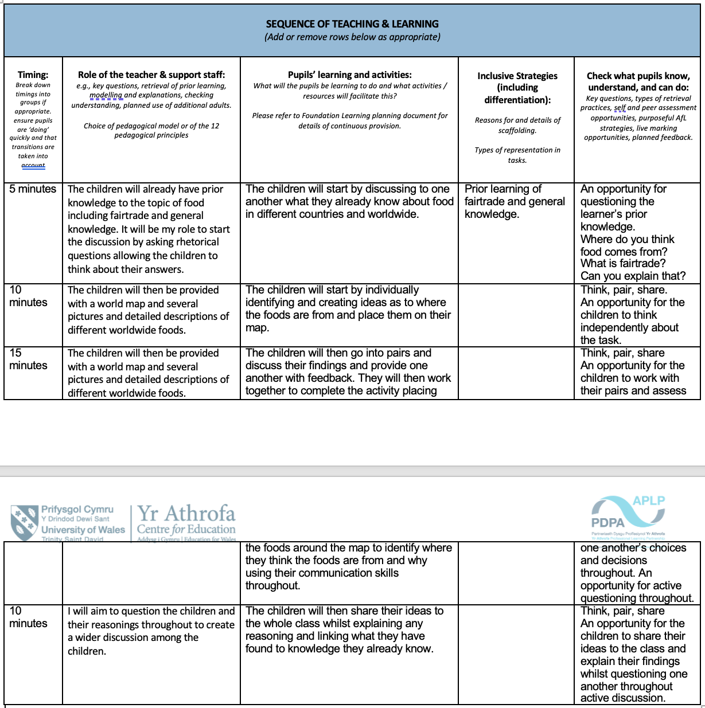

- Lesson Plan Two – Health and Well-Being

Student-teacher: | Olivia Louise Blandford | Class / Group: | Year 3
AoLE or Subject: | Topic – food (Smoothies)  Health and Well-Being  Languages, Literacy and Communication | Date (please note that this may be a continuous session): | December 2023
Meaningful links to Curriculum (What Matters Statements, Descriptions of learning, ‘previous’ curriculum...) | Health and Well-Being  - Developing physical health and well-being has lifelong benefits.  I am beginning to make connections between my diet and my physical health and well-being.  - Our decision-making impacts on the quality of our lives and the lives of others.  I can make decisions based on what I like and dislike.  I have an understanding that things can be safe or unsafe.  Languages, Literacy and Communication.  - Understanding languages is key to understanding the world around us.  I can listen to, understand, and communicate the general meaning of what I hear.  I can listen to understand later recall what I have heard.  I can understand information about a variety of topics, identifying main points.  I can understand and respond to a range of questions and multi-step instructions in a variety of familiar and unfamiliar contexts.  I can use a range of strategies to read with increasing fluency.  I can read different texts using a range of strategies to make meaning.  I can find and use information from different materials that I read.  I can infer meaning from text and images.  I can read aloud with expression, paying attention to punctuation.  - Expressing ourselves through languages is key to communication.  I can use single and multi-clause sentences, making choices to meet the intended audience and purpose.  I can vary the types of sentences I use in my spoken language.  I can review my work and am beginning to use a range of familiar strategies and tools to improve my speaking and writing.  I can explain where and why I have made any changes or corrections.  I can adopt a range of roles and manage my contributions appropriately.  I can change how I communicate, depending on where I am and who I am with.  I can ask and answer question and exchange ideas and information.  I can spell irregular words correctly.  I can use my knowledge of letter sounds and patterns accurately in my spelling.  I can use familiar punctuation.  I can talk to plan writing and write for different purposes and audiences.  I can organise my writing into a logical sequence.  I can write using an increasingly imaginative, varied, and precise vocabulary.

Meaningful links across the curriculum  Links to other AoLEs or the Cross-curricular skills frameworks) | Language, Literacy and Communication  Mathematics and Numeracy  Digital Competency Framework
Personal Targets (targets and consequent impact on learning - refer to any targets that have been identified in learning journal or weekly reflection meeting and describe the desired impact on learning)

Learning Intention
‘This should focus on the pupils’ learning during the lesson, rather than what they will be doing, and should be short, achievable and measurable.’ (Crichton, H., and Mcdaid, A. 2016 p. 196)
The children will find the nutritional value of specific foods and actively place different foods into the different food groups and conduct positive research on food groups and the different nutritional value of foods,

Success Criteria
What the pupils need to demonstrate to successfully meet the Learning Intention.
The children will need to use their prior knowledge to think, discuss and create their own ideas whilst thinking critically.
The children will use all resources provided to them whilst activating their own discussion throughout the task.
The children will use the food chart to visually see where specific foods are placed and gain an understanding of them.
Planning for misconceptions:
Use this section to anticipate pupil errors and misunderstandings and your planned responses to them.
I will continually remind the children to use the resources provided to them and encourage them to use the iPad and chrome books to further widen their curiosity.
Some lower ability children will struggle to understand what is asked of them and I will encourage the children to work and discuss together in groups or pairs to ensure their understanding throughout the task.

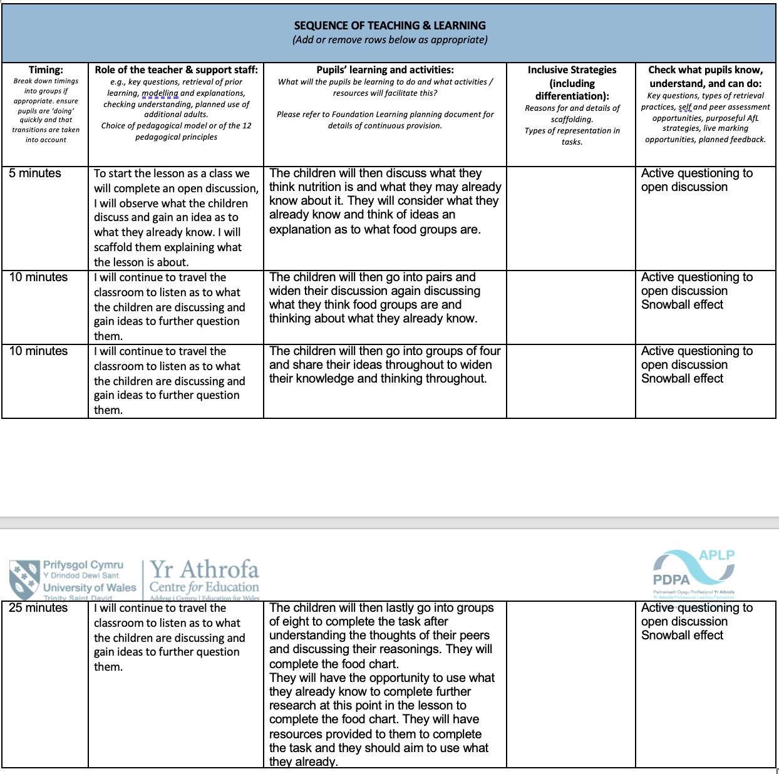

- Lesson Plan Three – Languages, Literacy and Communication
Student-teacher: | Olivia Louise Blandford | Class / Group: | Year 3
AoLE or Subject: | Topic – Food (Smoothies)  Mathematics and Numeracy  Languages, Literacy and Communication | Date (please note that this may be a continuous session): | December 2023
Meaningful links to Curriculum (What Matters Statements, Descriptions of learning, ‘previous’ curriculum...) | Mathematics and Numeracy  - The number system is used to represent and compare relationships between numbers and quantities.  I can understand that the value of a number can be determined by the position of the digits.  I am beginning to estimate and check the accuracy of my answers, using inverse operations when appropriate.  I can use my understanding of multiplication to recall some multiplication fact and tables starting with tables 2, 3, 4, 5 and 10 and I can use the term ‘multiples’.  I have explored and can use my understanding of multiplicative relationships to multiply and divide whole numbers, using a range of representation, including sharing, grouping and arrays.  - Geometry focuses on relationships involving shape, space and position, and measurement focuses on quantifying phenomena in the physical world.  I am beginning to tell the time using a variety of devices. I have explored and used different ways or showing the passing time, including calendars, timelines, simple tables, and schedules.  I have explored measuring, using counting, measuring equipment, and calculating, and I can choose the most appropriate method to measure.  I can estimate and measure, using non-standard units, before progressing onto standard units.  I can use a variety of measuring devices from different starting points.  Languages, Literacy and Communication.  - Understanding languages is key to understanding the world around us.  I can listen to, understand, and communicate the general meaning of what I hear.  I can listen to understand later recall what I have heard.  I can understand information about a variety of topics, identifying main points.  I can understand and respond to a range of questions and multi-step instructions in a variety of familiar and unfamiliar contexts.  I can use a range of strategies to read with increasing fluency.  I can read different texts using a range of strategies to make meaning.  I can find and use information from different materials that I read.  I can infer meaning from text and images.  I can read aloud with expression, paying attention to punctuation.  - Expressing ourselves through languages is key to communication.  I can use single and multi-clause sentences, making choices to meet the intended audience and purpose.  I can vary the types of sentences I use in my spoken language.  I can review my work and am beginning to use a range of familiar strategies and tools to improve my speaking and writing.  I can explain where and why I have made any changes or corrections.  I can adopt a range of roles and manage my contributions appropriately.  I can change how I communicate, depending on where I am and who I am with.  I can ask and answer question and exchange ideas and information.  I can spell irregular words correctly.  I can use my knowledge of letter sounds and patterns accurately in my spelling.  I can use familiar punctuation.  I can talk to plan writing and write for different purposes and audiences.  I can organise my writing into a logical sequence.  I can write using an increasingly imaginative, varied, and precise vocabulary.

Meaningful links across the curriculum  Links to other AoLEs or the Cross-curricular skills frameworks) | Literacy Framework  Numeracy Framework  Digital Competency Framework
Personal Targets (targets and consequent impact on learning - refer to any targets that have been identified in learning journal or weekly reflection meeting and describe the desired impact on learning)

Learning Intention
‘This should focus on the pupils’ learning during the lesson, rather than what they will be doing, and should be short, achievable and measurable.’ (Crichton, H., and Mcdaid, A. 2016 p. 196)
The children will read several different smoothie recipes to activate their creativity to create their own smoothie recipes considering what equipment they will use, which foods they will use and thinking of any measurements required allowing their smoothie to be successful.

Success Criteria
What the pupils need to demonstrate to successfully meet the Learning Intention.
The children will be in need of using their prior knowledge.
The children will need to think critically about what they want to use and why they want to use it whilst considering the quantities they will be using.
The children will need to use their prior knowledge to think, discuss and create their own ideas whilst thinking critically.
The children will use all resources provided to them whilst activating their own discussion throughout the task.

Planning for misconceptions:
Use this section to anticipate pupil errors and misunderstandings and your planned responses to them.
I will continually remind the children to use the resources provided to them and encourage them to use the iPad and chrome books to further widen their curiosity.
Some lower ability children will struggle to understand what is asked of them and I will encourage the children to work and discuss together in groups or pairs to ensure their understanding throughout the task.



