Digital Identity

Callum Mickelsen- P148765
BA Photography In The Arts
Word count - 1878
Tutor - Paul Duerinckx

How have image makers used digital technologies to explore identity?

Introduction

In this essay I will be exploring the different ways in which people have used digital technology to look at identity. Whether that is individual identity, group identity and our place in social groups or how we identify others based on our view of the world. Due to the nature of identity there will be themes of conflict being brought into this essay as well. And for the same reason as we are looking into digital media we have to discuss the surveillance state.

Individual Identity

When talking about individual identity we first have to know what individual identity means. “Personal identity is the concept you develop about yourself that evolves over the course of your life.” (Christine Serva, Philosophy 101: Intro to Philosophy.https://study.com/academy/lesson/what-is-personal-identity-definition-philosophy-development.html) What this means is that over the course of our lives we come up with ideas of who we are based on the world around us and our opinions, our likes, dislikes and who we decide to let in our lives. Personal identity is something all of us struggle with, especially when we are younger. Figuring out who we are when society threatens us to fit in or be shunned to the side makes it even harder.

How the media threatens individual identity

The influence of the media has forever changed how we view ourselves and others. How people are represented and the formations of stereotypes in T.V and film is one example of how our individual identity is being threatened by the media.

Michalina Wozniak
One artist I think encapsulates this idea is Polish photographer Michalina Wozniak “Photography is like a poem – it’s all about the impression and impulse. You need to feel it, to find the moment.” (https://www.boredpanda.com/identity-series-by-polish-photographer-michalina-wozniak/?utm_source=google&utm_medium=organic&utm_campaign=organic)
Wozniak has used the internet and a digital camera to broadcast their feelings and philosophy on identity. Putting it out there so people can connect with it.
When looking at Wozniak’s work you get a sense of what life is like for a lot of people who don’t fit in. This work to me signifies the hiding, putting up masks to hide who we are and hiding our real feelings. People who don’t fit what society expects of them are usually left on the fringe of it, so to stop this happening we pretend to be someone else, something else. It could also signify our own feelings of anxiety and ineptitude that we have to hide so people don’t realise that we are struggling so much. A lot of people are using spaces like this on the internet to showcase their thoughts and feelings because it’s easier than telling people face to face. We can hide behind screens and technology, making it easier to speak our minds online than in person. This could also be another layer to the idea of a ‘mask’. A mask is a way to hide or obscure parts of who we are, so are we hiding parts of who we are online or have our ‘masks’ we use in real life been stripped away to reveal who we really are. Has the fact that we are safe behind a screen given us some false sense of security enough for us to show a more ‘real’ version of us. Wozniak has put this work online meaning that it has reached a wider audience, bringing more attention to this work and influencing more people and making them form ideas on personal identity. In that way they have used the media to make a direct impact on people’s views on identity
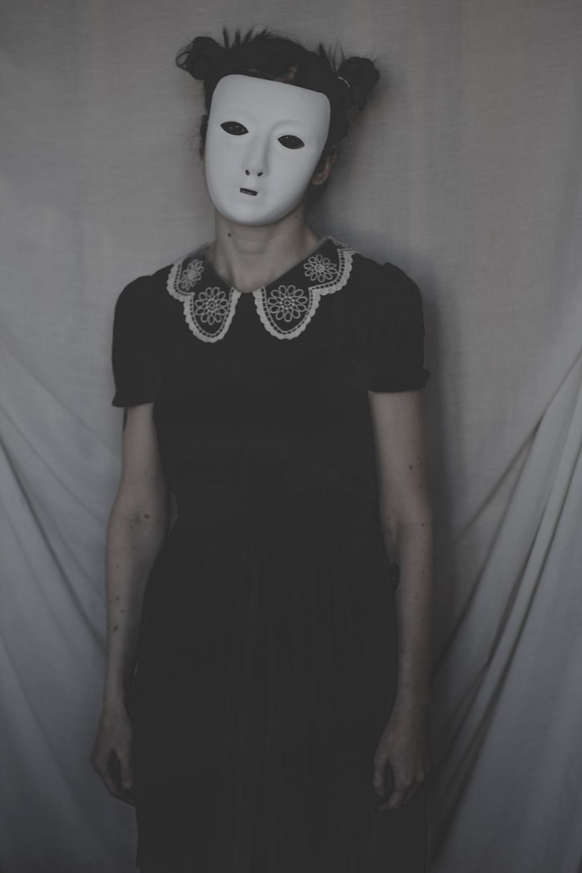

Katie Joy Crawford


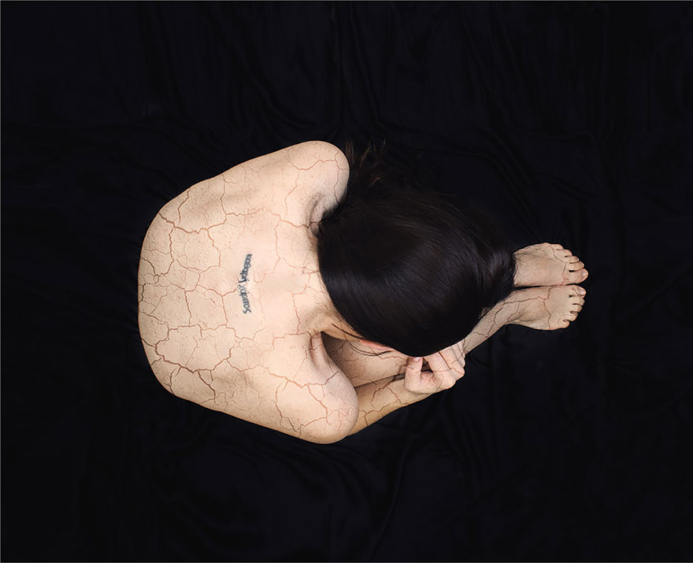
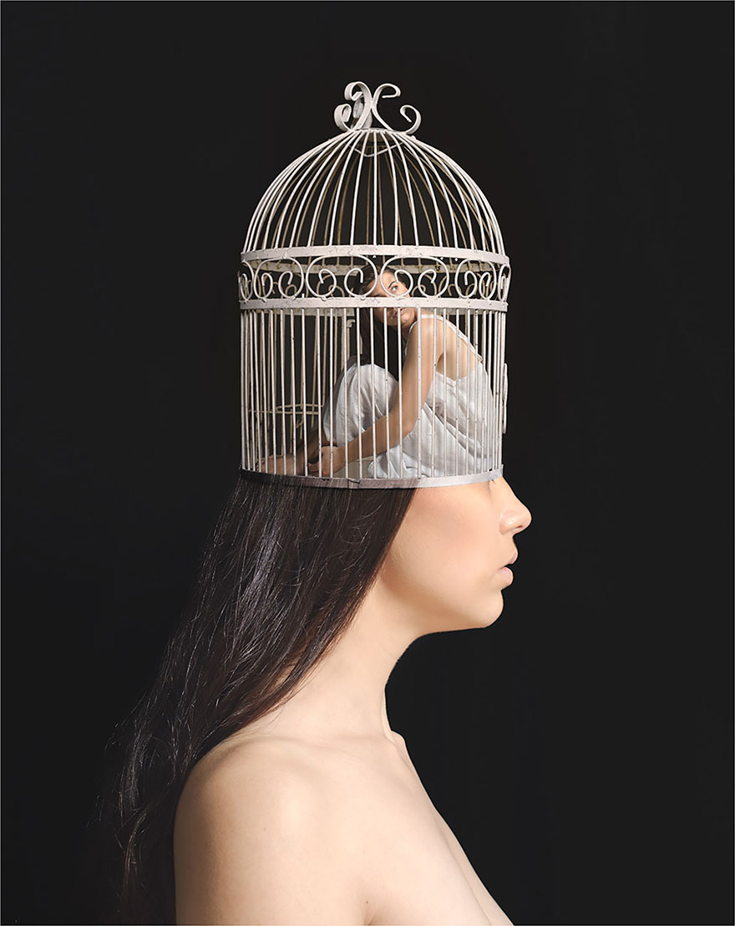
All of these images use digital media to represent identity, either using C.G.I or double exposure. These pieces of work could either represent individual identity or our identity within groups. We’ll first explore how these could represent the individual.

These pieces of work all show us a representation of how the maker feels, the first to me represents the anxiety of running out of time, whether we are spending our time wisely. We are constantly running out of time and our ideas of self are always changing. But are our ideas right now right? Are we making sure we’re going on the right path for us? Because this time we’ll never get back. The second could represent cracks in our identity, questions about ourselves we have yet to answer, alternatively it could represent the metaphorical scars and wounds that have made us who we are and shaped our identity. The third in this case is more compelling, we are constantly trapped in our own minds, we cannot escape ourselves. We are constantly thinking about who we are and our ideas of what it means to be us, but we are not the most important people in shaping who we are. This is where this image becomes a discussion on social identity.

Social identity
This is a definition of social identity “Groups give us a sense of social identity: a sense of belonging to the social world. In order to increase our self-image we enhance the status of the group to which we belong.” ( Saul McLeod, published 2008 https://www.simplypsychology.org/social-identity-theory.html)
The third image in this series gives us an important look on social identity, whereas we are trapped in our own heads thinking about what our ideas are, it’s the people around us that shape these ideas. Our belonging to the social world is based on these people and their ideas on the world. Our ideas are constantly changing based on the groups we are involving ourselves in. The first image of Crawford’s could come into play here now too. Playing on the idea of anxiety and time, are we spending our time with the people who are affecting our lives in positive ways and that are good for us. If we now go back to the image of Wozniak’s then we could also ask if these ‘masks’ are part of our social identity too and if we change who we are for other people in our social groups.

Seymour Templar
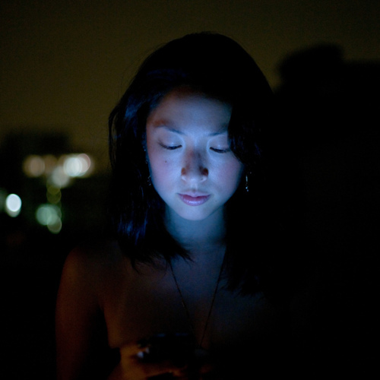
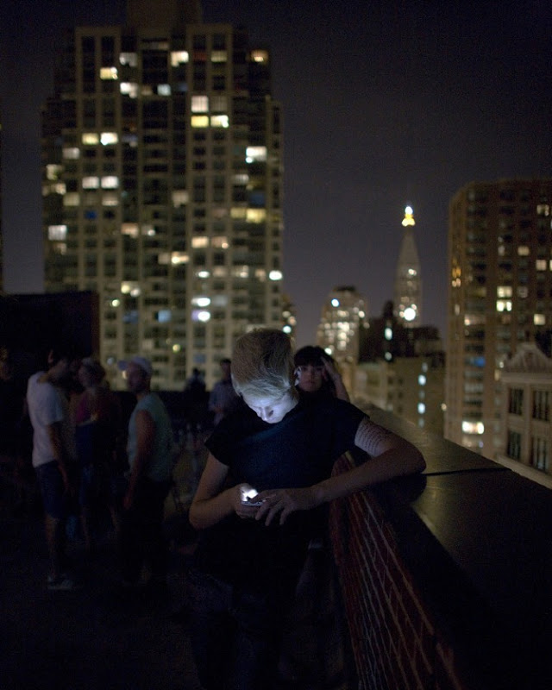
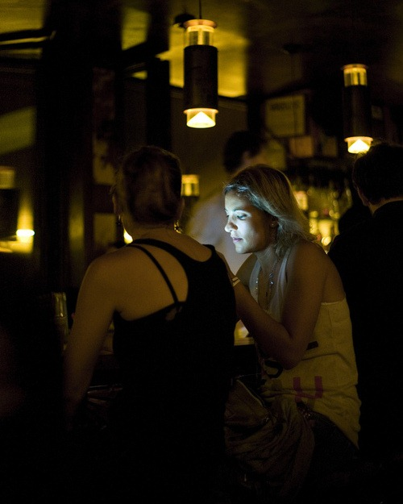

These images all use digital technology to make a point about digital technology. Using a digital camera and the light being given off by the mobile phones he’s taking these images, and using the internet to get a wider reach and influence to get his point across. One way we could interpret these is that a lot of our social interactions are made over social media, so we are even having social interactions while in bed, or at home alone. So our social identity has even more chance being affected, leading us to have different views on our individual identity even more and far more often. The first image is of a woman alone, but it is implied that she is on social media so she is even having social interactions now. Those social interactions changing her and her opinions and identity all the time, no matter how small the change. The second is of a man stood off from the main group, possibly missing the social interactions going on there and the chance to have his opinions and identity changed/altered in person. He’s instead on social media which could be doing the same thing, although it would not be to the same degree as in person you have to rely on your words, the way your brain processes them at that time and the people around you also giving their opinions on the topic. Also your social media often stops you from having as many group interactions, meaning your social identity is less known or not as developed. The way these images represent the effect on individual identity is also interesting as we can never know just how much of our individual identity comes from the people we choose to put ourselves in as much anymore. This is because there are lots of different ideas from different people all over the world on social media, meaning it’s no longer just the people we would comes across in our environment but people from lots of different social and economic environments. Meaning we get so many other points of view from so many different places that our opinions could be so much more or less developed than the places we live in.

Individual people or media made copies in the surveillance state
Because of all of this how individual is our identity now, how many people’s opinions are truly theirs. How can we say that our identity is individual when social media is constantly changing us. How do we know that the things we see on our social media haven’t been put there to specifically make us think one way or another. Our phones are always looking at where we are, where we’re going, what apps we use, what T.V shows we watch and what we look at on the internet. So they are always gathering information on us, how do we know then that what we are seeing isn’t specifically targeted at us to change our opinions or make us think differently about things, but our different way of looking at things would be the way we are expected or wanted to think. So is it always better to wear our ‘masks’ online and we wary, or let ourselves be as influenced by things. Possibly getting more information and becoming an individual or also possibly getting brainwashed to becoming media copies. The media and it’s ever watching eye has become an almost inescapable force, almost totalitarian in it’s demand for conformity. This ‘big brother’ type of constant vigilance reminds me of the book 1984 by George Orwell, his idea of the ‘thought police’ that fight against individualism is fitting and relevant in today’s world. The media has become almost omnipresent, making its way into almost every part of our lives.

conclusion

To conclude this essay, my points were we are constantly challenging our individual identity by listening to those around us. We are always wearing masks unless we chose to. Our social identity is constructed by the groups we put ourselves in, which in turn give us a sense of belonging. Meaning we choose our groups based on what we already believe in or socially shared experiences, these connections we make are ever changing and in turn we change those in our group as much as they change us. Social media influences us constantly, always changing our ideas on social and individual identity, but we are not always present in social situations giving social media more influence over us than the people around us most of the time. But when we are present the things we get changed by on social media affect the rest of the group as our new ideas will in turn change the ideas of those around us. Which could be a bad thing as our technology and social media are always watching us, which could be affecting our way of thinking making us less likely to be individual and making many different media copies, then using us to affect our social groups making them more likely to think the same way. Again making more media copies.

Bibliography

https://benjamins.com/catalog/dapsac.74

https://www.boredpanda.com/surreal-portraits-anxiety-disorder-my-anxious-heart-katie-joy-crawford/?utm_source=google&utm_medium=organic&utm_campaign=organic

https://www.amusingplanet.com/2011/12/social-lights-by-seymour-templar.html

https://www.britannica.com/topic/totalitarianism

https://www.theguardian.com/society/2017/aug/23/girls-and-social-media-you-are-expected-to-live-up-to-an-impossible-standard

http://www.bbc.com/culture/story/20180507-why-orwells-1984-could-be-about-now

Nineteen Eighty-Four by George Orwell, Published in June 1949

https://www.theguardian.com/books/2009/may/10/1984-george-orwell

https://www.philosophybasics.com/branch_totalitarianism.html

https://www.boredpanda.com/identity-series-by-polish-photographer-michalina-wozniak/?utm_source=google&utm_medium=organic&utm_campaign=organic

