Name Julia Jones
Student Number 2007994

Human Evolution and the Origins of Modern Human Behaviour

Practical exercise 2023

Please indicate your response clearly

Looking at faces 1
Look at the following images and then compare them to the list below. Indicate clearly (circle or highlight) the name of the early hominin skull you believe this to be.
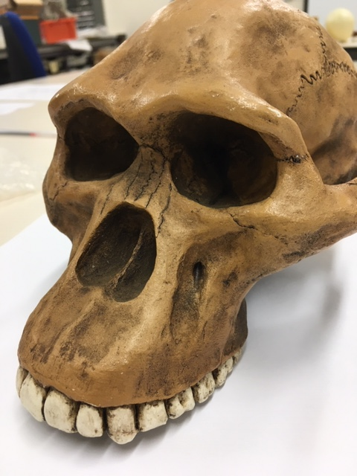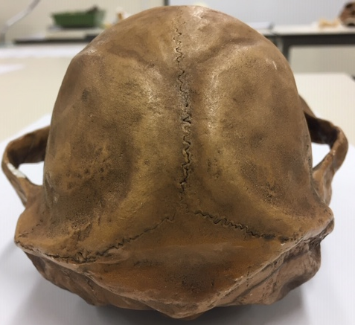

Chimpanzee

Australopithecus afarensis

Australopithecusafricanus

Australopithecus robustus

Homo habilis
Looking at faces 2
Look at the following images and then compare them to the list below. Indicate clearly (circle or highlight) the name of the early hominin skull you believe this to be.
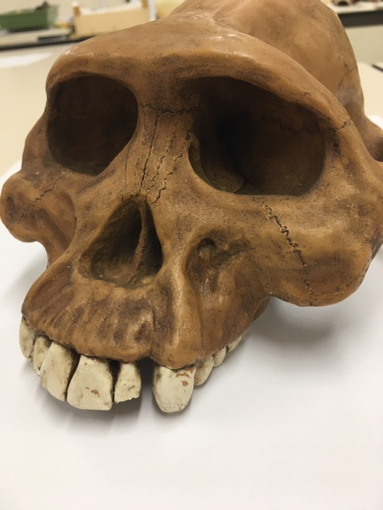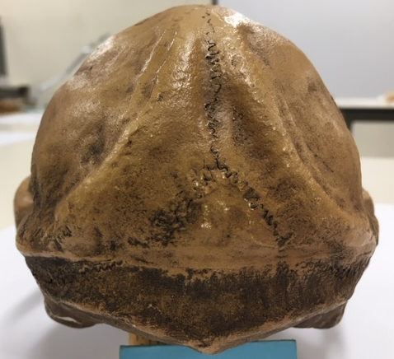

Chimpanzee

Australopithecus afarensis

Australopithecusafricanus

Australopithecus robustus

Homo habilis

Looking at faces 3
Look at the following images and then compare them to the list below. Indicate clearly (circle or highlight) the name of the early hominin skull you believe this to be.
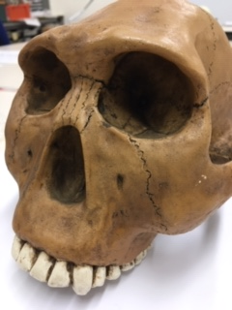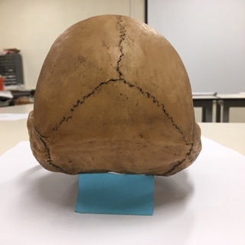

Chimpanzee

Australopithecus afarensis

Australopithecusafricanus

Australopithecus robustus

Homo habilis
Maxilla (upper jaw): Identify the species these belong to
A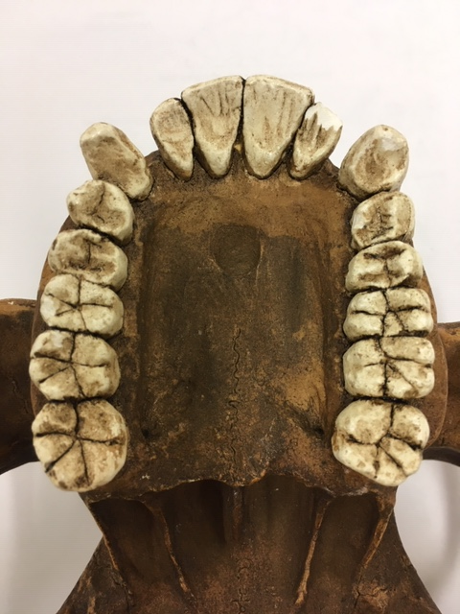B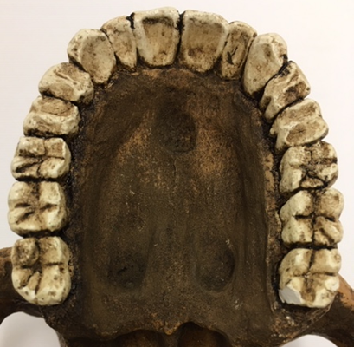
A: Australopithicus afarensis B: Modern human (Homo sapien)
Top row left Chimpanzee, Middle Australopithecus afarensis, Right modern human
Lower row Left Australopithecus africanus, Right Australopithecus robustus
Identify the skull to genus and species level
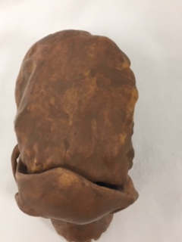
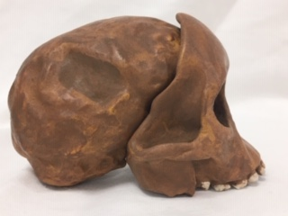
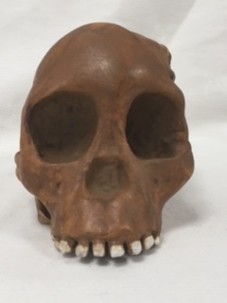
Answer: Afarensis africanus
Identify the skull to genus and species level
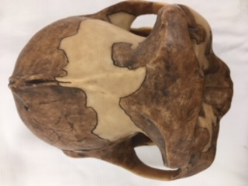
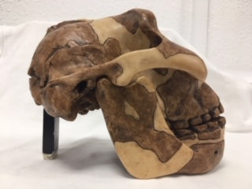
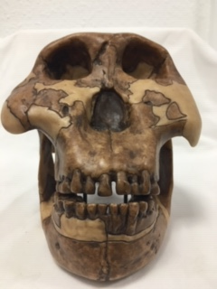
Answer: Australopithecus robustus
Identify the hominin skull to genus and species level
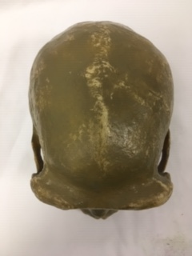

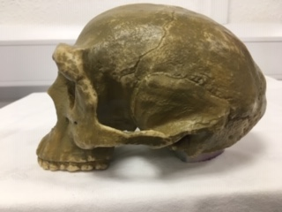

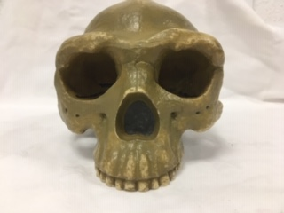
Answer: Homo erectus
Identify the skull to genus and species level
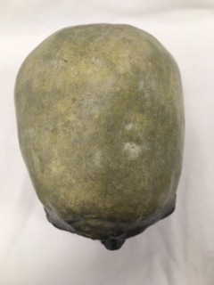
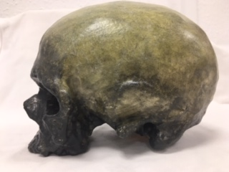
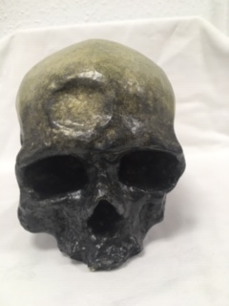
Answer: Cro-magnon (France) 1st modern Homo sapiens
Identify, compare and contrast these two mandibles. Use the illustration below to help if you need to.
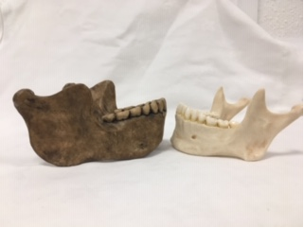
Lower mandible of a Homo heidelburgensis

The lower mandible of a modern human (Homo sapien)

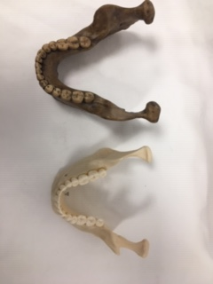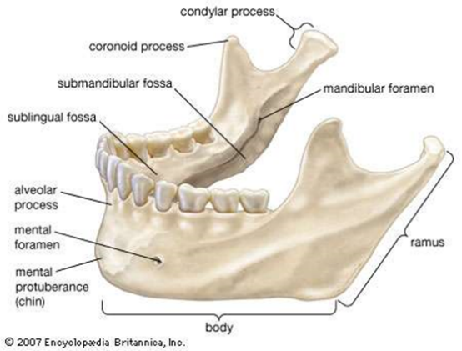

Answer: Homo heidelburgensis has no mental protuberance (chinless). The body of the mandible is longer, smaller curve/gap. Ramus is deeper, taller and thicker. The condylar process is wider, flatter and oval-shaped end. Coronoid process is rounded, shorter and thicker. Small teeth in a large jaw/mandible, slightly larger than in the modern human. Homo sapien Shorter body. Ramus is shorter, straighter tilted further back and more angled. Has a mental protuberance (chin). Condular process thinner, smaller, reasonably rectangle-shaped ends. The coronoid process is flattened, triangular, and more pointed. Incisors narrower, and fairly vertical. Both have parabolic /rounded dental arch/teeth, no space between canines and 1st pre-molars. 1 mental foramen, alveclar process and submandibular fossa. Short canines are almost level with other teeth, and relatively blunt. Y-5 cusp pattern, thick enamel.

Stone tools and tool technology: How to tell a stone is worked.
What features suggest this stone has been worked (knapped)?
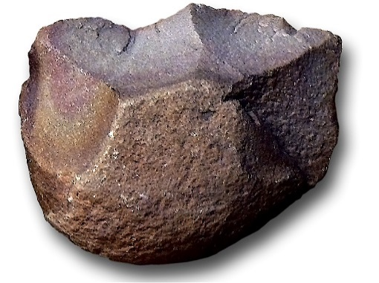
Answer: Has a striking platform (core) hit with a hammer stone to detach the flake (positive). Symmetrical dips outlining where flakes have been removed (negative).Fracture lines.

Features of stone tool flaking: identify features 1-5
3
4

1. Striking platform
2. Point of percussion
3. Bulb of percussion
4. Fishers or flake scaring
5. Ripples
Stone tools and tool technology: Stone tools not to scale
Below left: Oldowan Below Right: Acheulean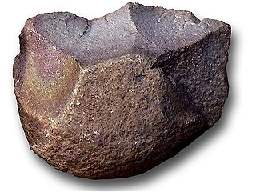 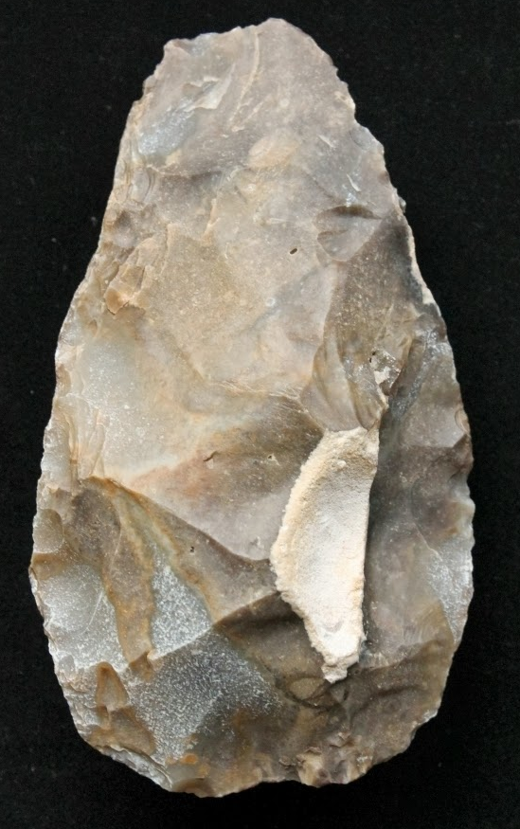
Images taken from https://images.search.yahoo.com

Task: Compare and contrast these two stone tools
Oldowan – basic model, possibly older, stone not flint, no scaring, no percussions, difficult to flake, coarser material, smaller in size, only half the original stone. Hard to distinguish from naturally created objects and has less cutting edge.
Acheulean – multiple flakes taken off both ends creating a teardrop shape out of the whole stone. Multiple flakes removed could be used for smaller, more precise tools such as scrapers. Most likely flint which has a higher silica content (more glass-like/sharper). A greater cutting edge, better suited for hand axes and used for butchering, skinning, digging and chopping wood.

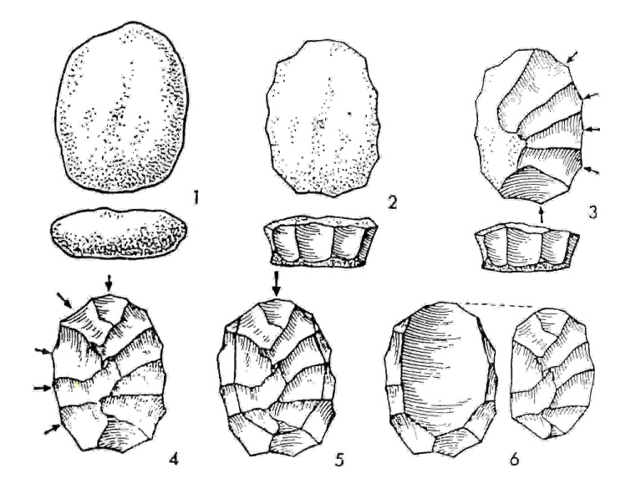
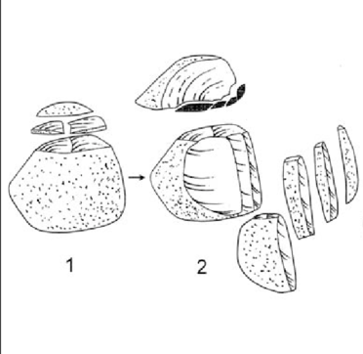
Above left: Levallois Technique and above right: Upper Palaeolithic blade technology.
Task: Imagine you are a mobile Hunter-Gather-Forager, briefly outline why these (Middle and Upper Palaeolithic) technologies would be seen as an advantage above the Oldowan and Achulean
A more sophisticated tool with greater control over the size and shape of the flake. Many flakes can be removed, improving its efficiency and lasting longer. It can be easily carried, removing slices as needed for scrapers, knives or projectile points. They have a thinner and sharper blade.

