Welsh Photographic Evidence
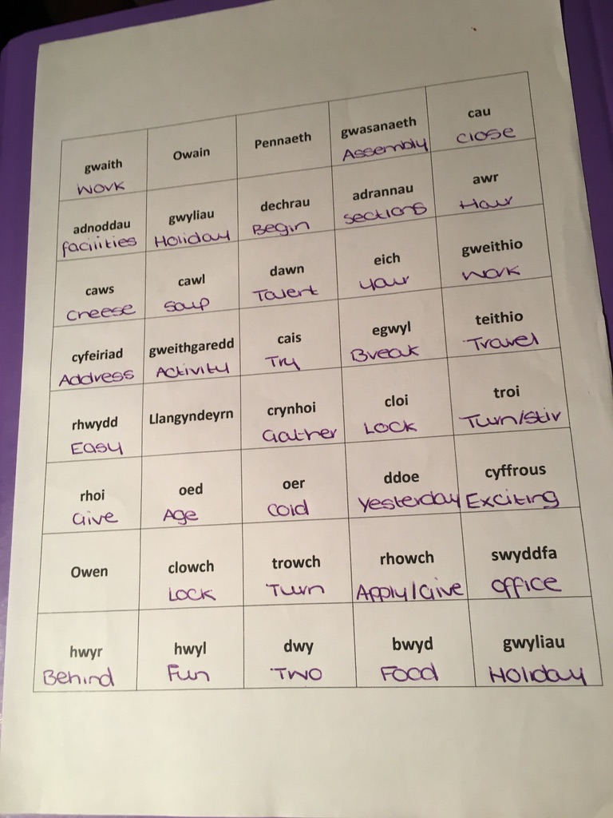
This worksheet was one of the first activities that I completed since doing welsh for GCSE. The purpose of the activity was to search the words using a welsh dictionary app called- App Geiriaduron.

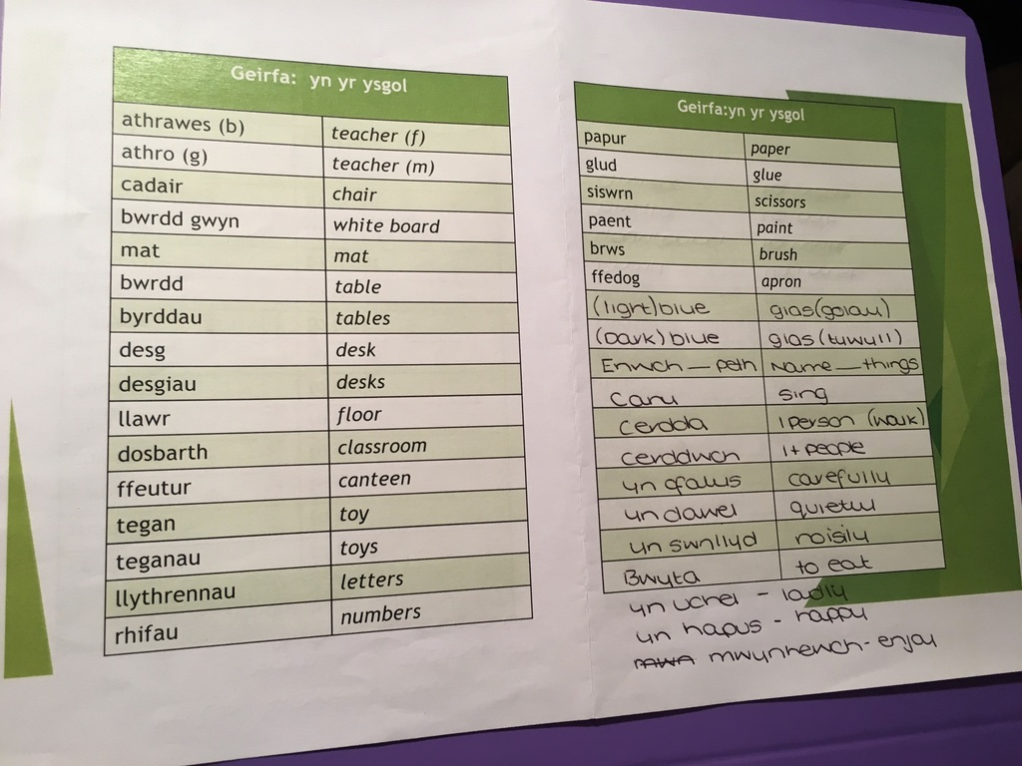

This is a welsh vocabulary sheet that I was given in university to help me know useful phrases. This sheet was very helpful for my placement as I looked over it many times to practice the phrases, in order for me to implement them in my own teaching.
I made sure to write down new vocabulary and phrases that I had learnt so that I could remember them and revise them.

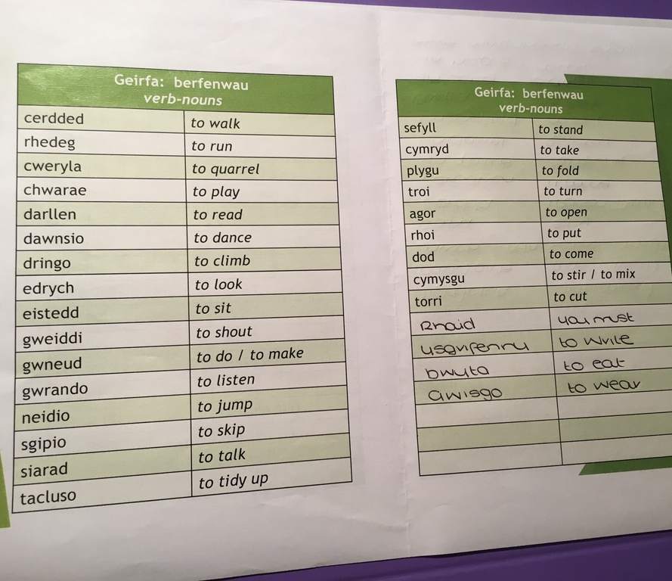
This is a welsh vocabulary sheet that I was given in university to help me know useful phrases. This sheet was very helpful for my placement as I looked over it many times to practice the phrases, in order for me to implement them in my own teaching.
I made sure to write down new vocabulary and phrases that I had learnt so that I could remember them and revise them.

This is a welsh vocabulary sheet that I was given in university to help me know useful phrases. This sheet was very helpful for my placement as I looked over it many times to practice the phrases, in order for me to implement them in my own teaching.
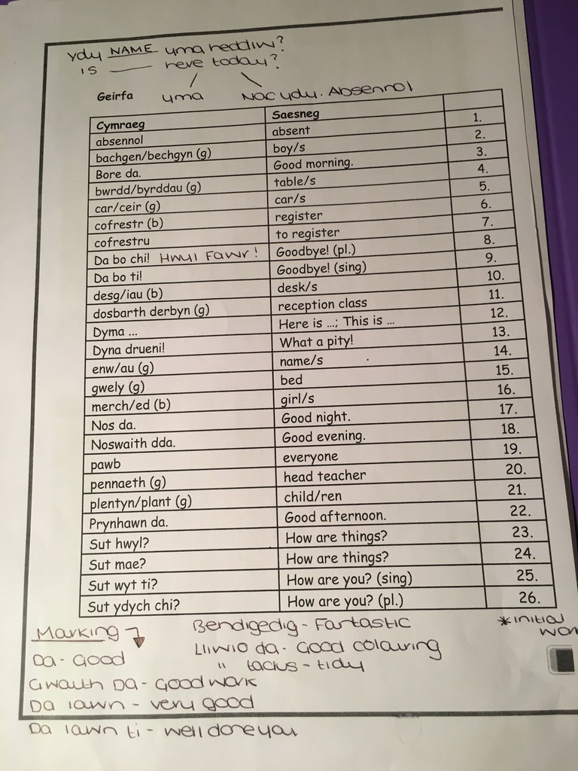

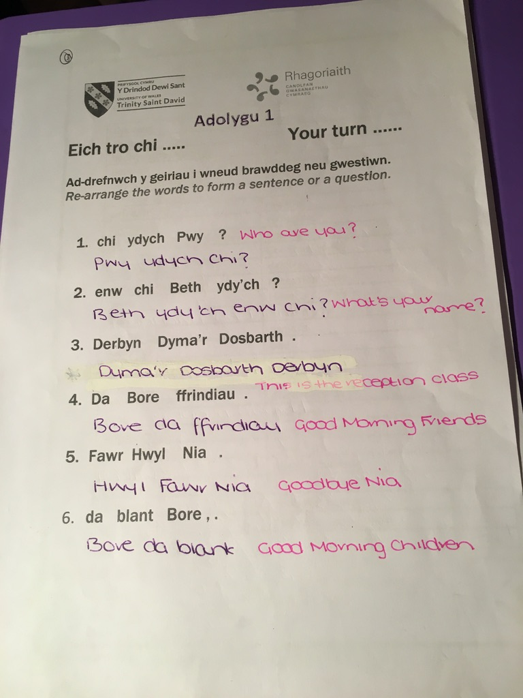
This worksheet was given to me in university to try and complete at home to practice the welsh that we had been taught in the lesson. I found it a good way to practice the welsh language patterns that we had been taught and to revise the welsh that I already knew.
To help myself for future revision, I wrote down the English translation so that I could use it in my own teaching.

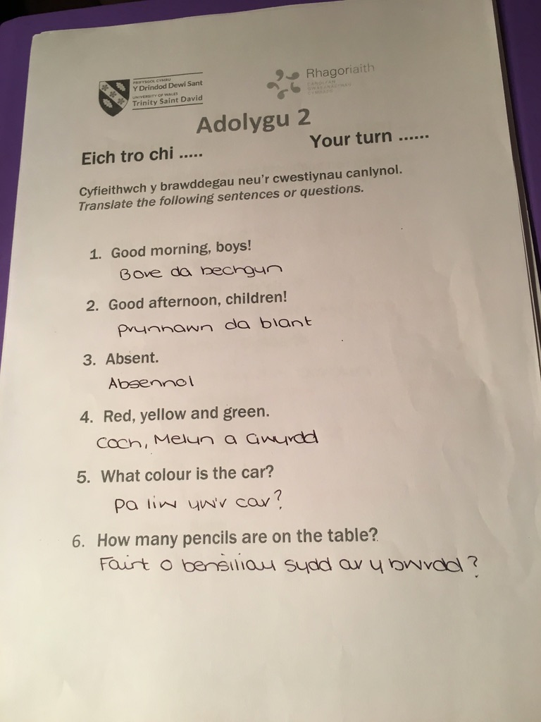
This worksheet was given to me in university to try and complete at home to practice the welsh that we had been taught in the lesson. I found it a good way to practice the welsh language patterns that we had been taught and to revise the welsh that I already knew.

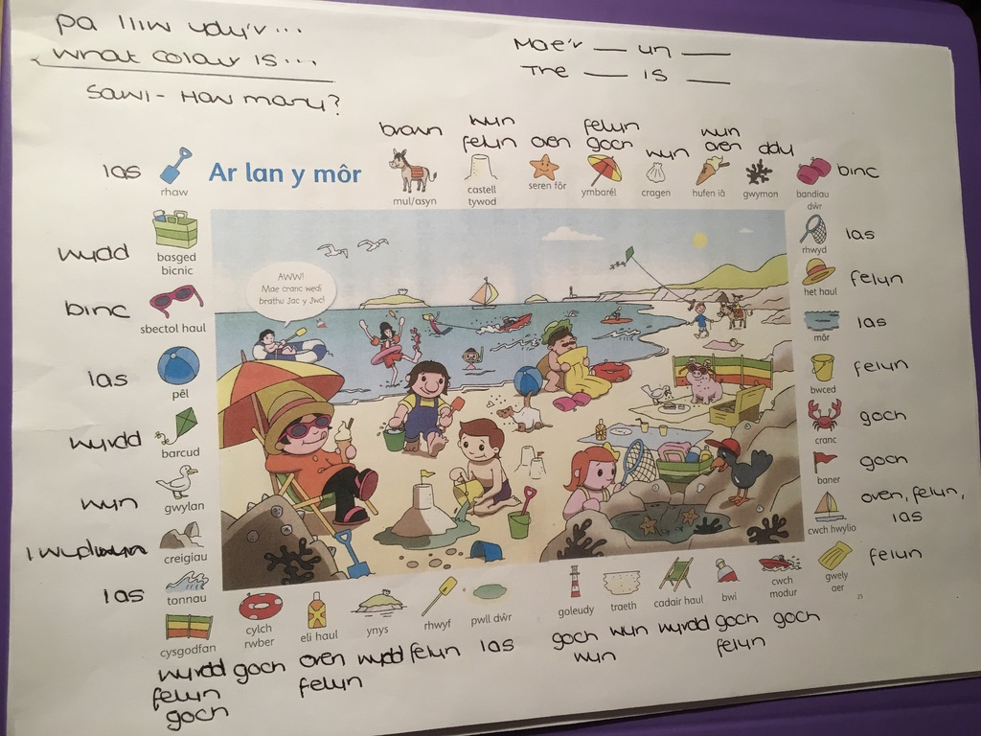
I was given and completed these mats in my university welsh lessons and thought that it could be a really good lesson to use in placement.
Unfortunately, this idea would be too complex for the nursery age group that I am with, but I still used some valuable vocabulary and will keep it in mind for other year groups.

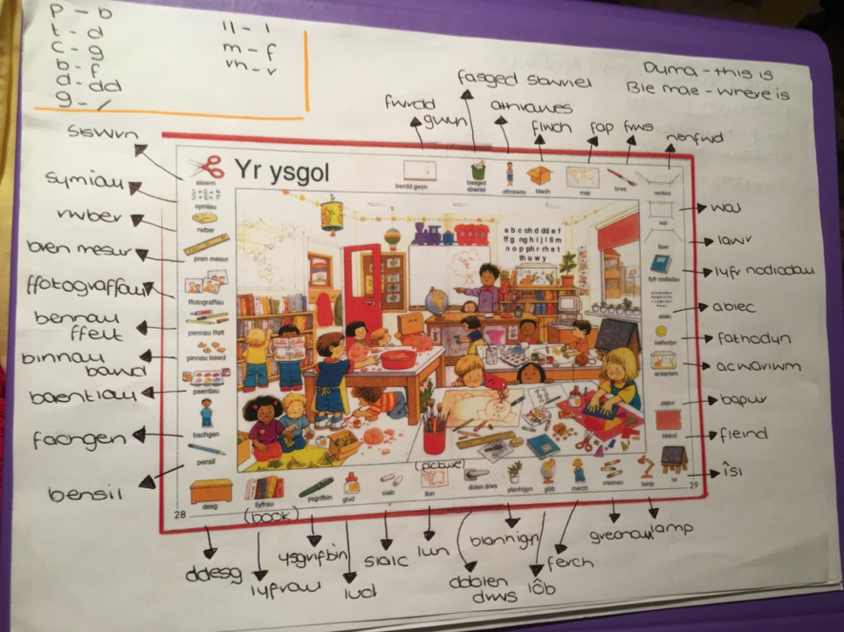
I was given and completed these mats in my university welsh lessons and thought that it could be a really good lesson to use in placement.
Unfortunately, this idea would be too complex for the nursery age group that I am with, but I still used some valuable vocabulary and will keep it in mind for other year groups.

This booklet was really useful in helping me with sentences and commands that I could use in my nursery class. It helped me to say phrases in welsh such as ‘sit down quietly’ or ‘put your hands up’, which are sentences that I would use frequently in English.

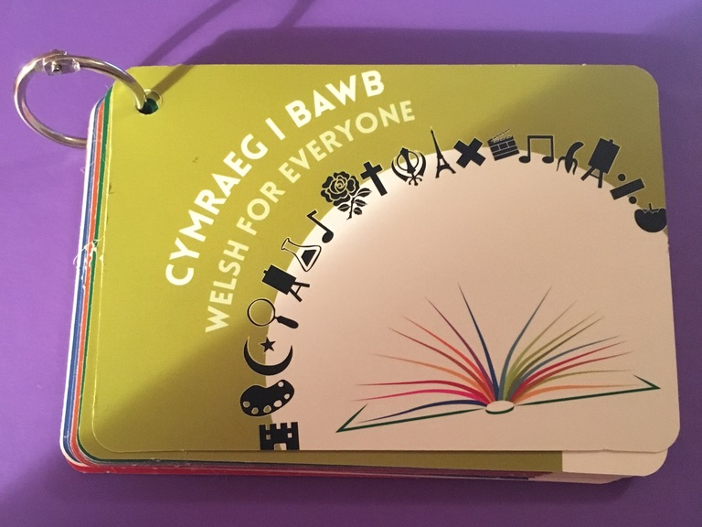
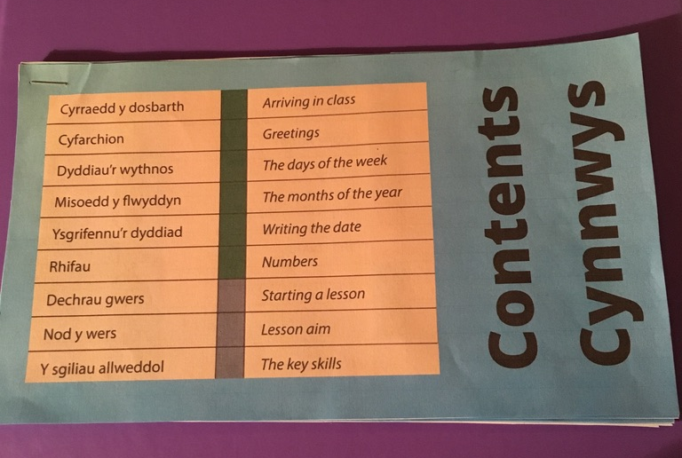
This is a booklet which is similar to the book above, but it provides some more complex sentences and vocabulary that I could use to challenge myself. This booklet was helpful in my placement, but I didn’t use the harder sentences as they would not be suitable or apply to the nursery age group.

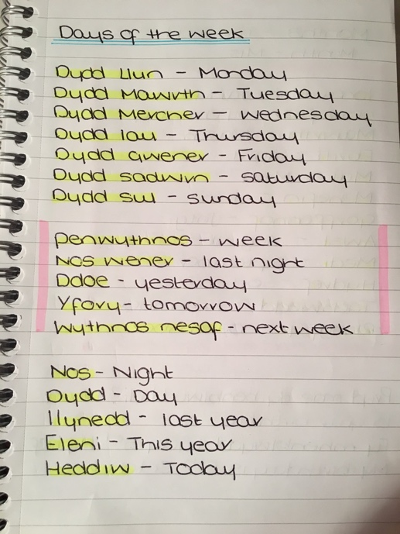
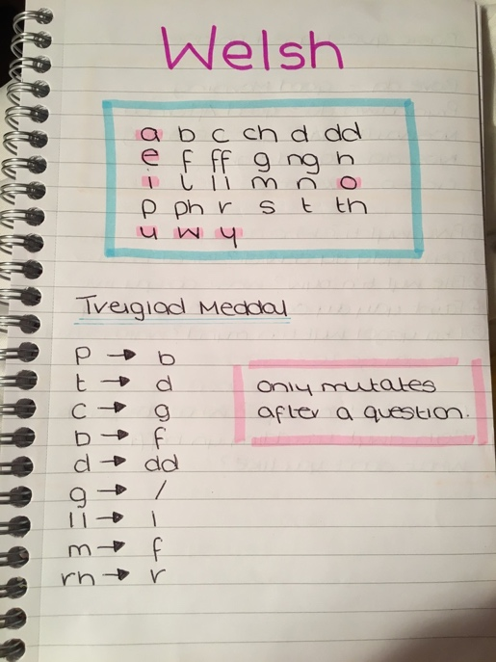
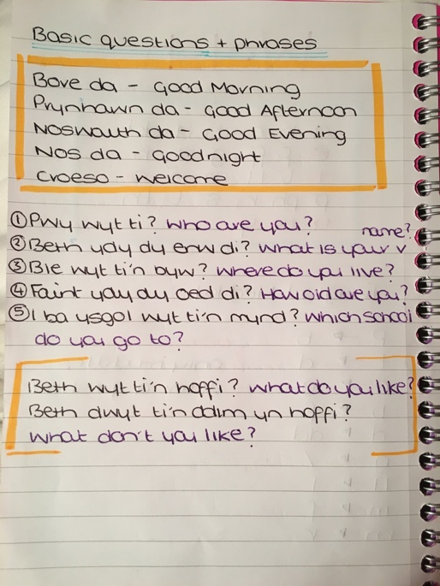
These are pages from the notebook that I used to revise welsh vocabulary and sentences. I made sure that I used topic’s that would be age appropriate and beneficial to use within a classroom.

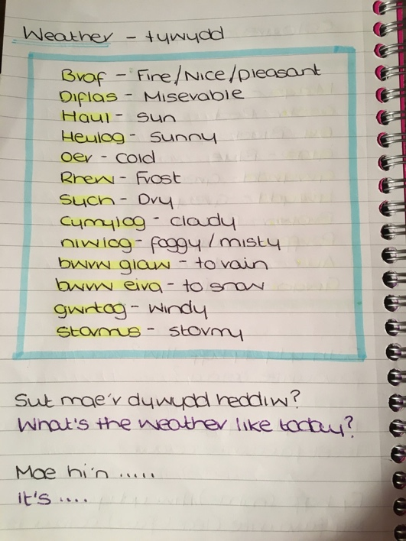
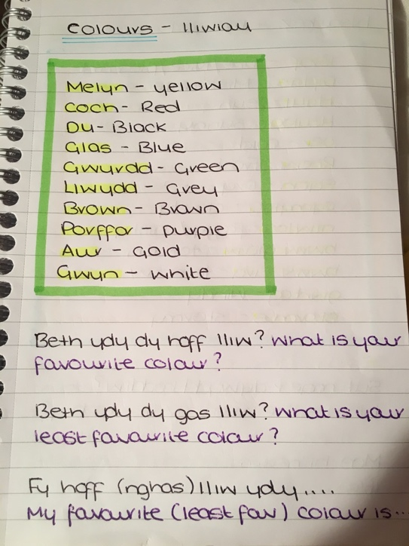
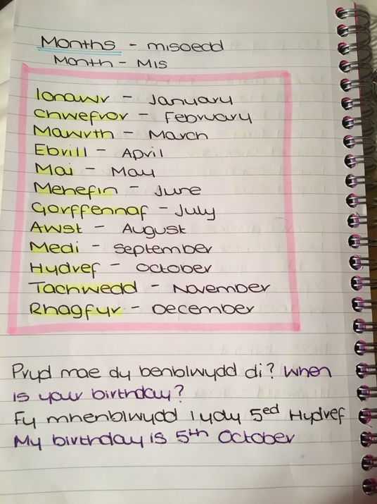
These are pages from the notebook that I used to revise welsh vocabulary and sentences. I made sure that I used topic’s that would be age appropriate and beneficial to use within a classroom.

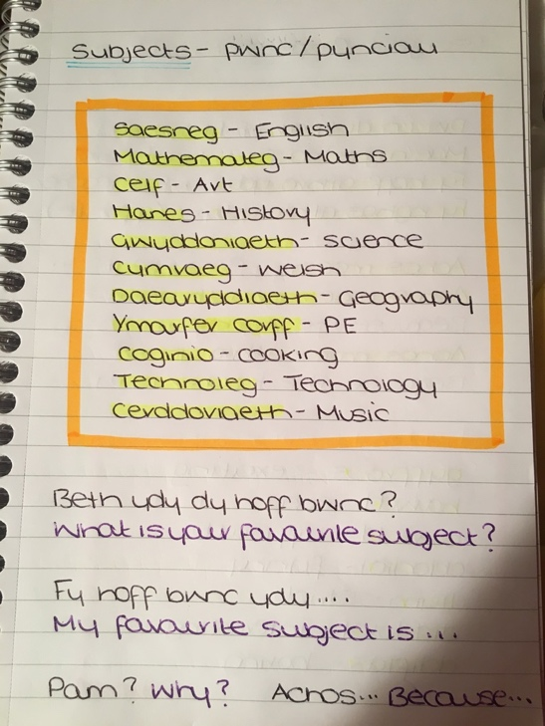
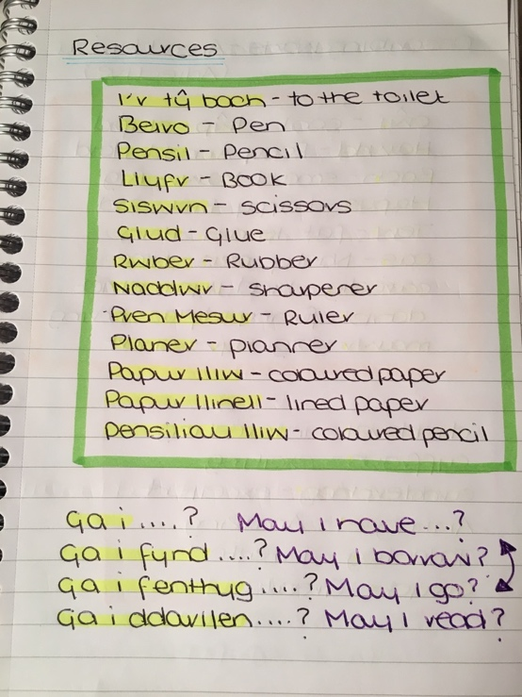
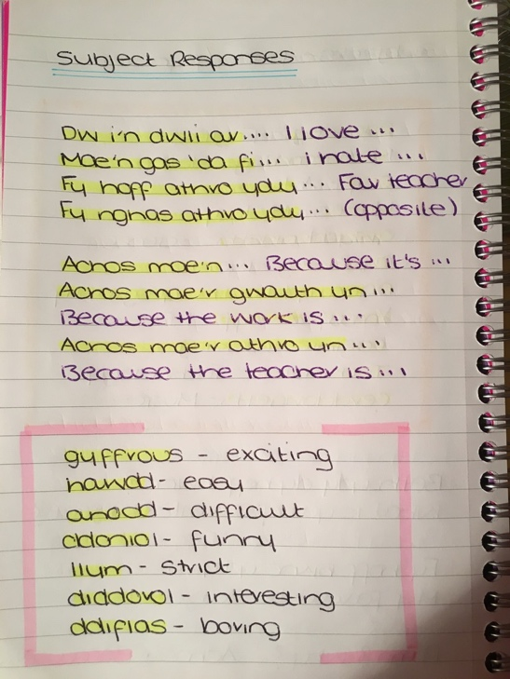
These are pages from the notebook that I used to revise welsh vocabulary and sentences. I made sure that I used topic’s that would be age appropriate and beneficial to use within a classroom.

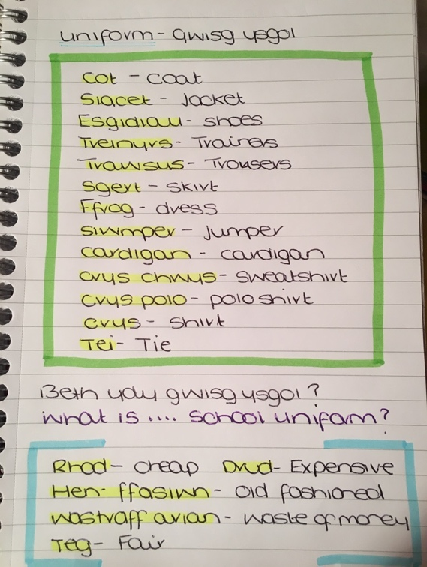
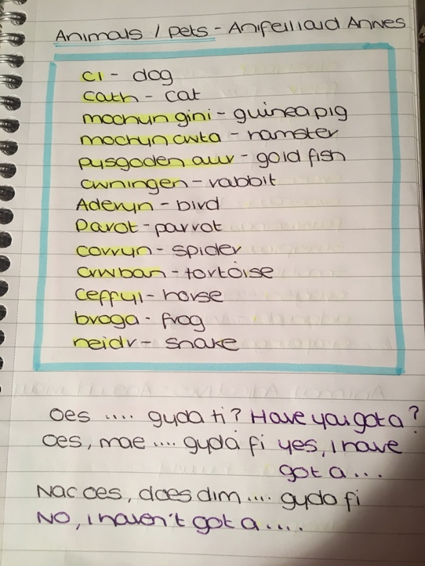
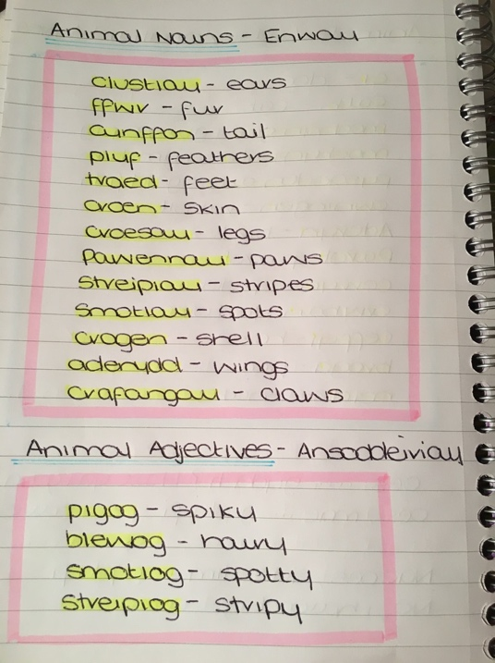
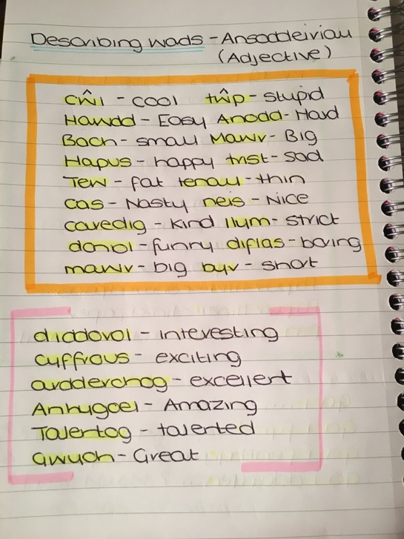
These are pages from the notebook that I used to revise welsh vocabulary and sentences. I made sure that I used topic’s that would be age appropriate and beneficial to use within a classroom.

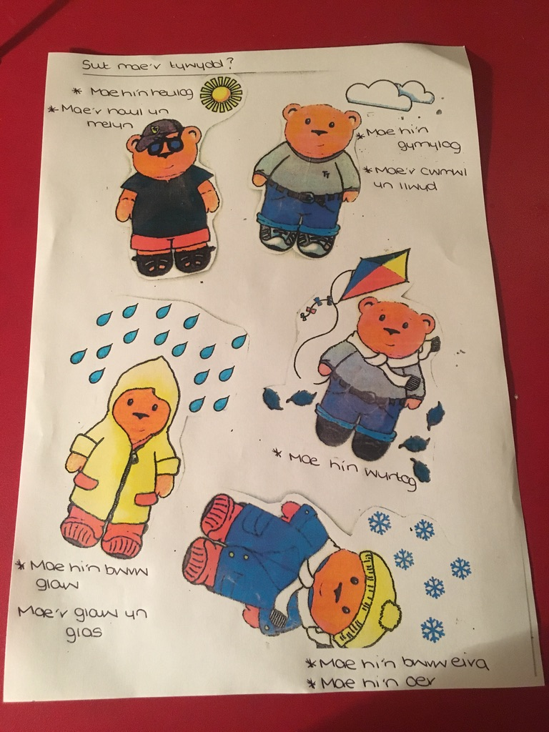

This is evidence of the preparation I did for my filmed welsh lesson. When I asked the pupil’s what weather each image showed, I wrote down the possible responses so that I could say them and ask the pupils to repeat the full sentence after me.
I made sure that the sentences were age appropriate for the pupils but were challenging enough. For example, for the sun and rain, I wrote down a sentence that said that the ‘the sun is yellow’ and ‘the rain is blue’.
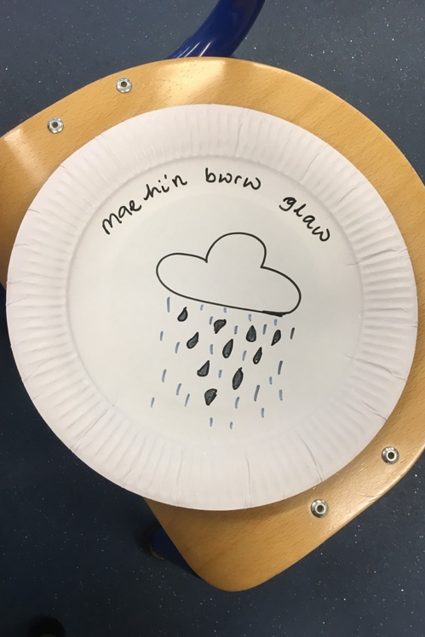
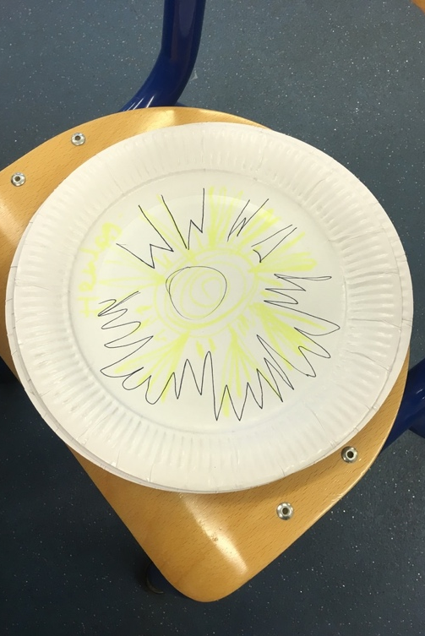
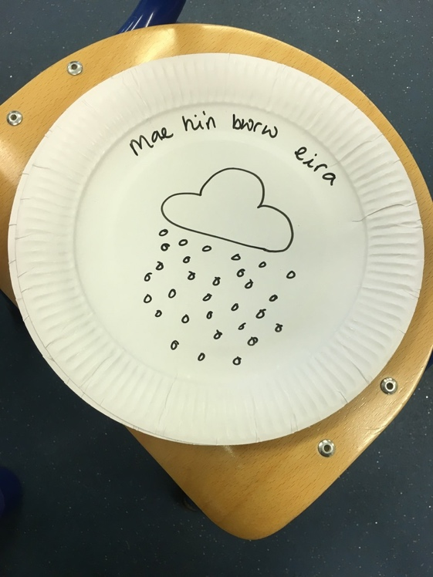

These plates were handmade to use during carpet time and registration to practice the pupils welsh with regards to the weather. There were plates for each weather type (sun, rain, snow, cloudy, windy, stormy) that were like the sun one which had no writing on and there were plates like the rain and snow which did have the full sentence on. The idea behind these plates were to use the plain one with just the drawing on to challenge the pupils, and to use the other ones just to test the pupil’s knowledge. I would hold up each plate in front of the class and either ask them to shout the answer out or put their hands up to answer.

A fun activity that I did which incorporated these plates was having a group of 6 pupils in a circle and giving them each a plate which was faced down on the ground. Each pupil then had to hold up their plate and tell the rest of the group what weather they had.
Another activity that I had planned but didn’t execute with these plates was a game of charades which follows a similar concept to the above activity. The pupils would each be given a plate and would have to try and act out the weather for the other pupils to guess.

These are photographs of work completed by some pupils on a lesson based on weather. This activity was completed with Rising 3 pupils so they were unable to do the same activity as the nursery pupils, as it would be too complex for them. To differentiate between the two classes, I would lay out the different Tedi Twt images in front of the pupil (as the activity was completed individually) and would ask them to tell me in welsh what weather each image showed. I would then ask them to choose one Tedi Twt image and for them to stick it in their book. I would then ask each pupil about the image and scribe what they said in their book. I wrote down whether they answered my question independently, or with my support.

This is photographic evidence of the nursery pupils doing a similar task as the rising 3 pupils based on weather. For this task I held up one out of five Tedi Twt images and asked the pupils to draw in their books what weather the image showed. I would then go around each pupil independently and ask them what they had drawn. I would scribe what they said in their books and state whether they said it independently or with help. When marking the books there were some drawings (like the ones above) that were unclear, so I would stick down the Tedi Twt image that it was supposed to represent to that the class teacher wouldn’t get confused.

