

Student name: Richard Oji

Student ID: 2013435

Module name: Changemakers: Building your Personal Brand for Sustainable Employment

Module code: BMHP5015

Lecturer name: Chizoba Esio - Bassey

Assessment: Assignment 1 Online Portfolio

TABLE OF CONTENTS

Cover Letter……………………………………………..........................................................3 - 4

C V……………………………………………………………………………………………………….5 - 8

PITCH ………………………………….......................................................................................9- 11

Reference List.……………………………………………………………………….………...12-13

Cover letter
A cover letter could be defined as a letter that accompanies a CV or another letter.
Cover letters provide extra or specific information’s about the person or the CV.
A cover letter help create employers first impression, allowing the person to expatiate more on certain areas of importance (reed.co.uk, 2018).

Richard Oji
London SE2
Email: richardrichard415@yahoo.com
Phone: 07946092210

August 1, 2022
The London clinic
20 Devonshire Place
London
W1G 6BW
UK

Dear Mr Richardson,
I am writing to apply for the position of a part-time Healthcare Assistant Team leader – Outpatient, recently advertised on the NHS jobs web page. I have also included my resume for your consideration. I applied for the job because the skills and qualities I have match the job description and I feel very delighted for the opportunity with your company and have kept my eyes and ears open to apply for a part- time position with your trust. I`ve been searching for this position for a Work - life balance, in accordance with my present situation. I have over 10year experiences in the industry, and have worked in various healthcare setting as a health care assistant, ranging from NHS Hospitals, Care homes, Day Centres and Domiciliary Home services, supporting individuals make positive choices, protecting and providing quality patient centred care. I can adapt easily and make a fast, immediate and positive impact as I already have the necessary experience needed for the job. I have carried out research on the job role and I believe, I will gain and contribute positively to your trust, as a dedicated hardworking, professional and loyal person ready to work towards achieving your company’s values and objectives. As a humble committed professional with great passion and empathy in supporting vulnerable people individually or as part of a team, I will always perform to high standard.
I have been working hard to continually develop the necessary skills, qualities and experience necessary to achieve the utmost professional goal of patient care satisfaction in healthcare. I am currently studying health and social care as a degree course at the University of Wales Trinity Saint David (UWTSD).
Since attending university, I have developed extensive skills through the varsities academic programmes combined with articulated modules, tailored to specific course. Working in groups has brought out my leadership skills and developed my confidence working and connecting with people as a team player. I am a mentee of healthcare professional from various backgrounds, which has given me an edge over work and studies. While studying, I was able to maintain my job as a Health care assistance. My strength comes from my ability to manage my time and multitask effortlessly, prioritising my work- load and able to work under pressure to meet expected targets.
Located in the heart of London Harley Street, The London clinic with its prestigious reputation of delivering pioneering treatment with state-of-the-art innovation and clinical excellence, I would like to work for your organisation with all certainty, I will make an immediate, positive impact as I already have the necessary experience needed for the job, and develop as a person be the best. Your hospital is well run and clearly support, treat patients with respect and cares, with value of diversity, equality and inclusion of its workforce and there are positive feedbacks from ex-employees. I am caring, efficient and hardworking with learning enthusiastic abilities, looking for new opportunities where to apply my skills within an establishment.
I believe my vast working experience and academic knowledge, would make me an asset to your company.
Thanks, and looking forward for your consideration.
Sincerely,
Richard Oji

C V
C V, otherwise known as (curriculum Vitae) could be defined as a written account of a person’s Education and work experience sent to a prospective employer when looking for a job (National Careers Service).

Richard Oji
London SE2
E-mail: richardrichard415@yahoo.com
Tel. No. 07946092210

PROFILE
I’m a highly talented and self- motivated person with great professionalism at work and very enthusiastic in delivering professional goals. I have 13years of working experience in the industry, with a genuine interest in working with individuals with special needs, vulnerable people, rendering other healthcare services to clients and organisations. I am reliable with a positive attitude to do and a team player. I am punctual, reliable with excellent communication skills and ability to work under pressure independently. I enjoy dealing directly with people of all levels and have gained invaluable experience through my employment years. Apprehensive of the unforeseeable future and in the quest of my future career ambition as a “Healthcare Assistant Team Leader’’ for utmost professional progression and goals, I am currently studying Health and Social Care as a degree course for future job elevation to optimize my passion working in the health sector.

PROFESSIONAL SUMMARY
I comply with organizational and departmental procedures for best practice which delivers a timely, efficient, and cost-effective service in accordance with legislative requirements.

KEY SKILLS

Versatile with many autoclaving machines.  Ability to work under pressure and independently.  Proficiency in Microsoft office.  Efficient and reliable team player  Appointed first aider / health & safety personnel | Excellent communication skills  Excellent command of English language.  Motivated & enthusiastic  Willing to learn new skills & methods of working.  Excellent observation skills
EDUCATION/QUALIFICATIONS/TRAINING
Current=Health and Social Care (Level 5) University of Wales Trinity Saint David.
Certificate of Higher Education in skills for the Workplace (Level 4 Health and Social Care) University of Wales Trinity Saint David.
NVQ Level 2 Health and Social Care
NVQ level 3 Health & Social Care (Adults with learning disabilities)
Mandatory & Statutory (practical) Training Course
HND Mass communication

OTHER TRAINING
Alcohol & Drug Awareness

Customers with disabilities

Mental Health Awareness

Safeguarding of vulnerable adults

Control of Substances Hazardous to Health (COSHH)

Occupational Health & Safety

Full First Aid at Work

Food Safety Essential

WORK HISTORY
Queen Elizabeth Hospital Woolwich
STERILE SERVICE TECHNICIAN
February 2020 -Till date (Bank staff)
Receipt, Checking, Sorting, Cleaning, Disassembling, Assembling and Packing, sterilizing and dispatching of medical equipment and instruments.

To ensure the effective preparation of sterile consumables (dressings, linen, instruments and equipment) within predefined quality standard.
Undertake daily testing of Autoclaves and washers/disinfectors.

Ensure all equipment are maintained at the required health and safety standard
.
Maintaining accurate records at every processing stage.

Ensuring all processed equipment and instruments are clearly and correctly labelled.

Domiciliary Care services Ltd

SUPPORT WORKER
April 2019 – Date
Health and wellbeing: Supporting individuals make positive choices such as; eating well, taking exercise, and maintaining good hygiene. Also providing emotional support, or helping them with dressing, washing and personal care.
Leisure and social activities. Supporting individuals to socialise in the community by engaging with numerous activities such as, eating out, swimming, shopping, yoga classes, painting, going on a trip or doing things they enjoy and getting involved in their local community to stay happy and healthy.
Daily living skills. Supporting individuals with independent living skills such as; banking, paying bills, attending appointments, shopping, cooking and cleaning, encouraging independent living.
Safeguarding. People with learning disabilities can be vulnerable to abuse or exploitation. As their support worker I make sure their rights are upheld and they are being treated with consideration and respect.

Marcus & Marcus Ltd

CARE WORKER
May 2018 – April 2019
Assisting vulnerable adults in achieving independence and self-management.

Engage in crisis prevention and response in various situations.

Substance abuse control and prevention.

Financial responsibility.

ST. Mark’s Social Education Day Service

SUPPORT WORKER
July 2009 – May 2018

Assisting vulnerable adults in achieving independence and self-management

Support the team in providing day care and social education to clients with
autism, learning difficulties, and other challenging behaviours.

Engage in crisis prevention and response in a various of situations

Educate and support clients on a wide range of interested issues

PERSONAL INTERESTS
Socialising and Playing sport.

REFERENCES
Available on request

PITCH
The Effect of Smoking on The Body.
There has been numerous campaign and advertisement on the dangers and adverse effect of smoking to people and the society at large. UK government, has been in the forefront of the campaign against smoking, through various medium, fighting the multi-billion-pound smoking industry as well as supporting and encouraging its smoking population to quit smoking for better living.
Christopher Columbus and fellow explores introduced smoking to Europe as it has long been in existence and practised by the native American tribes, which then spread and is now practiced globally (Tobacco Free Life). Smoking could be described as an act of inhaling and exhaling smokes from plant materials such as marijuana and hashish (Britannica). However, its more commonly linked with tobacco smoked in cigarette, cigar or pipe, containing addictive substance with stimulating and tranquilising effects. E.g., nicotine.
This silent killer (Tobacco) was said to have arrived in England on the 27th of July 1586 by Sir Walter Raleigh from Virginia (Johnson). who went as far as advising Queen Elizabeth to give it a go, and it has since remained in circulation spreading across generations, despite continuous efforts to stop and discourage tobacco habit causing worrying concern, since 1604, when king James condemned tobacco and imposed a tax on it. Religious group like the catholic church, also joined the condemnation of tobacco by banning it use from holy places and pronouncing its usage sinful considering its ugly nature and dangerous harmful consequences to human health. Tobacco usage and sales has quadrupled over the years despite all the effort from past to present to combat and discourage people from smoking. Irrespective of the challenges and difficulties faced in combating and discouraging people from smoking and the options of a healthier lifestyle and a cleaner unpolluted society, there has been a great resilience and a continuity of the fight against smoking which began centuries ago. UK government has been in the forefront of the battle through its numerous policies and various affiliated organisations including private bodies, non-governmental agency and charity organisation across the nation. The campaign against smoking and possible solutions on how to quite are more accessible than it was centuries ago. Before an in-depth campaign measure on how to quit smoking, we will review some of smoking negative effects to understand the importance of a consistence TV documentary series Pledge on smoking, in order to save lives. According to world health organisation, approximately 7 million people die each year due to direct use of tobacco and approximately 1 million die people die from second – hand smoke (World Health Organization). Smoking is could be classified into two categories, (Passive and Active smokers). Active smokers are those individuals who smokes the cigarette, while Passive smokers are those individuals who inhale the smoke that comes out of the cigarette, which is also known as second-hand smokers.
Beside death, none of the above-mentioned smokers are safe from exposure, as over 80% of the world Cigarette smoker are family members, friends and well-wishers, work colleagues, or live around us, living us with NO option but making us all Passive smokers, causing us smoking related damages in human body, such as in the respiratory system, which affect the lungs and damaged the airways and the small air sacs called alveoli. It can also affect the cardiovascular system, reproductive system etc.

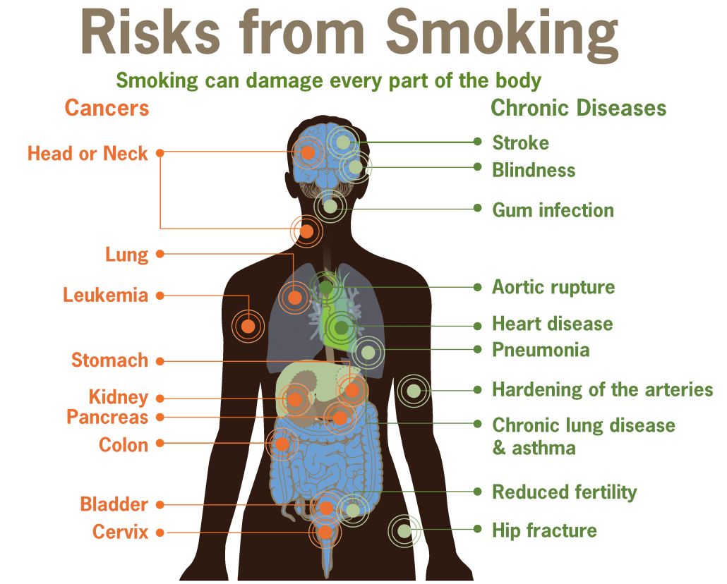
(Effects of Smoking on the Body).
Due to the devastating effect of smoking on human lives as shown on the diagram and many more, UK passed a legislation on the 1st of July 2007, making it illegal to smoke in all public enclosed areas and workplaces (Smokefree England). This legislation protects non-smoker and reduced or eliminate passive smoking. According to NHS England, approximately 80,000 people die a year from smoking, and the risk of developing 50 serious health conditions, such as, lung cancer, throat cancer, cervix cancer, coronary heart disease, heart attack, stroke, peripheral vascular disease, impotence, asthma and many more. According to ASH statistics, Smoking and its related health disease cost the NHS approximately £17 billion pounds a year, of the health budget (Action on smoking and health). Going by the statistics, smoking is a drain to the national budget and a cost to our health and wealth by placing extensive hardship on our NHS. Perhaps it’s time for stiffer measures to protect the society and the NHS.

References
Action on smoking and health. “Smoking Costs Society £17bn – £5bn More than Previously Estimated.” Action on Smoking and Health, 14 Jan. 2022, ash.org.uk/media-and-news/press-releases-media-and-news/smoking-costs-society-17bn-5bn-more-than-previously-estimated/. Accessed 19 Aug. 2022.
Britannica. “Smoking | Definition, Types, Effects, History, & Facts.” Encyclopædia Britannica, 2019, www.britannica.com/topic/smoking-tobacco. Accessed 19 Aug. 2022.
“Effects of Smoking on the Body.” SE Radiation Oncology Group, 12 Nov. 2014, treatcancer.com/blog/effects-smoking-body/. Accessed 19 Aug. 2022.
“I Smoke between 0-4 Cigarettes per Day. How Will This Affect Me?” Quora, www.quora.com/I-smoke-between-0-4-cigarettes-per-day-How-will-this-affect-me. Accessed 19 Aug. 2022.
Johnson, Ben. “Introduction of Tobacco to England.” Historic UK, 2017, www.historic-uk.com/HistoryUK/HistoryofEngland/Introduction-of-Tobacco-to-England/. Accessed 19 Aug. 2022.
National Careers Service. “CV Sections | Careers Advice | National Careers Service.” Nationalcareers.service.gov.uk, 2022, nationalcareers.service.gov.uk/careers-advice/cv-sections. Accessed 19 Aug. 2022.
Smokefree England. “Smokefree England - All about the Smokefree Legislation on 1st July 2007.” Smokefreeengland.co.uk, 2019, www.smokefreeengland.co.uk/. Accessed 19 Aug. 2022.
Tobacco Free Life. “History of Tobacco in the World — Tobacco Timeline.” Tobacco-Free Life, 2016, tobaccofreelife.org/tobacco/tobacco-history/. Accessed 19 Aug. 2022.
“What Is a Cover Letter? | Reed.co.uk.” Reed.co.uk, 28 June 2018, www.reed.co.uk/career-advice/what-is-a-cover-letter/.
“What Is a CV? Curriculum Vitae Definition and Examples.” Indeed, Career Guide, uk.indeed.com/career-advice/cvs-cover-letters/curriculum-vitae. Accessed 19 Aug. 2022.
World Health Organization. “Tobacco.” Who.int, World Health Organization: WHO, 24 May 2022, www.who.int/news-room/fact-sheets/detail/tobacco. Accessed 19 Aug. 2022

