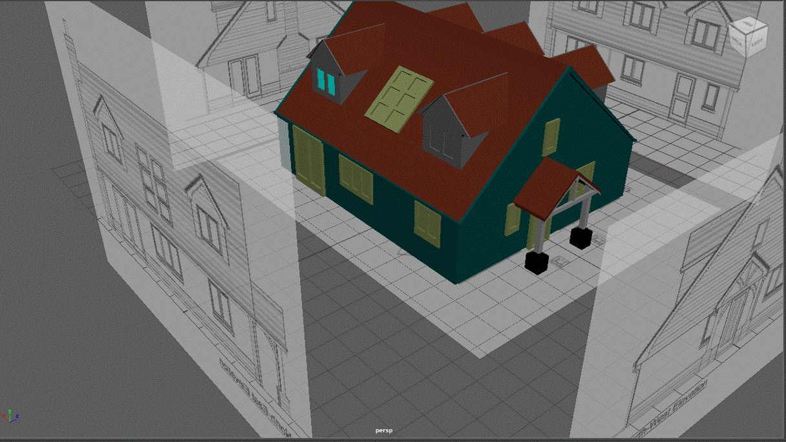
Assignment 1: Development Diary.
BA Games Design, BA Animation & VFX.
Philip Richmond (2212266) | 12/14/23 | Learning in the Digital Era

Contents
Table of Figures 2
Introduction 5
Reading Week 17
Streetlamp Post Asset 17
Soda Can Asset 21
Cup and Saucer Asset 25
Dumpster Asset 31
House Asset 36
Conclusion 43
Bibliography 44

Table of Figures
Figure 1 Maya Software. [1] 5
Figure 2 6
Figure 3 6
Figure 4 7
Figure 5 [2] 7
Figure 6 first attempt at making a streetlamp post. 8
Figure 7 experimenting with different design of lamp post. 9
Figure 8 Street lamp post practice. 10
Figure 9 Screw drive reference picture. [3] 10
Figure 10 Reference picture of screwdriver [3] 11
Figure 11 more practicing and trying to understand how Maya works. 11
Figure 12 [4] Reference picture of an anvil. 12
Figure 13 was not happy with the outcome of this anvil. 12
Figure 14 Reference picture from Ikea. [5] 13
Figure 15 showing loading reference pictures. 13
Figure 16 Happy with the outcome of this chest of draws making me feel that I’m stronger producing more solid objects. 13
Figure 17 Lego man reference picture. [6] 15
Figure 18 My Lego man with a bend neck 15
Figure 19 Axe refence picture. [7] 16
Figure 20 Axe attempt 16
Figure 21 streetlamp post reference for main asset. [8] 17
Figure 22. [9] More Insite into pipes and how to make them. 17
Figure 23 [10] I watch this video for some Insite and extra knowledge due to struggling with making the tablier section on the lamppost. 18
Figure 24 Practicing how to make the tube off the main post that I didn’t like. 18
Figure 25 here I tried to make many cylinders and then tried to join them. 18
Figure 26 failed attempt at extruding and stretching out the pip. 19
Figure 27 Another attempt at making the tube that I am using in the final project. 19
Figure 28 Completed tube. 19
Figure 29 with extruding and bending the pip multiple time I found the pip become flat and not circular. 20
Figure 30 Here I choose to make the light part of the streetlamp post separately and then add it on. 20
Figure 31 Final complete version of streetlamp post asset. 20
Figure 32 Soda can reference picture. [11] 21
Figure 33 Soda can top reference picture. [12] 21
Figure 34 [13] This tutorial I used, give me different methods in Am that I haven't experience defour. 21
Figure 35 To start I used the curved tool to deaw one side of the can as accurate as possible and using vertex button to tidy it up 22
Figure 36 This was then made into 3D using the revolve option in the surfaced tab. More polycount was added to make it more round 22
Figure 37 To get it back no normal I had to go to mesh display and use revers. 22
Figure 38 Next, I had to close both bottom and top using the mesh tool. 23
Figure 39 Then I use the poke tool to make sure all the edges match up. 23
Figure 40. Then extrude was used to make the top can indent 23
Figure 41 [14] Tutorial for can top. 24
Figure 42. Next step is to use quad draw tool with a flat plain active and trace over the can top image and fill with geometry shaps 24
Figure 43 Next I extrude the can pull ring to give it some thickness and then beveled the edge to complete my soda can asset. 24
Figure 44 Saucer reference picture. [15] 25
Figure 45 Cup reference picture. [15] 25
Figure 46 side angle of saucer. [15] 25
Figure 47 [16] I watched and followed this tutorial to make my Cup and saucer to help my learning in Maya. 26
Figure 48 Reference pictures added to Maya. 26
Figure 49 Here I added a polygon cylinder and scaled it to the shape of the reference picture of the saucer. 26
Figure 50 Shaping the bottom of saucer using the extrude Methode. 27
Figure 51 Shaping the saucer 27
Figure 52 Saucer completed and happy with the outcome. 27
Figure 53 28
Figure 54 28
Figure 55 28
Figure 56 Deleted the top to make the object hollow. 29
Figure 57 Next I extruded another face and gave it some thickness. 29
Figure 58 Deletd some faces ready to create the handle. 29
Figure 59 Made a cube extruded/stretched it to the right size and then bend it 90 degrees to fit. Deleted the ends of handle and then merge components. 30
Figure 60. Final version of my cup and saucer. Couldn’t work out how I put the blue mesh on and then how to take it away. 30
Figure 61 Dumpster reference picture. [17] 31
Figure 62 More reference picture showing different angles. [17] 31
Figure 63 Dumpster box made using a cube and extruding methods with edge loops added to give the box more details as the reference image has. 32
Figure 64 I made the Hook lift bare and the duplicated it for the other side. 32
Figure 65 The first few tries with making the dumpster wheels went wrong with trying to extrude the cylinder from a cylinder that left it inside out 32
Figure 66 My lecturer showed me a new technique to me to ? 33
Figure 67 33
Figure 68 Duplicated another 3 wheel and placed them in correct positions. 33
Figure 69 34
Figure 70 Completed lid 34
Figure 71 Lid Duplicated 35
Figure 72 Finished Dumpster. 35
Figure 73 House Reference Image. [18] 36
Figure 74 [18] 36
Figure 75 [18] 36
Figure 76 [18] 37
Figure 77 [18] 37
Figure 78 Reference pictures set in right place. 37
Figure 79 Cube made to fit image. 38
Figure 80 Roof made using edge mode and stretching it out to reference image. 38
Figure 81 Window make separately to reference image. 38
Figure 82. Double door made separately 39
Figure 83 Chimney breast made separately. 39
Figure 84 Single window made seperatly. 39
Figure 85 Bay window was the hardest asset to make for the house. 40
Figure 86 Complete bay window. 40
Figure 87 Duplication of bay windows 40
Figure 88 double check reference pictures 41
Figure 89 Experimenting with surface material on chimley. 41
Figure 90 The rest off windows and door are duplicated and fitted into place. 41
Figure 91 Hose porch created with some difficulty. 42
Figure 92 [19] Here I experimented with some colors. 42
Figure 93 Finished asset. 42

Introduction

Thursday 5 of October was the first day of introduction to Autodesk Maya which will support my first steps into the world of 3D design software. As Maya was opened for the first time, I was greeted with an intricated interface with endless buttons and panels which made me feel underprepared for what was to come. Knowing that I will be learning to sculpt 3D models, animating characters, and bringing my imagination to life will feel both exhilarating and a tad intimidating. From here you will see my journey into the world of Autodesk Maya in my first semester.

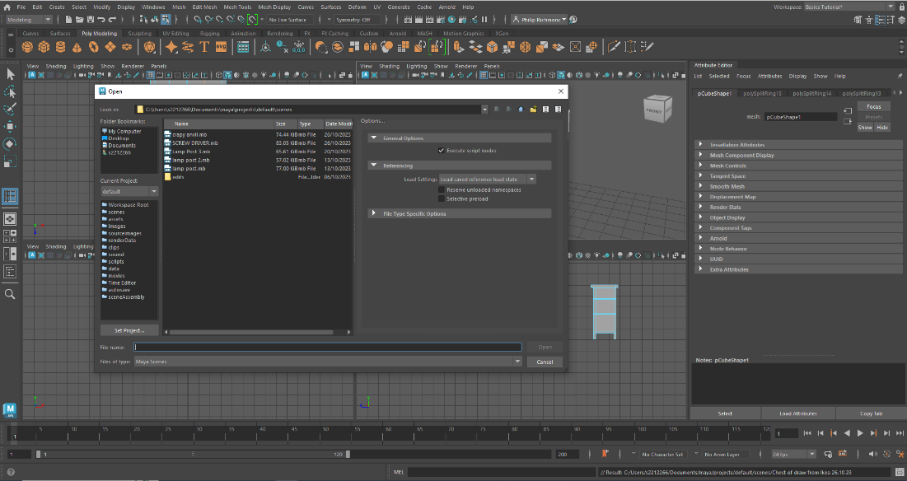
Figure 1 Maya Software. [1]

05.10.12
Introduction to Maya with Adam Head (Lecture) and starting tutorial in Maya. In this the basics were shown like how to move around the screen and different object and interact with them.
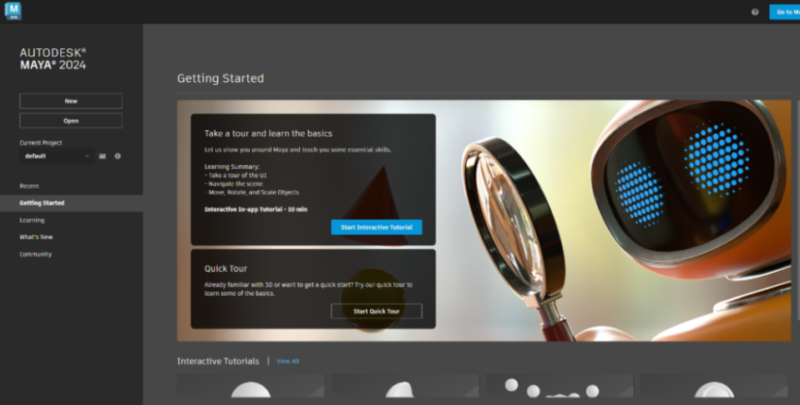
Figure 2
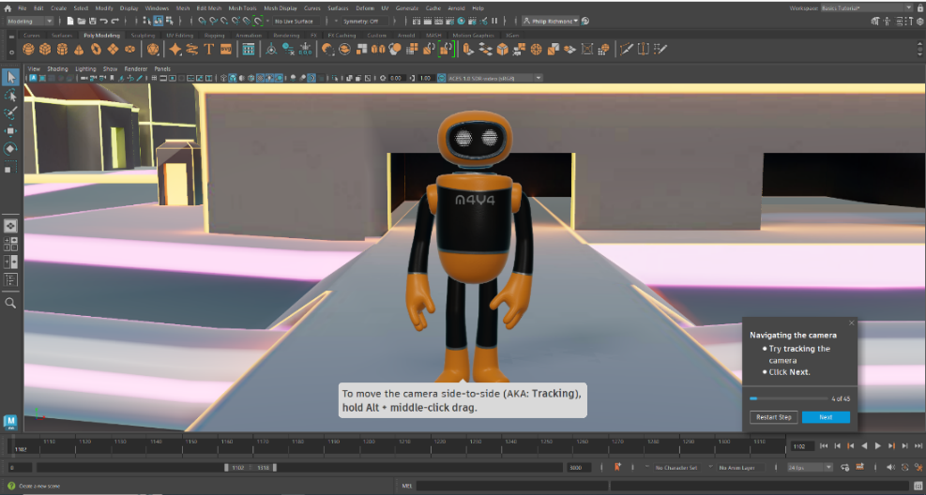
Figure 3
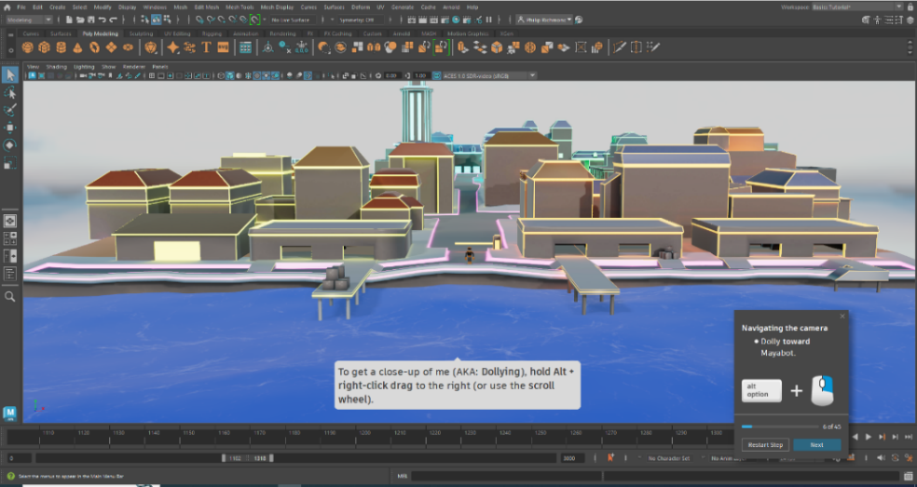
Figure 4
12.10.23
Stuart Gile came into class and had a chat about digital skills and Linkin learning.
13.10.23
Watch the beginning of a tutorial video in Linkin learning that will be used through my first semester to call from.

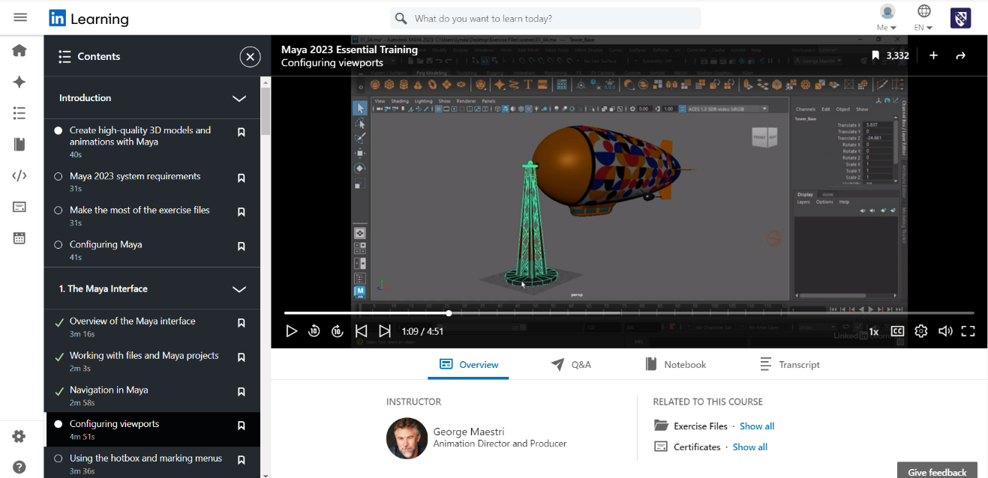
Figure 5 [2]

On 12.10.23 there was a demonstration on how to make a lamp post and this was used to start to get the required skills in the learning in Maya software. A polygon cylinder was added to the screen and then it was adjusted to extruded to resemble a streetlamp post.
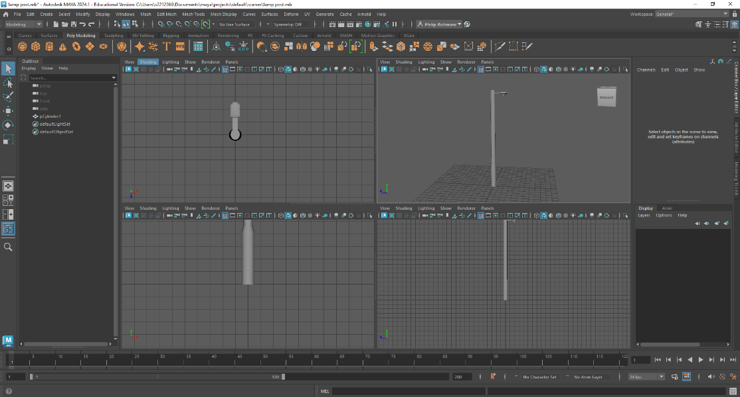
Figure 6 first attempt at making a streetlamp post.

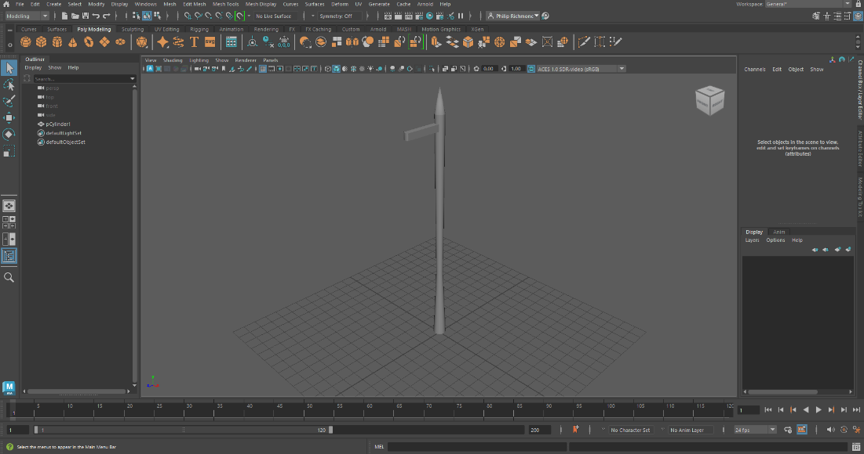
Figure 7 experimenting with different design of lamp post.

13.10.23 more lamppost practice with extruding Cude out of the top of the lamppost.

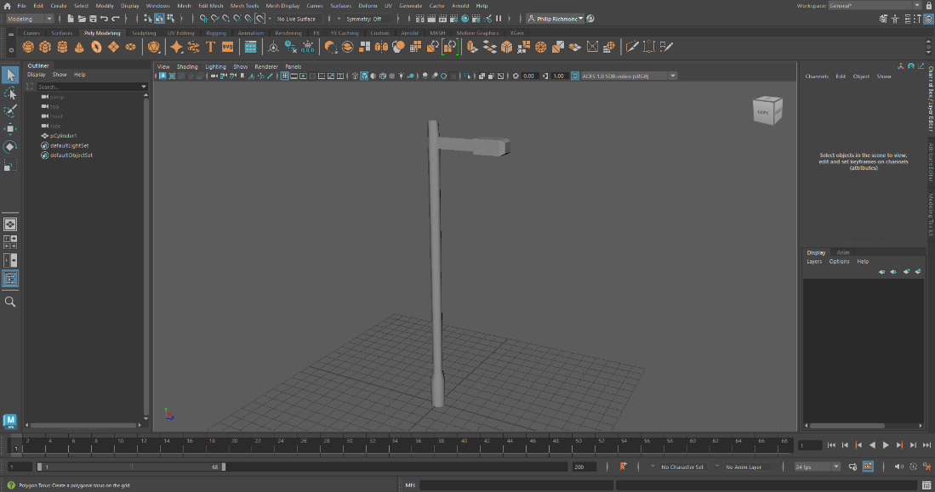
Figure 8 Street lamp post practice.
20.10,23 practicing how to get and import a reference picture to work from

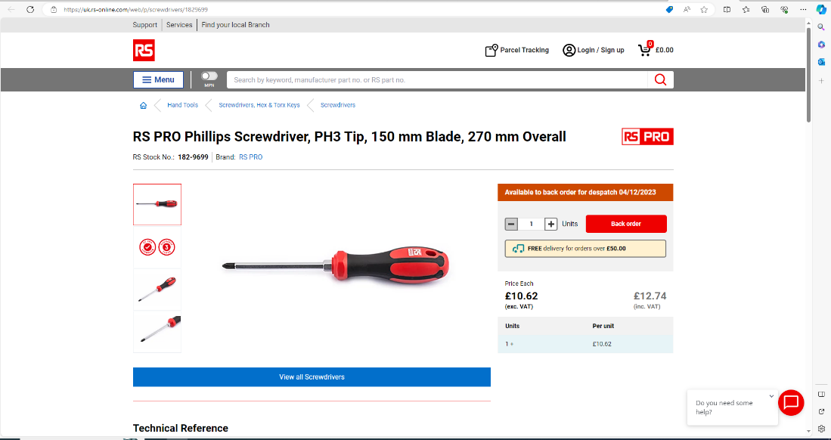
Figure 9 Screw drive reference picture. [3]
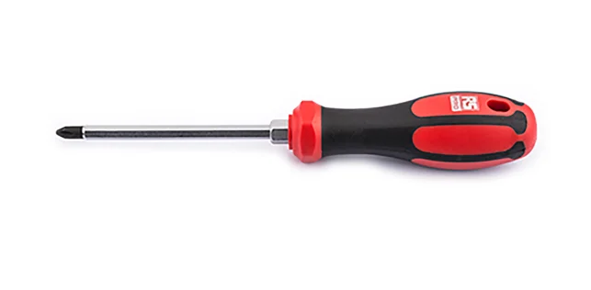
Figure 10 Reference picture of screwdriver [3]
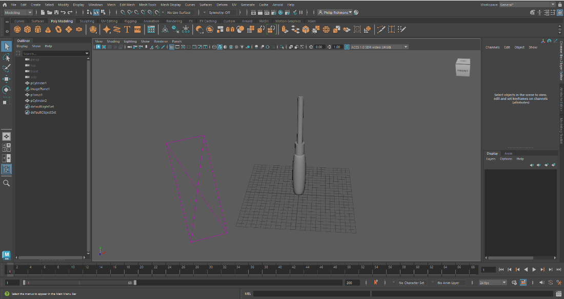
Figure 11 more practicing and trying to understand how Maya works.
26.10.23 more practicing to produce a quick result. Doing this kind of exercise can panic me and I find that the time restraint to finish this exercise put me off Maya due to me not completely understanding what I was doing. But I can understand why these exercises are put in to get me ready for the industry level required.
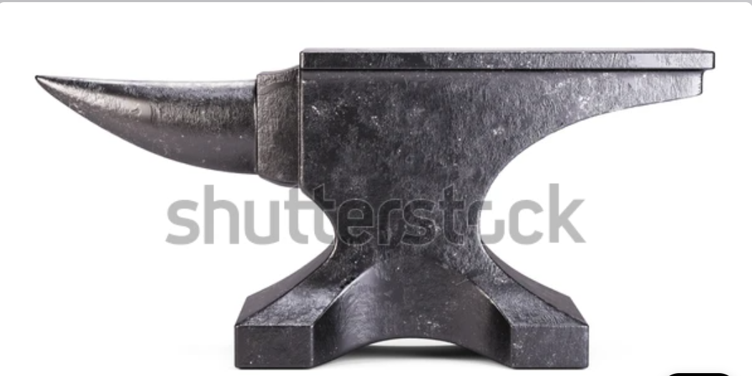
Figure 12 [4] Reference picture of an anvil.

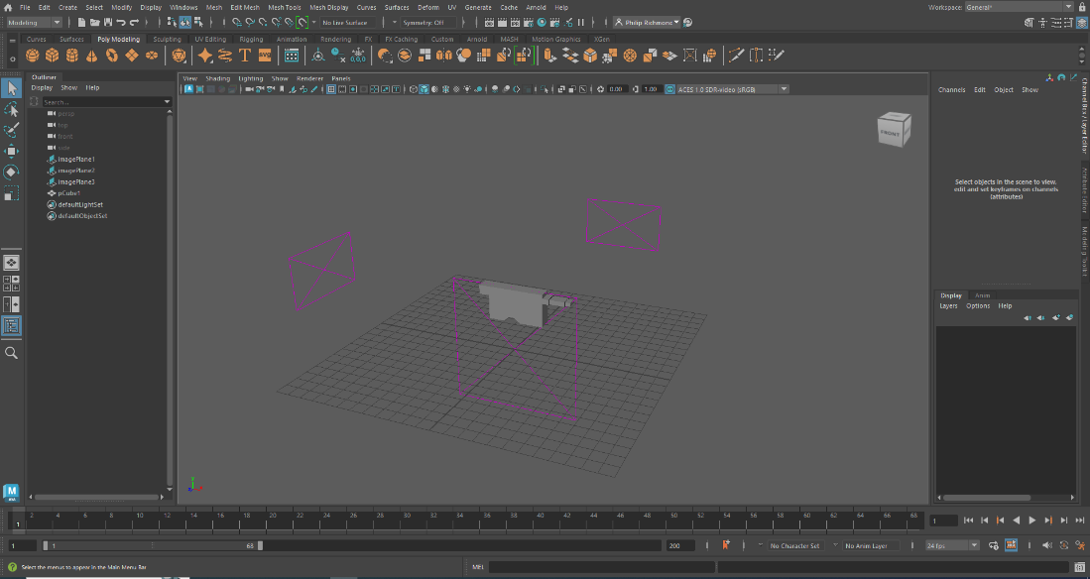
Figure 13 was not happy with the outcome of this anvil.

27.10.23 another speed run but doing this exercise I did feel more confidence in my outcome.
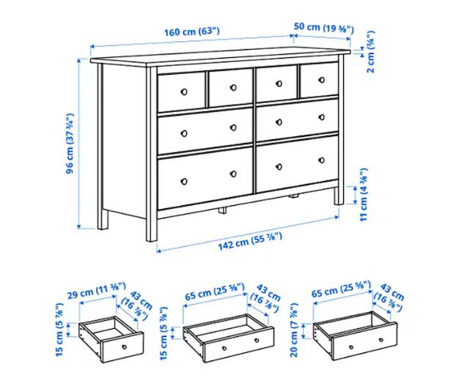
Figure 14 Reference picture from Ikea. [5]
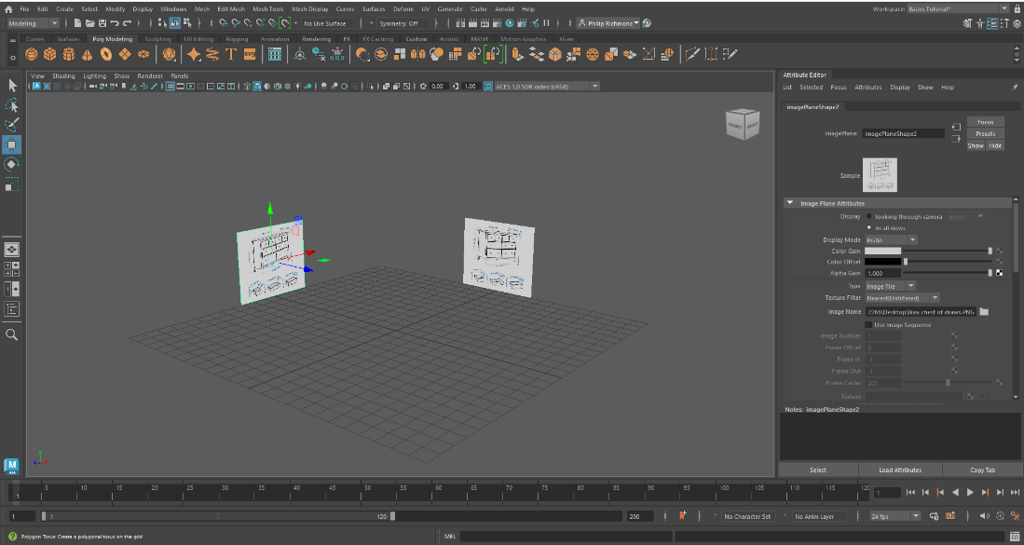
Figure 15 showing loading reference pictures.
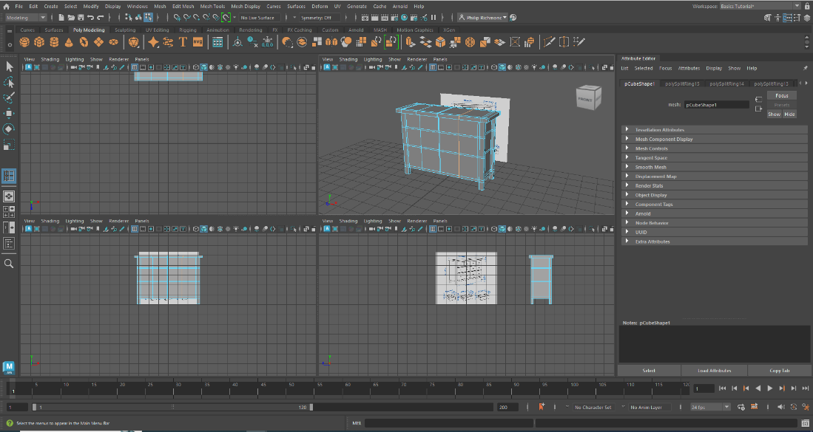
Figure 16 Happy with the outcome of this chest of draws making me feel that I’m stronger producing more solid objects.

27.10.23 Assignment 1: Development Diary and Assignment 2: 3D Modelling Showcase Video and PDP given out and discussed in class.
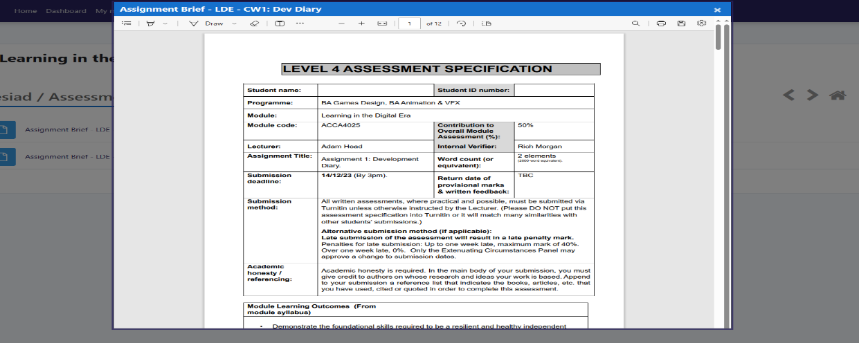
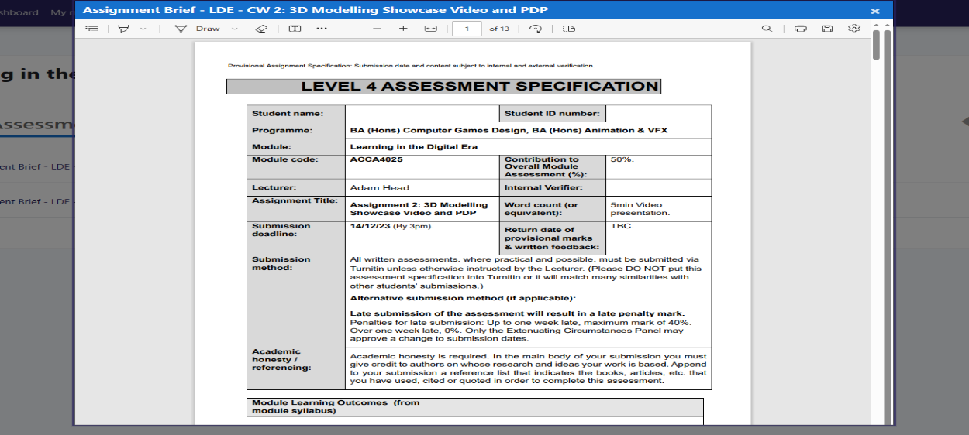
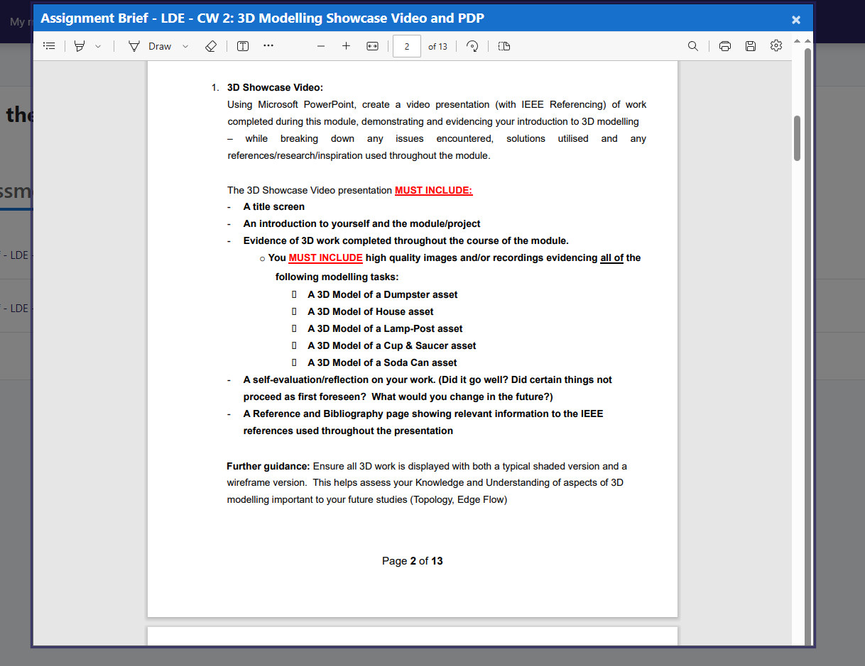

02.11.23 more speed runs with random object give to make in Maya
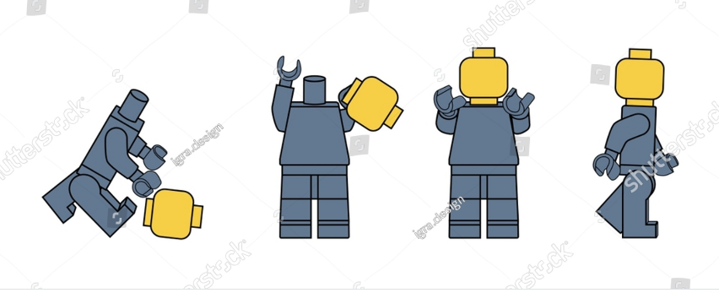
Figure 17 Lego man reference picture. [6]
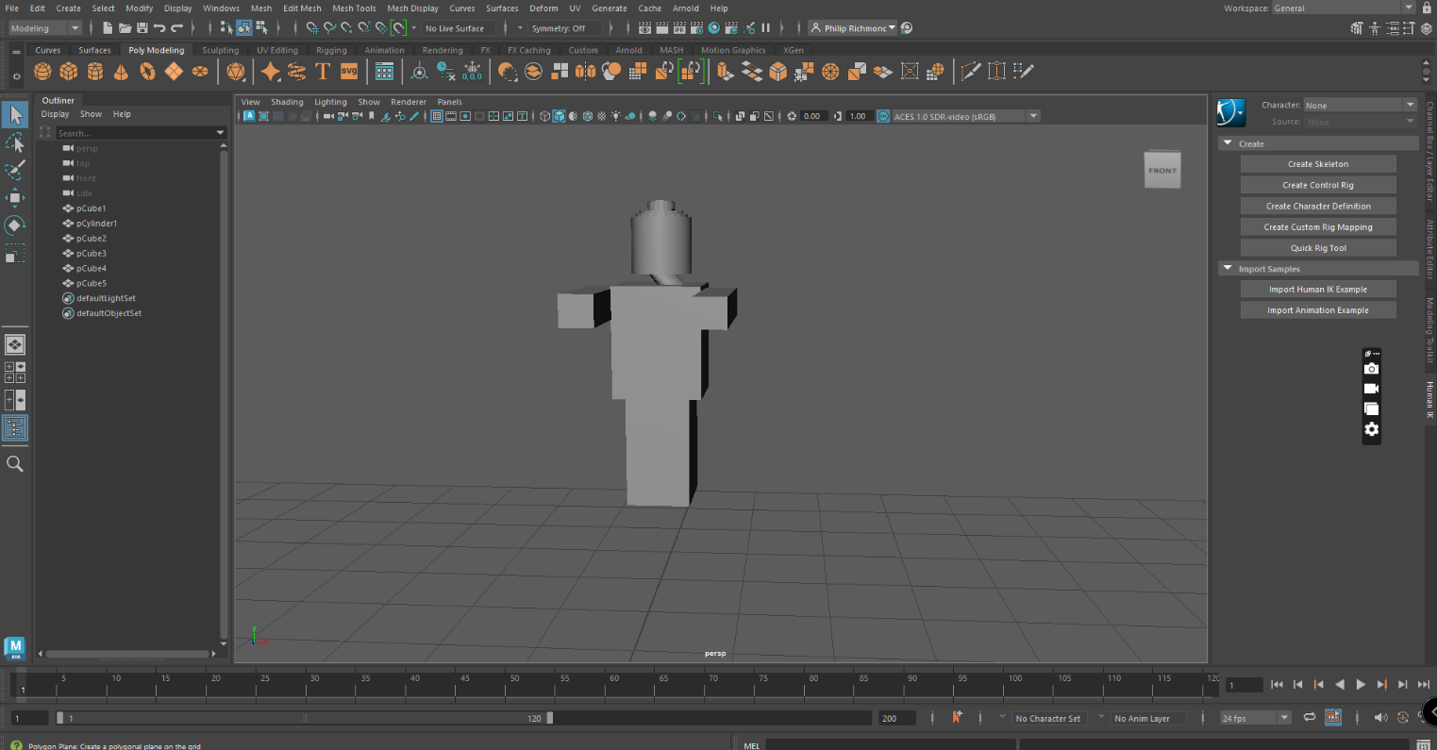
Figure 18 My Lego man with a bend neck

While doing this exercise I was still getting confused with using the different modes like Object mode, Vertex selection, Edge selection and face selection.
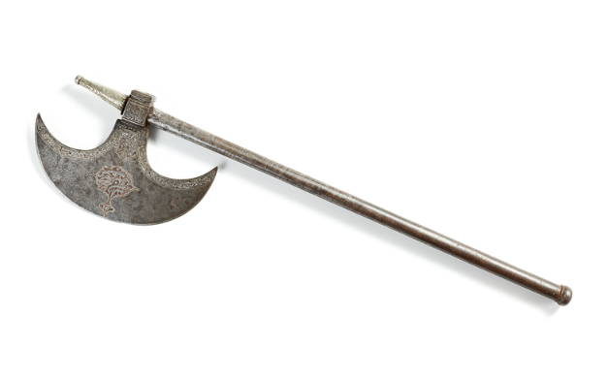
Figure 19 Axe refence picture. [7]
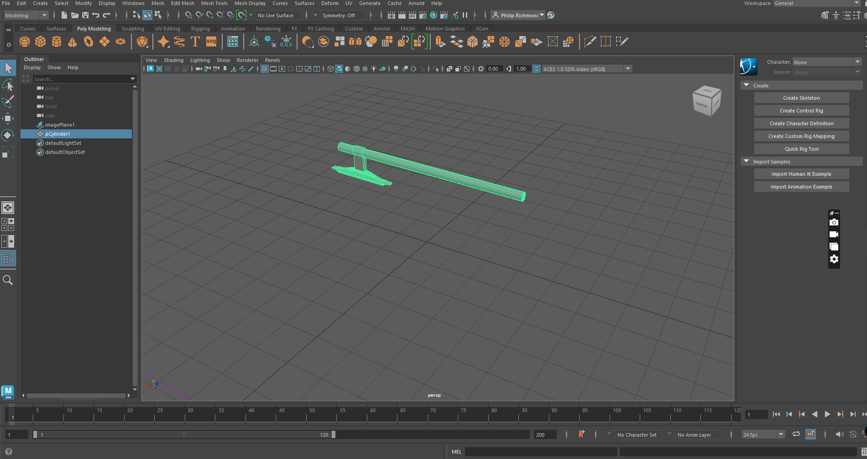
Figure 20 Axe attempt

Reading Week

Streetlamp Post Asset
06.11.23
In reading week, I made the decision to put most of my efforts into Maya and completing the five projects required for Assignment 2: 3D Modelling Showcase Video and PDP.
The first project that I chose to start was streetlamp post.

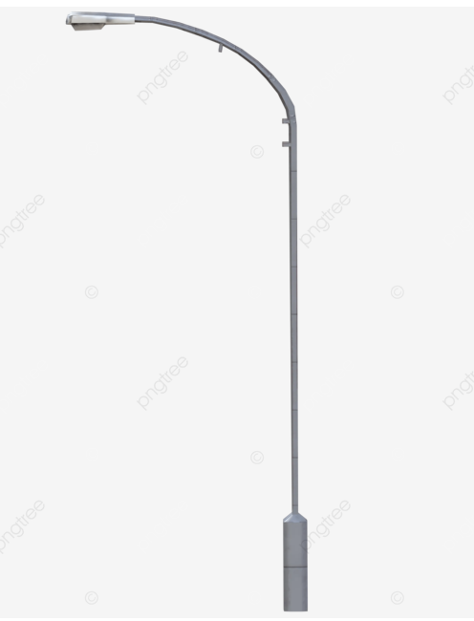
Figure 21 streetlamp post reference for main asset. [8]
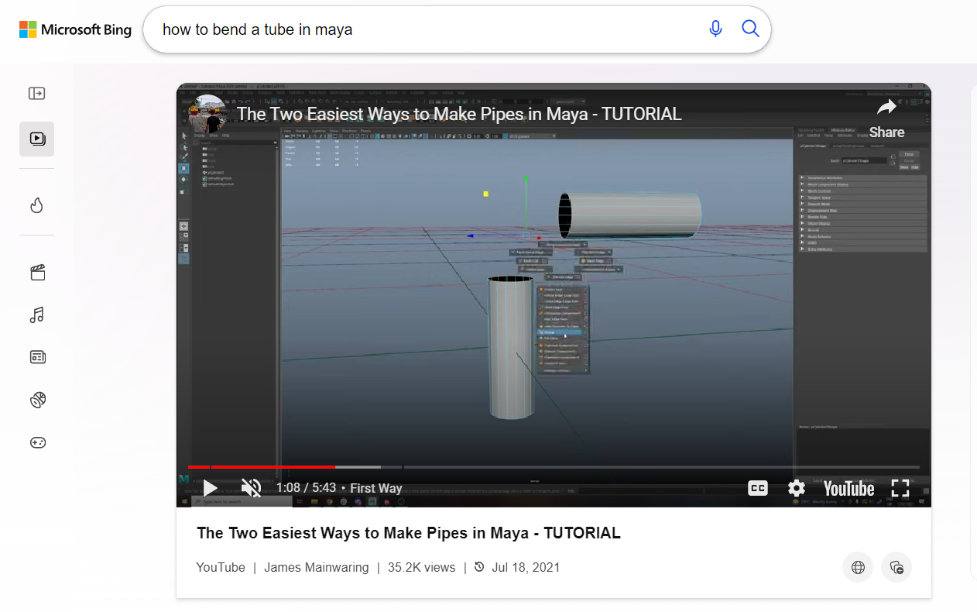
Figure 22. [9] More Insite into pipes and how to make them.
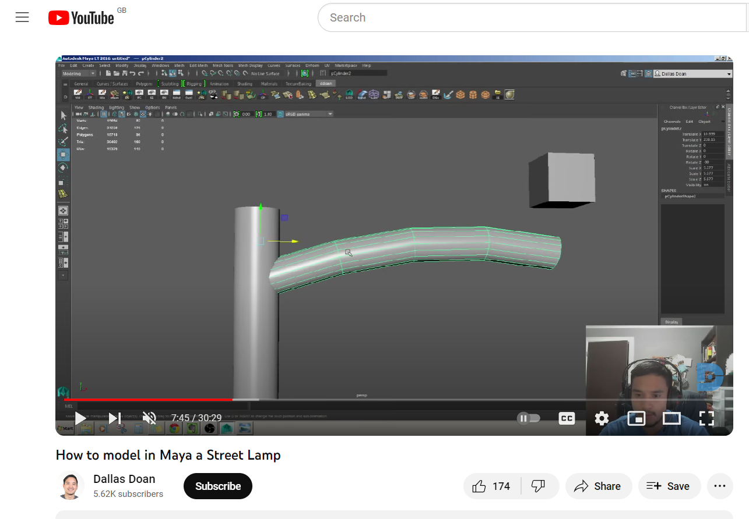
Figure 23 [10] I watch this video for some Insite and extra knowledge due to struggling with making the tablier section on the lamppost.
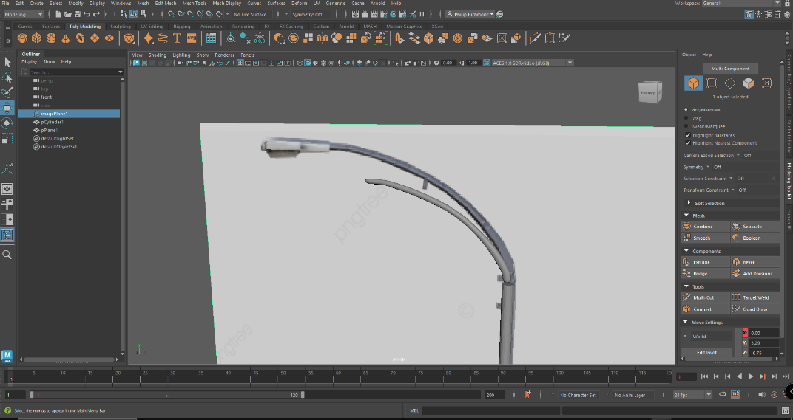
Figure 24 Practicing how to make the tube off the main post that I didn’t like.
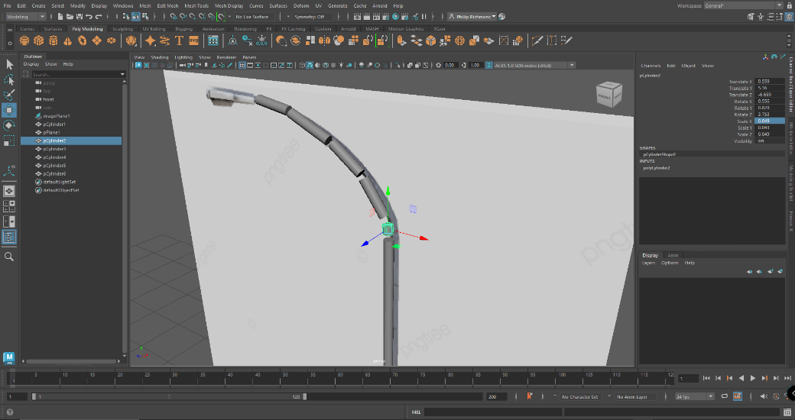
Figure 25 here I tried to make many cylinders and then tried to join them.
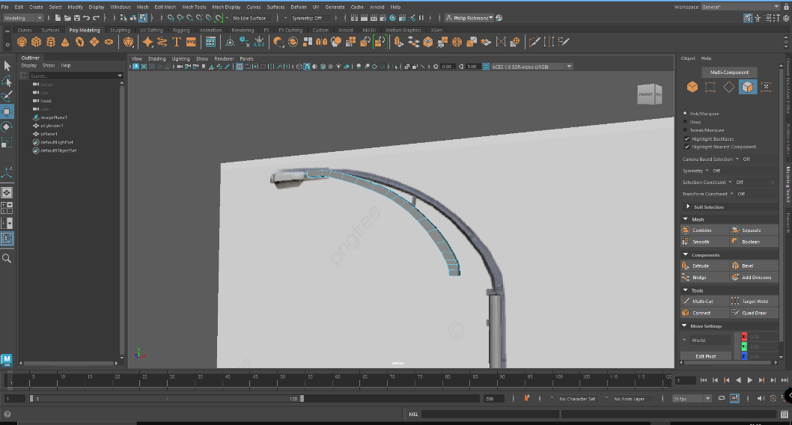
Figure 26 failed attempt at extruding and stretching out the pip.
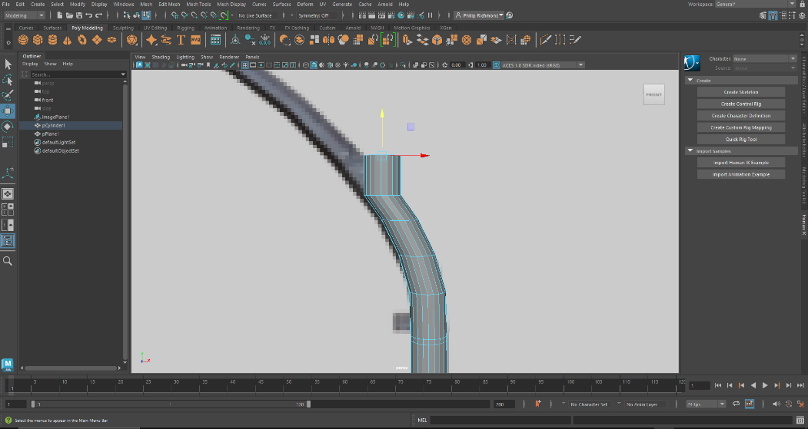
Figure 27 Another attempt at making the tube that I am using in the final project.
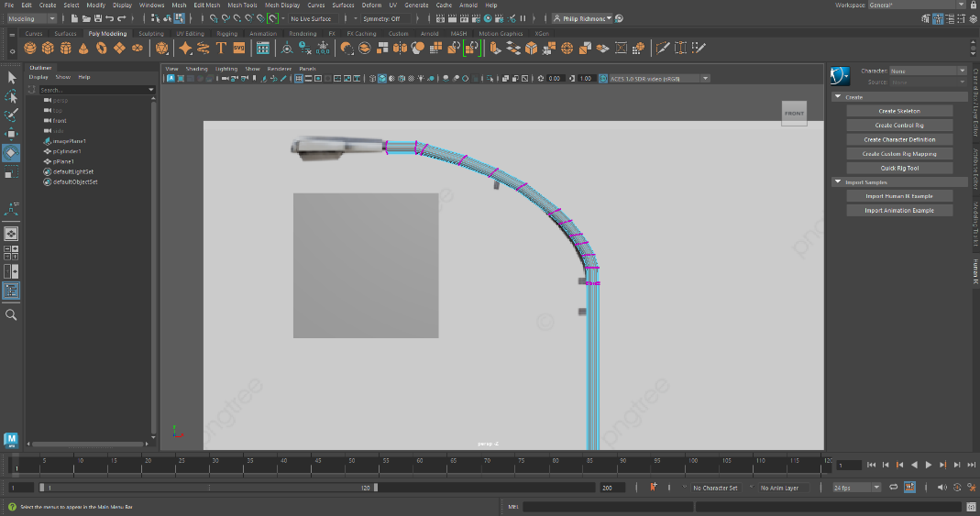
Figure 28 Completed tube.
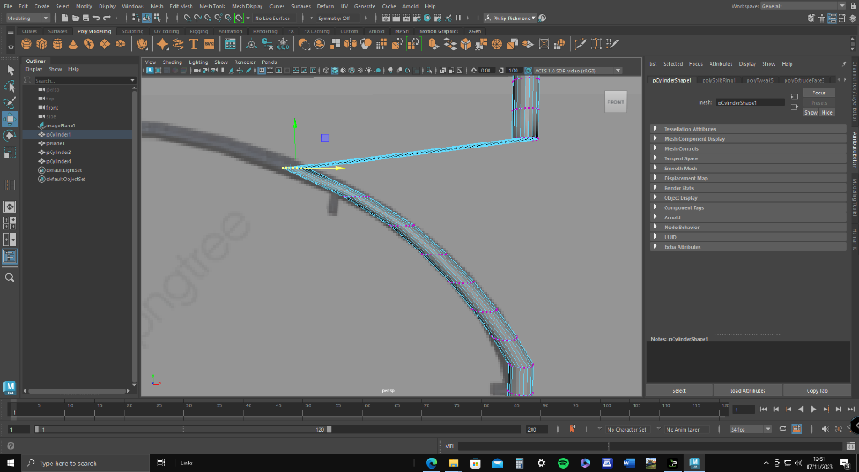
Figure 29 with extruding and bending the pip multiple time I found the pip become flat and not circular.

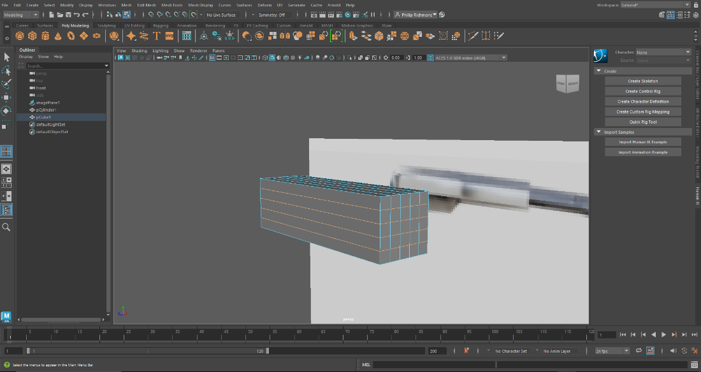
Figure 30 Here I choose to make the light part of the streetlamp post separately and then add it on.
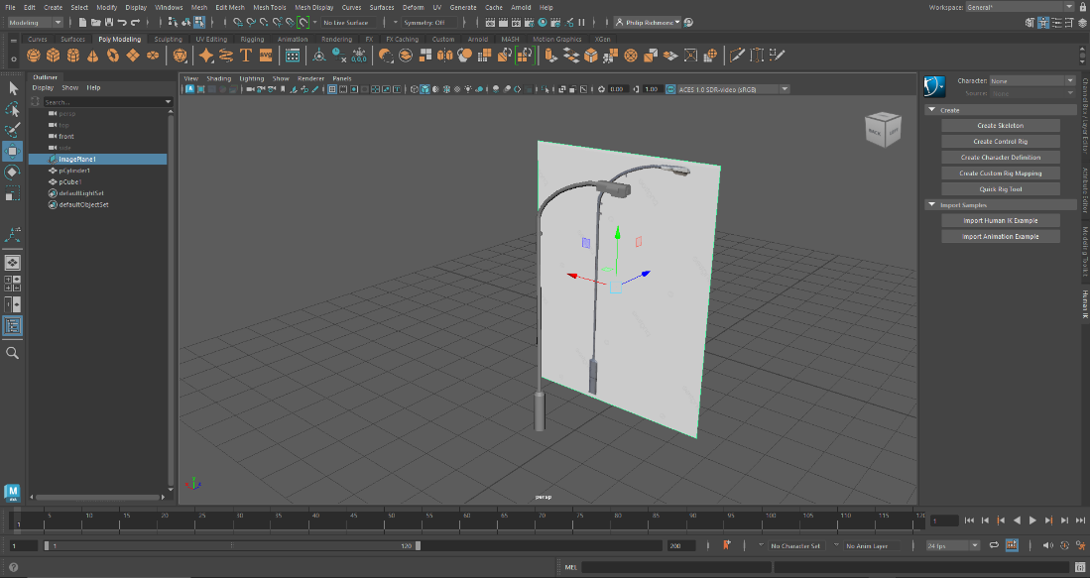
Figure 31 Final complete version of streetlamp post asset.

Soda Can Asset
07.11.23
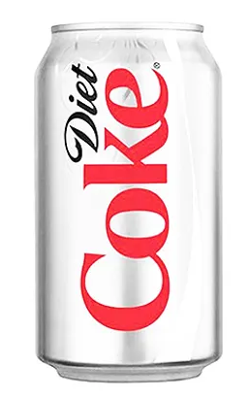
Figure 32 Soda can reference picture. [11]
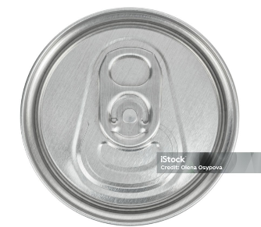
Figure 33 Soda can top reference picture. [12]

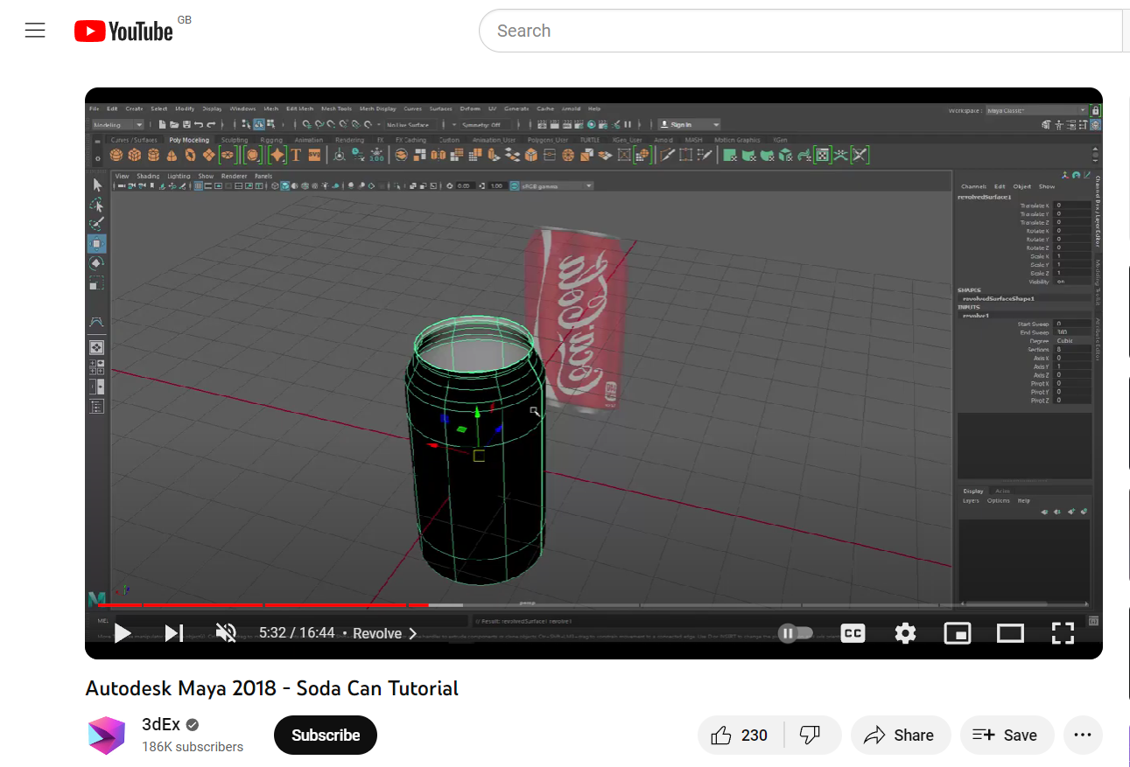
Figure 34 [13] This tutorial I used, give me different methods in Am that I haven't experience defour.
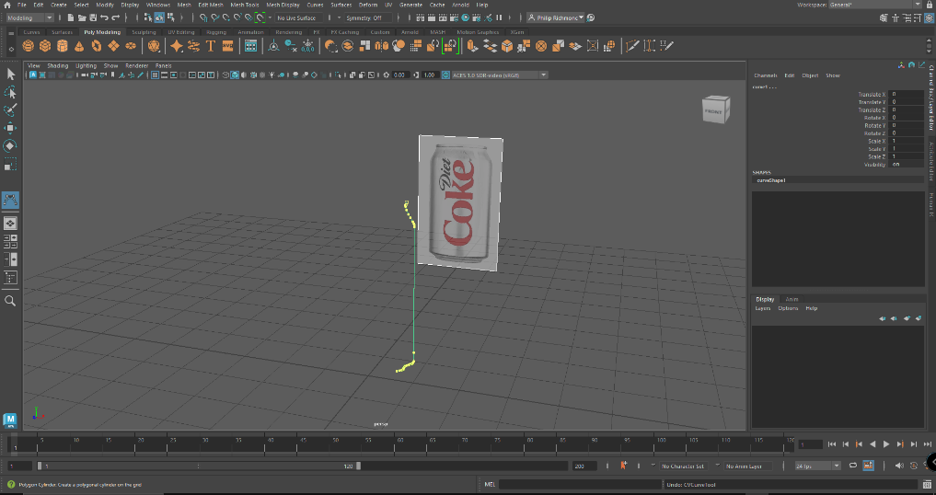
Figure 35 To start I used the curved tool to deaw one side of the can as accurate as possible and using vertex button to tidy it up
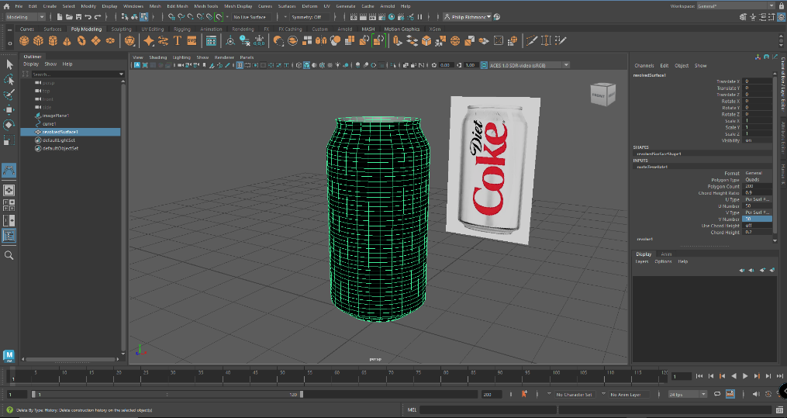
Figure 36 This was then made into 3D using the revolve option in the surfaced tab. More polycount was added to make it more round
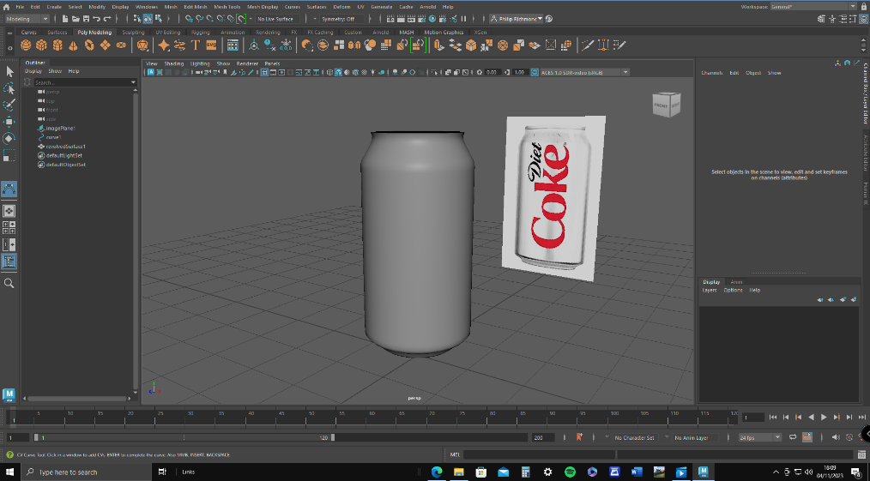
Figure 37 To get it back no normal I had to go to mesh display and use revers.
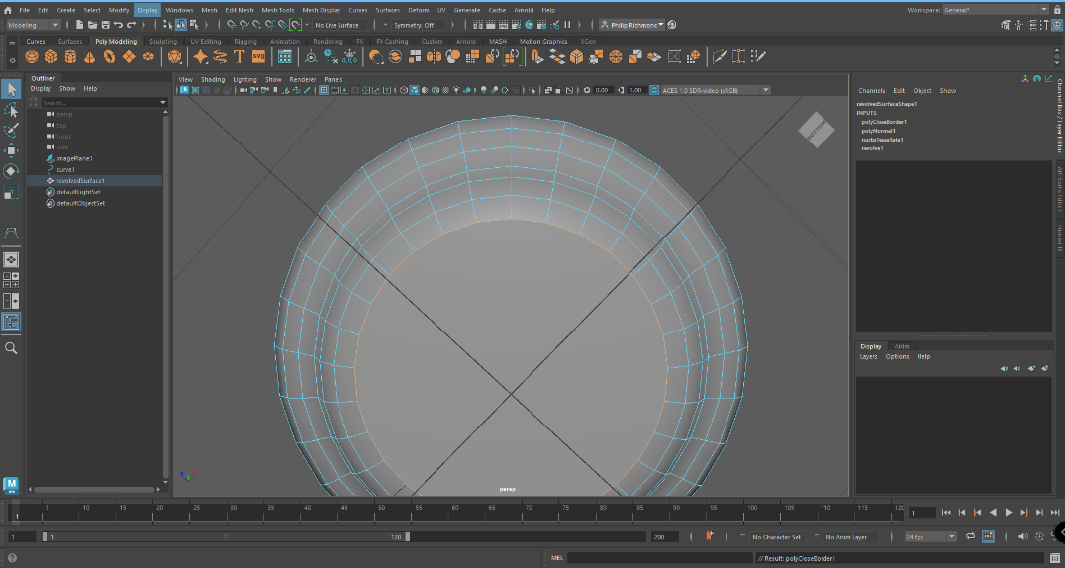
Figure 38 Next, I had to close both bottom and top using the mesh tool.
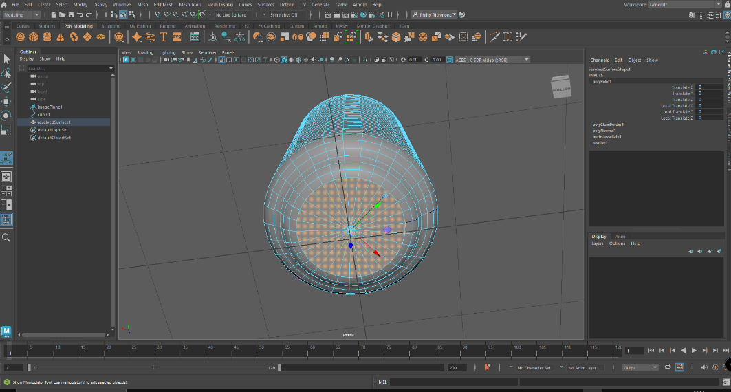
Figure 39 Then I use the poke tool to make sure all the edges match up.
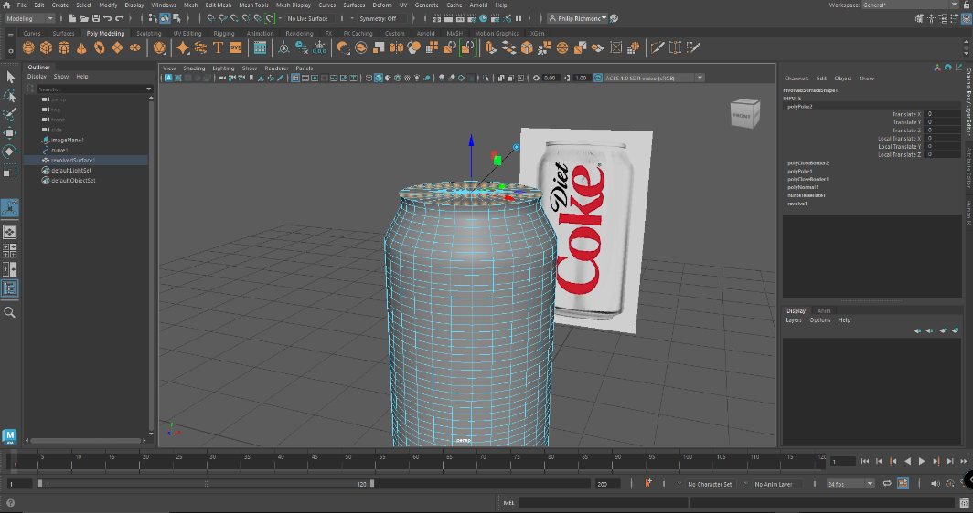
Figure 40. Then extrude was used to make the top can indent
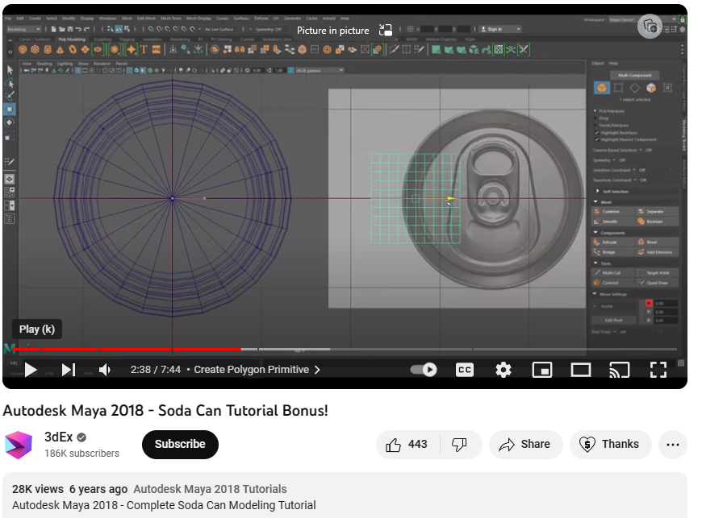
Figure 41 [14] Tutorial for can top.
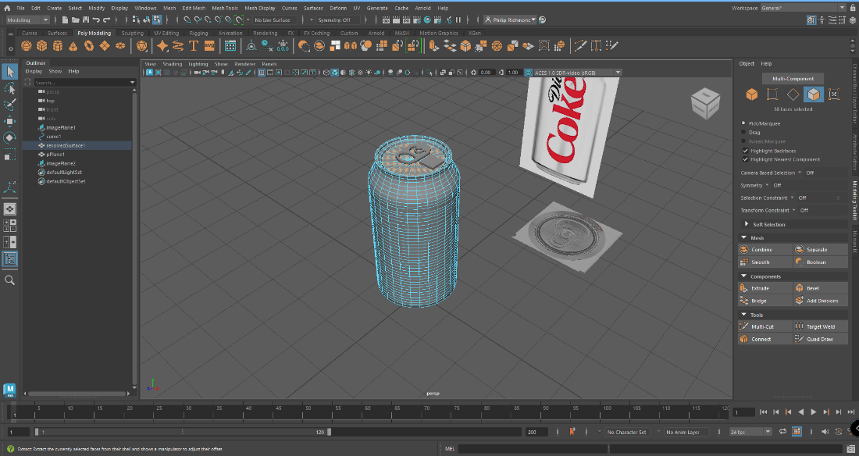
Figure 42. Next step is to use quad draw tool with a flat plain active and trace over the can top image and fill with geometry shaps
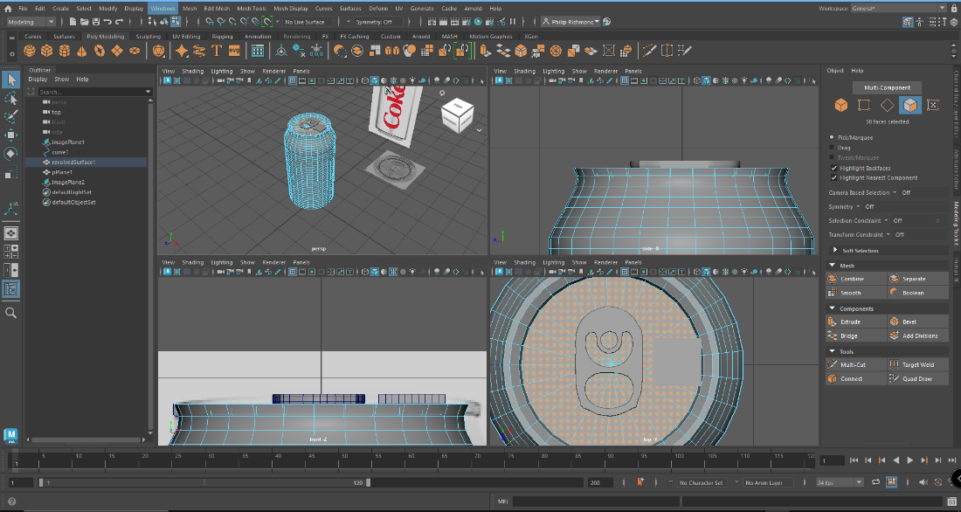
Figure 43 Next I extrude the can pull ring to give it some thickness and then beveled the edge to complete my soda can asset.

Cup and Saucer Asset
08.11.2023

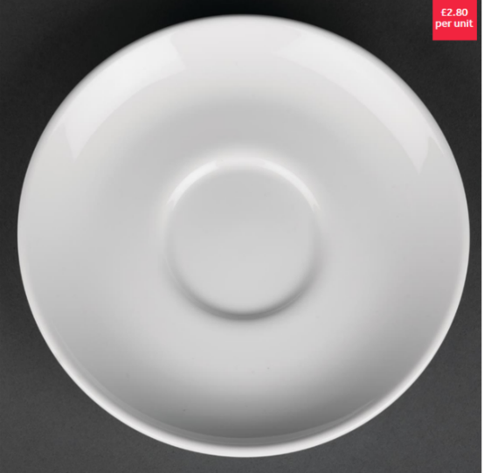
Figure 44 Saucer reference picture. [15]
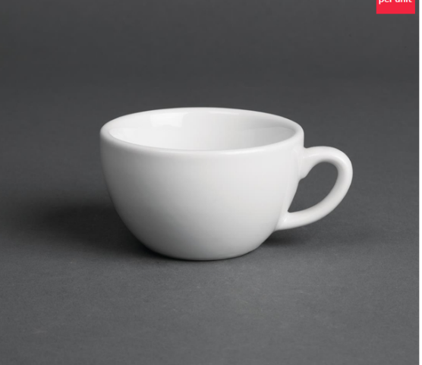
Figure 45 Cup reference picture. [15]

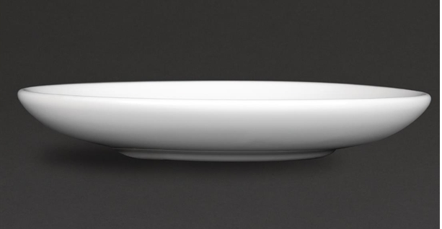
Figure 46 side angle of saucer. [15]
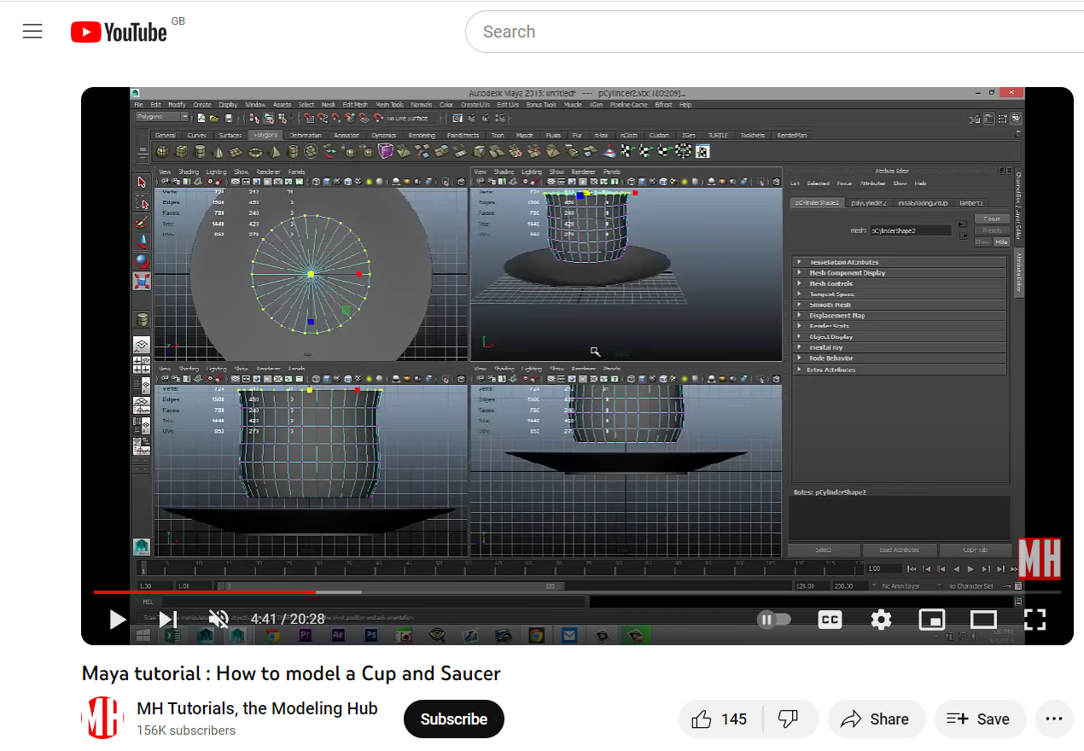
Figure 47 [16] I watched and followed this tutorial to make my Cup and saucer to help my learning in Maya.
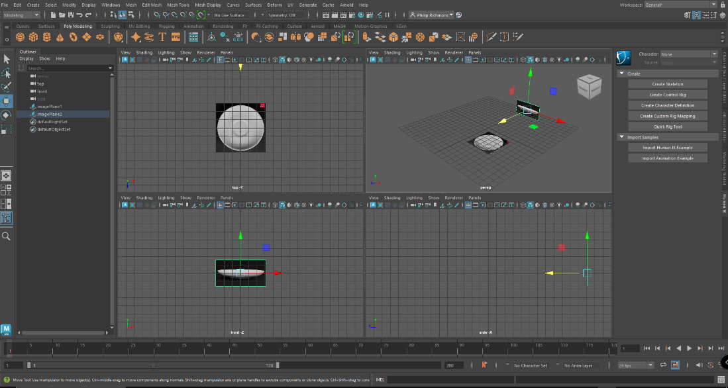
Figure 48 Reference pictures added to Maya.
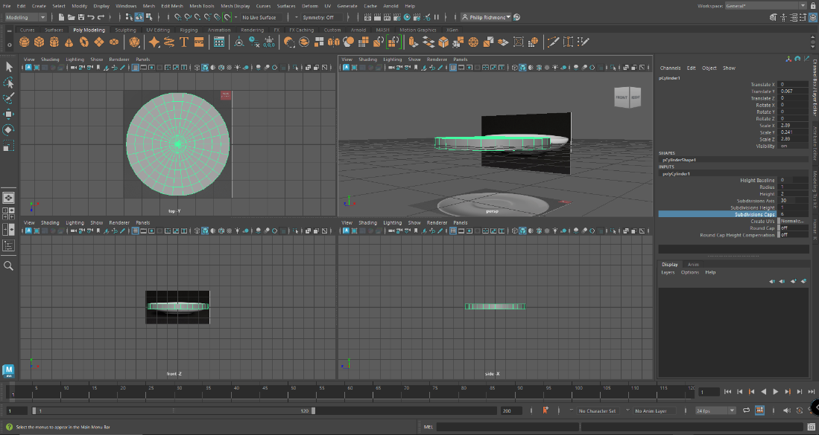
Figure 49 Here I added a polygon cylinder and scaled it to the shape of the reference picture of the saucer.
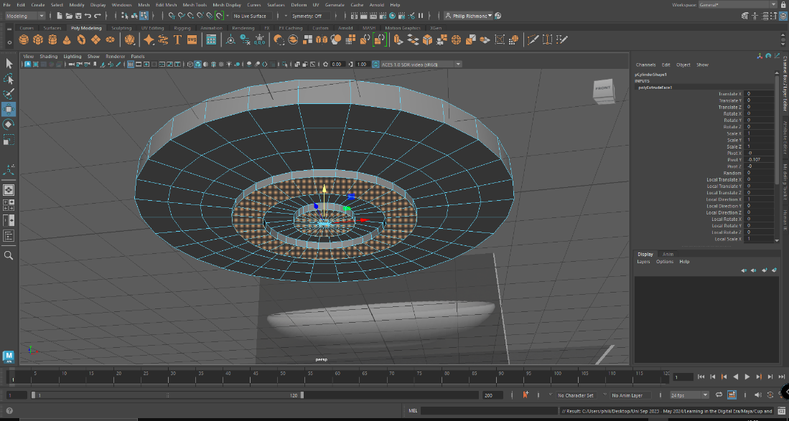
Figure 50 Shaping the bottom of saucer using the extrude Methode.
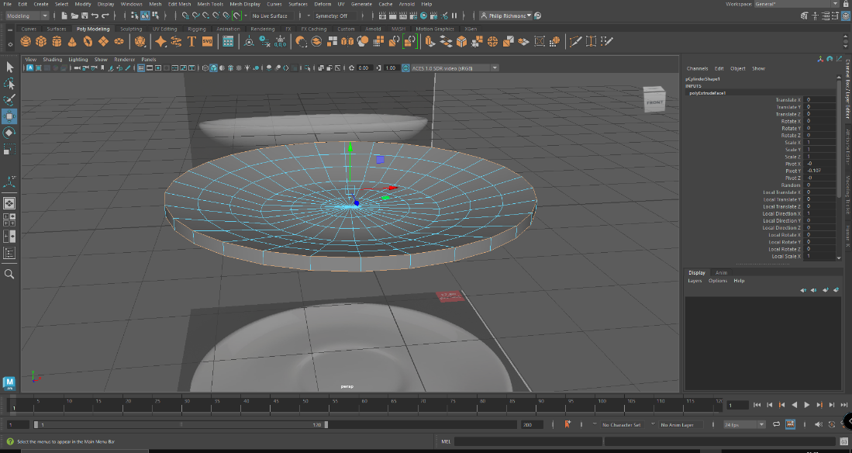
Figure 51 Shaping the saucer
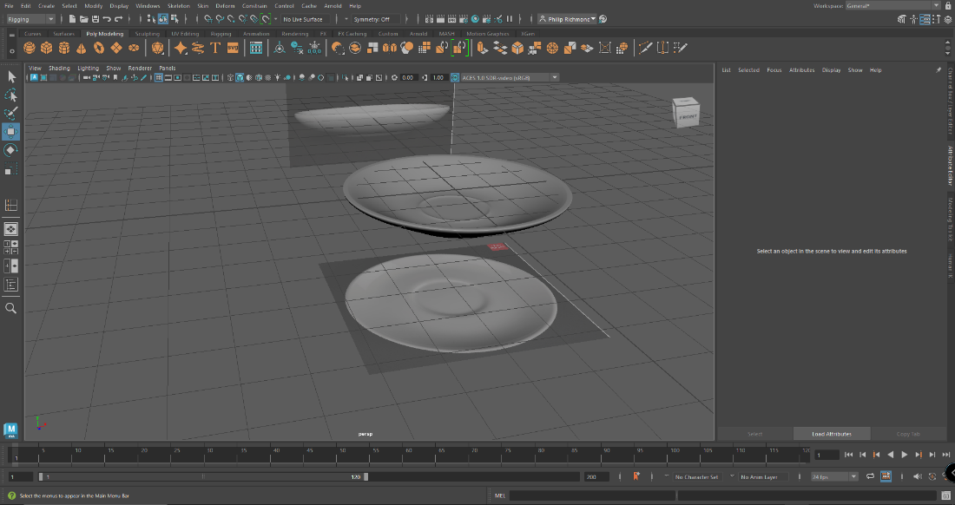
Figure 52 Saucer completed and happy with the outcome.
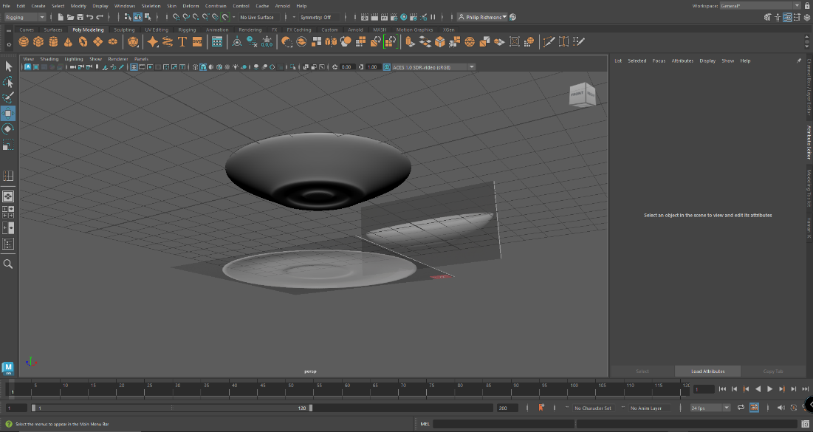
Figure 53
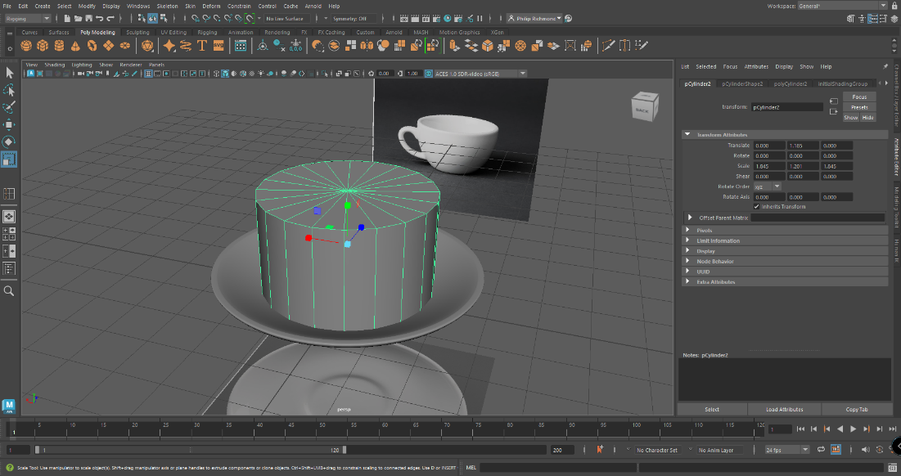
Figure 54
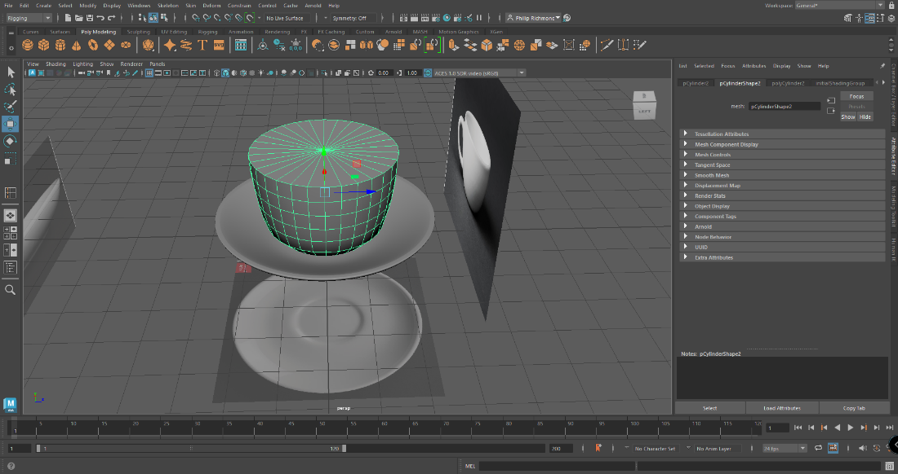
Figure 55
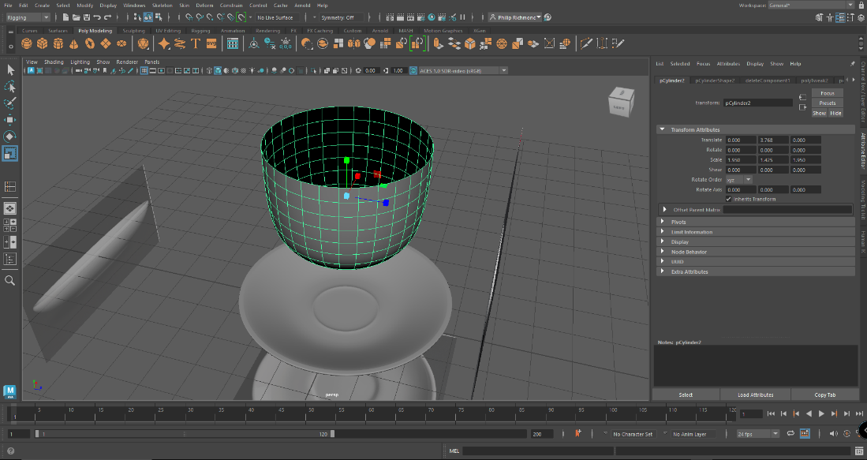
Figure 56 Deleted the top to make the object hollow.
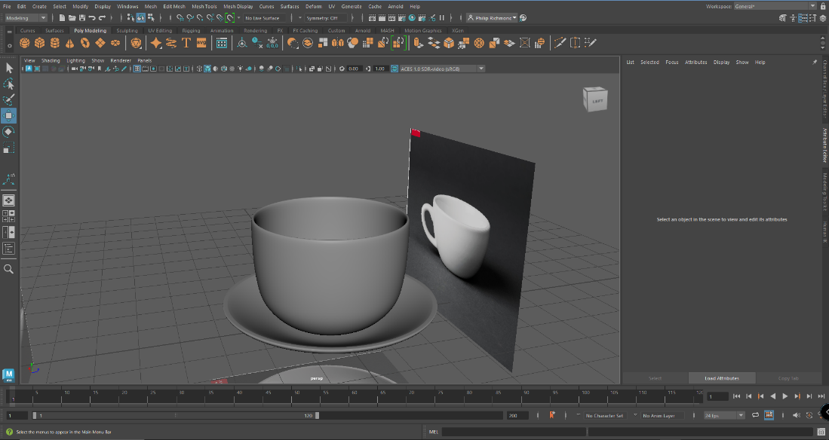
Figure 57 Next I extruded another face and gave it some thickness.
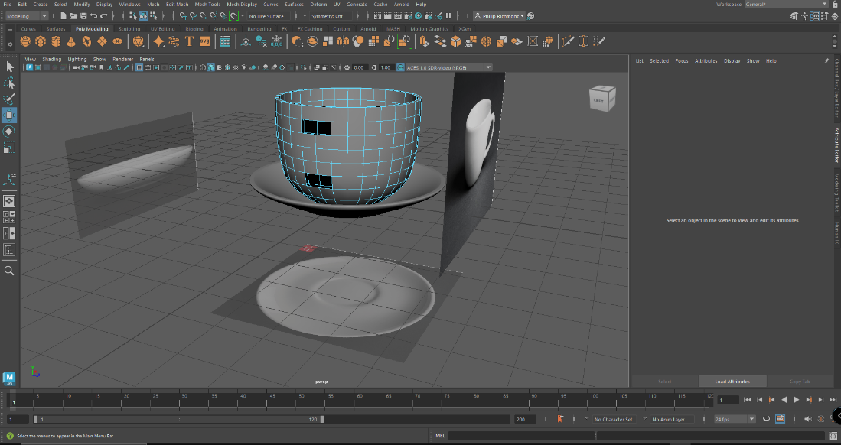
Figure 58 Deletd some faces ready to create the handle.
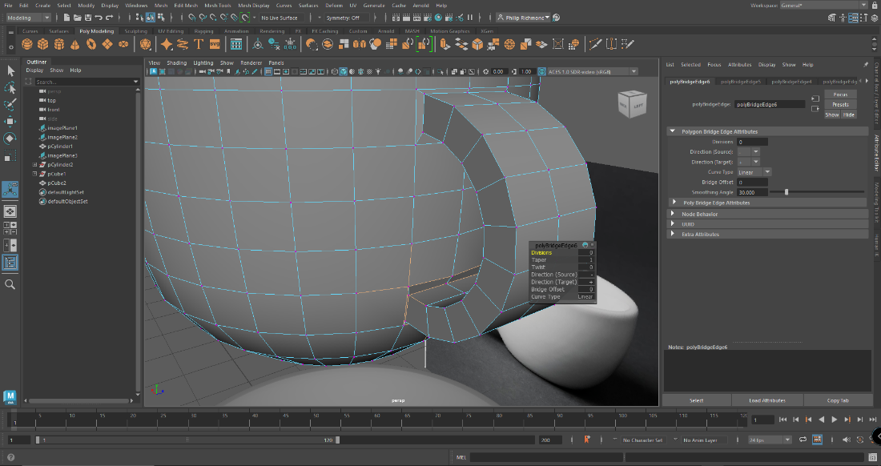
Figure 59 Made a cube extruded/stretched it to the right size and then bend it 90 degrees to fit. Deleted the ends of handle and then merge components.
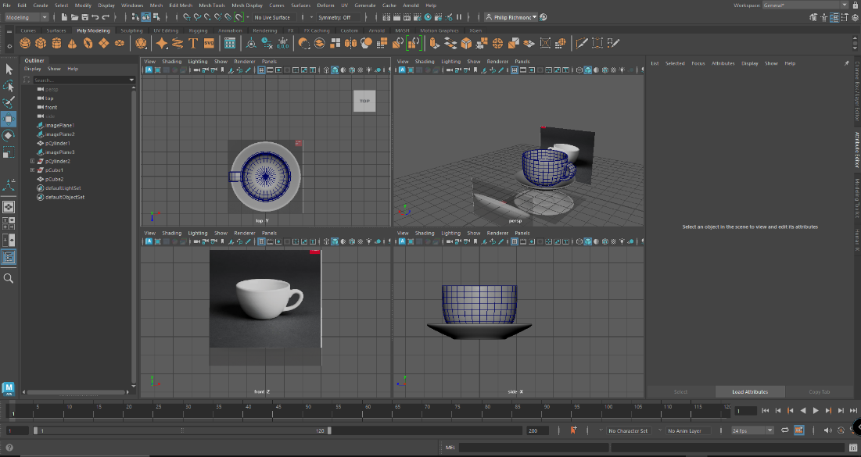
Figure 60. Final version of my cup and saucer. Couldn’t work out how I put the blue mesh on and then how to take it away.

Dumpster Asset
09.11.2023

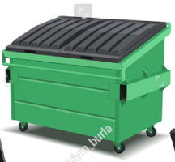
Figure 61 Dumpster reference picture. [17]
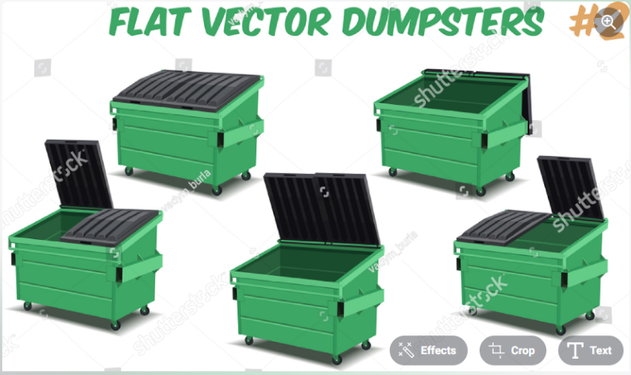
Figure 62 More reference picture showing different angles. [17]
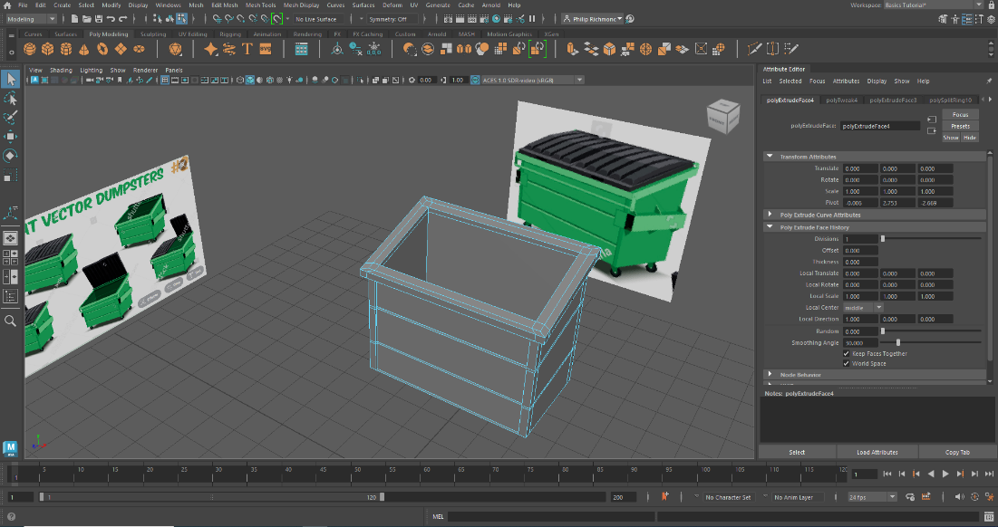
Figure 63 Dumpster box made using a cube and extruding methods with edge loops added to give the box more details as the reference image has.
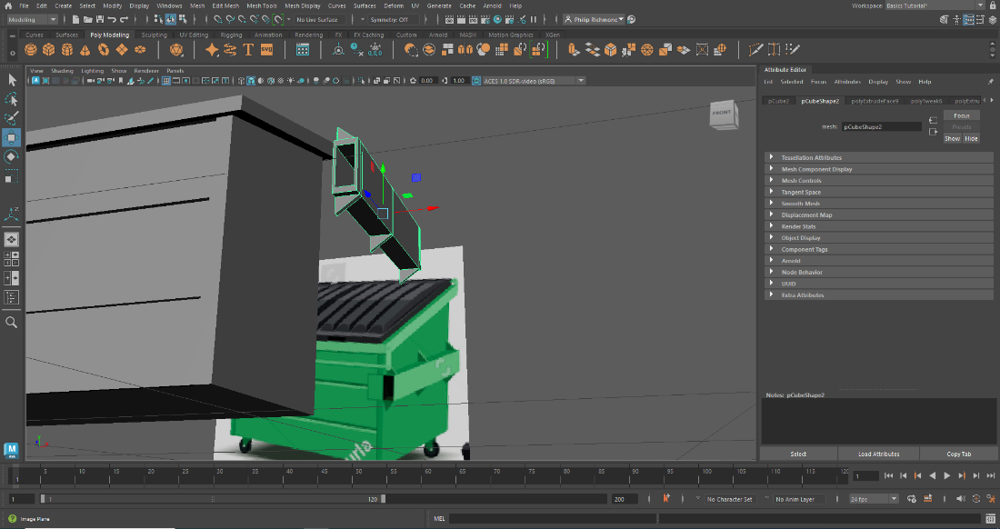
Figure 64 I made the Hook lift bare and the duplicated it for the other side.
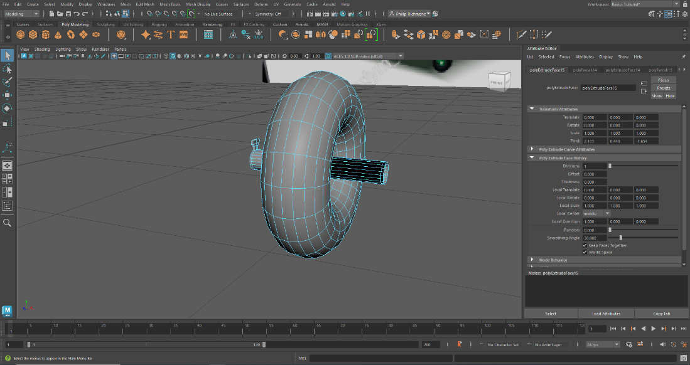
Figure 65 The first few tries with making the dumpster wheels went wrong with trying to extrude the cylinder from a cylinder that left it inside out
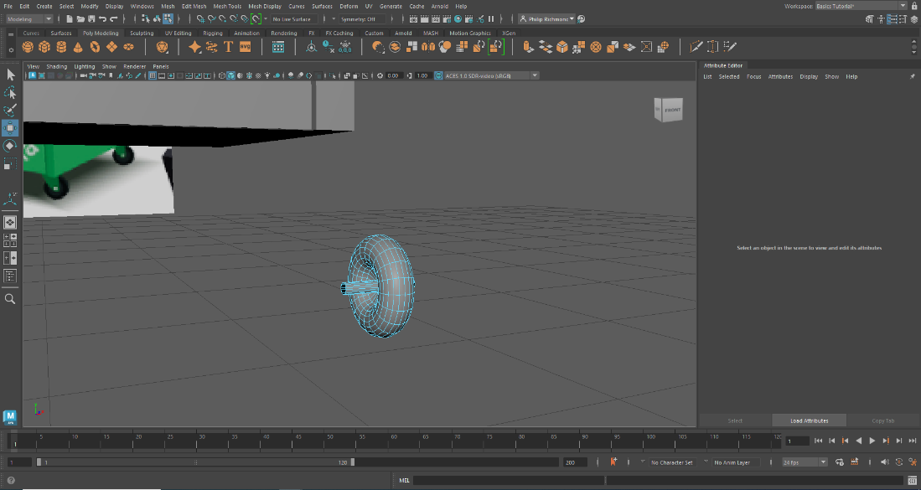
Figure 66 My lecturer showed me a new technique to me to ?
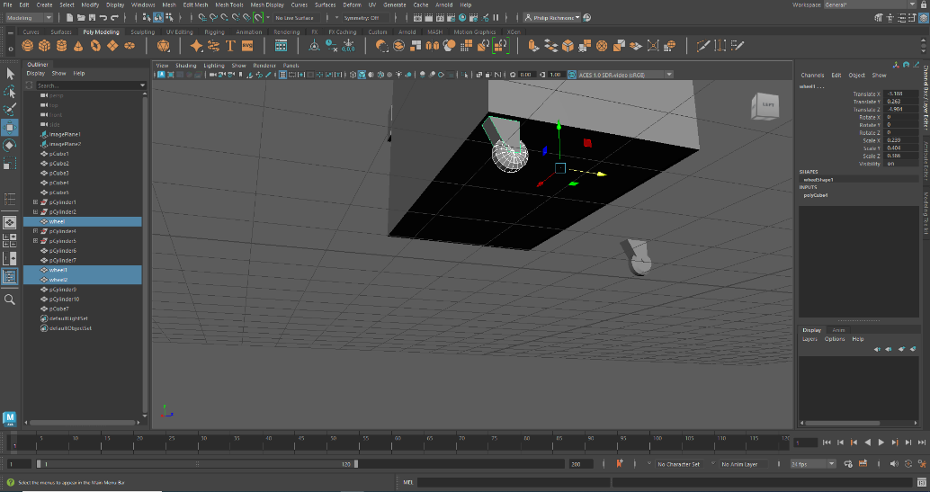
Figure 67
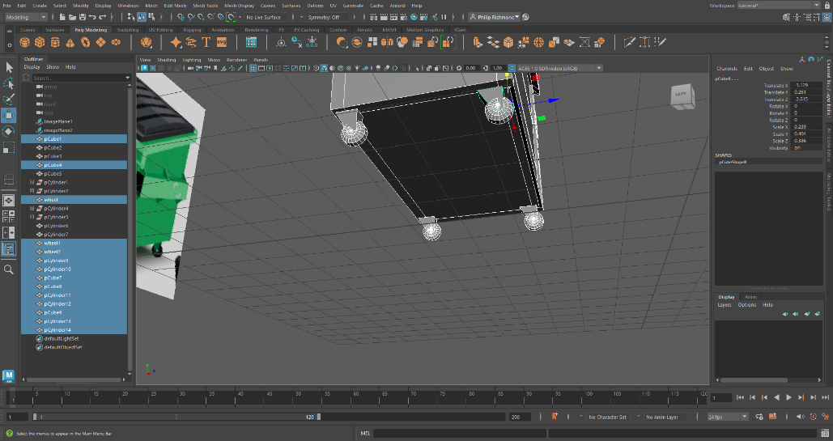
Figure 68 Duplicated another 3 wheel and placed them in correct positions.
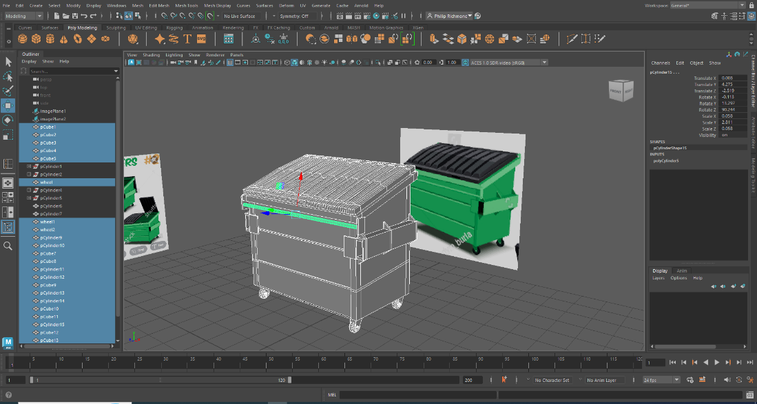
Figure 69

- A cylinder handle was added to the front.
- Supporting plates added to hook lift bar.
- Cube was added and made into the right door.
- Several edge loops were added to make the right number of raised edges.
- Extrude part were made to make the lid look like the reference picture.
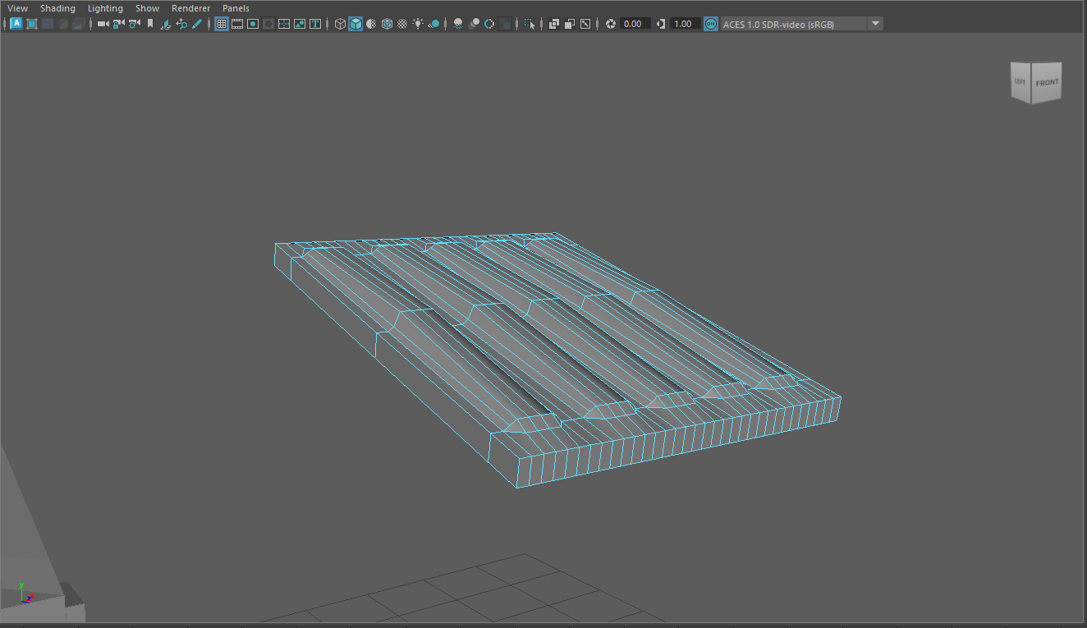
Figure 70 Completed lid

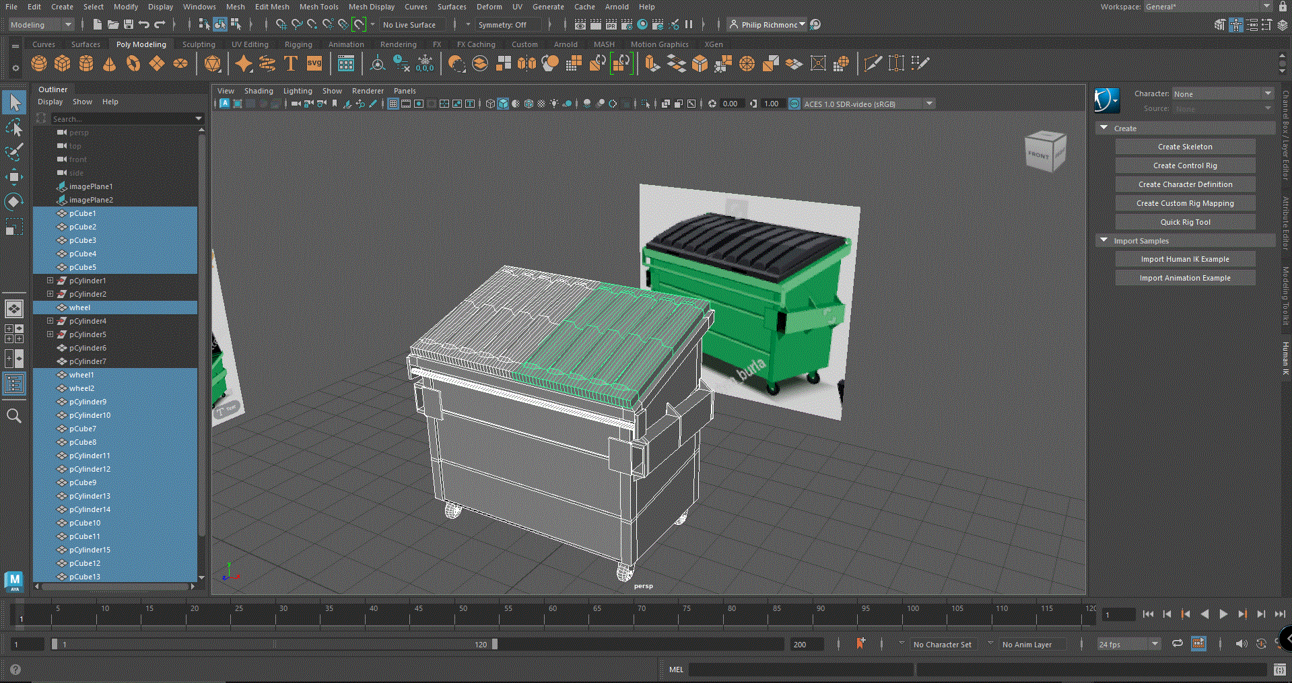
Figure 71 Lid Duplicated
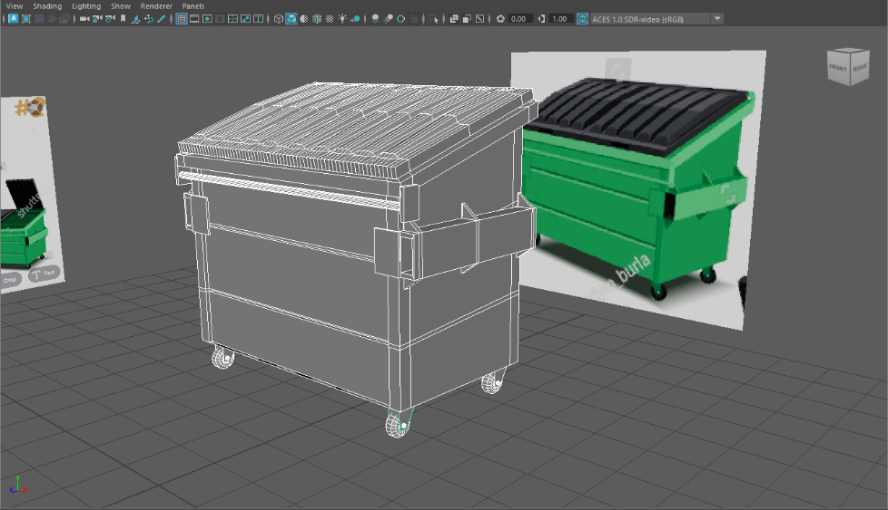
Figure 72 Finished Dumpster.

House Asset
10.11.23

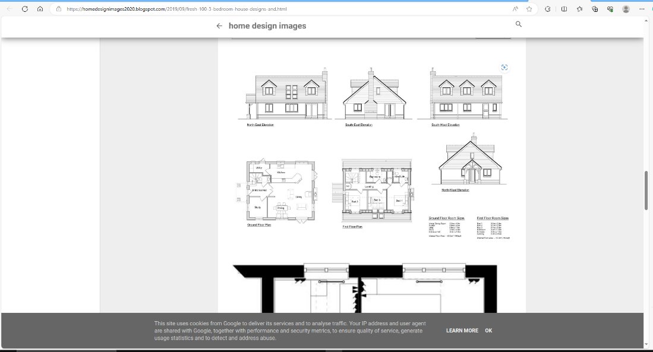
Figure 73 House Reference Image. [18]
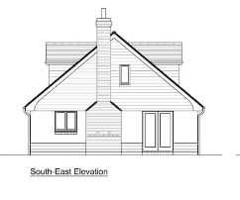
Figure 74 [18]
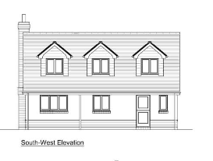
Figure 75 [18]
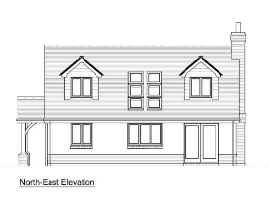
Figure 76 [18]
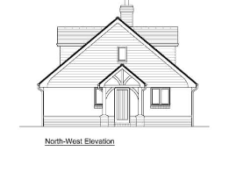
Figure 77 [18]

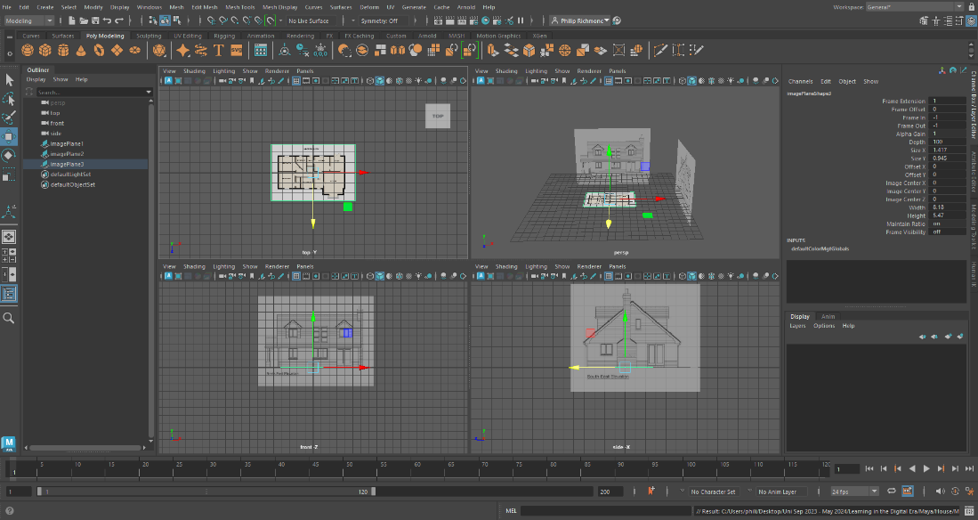
Figure 78 Reference pictures set in right place.

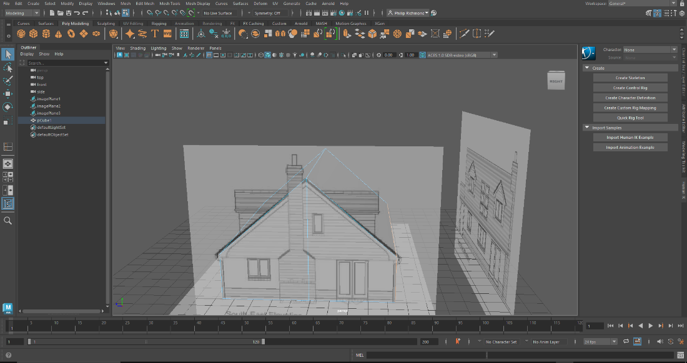
Figure 79 Cube made to fit image.
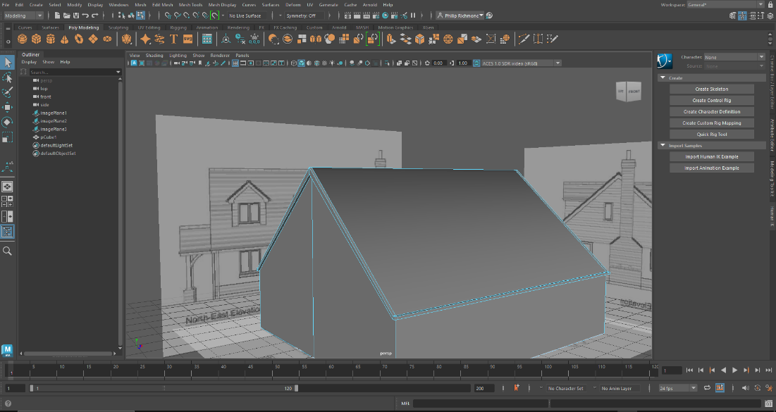
Figure 80 Roof made using edge mode and stretching it out to reference image.
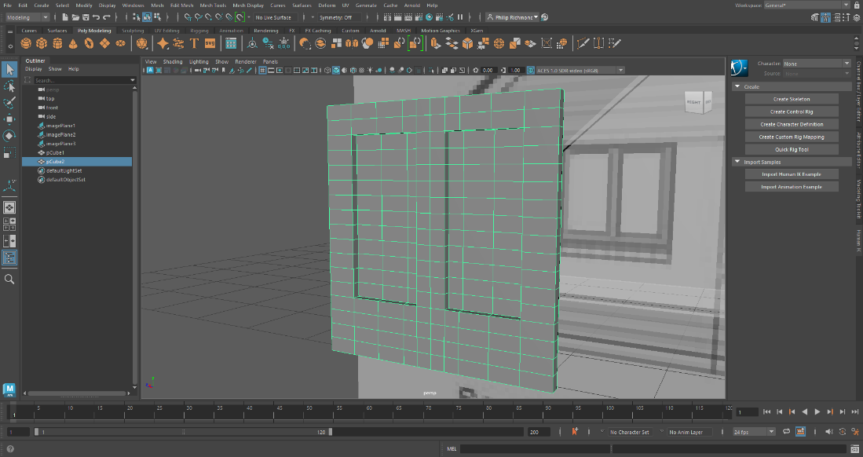
Figure 81 Window make separately to reference image.
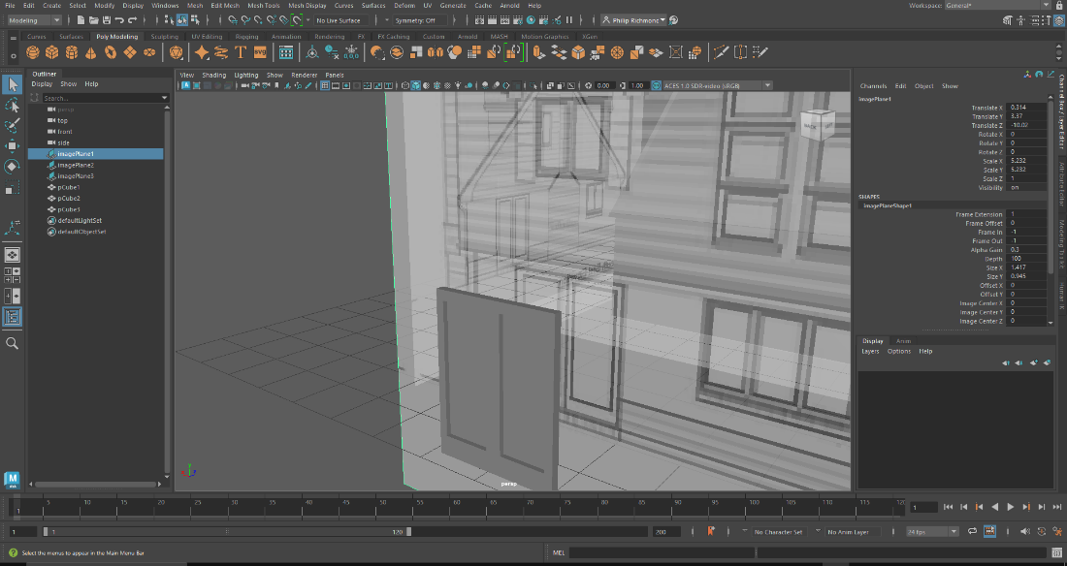
Figure 82. Double door made separately
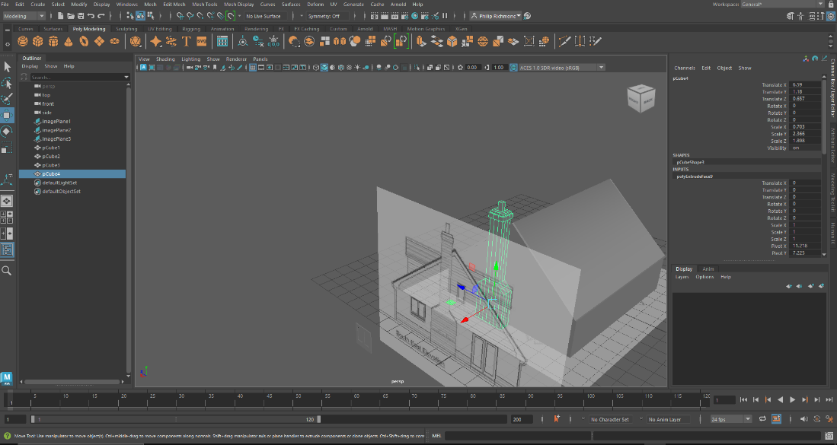
Figure 83 Chimney breast made separately.
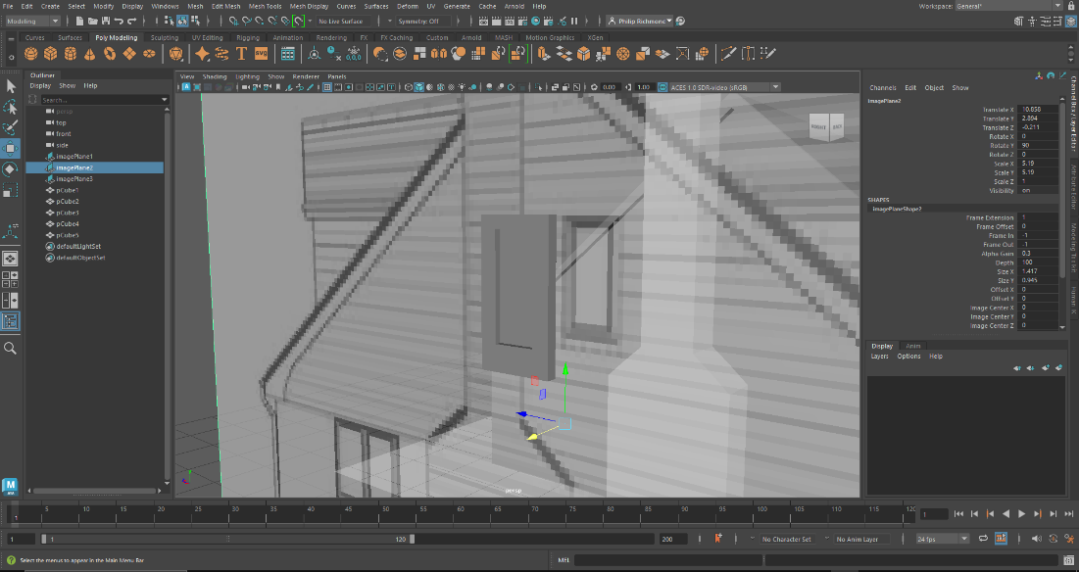
Figure 84 Single window made seperatly.
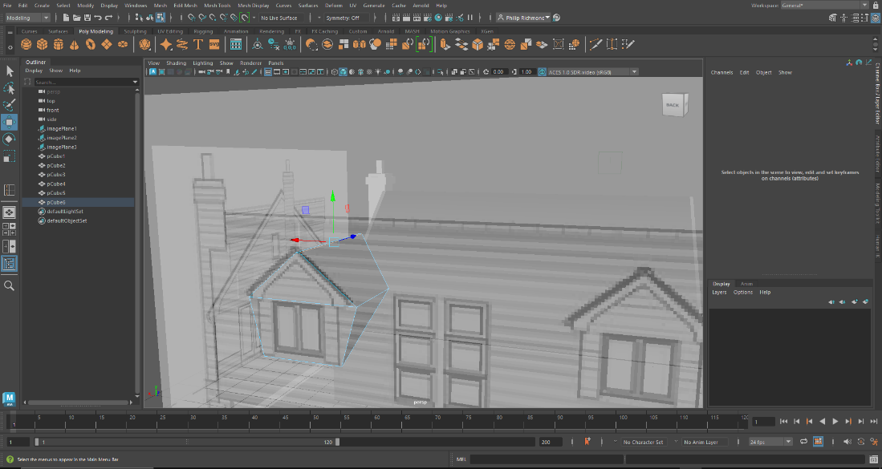
Figure 85 Bay window was the hardest asset to make for the house.
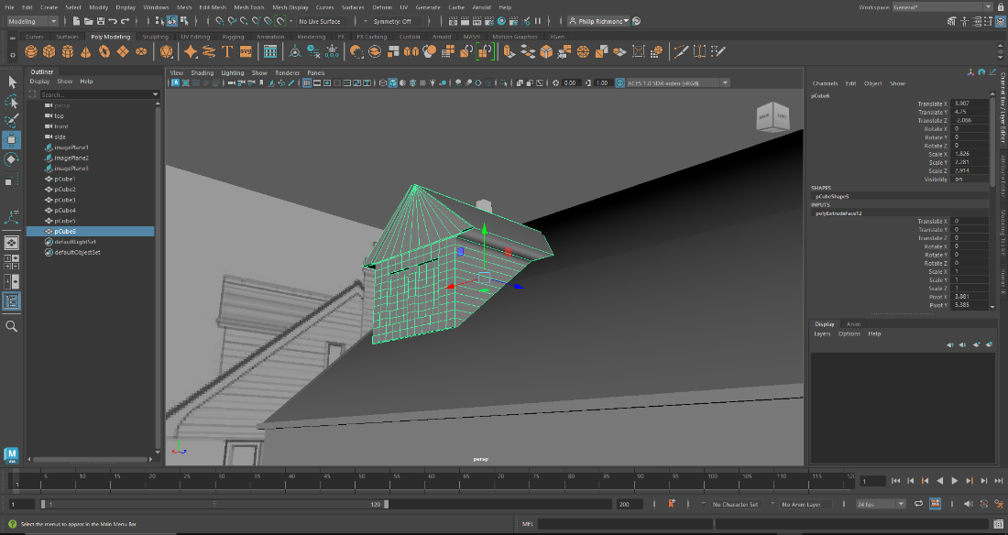
Figure 86 Complete bay window.
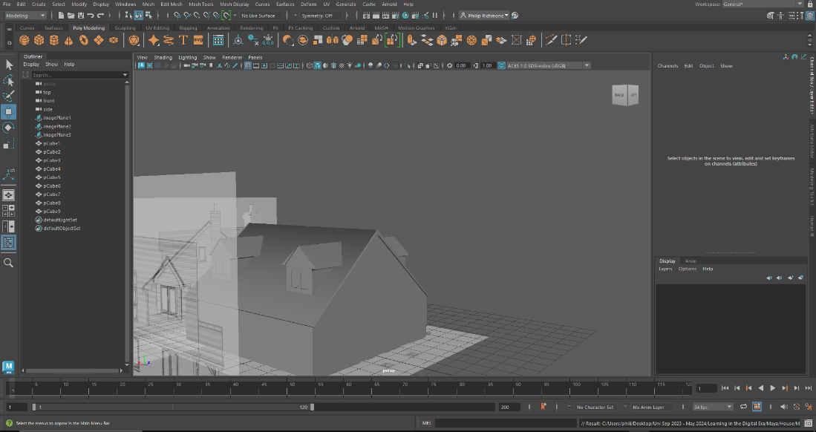
Figure 87 Duplication of bay windows
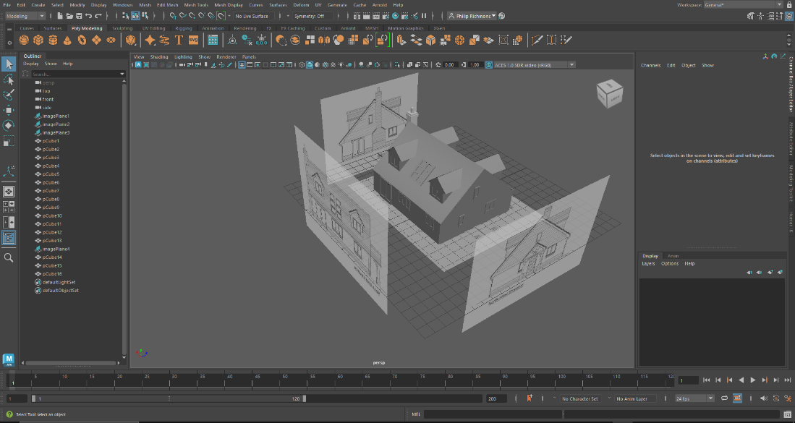
Figure 88 double check reference pictures
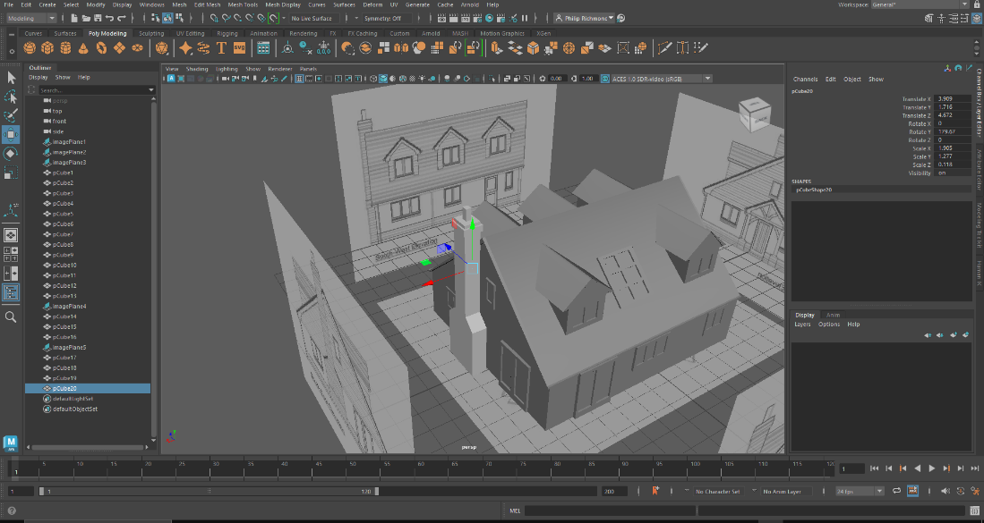
Figure 89 Experimenting with surface material on chimley.

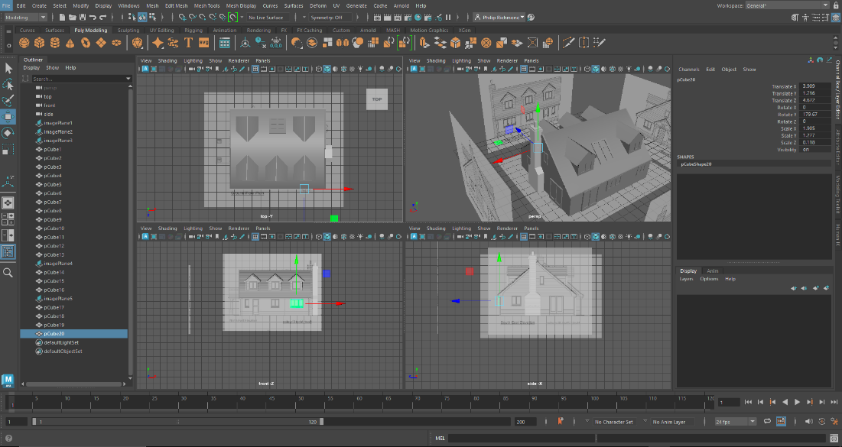
Figure 90 The rest off windows and door are duplicated and fitted into place.
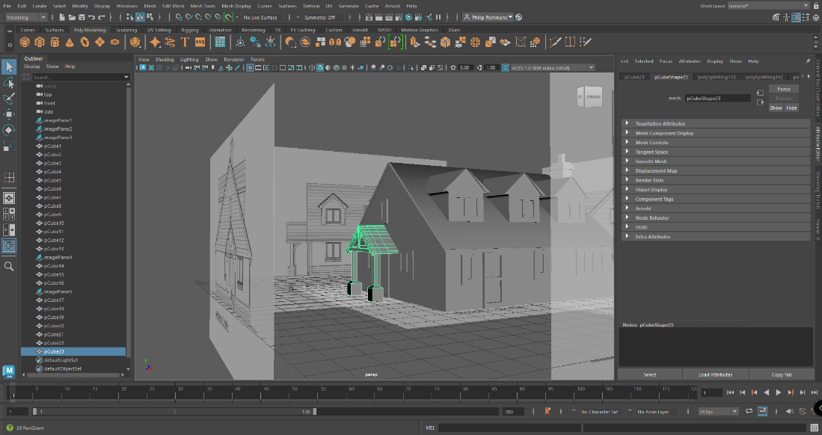
Figure 91 Hose porch created with some difficulty.
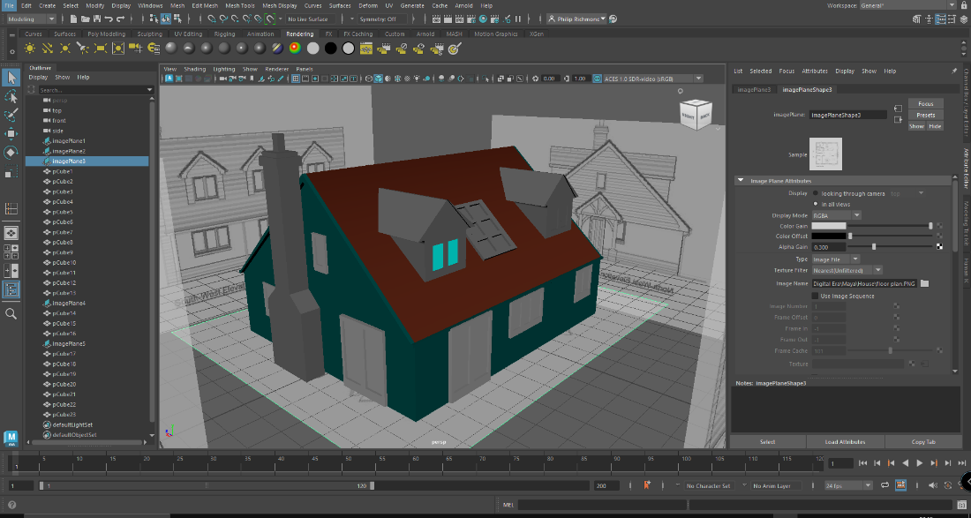
Figure 92 [19] Here I experimented with some colors.

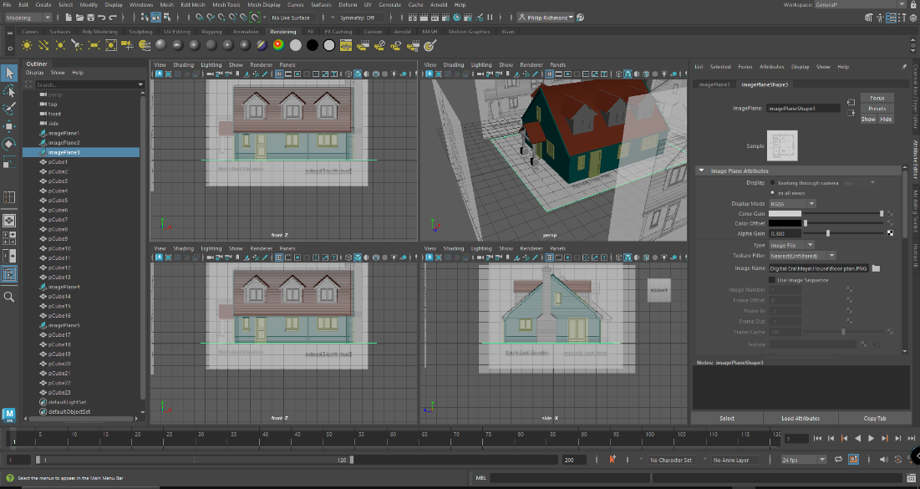
Figure 93 Finished asset.

Conclusion
03.12.2023
With the completion of all my assets in Autodesk Maya I feel my understanding of Mayas many functions and tools has significantly increased my knowledge from my first day starting out. This diary and detail log with help my further eduction into the world of Autodesk Maya.

Bibliography

[1] | "Autodesk.co.uk," 2023. [Online]. Available: https://www.autodesk.co.uk/products/maya/overview?term=1-YEAR&tab=subscription. [Accessed October 2023].
[2] | G. Maestri, "maya-2023-essential-training," [Online]. Available: https://www.linkedin.com/learning/maya-2023-essential-training/configuring-viewports?u=77966930. [Accessed 0ctober 2023].
[3] | "RS Online," 2023. [Online]. Available: https://uk.rs-online.com/web/p/screwdrivers/1829698. [Accessed October 2023].
[4] | "Shutterstock, Inc," Shutterstock, Inc, 2003-2023 . [Online]. Available: https://www.shutterstock.com/search/anvil-isolated. [Accessed October 2023].
[5] | "Ikea," Ikea, 1999-2023. [Online]. Available: https://www.ikea.com/gb/en/p/hemnes-chest-of-8-drawers-white-stain-10239280/. [Accessed October 2023].
[6] | "Shutterstock," 30 September 2023. [Online]. Available: https://www.shutterstock.com/image-vector/germany-september-08th-2021-vector-illustration-2199443665. [Accessed October 2023].
[7] | "Oriental Art Auctions," Oriental Art Auctions, 2023. [Online]. Available: https://www.orientalartauctions.com/object/artothe15872-a-ceremonial-battle-axe-tabarzin-persia-safavid-17th-18th-century. [Accessed October 2023].
[8] | "Pngtree," 2017 - 2023. [Online]. Available: https://pngtree.com/free-png-vectors/light-pole. [Accessed October 2023].
[9] | J. Mainwaring, " YouTube The Two easiest ways to make pipes in Maya," 18 July 2021. [Online]. Available: https://www.bing.com/videos/riverview/relatedvideo?q=how+to+bend+a+tube+in+maya&mid=7990A14C70C2A2202EBF7990A14C70C2A2202EBF&FORM=VIRE. [Accessed November 2023].
[10] | D. Doan, "Youtube," 22 September 2015. [Online]. Available: https://www.youtube.com/watch?v=itVYueBNV6g. [Accessed October 2023].
[11] | "Publicitários Criativos," 2013 - 2023. [Online]. Available: https://www.publicitarioscriativos.com/a-coca-cola-divulga-novo-design-minimalista-para-suas-latas/diet-coke/. [Accessed November].
[12] | "iStock Images," 2023. [Online]. Available: https://www.istockphoto.com/photo/top-view-of-aluminum-can-isolated-on-white-gm1293895898-388118382. [Accessed November 2023].
[13] | "3dEx," 13 September 2017. [Online]. Available: https://www.youtube.com/watch?v=hV8ZqVgL0Xg. [Accessed October 2023].
[14] | "3dEx," 3dEx, 2018. [Online]. Available: https://www.youtube.com/watch?v=odsfl0TS6Sc. [Accessed October 2023].
[15] | "NISBETS," 1983-2023. [Online]. Available: https://www.nisbets.co.uk/royal-porcelain-classic-white-cappuccino-cups-200ml/cg023. [Accessed November 2023].
[16] | "MH Tutorials, the Modeling Hub," 1 June 2015. [Online]. Available: https://www.youtube.com/watch?v=VRcGsMYEtQ4. [Accessed November 2023].
[17] | "Shutterstock," 2023. [Online]. Available: https://www.shutterstock.com/image-vector/flat-cartoon-design-green-dumpster-containers-1548894422. [Accessed November 2023].
[18] | "Home Design Images," Home Design Images, [Online]. Available: https://homedesignimages2020.blogspot.com/2019/09/fresh-100-3-bedroom-house-designs-and.html. [Accessed October 2023].
[19] | A. Schiffmann, 17 November 2017. [Online]. Available: https://www.youtube.com/watch?v=UhMLGdIppYA. [Accessed October 2023].

