Do levels of sensation seeking and tempo of music influence participants’ perception of time?
Student No. 1704208
University of Wales Trinity St David

Abstract
The topic of sensation seeking, tempo of music and potential influence on perception of time has been touched on many before, but seldom specifically investigated. This study aimed to examine whether or not there is in fact a relationship between sensation seeking, tempo of music and perception of time. The was done by studying thirty-nine participants, twenty-two females, fifteen males and one person who identified as other, between the ages of eighteen and fifty-six. The participants in this study completed a Brief Sensation Seeking Scale questionnaire, and a time perception task which was either accompanied by fast, slow or no music. Results were obtained by using a 2x3 between-subjects ANOVA. The results from this study were non-significant; F = (2,32) = .78, N = 38, p=.47. These results do not relate with a number of previous studies in this subject area. Going forward, a study of this nature could benefit from looking at additional factors of influence such as emotion and preference of music.

Introduction
Perception, can be defined as ‘the process or result of becoming aware of objects, relationships, and events by means of the senses, which includes such activities as recognizing, observing, and discriminating’ (American Psychological Association, 2019). This enables people to organise information, access and store previously acquired knowledge, as well as learning to act or behave according to the situation they may find themselves. Therefore, a person’s perception of time is how they analyse, distinguish and even characterise a period of time and its length.
A person’s perception of time can vary in the sense that they may overestimate, or underestimate the length of a period of time. This can mean an individual may be believe that a greater or lesser period of time has passed, than the actual amount. Interestingly, it is believed that time perception, particularly in humans, is actually prone to regular misinterpretations (Eagleman, 2008). It also advocated that a person’s internal clock, as well as their cognition and emotion, play a part in perceiving time (Wearden, 2016).
Sensation seeking can be described as a trait, where a person has the ‘need for varied, novel, and complex sensations and experiences and the willingness to take physical and social risks for the sake of such experience’ (Zuckerman, 1979).
But is there a link between sensation seeking, tempo of music and perception of time? A number of previous studies have sought to explore this potential relationship and topic area. In a study which analysed the relationship between sensation seeking and preference of music, Heydaria, Mohammadi and Rostami (2013), found a positive correlation between the two. This can be linked to the role emotion can potentially play in perceiving time.
Additionally, a study on music, emotion, and time perception, found that the tempo of music, combined with a subjective arousal effect, was a highly contributory factor producing incorrect perceptions of time. It saw periods of time being perceived as longer than their actual length with fast tempo music (Droit-Volet, Ramos, Bueno, and Bigand, 2013).
However, a study on musical tempo and time perception by North, Hargreaves and Heath (1998), found that there was in fact greater inaccuracies in time perception from those that had listened to slow tempo music.
This study will draw conclusions from analysing the data collected. This will be done using the programme SPSS, in keeping with APA standards. Sensation seeking will be measured using a Brief Sensation Seeking Scale (BSSS) (Stephenson, Hoyle, Slater and Palmgreen 2003).
This study will aim to expand on previous research undertaken on the subject of sensation seeking and tempo of music, and its possible relationship with time perception. Considering previous studies and literature published on the subject, it hypothesised, that those participants who are deemed to be high-level sensation seekers, and listen to fast-paced music, will overestimate time.

Method

Participants
Thirty-nine participants took part in this study. Participants were recruited from the SA1 campus of the UWTSD, Swansea, and volunteered take part. The study contained twenty-two females, fifteen males and one person who identified as other, with ages ranging from eighteen to fifty-six years old (M=27.5, SD= 9.61). One participant’s data was excluded as they did not give their age, which was considered to be an important piece of data for the study (N=38).
Design
The study was multi-factorial and between-subjects. The two independent variables were sensation seeking and tempo of music. Sensation seeking was a two-level independent variable, with the two categorises being high-level and low-level. Participants were placed into either category depending on their level of sensation seeking. If they scored twenty-four or below they were placed into the low-level sensation seeking category, if they scored twenty-five or more, they were placed into the high-level sensation seeking category. In order to measure levels of sensation seeking, a Brief Sensation Seeking Scale (BSSS) was used. Tempo of music was a three-level independent variable. Three categories were fast paced, slow paced, or no music at all.
The dependent variable was time perception. In order to measure the participants perception of time, a time perception task was used. The computer programme Superlab was used to create this task. This enabled the responses of the participants to be recorded.

Materials
In order to measure sensation seeking, participants were presented with a questionnaire, developed with the Brief Sensation Seeking Scale. The scale contained eight questions/statements. The statements were in relation to how people generally felt about themselves. The participants were required to respond to each one. A five-point Likert scale was used to measure explicit attitudes/levels of sensation seeking, with responses 1 = Strongly disagree, 2 = Disagree, 3 = Neither disagree nor agree, 4 = Agree and 5 = Strongly Agree. No results were reversed scored, and higher scores corresponded with higher levels of sensation seeking.
In order to measure time perception, a pink oval was used as the stimulus object. It measured 12cm x 16cm. The pink oval was used in the initial training part of the experiment, as well as the main part of the experiment. During the training part of the experiment, participants were taught to recognise the oval being on the screen for a long period of time, 1600 milli seconds (ms), as well as a short period of time for 400ms. In the experimental component of the study, the oval appeared on screen a total of twenty-two times, for a duration of 400, 800, 1000, 1200, or 1600 ms. Out of the twenty-two occasions the oval was displayed for 1000ms ten times. This was the oval used to gather data from the participants, to see if they would overestimate or underestimate time. To record this data, a regular QWERTY keyboard with two marked keys (A and L) was used in order for participants to respond to whether they thought the oval appearing for 1000ms was displayed for a long or a short period of time.

Procedure
When beginning the experiment, participants were presented with a consent form (see appendices item A), and instructed to read the information on it. The participants were asked to sign the consent form if they were happy with what they had read, thus agreeing to take part in the study.
The participants were firstly given a BSSS questionnaire (See appendices item B) and asked to complete all eight questions. Secondly, the participants were given the time perception task. They were instructed to read the information given to them and respond using the correct keyboard buttons. The participants were required to decide if the oval that had appeared on the screen, was present for either a long or a short amount of time. Whilst undertaking the task, the participants were given either a piece of fast or slow music or no music to listen to. This was randomised.
Researchers were interested in the responses of the participants to oval that was displayed for 1000ms, as this was directly between the two training ovals of 400 and 1600ms, previously characterised as either a short or long period of time respectively. This was shown a total of ten times. Perception of time, either estimation or underestimation, was determined on the number of times out of ten a participant responded to the oval being displayed on the screen for a long or short period of time.
At the conclusion of the study, all participants were given a debrief form (see appendices item C). This explained the purpose of the experiment and thanked the participants for taking part.

Results
A 2x3 between-subjects ANOVA was conducted to assess the effect of levels of sensation seeking and tempo of music, on the perception of time. The descriptive statistics for all variables included in the analysis are shown in Table 1. This was deemed to be reliable,
α = .83. However, in order to achieve this question 7 was removed.
The two-way interaction effect between was non-significant; F (2,32) = .78, p=.47. The main effect of sensation seeking on time perception was also non-significant, F (1,32) = .66, p=.42. Finally, the main effect of music tempo on time perception was also non-significant F (2,32)=.16, p=.86.
In terms of the levels of significance, between no music and slow music, significance was .90, which is non-significant. Between no music and fast music the significance was 1.00, which is non-significant. Lastly, the level of significance between slow music and fast music was .88. This means that the original hypothesis can be deemed non-significant and rejected.

Discussion
As briefly mentioned in the results section, the original hypothesis can be rejected. The two-way interaction effect was non-significant. Secondly, the main effect of sensation seeking on time perception was also non-significant. Finally, the main effect of tempo of music on time perception was also non-significant. This result does not support the idea that that individuals who are high-level sensation seekers overestimate time, and in fact could supports findings of North et al. (1998), that there could in fact be greater inaccuracies in time perception from those that had listened to slow tempo music.
Although the results of the study do not support the original hypothesis, there are certain factors which could also be examined, such as preference of music (Heydaria, 2013). An additional factor that can be examined going forward is emotion (Droit-Volet et al., 2013), particularly as it has been found that emotion, can play a part in perceiving time (Wearden, 2016).
Furthermore, the participants preference of music could also potentially influence their perception of time (Heydaria, 2013), as well as their emotion. This was seen in the study as one participant withdrew, as they found one of the pieces of music, the slow music, to be too emotionally overwhelming.
A potential influence on the findings of this study could be the number of participants, thirty-nine, which is quite a small, and arguably unrepresentative number of people. Also, another possible influence could be gender. Out of the thirty-nine participants, twenty-two were female.
In conclusion, as the hypothesis was rejected, going forward, further research should consider additional potential influential factors such as emotion and preference of music.
References
American Psychological Association. (2019). Sensation level. retrieved from
https://dictionary.apa.org/sensation-level
Eagleman, D. (2008). Human time perception and its illusions. U.S. National Institutes of
Health’s National Library of Medicine. 18(2): 131–136.
doi: 10.1016/j.conb.2008.06.002
Droit-Volet S, Ramos D, Bueno JL, and Bigand E. (2013). Music, emotion, and time
perception: the influence of subjective emotional valence and arousal?
U.S. National Institutes of Health’s National Library of Medicine.
doi:10.3389/fpsyg.2013.00417
Wearden, J. (2016). The Psychology of Time Perception. London, England: Palgrave
Macmillan UK
Zuckerman, M. (1979). Sensation seeking: Beyond the optimal level of arousal.
NJ: Lawrence Erlbauam
Heydaria, H. Mohammadi, F. and Rostami, M. (2013). Analysing the Relationship Between
Sensation Seeking and Preference of Type of Music in College Students. Science Direct
doi.org/10.1016/j.sbspro.2013.06.644
Stephenson, M. T., Hoyle, R. H., Slater, M. D., & Palmgreen, P. (2003). Brief measures of
sensation seeking for screening and large scale surveys. Drug and Alcohol Dependency,
72, 279-286.
North, A. C. Hargreaves, D. J. and Heath, S. J. (1998). Musical Tempo and Time Perception
in a Gymnasium. Psychology of Music.
doi.org/10.1177/0305735698261007

Appendices
Item A
Consent form
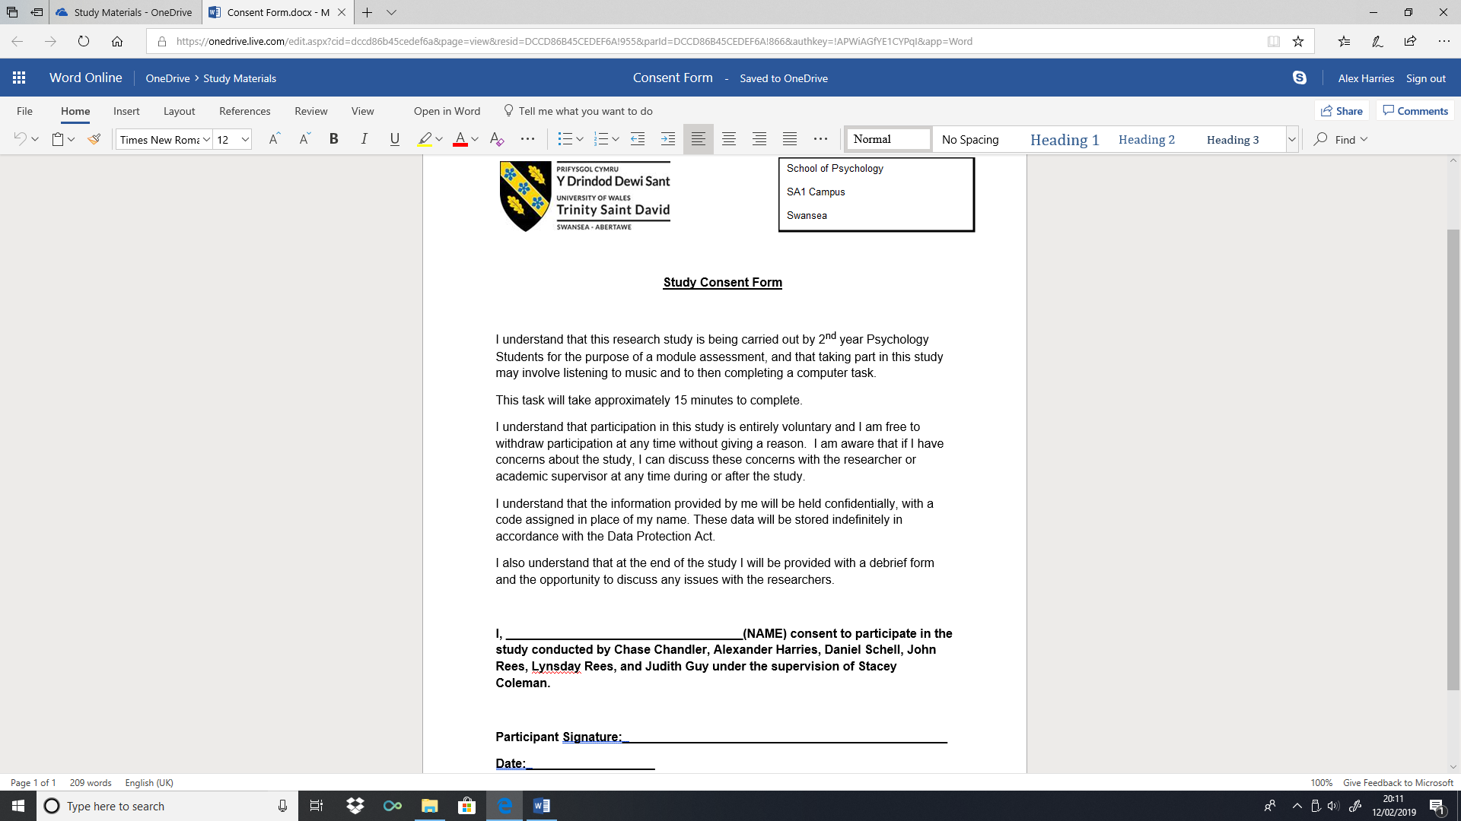

Item B
Brief Sensation Seeking Scale Questionnaire
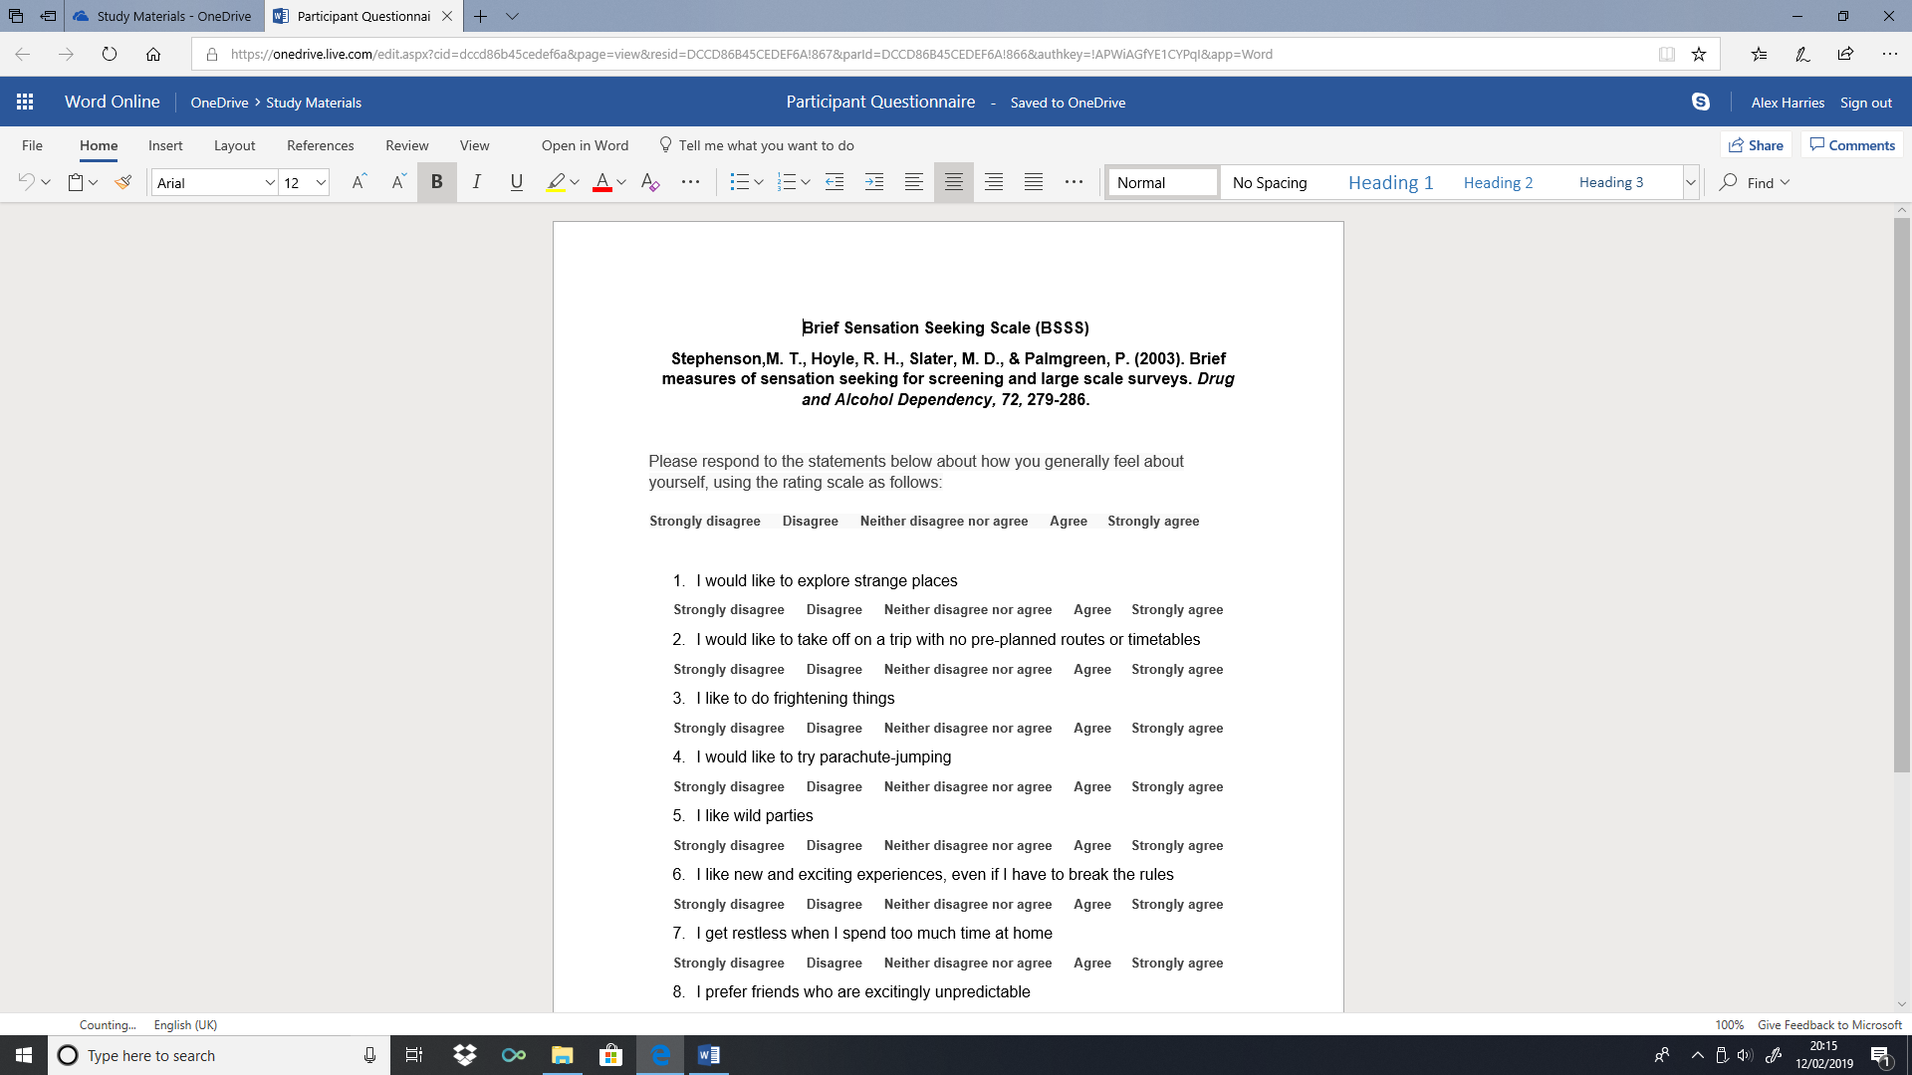

Item C
Debrief form
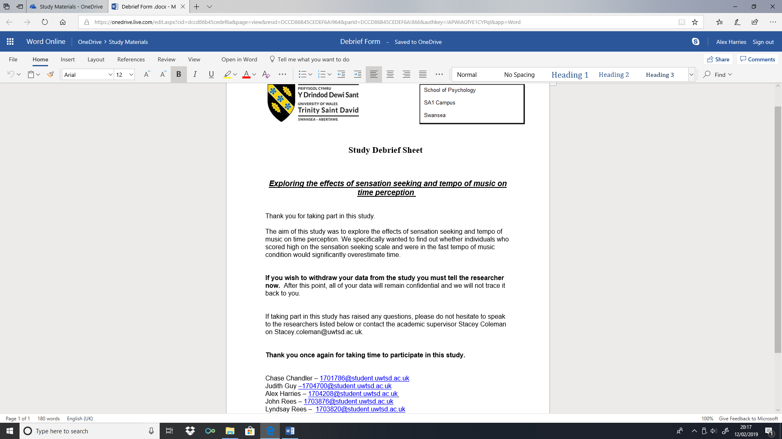

SPSS Outputs

Descriptive Statistics
 | N | Minimum | Maximum | Mean | Std. Deviation
Gender | 38 | 1.00 | 3.00 | 1.6316 | .54132
Age | 37 | 18.00 | 56.00 | 27.5135 | 9.60793
Valid N (listwise) | 37

Descriptive Statistics
 | N | Minimum | Maximum | Mean | Std. Deviation
TimePerception | 38 | 1.00 | 10.00 | 5.8684 | 2.77217
TotalSS | 38 | 18.00 | 40.00 | 27.4737 | 6.13249
Valid N (listwise) | 38

Between-Subjects Factors
 |  | Value Label | N
MusicTempo | 1.00 | NoMusic | 13
MusicTempo | 2.00 | SlowMusic | 12
MusicTempo | 3.00 | FastMusic | 13
SensationSeeking | 1.00 | Low | 15
SensationSeeking | 2.00 | High | 23

Descriptive Statistics
Dependent Variable: TimePerception
MusicTempo | SensationSeeking | Mean | Std. Deviation | N
NoMusic | Low | 4.2500 | 2.62996 | 4
NoMusic | High | 6.7778 | 3.70060 | 9
NoMusic | Total | 6.0000 | 3.51188 | 13
SlowMusic | Low | 5.5000 | 2.51661 | 4
SlowMusic | High | 5.5000 | 2.00000 | 8
SlowMusic | Total | 5.5000 | 2.06706 | 12
FastMusic | Low | 6.1429 | 2.67261 | 7
FastMusic | High | 6.0000 | 2.96648 | 6
FastMusic | Total | 6.0769 | 2.69139 | 13
Total | Low | 5.4667 | 2.55976 | 15
Total | High | 6.1304 | 2.92799 | 23
Total | Total | 5.8684 | 2.77217 | 38

Levene's Test of Equality of Error Variancesª
Dependent Variable: TimePerception
F | df1 | df2 | Sig.
1.864 | 5 | 32 | .129
Tests the null hypothesis that the error variance of the dependent variable is equal across groups.
a. Design: Intercept + MusicTempo + SensationSeeking + MusicTempo * SensationSeeking

Tests of Between-Subjects Effects
Dependent Variable: TimePerception
Source | Type III Sum of Squares | df | Mean Square | F | Sig. | Partial Eta Squared
Corrected Model | 20.179ª | 5 | 4.036 | .489 | .782 | .071
Intercept | 1116.673 | 1 | 1116.673 | 135.271 | .000 | .809
MusicTempo | 2.583 | 2 | 1.291 | .156 | .856 | .010
SensationSeeking | 5.440 | 1 | 5.440 | .659 | .423 | .020
MusicTempo * SensationSeeking | 12.828 | 2 | 6.414 | .777 | .468 | .046
Error | 264.163 | 32 | 8.255
Total | 1593.000 | 38
Corrected Total | 284.342 | 37
a. R Squared = .071 (Adjusted R Squared = -.074)

1. MusicTempo
Dependent Variable: TimePerception
MusicTempo | Mean | Std. Error | 95% Confidence Interval
MusicTempo | Mean | Std. Error | Lower Bound | Upper Bound
NoMusic | 5.514 | .863 | 3.755 | 7.272
SlowMusic | 5.500 | .880 | 3.708 | 7.292
FastMusic | 6.071 | .799 | 4.443 | 7.699

2. SensationSeeking
Dependent Variable: TimePerception
SensationSeeking | Mean | Std. Error | 95% Confidence Interval
SensationSeeking | Mean | Std. Error | Lower Bound | Upper Bound
Low | 5.298 | .768 | 3.733 | 6.862
High | 6.093 | .608 | 4.855 | 7.331

3. MusicTempo * SensationSeeking
Dependent Variable: TimePerception
MusicTempo | SensationSeeking | Mean | Std. Error | 95% Confidence Interval
 |  |  |  | Lower Bound | Upper Bound
NoMusic | Low | 4.250 | 1.437 | 1.324 | 7.176
NoMusic | High | 6.778 | .958 | 4.827 | 8.729
SlowMusic | Low | 5.500 | 1.437 | 2.574 | 8.426
SlowMusic | High | 5.500 | 1.016 | 3.431 | 7.569
FastMusic | Low | 6.143 | 1.086 | 3.931 | 8.355
FastMusic | High | 6.000 | 1.173 | 3.611 | 8.389

Multiple Comparisons
Dependent Variable: TimePerception
Tukey HSD
(I) MusicTempo | (J) MusicTempo | Mean Difference (I-J) | Std. Error | Sig. | 95% Confidence Interval
 |  |  |  |  | Lower Bound | Upper Bound
NoMusic | SlowMusic | .5000 | 1.15019 | .901 | -2.3264 | 3.3264
NoMusic | FastMusic | -.0769 | 1.12695 | .997 | -2.8463 | 2.6924
SlowMusic | NoMusic | -.5000 | 1.15019 | .901 | -3.3264 | 2.3264
SlowMusic | FastMusic | -.5769 | 1.15019 | .871 | -3.4034 | 2.2495
FastMusic | NoMusic | .0769 | 1.12695 | .997 | -2.6924 | 2.8463
FastMusic | SlowMusic | .5769 | 1.15019 | .871 | -2.2495 | 3.4034
Based on observed means.
The error term is Mean Square(Error) = 8.255.

TimePerception
Tukey HSD^{a,b,c}
MusicTempo | N | Subset
MusicTempo | N | 1
SlowMusic | 12 | 5.5000
NoMusic | 13 | 6.0000
FastMusic | 13 | 6.0769
Sig. |  | .869
Means for groups in homogeneous subsets are displayed.
Based on observed means.
The error term is Mean Square(Error) = 8.255.
a. Uses Harmonic Mean Sample Size = 12.649.
b. The group sizes are unequal. The harmonic mean of the group sizes is used. Type I error levels are not guaranteed.
c. Alpha = .05.

Case Processing Summary
 |  | N | %
Cases | Valid | 38 | 100.0
Cases | Excludedª | 0 | .0
Cases | Total | 38 | 100.0
a. Listwise deletion based on all variables in the procedure.

Reliability Statistics
Cronbach's Alpha | Cronbach's Alpha Based on Standardized Items | N of Items
.821 | .829 | 7

Item Statistics
 | Mean | Std. Deviation | N
Quest1 | 4.0263 | .78798 | 38
Quest2 | 3.6053 | 1.28483 | 38
Quest3 | 3.1316 | 1.14304 | 38
Quest4 | 3.5000 | 1.48415 | 38
Quest5 | 2.9474 | 1.13774 | 38
Quest6 | 3.3421 | 1.07241 | 38
Quest8 | 3.4211 | 1.05604 | 38

Inter-Item Correlation Matrix
 | Quest1 | Quest2 | Quest3 | Quest4 | Quest5 | Quest6 | Quest8
Quest1 | 1.000 | .598 | .536 | .497 | .484 | .341 | .279
Quest2 | .598 | 1.000 | .588 | .333 | .411 | .473 | .265
Quest3 | .536 | .588 | 1.000 | .566 | .359 | .469 | .199
Quest4 | .497 | .333 | .566 | 1.000 | .368 | .314 | .500
Quest5 | .484 | .411 | .359 | .368 | 1.000 | .325 | .334
Quest6 | .341 | .473 | .469 | .314 | .325 | 1.000 | .371
Quest8 | .279 | .265 | .199 | .500 | .334 | .371 | 1.000

Summary Item Statistics
 | Mean | Minimum | Maximum | Range | Maximum / Minimum | Variance | N of Items
Inter-Item Correlations | .410 | .199 | .598 | .399 | 3.002 | .013 | 7

Item-Total Statistics
 | Scale Mean if Item Deleted | Scale Variance if Item Deleted | Corrected Item-Total Correlation | Squared Multiple Correlation | Cronbach's Alpha if Item Deleted
Quest1 | 19.9474 | 25.673 | .657 | .499 | .792
Quest2 | 20.3684 | 22.455 | .610 | .515 | .789
Quest3 | 20.8421 | 23.055 | .654 | .562 | .782
Quest4 | 20.4737 | 21.175 | .598 | .524 | .795
Quest5 | 21.0263 | 24.405 | .520 | .302 | .804
Quest6 | 20.6316 | 24.725 | .531 | .347 | .802
Quest8 | 20.5526 | 25.551 | .456 | .366 | .814

Scale Statistics
Mean | Variance | Std. Deviation | N of Items
23.9737 | 31.540 | 5.61603 | 7

