

Evaluating the External Marketing Environment and Growth Strategies of Anglo American for Sustainable Business

Assignment Title: Marketing Environment Analysis
Lecturer: Laila Maazouz (London) - Taonga Kaonga Sobere- Snithers (Birmingham)
Module: Marketing Management
Programme: Master of Business Administration
Module code: LCMB7024
Submitted by
Student name: prerna p padmani
Student ID number: 2536257

Table of Contents
Introduction 3
2. Task 1: Marketing Environment Analysis 3
2.1 Overview of the Marketing Environment 3
2.2 Natural Environment Analysis (Main Focus) 4
2.3 Second External Marketing Environment Actor: Political and Regulatory Environment 5
2.4 Summary of Environmental Findings 6
3. Task 2: Strategic Growth and Competitive Positioning 6
3.1 Introduction to Growth Strategy 6
3.2 Application of the Ansoff Matrix 7
3.3 Achieving Competitive Advantage 8
3.4 Competitive Advantage Through Sustainability 9
3.5 Strategic Recommendations 9
4. Task 3: Critical Reflection on AI Usage 10
4.1 AI Tool Disclosure 10
4.2 Verification of AI Output 10
4.3 Contribution Analysis 10
4.4 Ethical and Professional Reflection 10
5. Conclusion 11
References 11

Introduction
Anglo American is a London-based global mining company that trades in copper, iron ore, platinum group metals, diamonds and crop nutrients. The company plays a significant role in supplying the raw materials that are crucial for the industrial growth and global shift to a low-carbon energy economy. In the metals and minerals sector, trends towards sustainability are resulting in greater demands for their behaviour to be aligned in a way that reduces their environmental footprint without compromising their profitability (Zrybnieva et al., 2025).

The threats of climate change, carbon emissions and environmental concerns grow ever greater and are compelling mining companies to adopt a responsible attitude towards their businesses. The Objective of this report is to analyse the external environment of marketing for Anglo American paying special attention to aspects related to sustainability that will affect the operations in the context of natural environment and political and other regulatory factors. In addition, options supporting strategic growth via the Ansoff Matrix are mapped out and strategies of positioning within competition are explored using sustainability options (Farhan, 2024).
2. Task 1: Marketing Environment Analysis

2.1 Overview of the Marketing Environment
Marketing Environment is the external and internal factors which affect the ability of an organisation to create value for the customers and to achieve the organisation's objectives. All these influence futures organisational performance, decision making, competitive positioning and resource allocation. These external forces have a substantial impact on business operations and market opportunities, but are typically outside of the manager's control.

Liquidating factors such as marimeters. Marimeters that may be liquidated are economic marimeters, political marimeters, technological marimeters, social and environmental marimeters (Alkaraan et al., 2024). Knowing what is happening to the marketing environment is definitely crucial for Anglo American since mining is tied to the world's questions on sustainability. The alteration of environmental laws, expectations from stakeholders, technological innovations, etc. has an impact on production as well as on profitability.
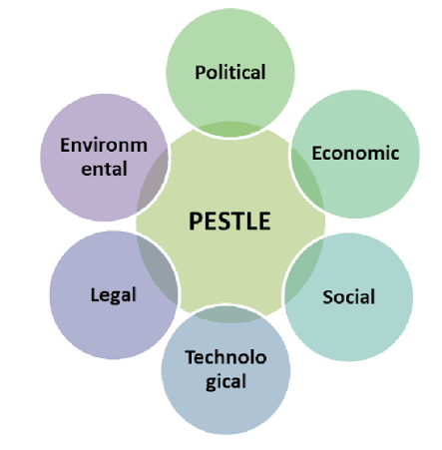
Figure: Marketing environment macro factors infographic PESTLE
(Source: Zioło et al., 2023)
The mining sector is undergoing a change that has never been seen before due to the rise in importance of sustainability. Investors, governments, customers and local communities, on the other hand, are holding mining companies accountable for reducing carbon emissions, delivering green outcomes and making a positive contribution toward the Sustainable Development Goals (SDGs) today. Environmental analysis is thus not a compliance question, but rather a strategic one (Zioło et al., 2023).
Looking to the future with an eye for environmental conditions and reacting appropriately could improve Anglo American's reputation, help optimize their operations, and create long term competitive opportunities.

2.2 Natural Environment Analysis (Main Focus)
The natural environment is one of the most external factors that most has been impacted on Anglo American operations. Greenhouse gas emissions are one issue of concern to mining companies as pressure on them to decrease the amount of GHGs they generate gets worse. Many of the mining operations represent large energy consumption and are subject of critical carbon reduction strategies. But there are some things that need to be addressed because of its limited resources. With the accessibility of mineral deposits getting harder, companies need to put their money behind new, groundbreaking mining methods, as well as effective and efficient management systems of mineral resources (Ulanov, 2024).

In addition, the lack of water at many sites poses problems for this operation and there are concerns from stakeholders regarding the environment. As a way forward, Anglo American has concentrated on renewable energy, emission reduction and sustainable mining. The Company's goal is to reduce environmental load and assist in creating an economy for lowering carbon emissions.
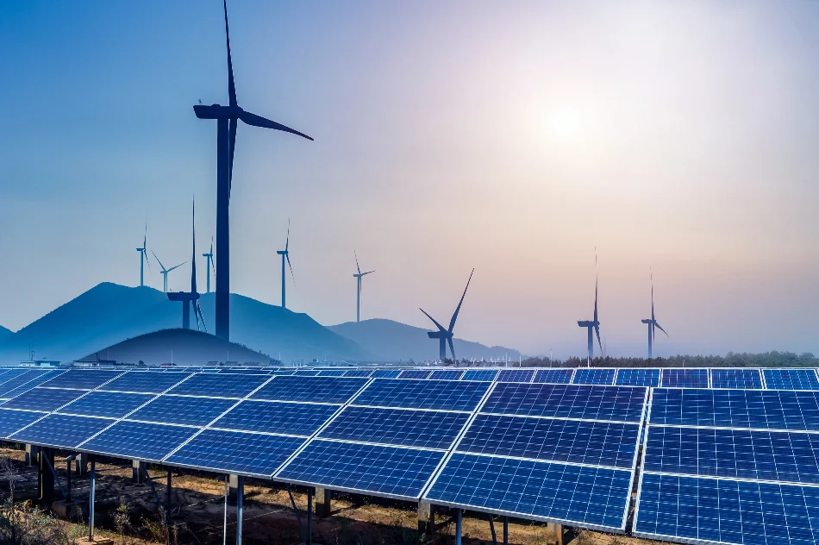
Figure: Renewable energy at mining sites solar wind power mining industry
(Source: Gerged et al., 2023)
Opportunities and threats can be found within the natural environment, critically. Implementing sustainable products can enhance the added value of brands and set advantages for the company's products and services. However, not responding to environmental issues could lead to reputation loss, regulatory fines and loss of trust from stakeholders (Gerged et al., 2023).

2.3 Second External Marketing Environment Actor: Political and Regulatory Environment
Anglo American's sustainability initiatives and strategic decisions are strongly affected by the political and regulatory environment. Avoiding the excesses of climate change combined with the challenge of sustainable economic development, more Governments of the world make tough on environmental regulations (El Fallahi et al., 2023). These policies can affect mining companies in many ways, such as through carbon taxes, emission reduction targets, environmental reporting and resource management policies. Meeting environmental legislation adds to the expense, but also may spur innovation and efficiency gains. Anglo American needs to be flexible in executing its operations and adjust to evolving regulatory requirements in various international markets.

But while government policies encourage renewable energy and sustainable industrial development, mining companies are presented with avenues to supply the minerals that generates clean energy (Alonso‐Martínez and González‐Álvarez, 2024). A critical angle: regulatory pressure is a challenge, as well as an opportunity. Restricting standards may lead to high costs of adherence as well as limited choices on operations. However, companies can strengthen their market position and continue to be leaders in sustainability in the eyes of their customers and the eyes of government by responding proactively to emerging regulations.
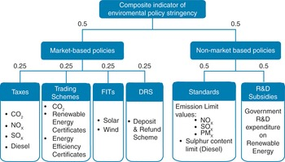
Figure: Environmental regulations mining industry government policy
(Source: Alonso‐Martínez and González‐Álvarez, 2024)
Environmental assessments/ compliance is of utmost significance to customers, investors, and stakeholders. Rather than just relying on protecting their property and assets, Anglo American would show why it is good to invest in sustainability, and enhance its reputation as a good company to invest in (Dobija et al., 2023). The opposite, however, may have negative impacts on the involvement of stakeholders and the competitiveness of the market because of shortcomings in the regulation.

2.4 Summary of Environmental Findings
In the environmental analysis, Anglo American identified a lot of opportunities and challenges of the context. Demand for greater sustainability within the mining business, for renewable energy technologies and for responsible resource management offers opportunities for businesses to grow and differentiate. But due to climate change stress and resource constraints, as well as more and more stringent Environmental regulations, they are facing serious operational challenges. The company's ability to weave sustainability into business decision-making, adapts to the changing regulation and keeps the trust of the stakeholders can be vital for its strategic success while meeting long-term business and environmental needs.

3. Task 2: Strategic Growth and Competitive Positioning

3.1 Introduction to Growth Strategy
In today's fast-paced business world, strategic growth is the key to competitiveness in the marketplace. Anglo American's growth strategies need to be in line with its sustainability goals and able to tackle environmental issues and regulatory challenges highlighted in the external analysis. Successful Growth strategies allow the organisation to maximise opportunities, improve profitability and strengthen competition (Blinova et al., 2022). As a company that is competing for sustainable resources and for low-carbon technologies, Anglo American needs to get more creative around its growth programmes to ensure that it creates long term value for stakeholders and improves the overall performance of the organisation in doing so, while fostering environmental responsibility.

3.2 Application of the Ansoff Matrix
Market Penetration
Market penetration is geared towards expanding sales of the same product in the same market. Anglo American can further enhance its sustainability communication and operational efficiency through improving customer relationships, to achieve growth in market share (Grayson et al., 2022). Business relationships can be long-term and stakeholder trust can be gained by responsible mining practices that have been demonstrated.
Product Development
Product Development is the creation of new products, which are targeting old markets. Investments in minerals and materials provide a diversification opportunity for Anglo American which can help contribute to low carbon technology (Rathobei et al., 2024). The increasing demand for copper; opportunity for sustainable product innovations such as in renewable energy systems; etc. Increased investment in fuel processing technology which results in less carbon, air and water pollution, and less mercury and other contaminants into the environment can further strengthen product value.
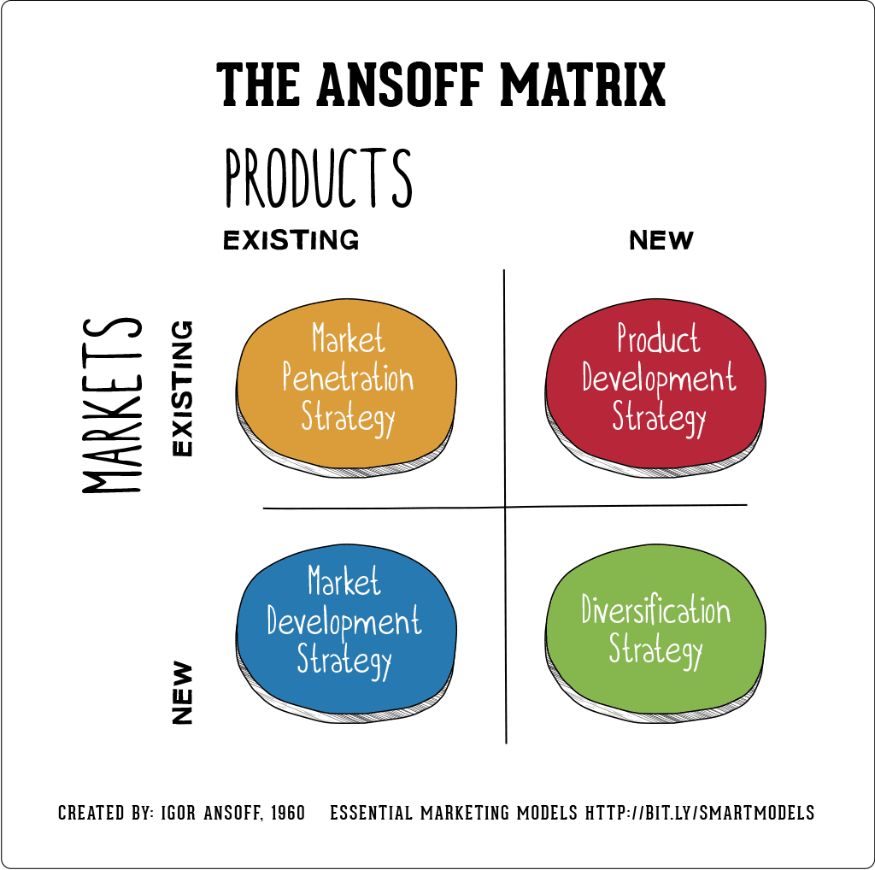
Figure: Ansoff Matrix business growth strategy
(Source: Rathobei et al., 2024)
Market Development
Market development is to build up existing products in new markets. The world's mining industry must provide essential commodities to energy infrastructure projects in growing numbers of countries and industry sectors venturing into renewables (Hampl and Vágnerová Linnertová, 2025). Anglo American can play a role in filling this growing demand for responsibly sourced minerals with the sustainability-focused markets that they serve.
Diversification
Diversification means to invest in new products that are different from one's current portfolios in different markets. Anglo American is investing in renewables, re-processing technologies or sustainability solutions and how it can better manage resources (Quaye et al., 2026). These can minimize reliance on traditional mining activities and by extension on alternative livelihoods.
Recommended Strategy
The best growth approach is to develop products. There will be a lot of demand for minerals in clean energy technologies. Innovative, low carbon products and extraction processes, developed by Anglo American would satisfy market demand and mitigate environmental concerns. This approach has a connection to sustainability objectives, high competitiveness and sustainable business growth.

3.3 Achieving Competitive Advantage
Porter's Generic Strategies states that organisations can achieve competitive advantage through three business strategies: cost leadership, differentiation, and focus. Anglo American's best choice of strategy is a differentiation strategy as sustainability is one of the drivers’ influencing investors and other stakeholders. Understanding the difference is the ability of companies to be different: by having ethical mining, innovations in the environment and sustainability based on the management of values (Kalyuzhna et al., 2023).

There are increasing customer, investor and regulatory preferences for organisations with superior environmental performance. Sustainable investment in renewable energy, emission reduction technologies and transparent sustainability reporting is a way to develop an added-value market position for Anglo American. While it is a significant factor in the industry, merely being a “low-cost producer” might not give an Iron Ore company long-term return. Environmental Regulation and Stakeholder's Expectation are driving companies to become sustainable, which is a better proposition than differentiation (Di Stefano et al., 2024).

Net-net, a change towards a sustainability oriented differentiation approach may benefit in some aspects, including better stakeholder relationships, good reputation and better customer trust. It also could attract those who are worried about environmental, social and governance issues who trust that they can invest in companies that impress others by talking about their environmental, social and governance performance.
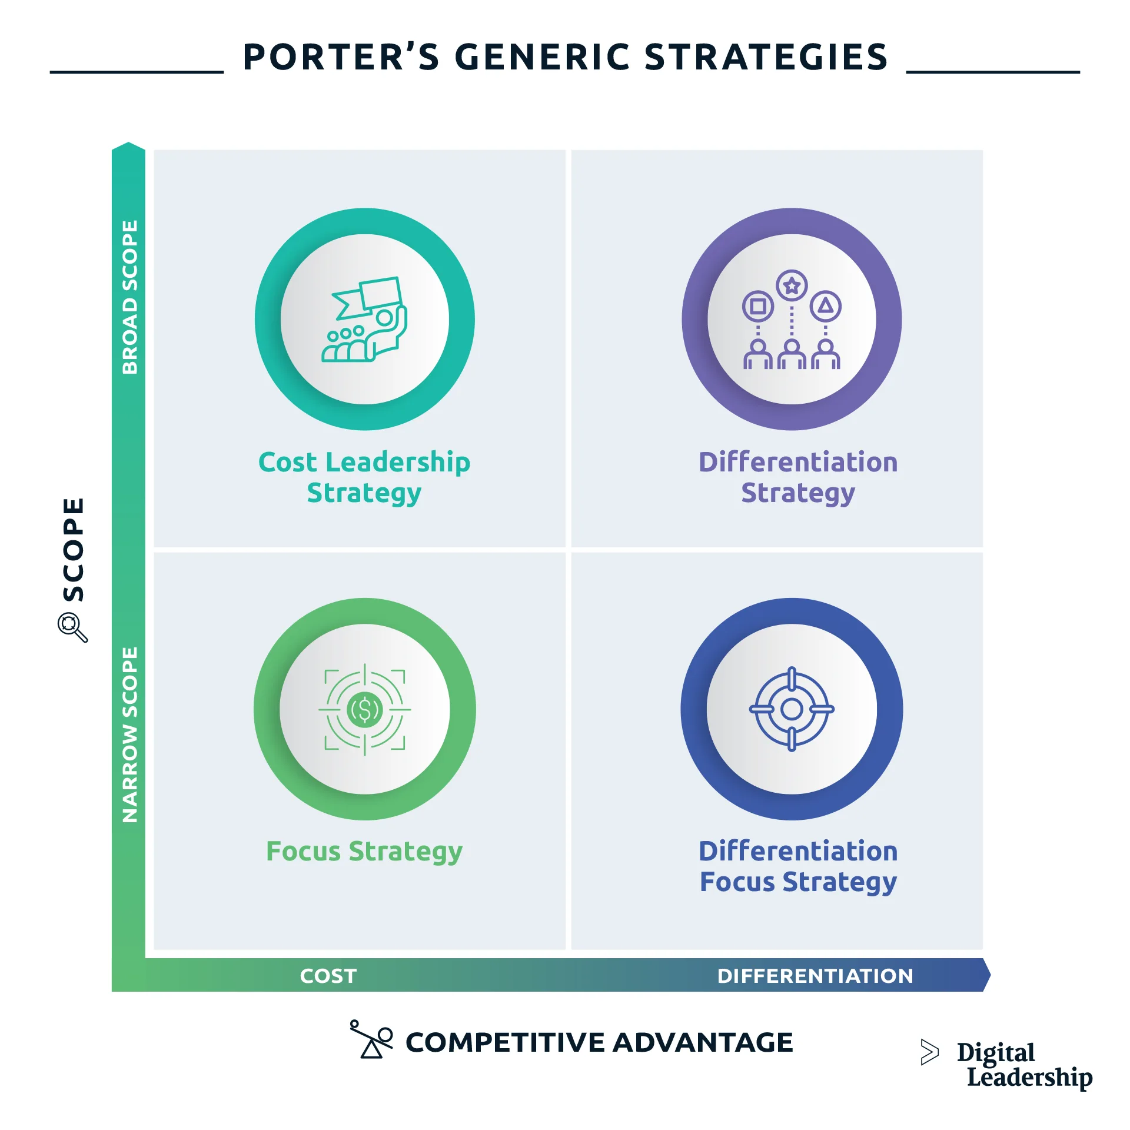
Figure: Porter's Generic Strategies diagram cost leadership differentiation focus
(Source: Di Stefano et al., 2024)

3.4 Competitive Advantage Through Sustainability
Sustainability can be an excellent source of competitive advantage to Anglo American. Green branding programmes can be harnessed to communicate the company's environmental responsibility and sustainable practices.
This has a positive impact on corporate reputation and trust among stakeholders to improve performance in sustainability. Sustainable innovations are also a competitive positioning (Zrybnieva et al., 2025). The savings achieved in these areas of renewable energy, improved production techniques and the latest production technology in the environmental area improve performance and reduce environmental impacts. These programmes will support business to be resilient and compliant in the long-term. Another critical value added is customer value creation.
An indicator of the importance that organisations are seeing in adopting a pathway towards sustainability aims in their procurement processes is the inclusion of an increased amount of emphasis regarding the achieved mining products from supplier organisations on their sustainability pathway (Farhan, 2024). By using material that is responsibly sourced, Anglo American can develop customer relationships and be more attractive in the marketplace. In the long-term, sustainability programmes can help movement towards the market through time, if they choose a differentiating trajectory towards the market and meet the expectations of the stakeholders.

3.5 Strategic Recommendations
Recommendation 1: Scale up renewable energy facilities at mines (Alkaraan et al., 2024). This will enable us to reduce some of the carbon emissions, increase in operational efficiency and achieve sustainability for the longer run.
Recommendation 2: Encourage more research and development in minerals for renewable energy technologies. However, demand for products that are good for the environment is also steadily rising, creating a positive possibility to generate income and expand the markets.
Recommendation 3: Enhance strategies to engage, and communicate sustainability (Zioło et al., 2023). Cooperation and solid disclosure by private enterprises can build consumer and investor confidence, and bolster private companies' reputations.

4. Task 3: Critical Reflection on AI Usage

4.1 AI Tool Disclosure
This report does use Artificial Intelligence (AI) tools, especially ChatGPT, to complement the actual creation of the report. The primary application of the AI was as a tool to collect information, to organise reports, to give ideas, and begin content (Ulanov, 2024). AI identified six concepts: prioritized sustainability, marketing environments, strategic growth and competitive advantage that were prioritized in the mining industry. The technology made it possible to organize the information into logical components, which were linked into the expectations of the assessment.

4.2 Verification of AI Output
All output generated from AI tools has been checked, cross-checked and verified with academic research, business reports, industry publications and other reliable and quality business sources. This is because AI-generated content ought to be accurate, up to date, and unaffiliated with false claims (Gerged et al., 2023). Sustainability dates and facts from Anglo American's relevant sustainability reports and from peer reviewed academic sources were consulted to ensure key facts and strategic insights were accurate. As inconsistencies were noted, they were corrected on the basis of evidence which was credible.

4.3 Contribution Analysis
AI has been effective in brainstorming, summarising content, suggesting contents of a report and enhancing its organisation.
It provided a direction to marketing frameworks like the Ansoff Matrix and Porter's Generic Strategies, so that it could lay a stone to analyse (El Fallahi et al., 2023). The results were interpreted; critical appraisal of the environmental factors and development of recommendations were carried out independently and personally while the integration of the strategic theories in Anglo American was also completed independently and personally. Sources were used in a critical way to support arguments and strengthen conclusions in academic sources. Each report was the result of a critical analysis, evaluation of evidence and decision by a researcher.

4.4 Ethical and Professional Reflection
The use of AI has several benefits including efficiency, information accessibility, and aiding with the development of ideas. Such benefits can assist researchers to structure complex subjects and enhance productivity. The application of AI, however, presents several risks associated with it, such as misinformation, being biased, using it excessively, and even the likelihood of academic dishonesty (Alonso‐Martínez and González‐Álvarez, 2024). All work created using AI must be clearly marked and verified by the suitable software or services in order to keep academic honesty. AI can be used responsibly by using it as a resource for learning, rather than as a substitute for independent thinking and research.

5. Conclusion
The external marketing environment detected in which Anglo American operated was analysed and then two issues of strategic possibilities enabling Anglo American to discern sustainable business transformation were examined.
Analysis revealed that two factors namely the natural environment and the political-regulatory environment play an important role in organizational decision making. The scope of the impacts and opportunities on the climate landscape to the company are both resource scarcity and carbon reduction needs as well as environmental regulations. The results highlighted the importance of sustainability issues in terms of the businesses activity and strategy.

References
Zrybnieva, I., Burdyak, O., Venherova, O., Nosachenko, O. and Serhiienko, O., 2025. Sustainable Marketing within the Environmental Responsibility Context: Research and Communication Strategies for Businesses Growth. https://elar.tsatu.edu.ua/items/65f91107-b091-4805-9d3b-e5320cc0b8c0
Farhan, B.Y., 2024. Visionary leadership and innovative mindset for sustainable business development: Case studies and practical applications. Research in Globalization, 8, p.100219. https://www.sciencedirect.com/science/article/pii/S2590051X24000285
Alkaraan, F., Elmarzouky, M., Hussainey, K., Venkatesh, V.G., Shi, Y. and Gulko, N., 2024. Reinforcing green business strategies with Industry 4.0 and governance towards sustainability: Natural‐resource‐based view and dynamic capability. Business Strategy and the Environment, 33(4), pp.3588-3606. https://onlinelibrary.wiley.com/doi/abs/10.1002/bse.3665
Zioło, M., Bąk, I., Cheba, K., Filipiak, B.Z. and Spoz, A., 2023. Environmental, social, governance risk versus cooperation models between financial institutions and businesses. Sectoral approach and ESG risk analysis. Frontiers in Environmental Science, 10, p.1077947. https://www.frontiersin.org/journals/environmental-science/articles/10.3389/fenvs.2022.1077947/full
Ulanov, V.L., 2024. The need for the green economy factors in assessing the development and growth of Russian raw materials companies. Journal of Comprehensive Business Administration Research, 1(1), pp.19-26. https://ojs.bonviewpress.com/index.php/JCBAR/article/view/2237
Gerged, A.M., Salem, R. and Beddewela, E., 2023. How does transparency into global sustainability initiatives influence firm value? Insights from Anglo‐American countries. Business Strategy and the Environment, 32(7), pp.4519-4547. https://onlinelibrary.wiley.com/doi/abs/10.1002/bse.3379
El Fallahi, F., Ibenrissoul, A. and El Amri, A., 2023. Defining and measuring overall performance in emerging countries: A comprehensive financial perspective review. Financial Markets, Institutions and Risks, 7(3), pp.81-93. https://armgpublishing.com/journals/fmir/volume-7-issue-3/article-7/
Alonso‐Martínez, D. and González‐Álvarez, N., 2024. A bibliometric analysis of B Corps and sustainable business ecosystems. Corporate Social Responsibility and Environmental Management, 31(6), pp.6019-6043. https://onlinelibrary.wiley.com/doi/abs/10.1002/csr.2906
Dobija, D., Arena, C., Kozłowski, Ł., Krasodomska, J. and Godawska, J., 2023. Towards sustainable development: The role of directors' international orientation and their diversity for non‐financial disclosure. Corporate Social Responsibility and Environmental Management, 30(1), pp.66-90. https://onlinelibrary.wiley.com/doi/abs/10.1002/csr.2339
Blinova, E., Ponomarenko, T. and Knysh, V., 2022. Analyzing the concept of corporate sustainability in the context of sustainable business development in the mining sector with elements of circular economy. Sustainability, 14(13), p.8163. https://www.mdpi.com/2071-1050/14/13/8163
Grayson, D., Coulter, C. and Lee, M., 2022. The sustainable business handbook: a guide to becoming more innovative, resilient and successful. Kogan Page Publishers. https://books.google.com/books?hl=en&lr=&id=qeFZEAAAQBAJ&oi=fnd&pg=PP1&dq=Evaluating+the+External+Marketing+Environment+and+Growth+Strategies+of+Anglo+American+for+Sustainable+Business&ots=cykIegsnZe&sig=q5O6z_fEH398qkjNSPqikTg85l8
Rathobei, K.E., Ranängen, H. and Lindman, Å., 2024. Stakeholder integration in sustainable business models to enhance value delivery for a broader range of stakeholders. Business Strategy and the Environment, 33(4), pp.3687-3706. https://onlinelibrary.wiley.com/doi/abs/10.1002/bse.3651
Hampl, F. and Vágnerová Linnertová, D., 2025. How the interaction between board gender diversity and ESG shapes dividend policy. Corporate Social Responsibility and Environmental Management, 32(2), pp.2472-2490. https://www.sciencedirect.com/science/article/pii/S0301420723007651
Quaye, J.N.A., Halsall, J.P., Winful, E.C., Snowden, M., Opuni, F.F., Hyams-Ssekasi, D., Afriyie, E.O., Opoku-Asante, K., Ocloo, E.C. and Fairhurst, B., 2026. Social enterprises and the Sustainable Development Goals (SDGs): a means to an end. Environment, Development and Sustainability, 28(4), pp.9879-9908. https://link.springer.com/article/10.1007/s10668-024-05359-x
Kalyuzhna, N., Smutchak, Z., Chorna, N., Chornyi, R., Baldyniuk, O. and Chuba, R., 2023, May. Toolkit for multi-vector adaptation and development of corporate culture of international companies. In International Conference on Business and Technology (pp. 501-514). Cham: Springer Nature Switzerland. https://link.springer.com/chapter/10.1007/978-3-031-54009-7_45
Di Stefano, C., Fratocchi, L., Martínez‐Mora, C. and Merino, F., 2024. Manufacturing reshoring and sustainable development goals: A home versus host country perspective. Sustainable Development, 32(1), pp.863-875. https://onlinelibrary.wiley.com/doi/abs/10.1002/sd.2710

