Data Security and compliance
Josh Naylor
Student University of Wales Trinity St David, Swansea, Wales

Table of Contents
Introduction 1
Task 1 1
Part 1-Physical Security 1
Part 2 Intrusion Detection and Prevention systems, Other Security Tools 3
Task 2 6
Conclusion 9
Reference 10

Introduction
In this essay I will be writing about the Physical Security as it will explain the different security options. Next, I will talk about the intrusion Detection and Prevention systems, Other Security Tools, and the benefits of this. After that I will explain what it is like setting up a new information security unit.

Task 1

Part 1-Physical Security
There is lots of different ways of protecting your security on the software side of the device but not many people think of the problems it can face when you are in a physical security as you could have lots of different cause like fire, flood or theft as all of this can happen to you in real life but not many people think about it as you wouldn’t think a theft would happen to you. “While most of these are covered by insurance, physical security's prioritization of damage prevention avoids the time, money and resources lost because of these events.” [1]. There are three main frameworks too the physical framework as the first one is the access control, and this will only allow certain people into the build or facility you may have the computer on. “Access control encompasses the measures taken to limit exposure of certain assets to authorized personnel only.” [2]. You can easily limit the people coming in and out of the building as you can have key card readers on the doors as when employees or other staff want to come in, they will have to key cards in, and they will be allowed into the building this could also be very costly for the building as you would have to get on every single door. They have also down lots of research where they will put NFC chips just below the skin so they can open the door with their hand, and they will never lose card. This however will greater the chances of unwanted people coming into the building, other ways you could also prevent unwanted guests are things like fences, gates, and signs like “dogs will attack” as this can prevent criminals. The next main component is the surveillance, and this can be most of the best technology on the market as you can use it to identify the criminals that have stolen from you, or you can identify where a fire might have started from as this could be key evidence if you were to get robbed. When you are buying your camera system you can get closed circuit television (CCTV), or you can get open system but the most common is the closed system and that would be better as you can keep it on site, and you don’t have to have lots of wires going everywhere. “Threat actors who see a CCTV camera are less inclined to break in or vandalize a building out of fear of having their identity recorded” [3]. You can also add multiple of other devices that can be used for surveillance like patrol guards and heat sensors as this can help with prevention of theft. The heat sensor will know if someone is near the sensor, and it can be reported back to a central location on the site like an office. The last main component is the testing, this is properly the most important as you always need to test the system when you first install and probably every month or so as you can keep updating it as new technology comes in. You also need to keep testing the staff with different scenarios as they can become lazy, and they might not respond to an alert. This could be for a fire or a theft you need to keep testing them. “Regular basis to practice role assignments and responsibilities and minimize the likelihood of mistakes.” [4]. If you have very important computer or area you need to protect you will need a disaster recovery also known as a DR and they can be very helpful if there is ever something to go wrong like a natural disaster as you will need to know what to do so you don’t panic. This is the centre of the testing stag as it will have everything. The best way of checking if this is written is by using it as this is where the testing will help so you will know it will work when it comes time. If you are using the door key cards you can keep track of who is using the cards and they can be tracked by the security office so they will know where every is. This can also help as if anyone as their key cards stolen, they can see where they are being used and them stop them and cancel the card so they can’t use it.

When you have your business, you will need to make a risk-based approach as you sometimes need a bit more security than a normal house or somewhere they don’t keep much. As if the business haves a bit more risk to it they can invest in more security like the cameras and the key cards when you have a lot more staff. “If a business is particularly risk-averse -- such as a credit union or a restaurant -- it will opt to invest in a more expensive physical security system” [5]. if the if your business gets a risk approach, they will use a data analysis technique as this will be the best option to get the best technology for your business as you can’t have a too little of security but you can’t have too much as you don’t want to be over protective or it could be a bad investment as you would be worsting your money on security you don’t actually need.

You could set up your security system in a smart way as you could set it as some people are allowed in the room but some people aren’t as this will help with the different rooms you may have where staff aren’t allowed in the room so they can access it. There can could be something very important in the room like a computer or servers as only a few people can assess it. You could also have time limits as if someone needs access to the room for several hours you could have them gain access to the room and then after that time has passed, they can no longer access the room.

If you were to have your security set, you will need it in certain places as you could have all the security on one door. “They'll put all of the security in the front door; surveillance cameras, security guards, badge access, but what they don't focus on is the entire building of the whole.” [6] certain places. If you were to put all your eggs in one backet you would have to keep an eye on the rest of the builds and there can be weak spots everywhere and you will need an expert to analyse them so you can put better protection in place so nothing will happen to you. This could be very challenging as you will need to put more protection in other places than others as you may have a limit budget and you won’t want to have anything stolen. You may have a few places where you don’t need security like the gyms smoking areas and toilets as most of them are private areas, so you won’t need them.

Part 2 Intrusion Detection and Prevention systems, Other Security Tools
The intrusion detection systems (IDS) and the intrusion prevention systems. The IDS will “Signature-based detection compares signatures against observed events to identify possible incidents” [7]. This way is the simplest way of doing it as compares the activity that is currently using the string it will compare the operations to detect the incidents. It will also observe the data that is considered normal and then it will look against that normal data to the data that is flowing through to work out if there are any threats in the data so it can get rid of them. Both IDS and the IPS will identify the threats that will; be coming into the computer or server. Which they both will use their ability to stop the attack using the vulnerabilities of the device. As the device will have many vulnerabilities so they must block them trying to come through. They will both keep always watching your network and they will both identity any possible incidents they can also log information about the incidents so you will be able to see what I went wrong with it. While an attack is happened, they can identity the problem and stop the threat while doing that they can also gather the information you will need to stop the attack if you have another one next time. Therefore, the IPS, and IDS are in most organizations as they have become a very important part of the system. The IDS is responsible for “identifying attacks and techniques and is often deployed out of band in a listen-only mode” [8]. This is so is would be able to analyse the traffic and make the intrusion from the bad traffic. On the other hand, the IPS will deploy in the path of the traffic. This is so it must pass through it to get to the destination. It can be very helpful as nothing will get past as it is in the middle, so this is a very big benefit. If the IPS ever detects the virus or malicious traffic going through it will be automatically break the connection with the host and then drops the session so nothing will get past. This is very helpful as you will never get traffic going though if you break the connection and drop the traffic. They are ae both very good at protecting the network especially the IPS as it will monitor the traffic as I can take one of three actions the first is detect and log the traffic this is quite an easy approach as they as just trying to work it out. The second on is detect and block the traffic this is a bigger approach as you are completely blocking the traffic, but you aren’t getting any data back as you aren’t logging it. Then there is the last one which is properly the best one and the one most people will use as it is a combination of all of them as it will detect, log, and block the network as you will be able to get data back from it and it will also block the network in the process. The IPS is so good that it can even prevent DDoS or distributed denial of service. This is very hard task to do as DDoS are very hard to detect and get rid of, but the IPS can do it. It does have a draw back as you will need a certain software for to get rid of some of the more violent DDoS attacks. There is a lot more security that everyone should be using as the best one is the firewall as this is the standard for everything as it is the first line of defence against the virus and malware. The firewall will “filters both incoming and outgoing data. Users can also customize rules and policies based on their needs.” [9]. The firewall is the best tool for protecting yourself it basically a wall that will sit between the private network which is your computer or Wi-Fi and the public internet, so you don’t just get anything that tries to get in. The firewall is like a bouncer as a night club as you it will restrict you from coming in and then will let you out. The firewall has security rules on it so if the packet doesn’t below in your network it will get kicked out. You can either get a hardware firewall or you can get a software firewall but if you can it is best to get both ad you will never know what is about to happen.

The better the security you have on your devices the hard it is for the hackers to get into your personal information so while you are online you should be using a VPN a this will help you with securing your personal data. A VPN stands for virtual private network as this will encrypt you information have on the internet as it will basically hide your traffic for the people that want it. Every device can use a VPN from a smartphone to a computer and even as server as you can set a VPN in different countries as you could be in the UK, and you can set your location as in the USA. This can be helpful as if you want to watch content that is only available in the USA, you could watch it from your house in the UK. The VPN will encrypt your connection by sending it through a tunnel as it will go through the tunnel, and everyone will not be able to see it as it will be encrypted. “It includes VPN technology that uses strong ways to authenticate the user or device.” [10]. The best time to use the VPN in when you are in a public connection as with a public Wi-Fi there could be many viruses that you will know about it until it has already happened. The VPN will use a proxy server so hide your data that is how it will use all the servers around the world as the company you can getting the VPN from is using renting out the severs and you are just using them as a proxy server. They use the proxy server so no one can spy on you not even the owners of the server or the company you are using the VPN from. The VPN will give you an IP address that many people might be using so it will mask your location, and no one will know where it is coming from. The data is first passed from a proxy server and not to your ISP like it is normally doing. Then it will go to the destination so they will not know where is has come from and you can stay safe online. In the big picture you will have your device that you want to send a message or look at something on the internet and then you will sent that to the VPN client they will then mask that and put it into a tunnel and then passes through the ISP but while trying to get there many people have tried to look at it but they could because it is encrypted. After that it will end up in the final location where more people will try and look at it, but they couldn’t also it will pass through the VPN server which will send to the internet.

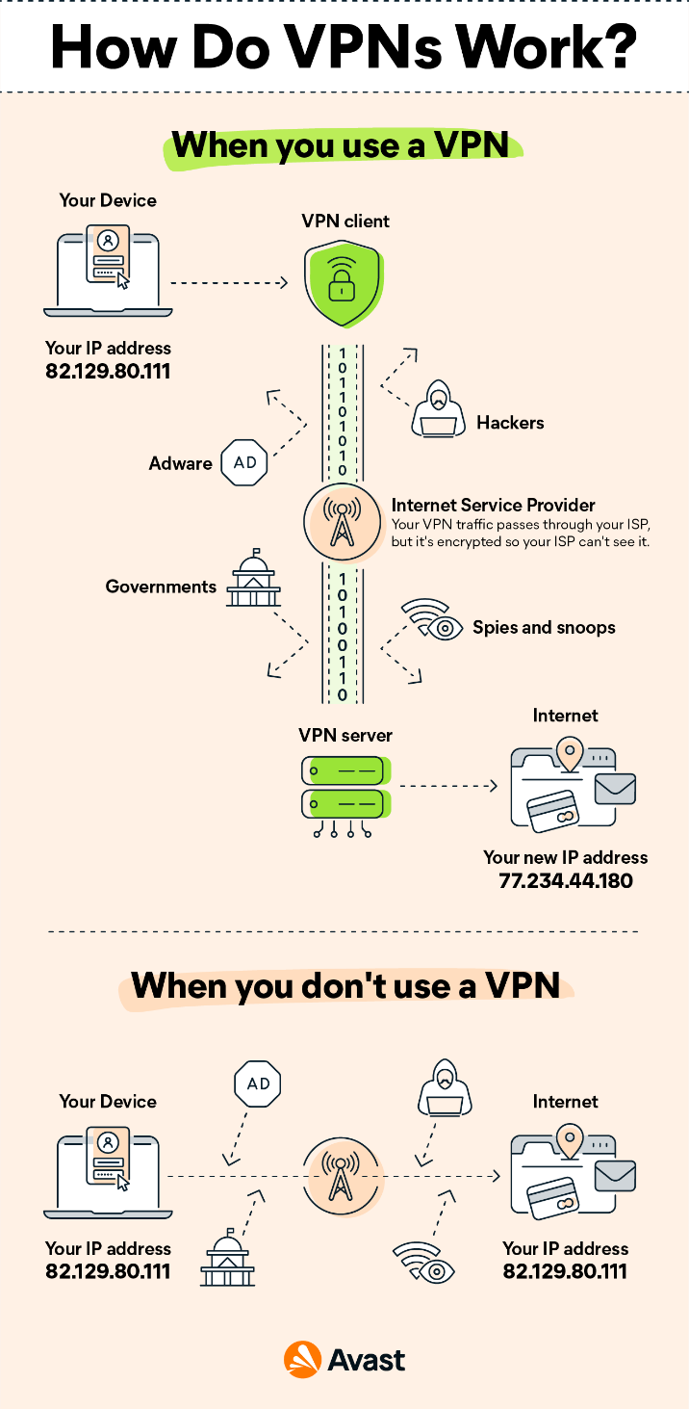
This is a chart showing how the VPN will work. This is from the Avast website:
[13]https://www.avast.com/c-what-is-a-vpn

Task 2

While setting up an information security unit maybe hard to do, I think I could do a good job as you know what tool you will need to set up the business. The first bit of the plan is the polices of the information as you will need to know where you information will be stored and what will be used for. It can “acts as a resource for employees, outlining how your organization stores, protects, and disseminates information, as well as expectations for employees.” [11]. You will need to have all the information sent to your employees as they will trust you more and you will keep your information safe for them. The most important part is all the employees will know what to do with the information as to keep the company safe from the threats from the outside world as you will need to keep the data safe from the different viruses they may have. You also don’t want any private information leaking before you may release it to the public.
The polices are:
- Protect the confidentiality and integrity of your data
- Minimize the risk of security breaches
- Plan for the digital security across your whole organization
- Help with the regulatory compliance
Policy is from Power DMS by Neogov
https://www.powerdms.com/policy-learning-center/how-to-develop-an-effective-information-security-policy

Theses polices will help with keeping the information safe from the outside threats and everything that they may come at the company. The first policy is you must protect the company’s data this will mean that you can’t share the data and sell the data. The next is the minimize the risk of breaches this means not getting virus on your computer, so they won’t be able to get the data. The next one is the digital security as they will need to use firewalls and VPNs to protect them self from the hackers. The final one is the regulatory compliance, and they will need to follow this to the law, and they could get arrested if they go out a share data that is for people sensitives information.

When I am setting up my information security unit (ISU) I will need tools for the online presence as they have lots of tools that will be needed to sell the services. You will need a way to recover the data if they wanted to have their data recovered they would of needed to have their data backed up to the cloud service that the company provides as if would be very hard if the data has been wiped from the computer so they will need there data back but they will need to be verified that it is them so you don’t give the wrong data to the wrong person. Another service would be customer state of compliance as if they were to use services, they will need to sure they aren’t going to ruin the system as they could add a virus to your server and that would be bad for your server. When you have the compliance, you need to follow the laws to the point as it is customers information you are messing with so it would be against the law to mess with it or sent it away to a third party to sell as many other companies must follow the law with the information. “The action taken to ensure a benefit customer gives the correct information” [12]. When using the information, you will have to be very careful as if you make one mistake you will be arrested. As more and more information are being processed online as everyone is bearing away from paper and all going online so there has to be rules in place to have the security of the information juts like if it was on paper as there would only be a few people that will be allowed to see the data. Another tool they may use will be when you start a new business you will need to do a risk management as you won’t know what you need to prepare for as you don’t want to have a very risky part and not know what it will fail. The first part of the risk management is assessing the customers risks as if they have a lot of risks in their own business you could have a big problem. The next is putting the risks in order as you will need to riskiest first and the one that is the least risky last as then you can prioritize them, so you know where you are at with all of it. When you have them in the order you will need to figure the risk profile as you if you were to put all the money in to the risky descions you have a higher chance of losing it all but if you were to put it in too the lowest risk you have a much lower chance of losing it. “Asset risk management is the process of managing the risk of loss associated with assets.” [14]. You need to make the money in a business so you will need to not too much in the risky asset, but this is where the services of the company can make their money as you can telling them about the risky assets in the business you can use the technology you have to make the monitor the assets so you will be able to tell them. The assets managers will use all the tools they have make sure your business in secure so you will never make a mistake they will have to thoroughly make the decisions to make a return on the customers assets. 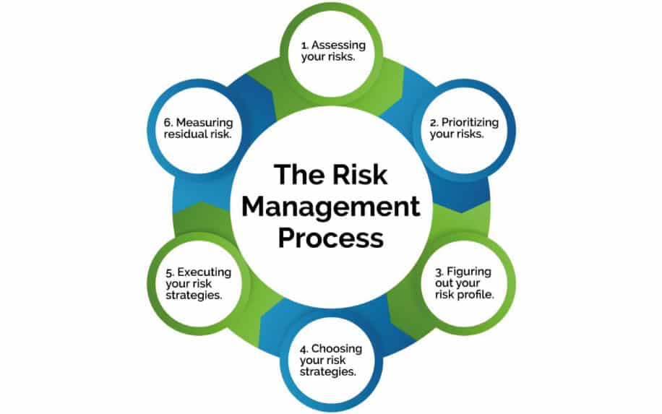
This is a diagram showing the order they will evaluate the risk of the assets. This has come from the website of: https://www.agilus.ai/what-are-the-5-types-of-risk-management/
[15]

In the new ISU you will need a protection mechanism which can help with the security of the system as the program will enforce the rights of where the user can go on the server as some people can’t get into different files. For every person in the office they will have different security levels to the company so when you will have the protection mechanism you can have different orders as the people at the bottom will have a much lower security level the staff at the top but the ISU will have to enforce it as staff will be promoted to other levels which will mean they will have to have a high level in the company so they need to see more. “Not all guests are created equal; some have full VIP access to the party while others are only permitted to attend in a more basic capacity” [16]. The computer admins will have the most power in the company even more than the CEO as they will be able to change the power of everyone’s levels. They will need to have a better security pass as they will be able to see everything, they will need a much deeper dive into the background and be always maintain as if they were to go rogue the whole of SwanTech would be in trouble as they would know all the secrets. The protection mechanism is very good tool in the business as you know people can’t get into official documents what if they didn’t have the software, it would be very impossible to make sure they didn’t go onto the computer and try and look at the important data.

Another service you have in the business is the business continuity as this can be a very good tool for a business as this kind of a plan B so if everything was to go wrong in the company you will need to know what to do so this plan will tell you. For instance, you get a fire in the office you could have this plan downloaded on a phone which all the managers would have and they would know what to do as if the fire has started in another room in the office than the server room you would have to depressurized the room so no one can get in and especially no fire can start in there and no fire can start in there. You will also need to make sure that the all the recent files have been backed up to a server in the backup location off site so you don’t lose any data that might be on the computers where the fire was started. As if there were a customer information on there you would be intitled to get in back for them as it would be your fault that you would have lost their data. There would be many other scenarios where a disaster would happen in the business continuity as they would need to be down in that event of the emergency. In your business you probably wouldn’t use the business continuity as they are very rare to use unless it could be something very little like an injury as you could use it for that. It could also be used for a very violent virus on the network as you would have to know how to handle it. There would only be a couple of people that would know what do to straight away as it could be very difficult to handle. the most common out of all of them would be a power outage as this would be very straight forward as you would just have to make sure the generators come on and if they don’t make sure you turn them on.

When you are running the cloud business you would need at the right tools have success as if you don’t have the right tools you will fail. You will need to the right storing data solutions like a lot of storage as you will need to hold all the data that the customer will give you. You can also give this too another provides like AWS, and you juts manage the outcomes as it can be very expensive to storage the data as you need a lot of room, and you don’t get back much at the end of it.

You also have the security governance as this will be the process of the cyberteams as they will be “responsible for mitigating business risks. Security governance leaders make the decisions that allow risks to be prioritized so that security efforts are focused on business priorities rather than their own” [17] this means they very given the role of mitigating identify business risks. They will need to do a very important bit as they need to make effects on the business that many ruin the company is they make the wrong one. They make the key elements of the plan as the core security functions and security objectives. They will need to have all the items in place to decide to impact the company as you can’t make the wrong decision.

You have a lot of services in the company so you will have a lot of people in the company so you will need a chart on who is in charge as if you need to talk to a supervisor you need to know. This could be the chain of command as if at any time the CEO needs to talk to the whole company, they would be able to talk to them all as it would take month to sit down with everyone and you would need everyone to be in most of them time. So, the easiest way would be to have a head of all the department to tell the head of each department so they can tell everyone in their own department so everyone will know in the end. In any business you need to have a structure as if you don’t it can all crumble as know body will know who to talk to and no work will get down as they have no one to look over the work that will be down.

Conclusion
I have talked about a lot in this paper on what the main securities of the physical systems like a how you need to be safe on the computer and in real life as they can both be very harmful you other all. I have also done a case where I have gone into depth on how to set up a business which will have a new Information security unit which will be able to have the right set of tools you will need the job as you will need a lot of different tools to have a for the different services they run in the business.

Reference

[1], [2], [3], [4], [5]
C. Michael, “Mr,” Apr. 2021. https://www.techtarget.com/searchsecurity/definition/physical-security.

[6]
S. Dan, “Mr,” Aug. 04, 2021. https://www.csoonline.com/article/3324614/what-is-physical-security-how-to-keep-your-facilities-and-devices-safe-from-on-site-attackers.html.

[7], [8]
“Mr,” 2022. https://www.juniper.net/gb/en/research-topics/what-is-ids-ips.html.

[9]
S.-H. Derick, “Mr,” Feb. 15, 2018. https://blog.devolutions.net/2018/02/4-types-of-security-tools-that-everyone-should-be-using/.

[10]
“Mr,” 2022. https://www.cisco.com/c/en/us/products/security/vpn-endpoint-security-clients/what-is-vpn.html#~how-a-vpn-works.

[11]
“Mr,” Dec. 23, 2020. https://www.powerdms.com/policy-learning-center/how-to-develop-an-effective-information-security-policy.

[12]
“Mr,” [Online]. Available: https://www.whatdotheyknow.com/request/76479/response/194086/attach/2/01%20Overview%20of%20Customer%20Compliance%20FRAIMS%202.pdf?cookie_passthrough=1.

[14]
“Mr,” 2021, [Online]. Available: https://www.agilus.ai/contact-us/.

[16]
T. S. Adams, “Mr,” Nov. 18, 2022. https://www.easytechjunkie.com/what-is-a-protection-mechanism.htm.

marking criteria and Student FEEDBACK

This section details the assessment criteria. The extent to which these are demonstrated by you determines your mark. The marks available for each criterion are shown. Lecturers will use the space provided to comment on the achievement of the task(s), including those areas in which you have performed well and areas that would benefit from development/improvement.

Common Assessment Criteria Applied (Assignment 1) | Marks available | Marks  awarded
1. Engagement with Literature Skills
Extent of research and/or own reading, selection of credible sources, application of appropriate referencing conventions.
While there is evidence that you have done some research, you have used all websites. Your references are lacking creditable peer reviewed articles. Use credible sources; academic journals are normally highly credible sources while websites require careful consideration/selection and should be used sparingly. Utilise the university online resources and journals from the library site. (Grade mark: 45.00%) | 20 | 9
2. Knowledge and Understanding Skills
Extent of knowledge and understanding of concepts and underlying principles associated with the discipline.
To showcase your knowledge and understanding try to incorporate more critical appraisal of the literature. See comment above to improve this area. | 10 | 4
3. Cognitive and Intellectual Skills
Analysis, evaluation and synthesis; logic, argument and judgement; analytical reflection; organisation of ideas and evidence
You have done task 1. Your introduction and your conclusion need improvement. Your introduction should give a background to the work along with some general research information of the subject areas preferable from peer reviewed articles to enhances your work. Your conclusion should summarize your key areas of the report. You have explained the case study but need to link your discussion to it. Your discussion was more generic than focus. You need to demonstrate your knowledge and understanding of the case study. | 25 | 12
4. Practical Application Skills
Deployment of methods, materials, tools and techniques; application of concepts; formulation of innovative and creative solutions to solve problems.
You have not designed your own approach (diagrams, tables, charts and any other design methods utilise that will enhance marks). You only use the existing diagrams and content. | 25 | 10
5. Transferable Skills for Life and Professional Practice
Attributes in professional practice: individual and collaborative working; deployment of appropriate media; presentation and organisation.
You need to have your cover page separate. You have not used the IEEE report format for at least task 1. Your work needs formatting and consistency; various font, cut and paste information not formatted. There are typo and grammatical errors; all acronyms need to be spelt out first time use, for academic work first person tense must not be used unless you are doing a piece of reflective work and you should not use contraction grammar. | 20 | 8
Assignment Mark (Assessment marks are subject to ratification at the Exam Board. These comments and marks are to give feedback on module work and are for guidance only until they are confirmed. ) | Late Submission Penalties (tick if appropriate) |  | 43%
 | Up to four weeks late |  | 43%
 | First Attempt? |  | 43%

