Appendix 1


Figure 1.0

Contents
Management Summary 4
Introduction 6
Initial Potential Project Problems 7
Problem – Prolonged & Overcomplicated Hotplate Changeovers 9
Project Charter: Prolonged & Overcomplicated Hotplate Changeovers 9
Pros and Cons of Pursuing Issue 10
Evaluation of 12
3 – Feasibility Study 12
Problem: 12
Design Brief and Product Design Specification 14
Product Design Specification For Solution Of Chosen Maintainability Problem 16
How was the PDS influenced by the customer brief? 19
How does the PDS compare to the industry standard PDS BS7373? 19
Further Investigation and Data Collection Of A Chosen Problem 22
Project Charter Review 25
Project Charter: Prolonged & Overcomplicated Hotplate Changeovers 25
Initial Gantt Chart 27
Design & Planning Summary 30
3 Potential Solutions To The Maintainability Problem 32
1 – Universal Hotplate Changeover Procedure & Teflon Roll Clamping System 32
2 – Pre-Heat Stations Dedicated To Each Welder 34
3 – Automated Changeover Process 36
Evaluation Of 3 Potential Solutions To The Problem 38
1 – Universal Hotplate Changeover Procedure & Teflon Roll Clamping System 38
2 – Pre-Heat Stations Dedicated To Each Welder 41
3 – Automated Changeover Process 44
Conclusion Of Best Solution To The Problem 47
Project Scope 49
Project Implementation: 51
Finalising the Design of the Modification 51
Production Surveys 62
Selection of Pilot Hotplate Welder 64
Gaining Quotation & Budget Code 66
Universal Hotplate System Implementation 67
Universal Hotplates Changeover Training and Production Sign-off 70
Interim Gantt Chart 71
Project Control Plan - Monitoring New System 72
Further Modifications required to optimise/fine tune tooling before Roll-out 73
Impact of the solution 75
Project Development Summary 76
Impact of Product Design Specification on Project 78
The Role of a Product Design Specification 78
Design Solution Assessment/Evaluation 80
Does this solution have a positive impact on Maintainability? 82
Conclusion 83
Final Gantt Chart 84
Evaluation 85
Overall Project Evaluation 89
Maintainability Project Presentation 90
Types of Communication methods available when delivering a presentation 90
Presentation Performance Reflection 90
Overall project feedback from assessor 91
Lessons Learned 92
Reference 94
Figure 1 94
Figures 2, 3 & 4 94
All Other Figures 94
Appendices 95
Appendices 1 95
Appendices 2 96
Appendices 3 97
Appendices 4 98
Appendices 5 99
Appendices 6 100
Appendices 7 101
Appendices 8 102
Appendices 9 103

Management Summary
The drive behind this project was the companies focus on improving the maintainability of a given task that consumes a large amount of technicians time during day to day activities. After initial brainstorming and investigation activities took place the team highlighted the huge amount of time overcomplicated and non-standardised hotplate changeovers take and how much scrap was produced due to the wear of the old plates. This was a large concern for the company due to the increased workload of technicians and the amount of lost productivity created by this issue, which had been festering for years.
A great deal of cost had been incurred over the years due to downtime and maintenance technicians availability, with a large amount of KHE’s production line being the welded container assembly lines. It was defined as a critical task to heavily reduce downtime and simplify technicians roles in order to free them up to deal with other breakdown issues whilst improving standardisation and critical spares stock.
The Manufacturing Engineering team were tasked with implementing a control measure for this problem. Lots of time and resources were invested into the testing and development of the chosen solution. The chosen solution was the Universal Hotplate and Teflon Clamping System. This system can be quickly retrofitted across all hotplate welder systems within the business and can be rolled out globally if required. This solution heavily reduces workload and simplifies tasks which enables technicians to complete changeover operations much faster and heavily reduces the waste created in materials, time and movement.
The cost of this countermeasure was initially targeted to be around £2500 per machine, this target was successfully achieved and brought under budget by communicating our needs to the Tool Maker who designed and manufactured the specified modification and fitted it at a cost of just over £1600 per modification which is nearly half of the targeted amount and is a huge plus for the team as a cost saving occurred. This price will be the same for all future Hotplate welder modifications at the present time but many areas for costs to be driven down in the future have been highlighted and will be pursued going forward.
When comparing this cost to the costs incurred from the most recent customer driven complaint, this solutions payback time would be within a very short period of 3.76 months from when the solution is implemented.
This project was an overall great success with very good time management from all members of the team. From the structured approach the team were able to bring the initial project to completion 4 weeks ahead of the targeted end date which allowed extra resource/labour to be freed up within the plant and assist in other matters. It is now felt by all parties that this will prove to be a very robust counter measure that can be implemented on all other welders and also new projects to ensure customer satisfaction and assurance that all parts are produced correctly and supplied at the highest standard and maintaining the newly set conditions for all technicians.

Introduction
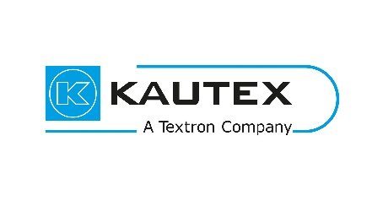
Kautex Textron CVS LTD is a multinational company, which specialise in clear vision systems. These are windscreen wash systems, camera cleaning systems and headlamp wash systems for the automotive industry. As a business Kautex Textron CVS Ltd have been coming under an increasing amount of pressure in improving all aspects of HSE, Improving SMED and Reducing Maintenance Technician workload by improving production processes.
Figure 2
Hengoed Plant:

Hengoed is the global Head Quarters for CVS division within Kautex with 5 other International Plants creating all of the systems mentioned above with combinations of manual assembly, Blow Moulding, Injection Moulding and Corrugated Extrusion.
Figure 3
CVS System:
The CVS System consist of:
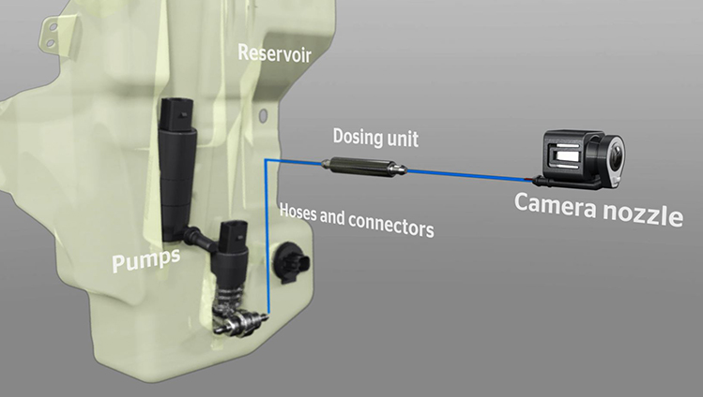
Reservoir – Holds the Wash fluid.
Figure 4
Low Level Sensor – Alerts the driver when the wash fluid is at a low level and needs replenishment.
Hose & Connectors – Carries the fluid to the situated CVS Dispenser mounted to the car.
The Dispenser – Spray the required area to clean.

Initial Potential Project Problems
In order to correctly select and maximise the benefit of a potential process improvement within the maintainability aspects of manufacturing, it was decided that the first step would be to conduct a team brainstorming activity between the Manufacturing Engineering and Maintenance Departments. This allowed all members of both teams to have their input as to what their biggest issues are during their day-to-day shifts and highlight potential issues which have been previously overlooked, for further investigation. The outcome of the exercise (Arranged and Led by William Davies) was as follow.

Problem – Prolonged & Overcomplicated Hotplate Changeovers

Project Charter: Prolonged & Overcomplicated Hotplate Changeovers
Process Name & Purpose:  Container area hotplate changeovers when changing product variant and/or when Teflon sheeting breaks and quality of weld is put at risk. | Process Owner:  Joshua Swift & William Davies
Workshop Leader:
David Kristek – Focus Factory 2 Production Manager.
Process Boundaries:  Welded Container Assembly Section  Starting Point:  Teflon sheeting failure/variant changeover.  Ending Point:  Teflon sheeting failure/variant changeover. | Team Members:  Operators, Stephen Mills, David Kristek, Rhys Lewis, Maintenance Technicians, Operator Technicians, Lee Stinton, Packham Engineering.
Process Sponsor:  David Kristek  Stephen Mills | Process Sponsor Expectations:  Stephen Mills & David Kristek would expect:  - At a minimum of halving downtime due to hotplate changeovers.  - Simplification of changeover procedure.  - Reduction in machine downtime.  - Standardisation of the process.  - Improvements in maintenance spares.  - Increased productivity and throughput/output.
Resource Team:
Operators
Stephen Mills
Joshua Swift
David Kristek
Rhys Lewis
Maintenance technicians
Stakeholders:
David Kristek, Rhys lewis, Stephen Mills, William Davies, Wayne Palmer, Joshua Swift.

A large issue faced by Maintenance & Operations Technicians Teams are the volumes of overcomplicated and long changeovers of product-specific hotplates and renewal of non-stock Teflon sheeting when it breaks away. When these changeovers are required the technicians have to down-tools and deal with the issues as these lines are the most critical in the factory and downtime comes at a high premium. Due to the fact that these changeovers are so overcomplicated and lacking in the correct equipment means that every time they have to be conducted there is a huge amount of time and materials wasted.
Budget Code for solving this problem - £2500 per welder (7 welders).

Pros and Cons of Pursuing Issue
Pros | Cons
Huge scope for improvement. | Could be costly.
Relieves technicians time and resources to focus on other issues. | Large project to be undertaken.
Has the potential to SMED.
Has the potential to improve safety aspects of changeover.
Potentially improves overall machine made piece part spares storage.
Potentially improves machine cell output by minimising downtime.

Evaluation of
Problem/Solution Selection Matrix
Project Name: Prolonged & Overcomplicated Hotplate Changeovers
Project Manager: William Davies |  |  |  |  |  |  |  |  | Date: 10/12/2020
 |  |  | Selection Criteria
 |  |  | Low Effort | High Impact | Acceptable Cost | Acceptable Time | Acceptable Risk | Resources Available | Cultural Acceptance | Addresses Root Cause
Weight |  |  | 3 | 9 | 8 | 8 | 9 | 9 | 9 | 9 | Total Score | Implement (Y or N)
Output (y) CTC | Root Cause | Potential Solution | 1 = No, 5 =Somewhat, 9 = Yes |  |  |  |  |  |  |  | Total Score | Implement (Y or N)
Yes | Poor Implementation | Simplifying system | 3 | 9 | 8 | 8 | 9 | 9 | 9 | 9 | 64 | Y

3 – Feasibility Study

Problem:
Technical – With the technical skillset mentioned above Kautex would have the resources to overcome this issue up until the design phase, any modifications made to the tooling/machine would have to be out-sourced to our sub-contracted tool-makers.
Economic – Due to the fact that this issue has been given a reasonably generous budget there should be no issues whatsoever in producing a robust and reliable solution to overcome it, when looking back on other large project undertaken within the business and brief communications with the tool maker around this potential project no issue were seen.
Legal – Due to the fact that any modifications undertaken would be on our internally designed system there would be no legal issues with CE marking or warranty of machinery. Any changes made would be hoped to improve compliance and increase safety.
Operational – If this project were to go ahead the team would firstly target the lowest running welder to prove out the concept generated before rolling out to other welders. This implementation would require up to 1.5days downtime to make substantial changes to machinery.
Scheduling – The team feel that this task could be easily achieved within the allocated timescale as the support system is in place but we would only target the pilot welder, prove this out and roll-out in future months.

Design Brief and Product Design Specification

Client Company:
Kautex Textron CVS LTD.
3 Alder Avenue Dyffryn Business Park Ystrad Mynach
Hengoed UK-CF82 7TW
www.kautex.com
Office: 01443621851
Fax: 44-14-4362-1940
Email: Stephen.mills@kautex.textron.com
Designers:
William David Davies
Problem Statement:
A large issue faced by Maintenance & Operations Technicians Teams are the volumes of overcomplicated and long changeovers of product-specific hotplates and renewal of non-stock Teflon sheeting when it breaks away. When these changeovers are required the technicians have to down-tools and deal with the issues as these lines are the most critical in the factory and downtime comes at a high premium. Due to the fact that these changeovers are so overcomplicated and lacking in the correct equipment means that every time they have to be conducted there is a huge amount of time and materials wasted.
Design statement:
Any modifications to process or machinery must have a positive impact in the reduction of changeover cycle times as well as simplifying the technicians rolls. The modification must comply with all HSE guidelines in relation to manual handling with no effects on machine functionality and performance. The modifications undertaken must be rolled out across all hotplate welders within the facility.
Target Market:
The modifications to process and equipment will be aimed at heavily reducing Maintenance and Process Technicians workload and simplifying one of their major daily tasks. By halving the changeover times it will also have a positive impact on output
Constraints:
- The new system must be easily rolled out across all 7 welders as a standard.
- The solution must not increase machine cell footprint.
- The solution must not exceed 1 tonne in weight.
- The solution must not exceed £2500 per welder.
- The pilot welder selected must be complete and optimised before the 06/2021.

Assumptions:
- The new system will have a 50% impact on hotplate changeover time.
- The system will be rolled out across 2 welders within the project timeline.
- At least 2 modifications will have to be undertaken to fine tune the system.

Product Design Specification For Solution Of Chosen Maintainability Problem
- Performance/Functionality
1.1 The desired solution to the issue must have a 50% reduction impact on changeover cycle times without further complicating the process and overall simplifying it.
- Reliability
  - The solution must be able to be fully functional 100% of the time and allow a smooth changeover process to occur and not deviate from the desired/set cycle time.
- Operational Conditions
  - The solution must not affect that machine manufacturing functionality or hinder operations in anyway.
  - No negative effect on welding cycle time.
- Scale of Operations
  - The solution will be rolled out across all 7 hotplate welder systems within KHE (Kautex Hengoed) within a 2 year timeframe.
  - 1 Pilot Welder Implementation Within initial project scope.
- Maintenance
  - The solution will have a significant impact on the daily maintenance processes required with the Hotplate Welder systems.
  - It must simplify changeover processes to free up maintenance technicians time elsewhere.
- Cost
  - The solution manufacture and implementation process costs cannot exceed the sum of £2500 per Hotplate Welder System.
  - System Maintenance costs must also be under £200 per annum.
- Aesthetics
  - If tangible, the solution must be manufactured from high grade materials and hard wearing materials.
  - The must be resistant to temperatures in excess of 200 degrees centigrade i.e. Steel, Aluminium with a high durability rating.
- Ergonomics
  - The solution must not have any adverse affects on cycle times or ease of tooling use.
  - Must be easily transported by hand (if necessary/required).
- Size/Weight Restrictions
  - My solution must not have any impact on the hotplate welder cell footprint.
  - Must not weigh more than 1 tonne in order to be within our MPLW lifting/rigging machines capabilities.
  - Complying regulations with PUWER regulations.
- Capacity
10.1The solution must ensure that 100% of changeover procedures are repeatable and a set process, it must be flexible enough to cover all welders in a standardised format.
- HSE
11.1The solution must not have any sharp corners or edges.
11.2 Must be protected and incorporate heat safe PPE/insulation.
11.3 If autonomous must be in compliance with all safety standards and run off of maximum 240 Volts and 6 Bar pneumatic pressure.
11.4 Must not exceed a 1 person lift <25KG.
- Legislation
12.1The solution must be in compliance with the Textrons manual tooling handbook and global legislations:
- Rula Recognised Standard.
- Kim Recognised Standard.
- Approved code practice of temperatures.
- Lifting Operations and Lifting Equipment Regulation 1988.
- Any modifications must not affect parts compliance with ISO 9001.
- Installation
13.1The solutions installation onto the production machinery lines will require no more than 2 Shifts (16 hours) operations downtime.
13.2 Will require no more than 3 employees:
- Supervising engineer.
- Operations technician.
- Maintenance Technician.
13.3The solution will require all changeover documentation to be updated in order to reflect the updated process implemented.
13.4It will also require a full company risk assessment to be completed prior to installation due to non-standard working practices being undertaken.
Disposal
15.1The solution must be easily decommissioned if required and not contain any harmful/non-disposable materials which would require specialists involvement.
Environmental Impact
15.1The solution must be manufactured from 80% recyclable and sustainably sourced materials to ensure that when it comes to the end of its life cycle the environmental impact is minimal.
Customer Requirements
16.1The solution will have no direct impact to the customer.

How was the PDS influenced by the customer brief?
Before creating the PDS the team reviewed the customer brief. Before any form of PDS is created it is essential to refer back to the customer brief in order to correctly capture all of their needs and points.
All product design specifications are initiated by a customer brief with the aim of meeting each and every point raised on said brief. The brief describes exactly what the issue is and gives details of the overall target of the project.
This is why all points stated in the brief are included within the PDS along with other detailed elements, which would ensure that the brief is met in compliance with all industry standards and regulations.
The team concluded that all points on covered in the specification would ensure that all customer design brief specifications were achieved to ensure full customer satisfaction.

How does the PDS compare to the industry standard PDS BS7373?

When creating the PDS for this particular project the team used the BS7373 as a standard template to build on. As can be seen when comparing the standard against this projects brief, there are many similarities. These include:
Format:
The standard numbering format has been carried over into the teams PDS which is similar to the standard. The team felt this was a good aspect and allows the specification to be easily classified into each section. It also allows improved traceability of each criteria point and gives the specification structure.
Key Criteria Points:
Nearly all of the PDS’ criteria points tie in with the global standards, examples of these are:
- Cost – This was a huge factor for the team and would be for any business project. All project inevitably come down to cost and if the benefits of the projects out weight the initial cost of completing it. In this case the cost was very important due to the fact the maintenance manager has allocated a certain portion of his yearly budget and expected payback within a reasonable timescale.
- Regulations and standards – similar to the example given in the standard, the team put a significant amount of detail to ensure that all company and industry standards were met in order to be fully compliant and ensure that the system was safe and fit for purpose.
- Health and safety – it was essential that the teams PDS covered all necessary HSE guideline points in detail to ensure that the system was safe for use. Throughout any project undertaken the safety of the employees or anyone exposed to the machineries safety should always be the main priority.
- Transport/Size/weight restrictions – due to the nature of the task it was essential that size and weight restrictions were included in the PDS. This was to ensure that any system implemented could be safely handled at all times.
- Supporting systems – this was seen as a critical point for the team due to the fact that Kautex have restricted facilities which would require huge overhaul if any deviations were required. This would mean that the budget would be consumed on unnecessary additions.
All of these criteria points were decided to be essential when the team were creating the PDS in order to fully meet the design brief and comply with government/industry standards.

However, each PDS is unique to the customer design brief and changes in order to meet every point. This was exactly the reasoning behind some further additions outside of the standard format.
Although all generalised points were covered in the standard format the team went into more specific depth of what was require and gave specific measurables, an example of this would be the exact temperature required of the tooling even down to the company specific legislations it must comply with.
The example template also covers a larger range of points under each section to be able to cover all functions whereas the team only included the required points to ensure the exact customer driven goal was achieved and only the required aspects of the improvement was included to reduce costs and implementation time.

Further Investigation and Data Collection Of A Chosen Problem
Hotplate Welder Changeover Process Standard Operating Procedure
(Appendices 1)
When analysis was undertaken into this particular process step, it was clearly seen that there are a large number of issues and potentials for improvement within the process, these include:
- The large number of bolts, which need to be completely undone before being able to remove the superseded hotplate. And visa versa when fitting the new one.
- Gaining access to the hotplates by firstly having to completely undo the bolts holding the Teflon sheet clamp.
- The use of a bottle jack to correctly locate the bottom plate.
- Some hotplates being outside of Kautex standards by not being Teflon coated.
- The long periods of time that it takes for the new plates to warm up before being ready to use.
- The significant amount of time the technician needs to be within the body of the machine and possibly injuring themselves with risks of scalding and entrapment.
- The awkwardness of trying to control and retain tension of the Teflon sheet when replenishing it (Muscular skeletal injury issue and repetitive strain injury).
- The amount of Teflon sheet material wasted during the process when trying to tension it.
- The amount of time wasted by technicians by awkward processes and techniques being utilised.
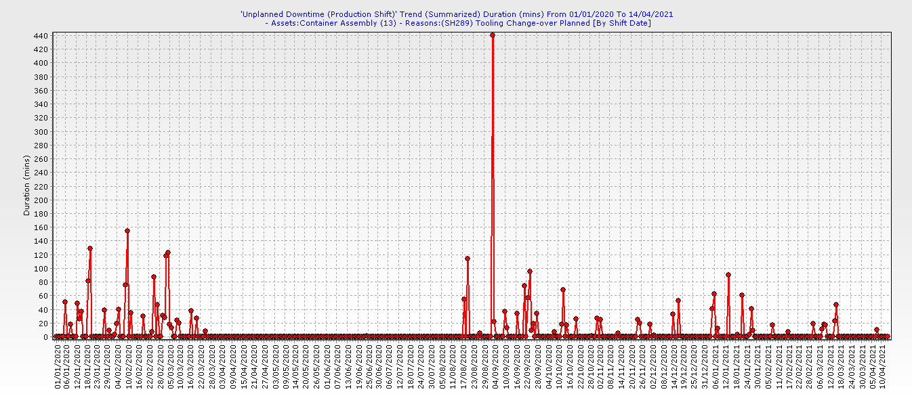
Hotplate Welder Changeover Process Average Changeover Times Effect On Production Downtime
Figure 5
Technician Comments when asked “How do you feel about the current hotplate changeover process?”
Technician 1 – “The process is far too complicated for the amount of time allocated for the changeovers and my time could be far better utilised elsewhere in the factory by maintaining machines and reacting to breakdowns.”
Technician 2 – “There has been several occasions where I have been pressurised to hurry up with the changeover process and missed steps under the pressure, when rushing we are also seriously increasing the risk of injury due to it being a one man operation.”
Technician 3 – “There is huge amounts of scope for improvements in this process, the worst parts about it for me is the shear amount of bolts that need to be completely removed from the tooling before being able to make the change.”
Technician 4 – “Once trained it is an easy but long winded process to undertake, I think we could easily pass this roll onto the operators of the machines if the process was further simplified and the correct training was provided. But that Teflon sheeting is a real pain and we waste huge amounts of it trying to achieve the correct tension.”
Technician 5 – “The time constraints we are under are far too much and will eventually result in an injury due to the natural of the job and the techniques that are trained out. The main things that slow us down are all of the bolts, having to position the bottle jack under the carriage, the Teflon sheeting tensioning and waiting for the plates to warm up.”
Production Group and Team Leaders Comments when asked “How do you feel about the current hotplate changeover process?”
Group Leader – “It takes far too long and the boys always run over which heavily effects the sections overall performance due to unplanned downtime, they are always complaining about not having enough time and it would be of huge benefit if they could be freed up to deal with other issues which also have effect on overall performance and the section being able to meet deliveries each week.”
Team Leader 1 – “I feel that the boys time could be far better utilised elsewhere and them continuously overrunning and the amount of waste created is a large problem which needs to be addressed, surely this process could be automated.”
Team Leader 2 – “I completely understand the lads frustration with the process and the time constraints which they are under and it seems to be that we are always playing catch-up after changeovers due to the huge amount of the day they take up.”

Project Charter Review

Project Charter: Prolonged & Overcomplicated Hotplate Changeovers
Process Name & Purpose:  Container area hotplate changeovers when changing product variant and/or when Teflon sheeting breaks and quality of weld is put at risk. | Process Owner:  Joshua Swift & William Davies
Workshop Leader:
David Kristek – Focus Factory 2 Production Manager.
Process Boundaries:  Welded Container Assembly Section  Starting Point:  Teflon sheeting failure/variant changeover.  Ending Point:  Teflon sheeting failure/variant changeover. | Team Members:  Operators, Stephen Mills, David Kristek, Rhys Lewis, Maintenance Technicians, Operator Technicians, Lee Stinton, Packham Engineering.
Process Sponsor:  David Kristek  Stephen Mills | Process Sponsor Expectations:  Stephen Mills & David Kristek would expect:  - At a minimum of halving downtime due to hotplate changeovers.  - Simplification of changeover procedure.  - Reduction in machine downtime.  - Standardisation of the process.  - Improvements in maintenance spares.  - Increased productivity and throughput/output.
Resource Team:
Operators
Stephen Mills
Joshua Swift
David Kristek
Rhys Lewis
Maintenance technicians
Stakeholders:
David Kristek, Rhys lewis, Stephen Mills, William Davies, Wayne Palmer, Joshua Swift.

With the problem area now selected and further work undertaken by the team, it was decided to review the initial project charter to ensure it was relevant and detailed enough to be carried forward as the project progressed.
The teams review concluded that the work done initially when creating this charter was very in depth and had captured all of the necessary points to ensure it was still valid and detailed enough to be carried through onto the next phases of the project with no amendments required.

Initial Gantt Chart
(Appendices 2)
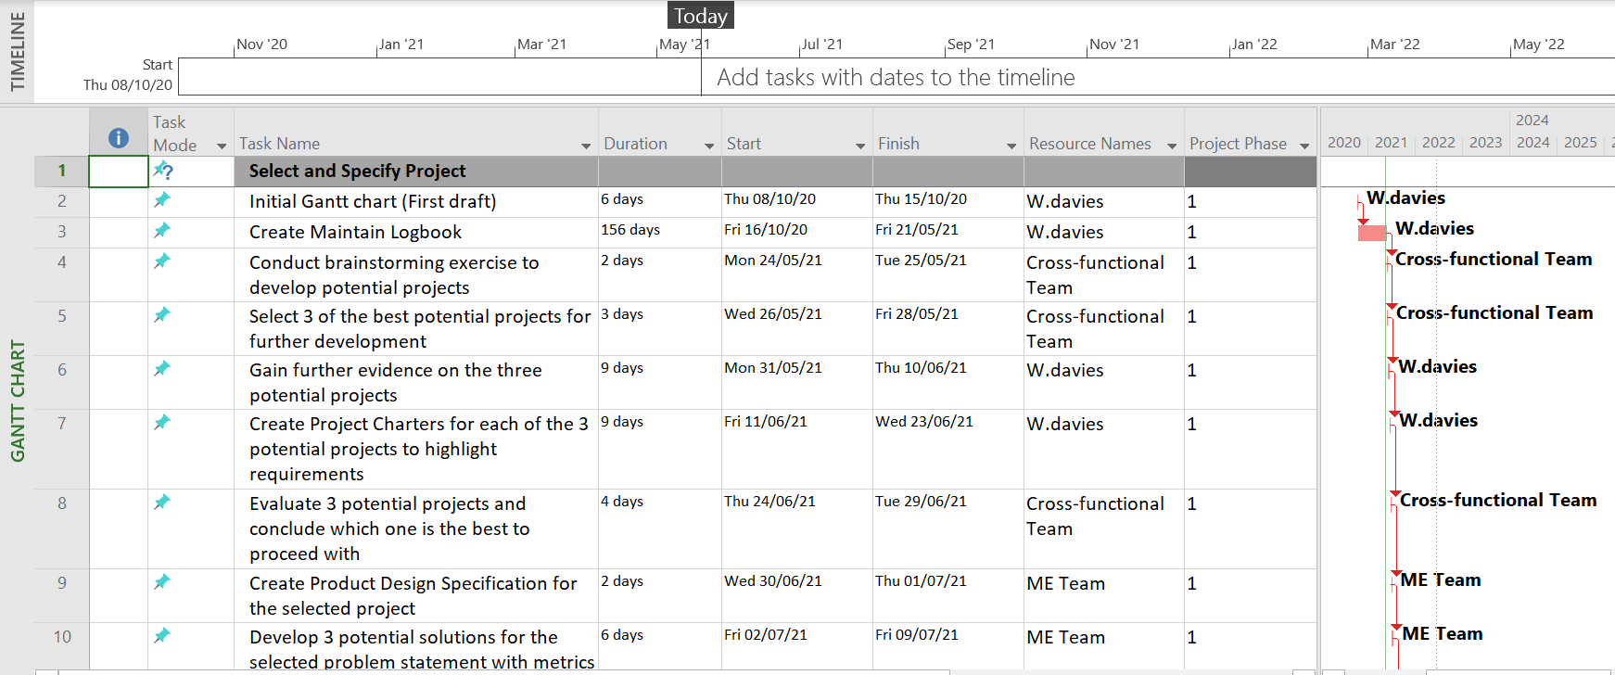
Figure 6
In simple terms a Gantt chart is a bar chart that provides a visual view of tasks scheduled over a period of time. They can be used for planning projects of all sizes and are very useful for showing scheduled works for a specific day and how each task leads on from the previous one. They easily show the start and end dates of a project in one simply formatted chart.
The most critical element of a Gantt chart is the defined Critical Path Analysis. As the team have shown in the initial project Gantt chart, the CPA highlights the critical tasks and their completion dates. Once the key tasks are mapped out with definitive dates it allows the project team to effectively plan out the expected project completion date. This method allowed the team to highlight critical tasks, which followed on for one another and showed the priority actions, which were vital for the overall completion of the project in a timely manner. When these tasks are prioritised it allows the team to fully focus on key dates without worrying too much about the actions which will not have a direct impact on the projects overall completion date.
One of the primary function that a CPA does is it allows the correct management of the project by highlighting key tasks and gives the project manager the ability to assign the correct individuals to ensure the task is completed correctly whilst putting the accountability on the task owner to complete the job on time.
When creating the Gantt chart the team decided to use the company standard Microsoft project Planner software. This was due to the fact that it has a huge amount of automated features which benefit the efficiency and effectiveness of the Gantt chart. Although other planning techniques are available, such as:
- Cross-Functional Flow Chart
- Scrum Boards
- Kanban Boards
- PERT Charts
- Project Network Diagrams
- Project Management Timeline
The team felt that all of these other methods were not suitable for the project at hand, this was due to:
- The complexity of the project meant that the Gantt chart method was the most simple and effective way of capturing all necessary tasks and deadlines.
- Its ability to break down large sections into key tasks and dates.
- The simplistic layout and ease of visuals of how each of the tasks follow on from one another.
- All members of the team had access t the software and were familiar with it.
At this point the team took the time to review the initial project plan and identified many areas for improvement as the project was progressing and a better idea of the goal had now been established. Although the main bones and structure of the project plan were in place and defined, the areas for improvement highlighted within the review were:
- The addition of slack for critical tasks to allow more project flow and eliminate the risk of the project stagnating for no critical reason.
- Assigning owners to each particular task to put accountability on the team members so ensure they take up the tasks and action them by the defined deadlines.
- Divide each project phase up so that milestones can be bench marked against, which would enable the project success to be tracked more easily.
All of these recommended improvements were taken on board by the project manager and changes were made over the following few weeks as the project evolved to encompass everyones suggestions in order to achieve a professionally structured project management tool which would enable all team members to track and fulfil their goals.

Design & Planning Summary
As a whole the design and planning phase of the project went very well, with all target areas of this section completed ahead of the deadline.
When looking back over this section it was very pleasing to see that the team had:
- Put together a well-structured design brief, which covered all relevant areas.
- Took that customer brief and converted it into an in-depth Product Design Specification which was heavily reliant and based around the Kautex internal and global external legislations.
- Benchmarked against the global standards for a PDS and shown how the team have created the PDS fully meet all customer specified requirements and ensure they complied with global standards and regulations.
- Completed in depth interviews and data collection to fully gauge the problem at hand and understand the target areas for improvement.
- Reviewed the project charter as a team to ensure that no areas were missed and it was robust enough to be carried forward onto the next stages of the project.
- Created the initial Gantt chart and established the critical path for the overall success of the project.
- Validated the use of a Gantt chart over other industry recognised planning techniques.
There were many different factors which had a direct impact on this phase of the project and these were mainly around the construction of the Product Design Specification. The 2 difficulties faced within the team were redirecting customer expectations and setting out each area of the PDS and collectively agreeing on certain areas. An example of each problem areas being:
Problem 1 – The technical manager requested that all welders were rolled out with the new system within the allocated project timeline. This was nowhere near enough time to successfully and correctly achieve this request.
Solution 1 – I sat down wth the manager and explained the reasoning behind the fact that this was an unrealistic request and that we require this time to fine tune the system to ensure that it is a robust and effective system. By taking the extra time up front rather than rushing we would save a huge amount of time and stress in the long run. This was taken on board and we agreed that this time would be set aside to correctly implement and mature 1 pilot welder.
Problem 2 - HSE Guidance that tooling must be a 1 person lift - The HSE manager expressed their disapproval of the weight restrictions due to the fact that the facilities were available in work to mechanically transport the equipment during changeover and to remove the human interactions and comply with Lifting and rigging legislations. The engineering team however felt that any manual handling undertaken should be done by the Technicians in order to speed up the process and keep costs low.
Solution 2 – A controlled review meeting was undertaken and it was agreed that if the solution required manual handling it would need to be a maximum of 1 person lift and be under the maximum amount to ensure fast changeover times and allow the skilled technicians to effectively complete tasks whilst keeping costs low.
Overall I was very happy with the teams overall performance where the collective team spirit remained high throughout. I was glad that with some guidance and management of the difficult agreement of the specification, an overall happy medium could be reached with no ill feeling between the team members. At this point in time the team were still very motivated and now had the plan and focussed target areas to achieve the overall project goal.

3 Potential Solutions To The Maintainability Problem

1 – Universal Hotplate Changeover Procedure & Teflon Roll Clamping System
Initial Concept Design Idea:
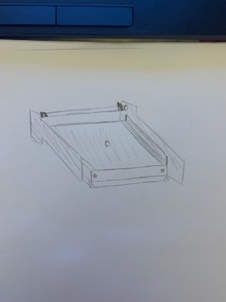
Figure 7
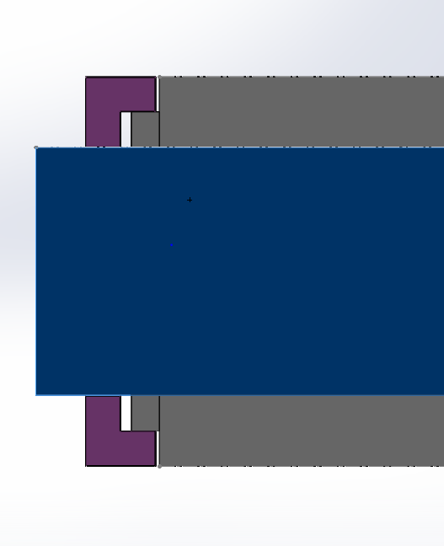
Quick Release Hotplate Clamping System
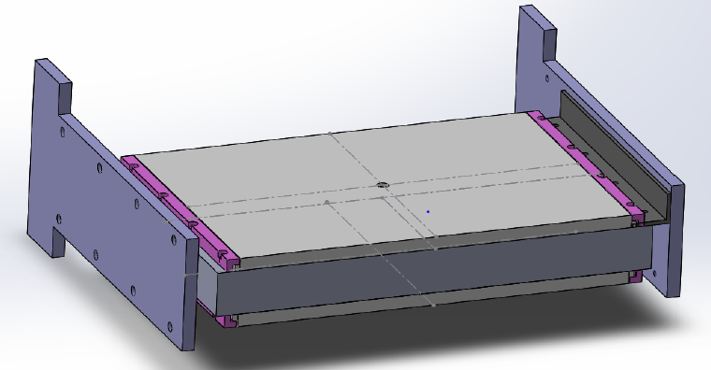
Figure 8
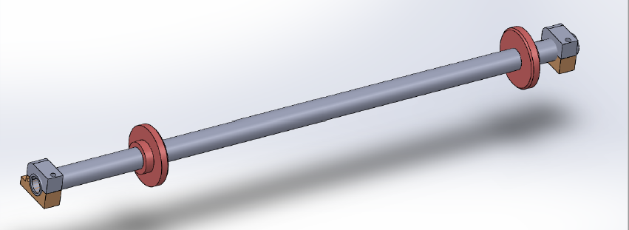
Teflon Roll Clamping/Tensioning System
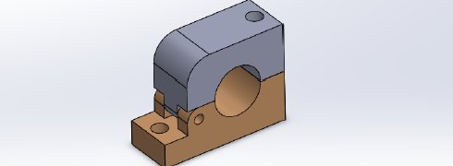
Figure 9

Estimated Costs:
Due to the fact that the manufacturing engineers have a very good working relationship with our local toolmaker we were able to run through the initial concept design idea and what we were aiming to achieve. He was then able to provide a budget for £2500 per welder, which is subject to the amount of hotplate, which would require modification (these vary on each cell due to different customers).
Estimated Implementation Timescale:
The majority of these modifications and piece parts can be produced off-site by our local toolmaker with no impact to production and would take around 1 week of manufacturing time. The line would then need to be stopped for 1 whole day (Days & Afternoon Shift) for the full machine carriage to be sent out to have the new items fitted and then refit to the machine.
Bill Of Materials (BOM):
- New style universal hotplates Teflon coated.
- 4 X Clamping strips for each side top and bottom of the carriage.
- New Teflon sheeting roll bar with new clamping system.
Estimated Time Saved:
20-30 minutes per changeover.

2 – Pre-Heat Stations Dedicated To Each Welder
Initial Concept Design Idea:
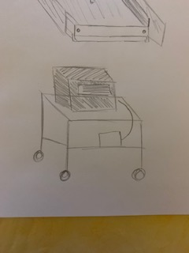
Figure 10
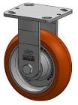
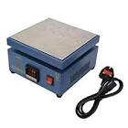
Figure 11
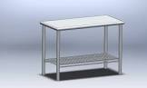
Figure 12

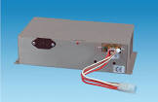
Figure 13

This design would be a scaled down version of the industrial unit example shown. It would be either situated be one to each welder if there were constraints on moving this type of equipment or it could possibly be a portal version that would be moved to wherever the changeover was occurring.
Estimated Costs:
When bench marking against other similar items when researching the team decided a good ball-park figure to base this type of equipment would be around £3000 due to the fact that it would need to be designed and manufactured by a specialist to exactly suit our requirements.
Estimated Implementation Timescale:
Looking at other manufacturers we would estimate that the implementation of the equipment would be around 3-5months (Subject to manufacturing time).
Bill Of Materials (BOM):
- Externally manufactured heater box.
- Industrial casters to be mounted to the base of the heater box.
- Steel table for the heater box to be fixed to in order to achieve correct height to comply with ergonomic standards.
- Electrical transformer unit to step up supply from 240V socket at each station.
Estimated Time Saved:
10 minutes per changeover (waiting for hotplates to warm up to 200 Degrees centigrade).

3 – Automated Changeover Process
Initial Concept Design Idea:
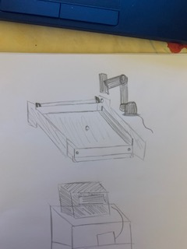
Figure 14

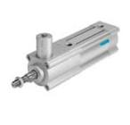
Figure 15

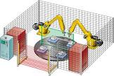
Figure 16

Estimated Costs:
The team decided to benchmark against our other robotic cell which has recently been implemented and decided the best budget figure to put to this project would be between £50,000-£60,000 which is far above the original budget but we feel it is worth investigating due to the fact that the potential head reduction would contribute to a fast payback time.
Estimated Implementation Timescale:
When benchmarking against our other robotic the team decided that a timescale of around 6 months would be sufficient as this project would be externally design and created and lots of trials would need to be undertaken prior to implementation.
Bill Of Materials (BOM):
- Co-bot.
- End of arm tooling for co-bot.
- Sufficient guarding.
- 4 x pneumatic locking cylinders.
- HMI control screen.
- PLC programming.
- Changeover table.
Estimated Time Saved:
35 minutes per changeover.

Evaluation Of 3 Potential Solutions To The Problem

1 – Universal Hotplate Changeover Procedure & Teflon Roll Clamping System
Pros & Cons:
Pros and Cons of Pursuing This Solution
Pros | Cons
Can be completed within budget. | Still requires manual process by technician.
Can be completed within timescale. | Requires existing hotplates to be modified.
Known supplier ready and available to conduct change. | Does not solve issues with wait times of hotplates.
Offers a large time and labour saving. | 1 day of machine downtime to implement.
Increases safety and safe working practices.
Improves SMED.
Heavily reduces workload and frees technicians up to undertake other roles.
Has potential to be rolled out across all of the factory.
Heavily reduces material wastage by tensioning Teflon sheeting.

Payback:
$$Average Labour Costs per changeover=\left(1x Op Tech=£14 per hour\right)+\left(2 x Operators=£9 per hour\right)$$
$$=£32 per hour$$
$$Average Changeover time=40 minutes$$
$$Cost of production downtime (Lost parts)=\left(£5 x 50 parts\right)=£250$$
$$Total changeover cost=£271.33$$
$$Projected downtime saved \%=\left(30÷40\right)×100$$
$$=75\%$$
$$Savings per changeover=\left(£271.33÷100\right)×75$$
$$=£203.50$$
$$Project Payback time=£2500÷£203.50$$
$$=13 changeovers$$
$$Average Changeovers per, per welder=3$$
$$Project Payback time=\frac{13}{3}=4 weeks$$

XY Matrix:

Lean Six Sigma XY Matrix
Date:04/11/2020
Project:1 – Universal Hotplate Changeover Procedure & Teflon Roll Clamping System
XY Matrix Owner: W. Davies
Output Measures (Y's)* | Y₁ | Y₂ |  | Y₃ |  | Y₄ |  | Y₅ |  | Y₆ |  | Y₇ |  | Y₈ |  | Y₉ |  | Y₁₀
Weighting (1-10): | Cost | Performance |  | Maintenance |  | Ergonomics |  | Disposal |  | Aesthetics |  | Environmental Impact |  | Installation |  | Size/Weight |  | Capacity
Input Variables (X's)# | For each X, score its impact on each Y listed above (use a 0,3,5,7 scale) |  |  |  |  |  |  |  |  |  |  |  |  |  |  |  |  |  |  | Score
Reduces Changeover Times | 7 | 7 |  | 7 |  | 5 |  | 0 |  | 0 |  | 0 |  | 7 |  | 7 |  | 7 |  | 37
Simplifies technicians jobs | 7 | 7 |  | 7 |  | 7 |  | 0 |  | 0 |  | 0 |  | 7 |  | 7 |  | 7 |  | 49
1 person lift | 3 | 5 |  | 5 |  | 7 |  | 3 |  | 5 |  | 0 |  | 5 |  | 7 |  | 5 |  | 45
Manufactured using high grade materials | 7 | 7 |  | 7 |  | 7 |  | 7 |  | 7 |  | 7 |  | 5 |  | 5 |  | 5 |  | 64
Heat Resistance capacity | 3 | 7 |  | 7 |  | 5 |  | 7 |  | 7 |  | 7 |  | 5 |  | 0 |  | 0 |  | 45
Easily rolled out across all welders | 7 | 7 |  | 7 |  | 7 |  | 7 |  | 7 |  | 7 |  | 7 |  | 7 |  | 7 |  | 70
Within budget | 7 | 0 |  | 0 |  | 0 |  | 0 |  | 5 |  | 5 |  | 7 |  | 5 |  | 7 |  | 36
Easily Contained within welder cell layout | 7 | 5 |  | 5 |  | 7 |  | 7 |  | 7 |  | 5 |  | 7 |  | 7 |  | 7 |  | 64
Weighs less than 1 tonne | 5 | 5 |  | 5 |  | 7 |  | 7 |  | 3 |  | 7 |  | 7 |  | 7 |  | 5 |  | 58
Ensures good parts being produced | 7 | 7 |  | 7 |  | 3 |  | 3 |  | 3 |  | 3 |  | 0 |  | 0 |  | 7 |  | 33
XY Matrix Premis: The XY Matrix or "Cause & Effect Matrix functions on the premis of the Y=f(x) equation.
*Rate each "Y" on a scale of 1 to 10 with 1 being the least important output measure
#For each X rate its impact on each Y using a 0,3,5,7 scale (0=No impact, 3=Weak impact, 5=Moderate impact, 7=Strong impact).

2 – Pre-Heat Stations Dedicated To Each Welder
Pros & Cons:
Pros and Cons of Pursuing This Solution
Pros | Cons
Relatively simple to implement. | Increases electricity use in factory.
Reduces machine downtime. | Adds a safety risk when handling 200 degree+ hotplates.
Within budget. | Does not reduce technicians workload.
No Machine downtime to implement. | No allocated contractor who could create this.

Payback:

$$Average Labour Costs per changeover=\left(1x Op Tech=£14 per hour\right)+\left(2 x Operators=£9 per hour\right)$$
$$=£32 per hour$$
$$Average Changeover time=40 minutes$$
$$Cost of production downtime (Lost parts)=\left(£5 x 50 parts\right)=£250$$
$$Total changeover cost=£271.33$$
$$Projected downtime saved \%=\left(10÷40\right)×100$$
$$=25\%$$
$$Savings per changeover=\left(£271.33÷100\right)×25$$
$$=£67.83$$
$$Project Payback time=£3000÷£67.83$$
$$=45 changeovers$$
$$Average Changeovers per, per welder=3$$
$$Project Payback time=\frac{45}{3}=15 weeks$$

XY Matrix:

Lean Six Sigma XY Matrix
Date:04/11/2020
Project:2 – Pre-heat stations dedicated to each welder
XY Matrix Owner: W. Davies
Output Measures (Y's)* | Y₁ | Y₂ |  | Y₃ |  | Y₄ |  | Y₅ |  | Y₆ |  | Y₇ |  | Y₈ |  | Y₉ |  | Y₁₀
Weighting (1-10): | Cost | Performance |  | Maintenance |  | Ergonomics |  | Disposal |  | Aesthetics |  | Environmental Impact |  | Installation |  | Size/Weight |  | Capacity
Input Variables (X's)# | For each X, score its impact on each Y listed above (use a 0,3,5,7 scale) |  |  |  |  |  |  |  |  |  |  |  |  |  |  |  |  |  |  | Score
Reduces Changeover Times | 7 | 7 |  | 7 |  | 5 |  | 0 |  | 0 |  | 0 |  | 7 |  | 7 |  | 7 |  | 47
Simplifies technicians jobs | 5 | 7 |  | 7 |  | 7 |  | 0 |  | 5 |  | 7 |  | 7 |  | 7 |  | 7 |  | 56
1 person lift | 3 | 5 |  | 5 |  | 7 |  | 3 |  | 5 |  | 0 |  | 3 |  | 7 |  | 7 |  | 45
Manufactured using high grade materials | 7 | 7 |  | 5 |  | 7 |  | 7 |  | 7 |  | 7 |  | 5 |  | 5 |  | 5 |  | 62
Heat Resistance capacity | 3 | 7 |  | 7 |  | 5 |  | 7 |  | 7 |  | 7 |  | 5 |  | 3 |  | 0 |  | 51
Easily rolled out across all welders | 7 | 7 |  | 5 |  | 7 |  | 7 |  | 7 |  | 7 |  | 5 |  | 7 |  | 7 |  | 66
Within budget | 7 | 0 |  | 5 |  | 0 |  | 0 |  | 5 |  | 5 |  | 7 |  | 5 |  | 7 |  | 41
Easily Contained within welder cell layout | 7 | 5 |  | 5 |  | 7 |  | 7 |  | 7 |  | 5 |  | 7 |  | 7 |  | 7 |  | 64
Weighs less than 1 tonne | 5 | 5 |  | 5 |  | 7 |  | 7 |  | 3 |  | 7 |  | 7 |  | 7 |  | 5 |  | 58
Ensures good parts being produced | 7 | 7 |  | 7 |  | 3 |  | 3 |  | 3 |  | 3 |  | 0 |  | 0 |  | 7 |  | 33
XY Matrix Premis: The XY Matrix or "Cause & Effect Matrix functions on the premis of the Y=f(x) equation.
*Rate each "Y" on a scale of 1 to 10 with 1 being the least important output measure
#For each X rate its impact on each Y using a 0,3,5,7 scale (0=No impact, 3=Weak impact, 5=Moderate impact, 7=Strong impact).

3 – Automated Changeover Process
Pros & Cons:
Pros and Cons of Pursuing This Solution
Pros | Cons
Completely eliminates technician support and allows them to deal with other tasks. | Large set-up costs.
Large SMED saving. | Implementation time not within target dates.
Eliminates manual handling processes. | Potential to create more maintenance issues.
Could potentially result in a head-count saving. | Machine downtime would be a significant loss.
 | Cell footprint would be significantly increased.

Payback:

$$Average Labour Costs per changeover=\left(1x Op Tech=£14 per hour\right)+\left(2 x Operators=£9 per hour\right)$$
$$=£32 per hour$$
$$Average Changeover time=40 minutes$$
$$Cost of production downtime \left(Lost parts\right)=\left(£5 x 50 parts\right)=£250$$
$$Total changeover cost=£271.33$$
$$Projected downtime saved \%=\left(35÷40\right)×100$$
$$=87.5\%$$
$$Savings per changeover=\left(£271.33÷100\right)×87.5$$
$$=£237.41$$
$$Project Payback time=£60000÷£237.41$$
$$=253 changeovers$$
$$Average Changeovers per, per welder=3$$
$$Project Payback time=\frac{253}{3}=85 weeks$$

XY Matrix:
Lean Six Sigma XY Matrix
Date:04/11/2020
Project:3 – Automated changeover process
XY Matrix Owner: W. Davies
Output Measures (Y's)* | Y₁ | Y₂ |  | Y₃ |  | Y₄ |  | Y₅ |  | Y₆ |  | Y₇ |  | Y₈ |  | Y₉ |  | Y₁₀
Weighting (1-10): | Cost | Performance |  | Maintenance |  | Ergonomics |  | Disposal |  | Aesthetics |  | Environmental Impact |  | Installation |  | Size/Weight |  | Capacity
Input Variables (X's)# | For each X, score its impact on each Y listed above (use a 0,3,5,7 scale) |  |  |  |  |  |  |  |  |  |  |  |  |  |  |  |  |  |  | Score
Reduces Changeover Times | 7 | 7 |  | 7 |  | 5 |  | 0 |  | 0 |  | 0 |  | 7 |  | 7 |  | 7 |  | 37
Simplifies technicians jobs | 7 | 7 |  | 7 |  | 7 |  | 0 |  | 0 |  | 0 |  | 7 |  | 7 |  | 7 |  | 49
1 person lift | 3 | 5 |  | 5 |  | 7 |  | 3 |  | 5 |  | 0 |  | 5 |  | 7 |  | 5 |  | 45
Manufactured using high grade materials | 7 | 7 |  | 7 |  | 7 |  | 7 |  | 7 |  | 7 |  | 5 |  | 5 |  | 5 |  | 64
Heat Resistance capacity | 3 | 7 |  | 7 |  | 5 |  | 7 |  | 7 |  | 7 |  | 5 |  | 0 |  | 0 |  | 45
Easily rolled out across all welders | 7 | 7 |  | 7 |  | 7 |  | 7 |  | 7 |  | 7 |  | 7 |  | 7 |  | 7 |  | 70
Within budget | 7 | 0 |  | 0 |  | 0 |  | 0 |  | 5 |  | 5 |  | 7 |  | 5 |  | 7 |  | 36
Easily Contained within welder cell layout | 7 | 5 |  | 5 |  | 7 |  | 7 |  | 7 |  | 5 |  | 7 |  | 7 |  | 7 |  | 64
Weighs less than 1 tonne | 5 | 5 |  | 5 |  | 7 |  | 7 |  | 3 |  | 7 |  | 7 |  | 7 |  | 5 |  | 58
Ensures good parts being produced | 7 | 7 |  | 7 |  | 3 |  | 3 |  | 3 |  | 3 |  | 0 |  | 0 |  | 7 |  | 33
XY Matrix Premis: The XY Matrix or "Cause & Effect Matrix functions on the premis of the Y=f(x) equation.
*Rate each "Y" on a scale of 1 to 10 with 1 being the least important output measure
#For each X rate its impact on each Y using a 0,3,5,7 scale (0=No impact, 3=Weak impact, 5=Moderate impact, 7=Strong impact).

Conclusion Of Best Solution To The Problem
Pros & Cons Result:
Potential Solutions | Pros Score | Cons Score | Overall Total
Universal hotplate changeover procedure with Teflon roll clamping. | +9 | -4 | +5
Pre-heat stations dedicated to each welder. | +4 | -4 | 0
Automated changeover procedure. | +4 | -5 | -1

Payback Result:

Characteristics Matrix Result:
All 3 possible solutions had their strengths and weaknesses. After studying each aspect of all tables the team felt that the results show the Universal hotplate changeover procedure is the most viable option. This is due to the fact that the results showed the highest scores across all aspects and meets all specification requirements/guidelines.

Summary:
To conclude, throughout all aspects of my evaluation the Universal hotplate changeover procedure with Teflon roll clamping, has proven to be the best option in overcoming the issues and downtime at hand. Some of the key factors for choosing this solution are:
- Proven to be the cheapest out of all options.
- Cheapest out of all options.
- The most simplistic and hardwearing design.
- Most environmentally friendly and easiest to recycle.
- Meets all specification points.
- Within budget.
- Huge savings on downtime and the frequency that Technicians need to be called out.
These are some of the reasons why the team feel this is the most viable and business savvy solutions. This is also well within the teams comfort zone and technical abilities so should be the smoothest and most hassle free to implement with the overall best results and savings.

Project Scope

One of the main issues faced by Maintenance and Production Technicians since the implementation of hotplate welders is the Hotplate and Teflon changeover procedures. Since change in management and departmental reorganisations this issue has been highlighted as a huge waste and potential for very beneficial savings with slight modifications to tooling and procedures. When these machines were originally commissioned they were designed to hold 1 variant of hotplate and run 1 product per welder. As time has progressed and the company has won more business, the company have then added different variants and different products to existing lines, resulting in several hotplate variants and welder tools needing to be changed over in-line with customer call-offs. This has resulted in long and overcomplicated changeover times due to the process not evolving in-line with its increased demands.

With the welders being used so often, Teflon sheeting rolls were added to ensure that the hotplates were protected and to minimise them wearing. This has also added another intricate step to the process, which needs regular maintenance and replenishment. As well as this process being overcomplicated it is also very wasteful due to the lack of tensioning on the rolls, which creates issues when changing over and using too much sheeting in order to achieve the correct tension of the sheet against the hotplate.

The combination of these 2 design oversights in the past have created a huge amount of unnecessary downtime and undue stress on the Maintenance and Operator technicians due to the volume of changeovers that they are required to do and the wasted time where they could be utilised elsewhere. Due to increased pressures and breakdowns within the factory, time saved is a massive driver. This waste has been highlighted and the manufacturing team have been tasked to heavily reduce this to enable Maintenance to have more time to deal with other issues, which will increase overall output and profits within the company. William Davies (Manufacturing Engineering Apprentice) was nominated to be the owner/champion for this project due to his heavy involvement with the Hotplate welder production line and good understanding of it.

Project Implementation:

Finalising the Design of the Modification
Packham Engineering Services had previously been made aware of the design concept due to the fact that William Davies had previously reached out to them in his project selection phase for initial estimates of cost for the Tooling modification. Alan Packham (Director of Packham Engineering Services) came into KHE to finalise the Universal Hotplate and Teflon Clamping system design with William. They firstly went out onto the shop floor and surveyed the Hotplate carriage and plates that had the possibility of being selected for the modification and dimensioned them.

Once Alan was happy with the Welder layout and shown the prototype sketches which was developed by William the manufacturing team sat down with him in a meeting and discussed all of the requirements and provided him with the project specification. Everyone then agreed on what was required and Alan went away with the exact idea of what was required.

William and Alan then sat down and created the draft design on the Solidworks application. This then went onto be turned into a 3D model which was then dimensioned and converted into an engineering drawing and provided to Packham Engineering as the new standard that they will need to stick to when manufacturing the required products. These designs were archived as the standard within Kautex Textron CVS Ltd.

The design was then emailed to William Davies and it was circulated around the team for approval. The whole ME and Management Team were happy with the modification and approved this with Alan. Once approved Alan then confirmed he was happy to get involved with the project and produce and fit the required modification.

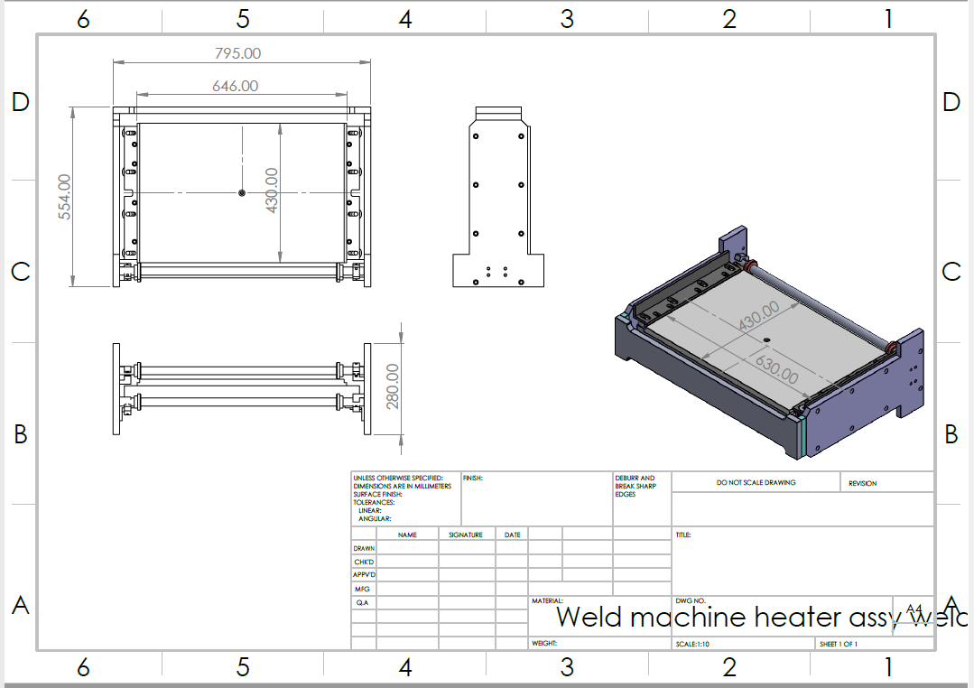
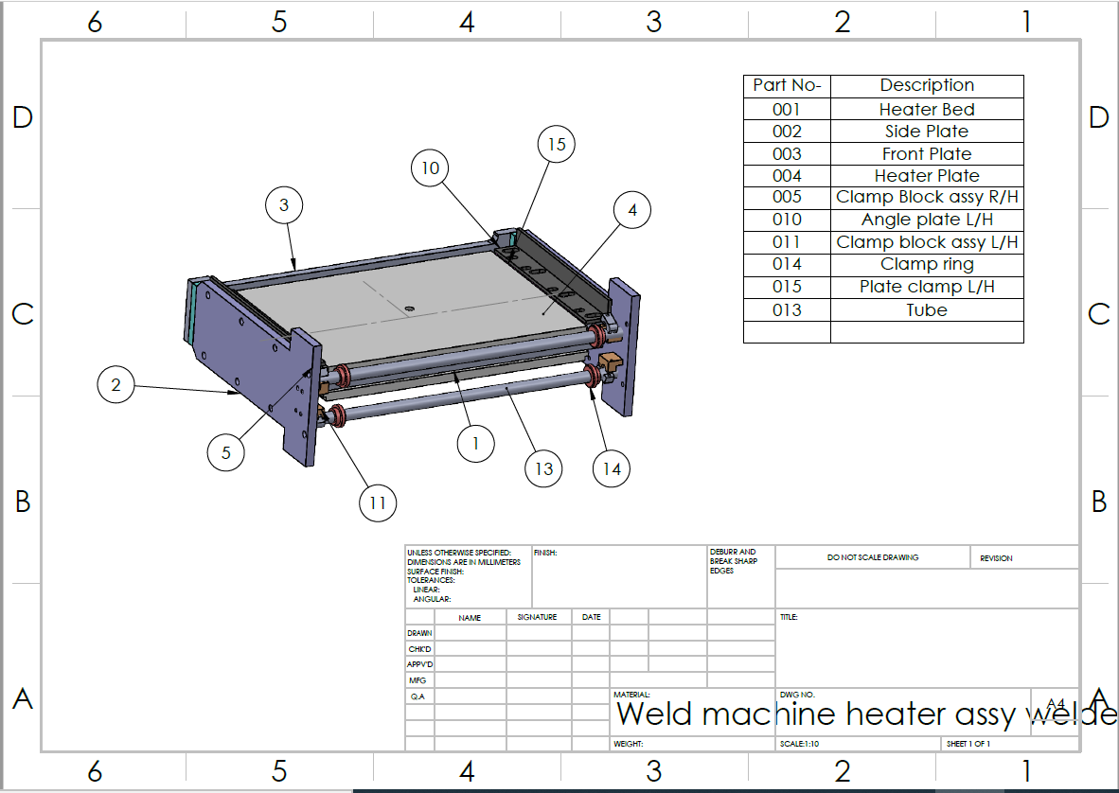
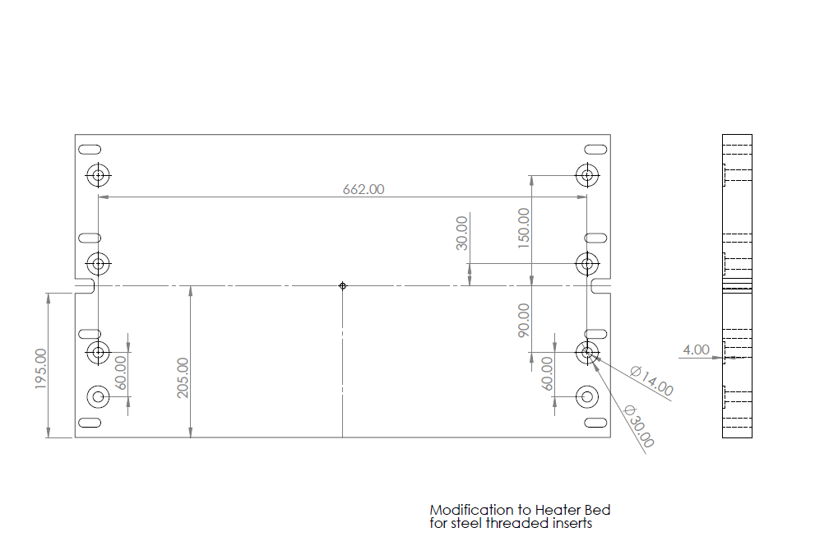
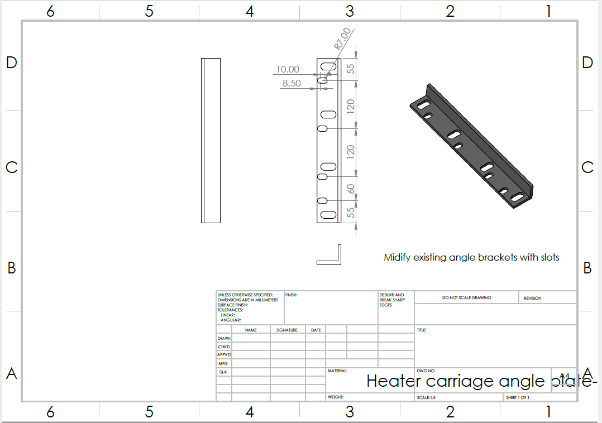
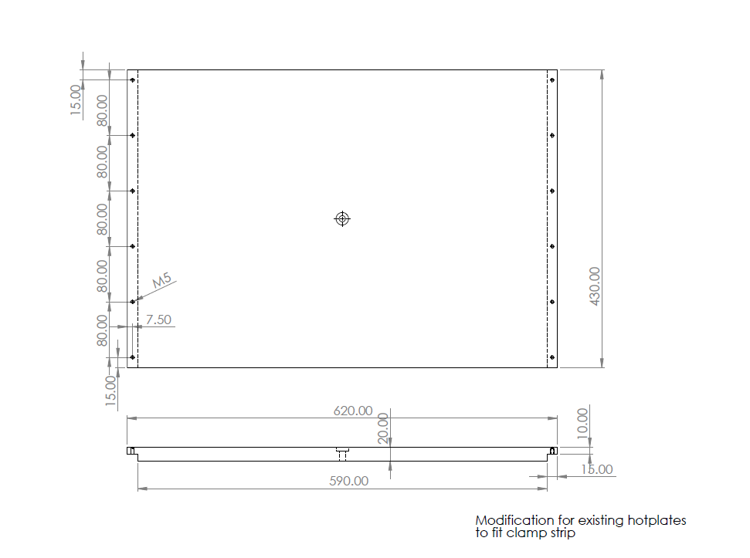

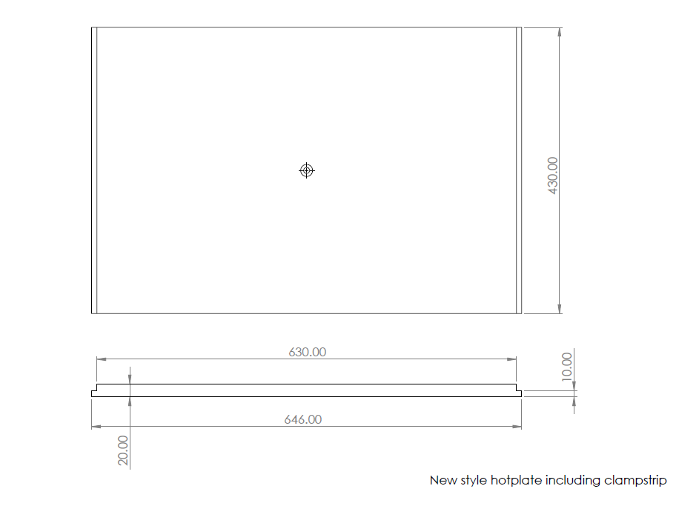
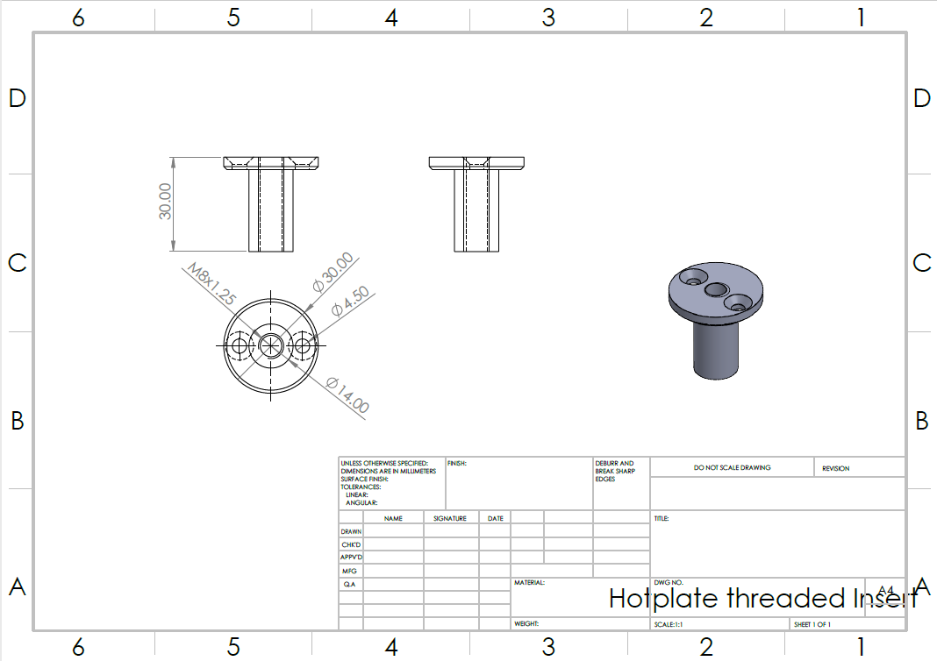
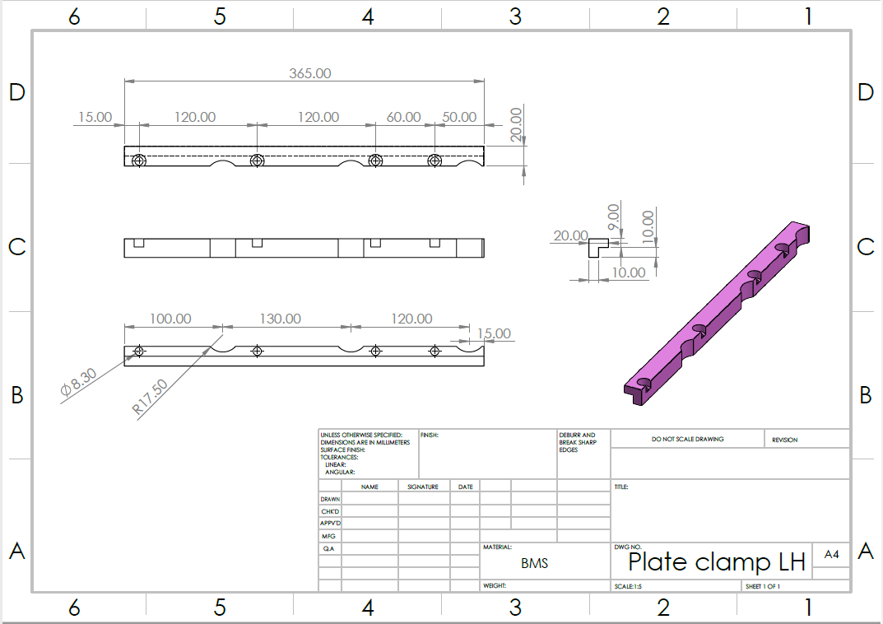
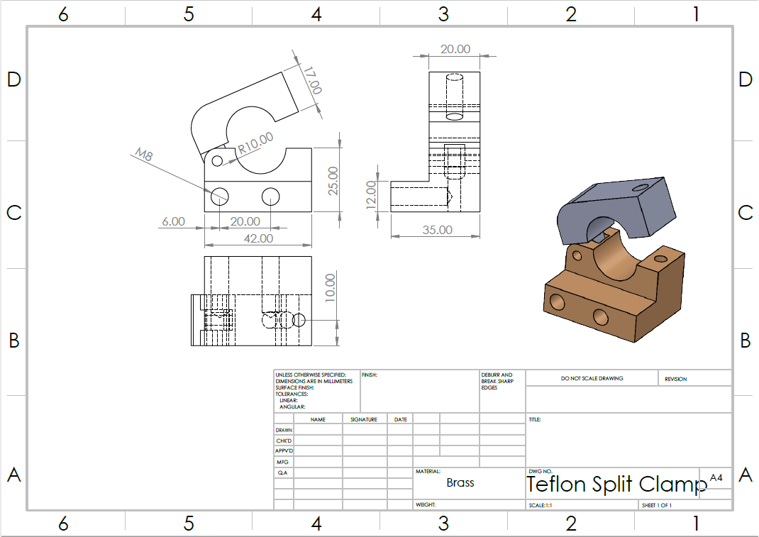
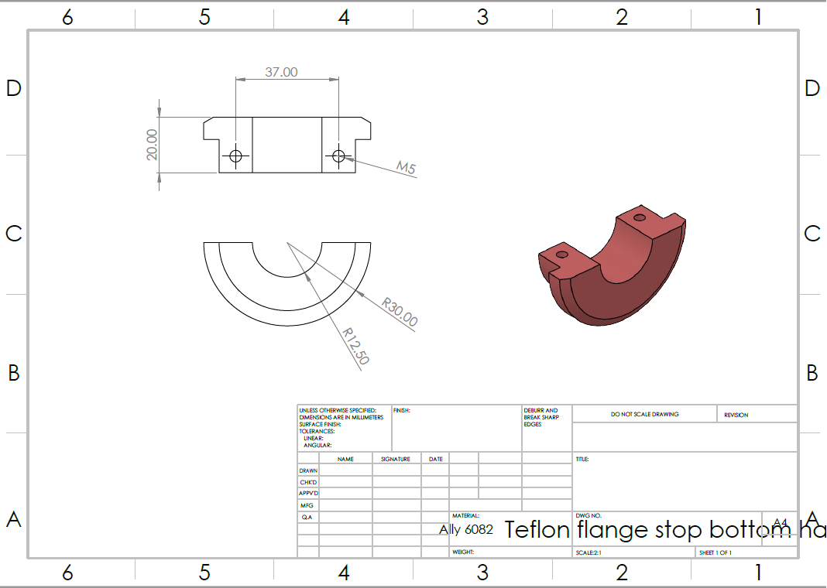

Production Surveys
It was necessary to gain feedback from the production team, so a survey was undertaken in the Welded container area. In this survey 14 operators, 3 technicians and all maintenance technicians from the line and the team leader of these operators were asked “do you agree/like the fixture modification?” when shown the 3D CAD and also the rough prototype. Their replies were as follows:

Reasons for the “No’s”:
- Operator 1 said that they think it is ‘pointless’ and ‘technicians’ shouldn’t have a job if they cannot complete simple operations such as changeovers.’
- Operator 2 said that they think it will increase changeover times and will be a waste of money which could be better spent on merit awards.’
Team Leader – Overall Comment
I feel that this would be a hugely beneficial change within the process and will be a great asset to the overall changeover/SMED/Maintenance procedure. As a whole the operators also really liked the modification and feel that the change needs to come as soon as possible. It gives the operators the piece of mind that they are not going to be held up from reaching their targets and producing good quality parts with a new and improved system. There are always going to be a few pessimists within the group but I would take their feedback and balance it against the group comments as a whole.
As a team we all reviewed the result of the survey and were very happy with them. This gave us the confidence in the design and spurred us on to continue as we have been correct to implement this trial modification and hopefully roll out in the future.

Selection of Pilot Hotplate Welder
Once the concept designs were finalised, the cross-functional team gathered together in order to decide the best pilot welder to trial this new concept. During the meeting it was concluded that the most valuable and best suited welder to modify and test would be Welder three. There were many deciding factors around this selection and they include:
- All variants of hotplates run through the welder are worn and require refurbishment and re-coating in Teflon.
- This welder is currently running under the least amount of customer demand and primarily supplies OEM spares.
- The volume of changeovers conducted on this line between the 2 variants is one of the most frequent.
- The basis of the designs have been built from this standard format and layout.
- This welder would be the first one available for the amount of downtime required without effecting customer deliveries.
- The least amount of plates that require modification.
All of these factors resulted in welder three being the most efficient and effective pilot welder, which would be used as the bench-mark and “Guinea Pig” to optimise and perfect the design and functionality before being rolled out across all other welders in the future.

This welder currently runs 3 different variants (as mentioned above). 2 of which of these variants have specialised plates with different thicknesses and cut-outs in order to compensate for the support ribs within the bottle. These are both top hotplates and will require specialised modification in order to suit the new system with the hopes and the drive that all future designs will be based around the standardised hotplate system and wont require any further hotplates to be manufactured. Alongside the 2 modified existing plates that remained in good working order it was decided that 2 sets of the new standardised hotplates were to be manufactured and purchased at the same time. One of these sets would be utilised in main production on Welder three whilst the other being a universal spare which will be kept to be used across all Welders if and when required.

From selecting this machine it was essential that the TPM for it was taken into account and calculated. It was agreed by the ME team that it would require:
- A monthly clean and inspection of the modification, once happy all bolts can be copper greased and the tooling can then be reassembled.
- A critical spares list to include:
- 2 x new Teflon roll clamping systems assembled with specialised bolts.
- 2 x universal hotplates.

This is the initial start-up cost with a larger investment in backup piece parts. This will then be far lower in the years going forward with bulk manufacture and spares being used across all welders with no need to re-purchase unless spares stocks were used in a breakdown situation.

Gaining Quotation & Budget Code
Alan was then approached by William and sent the welder modification details and was requested to quote for a single initial trial Poke Yoke device. With him already having all of the CAD data and also the Specified material he was very quick in turning around the quote, which only took 3 working days to generate.
(Appendices 3)
This quotation was then forwarded to Stephen Mills for approval and the Budget Code was requested from him.
He was very happy with the cost of the initial modifications and the new style variant price including supporting fitment to the welder. He approved the cost and gave William the approval to use the Maintenance Budget code and instructed him to raise the order on that day. William then raised the order through the Sourcing system used in Kautex called Ariba.
For the initial modifications the cost centre allocation was suitable but if when the new style system is fully approved and set as a standard, the cost will be absorbed by initial project start-up cost by the customer.

These 2 quotations were raised immediately due to the fact that budgets are limited and Stephen Mills was keen to capture this cost as soon as possible which would allow it to go through the approval flow and the purchase order reached Packham Engineering before any materials were purchased and manufacture occurred.

It was also essential that enough time was allocated to around manufacture of parts which would take 1 full week with 1 day of the full carriage being removed from the machine and taken off site where Packham engineering would require 6 hours to retrofit all mods to suit the new system.

Universal Hotplate System Implementation
With the positive feedback and overall production buy in, William called Packham engineering services and confirmed that he had received the purchase order. They confirmed that they would be able to start the Universal Hot-plate system manufacture straight away. The first step was to manufacture the 2 sets of the new style hotplates themselves in order to get them sent off for Teflon coating by Fluorotec to ensure they are in compliance with the global standard and to maintain the quality of the welded bottles coming off the machine after implementation.
The engineering team then informed the Production planner that we were all aligned and ready to be assigned an implementation date which would allow production to build the necessary stock to cover customer demands during the planned implementation downtime. The implementation timing plan was presented and reviewed, once all parties were agreed and happy the team were given the go ahead to implement on Wednesday 03/02/2021.
The maintenance supervisor was then approached and asked to provide 2 heads to assist the engineers in the removal of the old system and re-fitment of the new system in the evening (as highlighted in the timing plan below). When all of this was confirmed and all parties were aligned the implementation of the new system went ahead and was overseen by William Davies.
The implementation went ahead as planned with slight time deviations due to Packham Engineering experiencing some technical difficulties in removing some of the old piece parts of the assembly which pushed the delivery time of the system out by an hour meaning that the machine was not validated and handed over to production until 7:30pm. This did not present the team or production with any difficulties due to the fact that W.Davies had hourly progress updates from the Packham Engineering team and was able to escalate this risk out to production who had the necessary safety stock built up to match all delivery critical requirements.
Before the welder was handed over to production the new system was validated by the engineering team and initial start-up parts were pull-tested to ensure they met the customer specific quality requirements.
Due to the current circumstances a risk assessment was also undertaken and highlighted the necessary non-standard work PPE required to ensure all parties involved remained safe and protected from the risk involved.

(Appendices 4)

During the implementation W.Davies also managed to capture all the necessary images and process steps of the changeover process which then allowed him to go away and create a Standard operating procedure for the Operator Technicians once they were trained.

(Appendices 5)

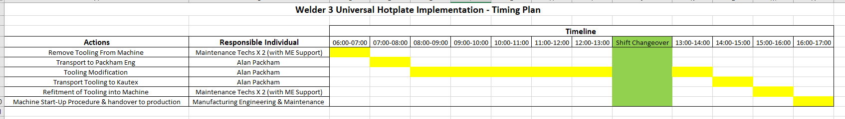

Universal Hotplates Changeover Training and Production Sign-off
When all of the standard operating procedure was finalised and signed off by all of the relevant individuals, W.Davies and J.Swift visited the production line when the machine was not running and conducted several training exercises with the Operator Technicians to ensure they understood the process and to gain their feedback.
When all of the Technicians were trained and happy the engineering manager D.Kristek was happy to sign off the new process as it had been correctly validated and handed over to production.
Although full training was given the engineers continually monitored the changeovers to ensure all technicians had the correct support needed and also to be able to highlight any discrepancies of the system which would need to be overcome.

Interim Gantt Chart
(Appendices 6)

As can be seen when referring to the initial Gantt Chart, there has been some significant developments made on highlighted the progress of the project with more information added as it was gained.
As a team we were able to revise all dates where different tasks had changed and also been able to assign the responsible individuals for each tasks.
We have also split the different tasks out into sections which has enabled us to focus on the tasks at hand and emphasise the successes being seen within the project.

Project Control Plan - Monitoring New System
With the full implementation of the new system the team decided that creating and implementing a control plan was essential to maintaining the standards within the project to ensure success.
It was decided that forms would be provided to the production line Team Leaders and stored at the front of the SOP’s and were to be filled out by each Operator Technician after each changeover will be reviewed each day by the team leader and representatives from the Manufacturing and Quality Engineering departments as a control measure for the implementation of the modification. These forms would allow the technicians to highlight any issues with the process and potential improvements, which could be easily retrofitted.
(Appendices 7)
After a period of time all of the forms were reviewed and the main areas that were continually highlighted as issues were taken to the operator technicians to discuss how the issues were effecting their changeover tasks and what they felt would be the best solution to these issues.
The main issues highlighted during the follow up surveys were:
- Bolts were hard to loosen during changeovers when the tooling was hot and require looking into.
- Still too many bolts require removal before being able to changeover the hotplates.
- When hot the plates are difficult to remove by hand and could potentially cause a HSE risk.
- The Teflon roll tensioning thumb-screws are very difficult to loosen when hot.
- The Teflon sheeting is very tight during renewal and adds a lot of wasted time onto the changeover.
Having collated all of the valuable data the engineering team met to discuss and evaluate what the best solutions to these issues would be in order to retrofit the design modifications and set a standard that all parties accepted and were happy to roll out across all other welders.

Further Modifications required to optimise/fine tune tooling before Roll-out
Having discussed the most effective methods of overcoming the technicians issues, the engineering team began to roll out the following modifications for each problem:
- Bolts were hard to loosen during changeovers when the tooling was hot and require looking into.
Solution:
W.Davies & J.Swift scheduled 3 hours downtime to remove all tensioning/location bolts from the top and bottom of the hotplate mounting brackets to apply “Copper Slip” to each thread. The application of the copper slip would lubricate each bolt and heavily reduce the chance of the technicians struggling to remove them along with removing the potential of shearing a bolt within the plate.
On inspection it was also clear that 3 of the original threaded insert had been cross thread and required replacing. Fortunately spares are readily available and it was completed straight away.
- Still too many bolts require removal before being able to changeover the hotplates.
Solution:
When further investigation was put into this statement it was found that the front plate of the system, which the Teflon sheet it fixed had 2 different size threaded holes (top & bottom), which were not standard to the M10 location bolts. Due to the fact that these fixing bolts were very awkward and not required the team decided to fix a threaded bar to the hotplate carriage and use heat-treated thumb nuts to fix the plate. The combination of the fixed threaded bar alongside the nuts allows the technicians to easily release the plate by hand, saving them time and energy whilst reducing the amount of tools required.
Due to the fact that there was threaded bar readily available within the company the only extra costs incurred was the purchase of the nuts which only came to the shipping costs due to W.Davies being able to secure samples to validate the product.
- When hot the plates are difficult to remove by hand and could potentially cause a HSE risk.
Solution:
This was a very big issue, which required quick resolution. Fortunately, the team had purchased a spare set of hotplates, these spares were sent out to Packham engineering where 2 threaded holes were inserted into the front of the plate along with 2 threaded handles.
This modification allows the technicians to be able to apply equal force across the plates whilst not having to actually touch it. This issue was not only linked to their safety it was also heavily increasing the changeover times due to the complexity and awkwardness of the task. This modification had a huge impact and was very beneficial.
- The Teflon roll tensioning thumb-screws are very difficult to loosen when hot.
Solution:
When taking a further look at this process when hot it was clear that these thumb screws were very hard to remove even with copper slip applied. They were also in an awkward position, which meant the technicians would be exposed to the heat of the plates for too long.
It was decided that these thumb-screws would be swapped out for standardised M10 bolts which meant they could be easily loosened with the ratchet spanner and extended alan key attachment which minimised exposure and the strain put on the technicians to loosen and tighten the tensioning clamps during a Teflon sheet changeover.
- The Teflon sheeting is very tight during renewal and adds a lot of wasted time onto the changeover.
Solution:
When taking a further look into the method it was identified that the fixing plate was sitting flush against the hotplate, which was acting as a clamp on Teflon sheeting. It was decided that the hotplates would be shortened by 10mm each side to allow the sheet to be pulled through easily and quickly. This modification was completed alongside the threaded holes to overall improve the hotplate and Teflon sheeting changeover times and complexity.

Impact of the solution

Original Design: Total Changeover time (inc. tool change, Hotplate change and Teflon change) 60 minutes.
New Design: Total Changeover time (inc. tool change, Hotplate change and Teflon change) Maximum 30 minutes.
Welder 3 Example:
Based on 1 full changeover per week. 15 parts gained based on 30 minute improvement at 50PPH target = 1200 Parts per year based on 48 weeks.
Based on V54X selling price of £7.55 per unit. Additional 1200 units per year = £9060
Operator saving: £13.42 per hour = £6.70 saving per changeover. Based on 48 weeks = £321.60 per Op Tech.
All 5 welders = £1608 per Op Tech. 125 hrs per year an optech can be utilised in another role.

Project Development Summary

When looking back at this phase of the project I can confidently say that this brought about the most management challenges and was the hardest area of the project. Although it came with its challenges the team were able to achieve a great deal and meet all customer driven specification points. These areas included:
- Collaboratively develop 3 robust potential solutions, which would cover all specification points along with their supporting information.
- Evaluate each of these solutions using 3 industry recognised evaluation tools, which the team decided were best suited to the type of project in hand.
- Reviewed all of the evaluation information created and came to a conclusion of which idea was the best one to take forward.
- Set in place a project scope of the implementation of the design concept.
- Developed industry recognised and compliant engineering drawings which were provided to the tool maker in order to further progress the project.
- Discussed how the solution was impacted by the PDS to ensure it met all specification points.
- Presented the concept to the production team to gain feedback.
- Selected the best Pilot welder to launch and trial the concept.
- Gaining quotations from the tool maker to create and retrofit the new design concept.
- Gaining the budget code from management to purchase the pilot concept modifications.
- Planning and implementing the new solution to the problem and managing production handover and training.
- Revising the Gantt chart to reflect the project at this point.
- Monitoring the new solution and further developing improvements.
- Analysing improvements made and data collection of impact.

As previously stated, the whole team found this the most challenging part of the project and this can often be said for the majority of projects undertaken in industry. The reasoning behind this is that the majority of things do not go the exact way you planned them first time around but what I have found is that the best solution for these difficulties is to maintain positive encouragement with the team and continue to drive for success. An example of this within this section is the difficulties I had personally in creating the CAD designs to be passed onto the toolmaker. With little CAD experience prior to this it took me time to create them and I had to work very hard to achieve the results within the allocated timescale.
Another challenge which wasn’t planned in was the time which the team ran over during the initial implementation and this was due to the tool maker having to remanufacture a part as it did not quite work correctly the first time around. However, the team worked through this obstacle and managed to get the job down but having a small deviation away from planned downtime.
The most rewarding part of this implementation was when all of the tuning modifications were complete and the results and positive feedback spoke for themselves. I ensured that all team members were praised and thanked for their hard work which enabled this project to be a success.

Impact of Product Design Specification on Project

The Role of a Product Design Specification
When looking at the project up until this point and the amount of concentration and time the team have put into the PDS, whilst ensuring compliance with this shows the huge impact a Product Design Specification has on a project as a whole.
A product design specification should be the back bone of all design projects which culminates all of the required attributes from the Design Brief along with all other industry driven standards.
When looking it this particular project it is clear to see that there has been a huge amount of input and emphasis around the Product compliance with the PDS and to ensure that all aspects of work undertaken are with this PDS at the forefront of everyone’s mind.
This has been no different throughout the project up to this point. At every stage of each section the PDS has been referred back to and has acted as a fool-proof guide on how to achieve the end goal and successfully achieve the customer driven requirements.
Examples of the many ways in which the design specification has impacted this project include:
Offers the design team guidance
The product design specification is the main point of guidance which the design team following even from the initial brainstorming process. As can be seen when referring to the product development phase of this project report, the PDS sets the standards the team were aiming for. Without the design specification the team would’ve faced an impossible task of trying to meet the customers expectations as they would not know what they were or how to even go about achieving them.
Identify trade-off points between requirements
By having the exact requirements identified within the PDs it allows the team to identify trade off points which could often save time and money. An example of this within the project could be seen when the tool maker suggested manufacturing some of the components from very high grade and expensive materials which would’ve been outside of the teams allocated budget. By having the PDS to refer back to they could validate that these materials were not specified and allowed them to reign on the toolmakers idea and come to a middle ground which met the specification along with the being within the budget.
A checklist during project progress meetings
The PDS also acts as a checklist during project milestone reviews to ensure that the project focus remains on the specified points and to ensure focus doesn’t drift from the overall goal of achieving the customer specified requirements. Each project milestone/Critical Path point must be linked to the specification and will act as a guide of ensuring the all points are covered within the allocated time and will allow the project to be managed correctly.
Allowed the evaluation of the 3 solutions against the PDS to pick the most suitable
The product design specification allowed the team to effectively evaluate the 3 final solutions created against it to ensure that the correct solution was taken forward and the solution covers all necessary points. This also gave the team confidence in the fact that they could cross reference between the specification and solution to double check all factors were met to achieve full customer satisfaction.
Acts as a company-supplier agreement
With the product design specification being a more in depth a comprehensive version of the customer brief it allows the team to be 100% sure that they have delivered what they set out to at the start of the project. It also covers the team from deviation from the customer and allows them to push back on any unnecessary criticism as the customer had bought into the PDS they were working against.
To trace the likelihood of change propagation
As briefly touched on above, this gives the team traceability of the projects developments and amendments made to the customer specified requirements and allows the management to highlight and justify if any deviation were put in place and exactly why these were undertaken.
Gives a product overview
It allows the team to benchmark/roll out the new concept across other sites/businesses giving an overview of what the product is and how they achieved it.

Design Solution Assessment/Evaluation

In order to validate the project up to this point the team found it necessary to conduct an interim evaluation of the project to ensure compliance with the PDS and that they remained on track to achieve the customer driven goal outlined in the PDS.
In order to effectively evaluate the report the design team needed a standard format of a problem solving strategy to compare against and they decided to use the Six Sigma DMAIC acronym, which stands for:
- Define – Define the problem at hand.
- Measure – Measure the extent of the problem.
- Analyse – Analyse the extent of the problem and possible solutions that would fix/improve it.
- Implement – Implement a solution to solve the problem.
- Control – Control the solution to the problem in order for it to remain effective.
When directly comparing the teams project against this one it is clear to see that the same method has been used in order to methodically identify rot cause of the issue at hand and implement a robust solution to it. When breaking these stages down, it is evident that a significant amount of work has gone into each, as can be seen below:
Define Stage
When looking back to the start of the project it was clear to see that a lot of time and effort was put in by the team to define the perfect Maintainability problem within the company to take forward for improvement and complete an in depth project on. They were able to conduct brainstorming and further analysis activities on a number of different problems and whittle them down into 3 main problems. These problems were then further broken down, analysed and evaluated for their potential impact on the company if they were improved and met the specification and budgets allocated. They were then able to dig down into the most pressing maintainability issue and effectively define the exact problem at hand via the customer brief and then converted this into an industry standard product Design Specification which outlines the exact issue.
Measure Stage
Once the problem was defined and set upon, the team went and gathered a large amount of data to support the problem statement and further highlight the impact the problem is having on the company. They were able to gather live production data to measure against and gain feedback from the effected individuals on exactly the issues they face and what they think needed to be done to improve it.
Analyse Stage
When all of the data was gathered the team took time to analyse it and further understand the issue at hand. This then gave them the correct knowledge and understanding to develop a solution to the problem. Although the analysis was sufficient the team did feel that more time could’ve been spent on this to further strengthen their design solution.
Implementation Stage
With a vast amount of lessons learned on the problem at hand the team were able to develop and implement a robust solution which was felt to meet all specification criteria and that was within the allocated budget. The team put a lot of time and effort into ensuring the solution was controlled during the implementation phase and had full support and buy in from the company. All activities were done safely and effectively.
Control Stage
Once implemented the team took time to properly train and validate the solution, which had been implemented. They also revised all process documentation for future reference and to act as a training aid. During the control stage they took the time to fine tune the solution and took on board the feedback from the technicians which allowed them to make slight adjustments to the design so that it was more effective and further improve the solutions compliance to the brief, from a HSE and overall improvement perspective.

As can be seen throughout the report and the summaries above, the team felt that each phase of the report followed and covered all of the correct target areas in a great deal of depth. This report correctly shows the steps that should be taken in overcoming an engineering problem.

Does this solution have a positive impact on Maintainability?

When looking back on this project and analysing its findings and the improvements made, the team definitely feel that they have met the brief of improving the maintainability of this process. They can justify this by presenting the facts that:
- They have heavily reduced the reliance on the Operator and Maintenance to conduct the changeover activities.
- Standardised the process so that the business now has heavily reduced the amount of spare parts required whilst no having the ability to run different products in different machines through standardisation in the event of a machine breakdown.
- Reduced the time taken by half when conducting a changeover, which frees the technicians up to be dealing with other issues.
- Improved manual handling and reduced the technicians exposure time to the machine which will have a positive impact on HSE compliance.
- Renewed all hotplates Teflon coating which allow them to last longer and withstand more use.
- Reduced the material wastage during Teflon sheeting changeover which is a huge cost reduction.

Conclusion
To conclude, this has been a very large and vital project within KHE and Kautex globally. Many different techniques and people were involved within all aspects of the project in order to take it to its completion date. Overall it is felt to be a great success and milestone which the Manufacturing Team at Kautex has overcome, resulting in a very robust process being implemented and avoiding large and serious downtime and extra work for all technicians allowing them to be freed up for other maintenance tasks. All aspects of the project have gone ahead to plan with very little adjustment. Within the Automotive industries often, fast paced and frantic environment it is very often that full project completion isn’t achieved and a quick fix is implemented, but this has not been the case. Each step of the project was completed to the highest standard achievable, with little to no points missed. This is why the result was one of the most robust process improvements implemented within the business in recent times. Not often that a project is implemented with little or no comebacks but this one most certainly has.

Final Gantt Chart
(Appendices 8)
As can be seen when referring to the two previous Gantt Charts this one is far more structured and shows the critical path highlighted in order to make this project a great success that it has been.

This Gantt chart is a valid map of the project journey containing the exact dates of when tasks were achieved and what team member achieved them

Evaluation
Comparison to the Specification:
Specification Points | Does it meet the Specification | Reason
Performance/Functionality | Yes | The implemented solution gives over a 50% reduction in changeover times, as a result of simplifying the operations and reducing the volume of time-consuming steps.
Reliability | Yes | The solution ensures that every changeover cycle is within the pre-set timescale and no issues have been experienced with the pilot welder since the launch including the new modifications highlighted.
Operational Conditions | Yes | The solution has had no effect on the manual and automated welding process and has actually improved the weld quality and strength due to the new Teflon coated plates.
Scale of Operation | Yes | This solution can be retrofitted across all welders within KHE within the timescale and a further 2 welders are planned in to be modified before the end of May.
Maintenance | Yes | The solution has heavily reduced the reliance on maintenance technicians by speeding up and simplifying their involvement, with all piece parts of the system being new it has also meant that no breakdowns have been encountered since the implementation.
Cost | 1/2 | The cost of fixture implementation came in at a cost of £2300 per welder which is significantly under targeted costs and TPM also costs will be at it’s highest of £400 for the first year but will be decreased significantly in on going years due to the spare plates requiring Teflon coating.
Aesthetics | Yes | The solution encompasses all specified materials and components in accordance to the specification.
Ergonomics | Yes | The solution has no effect whatsoever on the overall on cycle time or operational conditions, the removable elements of the system (hotplates) can easily be transported by hand.
Size/Weight Restrictions | Yes | The solution attached onto original tooling carriage which does not impact tooling footprint and weighs 200Kg which is well within KHE’s lifting capabilities.
Capacity | Yes | The solution is fully standardised and will not deviate from the set standard procedure across any welders where it is implemented.
Health & Safety | Yes | The solution has all edges/materials free from burrs and sharp edges, it also does not have any impact on the push forces which were within the specified limits before the modification, the fixture also remains a 1 person lift due to the decrease in hotplate weight. All hand operations have not been effected and doesn’t increase the risk of injury when using the modified tooling.
Legislation | Yes | The solution is within compliance of the Rula and KIM recognised standards within the Kautex organisation. It also complies with all other stated regulations within the specification.
Installation | Yes | The solution only required 12 hour of operational downtime and only required 2 employees at the time on implementation. It included a full SOP update along with a full company standard risk assessment.
Disposal | Yes | All materials used are easily recyclable and require no specialist treatment.
Environmental Impact | Yes | All aspects of the solution can be recycled.
Customer requirements | Yes | No impact at customer.

When reviewing this evaluation, it was felt across all boards that the project has been a great success. Nearly every aspect of the specification was achieved with one slight issue around the cost of TPM on the solution yearly. The reason why this is higher than the previously targeted amount is due to the fact that further spare hotplates required Teflon coating to get up and running. In future years this will decrease due to having the spare parts already there, and only labour being the contributing factor to TPM costs.

Overall Project Evaluation
What Went Well:
- Full project completion was achieved ahead of the targeted timescale.
- Very effective teamwork and networking skills were used throughout the project. (Appendices 9)
- Effective time and resource management skills were used.
- Huge internal maintenance availability benefits were achieved.
- Robust system implemented into a variable process to standardise procedure.
- Cost savings were highlighted for future projects.
- Kautex control standard was created and is set to be introduced globally.
- The design brief was achieved.
Even Better If:
- The time between quotation and delivery was shortened.
- It was felt across the board that more welders could’ve been retrofitted with the the system within the allocated timescale.
- More cost savings and material research had occurred.
- More people within the Manufacturing Team had involvement within the project due to heavily relying on the named few.
- A larger budget was awarded to introduce automation and less reliance on technician

Maintainability Project Presentation

Types of Communication methods available when delivering a presentation

There are many different ways in which information can be presented to an audience effectively. In these types of circumstances it is essential that the presenter engages with the audience and uses a method, which best suits them and the information being relayed. Some examples of these methods include:
- Power point presentation.
- Flip charts.
- Videos.
- Props.
- Hand-outs.
- Verbal communication.
When delivering my final project presentation I selected the most common methods of preparing a power point presentation and verbally communicating all information contained within to the audience. I decided to use this technique as I felt that this was the most engaging way of communicating all elements of the project to the audience along with giving visual representations of each step that was ran through. I also felt that this was the most professional and polished way of delivery a management summery presentation.

Presentation Performance Reflection

On reflection of my presentation and the feedback received afterwards I am overall very pleased with my performance and the techniques used to relay vital project information and developments via the power point presentation. I felt confident in my ability to present this information prepared and in the hard work put in to preparing the slides to back up my verbal communication. I felt as though I spoke clearly and confidently without the support of notes and effectively engaged with the audience giving them a clear understanding of the project and its outcomes. These statements can also be validation by Jonathan Preece (Presentation Assessor).
I was able to prepare and present relevant information through uncomplicated and engaging slides in a timely manner.
All feedback received from peers and assessor was positive and they found it very difficult to find faults.
The one constructive criticism point to be in mind for future presentation was raised by J.Preece and this was to ‘Add videos of the process to further strengthen the audiences understanding of the process and its issues.’ On reflection of this I feel that it was a very good point and my presentation would’ve definitely been enhanced if I were to have added a video of the process and the problems linked to it. This is something I would be sure to add when delivering any further project presentations.
Overall, I was extremely happy with how the presentation went and all of the positive and constructive feedback received. I walked away from this experience with a great sense of contentment that I achieved the goal that I set out to whilst using the knowledge and lessons relayed to me to further strengthen future projects and presentations.

Overall project feedback from assessor

One area for further investigation/improvement highlighted by J.Preece was to eliminate the technicians exposure to the heated elements of welder whilst performing a changeover activity. I have taken this feedback on board and plan to implement insulted changeover handles, which would mean that the technicians will be able to wind in the handles to the hotplate and complete the changeover process with no risk to being exposed to the 200 degree plus temperatures.
This feedback was very much appreciated and taken on board, I have now reached out to 3M who supply this type of insulating material to gain a quotation and this will be rolled out across all welders once validated. This has enabled me to further improve on my product and enhance the safety features by networking and gaining positive feedback/constructive criticism from my assessor.

Lessons Learned
As I have stated previously, I am very happy in they ways in which I have controlled and effectively managed this project and this can be seen through this project report, presentation and my weekly logbook activities. There has been a vast amount of learning in my part throughout the project and some examples of items learned are:
People Management
Throughout this project I have learned different ways in which individuals need to be managed to get the best results out of them.
Administrative Skills
I have had to use lots of administrative skills which were not previously required within my role. I have learnt several skills like taking meeting minutes, organising meetings, placing orders and much more.
Evaluation Techniques
I have picked up and been able to utilise several new industry recognised evaluation techniques to effectively chose the project and the solution to the initial chosen problem statement.
Project planning & Management Techniques
I have learned how to manage and track project progress through using Microsoft Project.
Risk Assessment Completion
I have learned and undertaken non-standard risk assessments in order to comply with HSE regulations and keep all team members safe during the implementation of this solution.

Throughout the project I learnt far more lessons around the physical project management side along with the skills listed above. When undertaking further projects in the future I will be carrying forward several ‘Lessons Learned’ which I would do differently, and these include:
- Breaking project milestones down further into quicker victories and achievements in order to keep better focus and maintain team motivation throughout each sector of the project.
- Delegate more tasks to other team members rather than undertaking the majority of the physical work myself rather than managing the project side of things more.
- Allow more slack in production downtime to alleviate risk of missed deliveries if anything overran with the implementation and handover.
- Allocate separate budget for start-up costs.
- Add videos of the process into presentations to give audience better understanding.

Reference

Figure 1
N/A. (2019). Project Problem Solving. Available: https://www.project-management-skills.com/problem-solving-techniques.html#:~:text=%20Problem%20Solving%20Techniques%20for%20Project%20Managers%20,causes%20has%20been%20completed%2C%20it%27s%20time...%. Last accessed 07/12/2020.

Figures 2, 3 & 4
All of these images were gained from Kautex’ internal web page.

All Other Figures

All other figures were taken from machine manuals and sales brochures within Kautex.

Appendices

Appendices 1

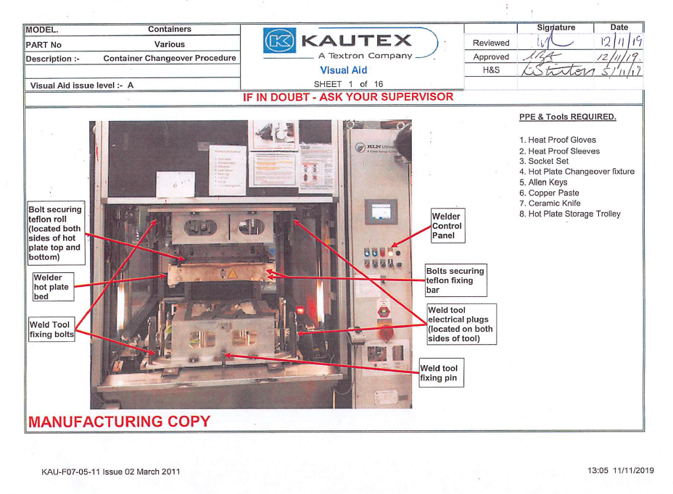

Appendices 2

Refer to file attached

Appendices 3
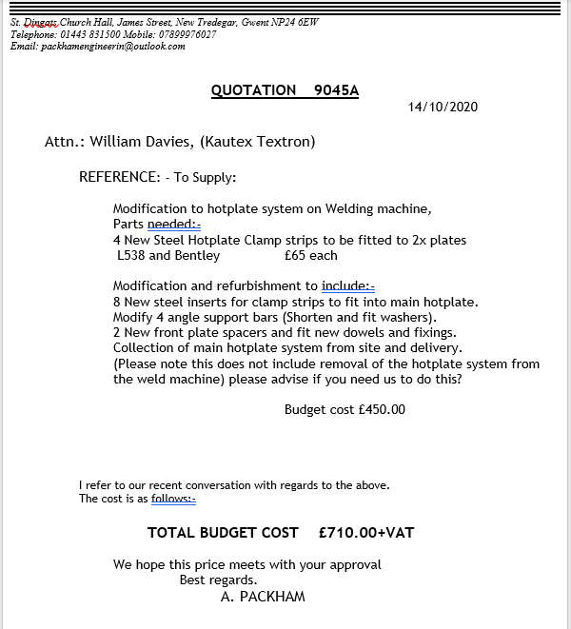

Appendices 4

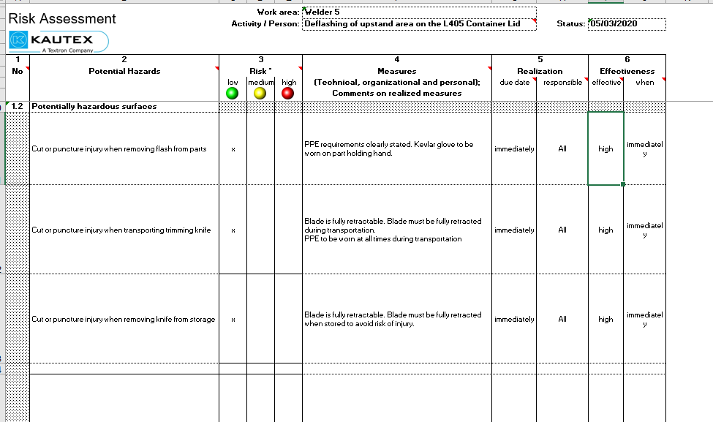

Appendices 5

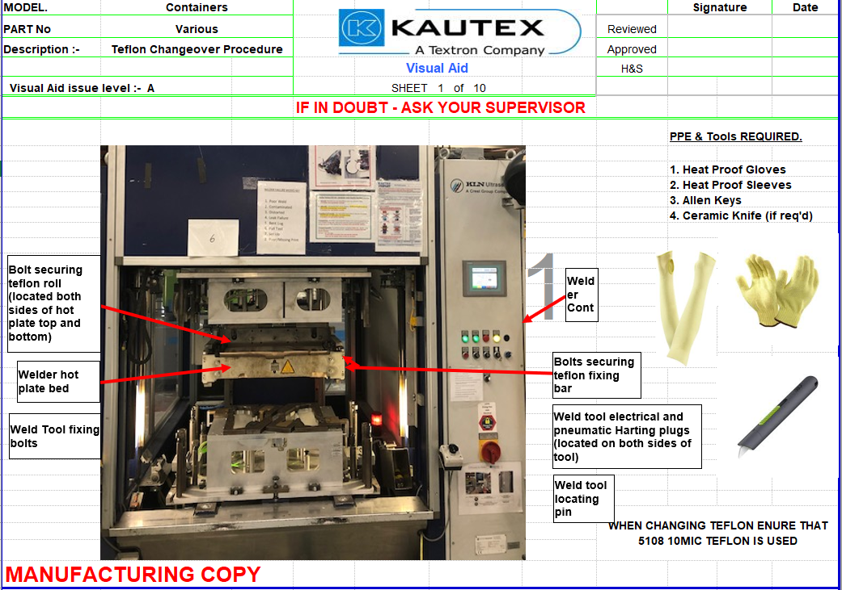

Appendices 6

Refer to file attached

Appendices 7

Technician Name:
………………………………………………………..
Date of Changeover:
…………………………………………………………
Products Being Changed Over:
…………………………………………………………
Problem Faced During Changeover:

Possible Solution To The Problem:

Appendices 8
Refer to file attached

Appendices 9
Time of entry: 10:00 | Progress report-tasks achieved | Issues/Risks identified | Problems | New Ideas / concepts | Personal achievements | Tasks Planned for next week | Project status | Actions
Week 1 (06/10/2020) | Attended College for first lessons of HNC year 2. The tutor ran through the course expectations for the year and what type of project we will have to look into and complete in order to pass the course. I went onto create a mindmap of different ideas and picked out the best 3.  No Changes made to project Plan. | I highlighted to my manager during my apprenticeship review that my current workload would need to be reduced in order to effectively manage this project and keep up with the set timeline. | No issues with this first week due to the fact that there are many projects which directly apply to the 'Maintainability' specification and i feel that there should be no issue in identifying one which could be completed within the timescale along with a high quality writeup. | Several initial maintenance improvement ideas generated which included:  - Shut-off valves for potting solution chambers to minimise waste of solution when having to remove them prior to TPM on dispensing head.  - Standardising Hotplates for Hotplate welders to minimise spares and heavily reduce changeover time whilst increasing safety.  - Introducing intergrated signature system which allows electronic signatures to be provided instead of taking up technicians time having to gain signatures.  - And several more. | I am happy with performance this week and that I managed to achieve the generation of 3 possible ideas to pursue. | Gain further information on 3 possible projects and start write/report. | On Schedule | Conduct further research into each possible project and format the report template.

Time of entry: 07:28 | Progress report-tasks achieved | Issues/Risks identified | Problems | New Ideas / concepts | Personal achievements | Tasks Planned for next week | Project status | Actions
Week 2 (13/10/2020) | More information gained with three possible projects which allowed me to start report write-up.  No changes made to project plan. | I spoke to my manager to preemt him with the future costs which will come along with the projects just to double check that we have enough money in the budget to cover the work needed to be undertaken. | No issues with funding and support from management, was given the go ahead to pursue the project of my choice which would benefit the company the most. | No change to ideas generated from the previous week.  At this stage I am leaning towards the universal hotplates which will standardise the process and feel that prior to any feasibility studies and payback calculations this would be of the most benefit. | This project will be a very good learning curve for myself and will help my gain further knowledge into different systems within the company. | Tasks which are still current priority include:  -Brainstorm initial ideas | On Schedule | WD - Organise project charter creation meeting and gain the correct format document to populate.

Time of entry: 13:20 | Progress report-tasks achieved | Issues/Risks identified | Problems | New Ideas / concepts | Personal achievements | Tasks Planned for next week | Project status | Actions
Week 3 (20/10/2020) | 3 project Charters all completed with supporting information and teams chosen for each.  Specific individuals highlighted for each team based on their areas of expertise and job titles.  No changes made to project plan. | Only risk identified this week were the current work load of some key individuals within the team and making sure they have enough time to devote to this project. | Some push back on the intelligent bench issues due to the fact that they are still within their trial phase and the initial implementation team have argued that this task should not sit with us and should remain with them. | Lots of idea generation around the 3 problem areas with several concepts of improvement highlighted for each of them. | Managed teams expectations and liased with intelligent bench team to calm and discuss their current situation.  Ran the 3 project charter creation meeting and successfully achieved 3 strong tables. | Evaluate the 3 potential projects and conclude the one which the team will proceed with. | On Schedule | WD - organised evaluation meeting.  Team - Discuss what evaluation techniques are best suited.

Time of entry: 17:00 | Progress report-tasks achieved | Issues/Risks identified | Problems | New Ideas / concepts | Personal achievements | Tasks Planned for next week | Project status | Actions
Week 4 (26/10/2020) | The team identified 3 evaluation techniques and applied; RAG Analysis, Problem/solution selection matrix and Feasibility Study to the 3 areas.  The concluded that the overcomplicated hotplate changeovers were the best problem to take forward.  No changes made to project plan. | Risks - manual handling risk as the changeover procedures were the heaviest and most awkward risk which involves the most human contact. | Further understanding of the process required before taking project further. | Create customer brief with management to give a strong foundation to create the Product Design specification. | Completed and concluded evaluation tasks ahead of schedule. | Meet with Stephen Mills to create Design Brief and create PDS following on from understanding the customer requirements. | Ahead Of Schedule | WD - Set up meeting with S.Mills.  WD - Set meeting with ME team to create PDS.

Time of entry: 16:00 | Progress report-tasks achieved | Issues/Risks identified | Problems | New Ideas / concepts | Personal achievements | Tasks Planned for next week | Project status | Actions
Week 5 (02/11/2020) | Meeting successfully went ahead with S.Mills and we were able to establish what he required out of this improvement project.  From this the ME team were brought together to create the PDS around the industry standard and managed to complete it.  The team took time to develop 3 initial solutions which would solve the issues.  No changes made to project plan. | The risk identified was the scale of this project and that we were not able to complete all 7 welders within this timeframe. | S.Mills initially requested all 7 welders were complete within the allocated timescale.  I explained the complexity of the project and that this was not achievable. we compromised and came to the conclusion that 1 pilot welder would be completed and optimised to ensure the project was completed correctly and not rushed. | Lots of ideas discussed around the modifications to be made.  3 new designs for the modifications were developed. | I was initially concerned with S.Mills expectations but happy that I successfully navigated the situation and achieved a good outcome.  Successfully managed the ME team in creating an in depth and detailed PDS which will ensure the outcome meets requirements.  developed 3 strong improvements which could be made to improve the issues. | Gain some more evidence around the 3 solutions to the problem and conduct a team evaluation to choose which problem will be taken forward. | On Schedule | WD - Calculate rough cost estimations for each design solution.  WD - Put meeting in place to evaluate all solutions once significant evidence is gained.

Time of entry: 06:25 | Progress report-tasks achieved | Issues/Risks identified | Problems | New Ideas / concepts | Personal achievements | Tasks Planned for next week | Project status | Actions
Week 6 (09/11/2020 | Cross-functional team brought together to evaluate the 3 solutions developed using a pros & Cons scoring system, XY Matrix and Payback from initial estimated costs against time saved. | Risks were identified throughout each of the solutions during the evaluation. These were scored and managed.  They had no effect on the project. | No problems faced during this segment of the project. | XY matrix was selected as an evaluation technique which had not been used by any of the team before hand. It was very successful and served it purpose. | Team was successfully managed during the scoring/evaluation sector of the project and allowed good data to be created when selecting the chosen problem.  I also learned how to use an XY Matrix. | Select the best solution from the evaluation and create CAD drawings which can be presented to the tool maker for quotation. | On Schedule | WD - Plan in team meeting for tomorrow to conclude/choose best design solution from the evaluation.  WD - Create engineering drawings using SolidWorks to present to tool maker and gain quotation.  WD - Chase up tool maker for quotation.

Time of entry: 09:30 | Progress report-tasks achieved | Issues/Risks identified | Problems | New Ideas / concepts | Personal achievements | Tasks Planned for next week | Project status | Actions
Week 7 (16/11/2020) | After taking some time to conclude the best solution W.Davies created all Solidworks design and presented them to packham Engineering.  When the designs were sent off it took Packham Engineering 3 days to put together the quotation and send it back to myself. | Packham engineering highlighted that 1 weeks worth of work would need to be done ahead of the implementation date. | There were some slight issues when getting to grips with the Solid works application. Once guided by one of our CAD engineers I was able to overcome them. | No new ideas were generated. | I managed to overcome some drafting issues and learn new skills/techniques when using solidworks. | The team to create a presentation of the final solution to management for sign-off. | On Schedule  On Schedule | WD - Set up meeting to create final presentation.  JS - Set up meeting with S.Mills to present final concept idea.

Time of entry: 19:00 | Progress report-tasks achieved | Issues/Risks identified | Problems | New Ideas / concepts | Personal achievements | Tasks Planned for next week | Project status | Actions
Week 8 (23/11/2020) | The team pulled together and created/presented the final concept to S.Mills and he was very impressed and gave the go ahead.  WD then reached back out to packham engineering to confirm the manufacturing time and to ensure all aspects were feasible. | No issues highlighted from team or suppliers. | Slight issues faced when get hold of Alan Packham due to him being busy with other projects, but this was overcome very quickly. | It was agreed that Packham engineering would manufacture all elements of modification up front and the days downtime used would just be to retrofit these to the original carriage. | I played a part in leading and presenting the concept to management.  I also liased with Packham engineering to come up with the best method of implementing this solution. | Create implementation timing plan and share with team/production.  Confirm labour with maintenance supervisor and Production manager before the implementation. | On Schedule | WD - To create timing plan with team.  JS - Confirm labour support during implementation.  GH - Confirm safety stocks will be in place for the planned downtime.

Time of entry: 10:00 | Progress report-tasks achieved | Issues/Risks identified | Problems | New Ideas / concepts | Personal achievements | Tasks Planned for next week | Project status | Actions
Week 9 (30/11/2020) | The team pulled together to create timing plan which suited all parties (production, maintenance, engineering & Packham Engineering).  They were able to confirm that safety stock would be put in place by adding another shift (nights) onto welder 3 to allow the downtime.  No change made to project plan. | No risks due to the fact that safety stock will be put in place to cover deliveries. | No problems up to this point. | Due to the fact that the implementation plan was very small the team decided to use an Excel spreadsheet rather than taking the extra time to input the data into microsoft project. | I am very happy with the teams performance and my ability to overcome the issues presented to me up to this point. | Confirm labour for the removal and reimplementation of the Universal Hotplate system on welder 3. | Ahead Of Schedule. | WD - To speak with R.Lewis to ensure he can allocate 2 heads for the removal and reimplementation of the new system.

Time of entry: 06:30 | Progress report-tasks achieved | Issues/Risks identified | Problems | New Ideas / concepts | Personal achievements | Tasks Planned for next week | Project status | Actions
Week 10 (07/12/2020) | Meeting set up with R.Lewis to confirm that 2 heads could be released to support in the implementation and removal of the new system. Maintenance confirmed that they would have 1 head available and W.Davies agreed to come into work early to assist due to it being a 2 person job.  Planning were also approached early to confirm release date to be 03/02/2021 and they saw no issues with this and appreciated the early communication. | The one risk identified was the amount of time required to changeover the system but this was overcome by planning rescheduling a planned extra shift the day before to cover the downtime. | The production planner was in meetings for the majority of the day the conversation was planned in for, although I managed to stay on for an extra 15 minutes to talk through the options. | No change to ideas generated.  Running an extra shift before the scheduled downtime for the extra safety stock to cover us if we run over at all. | I managed to confirm both labour and planning for the day scheduled and get all parties on board and aligned. | Pull together cross functional team to conduct a final review of the implementation plan. | Ahead Of Schedule. | WD - Organise meeting with all effected parties to review project implementation plan.

Time of entry: 12:30 | Progress report-tasks achieved | Issues/Risks identified | Problems | New Ideas / concepts | Personal achievements | Tasks Planned for next week | Project status | Actions
Week 11 (14/12/2020) | I have set up a meeting for all parties to review the drafted implementation plan tomorrow. All parties have accepted. | No risks identified at this point. | R.Lewis could not make the initially proposed time so I pushed the meeting back 30 minutes so everyone could attend. | Lots of idea generation around the 3 problem areas with several concepts of improvement highlighted for each of them. | Managed to find a suitable time for all parties to attend and discuss project implementation plan. | Review implementation plan so all parties are happy. | On Schedule | WD - organise evaluation meeting.  Team - Discuss what is the best way of implementing this solution and summarise in plan.

Time of entry: 07:15 | Progress report-tasks achieved | Issues/Risks identified | Problems | New Ideas / concepts | Personal achievements | Tasks Planned for next week | Project status | Actions
Week 12 (21/12/2020) | Implementation plan successfully reviewed and updated with all parties bought into the plan outlined and ready to progress with the project further after christmas holidays. | Christmas shutdown of plan meaning that no work will be done on the project for around 1.5 weeks.  this will not effect planned implementation date or modification manufacture. | Slight disagreements with the teams over timing.  I explained the size of this task and an agreement was made. | No new ideas raised this week. | Managed to keep the team on track to comfortably achieving all goals set out in the run up to this christmas shutdown. | No tasks planned as a company shutdown is in place due to christmas holidays. | Ahead Of Schedule | WD - enjoy christmas break.

Time of entry: 16:00 | Progress report-tasks achieved | Issues/Risks identified | Problems | New Ideas / concepts | Personal achievements | Tasks Planned for next week | Project status | Actions
Week 13 (04/01/2021) | No tasked achieved up to this point due to the Christmas shutdown where everyone was advised to relax and rewind from the busy year before and all came back in fresh and ready to get stuck into the project again. | No risks identified. | No problems identified at this point. | No new ideas or concepts raised. | I managed to not put any weight on over the Christmas break which was a huge achievement. | Give Alan the verbal go ahead to manufacture all of the system components and raise all orders/chase them through the approval flow system. | On Schedule | WD - Liase with Alan Packham and give him the go ahead to proceed with manufacture and ordering of materials required.  WD - Raise purchase order and chase through the approval flow system before 11/01/2021.

Time of entry: 06:50 | Progress report-tasks achieved | Issues/Risks identified  One risk highlighted was that there may be longer than planned delivery times on some materials due to COVID, the suppliers were contacted and an extra fee was paid in order to get them shipped express and arrive on time. | Problems | New Ideas / concepts | Personal achievements | Tasks Planned for next week | Project status | Actions
Week 14 (11/01/2021) | I contacted Alan Packham and ran through the plan again, whilst chatting he was given the go ahead to order all of the materials in readiness to kick off the modification manufacture.  I also raised the purchase order numbers on the system and chased them through so that he received them at the end of last week and was able to start work slightly earlier than planned. |  | No problems faced during this segment of the project. | The new idea that was raised was contacting the material suppliers and paying a small fee to get goods delivered in a timely manner. | I personally navigated the material problem and managed to overcome it. | Packham engineering to start the manufacture of the components ready to be retrofitted to the existing welding carriage. | Ahead of schedule | WD - Check progress of manufacture with Alan Packham is on track.  Packham Engineering - Manufacture the designed modifications as requested.

Time of entry: 09:23 | Progress report-tasks achieved | Issues/Risks identified | Problems | New Ideas / concepts | Personal achievements | Tasks Planned for next week | Project status | Actions
Week 15 (18/01/2021) | After initial discussion about possible projects on the RenAM 500ML line with Michael Cheeseman, There is need for possible projects to be listed and analysed.  Task is to be completed by 20/10/2020, With need to decide the project to take forward.  Currently completing the task.  No Changes made to project plan.  Packham engineering received all of the materials ordered in a timely manner and stared producing the modifications using his various machinery and techniques required to achieve the goal set out by the team.  I had a catch up on site and was very happy with the progress being made. | One risk identified was me visiting Packham engineering site but I took all necessary precautions before entering the premises. | No problems faced during this segment of the project. | No new ideas were generated. | I managed to visit Packham engineering and validate that everything was on track and running smoothly. | Packham engineering to continue manufacture and i will draft the risk asessmnet for the non-standard work of removing the carriage for modification which will occur next week. | On Schedule | WD - Complete non-standard risk assessment.  Packham engineering - complete system modifications ready to be retrofitted.
Time of entry: 19:00 | Progress report-tasks achieved | Issues/Risks identified | Problems | New Ideas / concepts | Personal achievements | Tasks Planned for next week | Project status | Actions
Week 16 (25/01/2021) | Non-standard risk assessment completed in readiness for the implementation planned in for next week.  Packham engineering managed to complete all parts ahead of schedule and we are in a good position for implementation as planned in. | One issue identified was the COVID-19 2 metre distancing would have to be broken during the removal and reimplementation of the new system. This was worked around by all team members being given PPE to ensure their safety. | No problems faced during this segment of the project. | The completion of a non-standard risk assessment. | I personally managed to complete a non-standard risk assessment and navigate the issues with social distancing to not impact the implementation. | Create implementation timing plan and share with team/production.  Confirm labour with maintenance supervisor and Production manager before the implementation. | Ahead of Schedule | WD - Confirm all parties are still aware of the implementation plan and there have been no changes which will effect this.

Time of entry: 16:35 | Progress report-tasks achieved | Issues/Risks identified | Problems | New Ideas / concepts | Personal achievements | Tasks Planned for next week | Project status | Actions
Week 17 (01/02/2021) | All parties were again made aware of the system implementation being undertaken this week with stock levels being correct and everything aligned so that the tooling could be implemented. | No risks identified. | No problems identified at this point. | No new ideas or concepts raised. | Everything remained on track and all parties feedback to myself to confirm they were happy to proceed. | Implement the new system safely within welder 3 and amend the Standard operating Procedure to suit new method. | On Schedule | WD - Come into work for 6am to remove welder carriage with technician.  AP - Complete system modifications.  Team - Validate new system and handover to production once implemented.  WD - Create new SOP.

Time of entry: 08:00 | Progress report-tasks achieved | Issues/Risks identified | Problems | New Ideas / concepts | Personal achievements | Tasks Planned for next week | Project status | Actions
Week 18 (08/02/2021) | The system was safely and effectively implemented and handed over to production.  During implementation I captured all required images and notes to update SOP which I have made a start on. | No new risks identified as all risks were highlighted in the risk assessment prior to undertaking the activity. | Packham engineering ran over 1 hour which pushed the handover out by around 1.5 hours. due to the safety stock being in place this did not effect production. | No new ideas or concepts were raised at this point of the project. | I extremely happy that the implementation went ahead as planned and that we were able to handover to production the new developed system in a timely manner. | I need to complete the SOP ready to handover to production and train out all technicians. | On Schedule | WD - Finalise SOP in readiness for training.

Time of entry: 09:23 | Progress report-tasks achieved | Issues/Risks identified | Problems | New Ideas / concepts | Personal achievements | Tasks Planned for next week | Project status | Actions
Week 19 (15/02 /2021) | Packham engineering received all of the materials ordered in a timely manner and stared producing the modifications using his various machinery and techniques required to achieve the goal set out by the team.  I had a catch up on site and was very happy with the progress being made. | One risk identified was me visiting Packham engineering site but I took all necessary precautions before entering the premises. | No problems faced during this segment of the project. | No new ideas were generated. | I managed to visit Packham engineering and validate that everything was on track and running smoothly. | Packham engineering to continue manufacture and I will draft the risk assessment for the non-standard work of removing the carriage for modification which will occur next week. | On Schedule | WD - Complete non-standard risk assessment.  Packham engineering - complete system modifications ready to be retrofitted.
Time of entry: 19:00 | Progress report-tasks achieved | Issues/Risks identified | Problems | New Ideas / concepts | Personal achievements | Tasks Planned for next week | Project status | Actions
Week 20 (22/02/2021) | The SOP was successfully completed and signed off. Myself and David visited the line each day of the week to train out all shifts on the new procedure so that they were confident and competent. | The only risk identified were the lack of training for the night shift. | As I was not present on night shift to train the team members this was undertaken by the team leader to ensure all parties were trained and happy with the new system. | No new ideas or concepts at this point. | I was very happy to be able to fully train all technicians and achieve this goal of the project to time. | Continue to support and offer guidance to technicians whilst they get used to the system. | Ahead of Schedule | WD - Continue to support technicians during this period of getting used to the new system.

Time of entry: 12:30 | Progress report-tasks achieved | Issues/Risks identified | Problems | New Ideas / concepts | Personal achievements | Tasks Planned for next week | Project status | Actions
Week 21 (01/03/2021) | Continual training and support has been given to the technicians and also further guidance was required for the technicians working on night shift the week prior. | No risks identified. | No problems identified at this point. | No new ideas or concepts raised. | I was able to give further guidance to technicians which I did not personally train the week prior. | Start the investigation work into any issues raised by the technicians. | On Schedule | WD - Check up with technicians daily and gain feedback. Start making notes on any problems that occur.  WD - Start project report.
Time of entry: 17:30 | Progress report-tasks achieved | Issues/Risks identified | Problems | New Ideas / concepts | Personal achievements | Tasks Planned for next week | Project status | Actions
Week 22 (08/03/2021) | Met daily with technicians on both morning and afternoon shift and gained their feedback on the system. Made notes of possible solutions that will be shared to the team this week.  Basic project report template was created. | Technicians have started to find some snag points which need further investigation and a countermeasure put against them. | No major problems raised other than the issues identified by technicians which do not directly effect anyone. | Technicians fed back some improvement ideas which we made note of for review. | Managed to pin point some issues and brainstorm some robust solutions to these issues ready to share with the team.  I also started the project report. | Continue to talk daily to technicians and make note of risks.  Keep on top of project report write up. | On Schedule | WD - Collate all evidence gained and plan in team meeting to brainstorm solutions to issues.  WD - Continue to push forward with project report.

Time of entry: 07:30 | Progress report-tasks achieved | Issues/Risks identified | Problems | New Ideas / concepts | Personal achievements | Tasks Planned for next week | Project status | Actions
Week 23 (15/03/2021) | Meeting was undertaken by cross functional team to brainstorm solutions to the problems raised by the technicians and ideas were finalised and Packham engineering was requested to undertake these modifications which would be captured by the budget code already agreed.  More progress made on project report. | No issues/risks identified this week | It was very difficult to arrange a meeting that suited everyone but we luckily found a 1 hour gap in everyones calendar to achieve the goal. | Lots of ideas generated to counteract the issues and these were all agreed and packham engineering was requested to undertake them. | I pulled the team together and managed a constructive problem solving activity where some very good solutions were suggested. | Allow Packham engineering a days slot to undertake the modifications requested. | On Schedule | WD - Book slot with production for the machine to be released for 1 day.  Packham engineering - Come to site and implement the modifications requested.

Time of entry: 17:00 | Progress report-tasks achieved | Issues/Risks identified | Problems | New Ideas / concepts | Personal achievements | Tasks Planned for next week | Project status | Actions
Week 24 (22/03/2021) | Production was not running on Thursday last week so Packham was able to visit site and retrofit the modifications which would eliminate all of the issues raised by the technicians and optimise the system.  More progress was made on the project report. | The only risk identified were the lack of training for the night shift. | No problems at this point of the project. | No new ideas or concepts at this point. | I was very happy to be able to fully close out all outstanding adjustments required to fine tune the solution. | Conduct final changeover timing analysis and calculate improvements made.  Continue to progress with the report write up. | Ahead of Schedule | WD - Conduct cycle time analysis and savings calculations to validate the effectiveness of the project.

Time of entry: 14:25 | Progress report-tasks achieved | Issues/Risks identified | Problems | New Ideas / concepts | Personal achievements | Tasks Planned for next week | Project status | Actions
Week 25 (29/03/2021) | Cycle time analysis successfully undertaken showing very positive results.  More focus was put onto the project report writing and lots of good progress was made. | No risks identified. | No problems identified at this point. | No new ideas or concepts raised. | I was able to undertake some cycle time studies and analyse the result to give a payback figure for the initial pilot welder. | Present information to manager to gain further funding for additional welders.  Continue to progress with the project report. | On Schedule  On Schedule | WD/JS - Complete 1 pager and present to S.Mills.  WD - gain further quotation for welder 6.

Time of entry: 17:30 | Progress report-tasks achieved | Issues/Risks identified | Problems | New Ideas / concepts | Personal achievements | Tasks Planned for next week | Project status | Actions
Week 26 (05/04/2021) | 1 pager of successful project findings presented and accepted by S.Mills.  Further go ahead granted and quotation received and all costs passed for welder 6. This project was then handed over the J.Swift as he was the designated process engineer and the initial project was a success. | No major problems raised other than the issues identified by the purchase order but this was successfully overcome.  1 issue came across was the quotation exceeding £1000.  This was overcome by raising the order for welder 6 in 2 separate purchase orders. |  | Splitting up the quotation into 2 smaller costs to ensure welder 6 would be pushed through quickly. | Managed to get the purchase order for welder 6 approved. | Gain a production release date and give packham the go ahead to start manufacturing Welder 6 parts ready to be retrofitted.  I am going to put a great deal of focus on the project report now that this project has been handed over. | On Schedule  On Schedule | WD - Complete handover of project to Josh Swift so he can continue the roll out across all welders.  WD - Continue to push forward with project report.

Time of entry: 10:30 | Progress report-tasks achieved | Issues/Risks identified | Problems | New Ideas / concepts | Personal achievements | Tasks Planned for next week | Project status | Actions
Week 27 (12/04/2021) | Project successfully handed over to Josh Swift to allow me more time to focus on finalising design report and project presentation. | No issues/risks identified this week | No problems identified at this stage of the project and Josh was very happy to take over this project as the results were proven and all necessary information was provided. | No new ideas or concepts were raised at this point. | I was very happy to be in a position to handover a successful solution to a very large problem and make some good progress on the project report. | Push to get at least 4000 words completed of the project report and collate all of the appendices highlighted up to this point. | On Schedule | WD - Continue with project report.  JS - Lead project implementation for all remaining welders.

Time of entry: 17:00 | Progress report-tasks achieved | Issues/Risks identified | Problems | New Ideas / concepts | Personal achievements | Tasks Planned for next week | Project status | Actions
Week 28 (19/04/2021) | Very good progress made and 5000 word added to the project report and the necessary evidence was gained to add to my appendix. | No risks identified at this stage of the project due to the fact that i am now in the consolidation phase of the project. | No problems at this point of the project. | No new ideas or concepts at this point. | I beat my target by 1000 words of the report and am currently in a comfortable position and on track to complete the project ahead of time. | Complete all write ups in order to successfully be able to evaluate the whole project before creating the presentation. | Ahead of Schedule | WD - Complete all points up to the evaluation stage of the project report.

