

Adrian Thomas – 1708738 OGM
Lecturer – Gareth Jones- WTSD Programme - B.Eng. EEE PT
Research & Development methods
Project Proposal

Declaration of Conformity

The work of this report completed under the supervision of Gareth Jones. I declare that this report is the product of my own work and is not being submitted for any other degree etc.

Signed : A.Thomas

Date: 11/04/2018

Abstract

This aim of this project report is to show the feasibility of a project in order to satisfy the criteria need for the BEng (Hons) Electrical and Electronic Engineering degree. The project will include research, design and building of a car wiring harness which is controlled through a micro controller and in car touch screen. The system will also have the ability to display warning alarm from various inputs on the cars other control system i.e. Engine control unit, dash display module.

The in car touch screen will be used for the majority of functions that would normally be seen or used on the control stalks on the cars steering column, however some of the functions may not be utilised to allow for compliance with the law.

Contents
1 Introduction 1
2. Personal Details 1
2.1 Personal background 1
2.2 Current Knowledge 1
3 Project details 1
3.1 Project title 1
3.2.1 CANBUS 1
3.3 Are there similar systems currently available? 1
4. Project Aim, Objective & Outcomes 1
4.1 Main Aim 1
4.2 Objectives 1
4.3 Outcomes 1
5 Project plan 1
5.1 Project milestones 1
5.2 Project Task breakdown 1
6 Project Requirements 1
6.1 Hardware (basic requirements) 1
6.2 Software 1
7 Cost Analysis 1
8 Research 1
8.1 Research Philosophy’s 1
8.2 Research approach 1
8.3 Research Strategy 1
8.4 Choices 1
8.5 Time Horizon 1
8.6 Data Collection 1
Works Cited 1

1 Introduction
This report is designed to be a feasibility report to ensure the chosen project is actually a viable option before project commences. The report will include background information as to why the project has been chosen, research into the methods that can be used and methods that will be chosen, brief description of the components that are going to be used and finally how this project will benefit the author with the future learning/career development.

The report will also contain a Gantt chart with critical milestones to ensure the project runs to schedule.

Project selection
The project has been selected as the author is currently in the process of building a 1979 Opel Ascona 400 rally car. When the car was new wiring technology was not as advanced as it is today so there are many features that can be utilised in designing a system with today’s technology.
As the car is going to feature various system that were not included in the original designed wiring harness it makes practical sense to design a new system, this is for both easy of fault finding and neatness.
In original form the car would feature a harness that would have single wire cables feeding each component on the system i.e. lighting, the new system will use a bus system which will not only substantially reduce the weight of the wiring but will also help in the fault finding process should this ever be needed.
To control the system a microcontroller will be used and software written to allow this control. There are 3 options of micro controller, Raspberry Pi, PIC & Arduino microcontroller. These 3 option will be evaluated and the best option chosen

2. Personal Details

2.1 Personal background
The author is currently studying at University of Wales Trinity St.Davids, Swansea campus studying BEng (Hons) Electrical/Electronic Engineering after completing the Foundation Degree in Electrical/Electronic Engineering also part time in Neath Port Talbot College.
Currently the author is employed by OGM UK which is an injection moulding company based in Hengoed South Wales. The author is currently employed as lead maintenance engineer on site. This role is very diverse and varied and tasks change from day to day. Duties can range from changing of thermocouples on press machines, to electrical installation and to major projects. Currently the site is looking to expand from having 12 moulding presses to 22 moulding presses over the upcoming 2 years so a lot of time is currently being spent in making decisions to facilitate this move.

2.2 Current Knowledge
The author currently has little knowledge with regard to automotive wiring systems, however there is a keen interest in all things car and in particular rally car related. The author has some previous experience in programming of microcontrollers however the experience again is limited.
Over the course of this project the author is looking to gain knowledge in automotive wiring systems as well as drastically improving programming skills which should be invaluable to completing the project successfully, these skills will then be transferable into industry so should bring a big benefit.
During the course there will be module which focus on microcontroller which should help the author achieve the end goal and complete the project.

3 Project details

3.1 Project title
“Design and implementation of wiring harness and touch screen for Opel rally car”

3.2 Project background
Over the last 50 years vehicle technology has evolved a great deal for example in 1950 1% of the cost of a vehicle was attributed to electronic systems, this massively increase to 30% by 2010 [1].
This large increase is due to the demand that the customer has put on vehicle manufactures to make vehicles more refined and include more and more technology such as radar guided cruise control, HVAC, entertainment systems etc.

During the 1970’s vehicle wiring system where quite simple and used a point to point type of system, this basically meant that each device had its own single wire system supplying the power and ground, however as the amount of electronic circuits in the vehicle increased so did the amount of wiring and by the 1990 car came with up to 1.5km of wiring which could weight up to 30kgs [2]
During the 1980’s engineers looked for ways to use a single wire to supply various systems around the car in order to try and increase durability and reduce weight, one type of system is called multiplexing, where by signals are converted from analogue into a digital signal and set though a cable to the end destination where is can be de-coded and the information used accordingly.
Advantages of this type of system are
- Increased reliability due to less connection/failure points
- Decreased weigh since there is less cabling
- Easier to fault find
In the late 1980’s engineers came together to create a standardised system which all manufactures would use going forward. This system is known as CANBUS and was originally developed by Bosch [3]

3.2.1 CANBUS

What is CANBUS? CANBUS is a high speed serial data bus system which uses a twisted pair wire system, one wire being CAN high signal and the other being CAN low signal. The bus is able to run up to 40m and have up to 30 ECU (Electronic Control Units) connected to it. At the end of each bus there is a load resistor to suppress any electrical reflection, these resistors are generally 120Ω. [2]
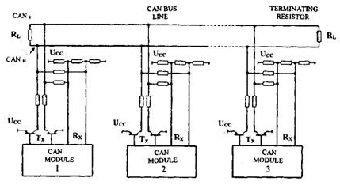 [2]
Above can be seen the CAN bus network connected to various ECU’s or modules, these modules will then switch on the end devices such as lights, motors, actuators. From the main 2 wire bus network there are any an additional pair of cables run directly from the main Bus network which is known as TX or transmitter wires, these wires link from the bus network to a pair of transistors which switch between CAN high 5v and CAN Low 0v. The other pair of wires labelled RX or receiver wires are connected to the CAN network via the load resistors. This system works by causing CAN high and CAN low to assume the same voltage value when a logic 1 is sent, during this state the system is said to be recessive as there is no appreciable difference in voltage between high and low, during this state no action will be taken.
If however a logic 0 is transmitted over the bus the transistor pair will be switch, current will flow and the will be a voltage difference of between 2-3v, during this state the system is said to be dominant and will action the command

A CAN system is a multi-master system meaning there are no master or slave MCU’s. Instead all MCU’s can transmit and receive data over the bus network simultaneously. Each transmission is given a priority number, the lowest priority number will be executed before a higher priority number, for example an ABS sensor may have a number of 100 where as an interior light may have a number of 1000 in this case if both data streams are transmitted at the same time the system will ignore the larger number until the lower number has completed its task and the bus network is back in a recessive state. [4]

This bus network will then run around the vehicle and connect to 5 PIC microcontrollers which will be located at each corner of the car and one in the centre console. A PIC microcontroller has been selected because they offer a large selection of different option, which include CANBUS, analogue and digital I/O and the ability to connect wirelessly to a touch screen. The other reason for this choice is because the university has the software and experience with these micro controllers so the author will have the best environment to learn.
These microcontrollers will then drive a series of MOSFET (Metal Oxide Semiconductor Field Effect Transistor) to switch on the output required such as lights, horn etc., the following MOSFET type transistor are suitable for automotive applications where high load current demands may occur [5].
To integrate this system the MOSFET’s will have to be connected onto a PCB board and wired to the output devices and input signals from the MCU.

3.3 Are there similar systems currently available?
From the research the author has conducted there are similar systems available which offer a generic off the shelf option to install CANBUS onto any vehicle. These systems offer a simply installation procedure and are proven to work, however the cos of such a system can be quite expensive and since there are design as universal it cannot be guaranteed that they will fit each individual car perfectly. [6] From this research the author can conclude that this project is feasible.

4. Project Aim, Objective & Outcomes

4.1 Main Aim
The main aim of this project is to provide a reliable wiring system that will be semi intelligent and be able to be upgraded in the future should this be required.

4.2 Objectives
- Manufacture and install wiring loom
- Incorporate PIC microcontrollers to allow the system to function as designed
- Ensure system works effectively in the real world and as expected
- Gain knowledge and understanding of both microcontroller programming techniques and automotive wiring systems alike.

4.3 Outcomes
At the end of the project, it is expected that a wiring and control system will be installed and tested
The Author will have gained valuable knowledge into automotive wiring, microcontrollers and transistors which will be of great benefit going forward
Completion of real world functional test to ensure all systems work as expected.

5 Project plan

5.1 Project milestones

Below can be seen a rough guide of major project milestones to be completed, if these completion dates are successfully implemented the project outcome should be achieved. A more detailed version will be shown in later section

Tasks: | Major Milestone dates:
Project Proposal | 16/04/2018
Project Plan | 16/04/2018
Research and Investigation | 31/07/2018
Implementation | 20/12/2018
Analysis | 31/01/2018
Evaluation | 10/03/2018
Final Report | 20/04/2018
Final Viva | 16/05/2018

5.2 Project Task breakdown
Major Milestone | Tasks | Task Description | End Date
Project Proposal | Project Proposal | Submit a proposal of project idea, ensure that idea is sound and feasible in nature | 16/04/2018
Project Plan | Research Methodology | Identify the type of research methodology to be used to ensure accurate data can be used | 16/04/2018
Project Plan | Produce Gantt Chart | Produce a detailed Gantt chart that includes major project milestone dates/deadlines. | 26/04/2018
Research and Investigation | Benefit Analysis | Describe how the project will be of benefit | 14/07/2018
Research and Investigation | Market Research | Research existing technologies and if there is a direct comparison available | 10/08/2018
Research and Investigation | Component Selection/Research | Research what components are available within the automotive sector and why the specific components have been chosen | 30/08/2108
Research and Investigation | Cost Research | Compare cost of an off the shelf solution with project, research component costs and approx. total project cost | 13/09/2018

Implementation | Prototype Simulation | Design a prototype circuit using simulation software. | 20/09/2018
Implementation | Source components | Source and obtain all components as per the prototype circuit | 27/09/2018
Implementation | Write PIC code | Design PIC code and upload | 22/11/2018
Implementation | Assemble CANBUS network | Mount PIC on PCB and wire in CANBUS. | 29/11/2018
Implementation | Build Local controllers | Assemble local controllers with MOSFET’s | 20/12/2018
Implementation | Test | Test system works as expected. | 20/12/2018
Analysis | Functional analysis | Ensure data from device is what was expected | 10/01/2019
Analysis | Validate data/ Update Design | Complete update modifications if needed and retest to ensure correct operation. | 14/02/2019
Evaluation | Project Conclusion | Sum up the project, was it a success, what could have been done better | 28/02/2019
Evaluation | Review Gantt chart | Compare Gantt estimated time scale with actual and give reasons for any differences. | 14/03/2019
Evaluation | Student development | What skills/development has been gained from completion of the project? | 28/03/2019
Evaluation | Self-evaluation | What could have been improved on should the project be done again | 04/04/2019
Final Report | Final Report | Final Report | 25/04/2019
Final Viva | Final Viva | Final Viva | 02/05/2019

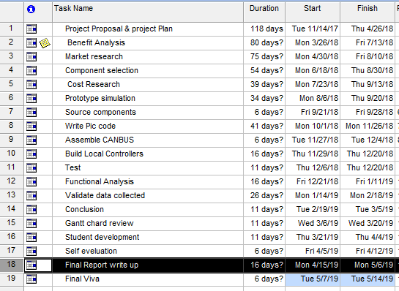
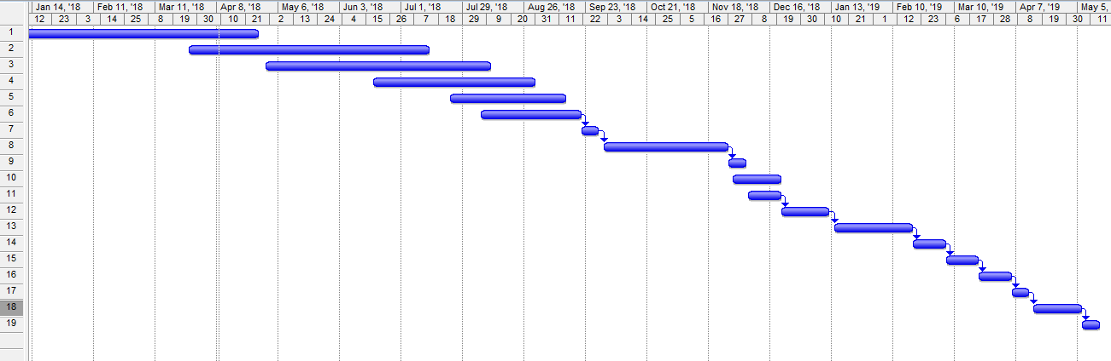

6 Project Requirements

6.1 Hardware (basic requirements)
Capacitors
Resistors
Fuses
Thin wall automotive cable
Automotive connectors
PCB boards x 5
PIC controller x 5
MOSFET’s
7” touch screen
Blue tooth adaptor for PIC

6.2 Software
CCS Compiler
MPLAB
Proteus
Microsoft excel
Microsoft word
Microsoft project

7 Cost Analysis
At this stage exact cost have not yet been established however a rough overall cost has been calculated based of the value of individual components however this is subject to change as the design evolves. It is estimated that the project will cost circa £600, the majority of this cost being the thin wall cable and electric connectors,
This estimate is based off PIC costs $1.51 x 5 = $7.55 [7]
MOSFET £1.88 x 10 = £18.88 [8]
I have then allowed £75 for the PCB and capacitors/resistors and £400 for wiring and connector components however the author has had two quote to compare against project costs 1 being for a conventional wiring system and one for a off the shelf CANBUS system. Both the quote are in excess of £2000 so finically the project is a viable option.

8 Research
During the project it is important that the correct information is used to ensure that the project outcomes are meet. In order to do this successful a proven research method should be used so that the data gathered is relevant and useful. The author has chosen to use the 'research onion’ that was developed by Saunders et al. (2007). [7]
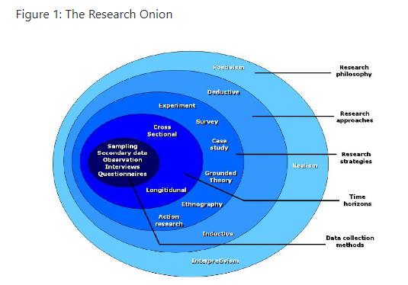

As the name suggests this methodology has clearly defined layers much like an onion, these layers include

8.1 Research Philosophy’s

There are two main types of philosophy’s positivism and constructionism, for this project the positivism philosophy will be used since research can be conducted on systems that currently exist and then modified to suit the authors individual needs.

8.2 Research approach

A Quantitative Approach will then be used for the data collection as this approach works well when there is statistical data to analysis such as input/output commands

8.3 Research Strategy
Due to the nature of the project an experimental research strategy will be used since different circuits/components can be used and tested to determine the best outcome and desired result

8.4 Choices
A multimethod approach will be used since there is likely to be multiple data sheets created for the various components used in the system.

8.5 Time Horizon
This defines the timeframe in which the project is to be completed.
A cross section horizon approach will be used in this project, this method has been chosen since the data will be collected from a specific point in time i.e. when conducting testing on the PIC of control circuit, this data will then not change with time hence the reason for the method choice

8.6 Data Collection
Both primary and secondary data will be used in different stage of this project. Secondary will be used more so at the beginning of the project when a greater understanding of current circuit design and components is being research. Primary will then be used later on in the project as this is data that will be derived from practical testing and experimentation.

Works Cited

[1] | wikipedia, “wikipedia,” 09 2017. [Online]. Available: https://en.wikipedia.org/wiki/Automotive_electronics. [Accessed 12 03 2018].
[2] | Unknown, “HOW-WHAT-WHEN.COM,” UNKNOWN UNKNOWN. [Online]. Available: http://what-when-how.com/automobile/vehicle-circuits-and-systems-automobile/. [Accessed 12 03 2018].
[3] | Unknown, “https://www.can-cia.org/can-knowledge/can/can-history/,” Unknown Unknown. [Online]. Available: https://www.can-cia.org/can-knowledge/can/can-history/. [Accessed 12 03 2018].
[4] | T. I. Incorporated, “http://www.ti.com,” 05 2016. [Online]. Available: http://www.ti.com/lit/an/sloa101b/sloa101b.pdf. [Accessed 12 03 2018].
[5] | Digikey, “Digikey.com,” Unknown Unkown Unknown. [Online]. Available: https://www.digikey.com/products/en?keywords=bts50080-1teaind. [Accessed 13 03 2018].
[6] | I. b. system, “Infintity box,” Unknown Unknown Unkown. [Online]. Available: https://infinitybox.com/. [Accessed 13 03 2018].
[7] | Unknown, “Microchip,” Unknown. [Online]. Available: http://www.microchip.com/ParamChartSearch/Chart.aspx?branchID=1012. [Accessed 20 03 2018].
[8] | Unknown, “Digikey,” Unknown Unknown Unknown. [Online]. Available: https://www.digikey.co.uk/product-detail/en/infineon-technologies/BTS500801TEAAUMA1/BTS500801TEAAUMA1CT-ND/2269926 . [Accessed 20 03 2018].
[9] | Unkown, “Ukessays,” 18 May 2017. [Online]. Available: https://www.ukessays.com/essays/psychology/explanation-of-the-concept-of-research-onion-psychology-essay.php. [Accessed 20 03 2018].

