ACCC4004 INFORMATION ENGINEERING
Student Name: Dumitru Radu Chirca
Student ID:1818843
Table of Contents
Introduction 4
Task 1 5
Table Structures 9
Task 2 12
Tables 12
Table Forms 15
Table Reports 19
Table Queries 21
Brief User Guide 23
Conclusion 24
References 25

Figures
Figure 1: Given ERD 5
Figure 2: Entity Relationship Diagram 6
Figure 3: Vendors 9
Figure 4: Properties 9
Figure 5: Sales 9
Figure 6: Offers 9
Figure 7: Estate Agent 10
Figure 8: Viewing 10
Figure 9: Buyers 10
Figure 10: Branch 10
Figure 11: Vendors 12
Figure 12: Branch 12
Figure 13: Buyers 12
Figure 14: Sales 13
Figure 15: Offers 13
Figure 16: Estate Agent 13
Figure 17: Sales 13
Figure 18: Properties 14
Figure 19: Sales Form 15
Figure 20: Vendors Form 15
Figure 21: Properties 16
Figure 22: Offers 16
Figure 23: Buyers 17
Figure 24: Branch 17
Figure 25: Estate Agent 18
Figure 26: Viewing 18
Figure 27: Branch Report 19
Figure 28: Buyer Report 19
Figure 29: Estate Agent Report 19
Figure 30: Offers Report 19
Figure 31: Properties Report 20
Figure 32: Sales Report 20
Figure 33: Vendors Report 20
Figure 34: Viewing Report 20
Figure 35: Output 1 21
Figure 36: Output 2 21
Figure 37: Output 3 22
Figure 38: Output 4 22
Figure 39: Output 5 22

Introduction
The assessment is based on the case study that is provided on “Home from Home” which is an estate agent that operates in South Wales. The complete solution of the scenario is added in this report that includes the tasks provided. Entity Relationship diagram, database creation, query optimization, normalization and many components of the database are added in the file. Moreover, the forms, reports, and tables generated by using Ms Access are attached in the provided report. Some SQL queries are also added so that the output of the queries can be understood clearly along with the query that is used. The complete assessment will help in enhancing the knowledge in the field of the database management system.

Task 1

Figure 1: Given ERD
This is the given entity-relationship diagram that is provided for the scenario of real estate.
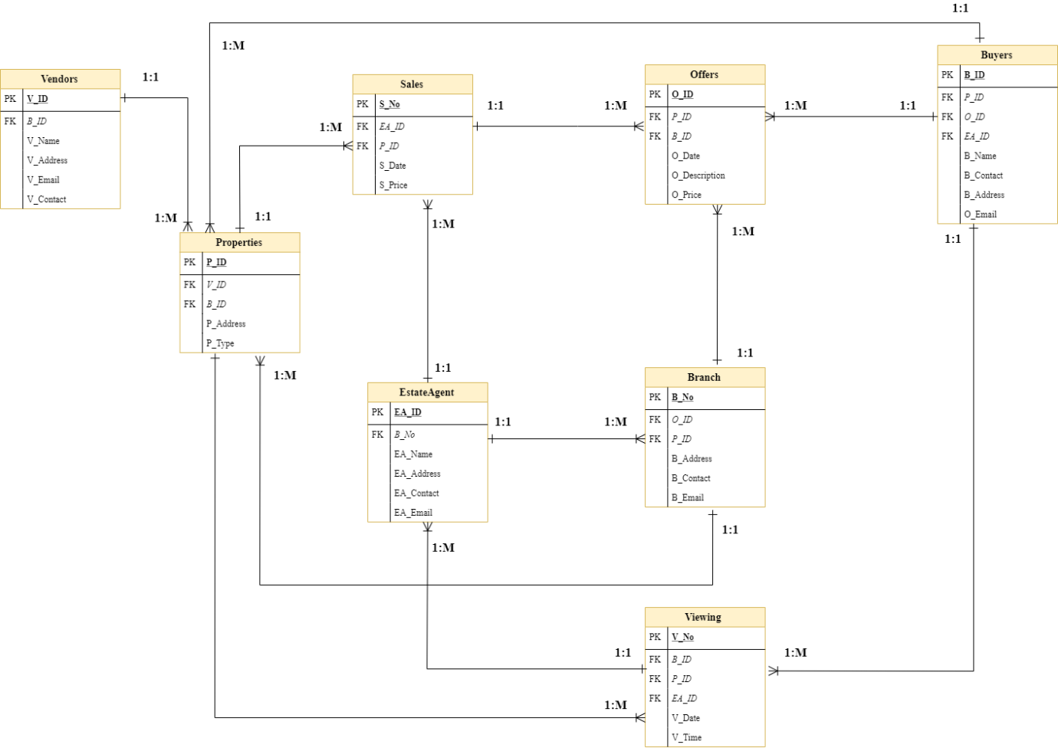
Figure 2: Entity Relationship Diagram
A total number of entities are eight that are interconnected with each other and they are listed here as:
- Vendors
- Sales
- Offers
- Buyers
- Properties
- Estate Agent
- Branch
- Viewing
All these are connected with one-to-many relationship and some of these relationships are listed here:
- Properties and Sales
- Sales and Offers
- Vendors and Properties
- Buyers and Viewing
- estate agent and Viewing
- Buyers and Properties
- Properties and Viewing
And similarly, many can be seen by the given entity-relationship diagram that is shown above (Guagliardo and Libkin, 2017).
Tables
Vendors are the table that has different constraints like a primary and foreign key. V_ID is primary key and B_ID is foreign key. There are many attributes that are present as well which will store the information of vendors.
Sales are the table that has different constraints like a primary and foreign key. S_No is primary key and EA_ID and P_ID are foreign keys. There are many attributes that are present as well which will store the information of Sales.
Offers is the table that has different constraint like a primary and foreign key. O_ID is primary key and B_ID and P_ID are foreign keys. There are many attributes that are present as well which will store the information of Sales (Al-Masree, 2015).
Buyers are the table that has different constraints like a primary and foreign key. B_ID is primary key and O_ID, P_ID and EA_ID are foreign keys. There are many attributes that are present as well which will store the information of Sales (Ma et al., 2018).
Properties are the table that has different constraints like a primary and foreign key. P_ID is primary key and V_ID and B_ID are foreign keys. There are many attributes that are present as well which will store the information of Sales.
Estate Agent is the table that has different constraints like the primary and foreign keys. EA_ID is primary key and B_No is foreign key. There are many attributes that are present as well which will store the information of Sales.
The branch is the table that has different constraints like the primary and foreign keys. B_No is primary key and O_ID and P_ID are foreign keys. There are many attributes that are present as well which will store the information of Sales (Soumiya and Mohamed, 2017).
Viewing is the table that has different constraints like the primary and foreign keys. V_No is primary key and EA_ID, B_ID and P_ID are foreign keys. There are many attributes that are present as well which will store the information of Viewing.

Table Structures
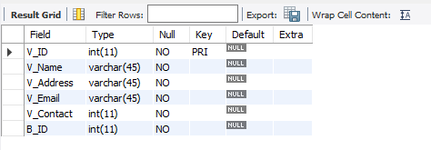
Figure 3: Vendors
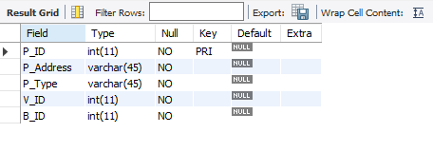
Figure 4: Properties
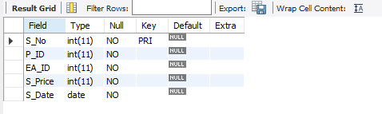
Figure 5: Sales
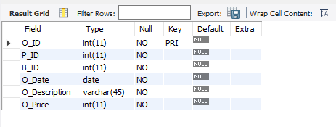
Figure 6: Offers
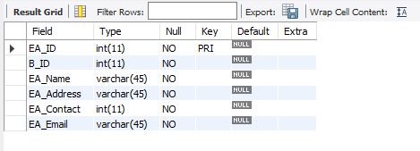
Figure 7: Estate Agent
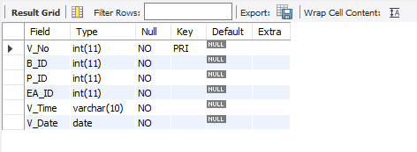
Figure 8: Viewing
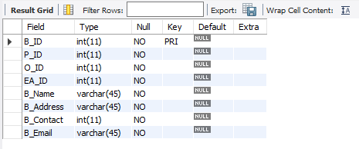
Figure 9: Buyers
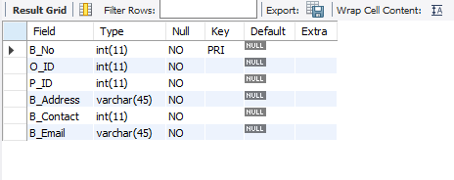
Figure 10: Branch
Foreign key Constraints:
There are various foreign keys that are present in the created database entity relationship diagram and some of them are shown here with the help of Alter command:
Alter table Branch add foreign key (O_ID) references Offers(O_ID);
Alter table Branch add foreign key (P_ID) references Properties(P_ID);
Alter table EstateAgent add foreign key (B_ID) references Branch(B_No);
Alter table Viewing add foreign key (EA_ID) references EstateAgent(EA_ID);
Alter table Properties add foreign key (V_ID) references Vendors(V_ID);
Alter table Buyers add foreign key (P_ID) references Properties(P_ID);
Alter table Sales add foreign key (P_ID) references Properties(P_ID);
Alter table Sales add foreign key (EA_ID) references EstateAgent(EA_ID);

Task 2

Tables
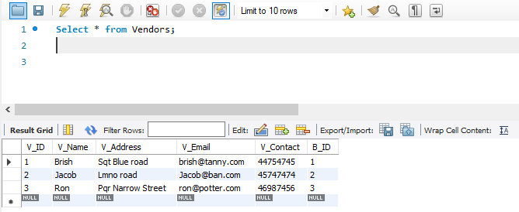
Figure 11: Vendors
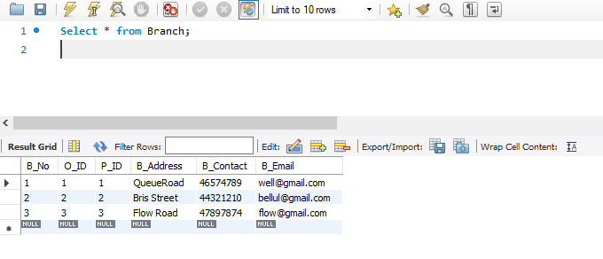
Figure 12: Branch
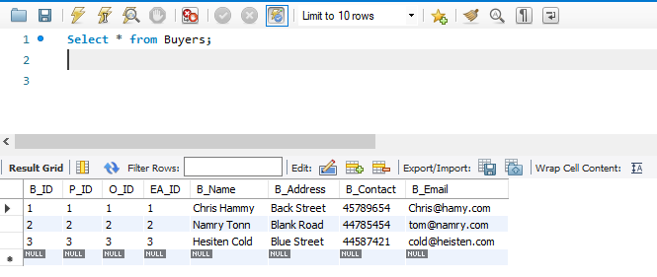
Figure 13: Buyers
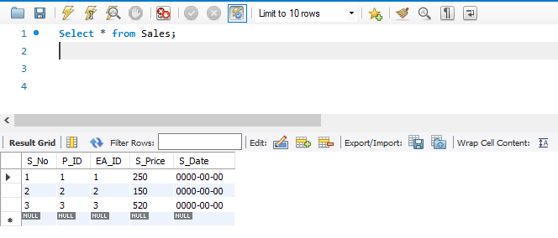
Figure 14: Sales
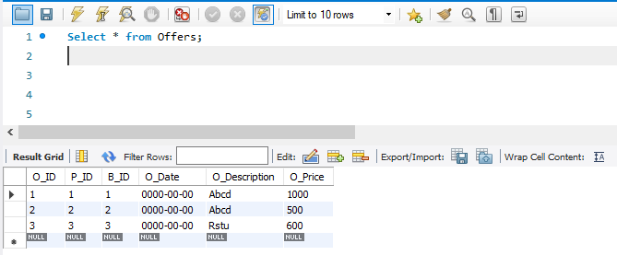
Figure 15: Offers
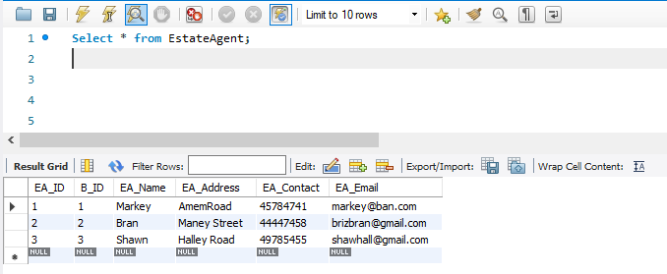
Figure 16: Estate Agent
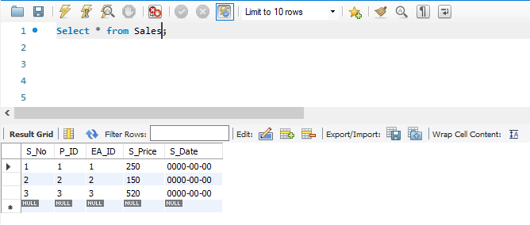
Figure 17: Sales
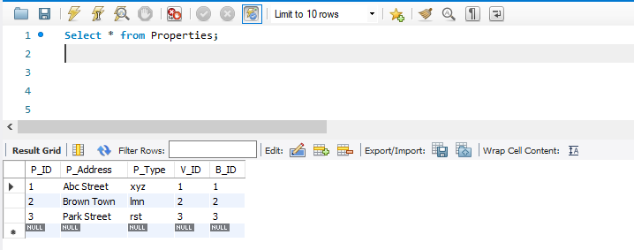
Figure 18: Properties
All these tables are used for completion of the database and some of the sample data has been inserted in the created table so that the complete table can be formed. All tables have 3-4 sample data which is shown by the help of screenshots provided above.

Table Forms
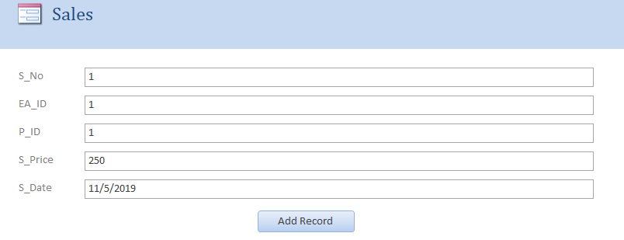
Figure 19: Sales Form
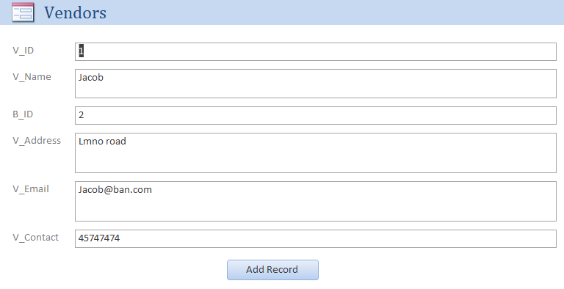
Figure 20: Vendors Form
(Yang and Cao, 2016)
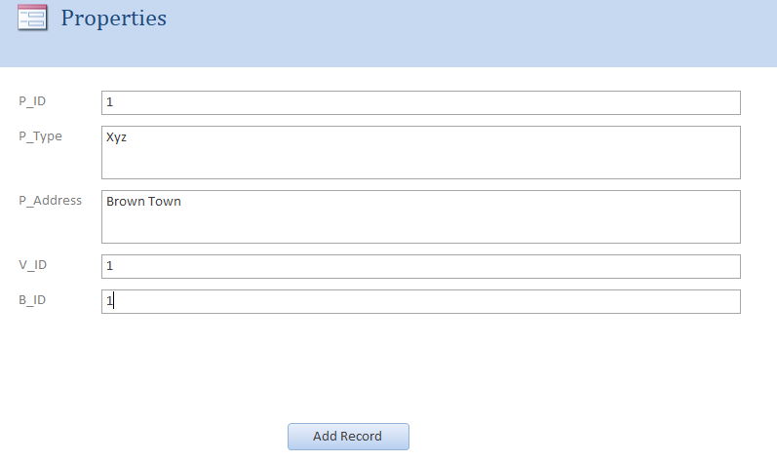
Figure 21: Properties
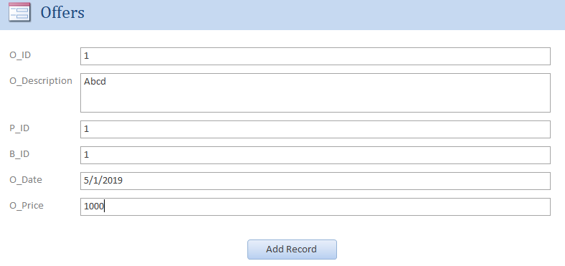
Figure 22: Offers
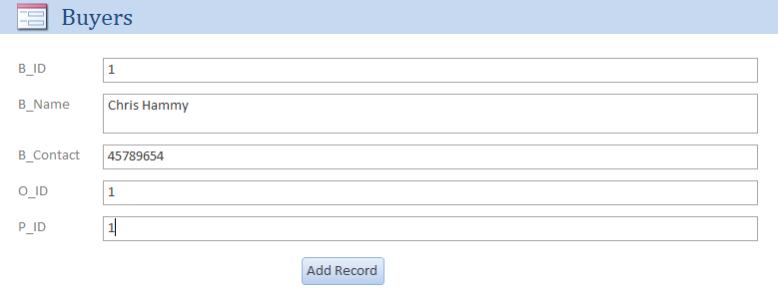
Figure 23: Buyers
(Shang et al., 2017)
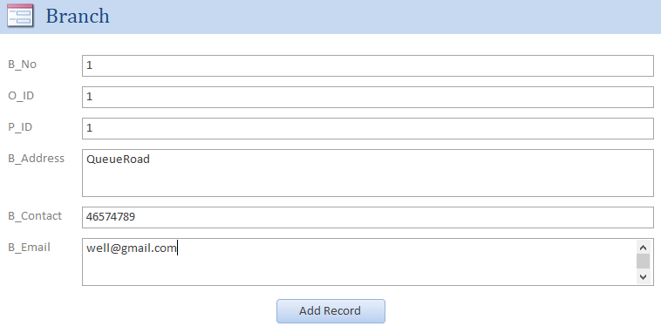
Figure 24: Branch
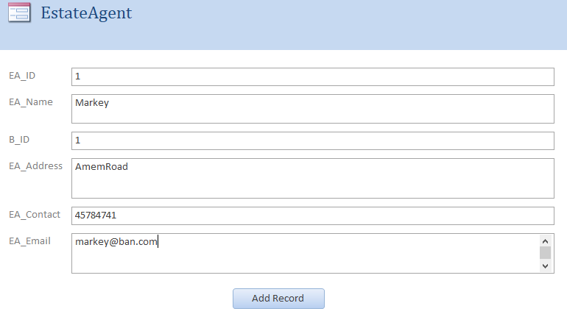
Figure 25: Estate Agent
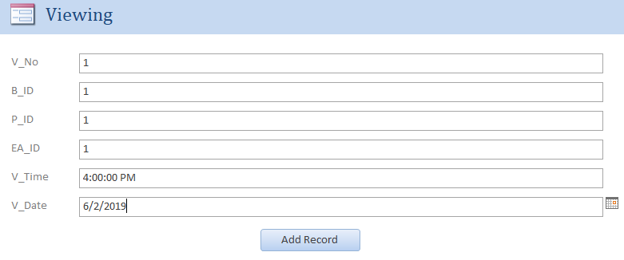
Figure 26: Viewing
All these were eight different forms that are generated by using the Ms Access tool for every table that is present (Lembo et al., 2018).

Table Reports
There are reports that are generated by using MS Access that is attached here in the form of screenshots. All the report contains the attributes that are present in the tables.
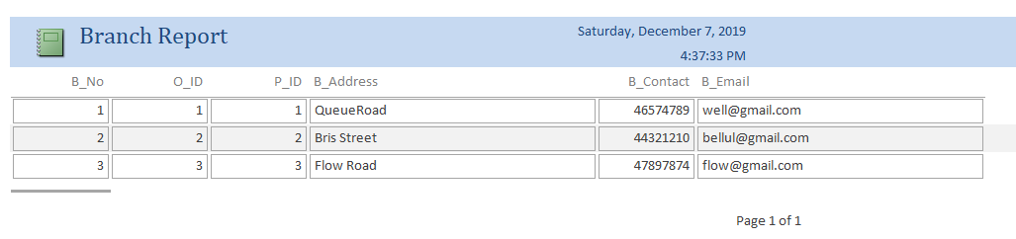
Figure 27: Branch Report
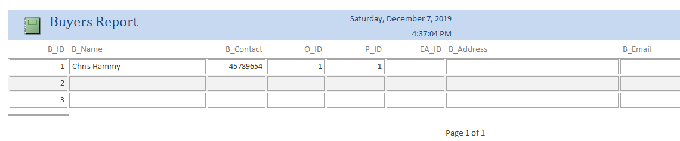
Figure 28: Buyer Report
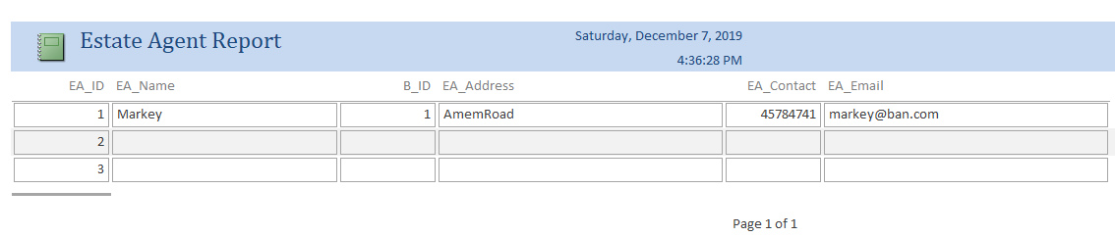
Figure 29: Estate Agent Report
(Kuzi et al., 2016)
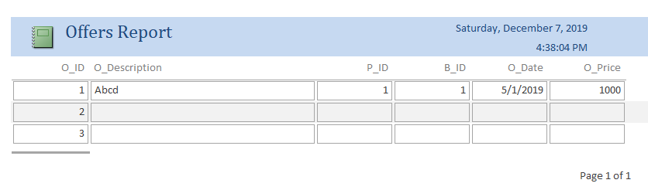
Figure 30: Offers Report
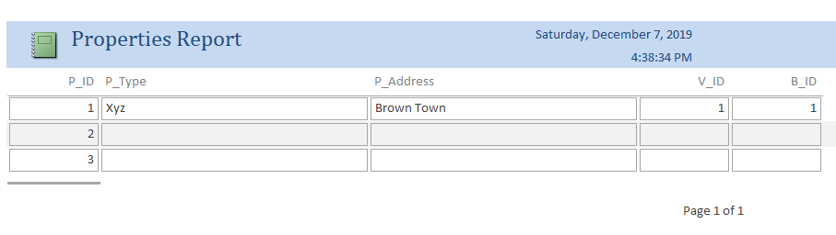
Figure 31: Properties Report
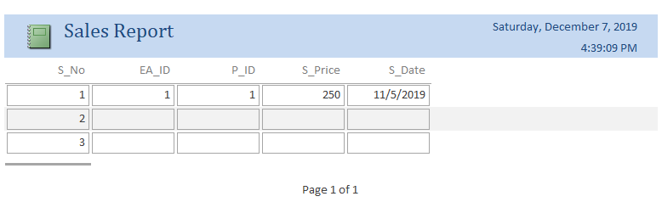
Figure 32: Sales Report
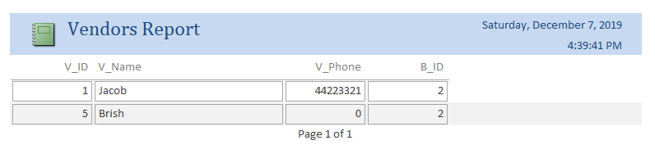
Figure 33: Vendors Report
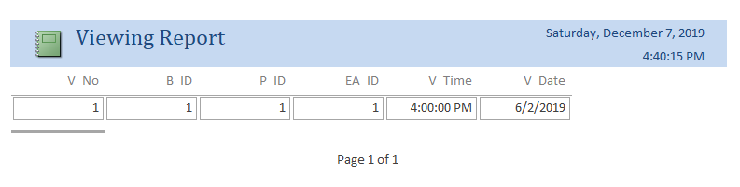
Figure 34: Viewing Report

Table Queries
Query 1: Buyers Query
Select Buyers.[B_Name], Buyers.[B_Email]
FROM Buyers where Buyer.[B_Contact] in ('45789654') ;
Output:
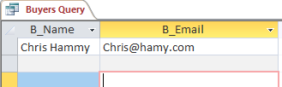
Figure 35: Output 1
Query 2: Estate Agent Query
SELECT EstateAgent.[EA_Name], EstateAgent.[EA_Email]
FROM EstateAgent where EstateAgent.[B_ID] = 1;
Output:
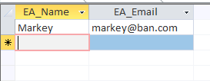
Figure 36: Output 2
Query 3: Sales Query
SELECT Sales.[S_Price], Sales.[S_Date]
FROM Sales where Sales.[EA_ID] = 1;
Output:
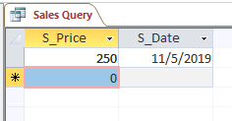
Figure 37: Output 3
Query 4: Properties Query
SELECT Properties.[P_ID], Properties.[P_Type], Properties.[P_Address],
Properties.[V_ID], Properties.[B_ID]FROM Properties;
Output:
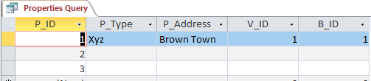
Figure 38: Output 4
Query 5:
SELECT Vendors.[V_Name], Vendors.[V_Contact]
FROM Vendors where B_ID = 2;
Output:
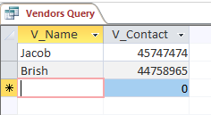
Figure 39: Output 5

Brief User Guide
The user can get to know about the complete database that is designed on the case scenario which is provided and related to the real estate company. In this report, the creation and implementation of the database along with forms, reports, and queries are added and all the screenshots of the completed work are provided in the report. The diagram is also formed which is known as entity relationship diagram which is displaying all the relationships that are present in the tables. Formation of reports, forms, queries are shown in the above file after the creation of the complete database by using the workbench.

Conclusion
The complete report concludes the formation of the database containing eight different tables that were provided in the given entity relationship diagram. The report has the practical implementation of multiple components that include table creation, table forms, table reports, and queries. The output of the queries is shown by the help of screenshot, the diagram is pasted in the report tools used for completion of the assignment required Ms Visio, Workbench to create the database and Ms Access to create different forms and reports. The completion of the assignment provided proper and deep knowledge of database management system with the implementation of it.

References
Al-Masree, H.K., 2015. Extracting Entity Relationship Diagram (ERD) from relational database schema. International Journal of Database Theory and Application, 8(3), pp.15-26.
Guagliardo, P. and Libkin, L., 2017. A formal semantics of SQL queries, its validation, and applications. Proceedings of the VLDB Endowment, 11(1), pp.27-39.
Kuzi, S., Shtok, A. and Kurland, O., 2016, October. Query expansion using word embeddings. In Proceedings of the 25th ACM international on conference on information and knowledge management (pp. 1929-1932). ACM.
Lembo, D., Rosati, R. and Savo, D.F., 2018, September. A Comprehensive Framework for Controlled Query Evaluation, Consistent Query Answering and KB Updates in Description Logics. In Sixteenth International Conference on Principles of Knowledge Representation and Reasoning.
Ma, L., Van Aken, D., Hefny, A., Mezerhane, G., Pavlo, A. and Gordon, G.J., 2018, May. Query-based workload forecasting for self-driving database management systems. In Proceedings of the 2018 International Conference on Management of Data (pp. 631-645). ACM.
Shang, Z., Li, J., Zhang, P., Song, D. and Wang, B., 2017, July. How Users Select Query Suggestions Under Different Satisfaction States?. In China Conference on Information Retrieval (pp. 93-105). Springer, Cham.
Soumiya, A.E.H. and Mohamed, B., 2017. Converting UML class diagrams into temporal object relational database. International Journal of Electrical and Computer Engineering, 7(5), p.2823.
Yang, L. and Cao, L., 2016. The Effect of MySQL Workbench in Teaching Entity-Relationship Diagram (ERD) to Relational Schema Mapping. International Journal of Modern Education and Computer Science, 8(7), p.1.

