Building a sustainable Employment
Halema begum 1816637
Lecturer Chloe Harris

Change makers


Contents
1
INSTRUCTIONS 4
HEADING TWO 5

Cover letter and Cv

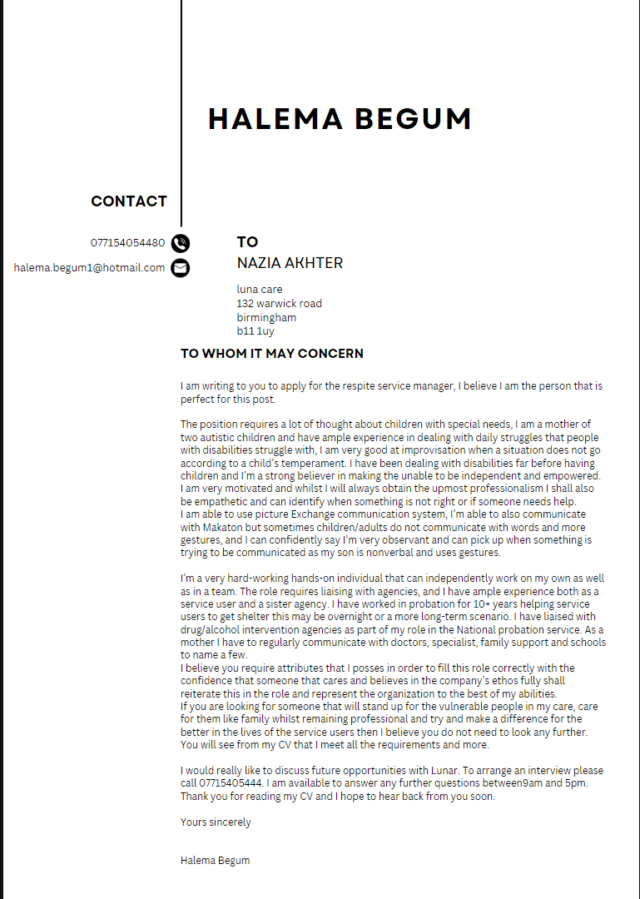

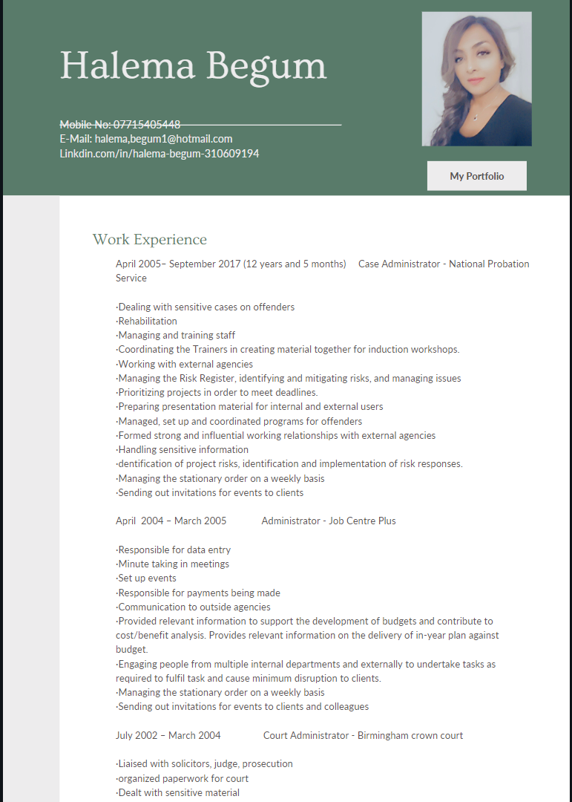

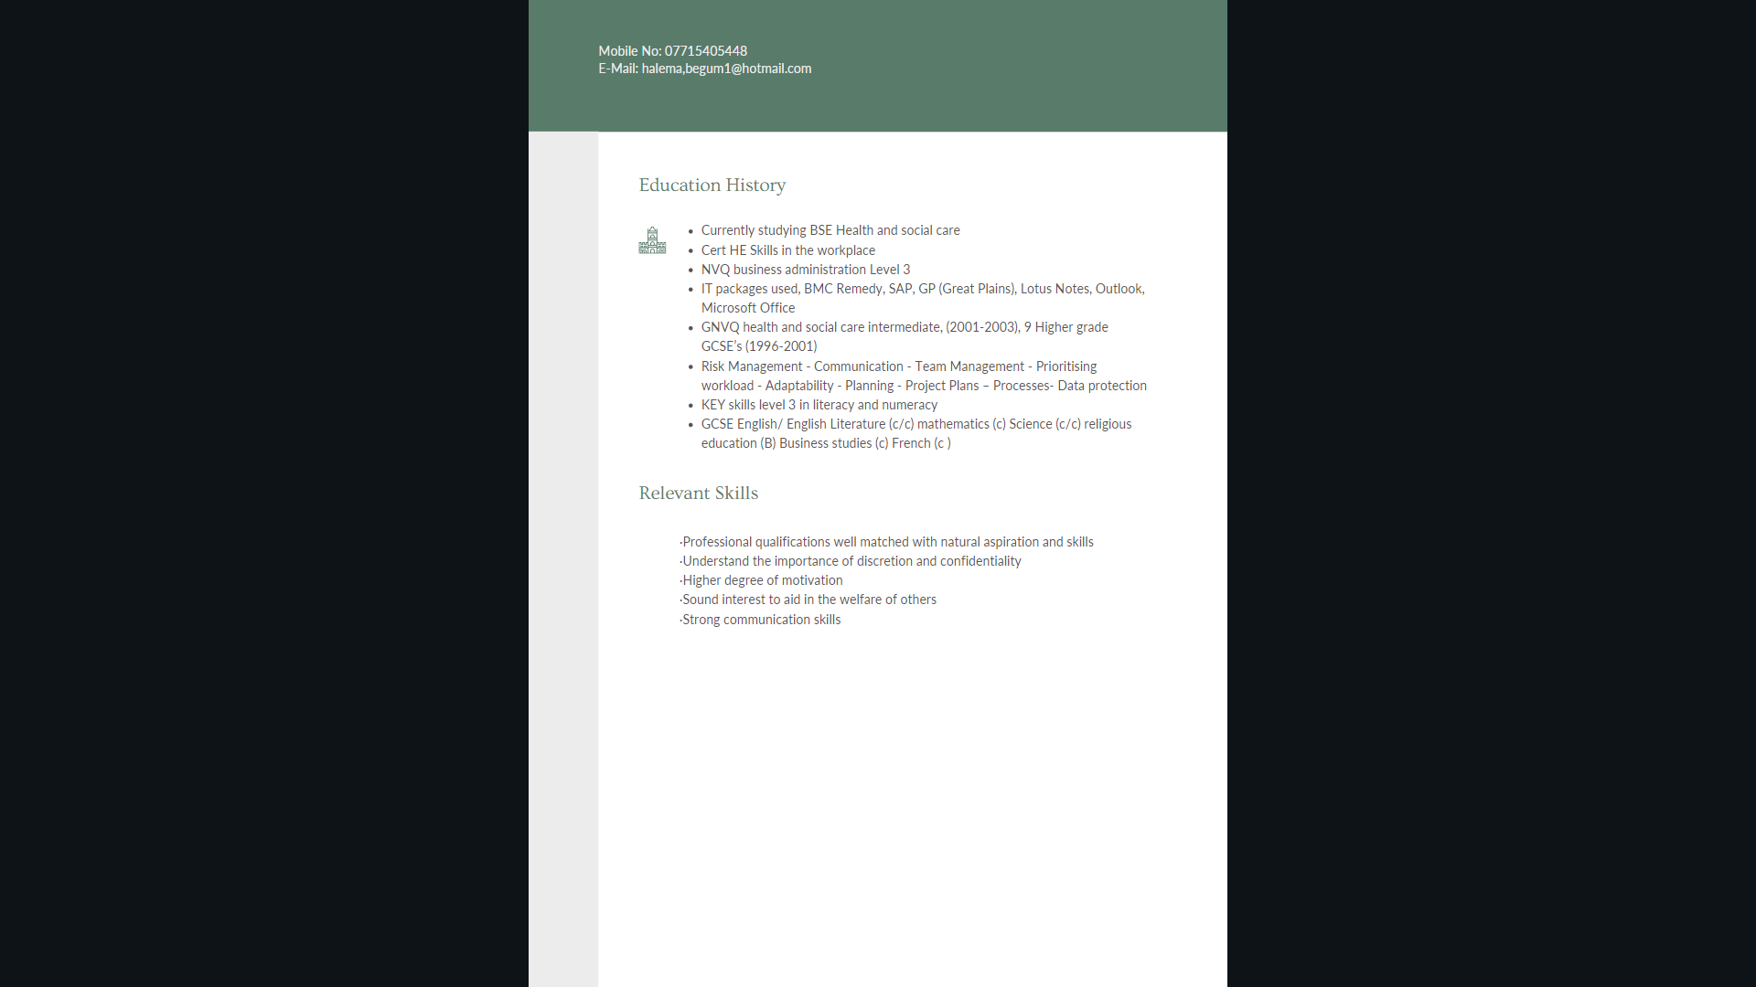

Pitch

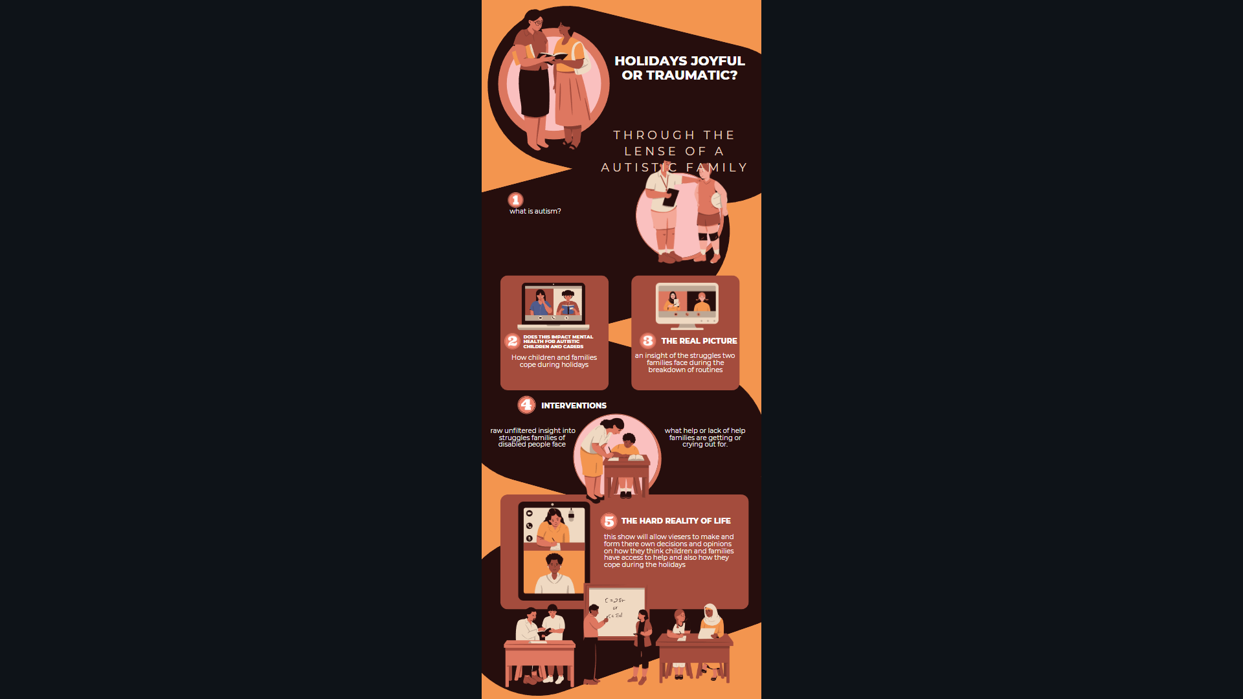
Documentary name- Holidays- joyful or traumatic

Intention – the documentary will look at children with autism? and their families and what struggles families and individuals face

Synopsis – the documentary will be broken down into three parts, a narrative of what autism is, how children and families cope and an interview with two different families to discuss the struggles or triumphs during holidays.

What is Autism?

Autism is a neurodevelopmental disorder (Livingston et al.,2017) that effects a person’s communication skills. (Lord et al., 2018) Autism is usually diagnosed during childhood (Carbone et al., 2020) compared to 40 years ago as there is a lot more awareness in today’s society. Autism has a whole month dedicated to it for this cause (DeVilbiss., 2014). Many families that have a newborn would not know the signs for autism in a toddler and by raising awareness it helps families to get relevant help for the child even if this is simply a diagnosis. The severity of autism is different from person to person. Autism is usually has attached diagnosis (Kabot et al.,2003) such as learning disability, attention deficit hyperactive disorder (ADHD). Parents usually notice signs as some children may show developmental delays (Estes et al., 2009) and typical signs of Autism such as not responding to their own name, not making eye contact not babbling or cooing (Rosenberg, 2022).
Autism is a lifelong condition (Matson et al.,2011) and is not miraculously cured or you don’t grow out of it as some communities believe. But whilst the individuals with the condition face challenges so do the family caring for them, dependent on needs of the child and level of functioning will depend on how little or how much help is required. Some families live’s purely revolve around the child they have with additional needs. If the family decide to extend their family there is a higher likelihood of the following child having a diagnosis of autistic (Waye et al., 2017). Some families deter from having another child due to the care needs being so high.

How children and families cope during holidays?
People thrive when a routine is in place and it allows for a person to feel somewhat independent as it allows a person to know what is expected and what is due to come, this routine is needed even more so with autistic children as any change can throw them off course and derail the whole day and sometimes they cannot verbalize how even the smallest change has impacted them so drastically

Respite is rest from caring duties and whilst some are granted this by children/adult services there are some that do not qualify or meet these needs, according to children/ adult services criteria. Whilst one or two weeks can be manageable 6 weeks can have a detrimental strain on physical and emotional wellbeing as researched by Vandepitte et al. This could impact the level of care that is given to the individual requiring care. Research by van Exel states that caregivers do not ask for help unless it is a last resort and the ability to caring for an individual is becoming impossible.

Holidays. Joyful or stressful

Whilst it is a joy for parents not having to wake up to the dreaded school run, this is not often the case for parents of children with special needs in this instance autism. This will be an interview of families with autistic children and possibly the autistic child dependent on the communication levels.

A lot of parents to neuro typical children will state the toll it takes on their mental health trying to keep the children occupied this is amplified when having a child with autism.

Working parents of school aged children may also find it very difficult to find childcare so this will hinder their work life balance. Parents are quite reluctant to leave their children with strangers and this is especially the case when leaving a child with autism as not everyone understands autism or the challenges a child may face so taking the child to a childminder or a nursery may not be an option.

Children and adults with autism thrive off routine and this does not change in the holidays. But having a slight change in routine or planned activities can lead to meltdowns not being able to cope with what seems like a simple change. When planning for 6 weeks can be near enough impossible unless you are planning the year ahead and even then things do change. During the school break appointments and therapies must also continue.

Families that have extra caring responsibilities with an autistic child social isolation is often part of there lives as caring responsibilities restrict from mixing in social gathering and this can result impacting mental health such as depression feeling socially isolated. Finding acceptance from people is hard especially when they can not comprehend what the family dynamics are and the actual care that is required.

Interview with children services manager- this will enable viewers to get a professional input into what is available during school closures for children with special educational needs and maybe delve into areas that are lacking or could possibly be improved.

Conclusion
The is no good or bad outcome but it opens the eyes of viewers to highlight what parents with Autistic children go through. It also allows viewers to gain some internal knowledge of situations that they may not be otherwise accustomed to. Awareness of any disability is a good concept, and it also allows for families suffering in silence to have some solace that they are not suffering alone and there are others out there facing similar battles.

Reference

Carbone, P., Campbell, K., Wilkes, J., Stoddard, G., Huynh, K., Young, P. and Gabrielsen, T., 2020. Primary Care Autism Screening and Later Autism Diagnosis. Pediatrics, 146(2).

DeVilbiss, E. and Lee, B., 2014. Brief Report: Trends in U.S. National Autism Awareness from 2004 to 2014: The Impact of National Autism Awareness Month. Journal of Autism and Developmental Disorders, 44(12), pp.3271-3273.

Estes, A., Munson, J., Dawson, G., Koehler, E., Zhou, X. and Abbott, R., 2009. Parenting stress and psychological functioning among mothers of preschool children with autism and developmental delay. Autism, 13(4), pp.375-387.

Kabot, S., Masi, W. and Segal, M., 2003. Advances in the diagnosis and treatment of autism spectrum disorders. Professional Psychology: Research and Practice, 34(1), pp.26-33.
Livingston, L. and Happé, F., 2017. Conceptualising compensation in neurodevelopmental disorders: Reflections from autism spectrum disorder. Neuroscience &amp; Biobehavioral Reviews, 80, pp.729-742.

Lord, C., Elsabbagh, M., Baird, G. and Veenstra-Vanderweele, J., 2018. Autism spectrum disorder. The Lancet, 392(10146), pp.508-520.

Matson, J. and Kozlowski, A., 2011. The increasing prevalence of autism spectrum disorders. Research in Autism Spectrum Disorders, 5(1), pp.418-425.

Rosenberg, K., 2022. Preemptive Intervention Beneficial for Infants with Early Signs of Autism. AJN, American Journal of Nursing, 122(2), pp.50-50.

van Exel, J., de Graaf, G. and Brouwer, W., 2008. Give me a break!. Health Policy, 88(1), pp.73-87.

Vandepitte, S., Van Den Noortgate, N., Putman, K., Verhaeghe, S., Verdonck, C. and Annemans, L., 2016. Effectiveness of respite care in supporting informal caregivers of persons with dementia: a systematic review. International Journal of Geriatric Psychiatry, 31(12), pp.1277-1288.

Waye, M. and Cheng, H., 2017. Genetics and epigenetics of autism: A Review. Psychiatry and Clinical Neurosciences, 72(4), pp.228-244.

