Technical report for a carbon fibre bonnet.
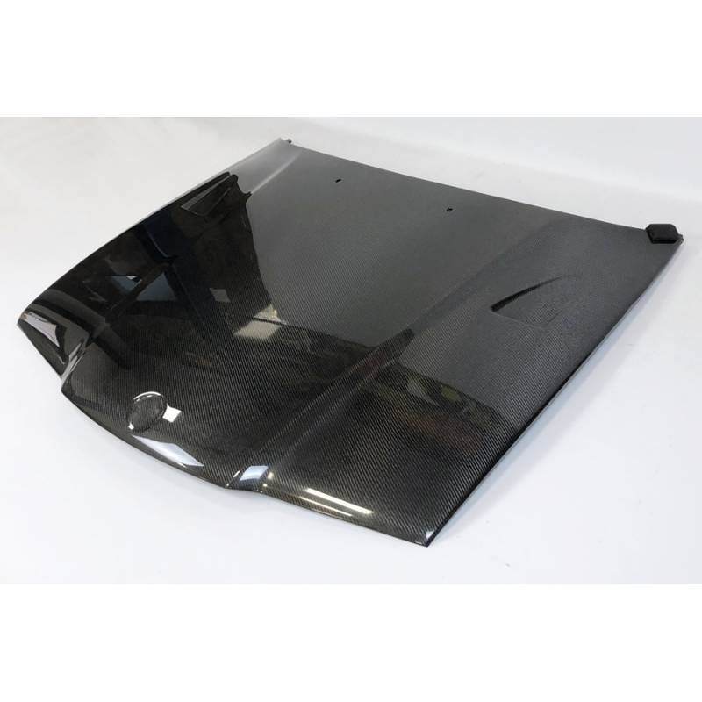

Contents page.
- Contents page………………………………………………………………………………………………………………………2
- Introduction…………………………………………………………………………………………………………………………3
- Engineering team structure…………………………………………………………………………………………………4
- Product development……………………………………………………………………………………………………………7
- Issues, legislation and standards…………………………………………………………………………………………10
- Personal development ………………………………………………………………………………………………………12
- Conclusion.................................................................................................................................13
- Reference list………………………………………………………………………………………………………………………14

Introduction.
In this report I will be writing about how I will be structuring a team to develop a carbon fibre bonnet. I will also talk about the development of the product. For this I will be considering how I will approach problems and solve them. I will be talking about the legislation that is required to be followed when manufacturing the product. Also I will mention industry standards.
I will write a personal development plan that will give one place where I need to work on to become a more effective team leader in an engineering environment. A small conclusion will follow, stating what I have learnt from working in a team.

Engineering team structure.
- I will be using research to demonstrate the type of team that I will need to develop my product. I will be mentioning the professional codes of conduct that all engineers must undertake.
- According to www.Zoltek.com, roughly 90% of all carbon fibres are made of polyacrylonitrile (PAN).
- The remainder of carbon fibres mass produced today are made from rayon or petroleum pitch.
- Although they have their differences, they are still both organic polymers and can be characterized by the long strings of molecules bound by tight carbon atoms

- Spinning is the first stage that will need to be done in order to complete. It consists of mixing in polyacrylonitrile (PAN) with other ingredients and are then spun into fibres that are washed and stretched.
- The stabilizing of the material -simply consists of making a chemical alteration to the material to make it more stable when bonding.
- Carbonising the material consists of stabilised fibres, heated to high temperatures to form tightly bonded carbon crystals.
- Oxidising the material is composed of adding oxygen to the surface of the material to roughen the edges slightly and give the surface of the material a mechanical bonding property.

Based on the steps above, It is clear to see that there are different components to manufacturing carbon fibre. Each of the processes take a severe amount of skill and knowledge. To create a team based around the production of a carbon fibre bonnet for a car will take more than just the carbon fibre developing team. Someone will have to measure the original Bonnet. Someone will also need to make mould based off of the original bonnet. As well as this, there will also need to a mould that we can lay the carbon fibre around. This mould has to be very accurate and precise in terms of measurements.
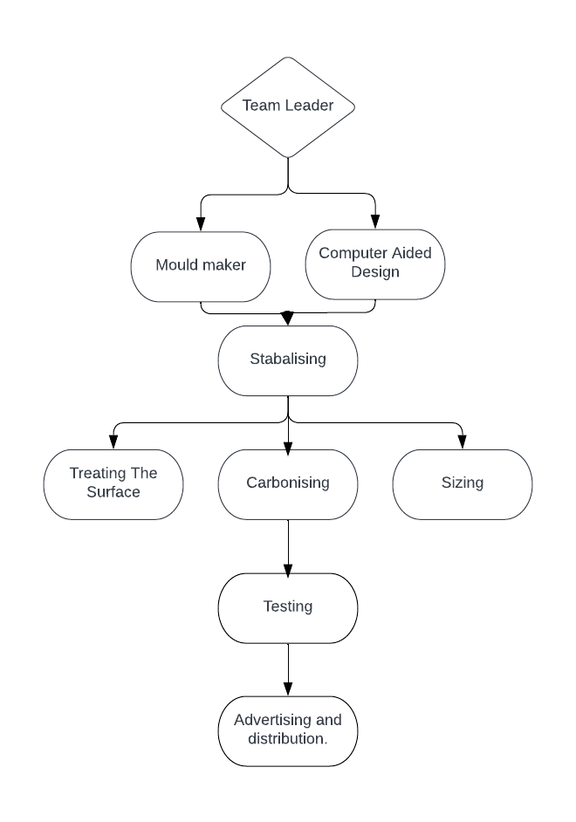

Here I have listed all the recognised. They are in the same order as they would on the production line.
I have put them in this specific order because each one that is listed must be completed before the next process can begin.

An engineer’s code of conduct.

1. Honesty and integrity
- Engineering professionals have a duty to uphold the highest standards of professional conduct including openness, fairness, honesty and integrity.

2. Respect for life, law, the environment and public good
- Engineering professionals have a duty to obey all applicable laws and regulations and give due weight to facts, published standards and guidance and the wider public interest.

3. Accuracy and rigour

Engineering professionals have a duty to acquire and use wisely the understanding, knowledge and skills needed to perform their role.

4. Leadership and communication
- Engineering professionals have a duty to abide by and promote high standards of leadership and communication.

Product development.
Below I will be writing a detailed step by step plan to manufacturing and distribution of the product:
- There are four main components to manufacturing carbon fibre.
- Stabilising the material is the first part of the process that needs to be addressed. Before the fibres can be carbonized, they need to be chemically treated to convert their linear atomic bonding, and making them a more thermally stable ladder bond. This is done by heating the material to roughly 200-300 Celsius for a time period in the region of 30-120 minutes.
- Carbonising is a process in which the material is heated to an extreme temperature, anywhere from the region of 1000-3000 degrees Celsius. This temperature is held for several minuets in a gas filled furnace that contains no oxygen. As the material is heated they begin to lose their non – carbon atoms. As the non – carbon atoms are removed, the remainder of the carbon atoms form tightly bonded carbon based crystals that are aligned parallel to the long axis of the fibre.
- Treating the surface is when the outer facing surfaces are oxidised so that the bonding agents that are used to stick layers of the material together can work more efficiently. The addition of oxygen atoms to the surface will often provide a mechanical bonding property. It does this by etching and roughing the surface slightly.
- Sizing is when the carbon fibre layers are coated in order to protect them from when the winding and weaving processes. This is known as sizing.
- The coated fibres are wound up onto a cylinder known as a bobbin. These bobbins are then loaded into a spinning machine and all the fibres are twisted into balls of different sizes.
The carbon fibre mould will need to be produced based on an original bonnet. All measurements must be transferred over as accurately as possible. To do this:
- The bonnet must be removed off of a donor car.
- The bonnet must be cleaned off as best as possible with a heavy degreaser or similar cleaning agent.
- The bonnet must be 3D scanned with a 3D scanner in order to get a rough copy of the bonnet that can be opened in a Computer Aided Design (CAD) software and mapped correctly.
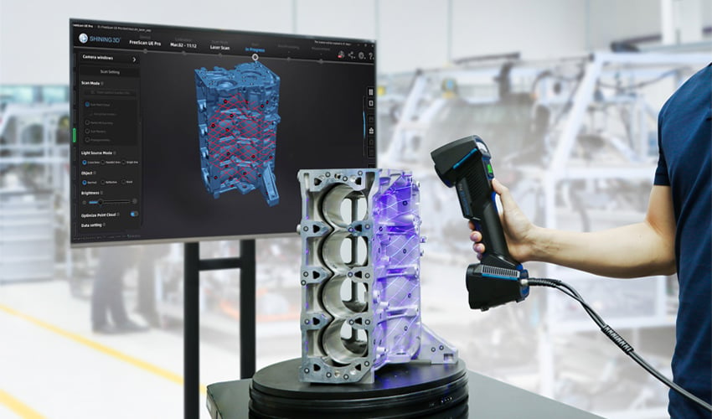
Engineer using 3D scanner.

- This CAD model can then be used to make a mould around the bonnet to allow for the carbon fibre to be layered around the mould to make the new bonnet.
During the production of the bonnet, the carbon fibre that is being used will be wet layered.
- The wet lay method consists of a carbon fibre cloth being added to the mould.
- This is done one layer at a time with each layer having its own coat of resin being brushed or rolled onto the carbon fibre layers.
- After the desired number of layers have been added to the mould, the carbon fibre layers can be left at room temperature to cure.
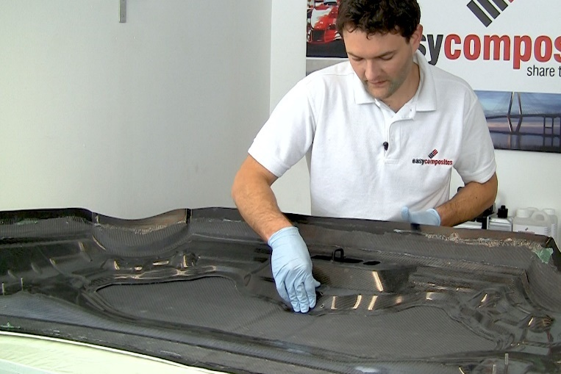
Carbon fibre specialist lining layers of carbon fibre.

Testing of the material:
- The material is very expensive to produce. In order to test them they must undergo a series of non-destructive tests.
- The first test that will be undertaken is the phased array ultrasonic testing (PAUT).
- The PAUT test can provides a large scanning radius with a variety of flaw types that the machine can detect.
- The PAUT can detect any porosities in the product, as well as this it can also detect any delamination’s of the material or if there are any foreign bodies betwixt the layers of the carbon fibre.
- Considering that the material is moulded into a relatively complex geometry, multiple probe combinations will be used. Typically, straighter or flatter parts of the product use linear 1D probes. The more complex gradients require a more advanced arc-shaped 1D probes.

The most important part to developing any product is making sure that it can be done as efficiently and as safely as possible. To do this, you will need to follow the steps previously stated in the report. To allow for the safest production line possible there will be a number of laws and legislations that will need to be put in place.
- The importance of knowing what you are doing is key. Having experience will help develop a stable and efficient manufacturing line. Being inexperienced is okay but being unaware of the dangers and precautions that come with working with carbon fibre is unacceptable.
- All team members must have training and be informed of the dangers that can be associated with the production of carbon fibre. Carbon fibre dust is well-known to be hazardous to electronics because carbon fibres are electrically conductive. If allowed to build up, this dust can short out computers and cause other digital device havoc. It’s also associated with lung damage in people.
- The 8 different teams will need to work in a very communitive manor to ensure that the product can be developed properly.
When developing a new product or developing any product for the first time, you will always run into problems. A lot of companies have their own ways or methods to resolving own problem, however, they all originate from the same basic structure.
- Identifying the problem is the first step required to resolving the issue.
- Defining the problem, break the issue down, analyse the issue. How long will it take to fix? Is it the biggest problem/does it have a higher priority over any other issues?
- Create a goal, envision what the problem is, how it’s hindering your product. Make a list of ways that could be used to fix the issue. Set yourself a time line to have the issue resolved by. Use this as a form of motivation. ‘’Motivation results in increased productivity since its basic object is to achieve the goals of the enterprise. The workers give their best performance which helps in increasing the productivity of the organisation.’’ Importance of motivation for increasing efficiency within an organization (2014) Your Article Library. Available at: https://www.yourarticlelibrary.com/motivation/importance-of-motivation-for-increasing-efficiency-within-an-organization/25795 (Accessed: December 3, 2022).
- Find the root of the problem, problems are often the effect of another much larger problem. To ensure that you don’t miss the initial problem, dig deep and find the first problem. Gether information and solidify your opinion by collecting about the issue.
- Develop actionable steps. Once the problem has been identified, a series of steps should be created that will help you to develop a solution to the problem.
- Execute steps. The steps have been made, now it is time to use them to help you resolve the issue.
- Observe and evaluate. There is no point in spending time and money tyring to resolve an issue if whilst you are resolving the issue, you begin to make another problem. To ensure that this doesn’t happen. Observe the product after each step is completed.

Issues legislation and standards.
When manufacturing a product. There are a few rules or guidelines that must be met to ensure the safety of workers and customers. as well as this, you would also need to take into account how dangerous each job is going to be with the legislation in place.
Health and safety.
Risk | Effects of risk | Severity (L,M,H) | How to overcome.
Carbon fibre dust can be very harmful to your lungs. | Can lead to breathing difficulty or permanent breathing issues. | M | Ensure that everyone working on developing the material will be wearing the correct PPE.
Cutting the excess material off with power tools. | Can lead to injury if the disc slips. Also, pieces of material can fly off. | M | Ensure that everyone who is working on the final stage of the material production is wearing the correct PPE
The resin that is used to solidify the layers of the carbon fibre together can cause irritation to the skin | This can lead dermatitis which can be extremely painful. | M | Ensure the correct PPE is worn when handling. Also, ensure COSHH is followed.
Being unsure of how to operate the machines. | Could result in the machine being damaged or the product being damaged. There could also be a serious risk of injury or even death. | H | Ensure that the correct PPE is followed as well as PUWER.

Legislation is a type of law that controls or regulates how certain things are operated or monitored. In the production of anything in a manufacturing environment. There is legislation that governs how jobs can be carried out.
Legislation.
- Control of Substances Hazardous to Health 2002 (COSHH)
- The Personal Protective Equipment at Work Regulations 1992
- Workplace (Health, Safety and Welfare) Regulations 1992
- The Provision and Use of Work Equipment Regulations 1998
- Manual Handling Operations Regulations 1992 amended 2002
- The Working Time Regulations 1998
- Health and Safety at Work etc Act 1974
- Management of Health and Safety at Work Regulations 1999
- The Regulatory Reform (Fire Safety) Order 2005
- Workplace (Health, Safety and Welfare) Regulations 1992

In terms of environmental impacts, carbon fibre isn’t the most environmentally friendly material and is considered to be the modern-day asbestos. This is due to the plastics and polymers that the material is filled with. The plastics and polymers make it very difficult to recycle; therefore, any carbon fibre product is sent to landfill at the end of its life cycle. 35% of carbon fibre ends up in landfill with only 20% being recycled. Not only this but carbon fibre isn’t currently biodegradable. This means that the 35% of carbon fibre that is in landfill, is going to be in the landfill for a very long time.

Some industry standards are required for the production of Carbon fibre.
- ISO:14127:2008-Carbon fibre reinforced composites, determination of the resin, fibre and void contents.

Personal development.
To progress myself further in this professional industry, I would need to gather more experience in the industry. To achieve my future goals, I would need to spend more time in the industry and gather more knowledge on how professional teams in the industry operate. I would then compare that to how I would operate a similar team and see what they do differently. I would then find out why they have their differences and change how I would run a team depending on what I find. This way I think that I will be able to assemble a productive and efficient team.

Conclusion.
To conclude, in order to make a successful and functional product, you will require a functioning team structure, who can communicate effectively with each other to ensure all considerations are taken into account. The team leader will need to oversee all stages of the development process and ensure all engineers working on the product are working to a professional standard and are following all of the required safety procedures.
This technical report has greatly increased my knowledge on all the processes required in order to develop a successful product.

Reference list.
How is carbon fibre made? (2017) ZOLTEK. Available at: https://zoltek.com/carbon-fiber/how-is-carbon-fiber-made/ (Accessed: November 28, 2022).
(no date) Engineering council. Available at: https://www.engc.org.uk/standards-guidance/guidance/statement-of-ethical-principles/#:~:text=Respect%20for%20life%2C%20law%2C%20the%20environment%20and%20public%20good&text=hold%20paramount%20the%20health%20and,personal%20information%20and%20intellectual%20property (Accessed: November 29, 2022).
Trimming and assembling a carbon fibre bonnet (or similar panel) (no date) Trimming & Bonding Carbon Fibre Car Panels - Video Tutorial - Easy Composites. Available at: https://www.easycomposites.co.uk/learning/how-to-trim-finish-and-assemble-a-carbon-fibre-bonnet (Accessed: November 29, 2022).
Krista (2017) 5 hazardous dusts commonly found in composites manufacturing, Industrial Vacuum Blog. Available at: https://news.nilfiskcfm.com/2017/04/5-hazardous-dusts-commonly-found-composites-manufacturing/#:~:text=Carbon%20fiber%20dust%20is%20well,with%20lung%20damage%20in%20people. (Accessed: December 3, 2022).
Laura (2021) The 8-step problem-solving method: Manufacturing improvements, MANTEC. Available at: https://mantec.org/eight-step-problem-solving-process/#WhatIsThe8StepProblemSolvingMethod (Accessed: December 3, 2022).
Health and safety legislation and regulations (2020) Plant and Safety. Available at: https://plantandsafety.co.uk/engineering-testing-inspection-and-certification/health-and-safety-legislation-and-regulations (Accessed: December 3, 2022).
Creating a sustainable future for carbon fibre in manufacturing (2021) The Manufacturer. Available at: https://www.themanufacturer.com/articles/creating-a-sustainable-future-carbon-fibre/ (Accessed: December 3, 2022).
ISO 14127:2008 (2021) ISO. Available at: https://www.iso.org/standard/37222.html (Accessed: December 3, 2022).

