Business Scenario:
You are helping a local gym called River Fitness. They collected customer feedback and want a simple, clear summary.

My digital artefact:
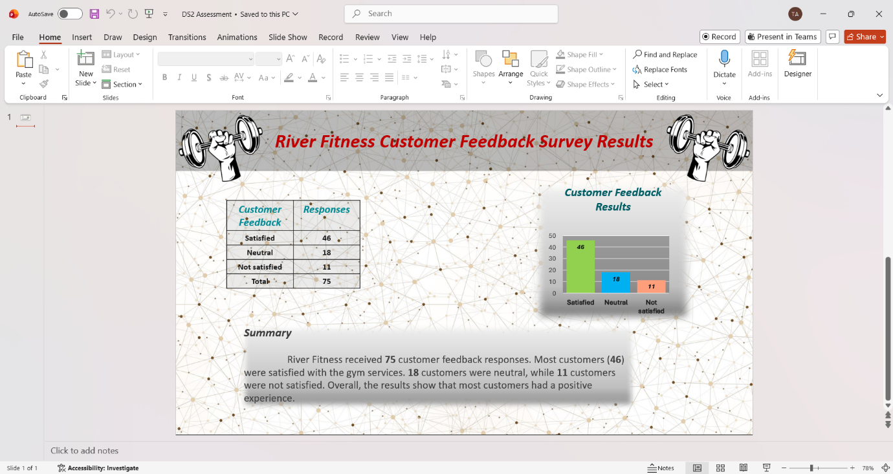
Explanation:
The chart shows that the gym has most of the customers satisfied with the services that the gym provides.

Decision & Iteration Log
- Why I chose my tool
I chose Microsoft PowerPoint because it is the tool that I’m most confident on using it and because it is a good tool for creating clear visual presentations. It allowed me to present the customer feedback using a table, a chart and a short-written summary on one slide.

- What information I used
I used the customer feedback survey results provided in the scenario.
The responses were:
- Satisfied – 46
- Neutral – 18
- Not satisfied – 11
I used this information to create a table, a chart and a summary.
- How I created my artefact
- First, I created a new PowerPoint presentation with one blank slide.
- I added the title “River Fitness Customer Feedback Survey Results”.
- Next, I inserted a table and entered the survey data.
- After that, I inserted a bar chart and entered the same data into it.
- I added data label to show the category names.
- Finally, I wrote a short summary explaining the survey results and checked the slide for spelling, layout and accuracy.

- What changes I made
- At first, I used a pie chart, but I changed it to a bar chart because it showed the responses more clearly.
- I resized the chart and table so the slide looked balanced.
- I used consistent colours and fonts to make the slide easier to read.
- I added an icon to make the presentation look more professional without making it messy.

- Feedback I used
I reviewed my slide after creating it and noticed that the text and chart needed to be balanced on the page.
I adjusted the layout, increased the font size to make it more visible and made sure the chart label were clear.

- Final explanation
This digital artefact provides a clear summary of the River Fitness customer feedback survey. It allows the manager to quickly understand the number of satisfied, neutral and not satisfied customers. The bar chart and table make the information easy to read and support better decision making.

I used:
- Microsoft Support helps me creating the organised chart. Available at: https://support.microsoft.com/en-us/PowerPoint/create-an-org-chart-in-powerpoint-by-using-a-template (Accessed:25 July 2026)
- Microsoft Support helps me to add pictures from my computer. Available at: https://support.microsoft.com/en-US/Word/training/insert-pictures (Accessed:20 July 2026)
- Microsoft Support also helps me to insert excel data in my slide. Available at: https://support.microsoft.com/en-us/PowerPoint/insert-and-update-excel-data-in-powerpoint (Accessed: 20 July 2026)

