How Kuwaitis Engage with Their Heritage
Heritage is a word that describes the features belonging to the culture of a particular society, such as traditions, languages, or buildings, that were created in the past and still have historical importance (Cambridge 2018). Since the realizations of heritage’s importance, communities and individuals have worked hard trying to save what was left of their heritage (Chitty 2017). They have also found many benefits in restoring and promoting their heritage (Onciul et al. 2017). Heritage can be adopted as an identity and be the source of celebrations and pride to many communities. (Waterton and Watson 2011). In Kuwait, the Kuwaiti society have been in the processes of preserving and keeping their heritage alive (UNESCO 2017). Many circumstances have occurred that affected the way Kuwaitis engage with their heritage. Nowadays, Kuwait’s heritage became an important aspect of Kuwaitis daily lives.
Kuwait is a small country that has in its heart important cultural and archaeological heritage. The Kuwaiti society have been exposed to all of these bricks of heritage. Kuwait is surrounded by Iraq in the north, Saudi Arabia in the south and the Persian Gulf in the east (Cohen 2010). Kuwait has nine islands and three of them are considered to be very important to the heritage sector (O'Shea 2004). These islands are Boubyan, Warba and Failaka. For example, Failaka has Greek, Dilmun and Islamic artefacts and monuments and it was a trading area between civilizations (Gagarin and Fantham 2010). In addition, Failaka was called Icarus by the Greeks and many Kuwaiti families that used to live in Failaka have adopted this name, calling themselves ‘Icarusi’ and ‘Failakawi’. Failaka also has the Failaka Heritage Village where the heritage industry has restored and preserved the old traditional Kuwaiti clay houses, mosques, markets and palaces. The public can visit the village and experience living in these traditional buildings anytime (Safir International Hotel & Resort Management , 2013). Moreover, Failaka still holds on its land all the buildings and vehicles that were destroyed during the Iraqi invasion, reminding the public of the terror that was brought to this land (Oxford Business Group 2013).
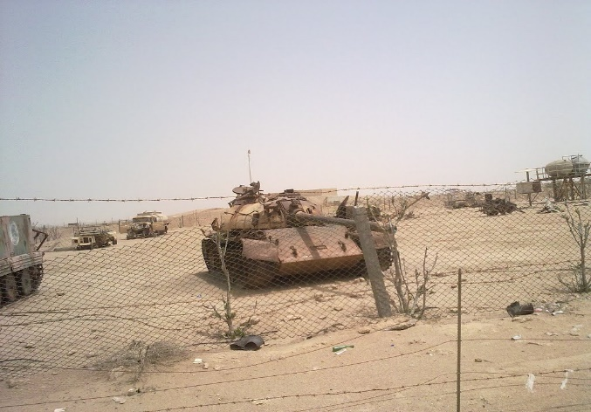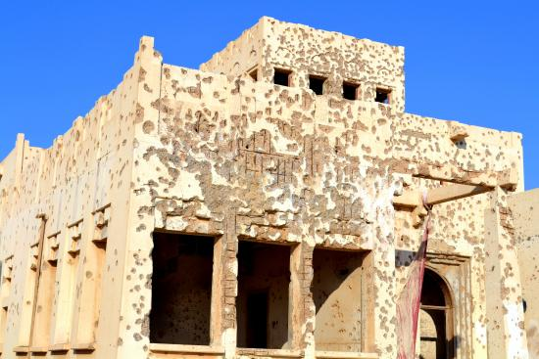
Figure 1- Iraqi tanks in Failaka Figure 2- A building with bullets marks
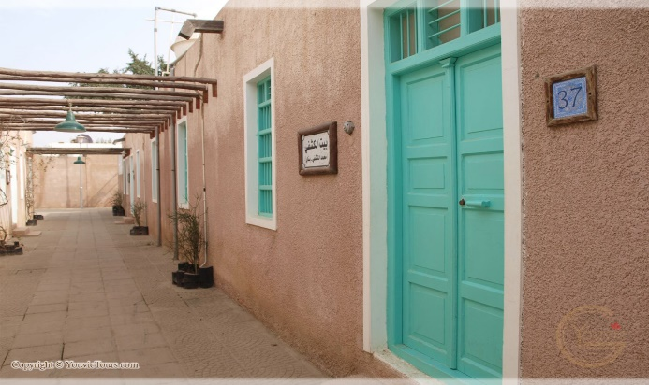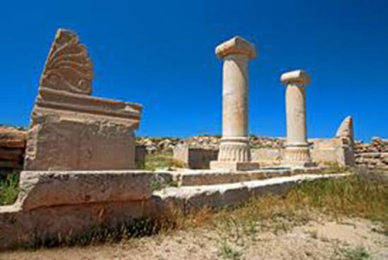
Figure 3- Failaka Heritage Village in Kuwait Figure 4- Greek ruins in Failaka
In the dawn of the 2nd of August 1990, Iraqi troops have invaded Kuwait. During the Iraqi invasion, Kuwait have suffered from a great losses and damages to everything including its cultural heritage (Forrest 2010). After seven months of destructions, Kuwait have been liberated by Arab and Western forces. The liberation action had reclaimed some of the Kuwaiti stolen heritage (Oxford Business Group 2013). Eventually, the damages and destructions have left the Kuwaiti society with great pains and increased their attachment to their heritage (Forrest 2010). The Kuwaiti society have felt that their heritage was going to be ripped off by their Iraqi neighbour, this had a major influence on how Kuwaitis engage with their heritage today (Forrest 2010).
After nearly 28 years of the Iraqi invasion, the Kuwaiti society still engage with their heritage in a daily basis to keep it alive. In early mornings, all Kuwait’s schools begin the day with singing the national anthem of Kuwait in front of two flags; the old Kuwait’s flag and the new one (Cerulo 1995). Both of these flags represent the Kuwaiti society in all its aspects and history. The anthem lyrics holds the description of Kuwait’s heritage and everybody engage in singing the lyrics to honour Kuwait’s heritage (Cerulo 1995). In addition, the teachers contribute in activities that will help the students in learning more about Kuwait’s folklore (O'Shea 2004). The teachers must train students different Kuwaiti dance routines while playing old Kuwaiti songs. All of the schools in Kuwait will compete to perform in front of the public and the Amir of Kuwait (Shavinina 2009). Furthermore, students whom participated have to wear the traditional Kuwaiti clothes, the females will be wearing the Kuwaiti “Darra’ah” and the males will have to wear the national Kuwaiti “Dishdashah” (Shavinina 2009).
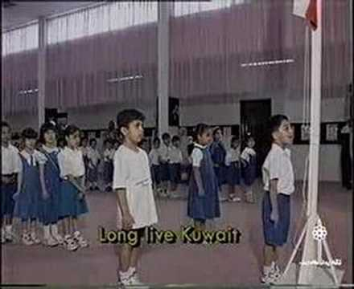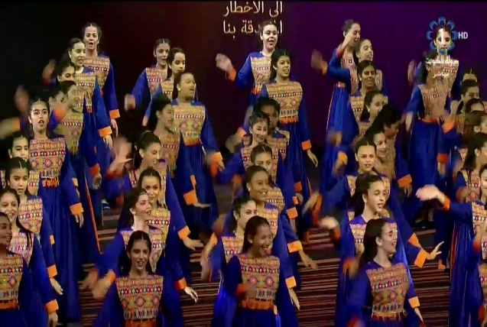
Figure 5- Student singing Kuwait's national anthem Figure 6- Students dance wearing the national Kuwaiti Darra’ah
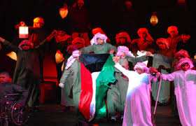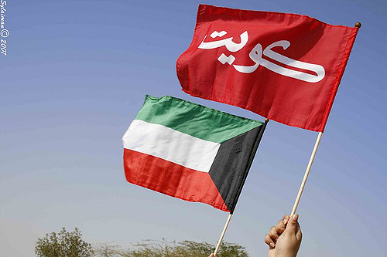 Figure 7- Students dance wearing the national Kuwaiti Dishdashah Figure 8- Old and new Kuwaiti flags
Moreover, the Kuwaiti society is diverse, and the majority are either ‘Hathar’ people of the sea or ‘Bedu’ people of the desert (O'Shea 2004). Many traditions are still practiced by both Hathar and Badu such as wedding traditions, Ghabga, Gerge’an and more. To give a clear example, a night before the Muslim’s holy month Ramadhan, Kuwaitis gather for a final feast called Ghabga. This feast is usually practiced with the involvement of Kuwaiti traditional food, songs and clothes (Urkevich 2015). On the15th of Ramadhan’s night, children gather wearing old traditional Kuwaiti clothes for Gerge’an. They walk together down the streets knocking all doors to collect their sweets and nuts. During that, the adults stand behind the doors and prepare the Kuwaiti candies in traditional weaved baskets that are made from palm fronds. The kids will not get any candy unless they sing the Gerge’an songs and calling the name of the homeowners (Urkevich 2015). At the end of the day, children return to their homes and spend the night eating their candies. After Ramadhan, and on the first day of Eid Alfitr, Kuwaitis gather in the Grand Mosque with the Amir of Kuwait to perform the Eid prayers (Cohen 2010). Then, they congratulate each other, and the Amir welcome them to his palace for the celebration. The rest of the day and for the next three days of Eid, the families will practice a tradition of wearing new clothes and visiting each other’s houses (Exell and Rico 2016).
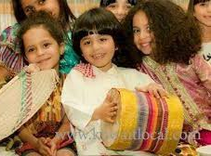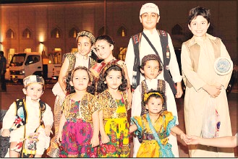
Figure 9- Kids wearing traditional Kuwaiti clothes for Gerge'an
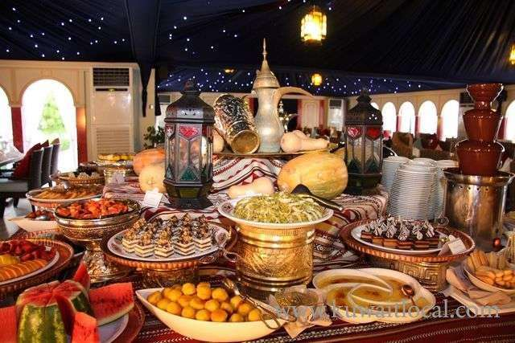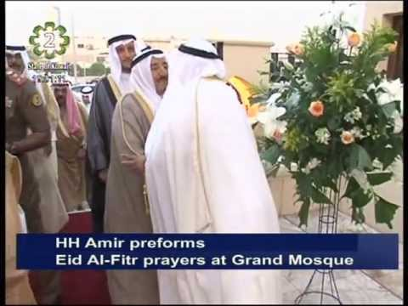
Figure 10- A section of desserts in Ghabga Figure 11- Amir of Kuwait performs Eid Al-Fitr prayers at Grand Mosque
Furthermore, the Kuwaiti society and especially Badu remind themselves of the past by leaving the city during the winter to live in tents in Kuwait’s desert (Casey 2007). These tents are made of herds wool and it is called ‘Bait Al-Sha’ar’ which literally means ‘the house of hairs’. Kuwaitis experience using old tools, pastoralism, Ganas and everything that brings back the meaning of lives as Bedouin tribes in the desert. Ganas is a type of hunting by training falcons to capture specific types of birds and rabbits. On the other hand, Hathar will practice Hadag in the summer (Exell and Rico 2016). Hadag means fishing by using old Kuwaiti fishing tools. The Kuwaiti government along with the help of Kuwaiti families are working together to keep these traditions alive (Forrest 2010). The Kuwaiti government have opened safe lands for Kuwaitis to camp. The government have also supported institutes and groups that teach traditional Kuwaiti crafts such as weaving (Exell 2016).
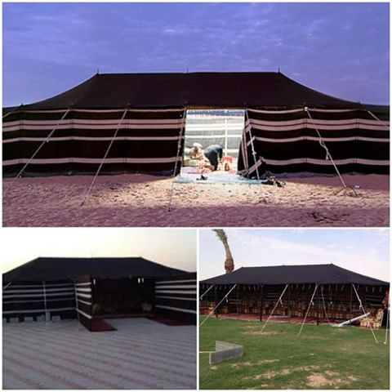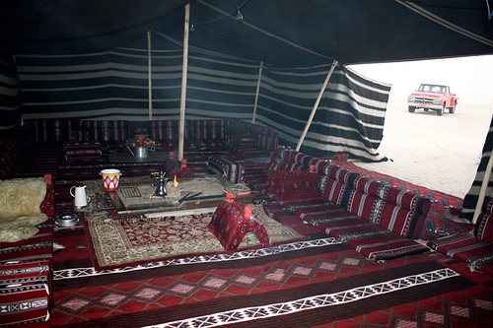
Figure 12- Pictures of Bait Al-Sha'ar
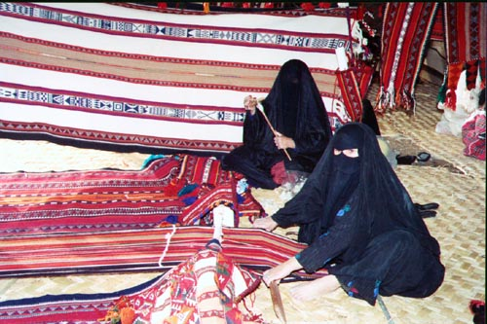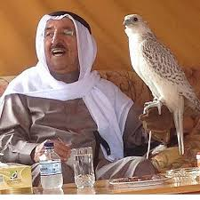
Figure 13- Kuwaiti eldery women participating in traditional weaving Figure 14- The Amir of Kuwait with his falcon

Moreover, museums have joined the local movement of saving and promoting Kuwait’s heritage. Nowadays, all Kuwaiti museums have sections that present Kuwait’s heritage. For instance, Kuwait’s scientific museum and the maritime museum are both located on the harbour (Exell and Wakefield 2016). The museums have preserved Kuwaiti Dhows. Before the discovery of oil, the Kuwaiti society used to work as ship-masters and later they would engage in a trip of pearl hunting that used to last four months in the sea (Villiers 2006). The Kuwaiti society are proud of this heritage, and in every home there are small model of Dhows. Kuwait is famous with making Dhows such as Boom, Jalboat and Sanbouk (Villiers 2006). The largest Dhow in the world was made by the Maarafi family in Kuwait and it is a part of Dhows’ collection at the Maritime Museum of Kuwait (Global Markets 2009).
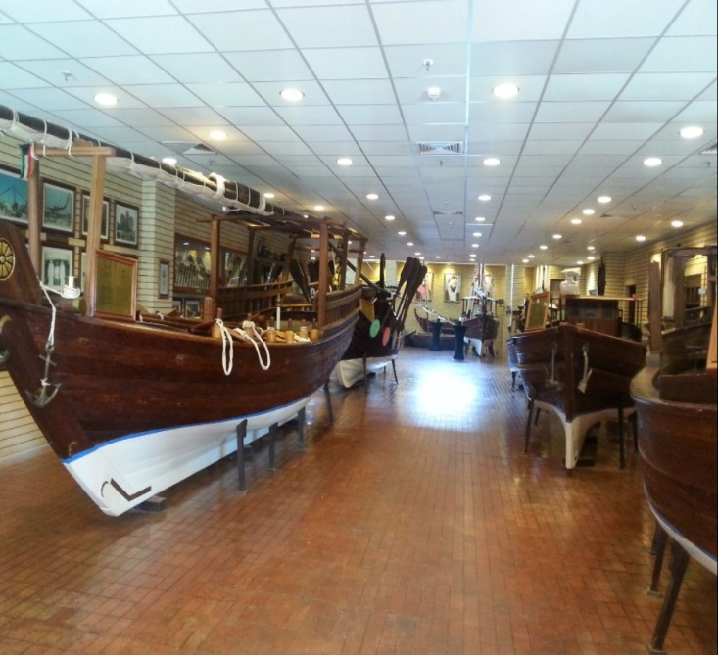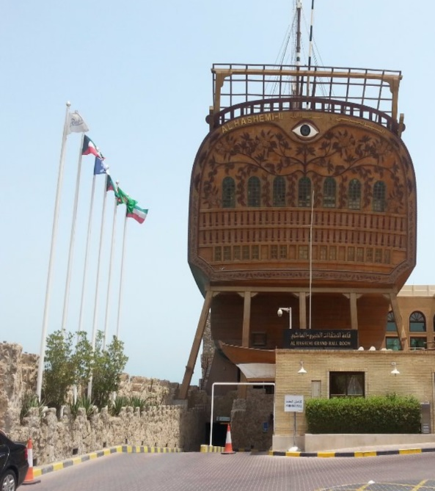
Figure 15- Different types of Kuwaiti Dhows at Kuwaiti museums
On the other hand, the economic sector has invested more in heritage. For example, many restaurants have been established that offer Kuwaiti food (Global Markets 2009). Not only do the restaurants offer the authentic Kuwaiti food, but also, they deliver the whole authentic Kuwaiti experience and atmosphere. Restaurants like ‘Freej Suwaileh’ and old Souks like ‘Al-Mubarakiya’ are well known in this matter (Urkevich 2015). Moreover, the Kuwaiti media have been a target of investments. Every Ramadhan, production companies race to produce the best dramatic Kuwaiti TV shows that will turn the heads of everybody in the Arab world. These TV shows are often filmed at Kuwaiti heritage villages and offer old Kuwaiti tales and stories (Media Kuwait 2018). Not to mention the involvement of the old Kuwaiti dialect in any series (Media Kuwait 2018). In addition, under the society’s pressure, the Kuwaiti government have updated Kuwait’s currency notes. The new Kuwaiti notes contain different representations of Kuwait’s heritage. The new notes have on them pictures of falcons, Dhows, Greek ruins and Kuwait Towers. Also, the State of Kuwait’s Logo contain pictures of Dhows, Sea and falcon (Centeral Bank of Kuwait 2014).
As a conclusion, it seems likely that heritage it what shapes communities. The Kuwaiti community was driven by many circumstances to engage with their cultural heritage. They have also engaged with it in a daily basis. The Kuwaiti society have developed the educational sector to preserve their folklore and pass it on to the next generations. In addition, the Kuwaiti society is still practicing the old Kuwaiti traditions in all social levels. They have also adopted different aspects of their heritage as an identity. The Kuwaiti government with the help of the society have developed the heritage sector and provided many traditional events. Moreover, the Kuwaiti society have invested in the heritage sector and developed Kuwait’s media using Kuwait’s heritage. Finally, Kuwaiti society have pushed the government to create new notes that represent Kuwait’s heritage.
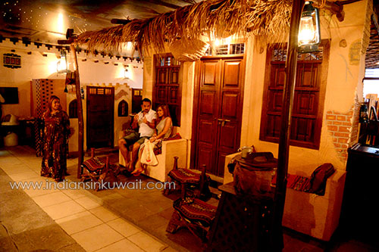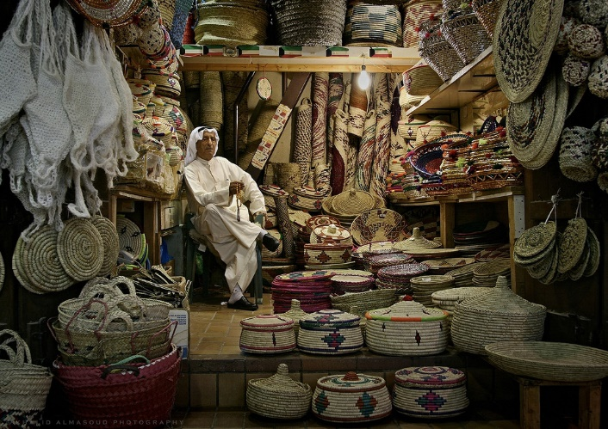
Figure 16- Fereej Suwaileh restaurant Figure 17- A shop in Souk Al-mubarakiya
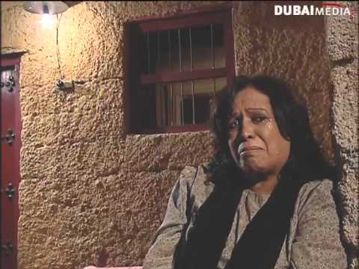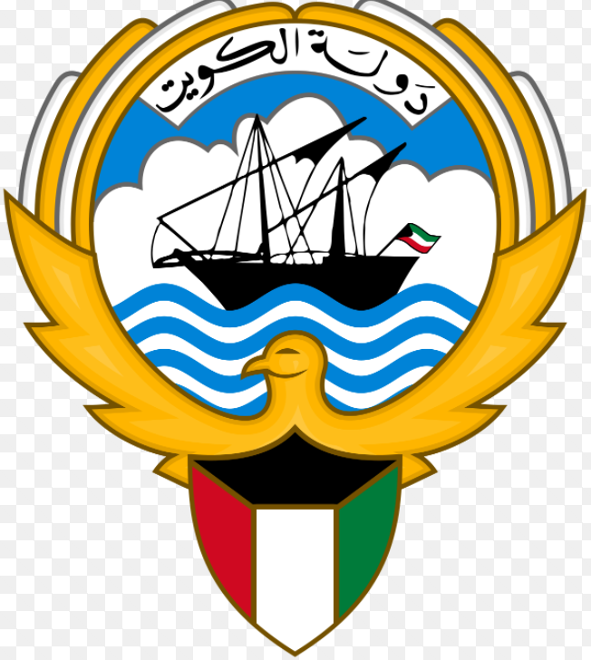
Figure 18- A scene of the Kuwaiti Series 'Al-Ferya' Figure 19- State of Kuwait logo
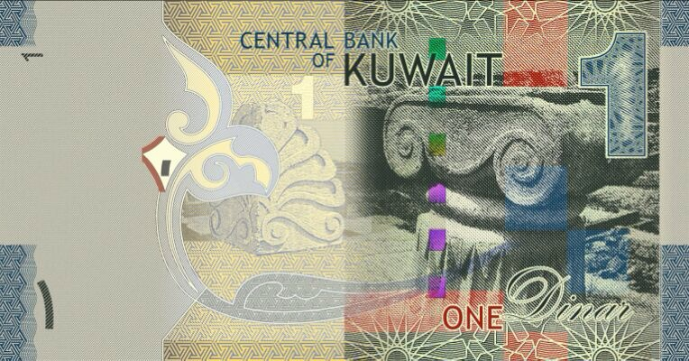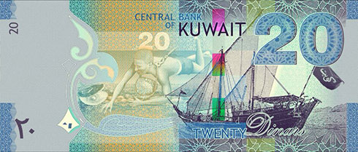
Figure 20- Kuwaiti notes

References List
Cambridge University Press. 2018. Cambridge Dictionary. [Online]
Available at: https://dictionary.cambridge.org/dictionary/english/heritage
[Accessed 20th January 2018].
Casey. M. S. 2007. The History of Kuwait. 1st ed. London: Greenwood Publishing Group.
Centeral Bank of Kuwait. 2014. New Kuwait's Banknotes, Beauty and Security. [Online]
Available at: http://www.cbk.gov.kw/en/images/Booklet-10-114950-3.pdf
[Accessed 21st January 2018].
Cerulo, K. A. 1995. Identity Designs: The Sights and Sounds of a Nation. 1st ed. New Jersey: Rutgers University Press.
Chitty, G. 2017. Heritage, Conservation and Communities: Engagement, Participation and Capacity Building. 1st ed. London: Routledge.
Cohen, H. M. 2010. Kuwait. 1st ed. Jordan: Mason Crist Publisher.
Exell, K. 2016. Modernity and the Museum in the Arabian Peninsula. 1st ed. Oxon: Routledge.
Exell. K. & Rico, T. 2016. Cultural Heritage in the Arabian Peninsula: Debates, Discourses and Practices. 2nd ed. Oxon: Routledge.
Exell. K. & Wakefield. S. 2016. Museums in Arabia: Transnational Practices and Regional Processes. 1st ed. Oxon: Routledge.
Forrest. C. 2010. International Law and the Protection of Cultural Heritage. 1st ed. Oxon: Routledge.
Gagarin. M. & Fantham. E. 2010. Ancient Greece and Rome. 1st ed. New York: Oxford University Press.
Global Markets. 2009. Kuwait Hospitality, Market Overview. 1st ed. Kuwait: Globat Markets.
Joyce. M. 2013. Kuwait, 1945-1996: An Anglo-American Perspective. 2nd ed. Oxon: Routledge.
Media Kuwait. 2018. Kuwait's Ministry of Media. [Online]
Available at: http://www.media.gov.kw/
[Accessed 21st January 2018].
Onciul, B. Stefano. M. L. & Hawke. S. 2017. Engaging Heritage, Engaging Communities. 1st ed. Woodbridge: The Boydell Press.
O'Shea. M. 2004. Cultures of The World: Kuwait. 3rd ed. New York: Marshall Cavendish Corporation.
Oxford Business Group. 2013. The Report: Kuwait. 1st ed. Oxford: Oxford Business Group.
Safir International Hotel & Resort Management. 2013. Heritage Village of Failaka. [Online]
Available at: http://heritagevillagefailaka.com/
[Accessed 21st January 2018].
Shavinina. L. 2009. International Handbook on Giftedness. 1st ed. Canada: Springer Science & Business Media.
UNESCO. 2017. About World Heritage, The States Parties. [Online]
Available at: http://whc.unesco.org/en/statesparties/kw
[Accessed 21st January 2018].
Urkevich L. 2015. Music and Traditions of the Arabian Peninsula: Saudi Arabia, Kuwait, Bahrain and Qatar. 1st ed. Oxon: Routledge.
Villiers A. 2006. Sons of Sindbad. 3rd ed. London: Arabian Publishing Ltd.
Waterton E. & Watson S. 2011. Heritage and Community Engagement: Collaboration Or Contestation?. 1st ed. Oxon: Routledge.

