UNIVERSITY OF WALES TRINITY SAINT DAVID
LONDON CAMPUS
Assignment 2
Learning in the Digital Era
Assignment
Video Link: https://youtu.be/Q9owTa-NsIs
Please be sure to give unrestricted access to your video presentation so that your work can be marked by the examiner.
Module Name: Learning in the Digital Era
Module Code: ACCA 4025

Student Name: Yahya Sugal Jama
Student ID: 2532858
Group: 1

Lecturer’s Name: Koushik Modak

Table of Contents
Introduction 2
Main Body 2
Conclusion 9
References 9

Introduction
This PowerPoint was created as part of the Learning in the Digital Era assignment Two coursework. Were we assigned three different tasks
Through ongoing self-reflection, I have developed an idea of my strengths and weaknesses, and personal traits as a learner, because I keep reflecting on my actions.

Main Body
Task one is a self-assessment, Task two is a personal development plan, and finally, Task three is to choose a topic in Moodle and write a summary of what I have learned.
Video Link:
Slide 1 COVER PAGE
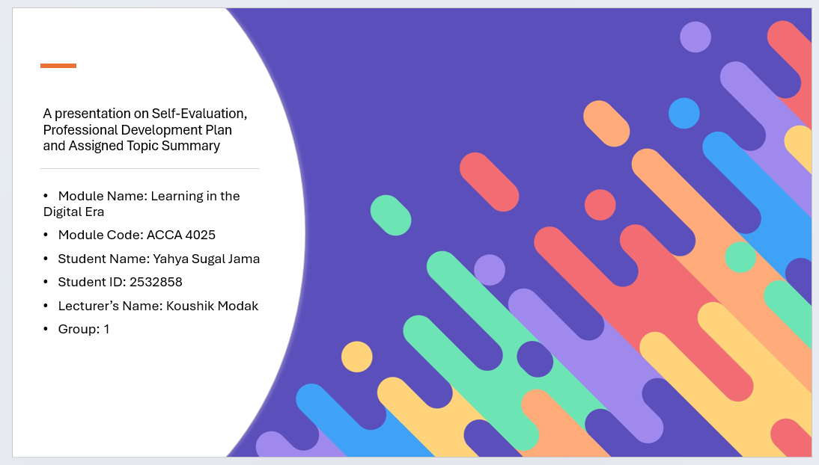

Slide 2 CONTENTS

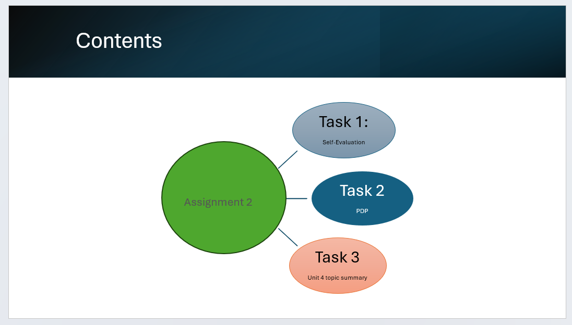
Slide 3 INTRODUCTION
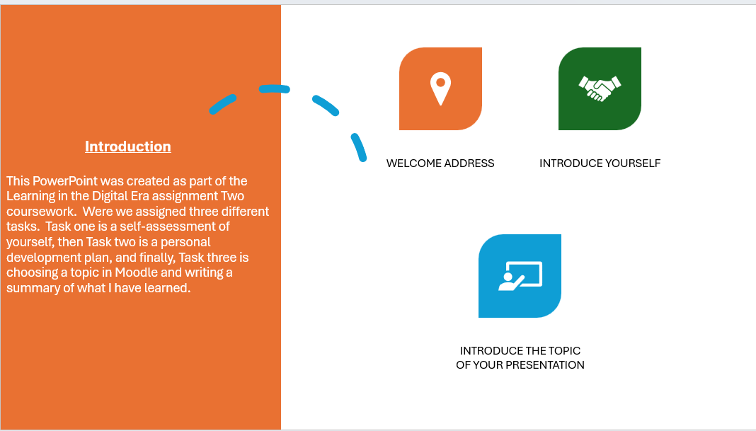

Slide 4 MAIN BODY

Slide 5 GIBB’s REFLECTIVE MODEL
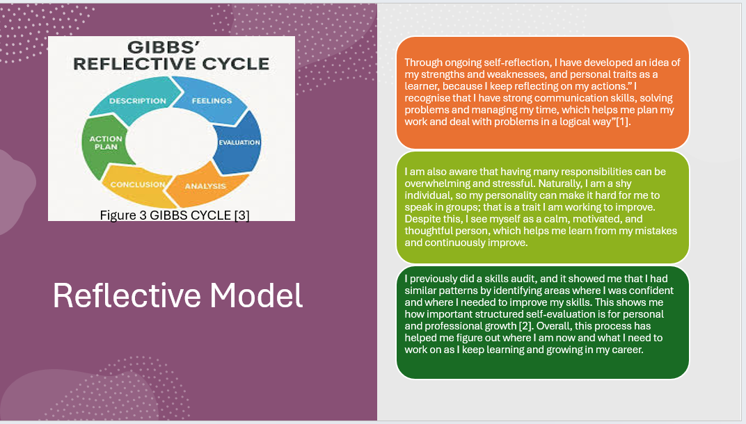
- Brief explanation:
Through ongoing self-reflection, I have developed an idea of my strengths and weaknesses, and personal traits as a learner, because I keep reflecting on my actions to further better myself as a student.
In-text citations are required in this section, along with the corresponding full citation at the end in the List of references.
Slide 6 TASK 1: SELF-EVALUATION
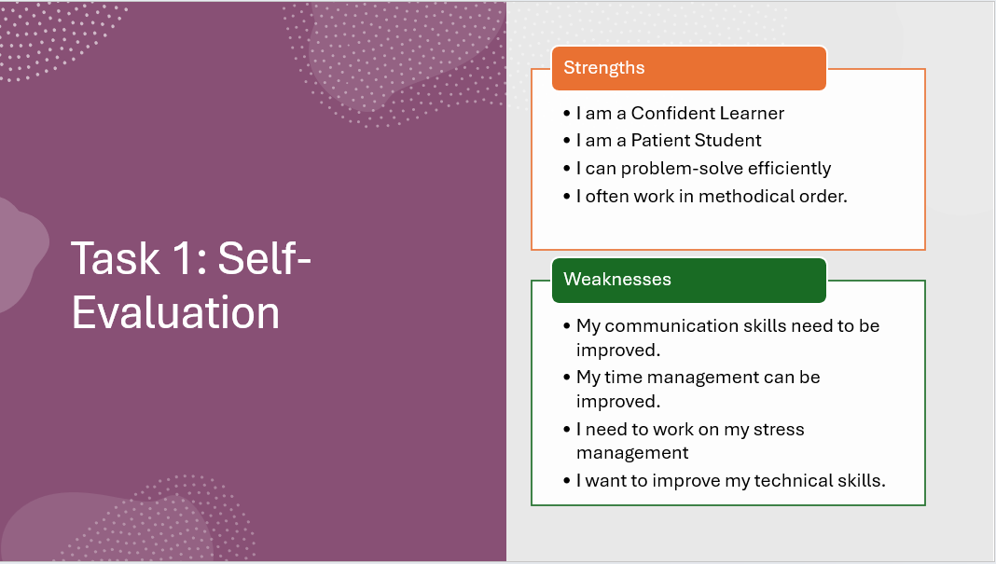
Brief explanation: (Discuss your strengths and weaknesses based on your individual SWOT analysis).
- I have listed out a few of my strengths and weaknesses. For example, one of my strengths is that I can problem-solve efficiently. On the other hand, one of my weaknesses is that I want to improve my technical skills.
Slide 7: TRAITS GAINED FROM THE SELF-EVALUATION
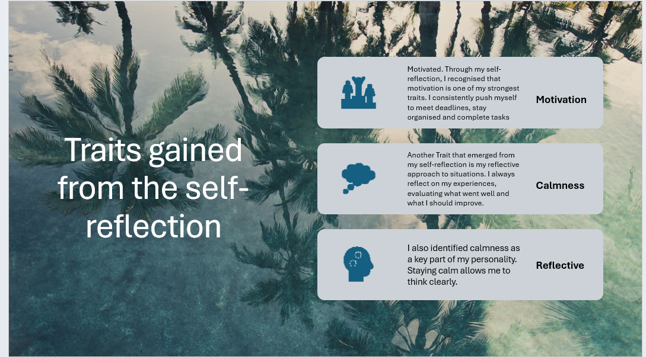

Brief explanation:
- My self-evaluation helped me better understand my most crucial traits, those being Motivation, Calmness, and being able to Reflect, which will help me grow both personally and academically in the future.

Slide 8 PROFESSIONAL DEVELOPMENT PLAN
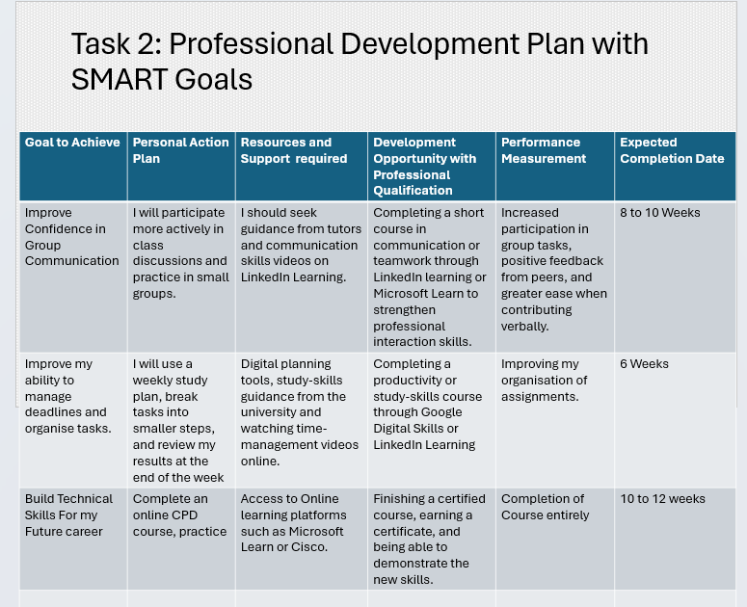
Brief explanation:
- This professional development plan lists the main goals I want to reach, the steps I will take to get there, and the tools that will help me along the way. It allows me to stay on track and stay focused on achieving my goals over time.
Slide 9 UNIT 4 TOPIC SUMMARY
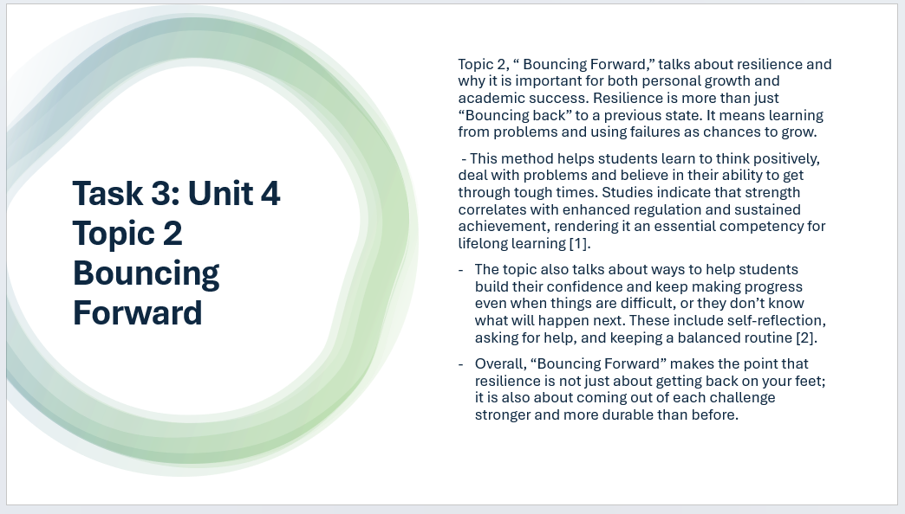
Brief explanation: Topic 2, “ Bouncing Forward,” talks about resilience and why it is important for both personal growth and academic success. Resilience is more than just “Bouncing back” to a previous state. It means learning from problems and using failures as chances to grow.
Slide 10 CONCLUSION

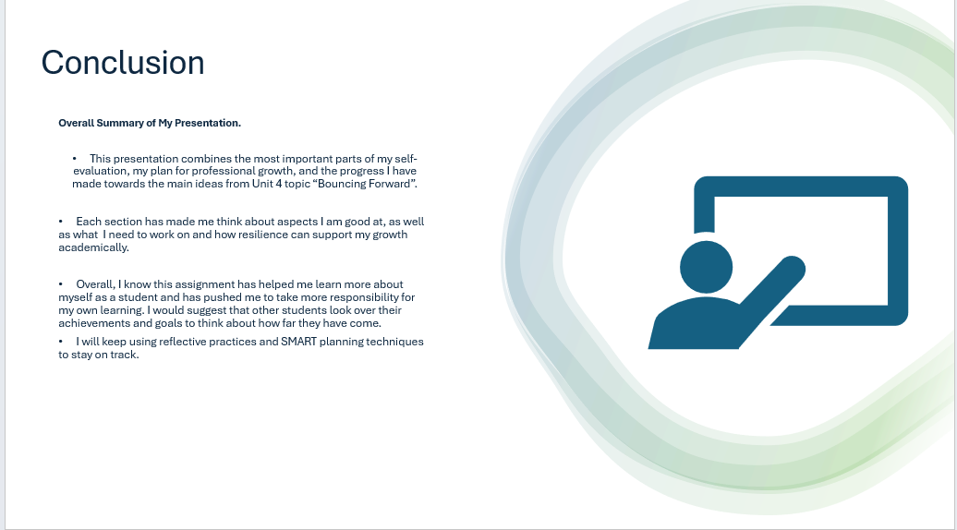

Brief explanation:
- In this assignment, I learned how important it is to think about myself to find areas where I need to get better. I realised that SMART goals help me stay focused and organised, and that staying solid helps me keep going when it gets tough.

Slide 11
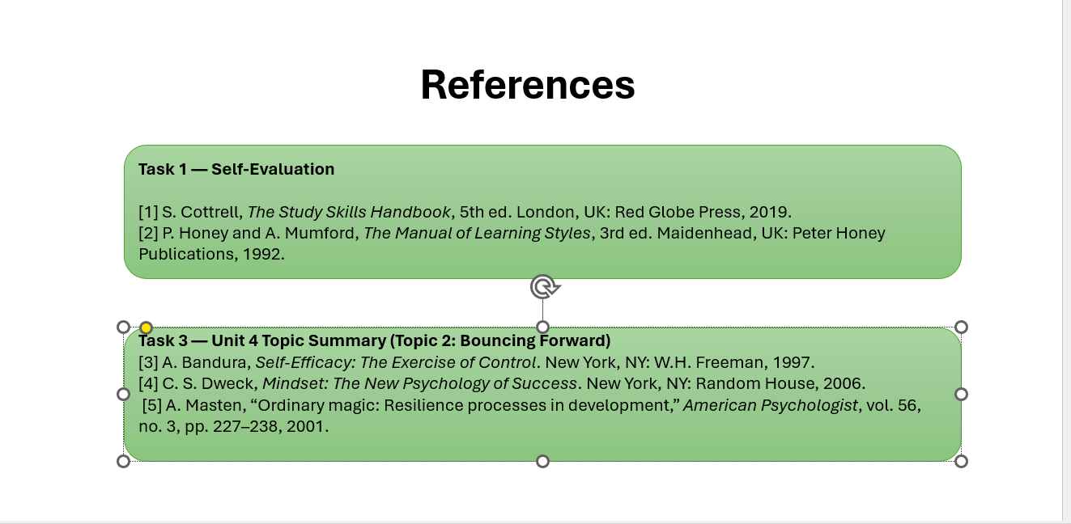

Conclusion
Overall, I would like to recommend that other students look over their goals and think about how far they have come regularly, as this builds confidence and helps them succeed in the long run.

References
Task 1 — Self-Evaluation
[1] S. Cottrell, The Study Skills Handbook, 5th ed. London, UK: Red Globe Press, 2019.
[2] P. Honey and A. Mumford, The Manual of Learning Styles, 3rd ed. Maidenhead, UK: Peter Honey Publications, 1992.
Task 3 — Unit 4 Topic Summary (Topic 2: Bouncing Forward)
[3] A. Bandura, Self-Efficacy: The Exercise of Control. New York, NY: W.H. Freeman, 1997.
[4] C. S. Dweck, Mindset: The New Psychology of Success. New York, NY: Random House, 2006.
[5] A. Masten, “Ordinary magic: Resilience processes in development,” American Psychologist, vol. 56, no. 3, pp. 227–238, 2001.

