
Figure 1. University of Wales Trinity Saint David Logo (UWTSD, 2017)

University of Wales Trinity Saint David
School of Engineering
Group Working – Reflective Essay
Christopher Price
1809108
BEng Materials Science
10th May 2019
Group Project (M5X00400)

Table of Contents
- Abstract 3
- Main findings 4
  - Team members 4
  - Gantt chart 5
  - Personality/team roles self-analysis 5
    - Five-Factor Model 5
    - Belbin’s Model 6
      - Monitor Evaluator (ME) 7
      - Implementer (IMP) 7
  - Background to steelmaking process 8
  - Implementation of trial 9
    - First concern 9
    - Second concern 9
    - Third concern 10
- Conclusion 12
- References 13
- Appendices 14

- Abstract
I assisted in a project where we were trying to ascertain whether it was possible to recycle our own waste iron oxides (slurry pellets) as a coolant material in the BOS convertor. The aim of the project was to ascertain whether slurry pellets were an effective coolant replacement for sinter. There was a potential £10 million benefit across the Heavy End (Coke, Sinter and Ironmaking and Steel Plant) of the Port Talbot works. If the trial was successful, the displacement of sinter at the Basic Oxygen Steelmaking (BOS) Plant would free up additional sinter for the Blast Furnace operation.
The addition of the recycled material in the BOS plant was critical in potentially opening up cost saving avenues throughout the Steel Works.
Success was measured by;
- Measuring the temperature control of the process. If the material didn’t have the desired cooling effect, the recycled material would be unsuitable. The cooling effect can be compared directly with the cooling effect of sinter, which is 6.477J/kg added.
- Determining whether the end chemistry of the steel met the desired specification and see whether the cooling effect affected this.

- Main findings
I needed to demonstrate several skills in order to successfully fulfil my roles within the project. As the individual responsible for conducting the trial, I had to come up with a trial plan and communicate this across several different areas within the process (Primary Steelmaking, Secondary Steelmaking and Casting). I needed to be able to assess the potential risks of using the material on plant and develop a contingency plan if difficulties arose As a Technical Specialist, I also had the responsibility of ensuring the material could be used safely without causing an issue to production and/or quality.
  - Team members
Table 1 shows team members involved in the trial.

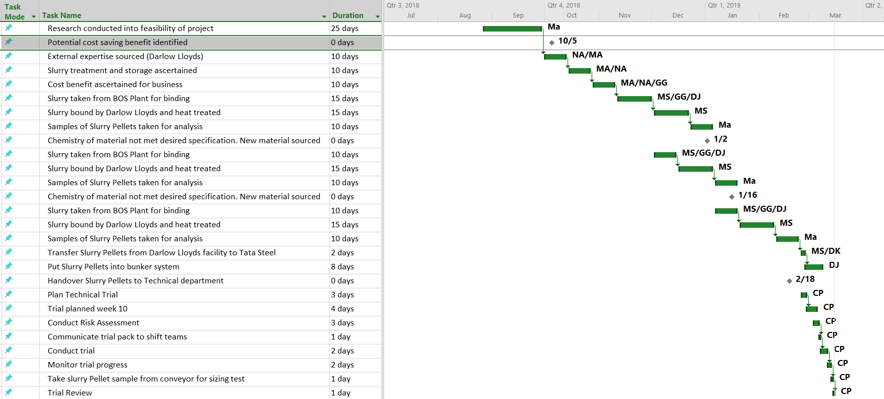
  - Gannt chart
Figure 2 shows a Gannt chart detailing the timeline of events within the project and the owners of the tasks.
(See appendix 1 for full breakdown of tasks and task owners)
  - Personality/team roles self-analysis
    - Five-Factor Model
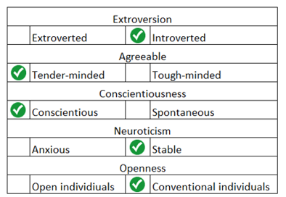
Figure 3 shows self-conducted FFM analysis.
The Five-Factor model (FFM) is a model developed Robert McCrae and Paul Costa, and they categorise five personality types and how they correlate to their roles within a work place (De Fruyt, et al., 2004). I’ve chosen to conduct self-analysis to see which trait I’m most aligned to. I believe I’m more introverted than extraverted. Introverts tend to make more careful, considered opinions and aren’t inclined to make gregarious decisions. This trait is pivotal in carrying out my role within this project. Neuroticism refers to the stability of the person. I feel like I’m more stable than anxious, as I have a calm and steady demeanour which is important in carrying out my role within the trial where correct decisions need to be made under difficult conditions. Being too anxious can cause a person to make irrational decisions. Openness refers to the propensity to take other people’s opinions on board and to be inquisitive. I feel like I’m more likely to be a bit more closed minded and compartmentalise, which perhaps isn’t ideal when working with a vast array of different people holding various positions. In terms of agreeableness, I believe I am more tender-minded than tough-minded as I feel like I have a lot of empathy with other people. Agreeableness is important when working within a team because decisions need to be made and a certain give and take is needed to progress the trial. Conscientiousness refers to the type of decision making that a person takes. In the trial, it’s key that conscientious decision making is at the forefront of all decisions made during the trial. Having a spontaneous personality trait can lead to rash and unconsidered decisions being made which could jeopardise the trial.
    - Belbin’s model
Dr R Meredith Belbin devised a model that considers personality types and skill sets needed within team roles. Belbin states that there are eight/nine clusters of behaviours that are needed within a team to successfully implement a project (see Appendix 2 for full breakdown of roles and associated personality traits).
To see which of the nine personality traits I have, I conducted a Belbin Self Perception Inventory (SPI):
Figure 4 shows the results of Belbin’s Self Perception Inventory.
Of the eight team role behaviours, the self-assessment came back showing that my highest scores were Monitor Evaluator (14%) and Implementer (13%). Inputting this into the FFM model, introverted people generally tend to score highly on the Monitor Evaluator (ME) team role (Manning, et al., 2006). However, a study found that the distinct team roles from Belbin’s model do not necessarily correlate with the FFM model (Davies & Eleftheria, 2006). In my opinion, my personality traits fit well with the requirements needed to fulfil my role. I feel that one trait I scored higher in was Team Working. To carry out the trial, I needed to work with a variety of difficult people across several disciplines and area of the Plant, from Production managers to conveyor operators. Having the ability to convey the purpose of the trial to all disciplines would have helped the ease in which the trial was implement.

      - Monitor Evaluator (ME)
Belbin states that ME can analyse problems and are able to think critically. They are logical people and will base decisions solely on this. My role was to successfully implement the slurry pellet trial. To do this, I needed to demonstrate critical and logical thinking. Before conducting the trial, I was required to think rationally about the potential issues the trial could have on the manufacturing process and the quality of the product being made. To mitigate this, I ensured that a risk assessment (see Appendix 3) was conducted prior to the trial to ensure that the problems would not come to light. From this assessment, there were many pessimistic and sceptical employees who doubted the credibility of the trial. Therefore, coming to the correct decision as to how the trial should be implemented needed careful decision making. At the time, when putting the trial pack together for the shift team, my boss passed a comment saying that I was being “overcautious”, but I was resolute that the countermeasures I implemented were necessary.

      - Implementer (IMP)
Implementers are disciplined, methodical and clinical in the way they approach a new task; and I was able to display these qualities during the trial. Having the ability to plan out a trial and successfully coordinate the logistics of the trial required a lot of thought and deliberation, considering the potential barriers that could prevent the success of the trial. I ensured that I examined all potential failure modes and had a solution to any problem that I might have encountered.

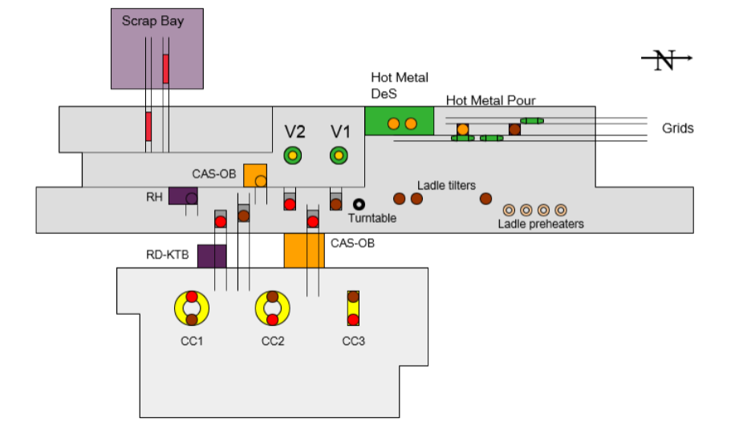
  - Background to steelmaking process
Figure 5 shows overview of BOS plant layout, including Converter 2 (V2) and CAS-OB where trial material was used/monitored.
5
4
2
1
300t of molten iron is transported from the Blast Furnace and enters the BOS Plant at the Hot Metal Pour station at approximately 1370°C (1). The Hot Metal is transferred into a ladle and is then lifted by a crane and positioned into the Hot Metal Desulphurisation station (2). Here, ~600kg of magnesium is added which reacts with the Sulphur to form MgS. The MgS rises to the top of the ladle in the form of slag. This slag is removed using a mechanical blade. Once the slag is removed, 50-70t of scrape metal is loaded into the Converter (V1 or V2), and crane transport the ladle from the Hot Metal Desulphurisation station and pour the ladle into the Converter (3). Oxygen is then blown into the Converter. This reduced Carbon content from ~4.5% to 0.050% and refines impurities such as Phosphorous and Manganese. The additions of slurry pellets were made during the blowing process to cool the steel to approximately 1680°C. Not cooling sufficiently can cause refining issues and damage to the refractory of the Converters. Once the Converter treatment has finished, the steel is poured into a ladle and transferred to Secondary Steelmaking (4). Here, they add additional alloys such as Ferro Vanadium and Ferro Niobium to meet the specification of the customer. Once this is complete, the ladle is transferred to the Continuous Caster the molten steel is cast into solid steel slabs (5).

  - Implementation of trial
    - First concern
The trial was scheduled to take place on the Tuesday 16th April, and I successfully coordinated the running of the material from the conveyor system into the bunker. During this operation I was able to stop the conveyor belt and obtain a 30kg sample of slurry pellets to be tested for sizing’s. My day was then beset with frustration, as external issues with production prevented me from using the material. One of the findings from the risk assessment was that there was a danger of Hydrogen pick-up in the steel. The only way to monitor hydrogen levels was to take a hydrogen sample which is only possible on two of the four Secondary Steelmaking units (CAS and CAS2). The issues with production meant that planned operations were re-routed to the Secondary Steelmaking stations that didn’t have Hydrogen sampling (RH and RD degasser units). It was at approximately 1pm where I decided to abandon the trial for the day until there was a suitable window. Upon reflection, I felt that I did everything I could to implement the trial on the 16th April. I decided to postpone the trial as I didn’t believe in deviating from the trial plan that I had communicated to the shift team. This corroborates with the strengths exhibited by ME and IMP; disciplined, sober and conservative.
    - Second concern
The following day, the schedule was conducive for starting the trial. For the first heat of the trial, the operator of the converter went to deliver the pellets from the bunker, but his operating matrix indicated that the material was not dispensing. I felt despondent at this point, as I had over 70t of the material to trial, and we’d encountered issues on the first addition. This concern I had could relate to my complete finisher (CF) personality trait as one of the weaknesses exhibited by CF’s is their inclination to worry. At this point, the Contracts Manager, Nick Ashton, came to the Converter 2 pulpit to see how the trial was progressing. As I told him that the material had not dispensed, he came onto Plant and joined me for a few hours during the trial. Together, along with the Team Leader, Kriss Trolley, we went up to Bunker 13, which contained the slurry pellets, to see what the issue was with the dispensing of the material. Figures 6 and 7 show the difference in fines content between the slurry pellets and sinter. It was at this point I was glad that I had the foresight of ensuring that a sample was taken from the conveyor belt for sizing testing to see if my observation of fines content would corroborate with the analysis.
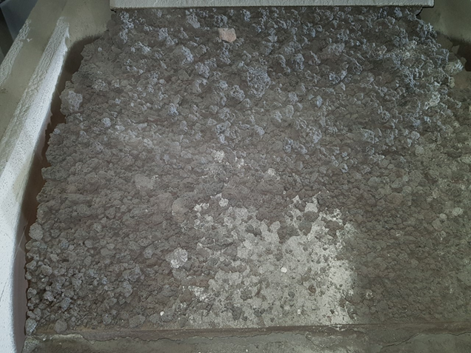
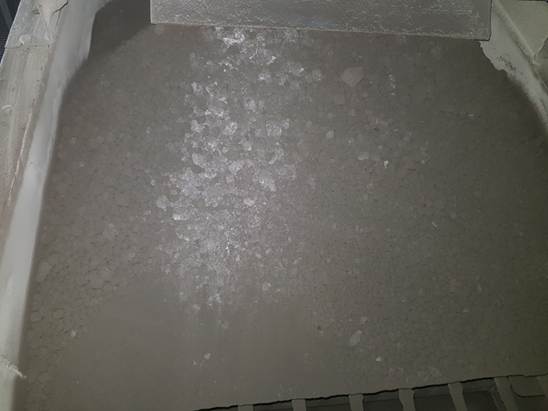
After observing the bunker, we had a radio call from the Converter operator, Steve Gulliford, and were told he had managed to sort out the problem with the dispensing of material. He found that the density of the material was different to that of sinter, and that 3t of this material was too much to contain in the bunker at once. So, following his advice we decided to reduce the maximum capacity to 2.5t. For me, it was important to take the advice of an operator who has vast knowledge of converter and show humility. In a situation like this, I valued someone else’s additional experience Sharing information within a team is can positively increased team building and creativity (Jia, et al., 2018).
Figure 6 shows slurry pellets situated in bunker 13.
Figure 7 shows sinters situated in bunker 11.
    - Third concern
The next heat saw a problem with Hydrogen levels in the steel at the Secondary Steelmaking unit. The hydrogen dip result came back showing the steel contained 9.8 parts per million (ppm). Acceptable hydrogen levels range from 1-5ppm. A reading of 9.8ppm was highly concerning, as high hydrogen steel can cause a process safety issue at the casters, blistering in the cast steel and embrittlement in the final rolled product (see Appendix 4). The feeling I felt at this point was similar to how I felt after the bunker was not dispensing material. For me, this was the most significant event that could stop the trial from succeeding. Subsequently, I felt that it was of paramount importance that I informed the Casters about the high incoming hydrogen level. A strength associated to CF’s is that they are diligent and conscientiousness. I could not let the Casters discover the high hydrogen content of the steel without warning them, therefore I believe I was demonstrating a trait strongly linked to CF’s. They requested another sample to be taken, which came back 9.6ppm which confirmed that the steel was genuinely high in hydrogen. At this point, any thought of continuing the trial was aborted. I needed to come up with a plan of action to safely dispense the remain ~65t of slurry pellets in the converter without adversely affecting quality or operations. All teams must have a member that can devise a contingency plan if an unwelcome or unexpected situation arises. Having the ability to see all the options on the table and be cool enough to come up with the correct plan of action. In this instance, I believe I came up with an adequate solution to a problem that I feared would arise at the start of the trial.
I determined that the safest cause of action was to only add a maximum of 1t per heat at the start of the oxygen blowing process. The thought process behind this was that the hydrogen content would be blown out by the time the blowing process finished. Any cooling material needed at the end of the blowing process would use sinter only. An email communication was sent to the shift team detailing these instructions. If this failed, the next stage would be to empty the converter and drop all 65t of material in the empty converter and tip the material onto the floor. The following morning, there were no reports of further issues with hydrogen, and the remaining material was safely dispensed. My overriding feeling at this point was relief that there were no further problems overnight.

- Conclusion
Looking back at how the trial went, I feel that I took all the correct measures to mitigate any issues that might have arisen during the trial. I listened to more experience colleagues when required, and I had the modesty to adapt the trial when needed. I feel like the role I was given was the correct one based on my own individual personality traits. Working as a Technical Specialist, it is necessary that I displayed sober, disciplined and conscientious decision making to ensure the trial was a success; traits that are synonymous to monitor evaluators, implementers and complete finishers. Having analysed the trial I now realise that I was quite fortunate that the hydrogen content in the steel wasn’t much higher than 9.8ppm (see Appendix 4).
I have significantly improved my ability to communicate with other team members, particularly those who I have never really dealt with before. This has been a weakness of mine for fear of not being listened to, or not being able to inspire other members of the team which is a weakness associated to Monitor Evaluators in Belbin’s model. Furthermore, I have learned that for the trial to be a success, it needed all members of the team on board from the start. Having negative people surrounded would have negatively impacted upon the success of the trial. In hindsight, perhaps I had prejudged certain people before the trial and was slightly reluctant to ask for their help and experience. It is key that the team members all have their Physiological and Safety needs met according to Maslow’s ‘Hierarchy of Need’ (see Appendix 5).
This knowledge will be essential to me as a I go forward, as another trial has been planned using slurry pellets with fewer fines and less moisture (hydrogen content). When coming up with a new trial plan, the results from Belbin’s Self-Perception Inventory to see what roles I thrive at, and what help I might need from other team members that have strengths in other areas (Shaper, Resource Investigator).

References
Aritzeta, A., Senior, B. & Swailes, S., 2007. Belbin team role model: Development, validity and applications for team building.. Journal of Management Studies, 44(1), pp. 96-118.
Benson, S. G. & Dundis, S. P., 2003. Understanding and motivating health care employees: integrating Maslow's hierarchy of needs, training and technology. Journal of Nursing Management, 11(5), pp. 315-320.
Davies, M. F. & Eleftheria, K., 2006. Interpersonal characteristics associated with different team roles in work groups.. Journal of Managerial Psychology, 21(7), p. 638.
De Fruyt, F., McCrae, R. R., Szirmák, Z. & Nagy, J., 2004. The Five-Factor Personality Inventory as a Measure of the Five-Factor Model: Belgian, American, and Hungarian Comparisons with the NEO-PI-R. Assessment, 11(3), pp. 207-215.
Gallup, 2016. State of the American Workplace, s.l.: Gallup.
Jia, H. et al., 2018. "Leader Humility and Team Creativity: The Role of Team Information Sharing, Psychological Safety, and Power Distance.". Journal of Applied Psychology, 103(3), pp. 313-324.
LaDue, S., 2016. Employee Retention and Psychology. [Online]
Available at: http://knowlton-group.com/employee-retention-psychology/
[Accessed 5 May 2019].
Manning, T., Parker, R. & Pogson, G., 2006. A revised model of team roles and some research findings. Industrial and Commercial Training, 38(6), pp. 287-296.
UWTSD, 2017. University of Wales Trinity Saint David Logo. Swansea: UWTSD.

- Appendices
- Task List
Table 2 shows the task list, the owners of each task and the start and end week for each task.

- Belbin’s team roles
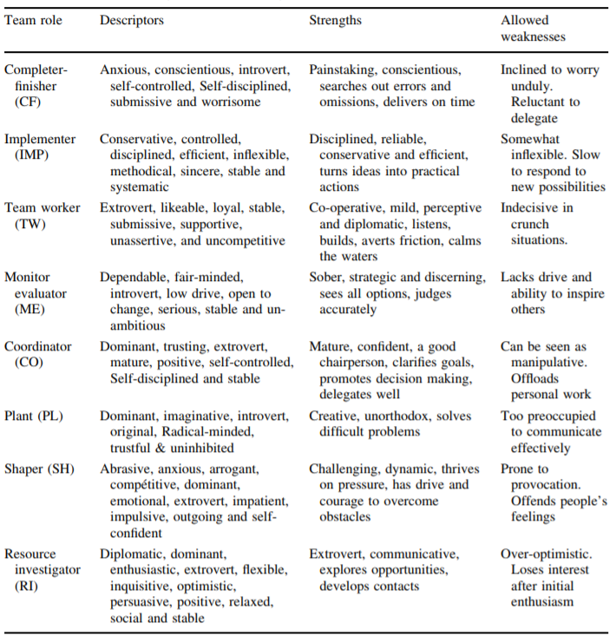
Table 3 shows Belbin's eight team roles and their associated strengths and weaknesses (Aritzeta, et al., 2007)

- Slurry pellet risk assessment
Table 4 shows the risk assessment carried out regarding the addition of slurry pellets
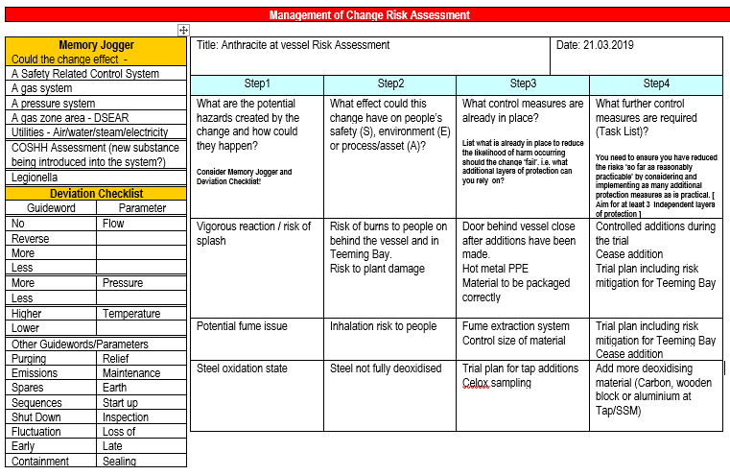
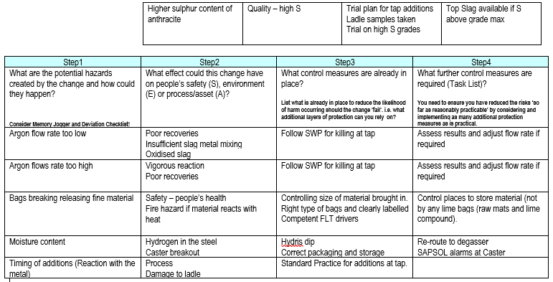

- Significance of 9.8ppm Hydrogen reading
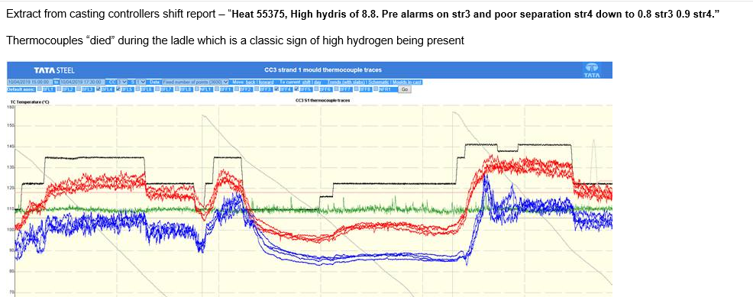
Figure 8 shows the thermocouple levels at the Casters indicating a problem with hydrogen in the steel.
Above is an extract from an email from Kevin Hicks, the Casters Area Process Technology Specialist. The graph shows the mould levels at the Casters. The concern of Hydrogen was seen by monitoring the trends of the two thermocouples at the mould (blue and red trends). If the blue trend inverts and goes above the red trend at any point, there was a risk of the molten steel breaking through the mould and causing a loss of containment in the steel. The two circles highlight to two critical points where the hydrogen almost cause a potential loss of containment.
Safe working procedure document no. KHIS-9Z5GAK states;
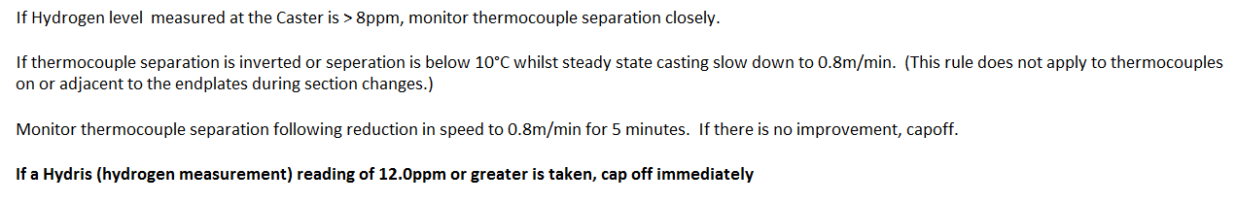
The term “cap-off” means to stop casting entirely.

- Maslow’s Hierarchy of Need
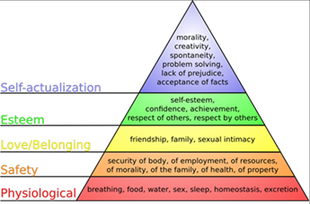
Within a group project, there are often several different individuals involved with their own pre-determined tasks which all contribute to the common goal. Each person has their own personality types, so their roles within a team can differ and influence others. In order to get the best results out of the team however, it is important that each person has the required level of motivation to carry out their tasks. Abraham Maslow was a psychologist who developed a “Hierarchy of Need” which states that people (or in this case) employees are at first only motivated to fulfil basic needs; Physiological and Safety (LaDue, 2016).
Figure 9 shows Maslow's Hierarchy of Need (LaDue, 2016).
Employees want to feel a connection with their colleagues and managers, but without the first two tiers of basic needs, this is not possible. According to Gallup (2016), “Fifty-one percent [of workers] merely put their time in, while the remaining 16 percent act out their discontent in counterproductive ways, negatively influencing others” (Gallup, 2016).

