UNIVERSITY OF WALES TRINITY SAINT DAVID
LONDON CAMPUS
Assignment 2
Learning in the Digital Era
https://uowtsd-my.sharepoint.com/:p:/g/personal/2440002_student_uwtsd_ac_uk/IQCTs7ztBNocSoDdmXlSeGLLAbN3aKRJuPJ3JITack-WDO0
Module Name: Learning in the Digital Era
Module Code: ACCA 4025

Student Name: Lucia Nieto Gisbert
Student ID: 2440002
Group: 1

Lecturer’s Name: Dipo Dunsin

Table of Contents
Introduction 2
Main Body 2
Conclusion 9
References 9

Introduction
This report is the written report of component 2 Professional Development Plan (PDP) video presentation of the Learning in the Digital Era module. It provides a brief description of the contents of the presentation, including a self-assessment of my personal and professional capabilities, a guided PDP using SMART goals, and an overview of a chosen topic of the course Becoming a Lifelong Learner. Gibbs Reflective Model is used in the presentation in order to package the process of self-reflection, which is a key component to recognizing a lack of skills and creating an initiative to develop in the future.

Main Body
The template required brief descriptions and placeholders on this section to give the explanation of the slides. The video will have a detailed analysis, discussion, and any other necessary citation.
Video Link:
Slide 1 COVER PAGE
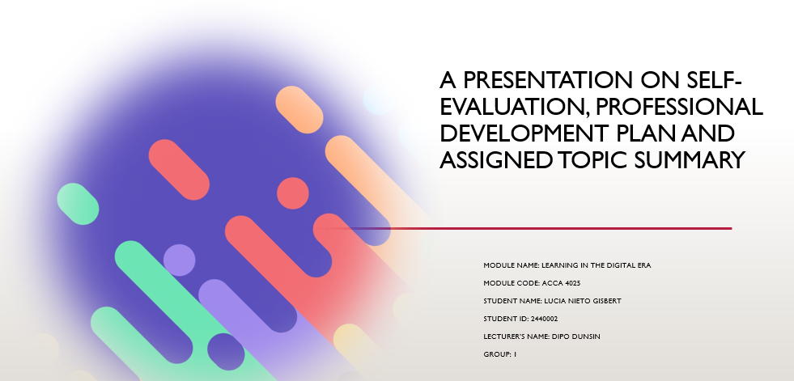
Slide 2 CONTENTS

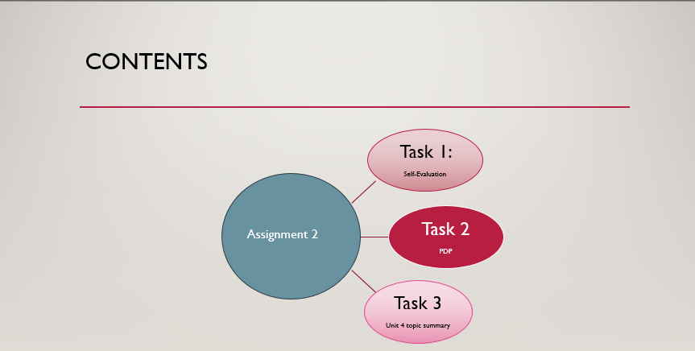
Slide 3 INTRODUCTION

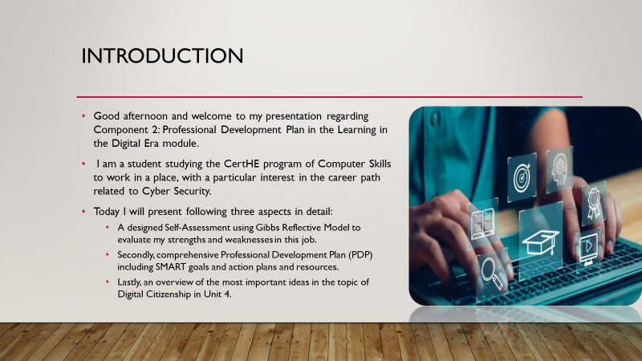
Slide 4 MAIN BODY
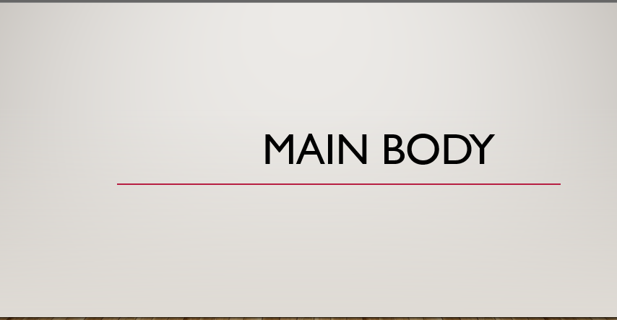

Slide 5 GIBB’s REFLECTIVE MODEL
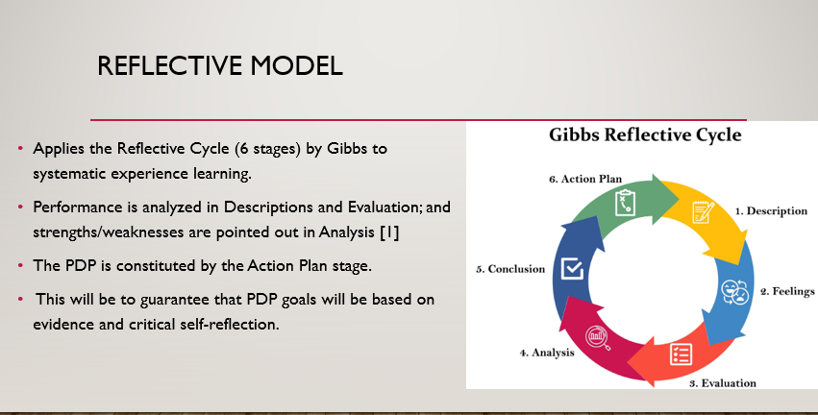
Brief explanation:
The Reflective Cycle by Gibbs is a popular systematic model of guided experiential learning, which normally has six steps; Description, Feelings, Evaluation, Analysis, Conclusion, and Action Plan. I will use the Description and Evaluation stages to be critical of my performance in the latest academic and professional settings [1]. Analysis and Conclusion stages will help to find the main strengths and weaknesses making the Action Plan be informed directly. This Action Plan is the core of my PDP because my developmental goals will be based on the systematic, evidence-based self-reflection.

Slide 6 TASK 1: SELF EVALUATION
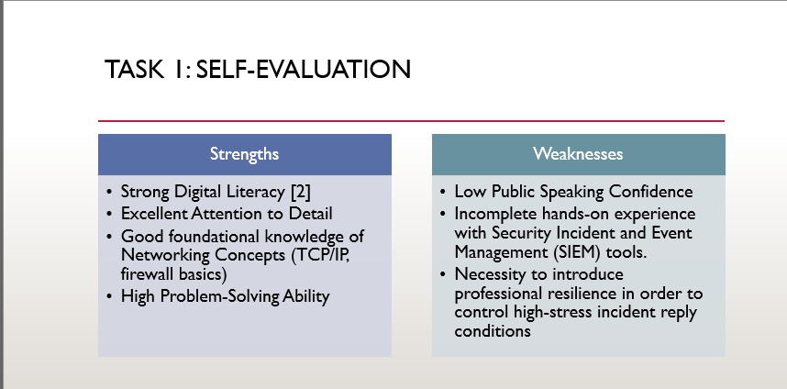
Brief explanation
Strength: Strength Digital Literacy
I am well versed and fluent with the diverse digital tools, digital platforms, and technologies due to my high digital literacy [2]. It will enable me to learn new software pretty fast, support technical problems easily, and keep up with the changing digital trends, all of which are needed in a more technological job, particularly in IT and cyber security.
Weakness: Low Confidence in Public Speaking
The lack of confidence in speaking before an audience may prevent my presentation skills, team briefing or ability to explain myself well during times of stress. It is a good skill to enhance teamwork, share knowledge, and become a leader, particularly when responding to an incident or communicating with stakeholders.
Slide 7: TRAITS GAINED FROM THE SELF EVALUATION
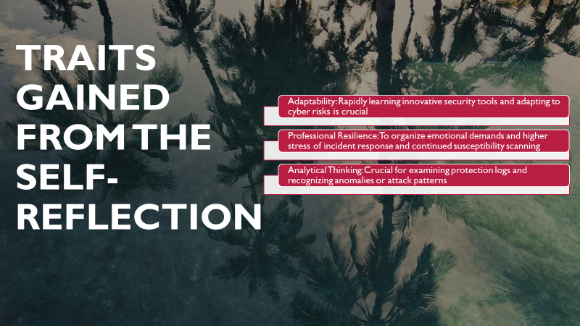
Brief explanation: The reflective process has enabled me to intervene the key characteristics of my professional path. The self-reflection underpins a robust characteristic of Adaptability/Flexibility because I embrace and acquire new programs and computer processes swiftly. It also indicated that there was a necessity to strengthen a bigger aspect of Professional Resilience in order to deal with constructive criticism and setbacks through a different approach [3]. It is imperative to be aware of these characteristics, both present and desired, in order to focus my developmental attempts to become a comprehensive computing professional.
Slide 8 PROFESSIONAL DEVELOPMENT PLAN
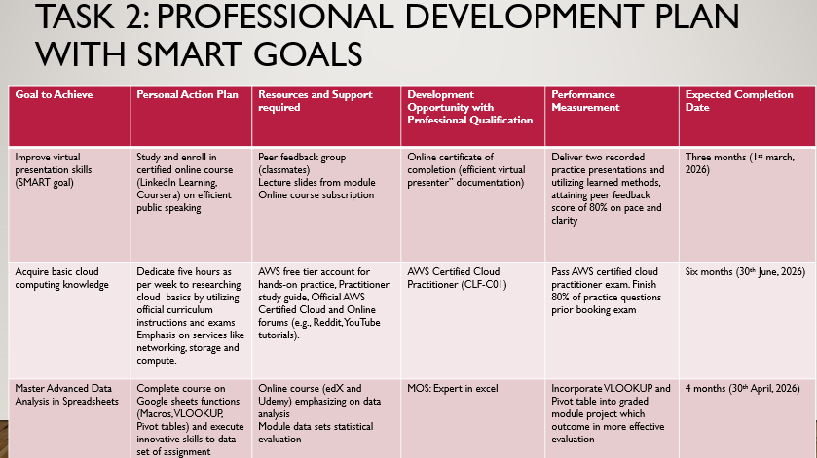
Brief explanation:
My Professional Development Plan (PDP) is a two-principles SMART goals plan based on self-assessment. Goal 1 will be to improve the skills in public speaking by taking a certified online presentation course and presenting two practice talks (Specific, Measurable, Achievable, Relevant, Time-bound). The purpose of Goal 2 is to gain cloud computing basics through passing the AWS Certified Cloud Practitioner exam within the first six months and therefore meet the demands of the industry. The PDP outlines the individual action plan, resources, professional credentials, measure of performance and the projected time when these objectives should have been attained.
Slide 9 UNIT 4 TOPIC SUMMARY
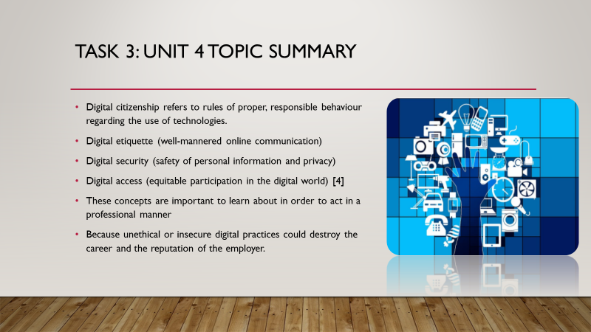
Brief explanation: The chosen issue, Digital Citizenship comes as a result of Moodle Unit 4: Becoming a Lifelong Learner. Digital citizenship is a term that summarises the acceptable, responsible behaviour in the use of technology. Some major terms and definitions relevant here are the digital etiquette (polite internet communication), digital security (protecting personal information and privacy), and digital access (providing non-discriminatory access to the digital realm) [4]. The knowledge of these notions is important in professional practice because any unethical or insecure digital habits may harm one career path and the reputation of a company.

Slide 10 CONCLUSION

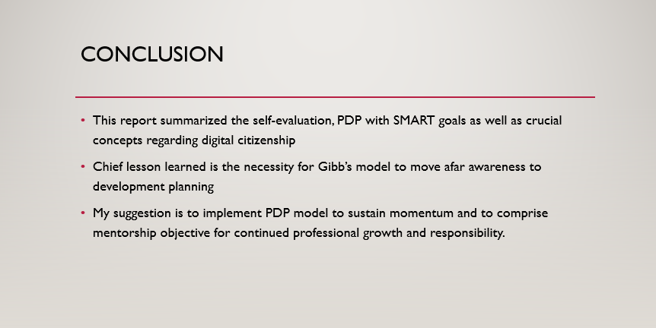

Brief explanation:
The assignment has helped me to conduct a systematic self-reflection through the Model of Gibbs and accurately determine my existing professional competencies and professional skills gaps. The present analysis was used to develop a specialized Professional Development Plan that has two SMART goals improved presentation skills, and cloud computing certification. Summarising the main ideas of Digital Citizenship, I have strengthened the need of responsible, ethical, and safe professional behaviour during the digital age.

Slide 11
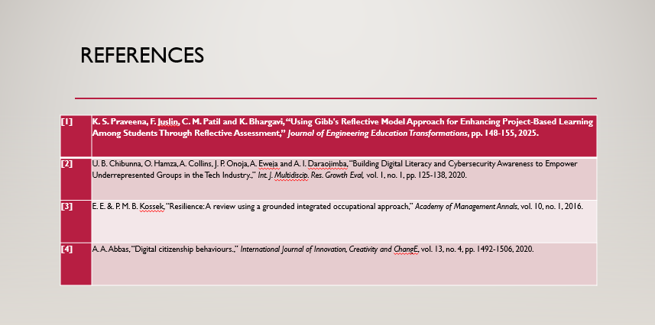

Conclusion
This report delivers documentation for PDP assessment with video presentation. It focuses on structured self-evaluation, PDP with SMART goals and concepts of Digital citizenship. Gibb’s reflective cycle was used to recognize strengths and weaknesses personalized my career in cybersecurity.

References
[1] K. S. Praveena, F. Juslin, C. M. Patil and K. Bhargavi, “Using Gibb's Reflective Model Approach for Enhancing Project-Based Learning Among Students Through Reflective Assessment,” Journal of Engineering Education Transformations, pp. 148-155, 2025.
[2] U. B. Chibunna, O. Hamza, A. Collins, J. P. Onoja, A. Eweja and A. I. Daraojimba, “Building Digital Literacy and Cybersecurity Awareness to Empower Underrepresented Groups in the Tech Industry.,” Int. J. Multidiscip. Res. Growth Eval, vol. 1, no. 1, pp. 125-138, 2020.
[3] E. E. &. P. M. B. Kossek, “Resilience: A review using a grounded integrated occupational approach,” Academy of Management Annals, vol. 10, no. 1, 2016.
[4] A. A. Abbas, “Digital citizenship behaviours.,” International Journal of Innovation, Creativity and ChangE, vol. 13, no. 4, pp. 1492-1506, 2020.

