Link to access sway - https://sway.cloud.microsoft/C8jVSv9dP4QW7FOG?ref=Link&loc=mysways
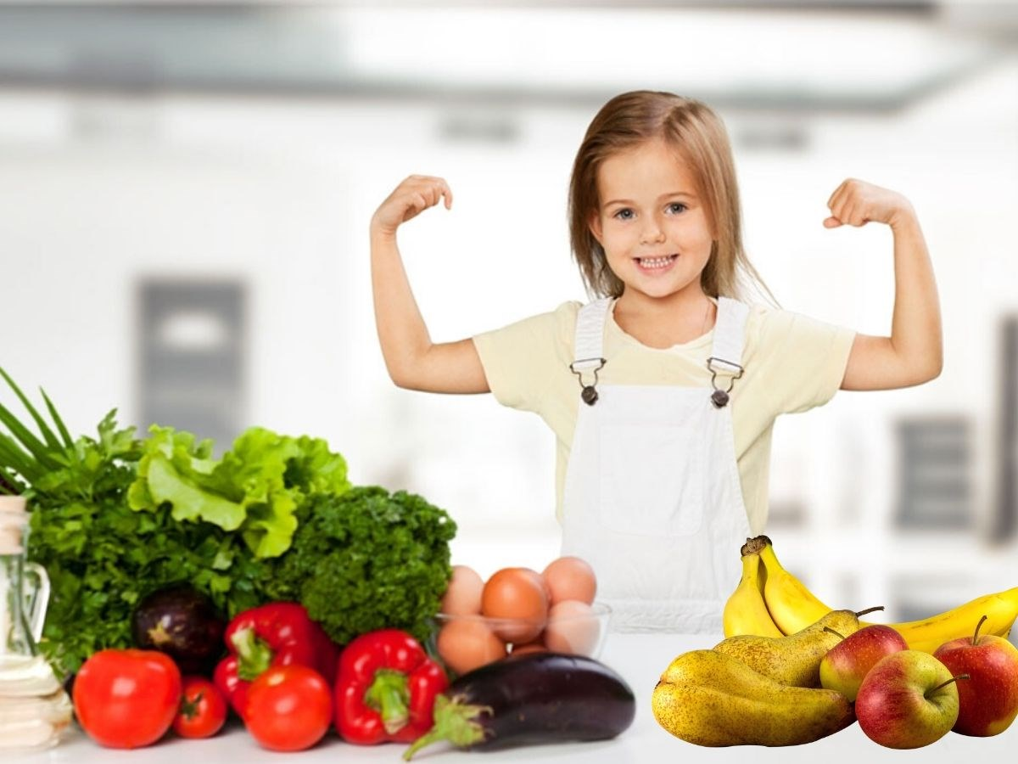
Jessica Mullins_ 2306250_ ECES4009/C
Nutrition influences more than a person’s body size. The nutrition a child receives during their first years of life can determine their health for years to come. Good nutrition is the foundation of child survival, growth, and development. Healthy children are better able to learn, play and participate in their communities. Children who are in fit health are also more resilient and in the face of illnesses and distress. (Unicef,2016). Balanced nutrition is important to child development, children need certain nutrients to flourish and grow. Poor nutrition can be a result of lack of food as well as overeating. Nutrition impacts almost all areas of a child’s development, physical growth, cognitive development and education, emotional and psychological development, and behavioural development. (Karratti, 2018)
As a child your body relies on a variety of foods too attain their daily nutrient needs. Maintaining a balance within nutrition is vital for normal physical growth. A lack of complete proper nutrition can hinder a child’s growth and can cause problems as they grow older. Maintaining healthy eating habits from an early age sets the stage for the rest of the child’s life. A diet too high in fat and calories can lead to obesity, which later interferes with physical fitness but also increases the risk of heart disease, diabetes, and cancer. A diet lacking in good nutrition can also result in stunted growth and bone disorders. (Martinez,2017)
“1 in 3 children under five is malnourished; 2 in 3 children under two live on poor diets”- (UNICEF, 2019) Brain development is most sensitive to a baby’s nutrition between conception to two years of ages. Children who were malnourished as fetuses and infants suffer long term behavioural and cognitive deficits, including delays in language and fine motor development, lower intelligence, and poorer academic performance. (Zero to Three, 2014). Malnutrition not only affects a child’s growth, but social development also. Undernutrition has been associated to poor academic achievement and behavioural difficulties. Nutritional stress because of food insecurity, can cause chronological physical stress and weaken the body. The impact of malnutrition, stress and food insecurity can contribute to negative impacts on a child’s social, emotional, and cognitive development. (UKEssays, 2021)
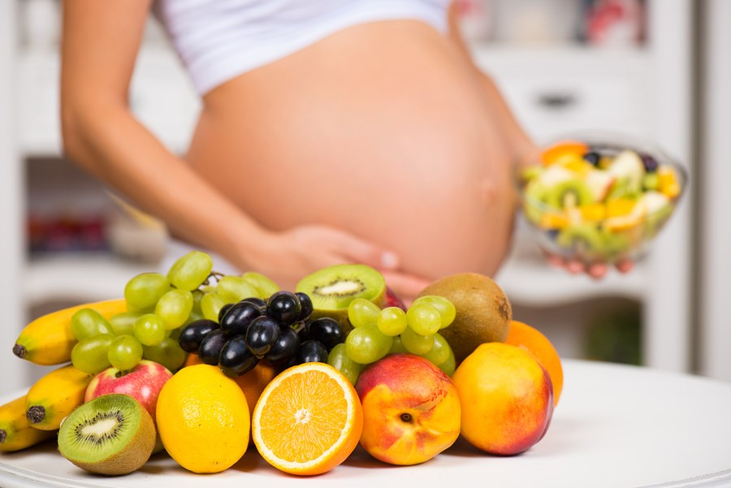
1 - (Borba,2017)
Women have clear nutritional requirements throughout their life. Especially before and during pregnancy and breastfeeding, whilst nutritional vulnerability is significant. Women maintaining a notorious diet and care is detrimental for the survival and well-being of mothers and their children. During pregnancy poor diets containing a lack of nutrients such as iodine, iron, calcium, and zinc can cause issues such as anaemia, pre-eclampsia, haemorrhage and death in mothers. They can also consequent into stillbirths, low birthweight, wasting and developmental delays for children. (UNICEF,2021)
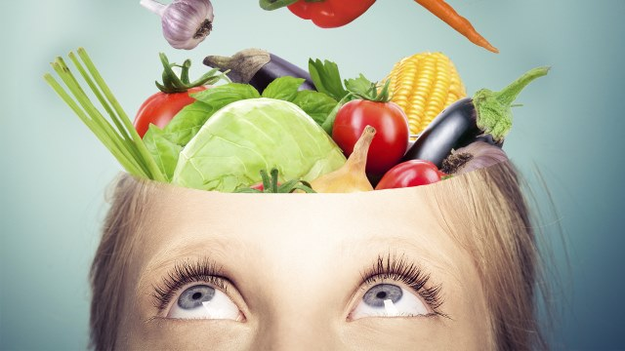
2 - (HealingLifestyles,2021)
“Healthy children learn better.” – (World Health Organization, 2023) A balanced diet feeds the brain, providing the brain with the nutrients it needs to support a positive mood. The nutrients required to support a healthy mind and brain are so vast, but it is important to consume a varied diet and add in nutrients that are low or missing in the diet. (BBC,2023). The human brain demands all essentials nutrients to configure and maintain its structure. Infant and child cognitive development is dependent on sufficient nutrition. Children who lack in sufficient nutrition are at a higher risk of displaying impaired cognitive skills. (MDPI, 2022).
According to Piaget the preschool period is a time when children learn lots of concepts and develop life-long habits. During this period children learn about healthy, balanced nutrition and obtain healthy eating habits for their later years. Piaget determined that a child’s cognitive development is important for their understanding of their community and the world around them. Piaget’s theory can be used as a guide in nutritional education. (ResearchGate, 2009).
However as recently as 2020, nearly one in four children who are eligible for free school meals were not taking up the offer. After carrying out a food dairy task as part of a survey evidence shows that in school dinners are noticeably healthier than packed lunch. School dinners in the UK are made of regulatory standards related to their nutritional profile, to create a balanced nutritional diet, which states that they should on average have 530 calories per day. However, another study showed that primary school children who have school dinners consume less energy, more protein and fibre and less sugar and saturated fats, than those who eat packed lunches. The evidence from these studies shows that by shifting more children form packed lunches to eating school dinners we can make a considerable improvement to children’s eating habits. Nearly three quarters of parents involved in the survey said that it was them or another carer that decided if their child had packed lunch or school dinners. Evidence shows that parents should be the main focus of attempts to increase in school free meals take up. The largest barrier to taking up free school meals amongst parent was that the food they put in their lunch boxes was preferred to the school meals. (Bone and Hilliard, 2022)
In practice Piaget’s theory offers a precise definition of children’s cognitive development, emphasizes a child-centred approach, highlights play and self-discovery and provides guidance in preparation of age-specific education contents. (ReadCube, 2009). Piaget’s theory can be used as guidance in nutritional education. It assists in designing an effective nutrition education, appropriate for the developmental stages of childhood. Piaget’s theory is to be used in the development of nutritional habits of young children and will try to provide a viewpoint for those who provide nutrition education. (ResearchGate, 2009).
In summary, poor nutrition significantly impacts a child development across various areas of development. The effects exceed beyond immediate health but impact cognitive, emotional, and physical development. Poor health can impact cognitive performance, academic achievement, and effect mental well-being. The impact of nutritional insufficiency during early childhood shows the importance of promoting and ensuring proper, healthy, and balanced nutrition to promote greatest development and well-being within children. Educational interventions aimed at raining awareness of nutritional insufficiency are crucial for reducing the effects on a child’s overall growth and development.
Poverty can be interpreted as persons lack resources to afford basic essentials like food, clothing and shelter. Poverty has many negative impacts on individuals and their families.
Poverty has a major impact on the increasing risk of mental health problems. Mental and emotional health is shaped by a wide range of characteristics of the social, economic, and physical environments in which people live. (Mental Health Foundation, 2023). Poverty can have a number of effects on a child’s physical and mental health. Families who live in poverty are unlikely to be able to afford household essentials such as food and heating. Families in poverty are unable to provide an upstanding standard of living or ability to take part in enjoyable activities with their families. They also face cramped living situations and food insecurity. All these issues influence children’s mental health. (ActionforChildren, 2023). Food insecurity is defined as the absence of access to the food types and food quantities required for each person to live an active and healthy life. Poverty is a cause of food insecurity which then causes malnourishment. (Filipenco,2022)

The impact of poverty on emotional wellbeing. (Anderson, 2016)
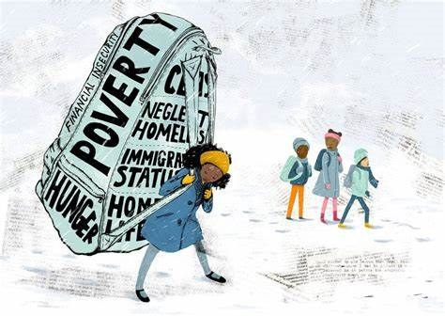
Childhood poverty is associated to worsened socioeconomic results in early adulthood, including lower levels of academic achievement, productivity within jobs, health, and even general levels of happiness. Poverty can be the cause of many mental health issues such as stress and anxiety. This is because people living in poverty tend to be unaware of what tomorrow holds for them, and weather they will be able to afford food and shelter. Furthermore, drug and alcohol abuse are more common among the poor as they view these products as a way to escape their reality. (Filipenco,2022)
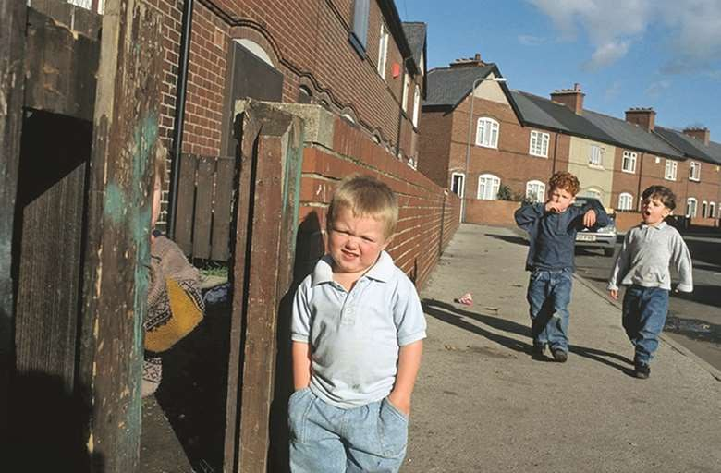
3 - "Child poverty having a 'detrimental effect' on pupils learning and behaviour." (Nursery world, 2019)
Children affected by poverty are also less likely to attend school and if they do there is little chance that they will achieve a high academic performance. Compared to children from wealthy backgrounds, they are less likely to complete secondary education or enrol into a college or university. Their lack of decent education further places them and their families to poverty, the cycle of poverty is repeated for future generations. (Filipenco,2022)
“Children from the poorest 20% of households are four times as likely to have serious mental health difficulties by the age of 11 as those from the wealthiest 20%.” (Kenneth, 2021) Affluency is a sort of strength and can be a morale booster. You can also note that when you have no money you tend to be anxious and less mentally stable. However, when you have money, your morals boost up and you tend to be more confident. Consequently, we can say children who suffer poverty are more pessimistic and may have a negative attitude towards life. (Ranga, 2020) Job loss and a decline in income are drivers of poverty, and often lead up to episodes of mental illness. Conversely, wealth and income increases can improve mental health. Some studies have shown that lottery winners have better mental health compared to those who win less or not at all. (Ridley, Rao, Schilbach, Patel, 2020)
Maslow’s hierarchy of needs is a motivational theory in psychology compromising a five–tier model of human needs, portrayed as hierarchical levels within a pyramid. According to Maslow, human needs were arranged into a hierarchy, with survival needs at the bottom, and the more creative and intellectually oriented ‘self-actualization’ needs at the top.
Maslow declared that survival needs to be satisfied before the individual can fulfil the higher needs. The higher up the pyramid, the more complicated it is to satisfy the needs associated with that stage. Our most basic need is for physical survival. This will be the first thing that motivates our behaviour. He believed that once this level was fulfilled, the next level up is what motivates us and so on. The human body cannot function perfect if physiological needs are not met. Maslow considered these needs to be the most important as all other needs become secondary until these needs are met. (Mcloed, 2023)
However, the order of needs within the hierarchy is inconsistent. A 2015 study shows that Maslow’s theory involves the order of needs within the Hierarchy. Some critics say that whilst Maslow’s theory is logical to put physiological needs first and self-actualization last, people do not necessarily follow or achieve the needs in this order. For instance, some argue that a happy healthy relationship with themselves is an important necessity for having a healthy relationship with others. Maslow argued that a person could only self- actualize once they had met their basic needs. However, sometimes not being able to meet one’s basic needs helps people to identify their self-actualizational goals. For example, a person may have a solid career for many years, fulfilling their needs. However, if they were too loose their job, they may later realize that their old career was not satisfying. Needing another source of income might inspire them to pursue the job that they truly want. In Maslow’s later work he acknowledged that unmet needs could be motivational for self-actualization. (Gepp and West, 2022).
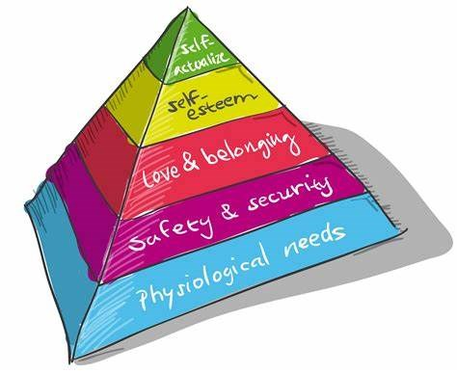
4 - (Acompli,2015)
To conclude, the impact of poverty on emotional wellbeing is a complex issue. Poverty significantly harms emotional well-being. The constant stress, limited access to resources, contribute to higher levels of anxiety and depression. Breaking the cycle requires addressing not only economic factors but also providing essential support for mental health. Poverty takes a toll on emotional well-being by creating a challenging environment marked by stress and limited resources. The mental health implications are affecting not only individuals but hindering opportunities for future success. Fundamentally, recognizing and addressing the emotional impact of poverty is essential for adapting a more empathetic and fair-minded society, where individuals have the support and opportunities needed to lead fulfilling lives.

How Covid-19 influenced children's social and emotional development.
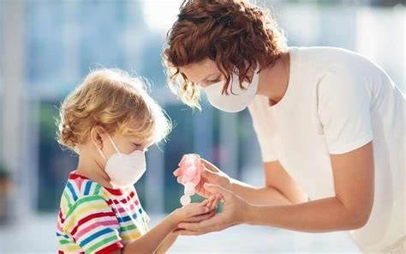
During COVID19 many challenges were identified for children and young people and how it affected their wellbeing. Some challenges recognized included isolation from friends, home schooling, and the worries that friends or families may get sick. Having said that many parents also believe that during this time they developed an improved relationship with their children and that most children spent time in outside spaces at least a couple of times a week during lockdown. (GOV,2020)
From growing rates of mental health problems to worries of rising levels of abuse and neglect and potential harm being done to the development of children. The pandemic is a major threat to having a destructive effect on the nation’s youngest. (Triggle,2021)
‘Closing schools closes lives.’ (Triggle,2021)
The closure of schools is inevitably damaging to children’s education. However, schools are not just a place for education. These are the places where children socialise, develop emotionally and for some an escape from a troubled family life. The pandemic has caused a variety of harms to children, from being isolated and lonely and reduced physical activity as alongside school closures all children’s sports clubs were banned at various times during the pandemic. (Triggle,2021)
Although, it’s not just the school closures. The stress that the pandemic has put on families, with increasing levels of unemployment and financial insecurity as well as the stay-at-home orders, has put a strain on home life throughout the UK. (Triggle,2021)
Unsurprisingly, there are obvious signs that disruption in children’s lives is having a detrimental effect on children’s mental health. A study produced by the NHS Digital and the Office for National Statistics found that overall, one in six children in the age range of five-sixteen had developed a probable mental health disorder, it also found that older girls had the highest rates. The children who took part in this research cited family tensions and financial worries in their households. Aswell as feeling isolated from their friends and fear of the virus for causing their distress. (Triggle,2021)
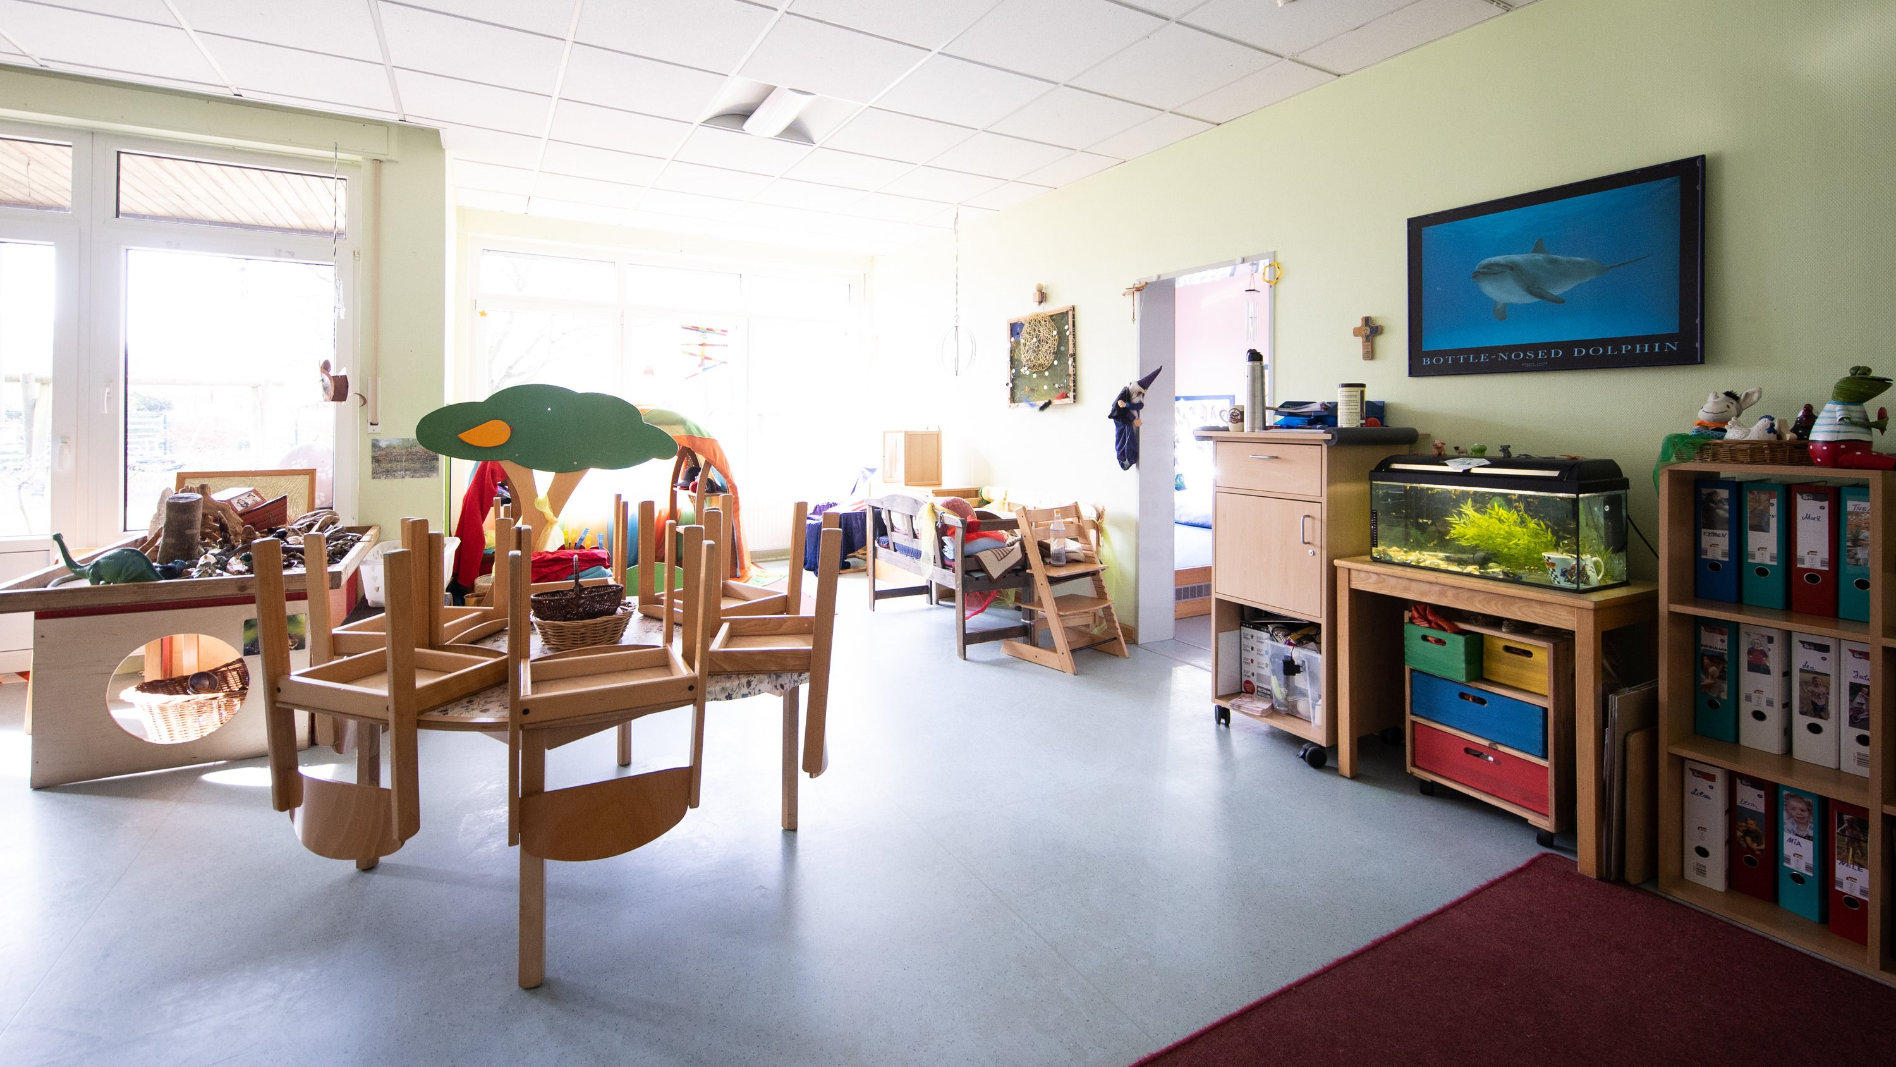
5 - (Carroll, 2020)
In another study by the Prince’s Trust which tracked the well-being of young people aged between 16-25 for 12 years. It established that more than half of young people throughout the pandemic were always or often feeling anxious – The highest level ever recorded. The study of The Prince’s Trust fears young people are “losing all hope for their future”. (Triggle,2021)
At the opposite end, health visitors are worried about the impact on newborns. Research shows that the first two to three years of a baby’s life are the most important periods of human development. If children at this age fall behind, they can find themselves at a long term/ lifelong disadvantage. Meanwhile, the non-attendance of baby and parent groups, and the friendships that develop from them has meant that pandemic babies have not benefited from social contact that is absolutely vital to their development. This is a cost of the pandemic that will have a lasting impact specifically in the most deprived areas. (Triggle,2021)
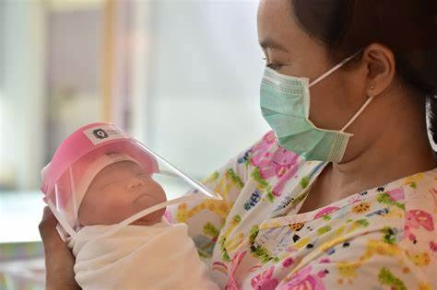
6 - (Suwanrumpha,2020)
For some children, covid19 has had dreadful consequences with the figure of children being harmed and abused, and numbers on the increase. Between the April and September there were 285 reports by councils of child deaths and incidents of serious harm, which also includes sexual exploitation. Arguments that the lockdowns, closures of schools and stay-at-home orders have led to a vulnerable generation of children. (Triggle,2021) These studies describe many potential mental and emotional results of the pandemic, severe anxiety and depression and throughout parents and stress disorders, post-traumatic stress, anxiety and depression amongst children. This situation becomes an adverse childhood experience and could initiate toxic stress with resulting potential losses for development and the long-term effects of cognitive development, mental and physical. (Pediatr, 2021)
Erikson’s theory included 8 psychosocial stages; from under two years old to 13-19, for example ‘Trust vs Mistrust; Can I trust the world?’, ‘Initiative vs Guilt’ ‘Identity vs Role confusion; Who am i?’ (Pelekasis,2021)
The first stage at under two years old, Trust vs Mistrust where they hold a significant bond with their mother, as a child wonders if they can trust the world it is necessary for the mother to develop an essence of trust with the child, which is considerably carried out during the breastfeeding stage. As breastfeeding is hindered to limited spreading of the virus this may make it almost impossible to achieve the development of this stage. (Pelekasis,2021)
At the age of three to six years old, the family has a crucial role in the psychosocial development of the child. Children at this developmental stage may not be able during the pandemic too recognise the intense stress of the family. At this stage, children may develop a lack of interaction with others and not develop team play to the extent in which they should. During middle and late childhood Erikson considered the school environment to be the base of development in children. In fact, sport plays a big role in the psychosocial development of the child. Limited group sports activities and limited contacts on the whole and interactions at this age and stage of development can obviously show helplessness of children to develop. (Pelekasis,2021)
At the stage of puberty, young people may not be able to develop their identity in a health way, Erikson felt this was vital to do so. During the period of puberty, it is likely that the identity of adolescents is not adequately developed, as they realise that they cannot impact the external reality to the extent that they would like. (Pelekasis,2021)
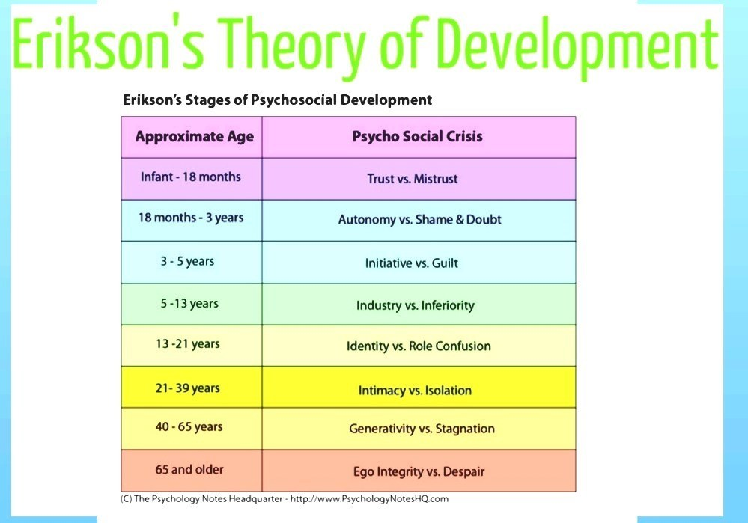
7 - (Pinsoftek,2021)
The effects of COVID19 on children’s social and emotional development is still an evolving area of research which we have not yet seen the consequences of. However, it is crucial to keep in mind that each person’s experiences can widely vary, and the effects of the pandemic on children’s development. The disruptions caused by the pandemic have altered social interactions, and educational environments creating challenges for growth. We have not yet seen the full effects of COVID19 to people’s mental health and social behaviour, this will be evident as more research is carried out and we can truly see the effect of the pandemic on children’s development as they mature.

Link to access sway - https://sway.cloud.microsoft/C8jVSv9dP4QW7FOG?ref=Link&loc=mysways

Reference list
Action for children., (2023), ‘How poverty affects children’s mental health.’ Accessed on 16/01/2024 at: How poverty affects children’s mental health | Action For Children
Anderson.M., (2016)., How to help kids in poverty adjust to the stability of school after break.’ Accessed on 18/01/2024 at: How To Help Kids In Poverty Adjust To The Stability Of School After Break : NPR Ed : NPR
BBC Food., (2023), ‘How diet can affect your mental wellbeing.’ Accessed on 10/01/2024 at: How diet can affect your mental wellbeing - BBC Food
Bone,J., and Hilliard, D., (2022),’Identifying barriers to free school meal take-up in Wales.’ Accessed on 15/01/2024 at: Identifying barriers to free school meal take-up in Wales | Nesta
Borba.J., (2017)., ‘Intro to pregnancy nutrition.’ Accessed on 18/01/2024 at: Intro to Pregnancy Nutrition - Naturopathic Family Health
Carroll.A., (2020), ‘Is closing the schools a good idea?’ Accessed on 18/01/2024 at: Is Closing the Schools Because of Coronavirus a Good Idea? - The New York Times (nytimes.com)
Cherry.K.,(2021)., ‘How Social learning theory works.’ Accessed on 17/01/2024 at: Social Learning Theory: How Bandura's Theory Works (verywellmind.com)
Filipenco. D., (2022), ‘How does poverty impact modern society?’ Accessed on 16/01/2024 at: How does poverty impact modern society? DevelopmentAid
Gepp. K, West.M.., (2022), ‘Maslow’s hierarchy of needs: Uses and criticisms.’ Accessed on 16/01/2024 at: Maslow’s hierarchy of needs pyramid: Uses and criticism (medicalnewstoday.com)
Gov.UK.,(2020)., ‘Effect of pandemic on children’s wellbeing revealed in new report.’ Accessed on 17/01/2024 at: Effect of pandemic on children's wellbeing revealed in new report - GOV.UK (www.gov.uk)
HealingLifestyles,(2021)., ‘The awesome brain-gut connection +10 “Brain foods”.’ Accessed on 18/01/2024 at: Brain Power: The Brain-Gut Connection + 10 Foods To Feed Your Noggin (healinglifestyles.com)
Karratti, D.,(2018), ‘How poor nutrition affects child development.’ Accessed on 10/01/2024 at: Foods to Accelerate the Growth of Malnourished Children (hellomotherhood.com)
Kenneth. E., (2021), ‘Want to Improve mental health? Reducing poverty is key.’ Accessed on 15/01/2024 at: Want to Improve Mental Health? Reducing Poverty is Key | Psychology Today United Kingdom
Martinez., E., (2017), ‘Influence of nutrition on physical development in early childhood.’ Accessed on 10/01/2024 at: Influence of Nutrition on Physical Development in Early Childhood | How To Adult
Mcloed. S., (2023, ‘Maslow’s Hierarchy of needs.’ Accessed on 16/01/2024 at Maslow's Hierarchy of Needs (simplypsychology.org)
MDPI.,(2022), The effects of nutritional interventions on the cognitive development of preschool- age children; A systematic review.’ Accessed on 11/01/2024 at: Nutrients | Free Full-Text | The Effects of Nutritional Interventions on the Cognitive Development of Preschool-Age Children: A Systematic Review (mdpi.com)
MentalHealthFoundation.,(2021), ‘A review to inform the Joseph Rowntree Foundation’s Anti- Poverty strategy.’ Accessed on 15/01/2024 at: Poverty and mental health | Mental Health Foundation
NurseryWorld.,(2019), ‘Child poverty having a 'detrimental effect' on pupils' learning and behaviour.’ Accessed on 18/01/2024 at: Child poverty having a 'detrimental effect' on pupils' learning and behaviour | Nursery World
Pelekasis, P., (2021), ‘Anxiety, Uncertainty, and Resilience During the Pandemic Period - Anthropological and Psychological Perspectives.’ Accessed on 17/01/2024 at: Forecasting the Long-Term Effects of the Pandemic on Children: Towards a COVID-Generation | IntechOpen
Pediatr.J.,(2021)., ‘The potential impact of the COVID-19 impact on child growth and development: a systematic review.’ Accessed on 17/01/2024 at: The potential impact of the COVID-19 pandemic on child growth and development: a systematic review - PMC (nih.gov)
Pinsoftek., (2021), Eriksons stages of development.’ Accessed on 18/01/2024 at: Eriksons Stages Of Development | pinsoftek.com Custom Academic Help
Ranga, (2020)., ‘Effects of poverty|Impact on children & society.’ Accessed on 16/01/2024 at: 12 Effects of Poverty on Children & Society in Everyday Life (mindcontroversy.com)
ResearchGate., (2009), ‘Use of Piaget’s theory in preschool nutrition education.’ Accessed on11/01/2024 at: (PDF) Use of Piaget's theory in preschool nutrition education (researchgate.net)
ReadCube.,(2009)., ‘Use of Piaget’s theory in preschool nutrition education.’ Accessed on 11/01/2024 at: Use of Piaget's theory in preschool nutrition education (readcube.com)
Ridley.M., Rao. G., Schilbach.F., Patel. V., (2020) ‘Poverty, depression and anxiety: Casual evidence and mechanisms.’ Accessed on 16/01/2024 at: w27157.pdf (nber.org)
Suwanrumpha.L., (2020)., ‘Newborn babies in coronavirus face shields: Adorable or Disturbing – or Adorably disturbing.’ Accessed on 18/01/2024 at: PHOTOS: Newborn Babies in Coronavirus Face Shields (mediaite.com)
Triggle.N., (2021)., ‘Covid: The devastating toll of the pandemic on children.’ Accessed on 17/01/2024 at: Covid: The devastating toll of the pandemic on children - BBC News
UKEssays.,(2021), ‘Relationship between nutrition and cognitive development.’ Accessed on 10/01/2024 at : Relationship between Nutrition and Cognitive Development (ukessays.com)
UNICEF,.(2016). ‘Nutrition; good nutrition is the bedrock of child survival and development.’ Accessed on 10/01/2024 at: Nutrition | UNICEF
UNICEF.,(2021), ‘Maternal nutrition: preventing malnutrition in pregnant and breastfeeding women.’ Accessed on 11/01/2024 at: Maternal nutrition | UNICEF
Unicef., (2019)., ‘Poor diets damaging children’s health, warns unicef.’ Accessed on 17/01/2024 at: Poor diets damaging children’s health, warns UNICEF - UNICEF UK
WorldHealthOrganization.,(2023).,’Nutriton’ accessed on 17/01/2024 at: Nutrition (who.int)

