
PROGRAMME: CERTIFICATE OF HIGHER EDUCATION SKILLS FOR THE WORKPLACE (HEALTH AND SOCIAL CARE)
MODULE: PROFESSIONAL DEVELOPMENT WITHIN HEALTH AND SOCIAL CARE
MODULE CODE: LCHS4009
ASSIGNMENT TITLE: PERSONAL DEVELOPMENT PORTFOLIO

LECTURER: ANIKA TAHSIN AHMED
SUBMISSION DEADLINE: SUBMITTED VIA TURNITIN, FRIDAY, 27TH MARCH 2026, 10 AM

STUDENT NAME: Serge Saidi
STUDENT ID:2423011

WORD COUNT: 2029

Table of Contents
Task 1: Professional CV 3
Task 2: personal statement 4
Task 3: SWOT and PDP 5
3.1 SWOT analysis 5
3.2 Personal Development Plan (PDP) 6
Task 4: Reflection on presentation assessment 8
References 10

Task 1: Professional CV
Name: Serge Saidi
Email:2423011@student.uwtsd.ac.uk
Phone number: 07404243822
Address: 26 Wlks Green. B218HR. Handsworth. Birmingham

I am a resilient and compassionate care professional, having years of experience in health and social care. This professional experience of mine is complemented by robust capability in assisting and mentoring. Additionally, my skills in offering daily living support to vulnerable individuals, working in a collaborative environment, can help provide integrated care to the required person. I am currently emphasising improving my knowledge by pursuing health and social care qualifications. Furthermore, I am having a strong interest in innovative, technologically advanced care practices. I am currently also starting to improve my multilingual skill set to offer culturally sensitive care by understanding individual needs.
Key skills
Hard skills
- Computer skills (MS Word, PowerPoint, Excel)
- Personal care
- Documentation
- Emergency response
Soft skills
- Problem-solving
- Communication
- Critical thinking
- Time management
- Adaptability
Hobbies and interest
- I often volunteer in community projects like a blood donation campaign
- I have recently developed an interest in learning new languages
- I also like to do gardening in my free time
- My cooking habit helps me to learn about the nutritious value of food
References
Available on request

Task 2: personal statement
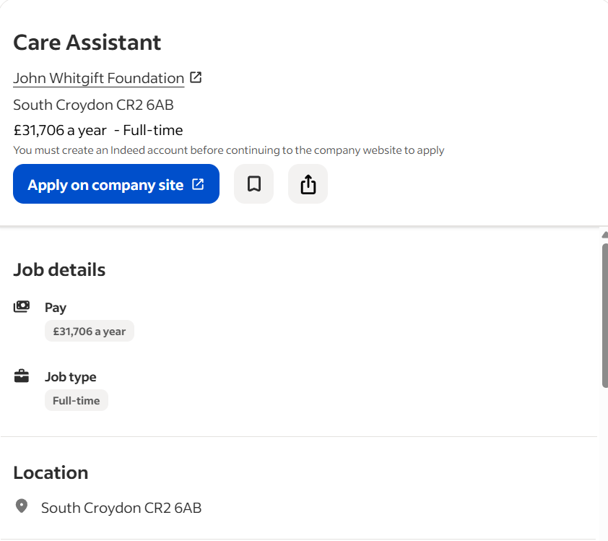
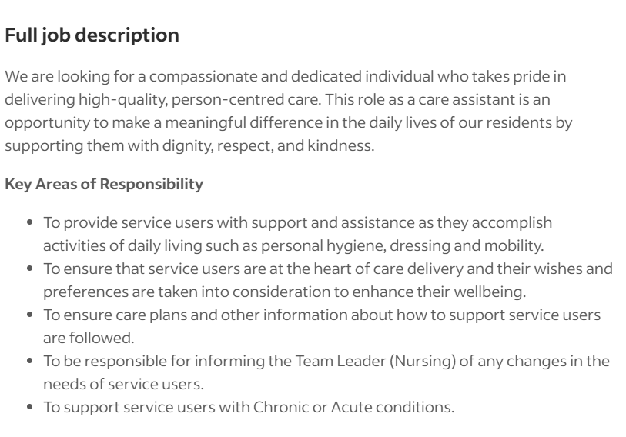
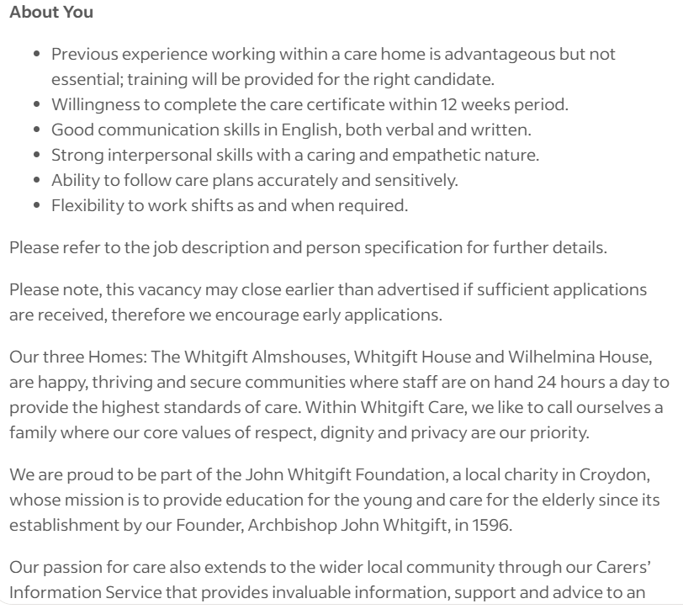
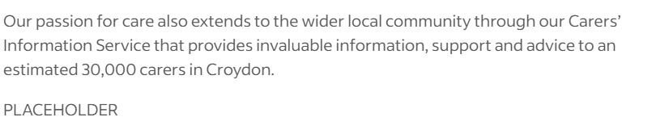
Figure 1: Job advertisement
(Source: Indeed, 2026)
Personal statement - Care assistant role at John Whitgift Foundation
I am currently applying for a Care Assistant job role at the John Whitgift Foundation. My main career aim is to deliver person-centred, high-quality care which promotes respect, dignity and wellbeing of individuals. My years of experience from the health and social care job role can significantly benefit from preventing mistakes while offering care assistance for elderly people. Additionally, a strong academic background teaches me how to use compassion, empathy and resilience in creating a meaningful difference for elderly people and the living conditions of residents.
I have started my career by working in a Care Home setting, where I am responsible for assisting elderly residents with daily living tasks like dressing, mobility and personal hygiene management. In the initial days, this role supported me in learning about the significance of empathy, patience and effective communication to ensure the residents feel respected and valued. Afterwards, I have also worked as a caregiver where I have to fulfil greater responsibilities such as working with nursing teams, concerning information, and teaching new staff as part of the care plan. These hands-on experiences improved my ability to document every crucial information, accurately follow care plans, provide consistent support, and quickly respond to the changing needs.
Academic background is another major strength that makes me fit for this job. I am currently pursuing certification in high-skilled roles related to Health and Social Care from a renowned university in the UK. This learning activity within the university helps me to solve critical problems, improve professional development, reflective practice and build emergency response capability. Furthermore, my academic background in technology and management keeps me inspired for technological changes, and I quickly adapt to new functions that could speed up the process of patient recovery. Quick adaptability also supports meeting job requirements, such as conveying messages to team leaders on time, which helps to overcome acute conditions. I am planning to complete my Care Certification within the given timeline, which will meet professional standards of care practice.
Resilience, accountability, adaptability, and effective communication are my key strengths, which are essential for offering person-centred care. Additionally, I am interested in learning new languages while simultaneously increasing my cultural knowledge to help in culturally sensitive diet planning. Additionally, my skillset in mentoring and training supports collaborative work that is suitable for working in large-scale organisations like John Whitgift Foundation. Accordingly, competency and confidence articulated from the professional experience is strongly aligned with the values of the John Whitgift Foundation, which makes me a suitable candidate for the job.
Furthermore, my passion for responsible consumption interests in digital technology helps me to follow care plans accurately by reducing human error. Additionally, I have previously practised waste reduction and healthier food systems promotion in care home settings, that help me to fit into the empathic nature of care. I am particularly interested in the care assistant job role of John Whitgift Foundation because of its long history of offering health and social care services alongside a commitment to wider community support. Thus, I feel confident about blending hands-on experience, personal values and education to be a suitable candidate for the job position.

Task 3: SWOT and PDP

3.1 SWOT analysis
Strengths | Weaknesses
- I have strengths in person-centred care with empathy and compassion  - I have hands-on experience in treating and assisting in daily activity for elderly people  - I have started to learn about multiple language for increasing cultural intelligence  - I have previous experience working with health care professionals who boost teamwork and collaboration skills | - I have limited formal training in patient-centred care and a low academic degree  - I am highly reliant upon written orders that restrict me from effectively engaged with individuals  - Poor time management skills negatively affect multitasking ability and increase the chance of missing
Opportunities | Threats
- Pursuing higher education in health and social care, alongside completing the current certification, will provide me with a competitive edge in the labour market  - My previous experiences as a caregiver will support me in applying for a senior care assistant role in the health and social care industry  - I could enrol in a training programme like first aid or improving knowledge on basic medication to better comply with care planning for elderly people | - Changes in policy can negatively affect job security  - A high number of people are applying for health and social care role that make the labour market highly competitive  - Lack of stress management capability can hinder the quality of care or increase absenteeism
Table 1: Personal SWOT analysis
(Source: Created by author)
The SWOT analysis has highlighted that hands-on experience in engaging with elderly people, care planning, and acting as a supportive member of the care team make me suitable for the care assistant job role. Additionally, strong empathy and adaptability support me in addressing the individual needs of people, which is necessary in elderly care. Empathy provides the ability to comprehend an individual’s circumstances, emotions, and thoughts for better understanding (Hu et al. 2024). However, limited academic qualification poor time management skills can be a potential barrier for me in securing a senior role in the health and social care industry. Accordingly, I need to increase my certification in emergency response, digital equipment usage, and first aid to manage critical situations as a care assistant. However, increasing competition nowadays has become a major threat to the health and social care sector, in which professional experience can only help to secure a job.

3.2 Personal Development Plan (PDP)
Goals | Strategic action | Monitoring progress | Timeframe
I want to improve my problem-solving skills for better decision-making in critical situations | - Brainstorming different ideas  - Identifying multiple possible solutions  - Use of reverse thinking and shared decision making | Assessing my abilities to recognise problems, brainstorm possible solutions, and execute data-driven and effective decisions can be significant areas to monitor the growth of my problem-solving skills | 6 months
I want to develop emotional intelligence skills to empathically communicate with elderly people | - Active listening to other people  - Participating in teamwork  - Self-regulation and journal writing  - Meditation and peer engagement to share ideas and express thoughts | Tracking participation tendency, motivation, self-awareness and socialisation would be effective traits to monitor my emotional intelligence skill growth | 8 months
I will build knowledge on first aid skills to offer immediate care | - Completing courses on CPR or NHS-approved training  - Participate in the workforce in emergencies such as cardiac arrest, falls, seizures  - View training videos on first aid training and guidelines  - Take support from knowledgeable peers, | - Achieving at least two certificates from a recognised institute  - Taking feedback from the trainer on improvements  - Discussing with colleagues to self-reflect upon skill growth | 10 months
Table 2: PDP
(Source: Created by author)
The above table has highlighted that problem-solving, emotional intelligence and first aid skill development will be my three most prioritised goals for self-improvement. Brainstorming ideas will support me to think from a different perspective that will boost my problem-solving ability, whereas self-journals help to reflect upon communication patterns that simultaneously improve my emotional intelligence. Although training from institutes like the NHS can improve first aid skills, it will be a highly time-consuming process.

Task 4: Reflection on presentation assessment
I am going to apply the Gibbs reflective model in order to structure reflection on the component 1 presentation creation that will explore performance, strengths, and areas for improvement.
Description: The component 1 activity is an absolute evaluation of the importance of the skill in health and social care practices in a critical manner. During analysis, I have considered aspects like person-centred care, individual needs, residential care, and changing preferences to underscore importance of the skill. I have learned from the analysis that, despite possessing the ability to increase team efficiency, inappropriate ways of skill management can lead to misunderstanding. In order to connect theoretical explanations with real-life examples, I have added practical examples from health and social care institutes. Although I have faced challenges in finding relevant care studies due to a lack of relevancy, not updated data, and low searching skills.
Feelings: At the initial stage, I felt overwhelmed by thinking about factors like deadlines, delivering presentations, and searching for relevant information. Before the presentations, I was extremely nervous about speaking in public (to peers and professors). Students are becoming nervous about making mistakes during presentations or using non-native languages (An et al. 2022). This makes me worried about missing crucial points, although I am motivated due to my belief in interpersonal skills. I started to respond more positively to the professor's query, although time management was a major challenge during the presentation. The professor has stated that, although I explain the skill with theoretical depth, I struggle a bit with connecting it to real-life practice.
Evaluation: Theoretical depth, clear structure, positive body language, eye contact are major strengths identified from the activity of delivering a presentation. For example, I have effectively described the skills relevant to teamwork, safeguarding dignity and personal care. However, my lack of explanation about real-life examples keeps some of the peer disengagement with the presentation. Non-verbal communication like waving hand or eye content mainly influences audience engagement (Utari et al. 2022). Furthermore, the professor has also pointed out that excessive information and speaking quickly negatively affects the quality of the presentation. Moreover, I believe that poor time management leads to inconsistent time allocation for each slide, which might reduce engagement from audiences.
Analysis: Looking back, I believe both the excitement and nervousness affected the way of presentation in front of others. This indicates I need to further work on my delivery style, such as slow pace, better time management, and reducing unnecessary words. I also learned that continuous practice can support better performance in the future, which requires rehearsal beforehand the presentation. Poor time management skill leads to misalignment between organising academic tasks and achieving expected outcome (Öztaş et al. 2024). On a positive note, the professor has provided positive feedback on my research, a critical aspect of writing. Additionally, the profession also highlighted that although real-life examples were strong, they needed better alignment to navigate between ideas. Therefore, the presentation activity supported me in learning the importance of feedback, individual needs, and confidentiality in health and social care.
Conclusion: The presentation activity has supported me to learn about both strengths ( active listening, critical thinking) and weaknesses (time management, searching, public speaking skills). I have used a strong and clear structure search about health and social care skills, although delivery patterns need improvement in future. Additionally, improving the connection between theory and real-life incidents can improve clarity.
Action plan
Skill to improve | Strategic action | Time frame
Time management skill | I will allocate time beforehand for each activity for better time management. Google Calendar can support in this process with a reminder. | 2-3 months
Public speaking skills | I will participate in university events, perform in front of the public to increase confidence and public speaking skills | 5-6 months
Table 3: Action plan
(Source: Created by author)

References
An, F.Y., Ravindran, L., Al-Shaibani, G.K.S. and Kamel, G., (2022) ‘Oral presentation anxiety among undergraduate Malaysian Chinese students in a private university’, ASEAN Journal of Teaching & Learning in Higher Education, 14(1), pp.59-77. http://dx.doi.org/10.17576/ajtlhe.1401.2022.06
Hu, H.L., Kuo, C.L., Wang, S.Y. and Chuang, Y.H. (2024) ‘Perceptions of Empathy Among Nursing Assistants in Long‐Term Care Facilities: A Qualitative Study’, Journal of Nursing Management, 2024(1), p.3072064. https://doi.org/10.1155/2024/3072064
Indeed (2026) Care assitance. Available at: https://uk.indeed.com/q-elderly-care-l-england-jobs.html?vjk=825b3f4494d7fe01 (Accessed: 13 March 2026)
Öztaş, G.S., Akçapınar, G., Hasnine, M.N. and Er, E. (2024) ‘Understanding high and low-performing students’ time management strategies through assignment submission patterns’, Procedia Computer Science, 246, pp.3503-3511. https://www.sciencedirect.com/science/article/pii/S187705092402221X/pdf?md5=1f51c1e4ca1c62590c70aa6e3c68684f&pid=1-s2.0-S187705092402221X-main.pdf
Utari, A.R.P., Mujiyanto, J., Suwandi, S. and Fitriati, S.W. (2022) ‘Engagement on Student’s Academic Presentation’, In Proceedings of International Conference on Science, Education, and Technology (Vol. 8, pp. 484-487). https://proceedings.unnes.ac.id/ISET/article/download/1794/1279

