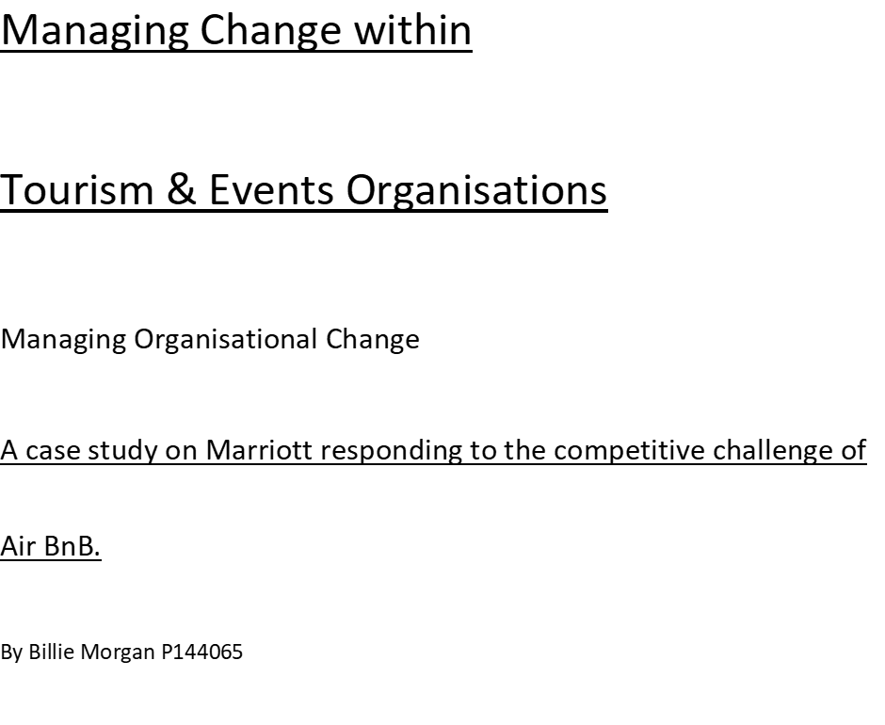

Executive Summary
Amongst the study applied change theory has been utilised were needed to additional developed the analyse of this change report. Though relevant theory vital incremental changes were exposed, these were programmes that was introduced to provide consumers a better experience at Marriott. The advancements made with online platforms is an action taken to compete with the sharing economy’s technological standard and an opportunity to reach the millennial demographic. The PlacePass scheme was a vital element to the report. It was a direct model set by Marriott to compete with Airbnb’s experiences, consequently this incremental change was proofed to be the most important due to the linkage of the sharing economy and has allowed Marriott to step into the new market trend of local experiences. This material has been critically

Contents

1.1 Rise of the Sharing Economy ………………………………………………………………………………………………………….5
1.2 A critical comparison between Airbnb and Marriott……………………………………………………………………….6, 8
1.3 The Change Process………………………………………………………………………………………………………………………..9, 12
1.4 Marriott’s Key Change Models……………………………………………………………………………………………………….13, 28
1.4.1 Incremental Change……………………………………………………………………………………………………….13, 15
1.4.2 Limitation of PlacePass Partnership………………………………………………………………………………..15, 17
1.4.3 The effectiveness of Marriott Incremental Change…………………………………………………………17, 18
1.4.4 Organisational Change…………………………………………………………………………………………………….18, 21
1.4.5 Political l Resistance…………………………………………………………………………………………………………22
1.4.6 Resistance with the Merger…………………………………………………………………………………………….23, 26
1.4.7 The assessment of the effectiveness of the Merger………………………………………………………..27, 28
1.5 Conclusion……………………………………………………………………………………………………………………………………….29, 30
1.7 Recommendations……………………………………………………………………………………………………………………………31, 32
1.8 References……………………………………………………………………………………………………………………………………….33, 37

1.1 The Rise of the Sharing Economy
This economy has many names however the most known is sharing economy. As the advancement in digital technology grows it is easy for the sharing economy to expand. This online service provides a whole new definition of supply and demand to exceed customer satisfaction.
According to N. Yaraghi (2016) ‘The sharing economy is estimated to grow from $14 billion in 2014 to $335 billion by 2025’. The forecast for this growth was due to the rapid increase of businesses from the sharing economy biggest players, Uber and Air BnB. The increased volume in demand for the sharing economy has caused a significant and drastic reason for change for many traditional organisations that are unincluded from the sharing economy’s online platforms. A possible solution for many businesses that have been affected by the sharing economy could be the introduction to change management frameworks as this term is the meaning of setting successful programmes that provide long term strategies. Change projects can bring benefits and structure to an organisation going through a period of modification and allows to be handled accordingly (Sofroninou, 2010). Thus, this report unearths Marriott’s undergoing change both organisational and incremental owing to the impact of the sharing economy. It has critically compared models that Airbnb are using and have linked strategies that Marriott’s operations are producing to combat this platform. Analysed throughout theory has given depth to the changes and has provided the advantages and disadvantages of the change models that are currently being performed.

1.2 A critical comparison between Airbnb and Marriott
“Belong Anywhere” this seductive slogan has influenced consumers worldwide, founded in 2008 Airbnb has triumphed the accommodation sector at a substantial rate. The industry has been overwhelmed by this online platform in the sharing economy as it has managed to capture 191 countries, hosted more than 60 million people and 3 million listings. In Europe, especially the consumer market has experienced high volumes of success ‘3 per cent of the accommodation market in London, 8 per cent of that in Paris and 11 per cent in Barcelona’ S. D’Arcy (2017). This statistic reflects how much influence Airbnb has captured in the tourism market, with their sector and shows the magnitude of how well they in performing externally, arbitrating by the growth gained from this company.
A contemporary tourist has a wide range of accommodation types that are available to them, such as hotels, hostels, friends and relatives, chalets and cottages or couchsurfing. However, it is important to understand why alternative services like Airbnb are thriving in the marketplace. (Yeoman, Brass & McMahon-Beattie, 2007 p.288) identified ‘There are less space to accommodate mass tourism in the modern world. (Cohen 2010 p288) ‘Tourists are increasingly seeking genuine, authentic, local, unique and especially, memorable experiences’. Thus, as this new market demand is developing it is the current reason why Airbnb is successful along with price to be a big influencer. Hence the why traditional accommodation providers are experiencing this new change in the marketplace and the reason why they are combating Airbnb and enhancing certain features to compete. M. Kurtz (2014) reveals that in just six year’s Airbnb room counts has surpassed traditional players in accommodation, whom are the largest and profitable hotel chains in the world including Hilton, InterContinental Hotels Groups and Marriott. To show to magnitude of the remarkable expansion in room counts, Airbnb’s CEO Brian Chesky revealed his point in showing how aggressive the growth of Airbnb is by a tweet, stated in 2014 “Marriott wants to add 30,000 rooms. We will add that in the next two weeks.” In 2016 the Marriott group was ‘400,000 rooms shy of Airbnb’s count’ M. Robinson (2017) therefore it is crucial that change management is implemented to combat Airbnb growth, however will the new change strategies introduced by Marriott be a solution to capture the mass market instead of consumers using Airbnb services, if so this will internally strengthen future success.
When examining Marriott’s organisational operations, it must be stressed the scale of their success “more than 6,000 properties in 122 countries and territories” Official Marriott website (2017). In 2016 they occupied ‘1.19 million international hotel rooms’ in addition the occupancy rate has also increased from ‘70.7 percent in 2013 to 72.5 percent in 2016’ plus according to Forbes (2017) Marriott was placed 11th in the global ranked companies as it is worth ’34.9 billion as of May 2017’ with sales from ‘$17.07 Billion’ and profits made from ‘$780m’ this success has been established due to the 31 operating Marriott brands along with the reputation of high end, first class guest service and five star facilities.
When analysed both organisations have advantages when competing with one another, however they each have limitations therefore below represents the evidence and reasons for change. The introduction of Airbnb has threatened this global franchise due to their offers in luxury stay, at fordable prices. The advantage that Marriott can offer to their guests and what Airbnb lacks, is that traditional accommodation providers offer service quality, brand reputation and security (Dredge 2017). However, the disadvantage for Marriott is the change in tourist behaviour, Airbnb benefits from this shift as the new market demand is ‘better prices, amenities, local experience and the possibility to stay in a ‘non-touristy’ area’ as the growing tourism trend is the search of authenticity (D. Dredge 2017 p.288) and as mentioned previous from a caption of Cohen (2010) tourists want memorable experiences, Airbnb offer these experiences. This certain challenge for Marriott would be the main driving force (Lewin’s Force Field model) in the reason to employ change within their operations and strategize new models that would successfully combat this trend.
Another rationale for change, along with market trend is the business traveller. There is evidence that Marriott key target market, business travellers are booking with Airbnb.

1.3 The Change Process
Lewin’s force field is a good representation of Marriott removing themselves from the status quo, however, various factors must be considered to reveal the overall outcome of the change. These factors are driving and resisting. Competition has been the biggest driving factor that has forced Marriott to change their brand and enhance it with various change strategies, to develop the company further. As Airbnb is the competition it has forced Marriott to use similar models in comparison with Airbnb, due to the popularity and attention it has be receiving in the current economy.
This graph has been taken from a survey produced from AlphaWise, Morgan Stanley Research (2017) it shows 2015 to 2016 the percentage of people whom took the survey, the accommodations that are being replaced by Airbnb, as you can see traditional hotels are at the top of the chart therefore suggesting why Airbnb and the sharing economy is having such an impact to competitors in the industry and evidence that Airbnb is Marriott’s competition and a high weighted driving force to change.
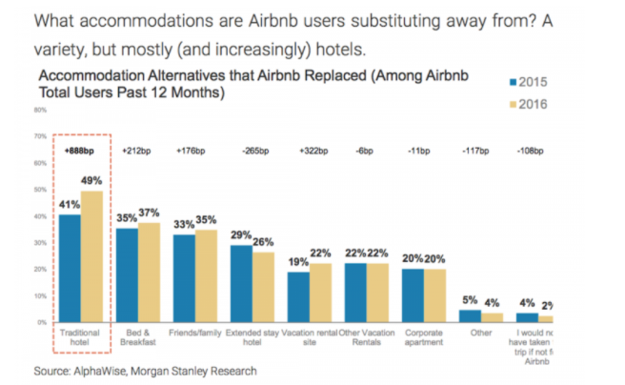
The changes mentioned below has been put forward to gain an advantage over the competition. Other driving forces including: market demand, technology, long term benefit and customer expectations they have triumphed against the restraining factors that has been mentioned below due to the changes that have been performed. Lewin’s theory contextualises the reason why Marriott has improved various services and expanded their company as it is a ploy to step out of existing status and move to a stable long-term state where the company is more effective, however restraining forces must be considered as they will highlight possible disadvantages, which has been commented on through the arguments in the report.
When strategising change there are many variables that must be concerned when implementing change, Cameron & Green explained this process through the diagram below.
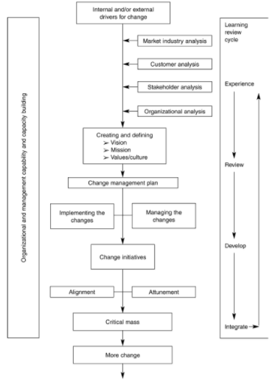
Fig 1 The strategic change process
This theory encompasses the elements that are needed to be considered by an organisation, to successfully diagnose the change needed and how implementing a plan will affect stakeholders and the appropriate steps are taken to ensure that Marriott’s changes to combat Airbnb, have achieved effectiveness.
It is important to be aware that the difficulty in undertaking change programmes are ‘60 per cent of change programmes fail to achieve targeted outcomes’ Hayes (2014) p.4, thus it is crucial to apply initiate steps when executing change.
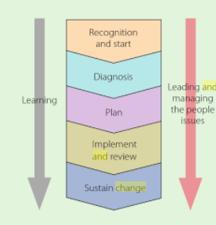
Fig 2 conceptual change framework
This diagram by Hayes (2014) p.2 represents conceptual change framework and beneficial structure to follow when developing a change strategy. It has been used to evaluate Marriot’s key change programmes to combat Airbnb as the process that Marriott is currently in is the stage of ‘Sustain Change’ as these changes have already been implemented therefore it is the process of achieving effectiveness through this change and sustaining these strategies that have been placed.

1.4 Marriott’s Key Change Models
1.4.1 Incremental Change
Continuous incremental change involves a small amount of change but happens at a constant rate. This system encompasses redesigning products to keep up with competition (Grundy 1993). Arguably the following incremental changes are believed to be the most effective form of change as developments, are fast and noticeable to consumers. Therefore, it is suggested that smaller changes to products and services are developed often to advance with the changing consumers needs and market trends.
Marriott’s recent attempt to fend of Airbnb with a strategy of introducing new apps and services to their consumers. In 2016, Marriott launched an extension to their loyalty programme: Marriott Rewards Member rates. The changes were in response to combating the competition by offering their guests an incentive to book with the company and appeal to a wider market especially the Chinese. The extension was in partnership with popular messaging apps such as Facebook Messenger, Slack and China’s largest messaging app WeChat. It allowed loyal customers to book hotel reservations and submit requests via these apps and the chance to search availability within the Marriott brands, and the opportunity to collect articles about the destinations the hotels were situated in. This service also allowed guests to connect with concierge before and during their stay. This small-scale change advances interaction with guests and utilises this through social media, this development is good as social media is the biggest form in how people communicate therefore by developing rewards in messenger services it can potentially enhance the company’s image and makes the organisation more accessible to its members. However, the limitation of this is this development is only accessible to existing rewards members which is a possible disadvantage as they are not attracting new consumers just enhancing the experiences of loyal guests. Although it’s a good strategy to keep an incentive for loyal customers the negative factor is, they should be strategising to reach new target markets. Especially as there is an opportunity to reach the millennial demographics through apps and social media as they are the expanding market, and one in which has the biggest influence of the internet. This change programme is relevant as it is a strategy placed by Marriott to improve online services, as Airbnb is challenging this element due to them being based via the internet and the online systems they utilise already.
Another strategic investment and the magnitude be seen as incremental change, is the new partnership with PlacePass, performed by Marriott in 2017. ‘Marriott International announced an equity investment in PlacePass, a travel website that specializes in activities and experiences.’ (C. Tkaczyk 2017) the partnership has given guests the opportunity to stay at any of Marriott’s 6,000 properties with the option of booking tours with options of 100,000 different experiences. A quote from Marriott’s global chief commercial officer and executive vice president Stephanie Linnartz, “Travelers have been asking us for more local experiences and we’re planning to offer them an array of options wherever they’re going,” this reveals that this change has a direct link from Airbnb success as mentioned previous the online company started this trend of local authentic experiences therefore Marriott has now grown wise to this development and has strategized a programme/ partnership that can achieve this new demand.
The key theory approach that has been implemented from both changes made by Marriott such as improvements of apps and services and the partnership with Placepass has been the planned approach (Lewin model). The organisation has planned change by improving the ability of the organisation to cope with changes in its environment, “change is initiated internally within the organisation in response to environmental pressures” (Ramanathan 2009 p.30) these pressures being the growth of Airbnb and the changes in the environment are market demand and growing technology therefore these incremental changes performed by Marriott has been a strategy to improve their services. The appropriate model used has been incremental due to the changes being small but relevant, the change will produce short actions performed by management to improve and adapt their services that will be needed over time. This chart explains that the above strategies to change Marriott’s services and compete on Airbnb’s level must be a continuous incremental change. Due to the strategies being involved constant updating of work processes and social practices (Hayes 2014) will be regular through a long period of time, as the changes made should be updating their services and providing new features for guests therefore small but continuous changes within these programmes, which is demonstrated through the diagram and it is the theory of adaption to change by an organisation.
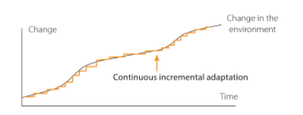
.Fig 3 Continuous incremental Adaption.
1.4.2 Limitation of PlacePass Partnership
In comparison to Marriott Placepass investment Airbnb’s trips offer excursions organised by locals, thus offering intimate and quirky activities whereas Marriott’s Placepass trips on a larger scale from large operators that have been established longer than Airbnb. To convey further contrast within these similar services offered by the two biggest accommodation providers in the world, it is important to show what is offered.
The researcher has selected two trips, one from Airbnb and one from Marriott’s Placepass trips. Both in the same location, Los Angeles undertaking the same activity, Surfing.
Airbnb’s EAT SLEEP SURF experience:
- 3 experiences over 3 days
- 1-night accommodation
- Drinks, Equipment and Transportation
- Offered in English
A total of $270 per person.
In comparison, Placepass Surf Camping Trip:
- 1 day 12 hrs
- Meals included
- Equipment provided
- Transportation
A total of $349 per person.
This reveals for a better option for consumers to select, for example by choosing the Airbnb experience it will give a guest a better experience over 3 days at a cheaper price compared to the Placepass trip such is only for one-and-a-half-day duration and a more expensive rate. This is a threat which a limitation to this incremental change, as it clearly shows a disadvantage to Marriott’s trip programme.
Another limitation that was analysed is the long-term benefit. It could be a challenge for the effectiveness as Airbnb in the future will grow their trips while expanding the range of destinations they have access to and offer more authentic experiences at a cheaper rate, which in turn could challenge the operations of Marriott’s Placepass investment. However, currently this change in offering trips to guests, is an advantage as it supplies an increased profit for the organisation and a service to further the guests experience.
The PlacePass scheme is a direct link to Airbnb’s experiences which demonstrates a change programme that has been solely derived from the success of Airbnb which tells the researcher that this is evidence of feared competition. It is a solution to capturing what the market is wanting from the accommodation industry, therefore is it recommended that investments are made to further expand this department and advance their partnership to produce more range of experiences in different regions as this sets Marriott in a good position for the future as it will return huge profits and long-term stability due to them offering their consumers an additional service. The programme is a great outcome sparked from Marriott widening their services as the advantage is that offering in-destination tours and activities with local flavour is a large and untapped area (Ting 2017), only Airbnb really offers this service therefore by also providing this service it has allowed Marriott to become relevant and on trend with the modern environment, thus posing to achieve a successfully implemented change programme.
1.4.3 The effectiveness of Marriott Incremental Change
‘Many forms of incremental change cause no resistance at all’ Heinrich (2004) p.176 as Marriott are increasing developing their products and services in small stages continuously it is apparent that resistance is not made via both external and internal forces, thus it is suggested for the future of Marriott to hold off drastic changes that would affect the company and its employees hugely and increased efforts in small changes over time as resistance will be minimised. Thus, this is the advantage in the PlacePass investment and the developed of its products.
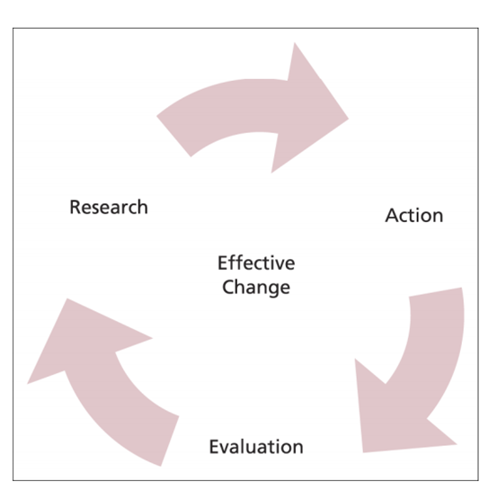

Fig 4 Effective Change
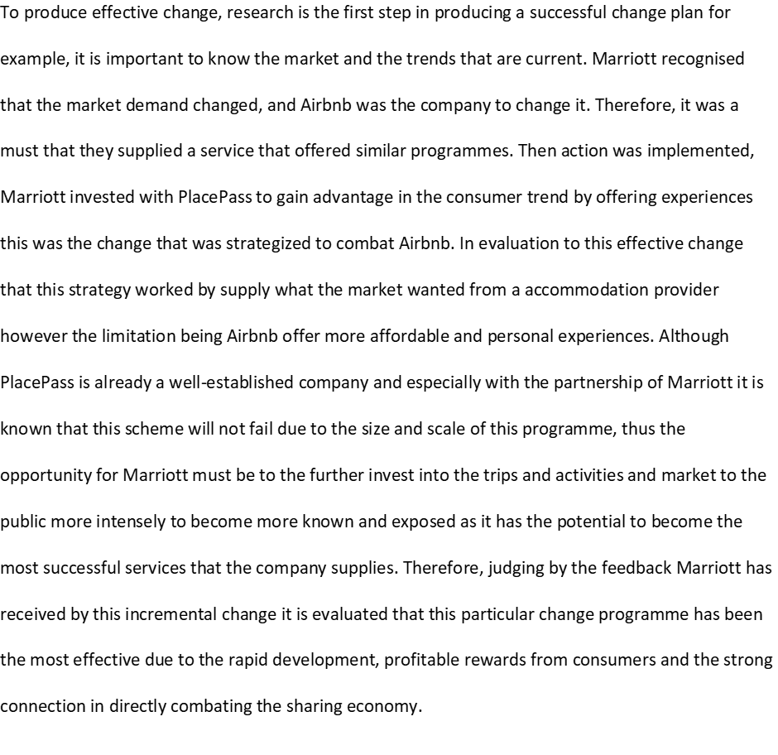
1.4.4 Organisational Change
The rationale to include the merger of Starwood and Marriott into this particular case study was to highlight the factor that this change is the biggest that has happened to Marriott structural in a while, it is important to also understand that it has a relevant link to the sharing economy has it is a solution in order to compete with the rapid growth of this new age in online system. By expanding their operations Marriott can further compete with Airbnb and stay ahead of the competition. Especially as research has found and shown below that both accommodation providers are aiming to capture China, therefore by expanding accesses and combining forces Marriott will reach these growth goals.
“Most organisations operate within a dynamic environment and to prosper in this changing world they need to be aware of and respond to emerging opportunities and threat” (Hayes 2014 p 47) this is the justification for Marriott’s organisational change as the sharing economy brings a new world. They are responding to Airbnb as a threat due to their performance in dominating the market thus the opportunity being, a restructure for the company. This was the $13 billion acquisition of Starwood Hotels & Resorts in 2016 (Robinson 2017) this is an organisational change and strategic implementation in the change process.
In 2016, Marriott won the bid for the synergy of Starwood Hotels and Resorts, their rivals from China’s Anbang. Starwood accepted Marriott’s deal of ‘stock offer of $79.53, valuing the company at about $13.6bn’ (J. Fontanella-Khan. 2016). However due to the competition by Anbang and pressures ‘Shares in Starwood were up a further 4 per cent in early afternoon trading in New York at $83.83. The fact they are trading above the latest offer price reflects a side deal to sell Starwood’s timeshare business for about $5.83 a share’. The decision to increase its offer aimed to appeal to Starwood to show how vital the deal was. As this merger is recent, it is important to evaluate the future of a successful merger as the bid was the change of planning and now currently it is in the stage of implementation (in relation to Fig 3 conceptual framework).
“most commercial mergers and acquisitions are about growth. Merging or acquiring another company provides a quick way of growing, which avoids the pain and uncertainly of internally generated growth” (Cameron and Green 2012 p.299) In relation to Marriott, the acquisition of Starwood Hotels is a quick solution to expand as it supplies instant growth for the brand. Consequently, this restructuring change strategy has been produced to compete with the growth of Airbnb listings and the advantage to this is that it avoids uncertainty of internal growth. However, a known disadvantage to an acquisition is explained by Selden & Colvin (2003) “70% to 80% of acquisitions fail” as the sharing economy has sparked a new overall economy it would be difficult for the acquisition to be a success and evaluate the effectiveness due to the changing structure of the current economy therefore it is difficult to assess the long-term future for this change.
An acquisition of a company is a huge change that an organisation goes through and only the big successful companies often come out of the change process in a desired state (three-step model), however this type of change requires a restructure therefore the factors of resistance could challenge the process.
To reach the Refreeze state (Lewin’s Three Step Model), Marriott must employ management strategies after the merger that will keep the change at an Internalisation stage where the result of the change has been successful and effective, has the change has happened it is now determine the long-term success of the merger. Therefore, by correctly structing management operations it will deliver a smooth transition which then will effectively produce overall positives outcomes, especially in triumphing against competition as the size and scale alone will be a threat to rising sharing economy platforms.
One challenge that is crucial to obtain is transformational leadership, illustrated within this theory.
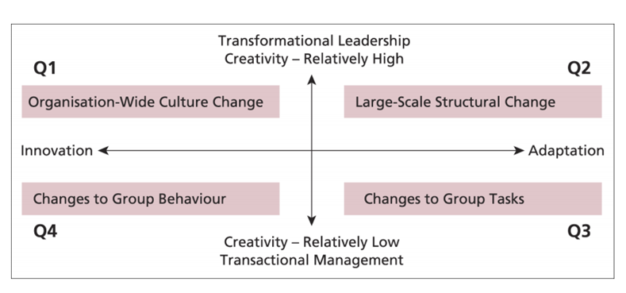
Fig 4 Leadership, Management and Change.

1.4.5 Political Resistance

1.4.6 Resistance within the Merger
It has been just over a year since the merger with Starwood, and during this change Marriott has experienced some resistance.
At the start of the bid for the merger Marriott’s biggest resistance was China’s Anbang insurance group as they were in direct competition to capture the bid of Starwood but withdraw due to the high amount offered by Marriott. But the risk due to this resistance made by the Chinese company is that China’s government could reject future business of this merger in the Chinese market due to the government wanting internally profits made by a traditional Chinese company instead of an outside company capturing the market.
“An unwillingness or inability to accept or to discuss changes that are perceived to be damaging or threatening to the individual.” (Buchanan & Huczynski, 2013 p.628)
The acquisition of Starwood Hotels demonstrates a large-scale change programme therefore it will be utilised in a different way on a much bigger scale which various factors could hinder the effectiveness as resistance would be a threat to Marriott.

- Regular team briefings
- E-mail communications
- Confidential helplines
- Conference calls
- Daily announcements
- Notice boards
- Updates via social media
- Newsletters

Various resistance was made by Starwood associates as these people were the ones affected negatively during this transition. (D. Eisen 2016) Glenn Jordi, a former Starwood Hotels & Resorts employee mentioned that the merger has caused unstable job roles for Starwood associates as many was given end dates to their jobs. This great uncertainty developed resistance especially as employees wanted Anbang, Marriott’s for the bid of this merger as their deal would offer employees less jobs cuts than Marriott’s. Therefore, amongst the process there was hospitality towards Starwood managers and Marriott as a whole due to the lack of security they could offer to their employees. However, Marriott combated this resistance by offering employees a chance to reapply at the new company. This shows mismanagement by Starwood executives towards employees as communication was weak.
In relation to the coping cycle theory, employees in resistance could possibility experience the changes related in this theory. Beginning of the merger would of seen denial and deference were the strongest resistance would have taken place, therefore explains the negative attitude towards Marriott however through process of the change employees would have adapted and become aware of the circumstances. Now the change in the final stage behaviour is different and Marriott’s employees are supporting this change due to the future security.
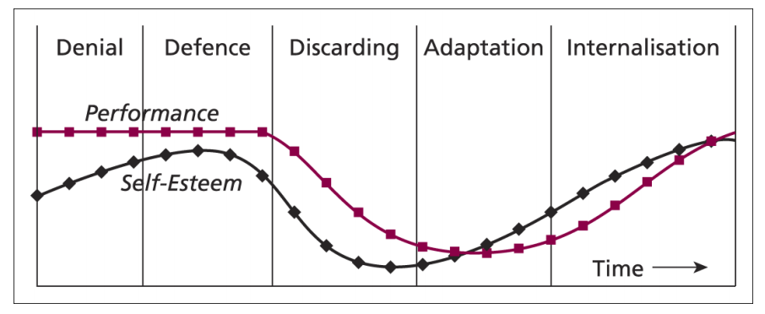
Fig 5 The Coping Cycle
The biggest risk through the merger was explained by, Marriott’s CEO Arne Soreman stated that technology was the biggest risk that would affect the integration with Starwood. The challenge is ‘figuring out the technology platforms that would link all of its more than 6,100 hotels worldwide, which Marriott hopes to complete by the end of 2018.’ (D. Ting 2017) further stated that technology will be the most cost and time consuming as it requires integrating Marriott’s hotels with Starwood legacy properties. However, this is a priority for Marriott has these develops will ensure success for the merger.
1.4.7 The assessment of the effectiveness of the Merger
To assess the effectiveness of an implemented change model it must be critically analysed, the merger is in the stage of evaluation however it is at an early stage therefore plans and actions can still take place to further improve the recent change and deal with resisting factors. Consequently, it is still vital to evaluate the progress made as this will help with the element of sustaining stage.
The synergy of the two companies’ will be greater than the sum of the separate individual parts, Marriott recognised this potential and reward of the change has been estimated that ‘Marriott International expects to extract $250 million in annual cost savings through its takeover of Starwood Hotels & Resorts’ (Travel Weekly 2016) and also the merger has resulted into Starwood Hotel and Resort Worldwide, ‘The new company will operate or franchise more than 5,700 properties and 1.1 million rooms, representing 30 leading brands from the moderate-tier to luxury in over 110 countries’ (Marriott Official 2017) therefore that this show effectiveness on an organisational level due to the spike in expansion and cost savings. The success of acquiring growth is it Marriott’s distribution has more than doubled in Asia and the Middle East & Africa combined’ the effectiveness of this is that Airbnb and Marriott were in direct competition to thrive within this region.
In addition, the advantage that has prospered the collaboration is that the merger was horizontal integration, ‘the process of acquiring with the industry competitors to achieve the competitive advantage’ (Hill & Jones 2008 p.164) it is for economic gain where to accommodation providers in this case work together to triumph in the sector. This develop has allowed Marriott to sustain their influence of the sector and gained advantage in the Asian market which has direct impact to Airbnb due to their efforts in trying to gain this market. As growth this the strategy to develop the Marriott brand in China, Airbnb’s strategy is completely different in comparison. The launch of Aibiying, this is the new marketing strategy by Airbnb it includes the brand name to be changed in China to Aibiying and to double investment. The translation of this name is ‘welcome each other with love’, However the Chinese consumers hate the brand name. The reason for this is, Aibiying is difficult to pronounce in Mandarin (Z. Hunang 2017) this dislike by consumers has caused Airbnb to rethink the name, therefore this strategy has not been effective which is a positive for Marriott as their brand has globally recognition anyway and it’s a setback for their competitor. Thus, the effectiveness’s has been revealed through the gain in the Chinses Market has Starwood alliance has often a growth for the brand and the failure in Aibiying has developed an advantage for Marriot.
Another long-term benefit that has contributed to the effectiveness of the acquisition has been the gain of diversification, a business strategy that has been explained by Stonehouse & Houston (2003 p.177) it is involved in developing growth through new products and new markets, “it can produce important synergies’ and can also help to spread risk” to Airbnb “by broadening the product and market portfolio” as this form of diversification is ‘related’ it reduces the risk of failure as the new product is to a form of accommodation to capture a new market therefore it is within the same industry thus prior knowledge is used in running successful operations.
The outcome of this diversification is Marriott is now involved with Aloft Hotels as it is owned by Starwood Hotels and Resorts, it allows Marriot to have alternative accommodation without disrupting the image of the existing luxury brand due to it being in the name of Starwood. Aloft Hotels supply consumers with a boutique style accommodation with lower rates and innovations through their available products and services to their guests such as the ChatBotlr programme (robots that communicate with guests and their needs) and also gives guests a completely unique experience. Marriott through the merge has gained a whole place in the market through this change therefore it shows a strategy in how they are combating Airbnb and developing further to embrace the new consumer demand. However, it is important that Marriott keep and develop Aloft unique style further in order of expansion to further offer guests a lower rate than traditional Marriott brands, but the challenge is keeping the authenticity of these hotels.

1.5 Conclusion
It is evident that the thriving sharing economy has affected the biggest traditional accommodation providers, however it is important to study how key players are combating this threat and what changes are being made to transform with market demand and to gain competitor advantage. In conclusion to the focused case study of Marriott many factors were revealed both positives and negatives in how the acquisition of Starwood would affect future operations in the company. Overall the researcher believes that the change both through incremental changes and the organisation change of the company’s recent activity have been proved to be a must. The merger has brought Marriott into a better position for long term gain in both profit and in market as the effectiveness of this change shows it success it has and will bring for the brand which outweighs the resistance and risk.
To completed merger of Starwood and Marriott is fresh therefore this is a disadvantage for the means of judging the future state of these change, however from the evidence given from the resistance of the acquisition which is deemed to be manageable. Due to the scale of the organisation future setbacks won’t affect the company massively as the income made globally can fight various resistances.
The most effective element of Marriott’s change plan that has been implemented to combat the sharing economy has been the develops made from their products and services and the Moxy Hotel. By enhancing online social media apps and technical services such as robots and in-destination trip and activities they are supply the market demand with fresh and new opportunities. Especially has products and services is often how to create additional revenue, it is clear that these changes have been beneficial for Marriott in aspects of both competing with Airbnb and establishing themselves in the new age of communicating with consumers online.
In addition, it is important to be aware of the limitations and the resisting factors, therefore it is believed that the recommended suggestions put forward would further increase the effectiveness of each change develop.
In conclusion, the incremental changes and the organisational restructure of Marriott has proved to be successful in terms of fending off Airbnb and tackling the sharing economy as they are appeal to the marketplace whilst globally expanding and diversifying with current trends and technology.

1.6 Recommendations

VI. Incremental changes are likely to not experience resistance therefore in future Marriott, should reframe from large organisational changes and produce small, continuous changes to its products and services to avoid possible resisting factors
VII. Reports reveals Marriott has enhanced social media channels and booking systems via apps, however further produce more online connections to enhance relationships through online communications with the millennial market due to be the future of consumers with different travel needs.
VII. Marriott focus of loyal customers and incentives although that is good in receiving returning customers, it is recommended that more of a focus in put into marketing efforts to attract new guests as findings revealed a marketing strategy hasn’t change drastically to fend off Airbnb.

33) M. Mallinger (2009) Graziadio Business Review ‘Recognizing Organizational Culture in Managing Change Structural changes can serve as the initial intervention for shifting culture’ Vol 12, Issue 1 p.1

