Created By: Cerys Bethan Nickels (P145484)
MComp Software Engineering (Level 7)
Marketing & Web Analytics (ACCA7013) - Assignment 1
Assessing Website Performance Using Google Analytics

Table of Contents
Table of Figures 2
Tables 2
Executive Summary 3
1.0 Introduction 3
2.0 Purpose 4
3.0 Aims 4
4.0 Successful Outcomes 4
5.0 Website Management 5
6.0 Effectiveness of Original Design Using Good Web Marketing Practices 6
6.1 Issues with Faculty Pages 6
6.2 Other Suggested Improvements 6
7.0 Recommendations 7
8.0 Site Map 7
9.0 Data Analysis 11
9.1 School of Applied Computing Google Analytics 11
9.2 Usefulness of Google Analytics Metrics 13
10.0 Conclusion 14
11.0 Bibliography 15
Appendix 1: Interview Questions & Notes 16
Appendix 2: Faculty Pages Issues List 18

Table of Figures
Figure 1: Faculty of Architecture, Computing & Engineering Site Map – Part 1 8
Figure 2: Faculty of Architecture, Computing & Engineering Site Map – Part 2 9
Figure 3: Faculty of Architecture, Computing & Engineering Site Map – Part 3 10
Figure 4: Comparison Between Page Views & Unique Page Views Chart 12
Figure 5: Average Time Spent on Pages Chart 12
Figure 6: Comparison Between Entrance Numbers & Bounce Rate Chart 13
Figure 7: % of Visitors Exiting the Page Chart 13

Tables
Table 1: Ease of Measuring Successful Outcomes 5
Table 2: School of Applied Computing Google Analytics Data 11

Executive Summary
The purpose of the site is to reach out to the wider audience by promoting the university’s activities and courses to industry, stakeholders, and prospective and current students. It is a bilingual site that aims to provide all the information required whilst providing a good user experience.
The existing site has several issues regarding broken and missing links, consistency, clarity and ease of finding relevant information, out of date information regarding academy courses and open day dates on courses, and unnecessary or duplicate information and pages. Reducing the number of pages and clicks to course information reduces the drop-off rate for site visitors, and aids in finding the information they require. This is extremely prevalent within the School of Engineering pages, or those with separate pages for those with a foundation year entry option. Improving the consistency within the schools, or faculty itself can help with finding the relevant information, with options to go back from course detail pages can also help with finding relevant information. This can be achieved with the use of templates, where the links have been tested prior to the page/site becoming live. In addition, consistency with web address links would improve the overall website management. For example, for a course, faculty or school, pages could have the following URL to distinguish similar courses within different schools or faculties https://www.uwtsd.ac.uk/{Faculty/School Name}/{Page/Course Name}.
The data collected using Google Analytics displays the courses with the lowest number of page views, which are HND Electronics Engineering (162) and BSc Data and Information Systems (156). The page with the highest time spent on is page is BSc Business Information Systems (120.38 seconds), and the lowest is the homepage (42.63 seconds), which is to be expected due to the nature of homepages. Course pages are expected to have the longest time due to the need for reading course details and ensuring the information the visitors require is available.

1.0 Introduction
This report outlines the use of Google Analytics to analyse the University of Wales Trinity Saint David (UWTSD) Faculty of Architecture, Computing and Engineering (FACE) website. This report highlights the purpose of the website and its intended goals, with several pathways to achieve these goals. This is then evaluated against good web marketing practices, indicating the expected user actions by the creation of a site map.

2.0 Purpose
The website is an informational site. Its purpose is to reach out to the wider audience by promoting the university’s activities and courses to industry, stakeholders, and prospective and current students. The site is updated every time minor modifications or course changes are required.

3.0 Aims
Its aims are as follows:
- To provide all the information required for prospective and current students, industry partners, and provide a good user experience whilst this occurs.
- To find out the number of applicants and those that request additional information, determining geographical regions in which to target marketing activities.
- To effectively choose key words and phrases for search engine optimisation (SEO) within the faculty to ease up the speed of searching for the relevant information.
- A flat form site, with minimal numbers of clicks to achieve the visitors aims.
- Mobile friendly and responsive, with the key information at the top of the site.
- User friendly for all, which is attractive to the main target audience (16/7+).
- Use the bilingual service as the content is available in Welsh and English.

4.0 Successful Outcomes
There is a combination of successful outcomes for each type of visitors, and are as follows:
For prospective students, this can be: number of clicks, course programmes viewed, their mode of study, requesting additional information, completing a visit/open/taster day form, or applying through UCAS/ online application form. If they know the course, then this will include looking for the employment opportunities, additional features, professional accreditations and modules.
For current students, this can be: term times, scholarships and bursaries, quick links, Moodle, library, MyDay, or MyTSD.
For industry partners, this can include: collaboration with the university, training opportunities, or research.
There are high levels of traffic around the UCAS deadline (January), which decreases after Easter. This is the most critical period for the university/ faculty, visitors looking for alternate universities in anticipation of entering clearing or searching for the following academic year.
Ideally, visitors should only need to visit the site once if they can get all the information they need. Ideally, the path should be course, then onto UCAS, although student services, accommodation and finance are also typical paths.
Successful Outcome | Ease of Measuring Success
Number of clicks/ course programmes viewed | Medium - although Google analytics does not give you this information clearly and easily, it does provide you with a flow map, highlighting routes and page details. This requires practice to ensure success.
Modes of study | Easy – can use eye tracking software to measure the interest on the page, although applicant information can be used to supplement this data.
Requesting additional information/ completing a visit/open/taster day form | Easy – can tell by the number of successful forms completed, or the number of requests.
Applying through UCAS/ online application form | Hard – Google Analytics does not provide you where the users next page is outside of the site. The numbers for the online application for postgraduate students is easier though.
Finding data on the same page | Easy – can use eye tracking software to measure this, or a walkthrough of the page, where someone provides a goal to a user, and they measure the time taken to achieve that goal.
Table 1: Ease of Measuring Successful Outcomes

5.0 Website Management
The web marketing team is responsible for updating the site. The team consists of 3 or 4 people, with one in charge, who approves changes to the site. There are also several members of the School of Applied Computing who have permission to make changes to the site. This works on a ticketing system, with the changes made using the T4 content management system.
Programme directors are responsible for updating their courses and its content, and the links on the page. These updates reflect changes to the courses every year. The Trades Description Act ensures that the information provided is up-to-date and accurate.

6.0 Effectiveness of Original Design Using Good Web Marketing Practices

6.1 Issues with Faculty Pages
There is an extensive and detailed list of issues regarding the faculty pages in Appendix 2. This list was compiled on 09/01/2018, and is summarised into the following four points:
- Missing and broken links as found on school visits and course pages.
- Outdated information as found on Contact Us and IT Academy pages.
- Hard to read text and information as found on the School of Engineering homepage.
- Excessive number of pages as found within the School of Engineering.

6.2 Other Suggested Improvements
Other suggested improvements with the faculty pages are:
- Consistency – The School of Applied Computing undergraduate course layout is not the same as the postgraduate course layout, or with any of the other undergraduate or postgraduate course pages. In addition, web address links should be improved to aid overall site management.
- Staff profiles could be linked to the school site/area (to avoid confusion by visitors to avoid missing them or are required to search) although the option to refine the staff by school is beneficial
- Open, visit and taster days could use the same event registration form
- Motorcycle Engineering MEng/BEng and BEng 4 year ‘Race Team Website’ links go to different sites (Possibly redirect it to https://www.uwtsd.ac.uk/raceteams/ instead?)
- Each course page could link to the page it corresponds to on the UCAS site, or to the application page with the course and university information details filled in.
- Applied Computing key facts – rearrange the durations and use a new line to separate part-time and full-time durations to increase clarity e.g. Full time: 1 year
- School of Engineering – lots of page clicks to get to course – can remove links to undergraduate and postgraduate and replace with a list
- Separate the undergraduate and postgraduate courses when they are on the same course details page and integrate the foundation year into the undergraduate course details pages.

7.0 Recommendations
All pages should be reviewed on an annual basis by both the web marketing team and the faculty staff members. This should ensure that all information is relevant, up-to-date, and there are minimal number of pages and clicks. All buttons and links should be tested after any changes are made to ensure that they work as expected. There should be minimal blank space on pages to reduce the need for scrolling and to improve usability for mobile/ tablet devices.
Consistency with the course details pages using the same template. This can also minimise the need for testing all page links and reduce those with missing important links, such as social media and course information.
Increase clarity for key facts and information. This can include a new line to separate full and part time course durations and the use of colons to separate the information.
Consolidate pages and reduce the number of pages required. This is prevalent within the School of Engineering, where the user is required to select whether they are undergraduate or postgraduate, and then the sector, such as logistics or automotive. The MSc courses could be included within these sectors, and the undergraduate/ postgraduate page becomes redundant. This is similar for courses that includes a foundation year, where this information can be included within its details.
Dates should be removed from pages where possible, such as the IT academy courses and open days on faculty pages. If this is not possible, these pages should be noted and updated regularly. Thus, reducing the number of pages that must be updated on a regular basis.

8.0 Site Map
Below is a site map of the website, with the hyperlinks between pages removed for ease. Most of the pages have hyperlinks to the same level pages, such as the course pages having hyperlinks to other related courses. The site map has been split into three sections for ease of display.
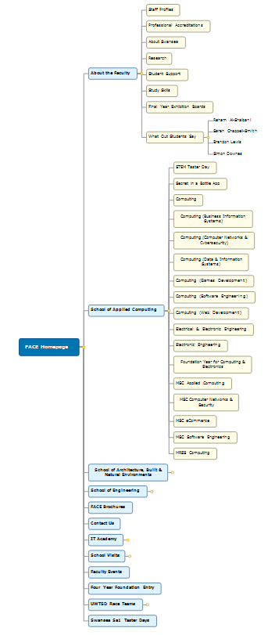
Figure 1: Faculty of Architecture, Computing & Engineering Site Map – Part 1
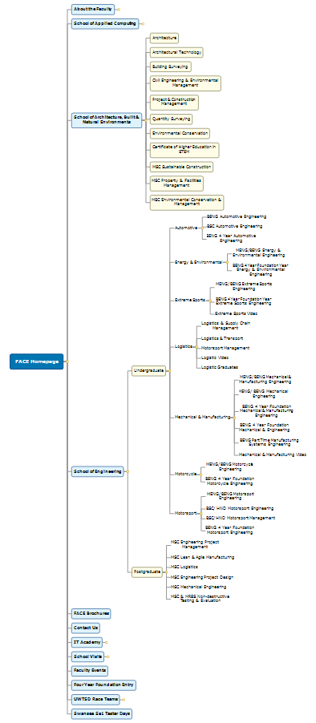
Figure 2: Faculty of Architecture, Computing & Engineering Site Map – Part 2
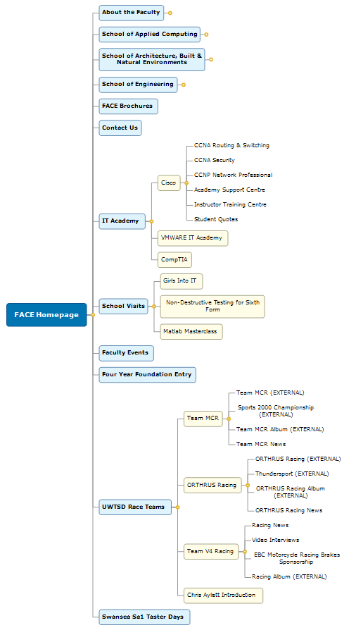
Figure 3: Faculty of Architecture, Computing & Engineering Site Map – Part 3
Due to the use of a content management system, the site map is not an accurate or realistic method of displaying the page structure, as the system represents this site in a flat-form structure. Instead, the site map above represents the links between pages. This makes it easier to look for certain pages, but noticeably harder for other users that are only responsible for certain pages, such as a school or faculty homepage.

9.0 Data Analysis

9.1 School of Applied Computing Google Analytics
Below is data taken between 1st December 2018 and 4th February 2019 for the School of Applied Computing pages:
Page | Page views | Unique Page views | Avg. Time on Page (s) | Entrances | Bounce Rate | % Exit
/computing (School home) | 1568 | 968 | 42.63 | 158 | 41.14% | 11.73%
/bsc-computer-networks | 480 | 315 | 111.37 | 93 | 49.46% | 39.38%
/bsc-computing | 457 | 342 | 115.19 | 138 | 72.46% | 39.17%
/bsc-software-engineering | 322 | 208 | 94.20 | 56 | 42.86% | 26.71%
/bsc-computer-games-development | 298 | 205 | 112.79 | 71 | 52.11% | 35.57%
/bsc-business-information-systems | 240 | 154 | 120.38 | 46 | 41.30% | 25.83%
/beng-electrical-electronic-engineering | 234 | 173 | 67.58 | 71 | 64.79% | 39.32%
/hnd-electronics-engineering | 162 | 109 | 86.72 | 36 | 58.33% | 33.95%
/bsc-data-and-information-systems | 156 | 119 | 74.99 | 25 | 40.00% | 25.64%
Averages | 293.63 | 203.13 | 91.76 | 77.11 | 51.38% | 30.81%
Table 2: School of Applied Computing Google Analytics Data
Note: The school homepage has been excluded from the page views and unique page views averages to contextualise the data for the undergraduate course pages.
With the exception of the homepage, this data shows that although the computer networks course had the highest number of page views, the applied computing course had the highest number of unique page views and entrances. This suggests that despite the popularity of the computer networks course, more visitors could be interested in the wider range of modules offered with the applied computing course. Despite this, these are the two highest accessed courses and have significantly higher page views than the next highest course, and are significantly above the averages for the two datasets.
The school homepage has the lowest average time spent on its page at 42.63 seconds. This is significantly lower than the next lowest (67.58), and the overall average of 91.76. The page also has the lowest percentage exit rate at 11.73%, which is just above a third lower than the average of 30.81%. These numbers could be explained by the page acting as a course finder for the courses it offers.
The following charts visualises the data gathered from Google Analytics:

Figure 4: Comparison Between Page Views & Unique Page Views Chart

Figure 5: Average Time Spent on Pages Chart

Figure 6: Comparison Between Entrance Numbers & Bounce Rate Chart

Figure 7: % of Visitors Exiting the Page Chart

9.2 Usefulness of Google Analytics Metrics
Google Analytics is an excellent tool to use when gathering data, as it is extensive and measures a variety of different types of data, including behaviour and statistical analysis. It is also beneficial that you can add or develop your own criteria searches to provide specific data. This data is provided in tabular and graphical formats, and can be downloaded in a variety of file formats for personal use. This is not provided with other metric providers. The site has an easy to use layout, but requires familiarity with the tools, and/or to use the provided tutorials as to develop these skills. This is suitable for those that use this on a regular basis, as they constantly change and add additional metrics on offer. This can often make it hard to fully customise data gathering and reports, such as selecting specific periods for data analysis. Despite these issues, there is no cost to the user, coupled with the free tutorials, it is an excellent solution for website analytics.

10.0 Conclusion
This report looks at the purpose, aims, and successful outcomes for the university website. The website is managed by the web marketing team, as well as staff members within each of the faculties. The website has a number of issues regarding missing and broken links, outdated information, hard to read text and information, and excessive number of pages. These issues can easily be resolved by following the recommendations outlined in this report. The data collected for the School of Applied Computing pages has been analysed, and is displayed in an easy to understand format.

11.0 Bibliography
[1] A. Kaushik, “3 Awesome, Downloadable, Custom Web Analytics Reports,” 2010. [Online]. Available: https://www.kaushik.net/avinash/best-downloadable-custom-web-analytics-reports/. [Accessed: 09-Feb-2019].
[2] A. Kaushik, “Smarter Insights: 5 Google Analytics Custom Reports FTW!,” 2015. [Online]. Available: https://www.kaushik.net/avinash/speed-focus-insights-google-analytics-custom-reports/. [Accessed: 09-Feb-2019].
[3] E. T. Peterson, Web Analytics Demystified. Celilo Group Media & CafePress, 2004.
[4] International Labour Office, Management Consulting: A Guide to the Profession, 4th ed. Geneva, Switzerland: International Labour Office, 2002.

Appendix 1: Interview Questions & Notes
- What is the purpose of this website?
To reach out to the wider audience: Industry, prospective and current students and stakeholders.
- What are the aims for the website?
All information for prospective and current students, industry partners, and provide a good user experience whilst this occurs.
This includes finding out the number of applicants and those that request additional information, determining geographical regions in which to target marketing activities.
There is also a significance of choosing key words and phrases, using search engine optimisation (SEO) for within the faculty to ease up the speed of searching for the relevant information.
- What are the successful outcomes for visitors? E.g. Application form/ UCAS, completion of the open/visit day form
It is a combination of outcomes for all types of visitors, but this can include contacting the university for additional information.
For prospective students, this can be: number of clicks, course programmes viewed, their mode of study, or have requested additional information. If they know the course, then it will include looking for the employment opportunities, additional features, professional accreditations and modules.
For current students, this can be: term times, scholarships and bursaries, Moodle, library, MyDay/ or MyTSD.
For industry partners, this can include: collaboration with the university, training opportunities, or research.
- How would you like users to use your website?
- Flat form site, with minimal numbers of clicks to achieve the visitors aims.
- Mobile friendly and responsive, with the key information at the top of the site.
- User friendly for all, which is attractive to the main target audience (16/7+).
- Use the bilingual service – WOULD BE INTERESTING TO SEE THE NUMBERS OF VISITORS USING THE SITE IN WELSH

- How frequently would you expect users to visit the site? How many times before they complete a successful outcome?
There are large levels of traffic around the UCAS deadline (January), and decreases after Easter, which is the most critical period for the university/ faculty, with the visitors most likely to look for alternate universities in case they go through clearing, or they are searching for the following academic year.
Ideally, visitors should only need to visit the site once if they can get all the information they need. Ideally, the path should be course, then onto UCAS, although student services, accommodation and finance are also typical paths.
- How often is the website updated/ reviewed? (Staff profiles, course info etc.)
The site is updated every time minor modifications or course changes are required.
I NEED TO SUGGEST A DURATION BETWEEN THESE (E.G. EVERY YEAR)
- How do people find the site? (UCAS, Google, etc.)
UCAS, Google, brochures, university banners (school and postgraduate opportunities) (REQUIRES A FACE ONE), posters etc.
Banners are used for external events or company visits, UCAS events, at one of the approx. 5 open/visit day events per year - THERE IS A NEED FOR MORE EVENTS OR OPPORTUNITIES TO UTILISE THESE – SOME NEEDS TO BE UPDATED
- How is the website managed/ updated, and who is responsible?
The web marketing team is responsible for updating the site. The team consists of 3 or 4 people, with one in charge, who approves changes to the site. There are also 2 or 3 members of the School of Applied Computing who have permission to make changes to the site. This works on a ticketing system, with the changes made using the T4 content management system.
Programme directors are responsible for updating their courses and its content, and the links on the page. The Trades Description Act ensures that the information provided is accurate. This is to reflect the changes to the courses every year.

Appendix 2: Faculty Pages Issues List
Faculty Homepage:
- Social media links should be located above the #FACEyourFuture video as to allow the calendar to become full width. This currently causes lots of blank space.
- Link to ‘About the Faculty’ needed
- Could merge ‘Faculty Events’ and ‘School Visits’
- Change ‘Cisco IT Academy’ to ‘IT Academies’ as it includes links to all academies
About the Faculty:
- ‘Contact Us’ button or link to the form is missing – or it can be merged with the faculty homepage
Contact Us:
- Mount Pleasant Campus address is on the page
School Visits:
- Broken links: ‘UWTSD welcomes Swansea’s Birchgrove Comprehensive to Schools Engineering Taster Event’ and ‘UWTSD's School of Applied Computing and EESW host IT taster event for girls’
- Recent examples of school visits???
Staff Profiles:
- Requires updating, with missing information and pictures
- Outline the structure of the faculty, maybe including a profile for the Dean of Faculty
FACE Final Year Exhibition:
- The stated date for the next Swansea open day is in 2017 – remove date
School of Applied Computing:
- Under related links, ‘Book a STEM Taster Day’ Link is linked to the same page (https://www.uwtsd.ac.uk/computing/)
- Courses often link to the same course – Link to the other school courses
- Cisco pages have out of date information – dates are 2016/7
MSc Computer Networks & Cybersecurity:
- ‘Bursaries for Postgraduate Students’ link missing (is the only one with the link), incorrect spelling of postgraduate (missing an ‘a’), and button does not fit in to the scheme
MSc Applied Computing:
- Missing a ‘Find Out More’ button, which links to the faculty contact us page
MRes Computing:
- Missing a ‘Find Out More’ button, which links to the faculty contact us page
- Same icons needed as the other ones for social media
School of Architecture, Built & Natural Environments:
- Under related links, ‘Book a STEM Taster Day’ Link is linked to the same page (https://www.uwtsd.ac.uk/face/architecture-built-environments)
- Under ‘Open Days’ section, the ‘STEM Taster Day’ button link is missing
BSc Architecture:
- Missing Twitter link and icon to FACE page
BSc Civil Engineering and Environmental Management:
- Missing ‘STEM Taster Day’ button
Certificate of Higher Education in STEM:
- Missing Facebook and Twitter links and icons for FACE
MSc Sustainable Construction:
- Missing Facebook and Twitter links and icons for FACE
MSc Property & Facilities Management:
- Missing Facebook and Twitter links and icons for FACE
- Is the link to the Swansea Environment Society relevant here?
MSc Environmental Conservation & Management:
- Missing Facebook and Twitter links and icons for FACE
School of Engineering Homepage:
- Gold text on cream background is hard to read
- Include links to all available courses within the school
Motorsport Engineering | BEng Four-Year Foundation Entry:
- Missing YouTube link and icon that is found on https://www.uwtsd.ac.uk/bsc-motorsport-engineering/
MSc Lean and Agile Manufacturing:
- Missing link to ‘MSc Engineering Project Management’ under related courses
MSc Engineering Product Design:
- The Facebook join us icon for UWTSD postgraduate is not found on MSc Logistics, Lean & Agile Manufacturing and Engineering Project Management courses. The icon could be updated or changed to improve design
MSc & MRes Non-destructive Testing & Evaluation:
- Missing link to BEng Computer Systems and Electronics

