

Methods and Search Strategy Academic Poster

Student ID: 2313056
Student Name: Sabya bibi Ali
Module name: Independent Project
Module code: BMHP6020

The Impact of Social Support on the Mental Health of Older Adults in Long-Term Care Facilities in the UK
01 Introduction and Research Aim  The research design of the research study is clearly stated in the method chapter and meets the requirements of transparency, reliability, and academic rigor (Prager et al., 2019). This poster's aim is to provide a summary of the methodology carried out in a secondary analysis of a mental health study of older adults in a long-term care setting in the United Kingdom that investigates the effect of social support. The poster presents the research process taken in conducting a search and how the information was retrieved.  Research Aim:  The primary aim of the proposed study is to explore how social support impacts mental and emotional health of older adults in the UK long-term care facilities. | 02 Search Strategy  A search strategy in the context of a research study is the way in which one searches, accesses, and analyses relevant literature in a systematic and organised manner (Rudman, Bringhurst, and Nagel, 2018).  Key search terms included Elderly people, Care home, Nursing homes, Long-term care facilities, Depression, social support, Mental health, older adults, Anxiety, Loneliness, Social isolation and Emotional wellbeing  Boolean operators were used to refine searches, involving "Social support" AND "mental health" “Older adults" AND "care homes" "Loneliness" OR "social isolation" "Nursing homes" OR "long-term care facilities"
03 Searching for Information  Academic data utilised from good sources which is Google Scholar, PubMed, ScienceDirect, Sage Journals and UWTSD Library databases.  Several steps were involved in the search process:  - Broad keyword searches were done to find any literature available regarding social support and mental health among older adults.  - To ensure only the most relevant articles about long-term care settings were included, filters were applied, including publication date (2015–2025), peer-reviewed articles, English language, and relevance to long-term care settings.  - The titles were screened based on the relevance of studies and the abstracts were used to determine whether there was a possibility of including relevant studies.  - Selected studies were 'transcribed' into a source tracking table for organisation and 'thematic analysis' (Gupta et al, 2018). | 04 Picture / Graph / Visual Aid / Statistics  In the UK depression affects around 1 in 5 older people living in the community and 2 in 5 living in care homes. However, fewer than one in six older people with depression ever discuss this with their GP as shown in figure 1 below (JSNA Blackpool, 2025).  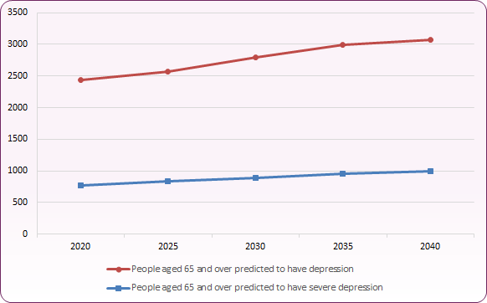  (JSNA Blackpool, 2025)
05 Research Validation and Analysis
The research validation in secondary research is the process of validating the selected sources to assure the credibility, reliability, and relevance of the sources to the research topic to enhance the trustworthiness of the research (Ahmed, 2024). To validate this paper, peer reviewed journal articles, government publications and publications from reputable organisations like Office for National Statistics, World Health Organization and NHS were chosen as the sources. The CRAAP test was applied to the evaluation of a source's Currency, Relevance, Authority, Accuracy and Purpose. V
06 Inclusion Criteria  - Peer-reviewed journal articles  - Studies published between 2015-2025  - Research focusing on older adults aged 65+  - Studies examining social support and mental health  - Research related to nursing homes, long-term care facilities and care homes.  - UK-based studies where available  - Full-text articles available in English | 07 Exclusion Criteria  - Opinion articles, blogs, and non-academic websites  - Articles published before 2015 (unless highly influential)  - Studies focusing on younger populations  - Research unrelated to social support or mental health  - Articles not available in English  - Sources without full-text access
- Ethical Considerations
The principles of ethics in secondary research are related to the proper and ethical use of information collected from primary sources available, ensuring academic integrity and respect for intellectual property rights (Kishan and Gupta, 2024).
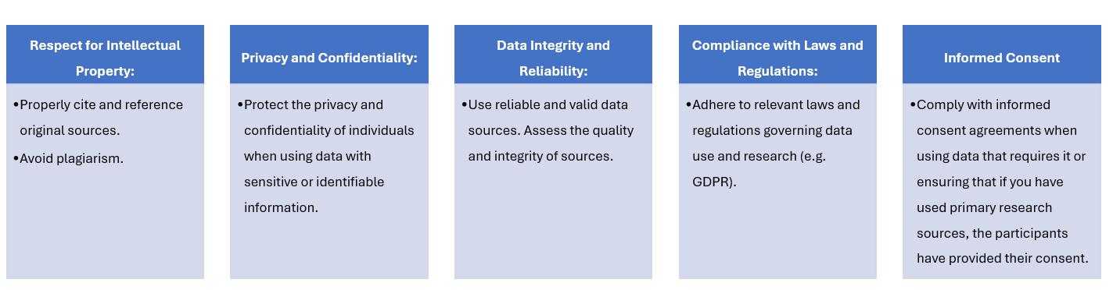

References

Ahmed, S.K. (2024) The pillars of trustworthiness in qualitative research. Journal of medicine, surgery, and public health, 2, p.100051.
Bramer, W.M., De Jonge, G.B., Rethlefsen, M.L., Mast, F. and Kleijnen, J. (2018) A systematic approach to searching: an efficient and complete method to develop literature searches. Journal of the Medical Library Association: JMLA, 106(4), p.531.
Gupta, S., Rajiah, P., Middlebrooks, E.H., Baruah, D., Carter, B.W., Burton, K.R., Chatterjee, A.R. and Miller, M.M. (2018) Systematic review of the literature: best practices. Academic radiology, 25(11), pp.1481-1490.
JSNA Blackpool (2025). Mental Health in Older People. [online] www.blackpooljsna.org.uk. Available at: https://www.blackpooljsna.org.uk/Ageing-Well/Mental-Health-in-Older-People.aspx. [Accessed: 3rd June, 2026]
Kishan, S. and Gupta, U. (2024) Research publication ethics: ensuring integrity, transparency, and responsible scholarship. Journal of Technical Education and Training, 13(2), p.128.
Prager, E.M., Chambers, K.E., Plotkin, J.L., McArthur, D.L., Bandrowski, A.E., Bansal, N., Martone, M.E., Bergstrom, H.C., Bespalov, A. and Graf, C. (2019) Improving transparency and scientific rigor in academic publishing. Journal of neuroscience research, 97(4), pp.377-390.

