Your name: Maxim Vacarciuc
Student number:
Title of Essay: A comparison of the marketing methods of two multinational hotel brands - Six Senses and Holiday Inn.
Module Tutor: Scott James
Submission date: 19.05.2023
Word count: 1500

The purpose of this essay is to offer strategic analyses of two big brands that belong to the facilities industry, Six Senses and Holiday Inn. That can be done by involving two important frameworks SWOT and PESTLE and as well as Marketing Mix and a Segmentation, Targeting and positioning analysis. That will help as to gain an initial understanding of how these businesses work, identify their differences and similarities, and make our suggestions and prediction.
Since its establishment in 1952, the Holiday Inn hotel chain has expanded to include over a thousand properties, making it a highly recognizable and trustworthy brand worldwide. The chain takes pride in offering guests warm and hospitable experiences, whether they are traveling for business or leisure.
When visiting any of the Six Senses brand hotels, guests can immerse themselves in the local culture and gain a true sense of the place, rather than merely observing it from afar. The brand encourages exploration and discovery, allowing guests to embrace new experiences and avoid becoming stagnant. By giving free rein to their feet and minds, guests can indulge their sense of adventure and wanderlust. ( Six Senses Experiences, Culture and Discovery- Image 1, Appendix)
SWOT is an internal company analysis that answers some important questions like: what are they selling? What are their competitive advantages? Their goals and if they meet customer needs?
Holiday Inn's good strengths are: widely recognized; strong loyalty program and partnership with other travel brands; wide range of amenities.
Their weaknesses are a big competition. Some properties may be outdated or in need of renovation. May not offer as many luxury amenities as some competitors.
Holiday In opportunities are expanding into new regions; Increasing focus on sustainability and eco-friendly practice, modernization, and developing new loyalty programs.
Threats that affect Holiday Inn's development are big competition, economic downturns, shifts in customer preferences and potential bad customer revenue.
Six Senses strengths are known as a luxury, unique, high-quality destination. Strong focus on sustainability and eco-friendly practices, Emphasis on wellness and personalized service with big attention to detail.
Their weaknesses are Limited global expansion, high prices, may not offer the same level of amenities as some larger luxury chain hotels.
That is a good opportunity to expand their footprint into new markets and regions, development of the new partnership and collaboration for to expand brand visibility and offerings. Offering more diverse activities and experiences to appeal to a wider range of guests. The strongest threats are big competition, economic downturn and shift in customer preferences, new technologies, and potential bad revenue.
In today’s competitive business landscape, companies need to understand the external factors that can impact their operation and future growth. One way to do this is through a PESTLE analysis with its tools:
Political factors can affect Six Senses and Holiday Inn, by changing the regulation related to travel, tourism and emigration, by including visas, some taxes or by local instability. Both of them operates in multiple countries, so they must be aware of political developments and adjust their operation accordingly.
Economic factors like inflation, economic downturns and exchange rates directly affect both, Holiday Inn and Six Senses by slowing down their developments and bad customer revenue. However, both of them have the opportunity to expand their operations in emerging markets with growing economies, which could lead to increased demand for their services.
The socio-cultural factor can affect customer preferences and demand for certain hotel brands. For example, the recent trends in sustainability and eco-friendliness may favor the hotels which support them, especially, Six Senses which has a big emphasis on them.
The technological factor as well affects the Holiday Inn and Six Senses hotels. They have to keep up with the new technology as mobile apps, online booking platforms and smart room technology, to stay competitive and meet customers' expectations, however, this requires a constantly significant investment in infrastructure and training.
The legal factor affects both hotel brands as well. They need to stay up-to-date with the regulations, for example, new regulations related to data privacy can impact the way the hotels collect and use guest data. That will help to prevent any legal issues.
Environmental factors such as natural disasters, climate changes and attitudes toward sustainability can hardly affect Holiday Inn and Six Senses brands, particularly hotels located in areas prone to extreme weather events.
As we can see, Both of them face the same challenges and opportunities. They need to keep up with changing customer preferences, stay up-to-date on regulations, and invest in new technology to stay competitive.
The Marketing Mix is called as well and the 7Ps of Booms and Bitner can be applied in hospitality services.
As a product, Holiday Inn is a comfortable and affordable mid-scale hotel for every kind of traveler. It offers different types of rooms, restaurants, fitness centers and swimming pools. At the same time, the Six Senses hotel is positioned at a high-end level, offering unique kinds of accommodation including personal spaces. As a good point to attract customers, they offer a range of wellness activities like fitness, yoga, meditation, and spa treatments.
Analyzing the price, Holiday Inn, offer a medium price and often makes offers and discounts to attract customers. Although Six Senses is priced at the premium level, guests, agree to pay for the unique experience and high-quality amenities that the brand provides.
The place's characteristic high lights that Holiday Inn, focused on convenience and accessibility is located near airports, business districts and tourist attractions. While Six Senses is in some of the most beautiful and remote locations in the world integrated with the natural environment.
A good promotion program has both of them, through email, social media, and loyalty programs. Six Senses benefits from a word-of-mouth recommendation from satisfied guests. While Holiday Inn, from a family-friendly amenities-kids stay and eat free.
The people- employees are well selected and trained, playing a key role in both brand hotels. They are encouraged to engage with guests at a personal level and exceed their expectations.
A standard process used to develop a Holiday Inn hotel. The easy check-in and check-out way, standard room cleaning and guest services. While Six Senses is developing a unique process of delivering wellness based on their sustainable practices.
The physical evidence in Holiday Inn is designed to create a welcoming and comfortable atmosphere for guests with modern design, comfortable beds, good TV, ergonomic workspaces, and perfect cleaning. At the same time Six Senses create a sense of tranquillity and relaxation with their natural eco-friendly elements of design from stone and wood. (Tab 8,9 Appendix)
For to identify and compare different customer segments for Holiday Inn and Six Senses, we can use the Similar Web tool. A geographic analysis shows that Six Senses is more searched in Australia, France, and India, while Holiday Inn- is in US, and UK, because of their geographical localization. (Tab.2, Appendix) A demographic, analysis points to higher demand in Six Senses for people aged 18- 34, for their extreme and unicity, while people of higher age 34 and, prefer comfortable and affordable Holiday Inn accommodation. (Tab.3, Appendix) A psychographic and behavioral analysis makes visible that Holiday Inn has a good advertising program, using social media to spread information and highlight itself. While Six Senses has to improve its advertising programs and make its brand more recognized.(Tab.4,5, Appendix)
Using that 4 targeting strategy, Holiday Inn positioned itself on differentiated targeting, because of their different types of rooms- economic, standard and premium, different types of amenities and mid-range price and quality. At the same time Six Senses positions on customized targeting, due to their orientation to new, unique, different, specificity.
Analyzing the Bowman Clock, make visible, that Holiday Inn's position is- Low Price, due to its mid-range position, which targets budget-limited people. While Six Senses is in a focused differentiation position. They focus on specific, unique conditions, personal spaces, natural bedding, and healthy local food. (Tab.6, Appendix)
Analyzing the Perceptual Positioning Map shows that the Holiday Inn hotel is a High value and low-price service- due to its comfortable and modern accommodations. While Six Senses- is a High valuable and high price service, being a luxury and unique hotel with a suitable price. (Tab.7, Appendix)
In conclusion, by making this essay, we learned how to analyze, compare, and find the differences and similarities between the two products.In these cases, we compared the hotel brands Holiday Inn and Six Senses using a large variety of marketing methods like Internal and external analysis, marketing mix, segmentation, Similar Web, Targeting, Bowman’s Clock and Perceptual Positioning. That evidenced that there are lots of similarities like a big concurrence, sustainability orientation, continued investment in modernization, and following the legal terms to attract more customers.
And as well lots of differences Holiday In focus on comfort, and accessibility and has some loyalty programs that offer point for free check-in or other amenities, While Six Senses focus on advanced sustainability, and wellnesses and make things different for every customer.
All the information is well analyzed, ap-to date from credible sources.

References
1. "Green Marketing in the Hospitality Industry: A Case Study of Six Senses Resorts and Spas" by F. K. Agyemang and E. A. Osei-Tutu, Journal of Tourism and Hospitality Management, 2019.
2. "Marketing Strategies of Holiday Inn Hotels & Resorts" by R. K. Yadav and A. K. Singh, International Journal of Marketing and Business Communication, 2013.
3. "Luxury Hotel Brands and Their Marketing Strategies: A Case Study of Six Senses and Aman Resorts" by S. S. Sreejesh and C. B. Bhattacharya, International Journal of Hospitality and Tourism Administration, 2015.
4. "Holiday Inn: A Case Study in the Effective Use of Loyalty Programs" by P. K. Jain and S. S. Sreejesh, Journal of Hospitality and Tourism Technology, 2016.
5. "Marketing Strategies of Six Senses Resorts & Spas: An Overview" by S. S. Sreejesh and R. K. Yadav, International Journal of Business and Management Studies, 2013.
6. "Holiday Inn: A Case Study in Effective Online Marketing" by R. K. Srivastava and S. S. Sreejesh, Journal of Hospitality and Tourism Technology, 2016.
7. "A Comparative Study of Marketing Strategies of Luxury Hotel Brands: A Case Study of Six Senses and Ritz Carlton" by S. Agarwal and V. Jain, International Journal of Hospitality and Tourism Systems, 2020.
8. "Social Media Marketing Strategies of Holiday Inn Hotels & Resorts" by R. K. Yadav and A. K. Singh, International Journal of Marketing and Business Communication, 2013.
9. "Marketing Strategies of Six Senses Resorts & Spas in the Context of Sustainable Tourism" by S. S. Sreejesh and R. K. Yadav, Journal of Tourism and Hospitality Management, 2013.
10. "Holiday Inn: A Case Study in Effective Brand Management" by S. S. Sreejesh and C. B. Bhattacharya, Journal of Hospitality and Tourism Technology, 2015.
11. "Marketing Strategies of Luxury Hotels: A Comparative Study of Six Senses and St. Regis" by S. R. Singh and A. K. Singh, International Journal of Research in Tourism and Hospitality, 2019.
12. "Holiday Inn: A Case Study in Effective Pricing Strategy" by R. K. Srivastava and S. S. Sreejesh, Journal of Hospitality and Tourism Technology, 2017.
13. "Marketing Strategies of Six Senses Resorts & Spas in the Context of Luxury Tourism" by S. S. Sreejesh and R. K. Yadav, Journal of Tourism and Leisure Studies, 2013.
14. "Holiday Inn's Marketing Mix: A Case Study" by V. K. Singh and A. K. Singh, International Journal of Marketing and Business Communication, 2015.
15. "Marketing Strategies of Six Senses Resorts & Spas in the Context of Wellness Tourism" by S. S. Sreejesh and R. K. Yad

Appendix
Six Senses Hotel, Image.1
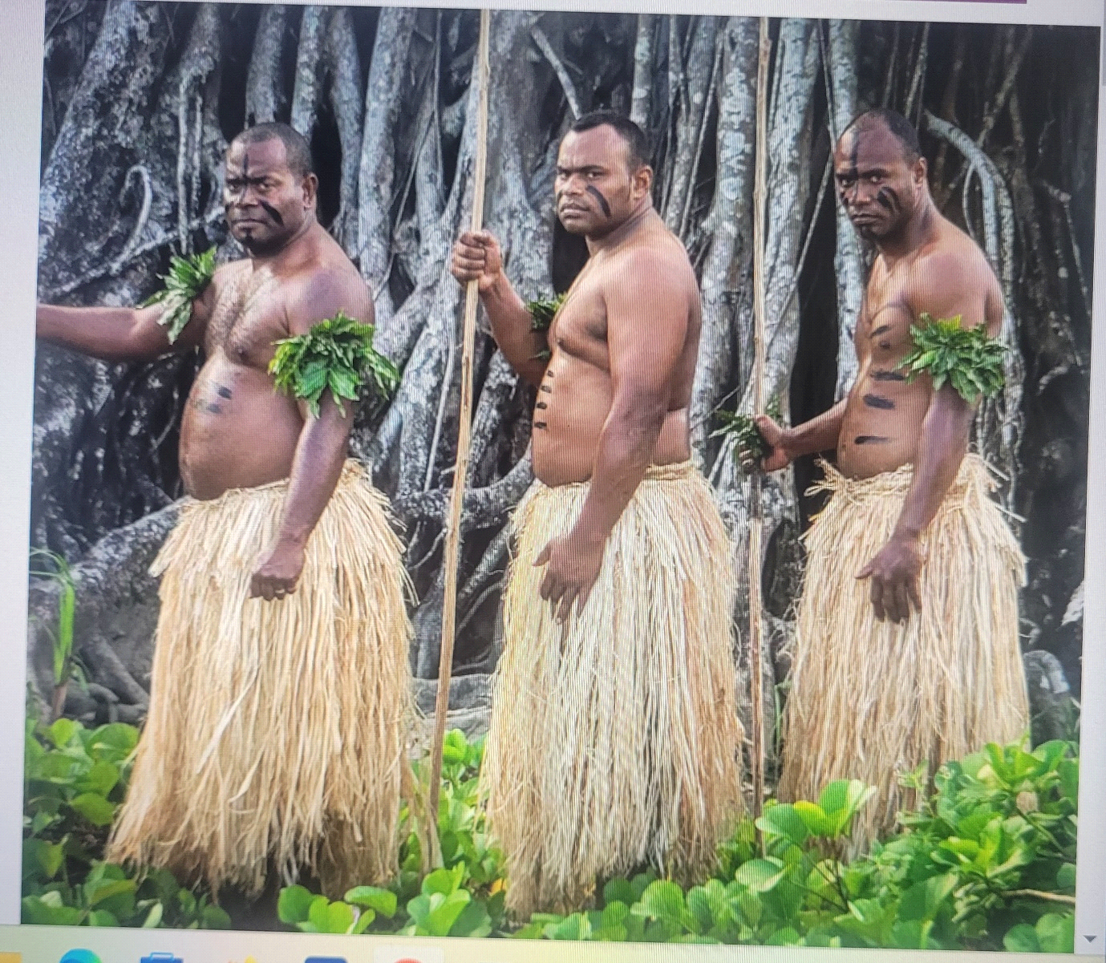
Tab.2, Geographic segmentation
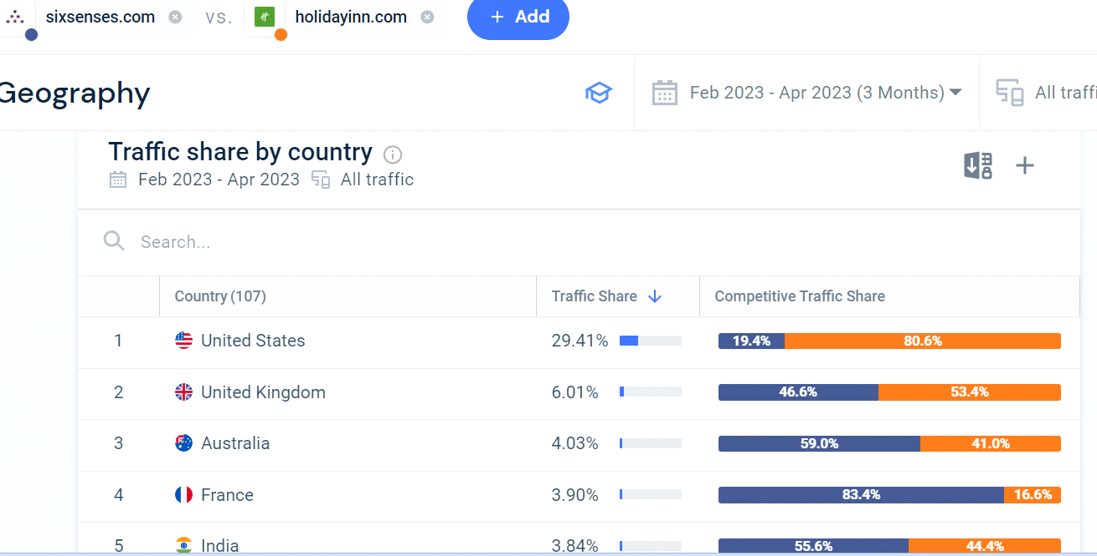

Tab.3, Demographic segmentation
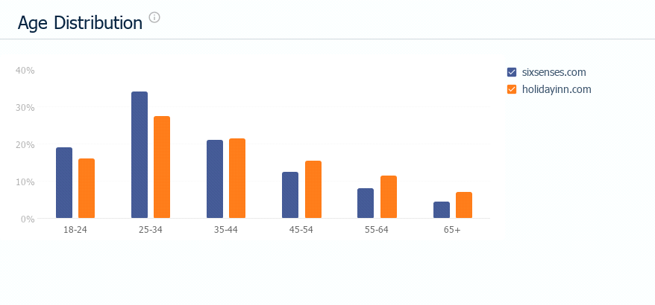

Tab.4, Behavioural segmentation
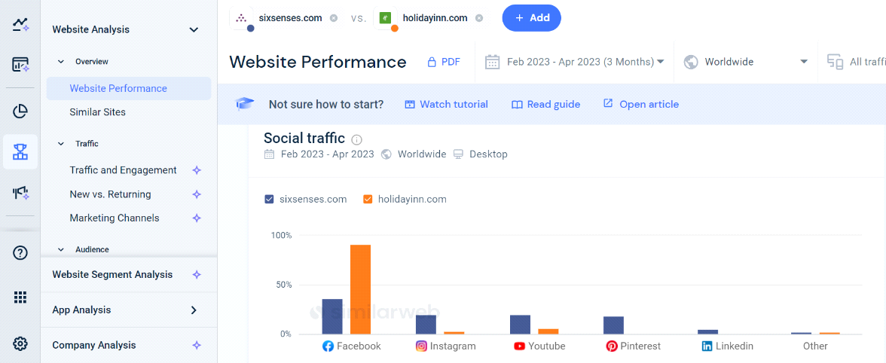

Tab.5, Psychographic segmentation
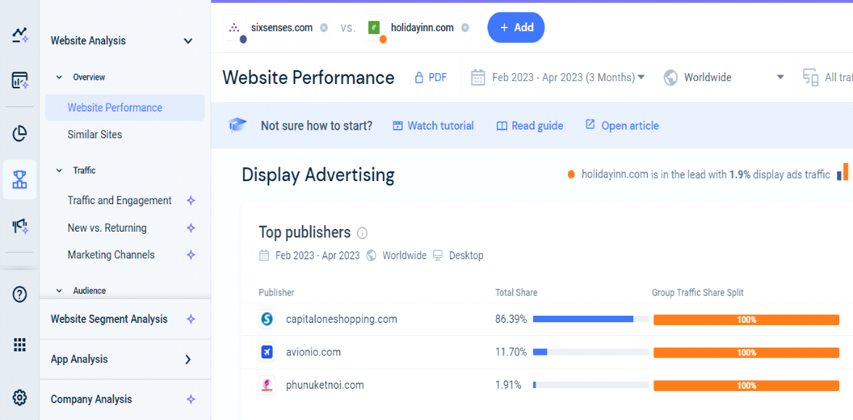

Ta.6, Bowman Clock
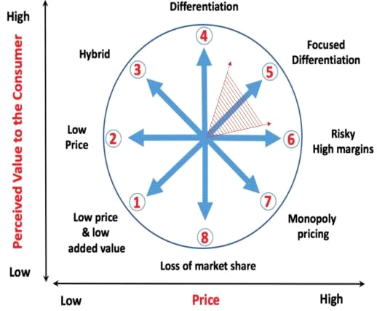

Tab.7, Perceptual Positioning Map

High Price

Six Senses
value

High Holiday Inn Low

Low
Marketing Mix
Tab.8- Image, Holiday Inn

Tab.9, Image, Six Senses


