Module title: Foreign Language and Cultural Awareness
Lecturer name:Heidi Prosser
Module code: BMIH5003
Student Name: Julian Gjoka
Student ID:2230507

Executive Summary
The proper operations of the hotel industry has been brought forward in this report to analyse the impact of the cultural and social aspects. This has helped in recognising the different types of differences between England and France to bring out the proper developmental aspects. Thus, the overall development of the regions has been brought forward regarding the different challenges which are faced by the firm. This helps in the smooth management of the organisational performance to develop the scope of operations.

Table of Contents
Introduction 4
Differences between England and France in terms of their operating process 5
Analysis and Comparison of Two Countries in terms of their leadership practices in the hospitality industry by using the globe project study. 6
Challenges of Intellectual Leadership in the hospitality sector 8
Recommendations to overcome the challenges 9
Conclusion 11
References 12

Introduction
The hotel industry influences the functionalities of the economies accordingly to bring forward the proper growth. There are multiple types of cultural differences which are present in the process of managing the hotels to bring forward the multiple leadership styles. These help to develop the organisational performance to analyse the differences in the countries related to the style of managing the hotels. This helps to improve the challenges which are faced by this industry to bring forward the proper growth and development in the firm. Thus, the improvement of the regions of operations is critically analysed in this section to bring forward the proper required recommendations. The GLOBE’s culture and the project will also be conceptualised to understand the operations of the organisations in the hospitality industry.

Differences between England and France in terms of their operating process
There are multiple differences between the operating process of these two countries which impacts the functioning.
Hierarchical
The structures which are followed in the hotel in France are much more hierarchical which is usually not followed in England. More of a formal relationship is maintained between the workers and the managers of the hotel industry (Uhlig, 2024).
Intellectual Style
The different types of intellects and the ideas of the people are given greater priority in France which is not usually found in the buildup of the people. The cultural practice of the people in Britain mainly focuses on the different types of revenue generation policies to influence operations (Thompson, 2020).
Social Structure
The different types of social conversations are carried out between the people of France and hence the bonding between the individuals and the hotels is widely maintained. On the other hand, the British always focus on the profit maximisation process and hence the social considerations are not followed always. This helps to build a cordial relationship between the employees engaged in the process of serving the hospitality industry (Quain, 2020).

Analysis and Comparison of Two Countries in terms of their leadership practices in the hospitality industry by using the globe project study.

England | France
The leadership style followed by the hotels and the hospitality industry in the UK is formal in nature. This helps to maintain a business-oriented framework in the process of maintaining the proper activities. The national culture of the country plays a major role in the process of developing the leadership culture which is followed in the country. This helps in framing the type of practice which is followed by the organisations to improve the business aspects (commisceo, 2024). | France follows a cordial type of leadership practice between the employees and the leaders of an organisation. This helps to improve the business aspects of the countries to develop the activities of the hotels to generalise the performance effectively. The development of the relationships between the customers is also carried out by this aspect to improve the organisational performance of the firm (Schofield, 2022).

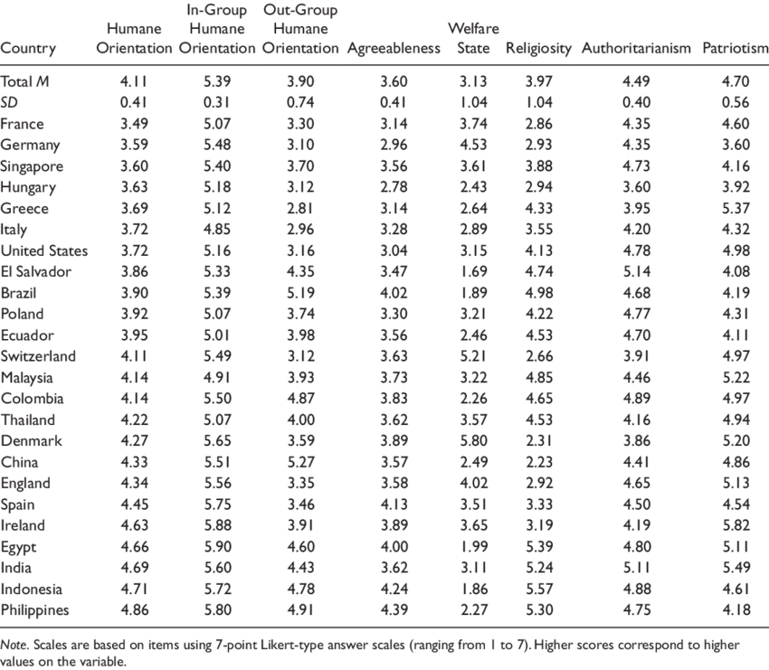
Figure: Score of the countries regarding the GLOBE Project
Source: (globeproject, 2024)
Analysis Hugh Schofield
The different types of parameters are carried out to develop the leadership practice of the hotels in the different countries to rate their leadership styles. Multiple types of strategies are taken into consideration to develop the relationship between these personalities to influence the growth of this sector. The different types of cultural values and the strategies which are followed by these regions help to infuse the hotel industry with the required aspects to develop their performance.

Challenges of Intellectual Leadership in the hospitality sector
The different types of problems are faced by the leaders during the process of managing the hospitality industry. This creates a reduction in this effectiveness for demonstrating the required performance in the organisations.
Barriers in communication
The leaders who operate multiple chains of hotels in multiple regions of the world often face problems related to communication issues. Language barriers serve as a major hindrance to the different types of impacts which are carried out within this industry. This creates communication gaps within the firms and the problems of managing an intellectual team are often seen. Thus, the problems in the organisations are also carried out due to improper communication practices (Gonzalez et al., 2020).
Lack of the proper understanding
The different types of cultural differences in the different areas of the hospitality industry create clashes among the people working there. This creates a disturbance to the smooth functioning of the hospitality industry, thus resisting the changes in the firm. Thus, the development of the different types of smooth management ideas are not properly identified within the firms and this creates further changes to the structure. This understanding issue reduces the opportunities for the leaders to serve the needs properly by respecting cultural differences (Neill and Bowen, 2021).

Recommendations to overcome the challenges
The different steps can be undertaken by the hotels to solve the potential issues which are encountered by them. This will improve the performing capacity of the leaders and thus develop the operations of the entire hotel to engage the leaders.
Recruiting of local candidates
The regional people are recommended to be given adequate chances in the hotels to develop leadership practices to increase the communication regions in this industry. This will also help in knowing about the local demands and the choices and hence the proper practices must be carried out to increase the involvement of the local people. The different types of policies and the business aspects must also be aligned properly to improve communication practices (Dominique et al., 2022).
Provision of proper training
Different types of training procedures are recommended to be carried out to infuse the proper leadership qualities to improve the fulfilment of the cultural aspects. This will help in developing adequate leadership practices to improve the working aspects of the people and apply proper leadership ideas. Further, this will help in solving the issue regarding the understanding issues within the organisations and proper processes will be carried out (Cabral and Jabbour, 2020).
Development of a feedback mechanism
The proper feedback generation technique is suggested to be adopted by the hospitality industry which takes into consideration the multiple types of views of the guests. This also helps to recognise the cultural problems which are occurring within the organisations and thus the necessary strategies can be implemented by the managers. Thus, the views of the local people and the culture will be properly addressed by this mechanism to implement the adequate business practices (Ntounis et al., 2022).

Conclusion
The cultural and social aspects of the people and the regions help to carry out the operations of the different chains of hotels. They are influenced by the perspectives of the nations in which they are operating to develop their operating process. The different types of comparison between England and the chosen country which is France has been brought forward in this report. This has helped in analysing the potential challenges which are faced by this industry along with the recommendations for the solving of issues.

References
Cabral, C. and Jabbour, C.J.C., (2020). Understanding the human side of green hospitality management. International Journal of Hospitality Management, 88, p.102389.
commisceo, (2024). Cross Cultural Management Guide for the U.K.. [Online] Available at: https://www.commisceo-global.com/resources/management-guides/uk-management-guide [Accessed 30 January 2024].
Dominique-Ferreira, S., Rodrigues, B.Q. and Braga, R.J., (2022). Personal marketing and the recruitment and selection process: Hiring attributes and particularities in tourism and hospitality. Journal of Global Scholars of Marketing Science, 32(3), pp.351-371.
globeproject, (2024). An overview of the 2004 study: Understanding the Relationship Between National Culture, Societal Effectiveness and Desirable Leadership Attributes. [Online] Available at: https://globeproject.com/study_2004_2007%3Fpage_id=data.html#data [Accessed 30 January 2024].
Gonzalez, R., Gasco, J. and Llopis, J., (2020). Information and communication technologies and human resources in hospitality and tourism. International Journal of Contemporary Hospitality Management, 32(11), pp.3545-3579.
Neill, M.S. and Bowen, S.A., (2021). Ethical listening to employees during a pandemic: new approaches, barriers and lessons. Journal of Communication Management, 25(3), pp.276-297.
Ntounis, N., Parker, C., Skinner, H., Steadman, C. and Warnaby, G., (2022). Tourism and Hospitality industry resilience during the Covid-19 pandemic: Evidence from England. Current Issues in Tourism, 25(1), pp.46-59.
Quain, S., (2020). Basic Types of Organizational Structure: Formal & Informal. [Online] Available at: https://smallbusiness.chron.com/basic-types-organizational-structure-formal-informal-982.html [Accessed 30 January 2024].
Schofield, H., (2022). Emmanuel Macron a chastened and greatly weakened leader. [Online] Available at: https://www.bbc.com/news/world-europe-61859595 [Accessed 30 January 2024].
Thompson, J., (2020). Advantages and Disadvantages of Transformational Leadership. [Online] Available at: https://smallbusiness.chron.com/advantages-disadvantages-transformational-leadership-20979.html [Accessed 30 January 2024].
Uhlig, D. K., (2024). Hierarchical Leadership vs. Nonhierarchical Leadership. [Online] Available at: https://smallbusiness.chron.com/hierarchical-leadership-vs-nonhierarchical-leadership-35422.html [Accessed 30 January 2024].

