Dhaskalio Kavos illustrated site report
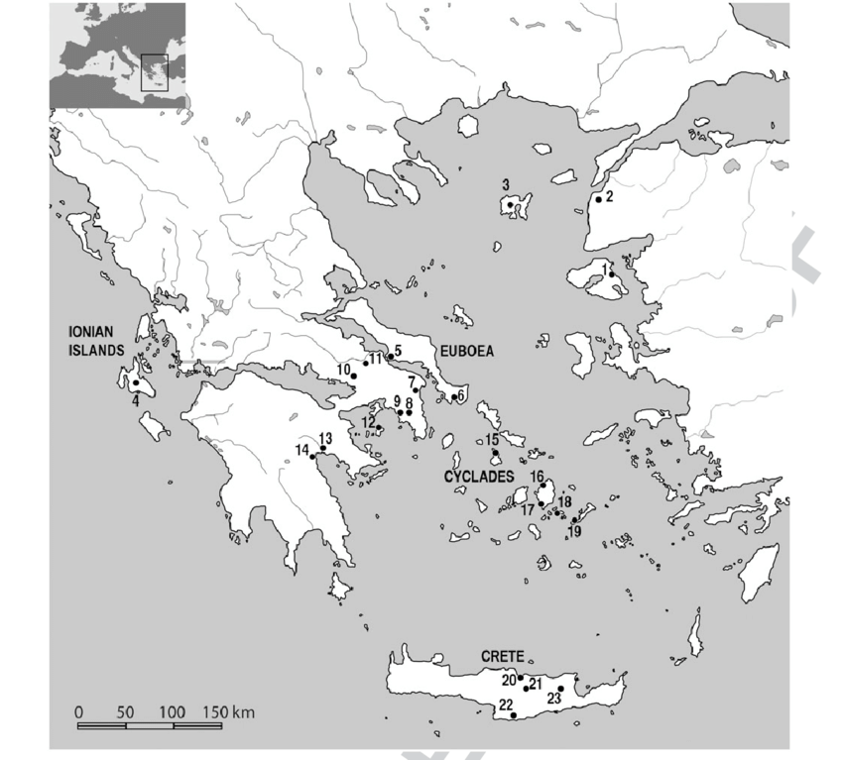
Where is it?
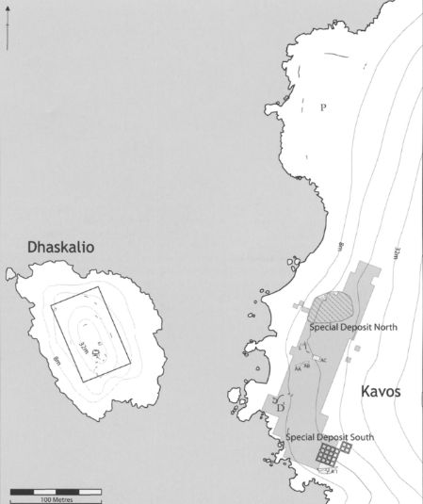
Dhaskalio Kavos (henceforth written as DK) is a group of two sites, one on the small island of Dhaskalio and one opposite the island on the island of Keros, which are incredibly close to each other in the Cyclades, and were likely connected to each other some 3000 years ago. They are found to the south of Naxos, in the south-east of the Cyclades, which are south-east of mainland Greece, and around 200km away from the island of Crete.

Figure 1: a map of Greece, with a star depicting where Dhaskalio-Kavos is
There are two ‘special’ deposits on Keros- named special deposit north and special deposit south, and three main settlements on Dhaskalio which are the most relevant to the overall site and it’s activity during the bronze age, one on each side of the island and one at the summit.
Figure 2: a site map of Dhaskalio Kavos
Chronology
The earliest possible activity at this site is from around 2800 BC. It was then un use until around 1900 BC. This is the earliest evidence of this era of settlement in the Cyclades. This report will focus on all development that occurred in this space. Phase A (2800 BC- 2500 BC) is the first construction phase, which is found in some trenches on Dhaskalio. Phase B (2500 BC- 2200 BC) seems to be where many of the structures were built, and phase C (2200 BC- 1900 BC) seems to be when all the pottery is made. The islands seem to have been abandoned since this point.
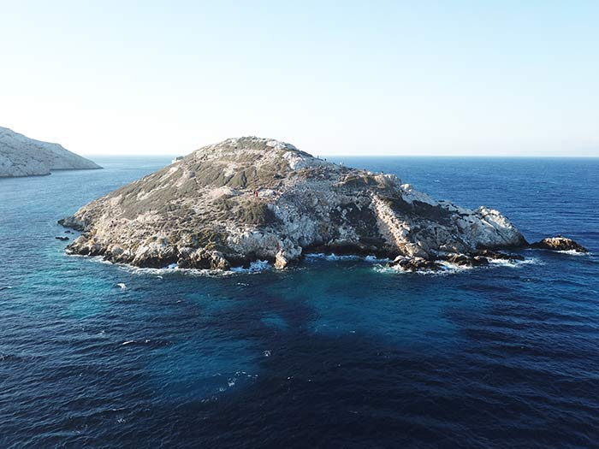
Figure 3: an image of the island of Dhaskalio, accessed via the Keros Project.
What was this site used for?
The main purpose of this site seems to have been trade, often described as the first ‘maritime sanctuary’. This can be evidenced with the range of import seen at the site. The site on K is often seen as a ritual dump site due to the level of broken marble plates and figurines of all sizes found across the west of the island.
The island of Dhaskalio is a range of structures, including residential buildings and metal workshops. One of the main structures on the top of the island is ‘the hall’. A large structure that would have been prominent and visible from the surrounding islands. In this hall, there is evidence of copper weaponry from phase C. this, along with bronze axe heads. This depicts this space as also being used to create weaponry.
Excavation history
Colin Renfrew is the main conductor of the excavations at Dhaskalio Kavos and has been working there since its initial excavation in 1963. Renfrew was in fact the first individual to survey the site before the initial excavation.
The 1963 excavation, run by doumas was a preliminary study into the deposits especially on the island of Keros, where deposits of broken material and figurines were initially found. It was a very preliminary excavation which mainly aimed to protect as much of the artefacts as possible due to extensive looting of the site occurring at the time. The strategic breaking of the artefacts which is now instrumental to this site was put down to the carelessness of the looters at this time and was not associated with ritual breakage. This excavation also delves into a structure on Dhaskalio, which was identified as a residential space, with no evidence for anything else until later excavations.
In 1987 another excavation was done, where the first special deposit was excavated. This is when the true extent of the significance and level of artefacts found in this space was discovered.
The 2006- 2008 excavations at Kavos, however, start to develop the concept that these breakages may not be attributed to the looting often seen at Dhaskalio Kavos, and instead were done by the cycladians themselves, and brought to the site to be deposited. It is also this excavation where the metallurgic work was found on site.
The 2015-2018 excavations carried out by Cambridge students with the aid of the British School at Athens specifically focuses on the structures on Dhaskalio, which show evidence of structures such as houses, and drainage from ECII. the material used in these buildings was at this point discovered to be imported marble from across the Cyclades, with around 3 different types of marble being used in the main structure. These types of marble seem to have been imported from spaces such as Naxos. This excavation also was prominent in revealing the extent of metal work on Dhaskalios.
Connections with the Mediterranean and the near east
Dhaskalio Kavos is often seen as an amalgamation of many different aspects of Aegean and Mediterranean, with it being named one of the earliest maritime ports of the west. There is definitive direct trade between this site and the rest of the Cycladic islands, Crete, and mainland Greece. Whilst this may not seem a large undertaking now, nor is it as vast as the travel and trade seen by other places in the near east and mediterranean, such as Crete or Egypt, for the technologies of the early bronze age, this is not a small undertaking, and it is the earliest trader of the Cyclades.
Some of the main artefacts found on DK that show trade include deposits of broken marble bowls and figurines, usually traced back to the Cycladic islands of Syros and Amorgos, and the north Peloponnese in mainland Greece. 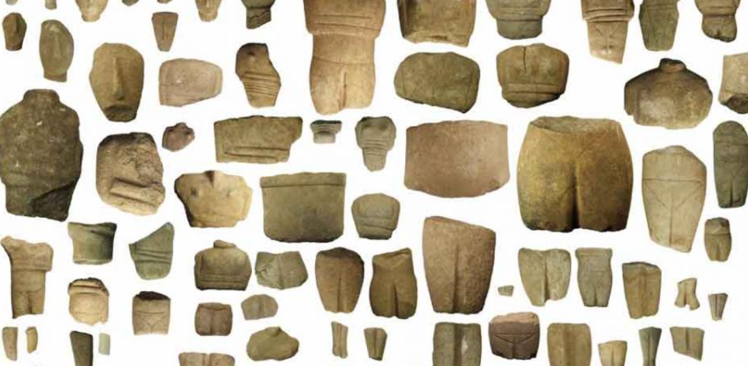
Figure 4: a collection of broken statue fragments found on Keros, accessed via Cambridge-Kerros project
There are mainly only fragments of each of this type of object, and many of the fragments to not connect to any other fragments to create a whole object, indicating that the items were broken elsewhere, and then taken specifically to DK. The main scholars engaging with this site, especially Renfrew, argue that this means that this site was used as a ritualistic site. However, this is not enough evidence to definitively conclude that the site’s main purpose was religious. Whilst it is odd that these items were all left in a specific space, there is no evidence that the dumping of these objects was a ritual or religious activity, and it could be just general housekeeping. The main things that work in Renfrew’s favour with arguing a ritual site from DK are the facts that many of the items were marble, and therefore extremely difficult to break, and the fact that many of the items do not have corresponding fragments to form an object.
Along with these marble fragments, there were also fragments of obsidian and human bone. The presence of bone could indicate a cemetery, but it would be an incredibly odd one, and the bone was likely a result of scrambling from the extensive looting before the excavation in 1963.
The obsidian is likely from Melos, indicating another port of trade. However, the obsidian seems to have been formed into tools on Dhaskalio, and the levels of obsidian tools being formed seemed to have been surplus to what would’ve been necessary for the upkeep of domestic life on the island, which indicates that the islanders could have been importing raw material, creating objects, and then exporting it back out again.
Another example of Marble showing the important trade links for DK can be seen with the material of the structures found on Dhaskalio. The structures are mainly made from limestone and marble. The marble found can be traced to Naxos or Schinousa. The limestone has been identified as Ano Kouphonisi. 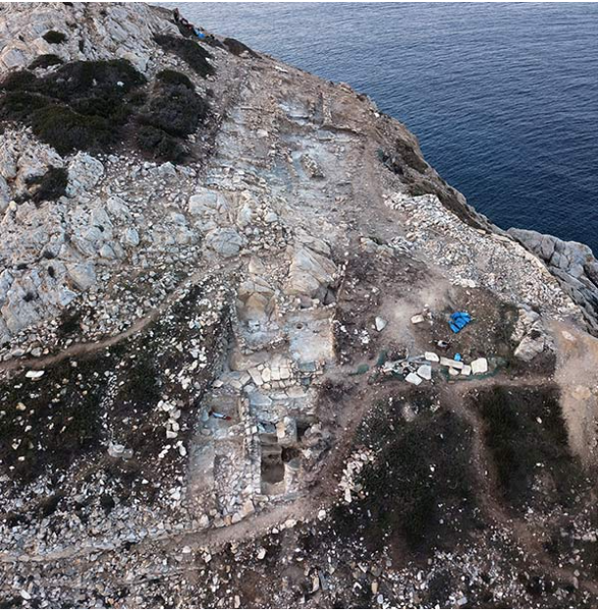
Figure 5: an image of one of the marble structures on Dhaskalio, accessed via the British School at Athens.
Along with this, there were bonze axes and metallurgy workshops on Dhaskalio which could indicate metallic trade and import at Dhaskalio. The evidence seems to point towards casting rather than smelting, with smelting likely happening on the island of Keros. There is also a large amount of copper being made into different weaponry, and even traces of gold. This can be seen by the discovery of moulds for spear heads. The evidence seems to be gradually pointing towards quite a significant amount of metal work on the site, meaning there is a very likely chance of large metal export from this site.
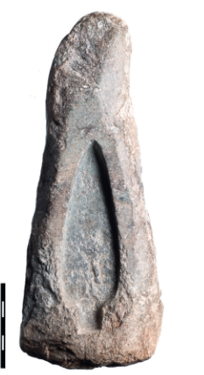
Figure 6: an image of one of the spearhead moulds found
There is a large amount of export from the Cycladic islands, and often kerros-syros style figurines and Cycladic materials (such as marble, copper, and pottery) can be seen across the Aegean. Despite this, there is very little import outside of the Cyclades and mainland Greece found on Dk or, indeed, across the Cycladic islands. The reasoning for this has been predicted to be that instead of trading in material, the Cycladic traders wanted information. There are instances of Cycladic art which replicates styles across the Aegean, and this could be an indication that the Cycladic societies were more interested in learning how to do things than gain new materials. It could also be that the imports were perishable, like cloth and food. In fact, the import of food is incredibly likely as the development of farming in the Cyclades is far more difficult than their building of boats. The islands aren’t incredibly fertile, and the main things that are available to farm are olives and grapes. In fact, Dhaskalio Kavos has the first well-stratified example of olive and grape seeds from the cycladic islands, indicating this is where the first instances of farming were seen in the Cyclades.
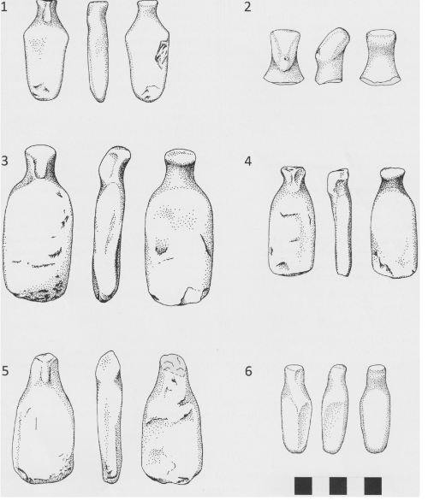
There are even distinct differences between the items found on Dhaskalio versus Kavos. For example, the folded arm figurines that are so often connotated with the kerros-syros culture are only found on the island of Keros, and not on Dhaskalio. The figurines found on Dhaskalio are significantly less developed.
Evaluation
Despite the textual evidence and extensive excavations at DK, there is not a large range of academic debate or perspective on what is happening at the site. This is mainly because Doumas, Renfrew and Broodbank all seem to have been writing about and organising excavations at this site since it’s conception as an archaeological site, which doesn’t particularly leave space for other considerations around what could be happening in this space.
Figure 7: figurines found on Dhaskalio
The extensive looting means that there is a chance that some of the observations made could be inaccurate due to stratigraphic disturbances, and a lack of certain objects which may have been important to understanding the true purpose of this site.
Conclusion
Overall, this site is undoubtedly an important space when considering the interactions between the Cyclades, and the Aegean. It is an incredibly unique location, with a distinct mystery to it’s exact use. It provides a very important insight into the art and import of the Cyclades.
Bibliography
British School at Athens : Evidence for Advanced Architectural Planning at the Early Prehistoric Site of Dhaskalio in the Aegean, n.d. <https://www.bsa.ac.uk/2019/05/06/evidence-for-advanced-architectural-planning-at-the-early-prehistoric-site-of-dhaskalio-in-the-aegean/> [accessed 16 November 2025]
Broodbank, Cyprian, ‘Ulysses without Sails: Trade, Distance, Knowledge and Power in the Early Cyclades’, World Archaeology, 24.3 (1993), pp. 315–31
Correspondent, Normand Hammond, Archaeology, ‘Symbolic Past of Early Aegeans Revealed at Dhaskalio Kavos Site’, 2 September 2008 <https://www.thetimes.com/travel/destinations/europe-travel/greece/symbolic-past-of-early-aegeans-revealed-at-dhaskalio-kavos-site-kp93k96bkzg> [accessed 16 November 2025]
‘Distance 36.87004983035989,25.636605714758957 > Crete, GRC - Air Line, Driving Route, Midpoint’, Distance Calculator, n.d. <https://www.distance.to/36.87004983035989,25.636605714758957/Crete,GRC> [accessed 16 November 2025]
Ioannides, Demetrios, and others, ‘Copper Smelting on Dhaskalio, Keros: Redefining Early Cycladic Metallurgy and Metalworking’, Journal of Archaeological Science: Reports, 65 (2025), p. 105228, doi:10.1016/j.jasrep.2025.105228
‘Island of Broken Figurines | University of Cambridge’, 10 June 2011 <https://www.cam.ac.uk/research/news/island-of-broken-figurines> [accessed 16 November 2025]
Margaritis, Evi, Michael J. Boyd, and Colin Renfrew, ‘Being an Islander in the 3rd Millennium BC Small Cyclades in the Central Aegean: Connectivity, Food Networks, and Sustainability of Resources’, in Islands and Communities, ed. by Anastasia Christophilopoulou, Perspectives on Insularity, Connectivity, and Belonging (Oxbow Books, 2024), pp. 117–36, doi:10.2307/jj.19755260.13
Renfrew, Colin, and others, ‘Keros: Dhaskalio and Kavos, Early Cycladic Stronghold and Ritual Centre. Preliminary Report of 2006 and 2007 Seasons’, The Annual of the British School at Athens, 102 (2007), doi:10.1017/S0068245400021444
——, and others, Keros, Dhaskalio Kavos the Investigations of 1987-88 (1987)
——, and others, ‘The Early Cycladic Settlement at Dhaskalio, Keros: Preliminary Report of the 2008 Excavation Season’, The Annual of the British School at Athens, 104 (2009), pp. 27–47
‘The Keros Project’, n.d. <https://kerosproject.org/> [accessed 16 November 2025]

Evi Margaritis, Michael J. Boyd, and Colin Renfrew, ‘Being an Islander in the 3rd Millennium BC Small Cyclades in the Central Aegean: Connectivity, Food Networks, and Sustainability of Resources’, in Islands and Communities, ed. by Anastasia Christophilopoulou, Perspectives on Insularity, Connectivity, and Belonging (Oxbow Books, 2024), pp. 117–36, doi:10.2307/jj.19755260.13.
‘Distance 36.87004983035989,25.636605714758957 > Crete, GRC - Air Line, Driving Route, Midpoint’, Distance Calculator, n.d. <https://www.distance.to/36.87004983035989,25.636605714758957/Crete,GRC> [accessed 16 November 2025].
Cyprian Broodbank, ‘Ulysses without Sails: Trade, Distance, Knowledge and Power in the Early Cyclades’, World Archaeology, 24.3 (1993), pp. 315–31.
Colin Renfrew and others, ‘Keros: Dhaskalio and Kavos, Early Cycladic Stronghold and Ritual Centre. Preliminary Report of 2006 and 2007 Seasons’, The Annual of the British School at Athens, 102 (2007), doi:10.1017/S0068245400021444.
Renfrew and others, ‘Keros’.
Colin Renfrew and others, ‘The Early Cycladic Settlement at Dhaskalio, Keros: Preliminary Report of the 2008 Excavation Season’, The Annual of the British School at Athens, 104 (2009), pp. 27–47.
Renfrew and others, ‘The Early Cycladic Settlement at Dhaskalio, Keros’.
Renfrew and others, ‘The Early Cycladic Settlement at Dhaskalio, Keros’.
‘The Keros Project’, n.d. <https://kerosproject.org/> [accessed 16 November 2025].
Renfrew and others, ‘The Early Cycladic Settlement at Dhaskalio, Keros’.
Colin Renfrew and others, Keros, Dhaskalio Kavos the Investigations of 1987-88 (1987).
Renfrew and others, Keros, Dhaskalio Kavos the Investigations of 1987-88.
Renfrew and others, Keros, Dhaskalio Kavos the Investigations of 1987-88.
Renfrew and others, ‘The Early Cycladic Settlement at Dhaskalio, Keros’.
British School at Athens : Evidence for Advanced Architectural Planning at the Early Prehistoric Site of Dhaskalio in the Aegean, n.d. <https://www.bsa.ac.uk/2019/05/06/evidence-for-advanced-architectural-planning-at-the-early-prehistoric-site-of-dhaskalio-in-the-aegean/> [accessed 16 November 2025].
Margaritis, Boyd, and Renfrew, ‘Being an Islander in the 3rd Millennium BC Small Cyclades in the Central Aegean’.
Renfrew and others, ‘Keros’.
‘Island of Broken Figurines | University of Cambridge’, 10 June 2011 <https://www.cam.ac.uk/research/news/island-of-broken-figurines> [accessed 16 November 2025].
Renfrew and others, ‘Keros’.
Normand Hammond Correspondent Archaeology, ‘Symbolic Past of Early Aegeans Revealed at Dhaskalio Kavos Site’, 2 September 2008 <https://www.thetimes.com/travel/destinations/europe-travel/greece/symbolic-past-of-early-aegeans-revealed-at-dhaskalio-kavos-site-kp93k96bkzg> [accessed 16 November 2025].
Broodbank, ‘Ulysses without Sails’.
Renfrew and others, Keros, Dhaskalio Kavos the Investigations of 1987-88.
Renfrew and others, ‘The Early Cycladic Settlement at Dhaskalio, Keros’.
Correspondent, ‘Symbolic Past of Early Aegeans Revealed at Dhaskalio Kavos Site’.
Margaritis, Boyd, and Renfrew, ‘Being an Islander in the 3rd Millennium BC Small Cyclades in the Central Aegean’.
Renfrew and others, Keros, Dhaskalio Kavos the Investigations of 1987-88.
Demetrios Ioannides and others, ‘Copper Smelting on Dhaskalio, Keros: Redefining Early Cycladic Metallurgy and Metalworking’, Journal of Archaeological Science: Reports, 65 (2025), p. 105228, doi:10.1016/j.jasrep.2025.105228.
Broodbank, ‘Ulysses without Sails’.
Renfrew and others, Keros, Dhaskalio Kavos the Investigations of 1987-88.
Margaritis, Boyd, and Renfrew, ‘Being an Islander in the 3rd Millennium BC Small Cyclades in the Central Aegean’.
Renfrew and others, ‘Keros’.
Renfrew and others, ‘The Early Cycladic Settlement at Dhaskalio, Keros’.

