Omar Qassem | 2316700 | Computing (Data & Information Systems)

Introduction to Web and Database Concepts
HTML & CSS Web Development 16th January 2024

Contents

Introduction……………………..................................................3
Requirements...........................................................................4
Implementation.........................................................................5
Validation………………………………………………………….11
Accessibility…….……………...................................................15
Usability…………………………...............................................17
Search Engine Optimisation……………………..………………20
Evaluation of Website……..……………………………………..22
Bibliography…………………...…………………………………..26
Appendices…………………….................................................27

Introduction
This report contains all relevant documentation describing the research and development of my website design and construction undertaken during the web design section of the module ‘Introduction to Web and Database concepts’.
The website is built using HTML and CSS and the requirements set for the website are detailed in the ‘requirements ‘section below.
The ‘Implementation’ section includes screenshots of the website to present the general design, the look and feel, and the logical layout of the site. It also includes validation of my HTML and CSS code and how any errors, warnings or information were rectified.
A detailed description of usability and accessibility regarding website on the internet is provided, including real-world journals and conference proceedings about the subject. Search Engine Optimisation (SEO) is discussed and a journal surrounding how it impacts businesses when implemented correctly is shown.
I then evaluated the websites usability & accessibility in relation to the generally accepted principles found across the web, and analysed, and made changes to, the website’s search engine optimization.
The report also includes a bibliography of all information used for reference and an appendix that includes all of the code of the website’s pages and stylesheet.

Requirements
The main purpose of the website is to assist in gaining and developing my knowledge of HTML, CSS and effective website design & implementation.
The website I have chosen to design and build details my love and need for fitness, specifically cycling, surfing, strength training and stretching. I explain my journey and why, during my early twenties, I had no choice but to begin taking better care of myself. I outline the benefits of leading a healthy lifestyle and why it is essential for quality of life, giving real-world examples of how it improved my life immeasurably, and will improve the lives of anybody else who strives to become more physically able.
The website is titled “Surfing the Zen” as I thought it sounded catchy and relates to my love of surfing and striving for physical and mental wellbeing.
The target audience is anybody who feels like they would like to incorporate more healthy and active activities in their life. I hope this website will become something that will give a person of any age or ability a bit of confidence to go out and try things and inspire them to lead a more active, healthy, and ultimately more enjoyable and longer life.
I have decided to use a grid layout to organize the layout website. The default for every page is six columns: five for the main body and one for date information at the bottom webpage. I have amended this as necessary in whatever way is needed throughout the website, some pages include more/less rows and columns, depending on their content and layout.
I have attempted to incorporate a lot of different website design practices, such as:
- Creating a professional, aesthetically pleasing look and feel to the site.
- Creating a logical layout and flow
- Adopting a common layout structure in the form of a grid layout and using that to incorporate common website layout concepts such as menus, banners, footers, navigation, graphics (both vector and image), and forms.
- Many of the common tags and concepts within HTML and CSS such as anchors, images, lists, grid containers and user inputs.

Implementation
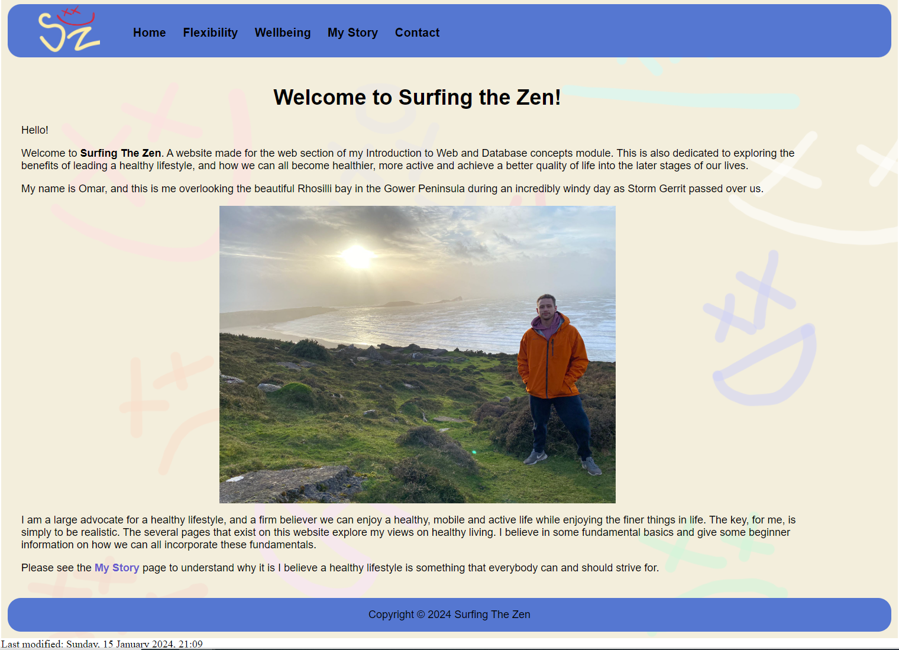
Home page (index.html)

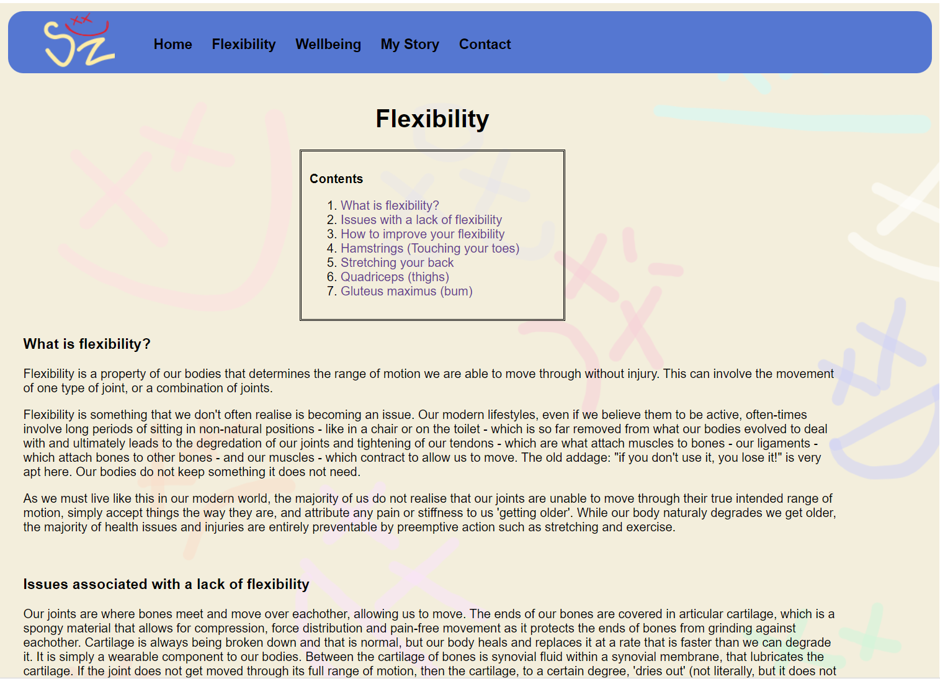
Flexibility page (flexibility.html) – several screenshots

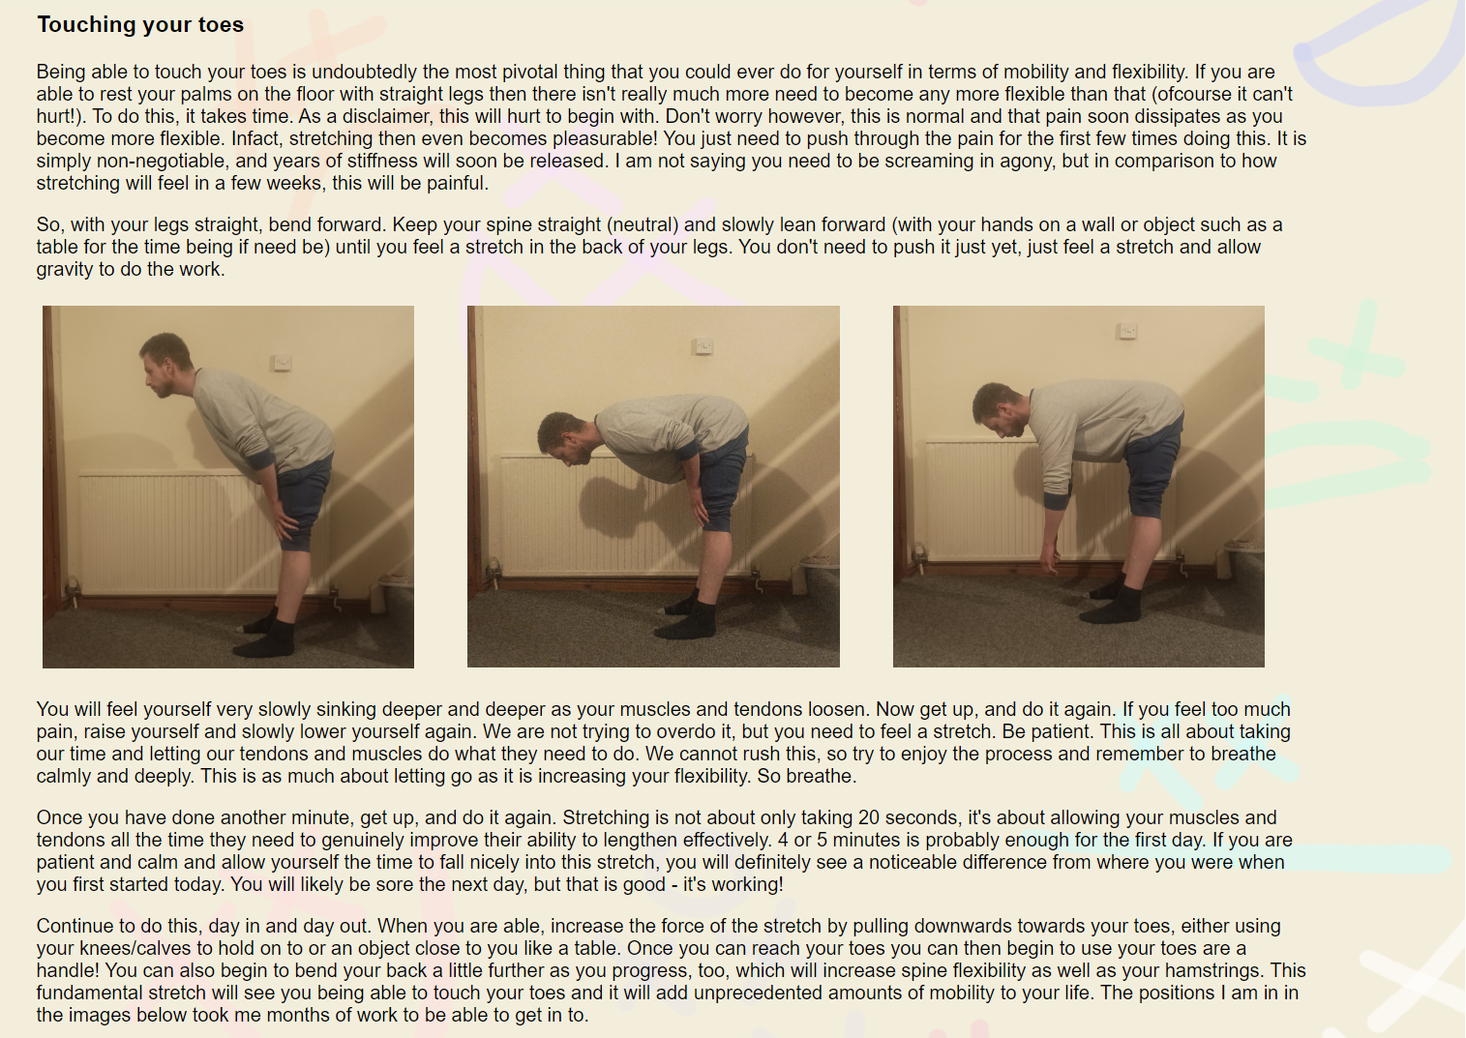
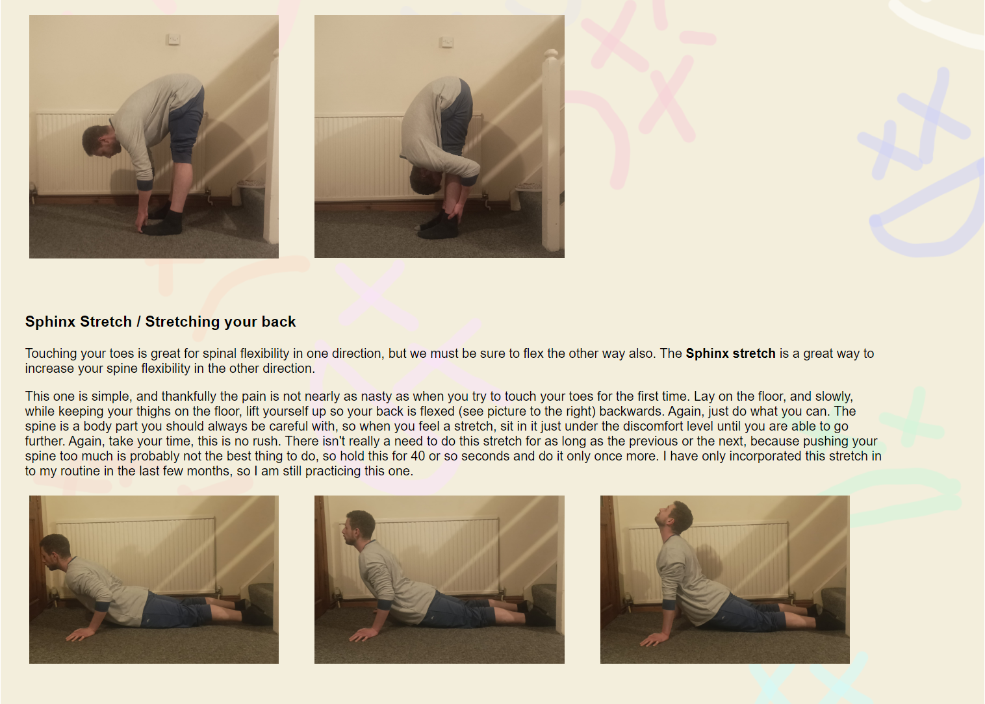
Page includes more. Screenshots not included.

Wellbeing (wellbeing.html)
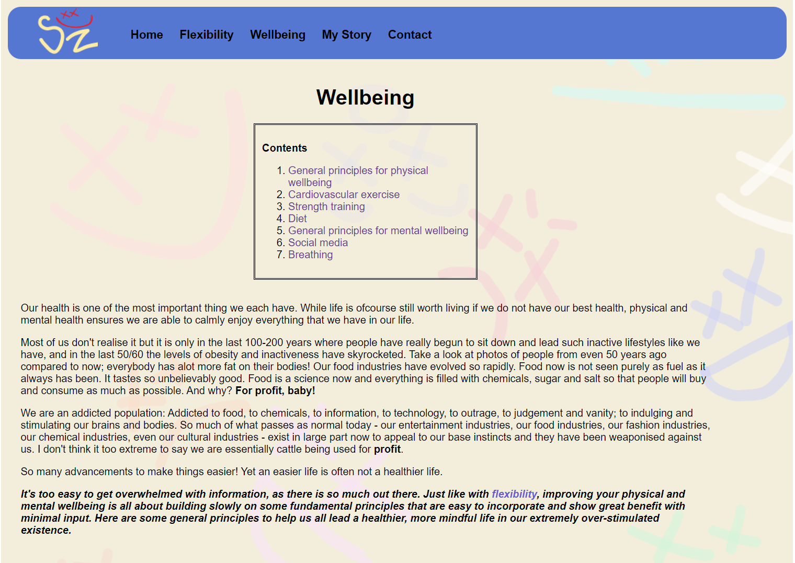
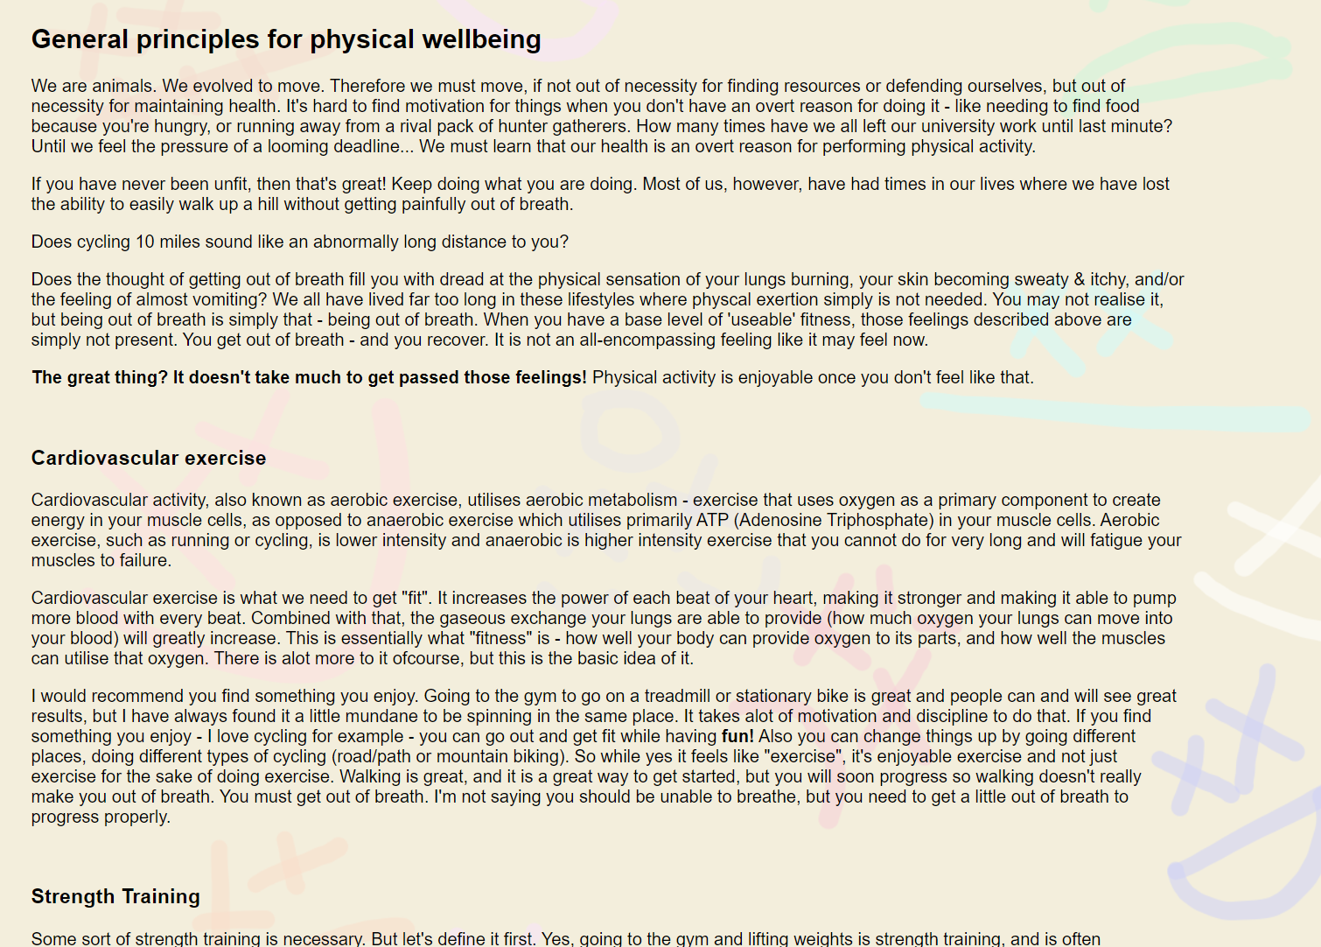
Webpage includes more. Screenshots not included.
My Story (mystory.html)
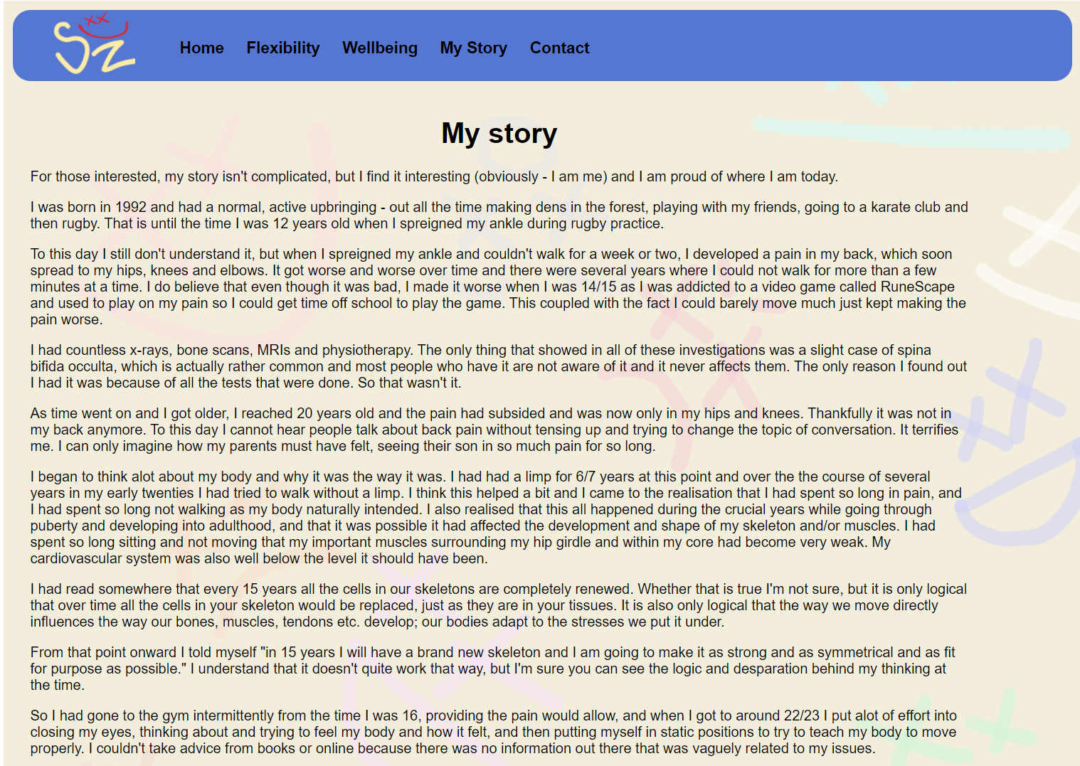

Contact (contact.html)
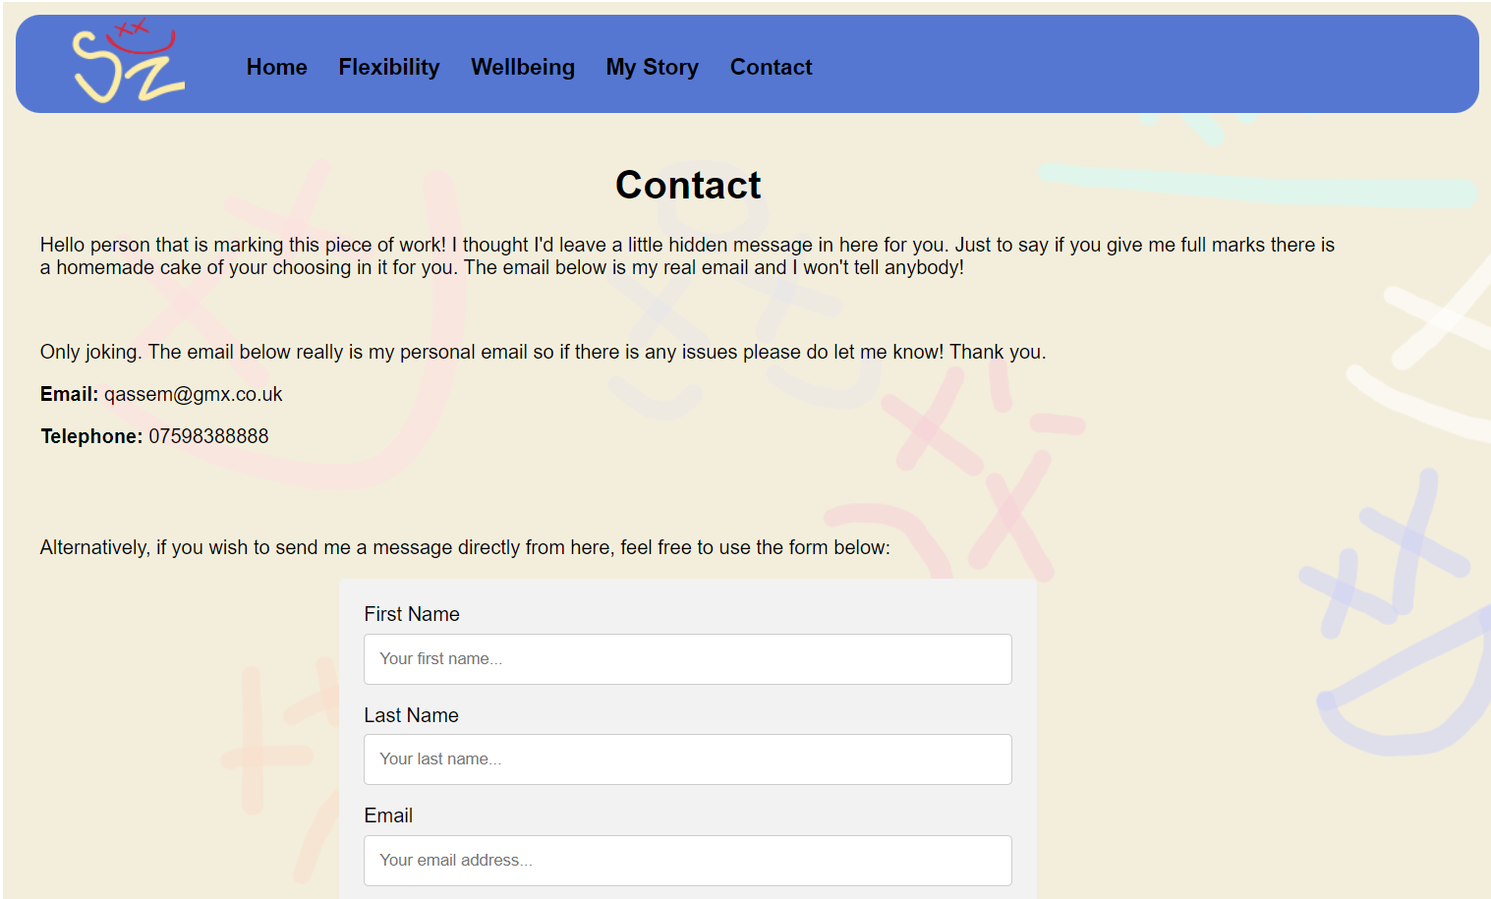


Validation
Validation of HTML of index.html
Warning:
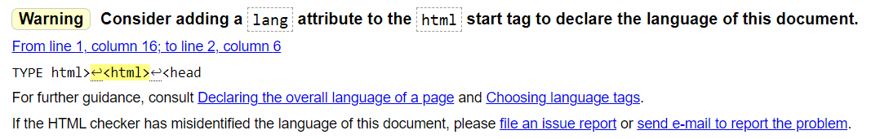

Original code:
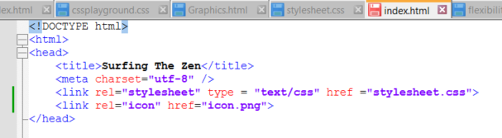

Amended code – added the lang attribute to the html tag:
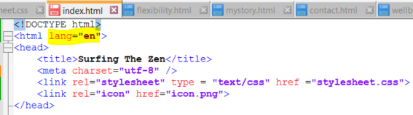

Information:
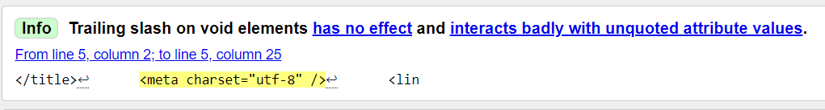

Original code:
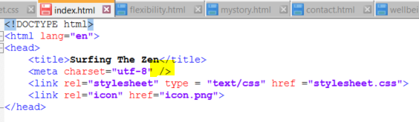

Amended code – removed the unnecessary forward slash from the meta tag:
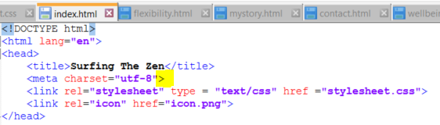

Error:
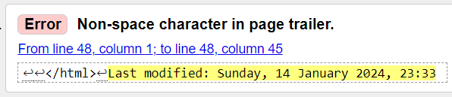

Original code:
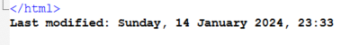

Amended code – put the Last modified date within the <body> tag:
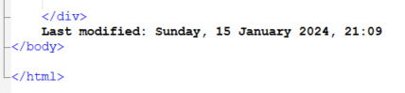

After changes, index.html now showing no errors:
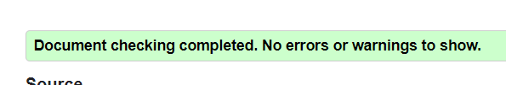

Validation of stylesheet.css
No issues found with CSS:
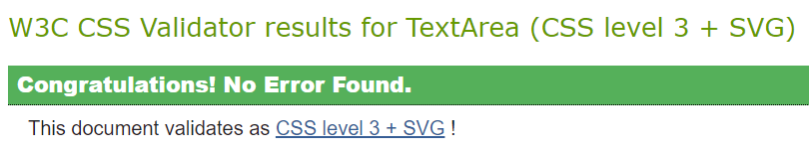

Evaluation
Website accessibility
Website accessibility means “websites, tools and technologies are designed and developed so that people with disabilities can use them.” [1]
The web allows people with all levels of ability to traverse, understand and interact with it and websites need to be designed and developed with this in mind.
The Web Accessibility Initiative (WAI) states web accessibility allows for access to those with disabilities or impairments relating to auditory, cognitive, neurological, physical, speech and visual function. It should also be accessible to all manner of different scenarios such as where people are, what language they speak, whether it is light/dark, what technology somebody is using, how fast their internet is etc.
The web has become such an essential part of the population’s daily life, that it is now defined as a human right in the United Nations Convention on the Right of Persons with Disabilities (UN CRPD). In relation to equal opportunity, everybody, no matter their ability, should have access to the same information and communication technologies that the web provides.
Accessibility also allows business to become more successful as their brand and business will be open to a greater audience and it also fosters gratefulness and a good reputation.
There are international standards for web accessibility that have been developed by the WAI, titled the Web Content Accessibility Guidelines (WCAG). They now have been accredited as ISO standard ISO/IEC40500. There are 12 guidelines that have been reached via international cooperation, and they are assorted into 4 categories:
- Perceivable – Many ways to perceive something. E.g. text for non-text content, captions for videos.
- Operable – Able to use and interact with the web page. E.g. functionality from a keyboard & plenty of time to work through content.
- Robustness – Compatibility with different/future tools. E.g. different browsers, up-to-date programming languages etc.
- Understandable – Different ways to understand. E.g. Available in different languages, easy to input into text-to-speech (i.e. no spelling errors), clear etc.
For each guideline there is a criteria a website’s conformance is evaluated against and is scored accordingly.
The components of web design and development that must be considered when creating web content that is highly accessible include:
- The content – when including text, images, multimedia etc. in websites, the different options that can be used to provide an accessible experience include things such as captions for audio content for those with hearing impairment or audio descriptions for those that have visual impairment, the ability to increase text size, and so on.
- The web browsers – should include options such as text-to-speech, or zoom functionality that doesn’t cause formatting issues.
- Authoring tools and technologies used to access the web – keyboard functionality does not get trapped in only one part of the site for example, or a keyboard has an ergonomic layout with braille lettering.
There are countless ways in which technology and content can provide accessibility to those with any number of physical or mental impairments.
Dongaonkar et al., 2017 [3] investigated various accessibility checkers that test for WCAG compliance on government websites. They concluded that accessibility is often lacking within websites as many open-source websites are often designed solely by those with an academic background in web design, and therefore there is a bias towards more complicated concepts as these developers often will find relatively complex design concepts easier to understand than those who are less knowledgeable in the subject. For example, a web developer may find it easy to navigate through their website with a keyboard while others may not.
They also concluded that while WCAG guidelines are being implemented, the rate at which governments are updating their websites to include accessibility options is slow. There is still a need for greater accessibility options and there is also a need to advertise more accessibility options on those government websites more effectively.

Website usability
As defined by standard ISO 9241 (Ergonomic Requirements for Office Work with Visual Display Terminals) usability is “the extent to which a product can be used by specified users to achieve specified goals with effectiveness, efficiency and satisfaction in a specified context of use.” [4]
Tailoring this definition towards a website; “ease of use from which users accomplish their goals or tasks when using a website.” [5]
A website must be designed with the users in mind, instead of what a designer thinks they would like. It must contain all necessary features and information to achieve its intended goals. The ultimate success or failure of a website is largely determined by its usability.
Proper website usability leads to:
- User satisfaction – a positive user experience will leave customers with a good impression.
- User engagement – your target audience will likely spend more time using your website.
- Better competitiveness in the industry – your website will be preferred over others occupying the same space.
The following are key principles to consider when designing websites that lead to enhanced usability:
- Availability – Ensuring a website is always online and available is common sense – if a website was not available to visit a lot of the time, then it would not get many visits. Availability is not just about it being online though, it is also its accessibility to different technologies such as smart phones and tablets, as well as laptops and desktop computers.
- Clarity – How clear and understandable a website is. Content structure, and a logical flow allow for intuitive ease of use. Keeping everything simple and organized is a good way to allow for clarity. It will also allow the website to load quickly. A fast load time allows users to feel like it is not cluttered and gives them trust.
- Recognition – Informs how easy it is to recognize what to do on the website. If a user is spending too much time trying to understand what it is they wish to do (buy an item for example) then it is likely they will go elsewhere. All web pages should have consistency of use. Building intuitive navigation and web pages will allow for easy recognition.
- Credibility – Proving credibility of the information and services provided by a website ensures users’ trust and will directly inform the success of the website. A professional design goes a long way, but including things such as testimonials, real-world examples and reviews prove the credibility of the website.
- Relevance – The content on the website should clearly be relevant, meaningful, and valuable to what the user is looking for. It also needs to be easily seen to be relevant, as most users will only look for a few seconds before going back to the search engine they found your website on.

Usability testing
86 percent of consumers will abandon a brand after two poor customer experiences. [6] Therefore ensuring effective usability is imperative to success. There are many tests that can be used to analyse the usability of a website, and all aim to evaluate a website’s effectiveness and efficiency, and ultimately user satisfaction.
Some of the following are tests that can be used to identify the efficacy of usability of a website.
- Card sorts – Allow target audience users to take the information/content that is to be on a website and put it in to categories of their choosing. This allows the developer to see where users expect information and content to lie.
- Field studies – Watching how a target audience works and how they walk through a process that is to be fulfilled/enhanced by the website you are developing.
- Eye tracking – track the users eyes and produce a graphical representation of where the user’s attention is mostly caught. This allows developers to see what layout works best. [7]
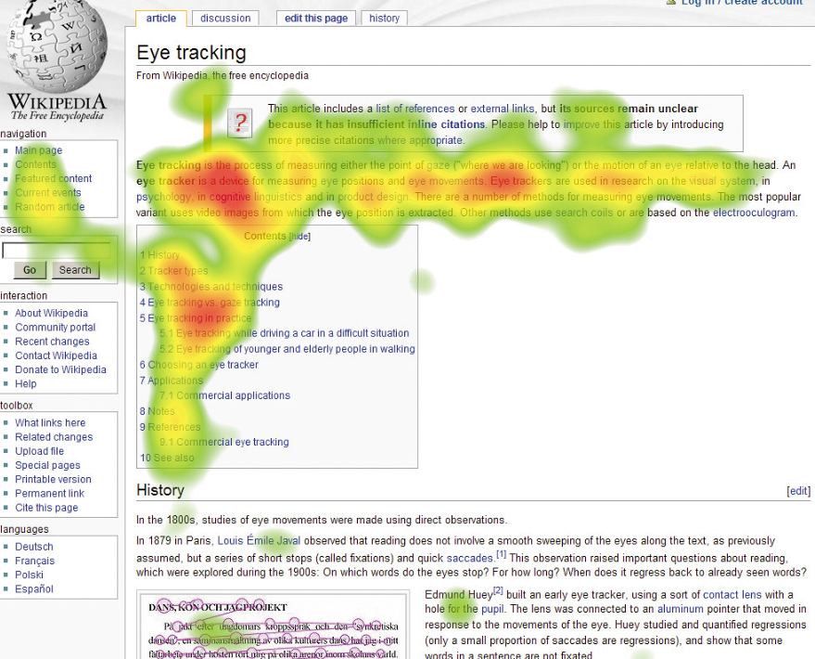

Source: flickr
(Breuch, 2018) explored social feedback about large public websites to better understand society’s values and expectations regarding website usability.
Breuch used automated in-vivo coding (the taking of key words and phrases within social feedback to determine opinions) of responses, and also looked directly at responses of feedback regarding website usability.
The research concluded that this could form a new branch of usability testing, as social websites provide a wealth of feedback information surrounding usability of websites. It found that many reviewers were willing to provide detailed reasoning for using a website, which will allow developers to gain a further insight into why users would use a website. It also found how users use a website as they would often provide “detailed descriptions of paths or journeys they took through websites, as the obstacles they experienced along the way.” They also offered up their attitudes about the experiences. [7]
Both findings provided “situated, contextual examples of use that are often difficult to capture.” Providing valuable insights for developers of websites and allowing developers to think of issues previously not considered.

Search Engine Optimisation (SEO)
Search engines are how we search the internet for websites. We have all used Google, Bing, Yahoo etc. to look for products and services. Simply put, search engine optimization (SEO) is the process of improving the chances a website will be visible in search engines when terms relating to that the purpose of that website are searched for.
It is worth noting there are several terms that SEO encompasses:
- Search Engine Optimisation (SEO) – Results included in search engine results that are not paid for by companies.
- Search Engine Marketing (SEM) – The same as SEO, but search engines are paid to include your website in their top results.
- Pay-Per-Click (PPC) – Essentially the same as SEM, but instead of paying a lump sum, search engine companies are paid per click on your website. [9]
Essentially, SEO encompasses only the unpaid visits and SEM/PPC includes both paid and unpaid visits. From here on out, unless explicitly stated, the term SEO will be used as an umbrella term to refer to SEO, SEM and PPC.
Google alone handles at least 2 trillion searches per year. [10] This is testament to how important it is to ensure your website is shown with relative ease on search engines. For a website to be successful, it needs to be visited. To do this, a website must be ‘search engine friendly’ and be available from any technology or platform.
Not only does SEO award a website with traffic, seeing a website consistently show in search results build an awareness to a brand, and ultimately trust.

There are four stages to how a search engine works:
- Crawling – Find contents of pages of a website and use links within that page to find more pages.
- Rendering – Generate how pages will look using the code found.
- Indexing – Metadata added to an index. This is where keywords are associated with pages.
- Ranking – Algorithms are used to determine if page is relevant and of high enough quality to be shown in a search for a certain keyword or phrase.

Types of SEO
Technical optimisation
Making it easier for search engines to crawl, understand and index pages of a website. Sometimes pages may need to stay private, like those with member-only content, so crawling can be controlled with certain techniques such as authentication & IP whitelisting.
A “robots” meta tag is an HTML tag within the <head> section of a webpage and tells a search engine how to crawl or index a page. [11]
How to ensure a website is technically optimised:
- Canonicalisation is the term used when there is more than one of the same page present, so a particular page is designated to show in a search engine. Ensure the most optimized page is canonicalised.
- Ensuring indexing is possible on as many pages as possible will ensure all possible. There are tools that can be used to find which pages are not indexable.
- Links from other websites can be broken as changes are made to a website and links change. Ensuring those old links point towards the new link is essential for keeping traffic incoming.
- As mentioned, crawling includes the process of jumping to different pages using links included on a webpage. If, for example, a website has a page that has a particular term on it, and that same website has a page relating to that term, then creating an internal link from that term to the related page creates more opportunity for further linkage and indexing.
- Schema markup is code that allows search engines to better understand structure and content of a website. [11]

Content optimisation
Content not only needs to be optimised for your audience, but for search engines also. The audience will see what’s on the page, and search engines will see the underlying code.
Content for an audience must be optimised so that people will search for what is in it, such as topics, keywords etc. and ensuring all the data is relevant, clear, well-written and accurate will ensure the intended audience can find it.
Content for a search engine include the different tags used, meta descriptions, headers etc. So a well-written, well laid out code will make sure search engines can search for code where it needs to be and it will find what it is looking for in the correct place.

Off-site optimisation
This is the process of ensuring there are links to a website in places other than dedicated search engines. The more places that point toward a website, and the higher the trust and better the quality of those places, the more traffic is likely to come a website’s way.
This includes placing ads on websites, building partnerships with companies, listing management, and PR. Ensuring a website has a presence on social media and has reviews and testimonials present on review websites etc. helps build trust and increase traffic.

(Bhandari & Bansal, 2018) looked at the impact search engine optimisation had on a business’ different market variables such as “market share, brand loyalty, brand recognition, product price, product information, brand image, brand awareness, consumer online behaviour and user reviews.” [12] and performed statistical analysis on the differences made by SEO.
They gathered data from 338 respondents from the National Capital Region of Delhi in India, a region that is renowned for its technical advancement and online presence.
The empirical results of the study revealed that SEO increased a companies’ market share by enhancing various factors including brand equity, product awareness, purchase persuasion and consumer insight.
Evaluation of website
Usefulness (usability and utility)
The functionality of my website does exactly what it needs to do; it is a simple website, with a menu at the top that is consistent over all pages and each page link is clearly labelled and recognizable. In the pages that go into detail about several different topics, there are navigation panes at the top of the pages that assist users in navigating to what it is they want to view.
I feel the website provides a positive and relaxed look and feel, though is not as professional looking as I would have hoped.
Its intended target audience is anybody wishing to begin a journey of health improvement and the content available on it I believe is extremely relevant. I have also provided a description of the issues I faced regarding health and how I overcame them, in doing so providing justification and testimonial to proof that the content provided is relevant.
Future improvements could include better graphics as these are a little light-hearted, and I should have provided more breaks and a different layout in the articles I wrote. In the “My Story” page for example, there is a lot of block text which should be interspersed with photos to make it more digestible. Where photos have been included, I would like to use the grid layout to further structure them and place them in different positions.
I would also have liked to include some vector graphics, but I could not provide a justification for using them. I thought about inputting some in the footer just for decoration.
The contact form in the “Contact” page calls a simple JavaScript function, but only to display a message stating the message entered has been received, and then returns the text boxes back to blank. I would have liked to get it working by sending an actual email.
I feel the website is of sound usefulness and caters to the intended audience well. It can be improved with further information about more detailed concepts, but for now the audience is well provided for.

Search Engine Optimisation (SEO)
The content is relevant and offers a unique take physical and mental wellbeing.
It is mentioned several times that the information is the fundamentals and for beginners, which the intended audience will search for.
Appropriate meta tags have been incorporated in the correct places for use by search engines:
- H1 tags have been used for page headings.
- H2 & H3 tags used for sub-headings, each of relevant names that will match searches.
Within the texts on pages there are anchors that point to internal pages. On the home page (index.html) there is a link to the “My Story” page at the bottom and on the Wellbeing page there is a link to the “Flexibility” page. On the “My Story” page there are two links to the flexibility page when that word is mentioned.
The image on the homepage has an alternate title of “Flexible fit healthy me” which is not intended to be egotistical, but it is done purely for search engine optimisation. It is also a smaller JPG file of 480kb instead of its original bmp file format that was more than 2mb, allowing for quick load times.
All images of stretches are called their correct names and are named as I expect audiences to search for them. They have also all been compressed using a piece of software, so they have been reduced in storage size by around 60%. Most are below 1mb in size.
The pages of the website are mobile-friendly and resize as necessary. The logo and banner are slightly rigid but the logo is of a set size so that is the reason for that.
The on-page SEO can and should be further optimised; more linkage between pages is needed as there are only four instances for which this occurs throughout the entire website.

Accessibility
The four main principles providing a foundation for web accessibility are perceivable, operable, understandable, and robust. The following is an evaluation of how the website I have designed meets those four guiding principles. They are evaluated against the criteria in WCAG 2.1. and their level of conformance is measured using the following success criteria:
A (lowest)
AA
AAA (Highest)

Perceivable
Images have relevant alternative text that describes the content of the image (with the exception of the image on the homepage that is “egotistical” when describing me in full clothing as healthy and flexible, but that is for search engine optimisation).
Navigation controls at the top of pages have appropriate headings and sub-headings. It also has appropriate class IDs and marked up appropriately within the code.
Colour scheme is not overly contrasting. Initially the smiley faces on the background were too opaque, so I remade it with more transparent imagery.
Overall, the website is highly perceivable and understandable.
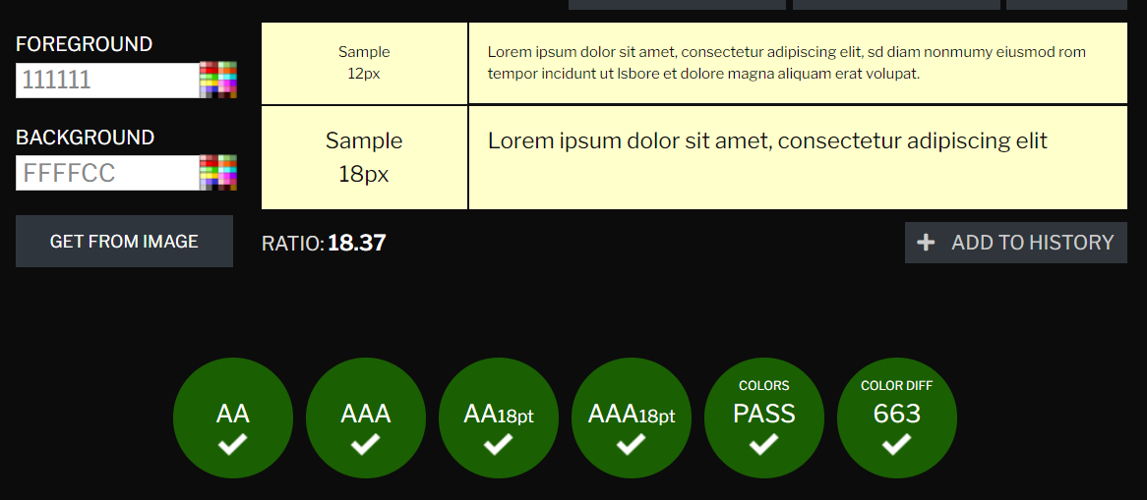
Using the contrast checker on www.contrastchecker.com, the colour scheme within my website passed all WCAG checks:

Conformance score: AAA.

Operable
Functionality is available with the keyboard. When tabbing through the contents on all pages at no point does the selection get stuck and require intervention from a mouse. All options on all pages are available to be selected.
There is no time limit to reading content, so all content comes without enough time to read and use it.
The colour scheme is pleasant and is not a strain on the eyes or intrude upon any part of the content or make it less understandable.
The content and navigation are concise and simple. Therefore, users can easily navigate, find where they are or find content. At no point is there convolution or confusion.
There are no specific input modalities included within the design of the website. If users wish to use input modalities such as voice recognition or gesture recognition, then that will need to be provided by the browser or other software packages.
Overall, the website is operable, but is missing in-built input modalities and require further software.
Conformance score: AA

Understandability
While there are no options for different languages, the text has no spelling errors so is understandable by those with text-to-speech software. It is marked up correctly within the code and appropriately tagged with appropriately named tags.
The content is consistent across web pages. The fundamental layout of the pages is the same: banner, menu, body, footer. It all appears in predictable ways.
The contact form on the “Contact” page has appropriately named textboxes with appropriate instructions within, so text-to-speech users can easily understand where they are or what needs to be entered at a specific time. It is also available if any user wishes to contact me to point out any issues with understandability or operability.
Overall, I believe the understandability of the website is of a high standard. I would wish to include more language options though, as health and wellbeing knows no language or race.
Conformance score: AA

Robustness
All content is compatible with different browsers and assistive technologies as markup is appropriately named throughout and all graphics are automatically resizable when the browser dimensions are changed.
Conformance: AAA

Bibliography
[1] S. L. Henry, “Introduction to web accessibility,” Web Accessibility Initiative (WAI), https://www.w3.org/WAI/fundamentals/accessibility-intro/ (accessed Jan. 15, 2024).
[2] S. A. Zahra, “Accessibility principles,” Web Accessibility Initiative (WAI), https://www.w3.org/WAI/fundamentals/accessibility-principles/ (accessed Jan. 15, 2024).
[3] S. Dongaonkar, R. Vadali, and C. Dhutadmal, “Content accessibility evaluation of government website using WCAG (web content accessibility guidelines),” Proceedings of the Second International Conference on Research in Intelligent and Computing in Engineering, 2017. doi:10.15439/2017r79
[4] “ISO/TS 20282-2:2013(en) Usability of consumer products and products for public use — Part 2: Summative test method,” ISO, https://www.iso.org/obp/ui/#iso:std:iso:ts:20282:-2:ed-2:v1:en (accessed Jan. 15, 2024).
[5] Ramotion, “Website usability 101: Definition, principles and methods: Ramotion Branding Agency,” Web Design, UI/UX, Branding, and App Development Blog, https://www.ramotion.com/blog/website-usability/ (accessed Jan. 15, 2024).
[6] A. Lal, “86 percent of consumers will leave a brand they trusted after only two poor customer experiences,” Business Wire, https://www.businesswire.com/news/home/20220202005525/en/86-Percent-of-Consumers-Will-Leave-a-Brand-They-Trusted-After-Only-Two-Poor-Customer-Experiences (accessed Jan. 15, 2024).
[7] B. Jackson, “The ultimate step-by-step guide on website usability testing,” Kinsta®, https://kinsta.com/blog/website-usability-testing/#identify-test-type (accessed Jan. 15, 2024).
[8] L.-A. K. Breuch, “Extended abstract: From research to practice: How insights from Social Web Research Inform website usability,” 2018 IEEE International Professional Communication Conference (ProComm), Sep. 2018. doi:10.1109/procomm.2018.00010
[9] D. Goodwin, “What is SEO - search engine optimization?,” Search Engine Land, https://searchengineland.com/guide/what-is-seo (accessed Jan. 15, 2024).
[10] D. Sullivan, “Google now handles at least 2 trillion searches per year,” Search Engine Land, https://searchengineland.com/google-now-handles-2-999-trillion-searches-per-year-250247 (accessed Jan. 15, 2024).
[11] P. Stox, “The beginner’s guide to technical SEO,” SEO Blog by Ahrefs, https://ahrefs.com/blog/technical-seo/#technical-seo-basics (accessed Jan. 15, 2024).
[12] R. S. Bhandari and A. Bansal, “Impact of search engine optimization as a marketing tool,” Jindal Journal of Business Research, vol. 7, no. 1, Mar. 2018. doi:10.1177/2278682117754016

Appendices
index.html
<!DOCTYPE html>
<html lang="en">
<head>
<title>Surfing The Zen</title>
<meta charset="utf-8">
<link rel="stylesheet" type = "text/css" href ="stylesheet.css">
<link rel="icon" href="icon.png">
</head>

<body>
<div class="grid-container">
<div class="banner">
<img src="logo.png" alt="zen logo" class="centre">
</div>

<div class="topmenu">
<ul>
<li><a href="index.html">Home</a></li>
<li><a href="flexibility.html">Flexibility</a></li>
<li><a href="wellbeing.html">Wellbeing</a></li>
<li><a href="mystory.html">My Story</a></li>
<li><a href="contact.html">Contact</a></li>
</ul>
</div>

<div class="mainbody">
<h1>Welcome to Surfing the Zen!</h1>
<p>Hello!</p>

<p>Welcome to <b>Surfing The Zen</b>. A website made for the web section of my Introduction to Web and Database concepts module. This is also dedicated to exploring the benefits of leading a healthy lifestyle, and how we can all become healthier, more active and achieve a better quality of life into the later stages of our lives.</p>
<p>My name is Omar, and this is me overlooking the beautiful Rhosilli bay in the Gower Peninsula during an incredibly windy day as Storm Gerrit passed over us.</p>
<img src="me.jpg" alt="Flexible fit healthy me" class="homeImg">
<p>I am a large advocate for a healthy lifestyle, and a firm believer we can enjoy a healthy, mobile and active life while enjoying the finer things in life. The key, for me, is simply to be realistic. The several pages that exist on this website explore my views on healthy living. I believe in some fundamental basics and give some beginner information on how we can all incorporate these fundamentals.</p>
<p>Please see the <a href="mystory.html" class="blueAnchor"><b>My Story</b></a> page to understand why it is I believe a healthy lifestyle is something that everybody can and should strive for.</p>

</div>

<div class="footer">
<p style="text-align: center;">Copyright &copy; 2024 Surfing The Zen</p>
</div>

</div>
Last modified: Sunday, 15 January 2024, 21:09
</body>

</html>

flexibility.html
<!DOCTYPE html>
<html lang="en">
<head>
<title>Surfing The Zen</title>
<meta charset="utf-8">
<link rel="stylesheet" type = "text/css" href ="stylesheet.css">
<link rel="icon" href="icon.png">
</head>

<body>
<div class="grid-container">
<div class="banner">
<img src="logo.png" alt="zen logo" class="centre">
</div>

<div class="topmenu">
<ul>
<li><a href="index.html">Home</a></li>
<li><a href="flexibility.html">Flexibility</a></li>
<li><a href="wellbeing.html">Wellbeing</a></li>
<li><a href="mystory.html">My Story</a></li>
<li><a href="contact.html">Contact</a></li>
</ul>
</div>

<div class="mainbody">
<h1>Flexibility</h1>

<div class="contentsBox">
<p><b>Contents</b></p>
<ol>
<li><a href="flexibility.html#flexibility" class="blueAnchor">What is flexibility?</a></li>
<li><a href="flexibility.html#issues">Issues with a lack of flexibility</a></li>
<li><a href="flexibility.html#improveFlexibility">How to improve your flexibility</a></li>
<li><a href="flexibility.html#toeTouch">Hamstrings (Touching your toes)</a></li>
<li><a href="flexibility.html#sphinx">Stretching your back</a></li>
<li><a href="flexibility.html#quads">Quadriceps (thighs)</a></li>
<li><a href="flexibility.html#glutes">Gluteus maximus (bum)</a></li>
</ol>
</div>

<h3 id="flexibility">What is flexibility?</h3>
<p>Flexibility is a property of our bodies that determines the range of motion we are able to move through without injury. This can involve the movement of one type of joint, or a combination of joints.</p>
<p>Flexibility is something that we don't often realise is becoming an issue. Our modern lifestyles, even if we believe them to be active, often-times involve long periods of sitting in non-natural positions - like in a chair or on the toilet - which is so far removed from what our bodies evolved to deal with and ultimately leads to the degredation of our joints and tightening of our tendons - which are what attach muscles to bones - our ligaments - which attach bones to other bones - and our muscles - which contract to allow us to move. The old addage: "if you don't use it, you lose it!" is very apt here. Our bodies do not keep something it does not need.</p>
<p>As we must live like this in our modern world, the majority of us do not realise that our joints are unable to move through their true intended range of motion, simply accept things the way they are, and attribute any pain or stiffness to us 'getting older'. While our body naturaly degrades we get older, the majority of health issues and injuries are entirely preventable by preemptive action such as stretching and exercise.</p>
<br>

<h3 id="issues">Issues associated with a lack of flexibility</h3>
<p>Our joints are where bones meet and move over eachother, allowing us to move. The ends of our bones are covered in articular cartilage, which is a spongy material that allows for compression, force distribution and pain-free movement as it protects the ends of bones from grinding against eachother. Cartilage is always being broken down and that is normal, but our body heals and replaces it at a rate that is faster than we can degrade it. It is simply a wearable component to our bodies. Between the cartilage of bones is synovial fluid within a synovial membrane, that lubricates the cartilage. If the joint does not get moved through its full range of motion, then the cartilage, to a certain degree, 'dries out' (not literally, but it does not get the full lubrication necessary for proper health) as it is not getting lubricated as it should be. This leads to cartilage becoming inflexible & stiff and causes degraded functionality and pain.</p>

<p>The stiffness we feel due to a lack of flexibility makes normal movement harder - quite literally. Our muscles have to exert more force to stretch themselves and the tendons when attempting to move. Moving therefore takes more effort and energy. Humans don't like doing difficult things - why would we? It's difficult! - so we are less likely to enjoy, or even want to move. This only compounds and exacerbates a lack of flexibility and the issues it causes.</p>

<p>We are not perfectly symmetrical creatures. We all favour one side of our body for most things; almost all of us are right or left side dominant, with the exception of a tiny minority. Not only that, we all have ways of doing things, for example some people may prefer to sleep on their left, or when sitting may prefer to put their left leg over their right leg when crossing their legs etc. There are countless examples of these little intricacies to us and they cause different muscles, tendons and ligaments on either side of our bodies to stiffen at different rates. This will often throw our movement out of alignment. Take for example one of the most common issues people face: gluteus maximus stiffness. The glutes are our bum muscles and they play a major role in walking. If one is stiffer than the other then our walk will be out of alignment and our biomechanics are not moving through their intended path. This causes a cascade of imbalances throughout our legs and back, compounding and exacerbating once again further issues throughout our bodies and leads to the improper use of our joints and muscles. Ultimately leading to uneven wear in our cartilage and the improper movement of ligaments, and you guessed it: <b>pain!</b></p>

<p>Our range of motion and our biomechanics are incredibly important for pain-free, easy movement.</p>

<p>Even though not every issue associated with a lack of flexibility is noted here, it is plain to see and only logical that when we lack what I would refer to as a normal, necessary, 'natural range of motion' for what the human body evolved for, it will cause a cascade of problems that will cause symptoms of (and often lead to) health conditions such as arthritis and tendonitis. Not only that, but you increase your risk of injury from normal every-day movement such as muscle strains & tears or dislocations etc.</p>
<br>

<h3>How we can improve our flexibility</h3>
<p href="improveFlexibility">We don't need to be as flexible as a gymnast or a contortionist, but we do need to have a basic level of flexibility that will afford us ease of movement and reduce the risk of injury.</p>

<p>The main things we should target are the main pivots of the body: the hip girdle. The back, the hamstrings, quadriceps, the gluteal muscles and the internal psoas muscles all anchor to the hip girdle. It is the body's main pivot point and if we have flexibility at this region then we will have an amazing amount of extra mobility and a better quality of life. Think about it: when we get up from the bed, or a chair, what is usually stiff? The lower back, our knees, our hips... Below are several important stretches and movements we should all be able to achieve to become a more functional human being:</p>

</div>

<div class="mainbody2">
<h3 id="toeTouch">Touching your toes</h3>
<p>Being able to touch your toes is undoubtedly the most pivotal thing that you could ever do for yourself in terms of mobility and flexibility. If you are able to rest your palms on the floor with straight legs then there isn't really much more need to become any more flexible than that (ofcourse it can't hurt!). To do this, it takes time. As a disclaimer, this will hurt to begin with. Don't worry however, this is normal and that pain soon dissipates as you become more flexible. Infact, stretching then even becomes pleasurable! You just need to push through the pain for the first few times doing this. It is simply non-negotiable, and years of stiffness will soon be released. I am not saying you need to be screaming in agony, but in comparison to how stretching will feel in a few weeks, this will be painful.</p>
<p>So, with your legs straight, bend forward. Keep your spine straight (neutral) and slowly lean forward (with your hands on a wall or object such as a table for the time being if need be) until you feel a stretch in the back of your legs. You don't need to push it just yet, just feel a stretch and allow gravity to do the work.<p>
<div class="imageRow">
<div class="imageColumn">
<img src="images/straight back forward lean.jpg" alt="straight back forward lean" style="width:90%">
</div>
<div class="imageColumn">
<img src="images/straight back forward lean further.jpg" alt="straight back forward lean further" style="width:90%">
</div>
<div class="imageColumn">
<img src="images/straight back reach for toes.jpg" alt="straight back reach for toes" style="width:90%">
</div>
</div>

<p>You will feel yourself very slowly sinking deeper and deeper as your muscles and tendons loosen. Now get up, and do it again. If you feel too much pain, raise yourself and slowly lower yourself again. We are not trying to overdo it, but you need to feel a stretch. Be patient. This is all about taking our time and letting our tendons and muscles do what they need to do. We cannot rush this, so try to enjoy the process and remember to breathe calmly and deeply. This is as much about letting go as it is increasing your flexibility. So breathe.</p>
<p>Once you have done another minute, get up, and do it again. Stretching is not about only taking 20 seconds, it's about allowing your muscles and tendons all the time they need to genuinely improve their ability to lengthen effectively. 4 or 5 minutes is probably enough for the first day. If you are patient and calm and allow yourself the time to fall nicely into this stretch, you will definitely see a noticeable difference from where you were when you first started today. You will likely be sore the next day, but that is good - it's working!</p>
<p>Continue to do this, day in and day out. When you are able, increase the force of the stretch by pulling downwards towards your toes, either using your knees/calves to hold on to or an object close to you like a table. Once you can reach your toes you can then begin to use your toes are a handle! You can also begin to bend your back a little further as you progress, too, which will increase spine flexibility as well as your hamstrings. This fundamental stretch will see you being able to touch your toes and it will add unprecedented amounts of mobility to your life. The positions I am in in the images below took me months of work to be able to get in to.</p>
<div class="imageRow">
<div class="imageColumn">
<img src="images/touch toes.jpg" alt="touch toes" style="width:90%">
</div>
<div class="imageColumn">
<img src="images/full forward bend.jpg" alt="full forward bend touching toes" style="width:90%">
</div>
</div>
</div>

<div class="mainbody3">
<h3 id="sphinx">Sphinx Stretch / Stretching your back</h3>
<p>Touching your toes is great for spinal flexibility in one direction, but we must be sure to flex the other way also. The <b>Sphinx stretch</b> is a great way to increase your spine flexibility in the other direction.</p>
<p>This one is simple, and thankfully the pain is not nearly as nasty as when you try to touch your toes for the first time. Lay on the floor, and slowly, while keeping your thighs on the floor, lift yourself up so your back is flexed (see picture to the right) backwards. Again, just do what you can. The spine is a body part you should always be careful with, so when you feel a stretch, sit in it just under the discomfort level until you are able to go further. Again, take your time, this is no rush. There isn't really a need to do this stretch for as long as the previous or the next, because pushing your spine too much is probably not the best thing to do, so hold this for 40 or so seconds and do it only once more. I have only incorporated this stretch in to my routine in the last few months, so I am still practicing this one.</p>

<div class="imageRow">
<div class="imageColumn">
<img src="images/sphinx 1.jpg" alt="sphinx pose 1" style="width:90%">
</div>
<div class="imageColumn">
<img src="images/sphinx 2.jpg" alt="sphinx pose 2" style="width:90%">
</div>
<div class="imageColumn">
<img src="images/sphinx 3.jpg" alt="sphinx pose 3" style="width:90%">
</div>
</div>
</div>

<div class="mainbody4">
<h3 id="quads">Quadriceps stretch</h3>
<p>The quadriceps (thigh muscles) are the second largest muscle in the body after the gluteus maximus, so are another main muscle to stretch and will cause a cascade of stiffness and pain if we allow them to get tight. There are several stretches we can do as we progress with quad flexibility, so here I will mention only the most basic for us to get started.</p>
<p>Nice and easy, lift your foot up behind you and hold your foot. Pull it towards your bum until you feel a stretch. Again, take it slowly and pull your leg so that you feel discomfort but not actual pain (unlike when initially trying to touch your toes), and allow your muscles to lengthen. Do this with both legs for 1 minute each and repeat the process 3 or 4 times. If you are unable to reach your foot with your hand that is totally fine, simply place it on an object like a chair behind you and lower yourself while supporting yourself until you feel a stretch in your thigh.</p>
<p>As you progress, you can begin to perform stretches that require a little more flexibility, as shown below in the third image.</p>

<div class="imageRow">
<div class="imageColumn">
<img src="images/quadriceps stretch 1.jpg" alt="quadriceps stretch 1" style="width:90%">
</div>
<div class="imageColumn">
<img src="images/quadriceps stretch 2.jpg" alt="quadriceps stretch 2" style="width:90%">
</div>
<div class="imageColumn">
<img src="images/quadriceps stretch 3.jpg" alt="quadriceps stretch 3" style="width:90%">
</div>
</div>
<br>
</div>

<div class="mainbody5">
<h3 id="glutes">Gluteus Maximus stretch</h3>
<p>The gluteus maximus is the largest muscle in the body. We use it every day for walking or any general movement that involves us propelling ourselves. We use it when we run, walk, cycle etc. It pulls our leg behind our body. We also sit on it alot, so bloody supply is often impeded to it. The simplest stretch for the glutes are to side straight legged on the floor, to pull one leg over the other so the soul of your foot is on the floor just above the outside of your opposing knee, and then pull your knee towards you. You will feel a stretch in your bum - the glutes! Hold this and pull your knee towards your chest slowly. Keep your back straight. If you feel a pinching in your hip back off a little and straighten up your back again and begin to bring your knee towards you slowly again. Do this the same as the others - for a minute each, 3 or 4 times.</p>

<div class="imageRow">
<div class="imageColumn">
<img src="images/leg over leg.jpg" alt="gluteus maximus stretch 1" style="width:90%">
</div>
<div class="imageColumn">
<img src="images/leg over leg pull toward chest.jpg" alt="gluteus maximus stretch 1" style="width:90%">
</div>
</div>

<br>
<p>The above are four very important and fundamental stretches you can do to improve your health and mobility in only a few days and weeks. The amount you will progress with a bit of effort really is life-changing. You should begin with these fundamental stretches, and then you can add in other stretches for other body parts, like your neck, shoulders, latimus dorsi muscles, obliques, calves etc. The above are purely to get you moving and are in no way an exhaustive list. They are a great road that you can use to begin your journey into the world of stretching. And what a journey it is!</p>

</div>

<div class="footer">
<p style="text-align: center;">Copyright &copy; 2024 Surfing The Zen</p>
</div>
</div>
Last modified: Monday, 09 January 2024, 12:37 PM
</body>

</html>

wellbeing.html
<!DOCTYPE html>
<html lang="en">
<head>
<title>Surfing The Zen</title>
<meta charset="utf-8">
<link rel="stylesheet" type = "text/css" href ="stylesheet.css">
<link rel="icon" href="icon.png">
</head>

<body>
<div class="grid-container">

<div class="banner">
<img src="logo.png" alt="zen logo" class="centre">
</div>

<div class="topmenu">
<ul>
<li><a href="index.html">Home</a></li>
<li><a href="flexibility.html">Flexibility</a></li>
<li><a href="wellbeing.html">Wellbeing</a></li>
<li><a href="mystory.html">My Story</a></li>
<li><a href="contact.html">Contact</a></li>
</ul>
</div>

<div class="mainbody">
<h1>Wellbeing</h1>

<div class="contentsBox">
<p><b>Contents</b></p>
<ol>
<li><a href="wellbeing.html#physicalWellbeing" class="blueAnchor">General principles for physical wellbeing</a></li>
<li><a href="wellbeing.html#cardio">Cardiovascular exercise</a></li>
<li><a href="wellbeing.html#strengthTraining">Strength training</a></li>
<li><a href="wellbeing.html#diet">Diet</a></li>
<li><a href="wellbeing.html#mentalWellbeing">General principles for mental wellbeing</a></li>
<li><a href="wellbeing.html#socialMedia">Social media</a></li>
<li><a href="wellbeing.html#breathing">Breathing</a></li>
</ol>
</div>
<br>
<p>Our health is one of the most important thing we each have. While life is ofcourse still worth living if we do not have our best health, physical and mental health ensures we are able to calmly enjoy everything that we have in our life.</p>

<p>Most of us don't realise it but it is only in the last 100-200 years where people have really begun to sit down and lead such inactive lifestyles like we have, and in the last 50/60 the levels of obesity and inactiveness have skyrocketed. Take a look at photos of people from even 50 years ago compared to now; everybody has alot more fat on their bodies! Our food industries have evolved so rapidly. Food now is not seen purely as fuel as it always has been. It tastes so unbelievably good. Food is a science now and everything is filled with chemicals, sugar and salt so that people will buy and consume as much as possible. And why? <b>For profit, baby!</b></p>

<p>We are an addicted population: Addicted to food, to chemicals, to information, to technology, to outrage, to judgement and vanity; to indulging and stimulating our brains and bodies. So much of what passes as normal today - our entertainment industries, our food industries, our fashion industries, our chemical industries, even our cultural industries - exist in large part now to appeal to our base instincts and they have been weaponised against us. I don't think it too extreme to say we are essentially cattle being used for <b>profit</b>.</p>

<p>So many advancements to make things easier! Yet an easier life is often not a healthier life.</p>

<p><b><i>It's too easy to get overwhelmed with information, as there is so much out there. Just like with <a href="flexibility.html" class="blueAnchor">flexibility</a>, improving your physical and mental wellbeing is all about building slowly on some fundamental principles that are easy to incorporate and show great benefit with minimal input. Here are some general principles to help us all lead a healthier, more mindful life in our extremely over-stimulated existence.</i></b></p>

<br>

<h2 id="physicalWellbeing">General principles for physical wellbeing</h2>

<p>We are animals. We evolved to move. Therefore we must move, if not out of necessity for finding resources or defending ourselves, but out of necessity for maintaining health. It's hard to find motivation for things when you don't have an overt reason for doing it - like needing to find food because you're hungry, or running away from a rival pack of hunter gatherers. How many times have we all left our university work until last minute? Until we feel the pressure of a looming deadline... We must learn that our health is an overt reason for performing physical activity.</p>

<p>If you have never been unfit, then that's great! Keep doing what you are doing. Most of us, however, have had times in our lives where we have lost the ability to easily walk up a hill without getting painfully out of breath.</p>

<p>Does cycling 10 miles sound like an abnormally long distance to you?</p>

<p>Does the thought of getting out of breath fill you with dread at the physical sensation of your lungs burning, your skin becoming sweaty & itchy, and/or the feeling of almost vomiting? We all have lived far too long in these lifestyles where physcal exertion simply is not needed. You may not realise it, but being out of breath is simply that - being out of breath. When you have a base level of 'useable' fitness, those feelings described above are simply not present. You get out of breath - and you recover. It is not an all-encompassing feeling like it may feel now.</p>

<p><b>The great thing? It doesn't take much to get passed those feelings!</b> Physical activity is enjoyable once you don't feel like that.</p>
<br>
<h3 id="cardio">Cardiovascular exercise</h3>
<p>Cardiovascular activity, also known as aerobic exercise, utilises aerobic metabolism - exercise that uses oxygen as a primary component to create energy in your muscle cells, as opposed to anaerobic exercise which utilises primarily ATP (Adenosine Triphosphate) in your muscle cells. Aerobic exercise, such as running or cycling, is lower intensity and anaerobic is higher intensity exercise that you cannot do for very long and will fatigue your muscles to failure. </p>

<p>Cardiovascular exercise is what we need to get "fit". It increases the power of each beat of your heart, making it stronger and making it able to pump more blood with every beat. Combined with that, the gaseous exchange your lungs are able to provide (how much oxygen your lungs can move into your blood) will greatly increase. This is essentially what "fitness" is - how well your body can provide oxygen to its parts, and how well the muscles can utilise that oxygen. There is alot more to it ofcourse, but this is the basic idea of it.</p>

<p>I would recommend you find something you enjoy. Going to the gym to go on a treadmill or stationary bike is great and people can and will see great results, but I have always found it a little mundane to be spinning in the same place. It takes alot of motivation and discipline to do that. If you find something you enjoy - I love cycling for example - you can go out and get fit while having <b>fun!</b> Also you can change things up by going different places, doing different types of cycling (road/path or mountain biking). So while yes it feels like "exercise", it's enjoyable exercise and not just exercise for the sake of doing exercise. Walking is great, and it is a great way to get started, but you will soon progress so walking doesn't really make you out of breath. You must get out of breath. I'm not saying you should be unable to breathe, but you need to get a little out of breath to progress properly.</p>

<br>

<h3 id="strengthTraining">Strength Training</h3>
<p>Some sort of strength training is necessary. But let's define it first. Yes, going to the gym and lifting weights is strength training, and is often enjoyable, but any activity that requires you to use all of the muscles in your body is technically strength training. Take tennis for example; you are holding a racket while hitting a ball, and running about a court, changing direction constantly and developing your hand-eye coordination. That takes every muscle in your body. They make it look easy on TV but it isn't!</p>

<p>Cycling is good but it doesn't really target all the muscles a sport like tennis would. Again, this is all about you finding something that you enjoy - so try different things, but strengthening your muscles will increase your metabolism and help you burn more energy and it will make you stronger and more able. As we get older we lose muscle mass so it is good to ensure you keep as much muscle mass as possible in order to stay safe and mobile in to older age.</p>

<p>The more able you are, the more confidence you are. Not to mention gaining muscle looks great no matter what gender you are!</p>

<br>

<h3 id="diet">Diet</h3>
<p>Diet is where almost everybody will fall. Even the healthiest of people have days where they splurge or indulge. We are humans, and our brains are wired to want calorie-rich food, just in the case we aren't able to find food tomorrow. Most of us are thankfully lucky enough that we will always (hopefully) have food tomorrow. But our brains and bodies evolved in a different time, so it is only logical we adore food.</p>
<p>While people can and do make drastic changes to their diets overnight, it is not something I would recommend. Simply because you are not used to it, and it is such an integral part of our lives and bodies that making sudden changes to something like this is unsustainable as we are likely to love motivation quickly. It isn't just a mental game; our gut bacteria change so that we can digest the food that we mainly eat. If we change our diet overnight, our bacteria cannot keep up, therefore we are likely to find the cravings for our original diets overwhelming, leading to lapses in diet and ultimately failure.</p>
<p>For most of us, a dessert is commonplace. It should not be. If that sounds bad to you, then sorry - tough! Food is fuel and nothing more. That is not to say you cannot enjoy your food, because good, healthy food can taste great. It simply means we cannot indulge every meal. <b>That, unfortunately, is just how things are.</b> We need to learn how to cook meals that have a well-rounded macronutrient and micronutrient profile.</p>
<p>A good rule to follow is to not eat processed food. That may actually sound relatively simple, but you would be surprised by just how much processed food there is. Processed food is food that has been altered in some way during its preparation before getting to your house - so bread, tinned foods, snacks like crisps, microwave meals... are all processed foods with alot of preservatives, fats and sugars added to them so they taste better and don't spoil.</p>

<p>So without going too far into detail, just attempting to cook your own meals with natural foods, ehrbs and spices will automatically put you in a good place when it comes to diet. Obviously don't go and eat 3 big bowls of the same food, but you will inherintly be in a far better position. If it doesn't taste good to begin with, then try again! Learning to cook is a skill that is invaluable.</p>

<br>

<h3 id="mentalWellbeing">General principles for mental wellbeing</h3>
<p>Our mental ellbeing is just as important as our physical wellbeing. They are intrinsicly linked and both should be taken care of. If we aren't mentally okay, then our physical health will take a downturn, and vice versa. People often forget that our brains are in our body and they are one and the same. Here are some easy ways to buidl resilience and help with staying mentally stable.</p>

<h3 id="socialMedia">Stop posting on social media</h3>
<p>Notice the wording of the heading? "Stop <u><b>posting</b></u> on social media." If you can get off social media entirely that is for the best. It may sound difficult reducing your social media usage, but it is not. You will soon realise your life is just as full without it. I recommend stop posting, as all that does is make you hang tightly on to how many likes and/or comments you get. It is not a photo album. You are posting on it get validation from other people. Don't kid yourself - you are not doing it for yourself. You are comparing yourself to the lives of others, forgetting that just like you, they are doing the same and only posting the best image they can of their life. When you compare yourself, there is nothing but hopelessness, despair and a feeling that you are not good enough. Look at it this way - when you see you're doing better than others, do you think "I'm glad I'm doing better than them." or do you feel bad for them? So when you compare yourself to others and see you're not doing as good as them, you may feel good for them, but you are also feeling sorry for yourself. There is no win in this situation. It is a vicious cycle of vanity and vacuousness.</p>

<p>On social media we are also bombarded with inhuman amounts of information, constantly. Incessent, endless amounts of information. We are not designed to deal with that amount of information. Our brains are so overly indulged and overly stimulated that there is no room for anything else.</p>

<p>When was the last time you were bored? What was the last creative thing that you did, instead of opening your phone and scrolling through social media?</p>

<p>Social media has its uses, but for the most part we are unable to distinguish between the good and the bad. I also find it interesting that none of us have ever had a dream we were on our phones, so do they really matter?</p>

<p>Use it to message your friends, that is useful. But we need to get back to reality and nature. So stop using it as much!</p>

<br>

<h3 id="breathing">Breathe</h3>
<p>Our brains are overly stimulated. In this busy world it is important to clear your mind of unecessary business.</p>

<p>Taking a minute or two every few hours to close your eyes, breathe deeply and intentionally and concentrate on only your breath is a good way to calm your mind. A calm mind is a calm person, and better decisions can be made and better work can be done. Your mind will wander but that is okay and natural. Simply be mindful of it and bring it back to your breath. I like to imagine my mind as a vessel or a container, and imagine it as empty.</p>
<br>

<p>The above are simple, fundamental methods that we can all employ to lead a calmer, happier, more joyful existence. They are simple yet effective. They do take work but what better thing to work on that oneself?</p>
<p>Remember: One step at a time. You do not, and probably should not, do this all at once. Give yourself a break and don't be too hard on yourself if you fail. We all fail and it's part of the process. Just keep going!</p>
</div>

<div class="footer">
<p style="text-align: center;">Copyright &copy; 2024 Surfing The Zen</p>
</div>

</div>
Last modified: Monday, 09 January 2024, 12:37 PM
</body>

</html>

mystory.html
<!DOCTYPE html>
<html lang="en">
<head>
<title>Surfing The Zen</title>
<meta charset="utf-8">
<link rel="stylesheet" type = "text/css" href ="stylesheet.css">
<link rel="icon" href="icon.png">
</head>

<body>
<div class="grid-container">

<div class="banner">
<img src="logo.png" alt="zen logo" class="centre">
</div>

<div class="topmenu">
<ul>
<li><a href="index.html">Home</a></li>
<li><a href="flexibility.html">Flexibility</a></li>
<li><a href="wellbeing.html">Wellbeing</a></li>
<li><a href="mystory.html">My Story</a></li>
<li><a href="contact.html">Contact</a></li>
</ul>
</div>

<div class="mainbody">
<h1>My story</h1>
<p>For those interested, my story isn't complicated, but I find it interesting (obviously - I am me) and I am proud of where I am today.</p>

<p>I was born in 1992 and had a normal, active upbringing - out all the time making dens in the forest, playing with my friends, going to a karate club and then rugby. That is until the time I was 12 years old when I spreigned my ankle during rugby practice.</p>

<p>To this day I still don't understand it, but when I spreigned my ankle and couldn't walk for a week or two, I developed a pain in my back, which soon spread to my hips, knees and elbows. It got worse and worse over time and there were several years where I could not walk for more than a few minutes at a time. I do believe that even though it was bad, I made it worse when I was 14/15 as I was addicted to a video game called RuneScape and used to play on my pain so I could get time off school to play the game. This coupled with the fact I could barely move much just kept making the pain worse.</p>

<p>I had countless x-rays, bone scans, MRIs and physiotherapy. The only thing that showed in all of these investigations was a slight case of spina bifida occulta, which is actually rather common and most people who have it are not aware of it and it never affects them. The only reason I found out I had it was because of all the tests that were done. So that wasn't it.</p>

<p>As time went on and I got older, I reached 20 years old and the pain had subsided and was now only in my hips and knees. Thankfully it was not in my back anymore. To this day I cannot hear people talk about back pain without tensing up and trying to change the topic of conversation. It terrifies me. I can only imagine how my parents must have felt, seeing their son in so much pain for so long.</p>

<p>I began to think alot about my body and why it was the way it was. I had had a limp for 6/7 years at this point and over the the course of several years in my early twenties I had tried to walk without a limp. I think this helped a bit and I came to the realisation that I had spent so long in pain, and I had spent so long not walking as my body naturally intended. I also realised that this all happened during the crucial years while going through puberty and developing into adulthood, and that it was possible it had affected the development and shape of my skeleton and/or muscles. I had spent so long sitting and not moving that my important muscles surrounding my hip girdle and within my core had become very weak. My cardiovascular system was also well below the level it should have been.</p>

<p>I had read somewhere that every 15 years all the cells in our skeletons are completely renewed. Whether that is true I'm not sure, but it is only logical that over time all the cells in your skeleton would be replaced, just as they are in your tissues. It is also only logical that the way we move directly influences the way our bones, muscles, tendons etc. develop; our bodies adapt to the stresses we put it under.</p>

<p>From that point onward I told myself "in 15 years I will have a brand new skeleton and I am going to make it as strong and as symmetrical and as fit for purpose as possible." I understand that it doesn't quite work that way, but I'm sure you can see the logic and desparation behind my thinking at the time.</p>

<p>So I had gone to the gym intermittently from the time I was 16, providing the pain would allow, and when I got to around 22/23 I put alot of effort into closing my eyes, thinking about and trying to feel my body and how it felt, and then putting myself in static positions to try to teach my body to move properly. I couldn't take advice from books or online because there was no information out there that was vaguely related to my issues.</p>

<p>I did things like balance exercises, where I would squat down slightly on one leg, to engage the muscles as they should be engaging. I had to teach myself to walk with proper technique - that which felt as natural and as energy efficient as possible. I discovered the muscles and tendons on each of my legs were significantly different in <a href="flexibility.html" class="blueAnchor">flexibility</a>, so I worked alot on that by learning to stretch. I noticed different parts of my body were tense and others weren't, so when laying in bed for years I concentrated on loosening some areas and tightening others... It isn't often found in literature about how we use our muscles, how each one of them fires during each movement we make and in what order and how it is controlled by the brain. It's very neurological and I had to learn how to do so many things again. We take for granted everything that we learn as we grow when we're a baby. It is hard to reinstate these natural neurological firings as you get older.</p>

<p>I learnt this all on my own by concentrating on different parts of my body and really feeling how they felt. I still get emotional when I think about the first time I ran in years. I felt free! No one person, profession or physiotherapist could have told me about this. My symptoms were too vague. I mean it took me years to figure out my body even felt a certain way!</p>
<br>

<p>So now I am the biggest advocate of exercise, good diet and most of all <a href="flexibility.html" class="blueAnchor">flexibility</a>. Flexibility for me is the most fundamental, most important, most necessary and most life changing thing that has entered my life. Without stretching and mobility exercises I don't know where I would be or what my health would be like. I don't dare to think about it.</p>

<p>Another life changing moment for me was buying a bike when I was 21. I did this out of necessity actually - to get to work and back as I had no car at the time. It was a painful realisation. Every time I rode my lungs and throat would feel like they were on fire, my legs would be burning and I would be struggling to breathe. It would have helped if I didn't keep waking up so late for work and having to rush! But it only took several months to get to a point where I was enjoying my ride to and from work, and it made me fall in love with cycling.</p>

<p>So here I am, at 31, so unbelievably happy with where I am, health-wise and career-wise. I do sometimes still experience knee pain, but it is <b>always</b> something that stretching or exercise can fix. <b><i>Always.</i></b></p>

<p>I recently had a scare where the doctor told me I potentially had arthritis in my knee, but lo and behold, x-rays showed no arthritis and it turned out to be the way I was positioning my knee as I slept in bed. A bit of knee strengthening exercises and a change to my sleeping position and it is back to full health.</p>
</div>

<div class="footer">
<p style="text-align: center;">Copyright &copy; 2024 Surfing The Zen</p>
</div>

</div>
Last modified: Monday, 09 January 2024, 12:37 PM
</body>

</html>

contact.html
<!DOCTYPE html>
<html lang="en">
<head>
<title>Surfing The Zen</title>
<meta charset="utf-8">
<link rel="stylesheet" type = "text/css" href ="stylesheet.css">
<link rel="icon" href="icon.png">
</head>

<body>
<div class="grid-container">

<div class="banner">
<img src="logo.png" alt="zen logo" class="centre">
</div>

<div class="topmenu">
<ul>
<li><a href="index.html">Home</a></li>
<li><a href="flexibility.html">Flexibility</a></li>
<li><a href="wellbeing.html">Wellbeing</a></li>
<li><a href="mystory.html">My Story</a></li>
<li><a href="contact.html">Contact</a></li>
</ul>
</div>

<div class="mainbody">
<h1>Contact</h1>
<p>Hello person that is marking this piece of work! I thought I'd leave a little hidden message in here for you. Just to say if you give me full marks there is a homemade cake of your choosing in it for you. The email below is my real email and I won't tell anybody!</p>
<br>
<p>Only joking. The email below really is my personal email so if there is any issues please do let me know! Thank you.</p>
<p><b>Email:</b> qassem@gmx.co.uk</p>
<p><b>Telephone:</b> 07598388888</p>
</div>

<div class="mainbody2">
<p>Alternatively, if you wish to send me a message directly from here, feel free to use the form below:</p>

<!-- form for user to input message. Does not go anywhere -->
<div class="formContainer">
<form action=#>
<label for="firsName">First Name</label>
<input type="text" id="firstName" placeholder="Your first name...">

<label for="lastName">Last Name</label>
<input type="text" id="lastName" placeholder="Your last name...">

<label for="email">Email</label>
<input type="text" id="emailBox" placeholder="Your email address...">

<label for="message">Message</label>
<textarea id="messageBox" placeholder="Your message..."></textarea>

<!-- This button would send an email to me, but it is not coded -->
<button class="button" onclick="ClearFields();">Submit</button>
</form>
</div>
</div>

<div class="footer">
<p style="text-align: center;"> Copyright &copy; 2024 Surfing The Zen</p>
</div>

</div>
Last modified: Monday, 09 January 2024, 12:37 PM
</body>

</html>

<!-- Trying sone javascript to clear the fields of the contact form -->
<script>
function ClearFields() {
alert("Thank you for your message. I will get back to you as soon as possible.");
firstName.value = "";
lastName.value = "";
emailBox.value = "";
messageBox.value = "";
}
</script>

stylesheet.css
.grid-container {
display: grid;
grid-template-areas:
'header menu menu menu menu menu'
'main main main main main right'
'main2 main2 main2 main2 main2 right2'
'main3 main3 main3 main3 main3 right3'
'main4 main4 main4 main4 main4 right4'
'main5 main5 main5 main5 main5 right5'
'footer footer footer footer footer footer';
grid-gap: 0%;
background-image:url('background.png');
padding: 10px;
font-family:Arial, Helvetica, san-serif;
}

.banner {
grid-area: header;
background-color: #5577D1;
border-top-left-radius: 20px;
border-bottom-left-radius: 20px;
padding-left: 40px;
padding-right: 40px;
}

.banner > h1 {
text-align: center;
margin: auto;
padding: 10px;
}

.centre {
display: block;
margin-left: auto;
margin-right: auto;
}

.homeImg{
display: block;
margin-left: auto;
margin-right: auto;
width: 50%;
}

.stretchImg{
display: block;
margin-left: 10px;
margin-right: 10px;
width: 30%;
}

.imageRow::after {
content: "";
clear: both;
display: table;
}

.imageColumn {
box-sizing: border-box;
float: left;
width: 33.33%;
padding: 5px;
}

.topmenu {
grid-area: menu;
background-color: #5577D1;
font-weight: bold;
border-top-right-radius: 20px;
border-bottom-right-radius: 20px;
font-size: 18px;
}

.topmenu > ul {
list-style: none;
display: block;
align-items: center;
padding-top: 15px;
padding-left: 0px;
}

.topmenu ul > li {
padding:10px;
list-style:none;
display: inline;
}

a {
text-decoration: none;
}

a:visited{
color:inherit;
}

a:hover{
color:yellow;
}

.mainbody {
grid-area: main;
padding:20px;
}

.rightbody {
grid-area: right;
padding:20px;
}

.mainbody2 {
grid-area: main2;
padding:20px;
}

.rightbody2 {
grid-area: right2;
padding:5px;
}

.mainbody3 {
grid-area: main3;
padding:20px;
}

.rightbody3 {
grid-area: right3;
padding:20px;
}

.mainbody4 {
grid-area: main4;
padding:20px;
}

.rightbody4 {
grid-area: right4;
padding:5px;
}

.mainbody5 {
grid-area: main5;
padding:20px;
}
.rightbody5 {
grid-area: right5;
padding:20px;
}

.mainbody > h1 {
text-align:center;
}

.contentsBox {
width: 30%;
border-style: double;
padding: 1%;
margin: auto;
}

.contentsBox > ol > li > a{
color: #683a8f;
}

a.blueAnchor {
color: slateblue;
}

.contentsBox > ol > li > a:hover{
color: yellow;
}

.footer {
grid-area: footer;
background-color: #5577D1;
border-radius: 20px;
}

.formContainer{
border-radius: 5px;
background-color: #f2f2f2;
padding: 20px;
width: 50%;
margin-left: auto;
margin-right: auto;

}

#message {
height:150px;
}

input[type=text], select, textarea {
width: 100%;
padding: 12px;
border: 1px solid #ccc;
border-radius: 4px;
box-sizing: border-box;
margin-top: 6px;
margin-bottom: 16px;
resize: vertical;
}

.button {
background-color: #04AA6D;
color: white;
padding: 12px 20px;
border: none;
border-radius: 4px;
cursor: pointer;
}
.button:hover {
background-color: #45a049;
}

