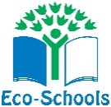

Foundation Phase and Theory
Eco Schools
Angela Davies, Rebecca Norrington-Davies, Heulwen Evans, Elizabeth Lewis and Stacey Rogers
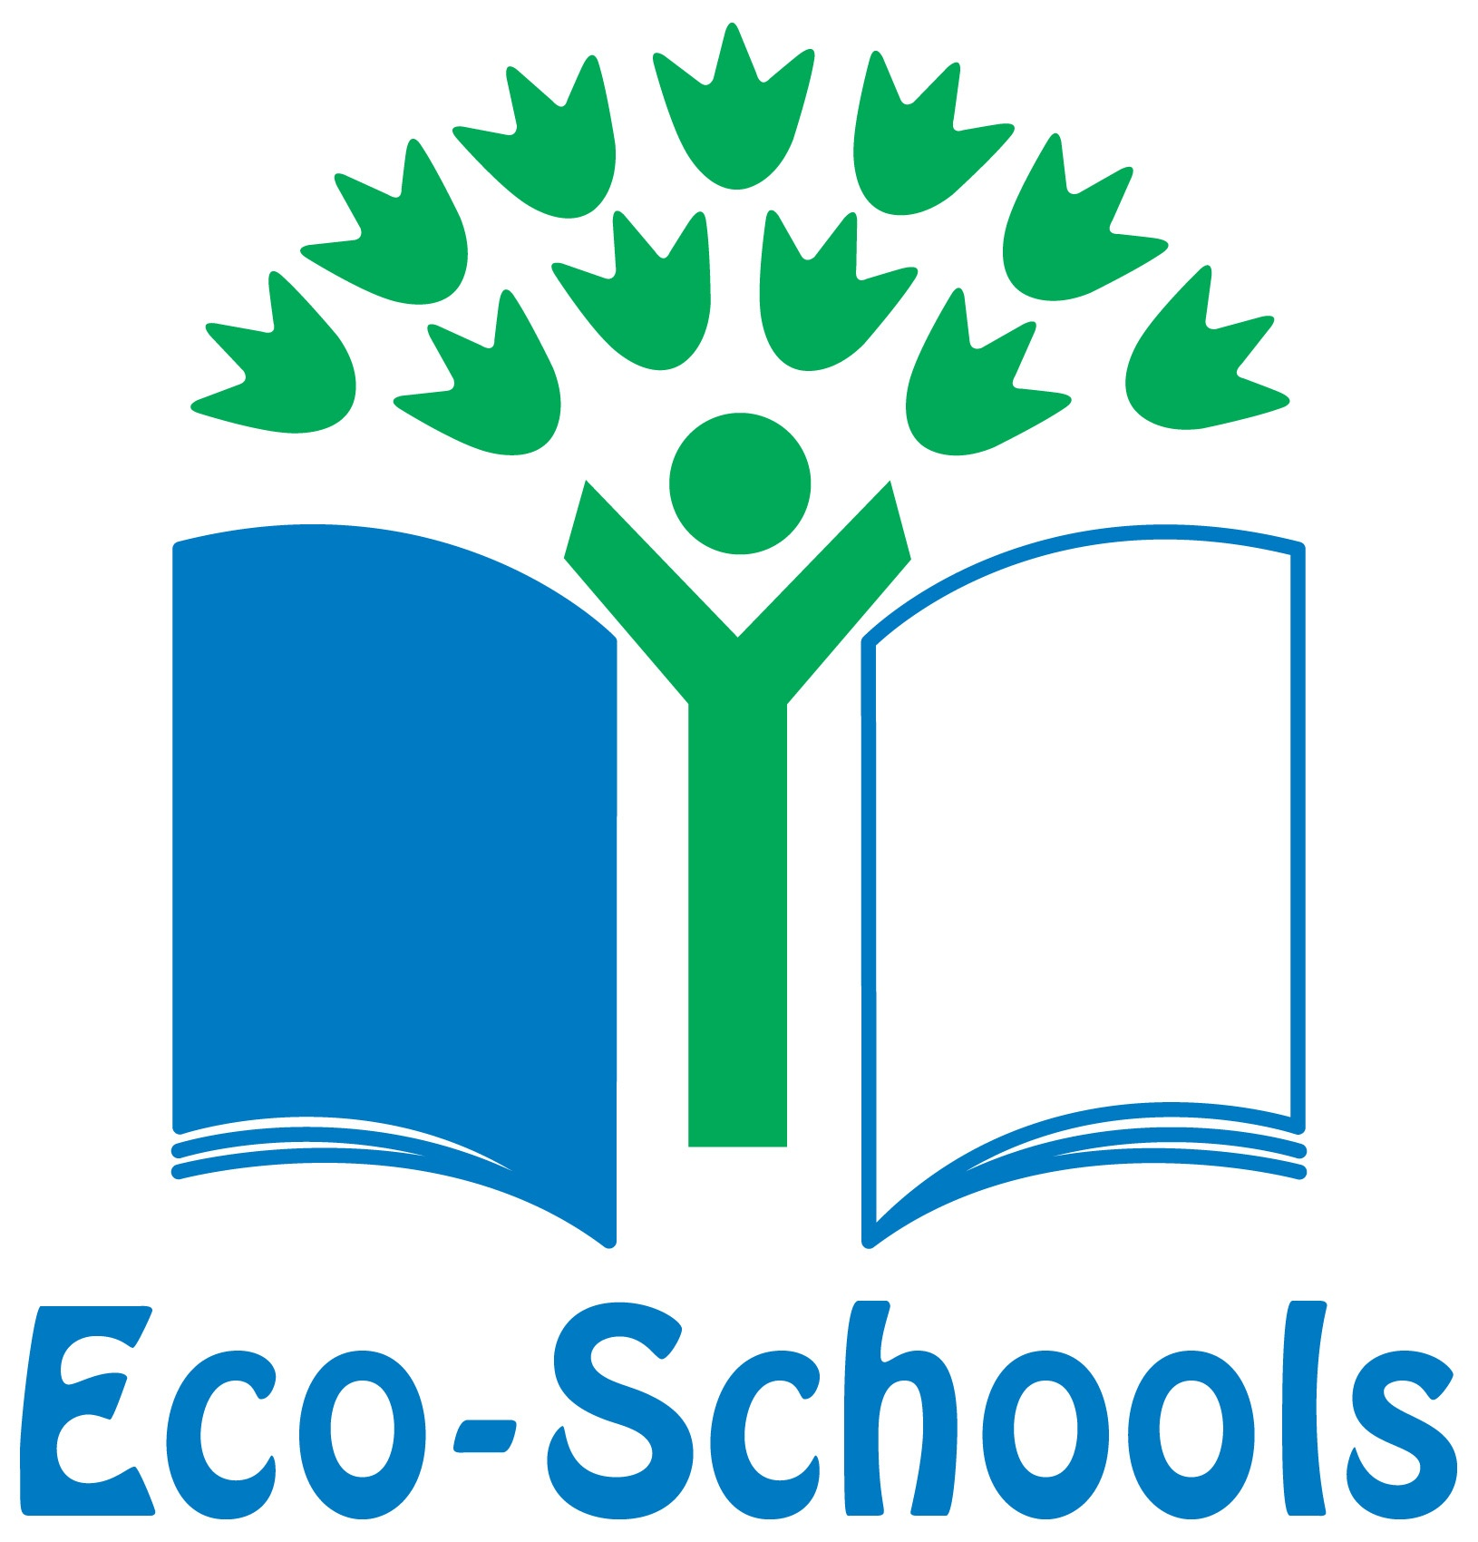

Su et alppp
Global Citizenship
ESDGC Key Principles

· Eco-Schools is a worldwide programme
· Environmental awareness through a seven-step process
· Sense of achievement
· Well being
· Being a part of policy making
· Three Flags
(Eco Schools.no date)

Introduction
Eco Schools is supported by The Foundation Phase as The Foundation Phase encourages children to learn and develop through the environment. Children also have the right to be listened to and links to the UNCRC Article twelve can also be made (Welsh Government, 2015).
Links to theory – Piaget, Vygotsky and Frobel’s theory’s link to the Foundation Phase by providing children with skills to enhance their development (Tudge and Rogoff ,1999) (Bruce, 2012).

- Being part of a community that believes in moral responsibility for other human beings globally
- Takes responsibility to make a difference to the condition of the planet
- Respecting and valuing our diverse world.
(Su et al., 2013)
· Key Principles
1. Active Discovery
2. Problem Solving and Reflection
3. A Whole Setting Approach
4. Inclusion
5. Student Led
6. Interdisciplinary
(Siencyn,2010)

MMMMMMM

Forest schools also believe that:
Through outdoor play, children learn how their actions can have an impact on the environment around them and globally.
A cross-curriculum approach is beneficial for learning holistically. (Knight,2011)
Both Eco Schools and Forest Schools believe that when a child experiences hands-on interaction within their community, this has a positive effect on the way a child perceives their world. (McCann,2014)
Additional Links
Eco Schools interlink with ESDGC Key principles.
These are cross curricular with the Foundation Phase.
The Eco school ethos is supported by theorists and legislations
The Forest School supports the well- being and development of the child within a hands --on outdoor environment.
Conclusion
http://www.eco-schools.org.uk/
http://gov.wales/topics/educationandskills/foundation-phase/?lang=en
http://www.forestschoolwales.org.uk/
Forest Schools supporting Eco Schools Ethos
Waste and Recycling
- Litter picking and monitoring (Eco Schools, no date).
- Recycle ink cartridges and mobile phones (Recycle4charity,2017).
- Recycling clothes and shoes (Bags2school,2016).
- Upcycling and scrap scheme (Ray Ceredigion,2017)
- Food Waste (WrapCymru,2011)
- Compost and growing vegetables (Riley,2016)
Bronze Award - Setting the fundamentals of becoming a fully-fledged Eco-School. Silver Award - Focuses on the activities the setting is undertaking on one of the Eco-Schools topics you have chosen. Eco Code – Making an Eco code for the setting. Green Flag - Show all the fantastic work that has been achieved on all seven steps.

(Eco Schools, no date)
Healthy Living
Global Citizenship
Litter
Biodiversity
Water
Grounds
Transport
Waste

Energy
(Source: Drawingcoach, 2006-2010)


