-

Student name:Ashura San-Sellus
Student ID:2412818
Lecture Name:Laila Surani

Change makers: Creativity and Value Creation
BMHP5014
Component 2: Written Assignment (Poster and Pitch)
Date: May 1st 2026

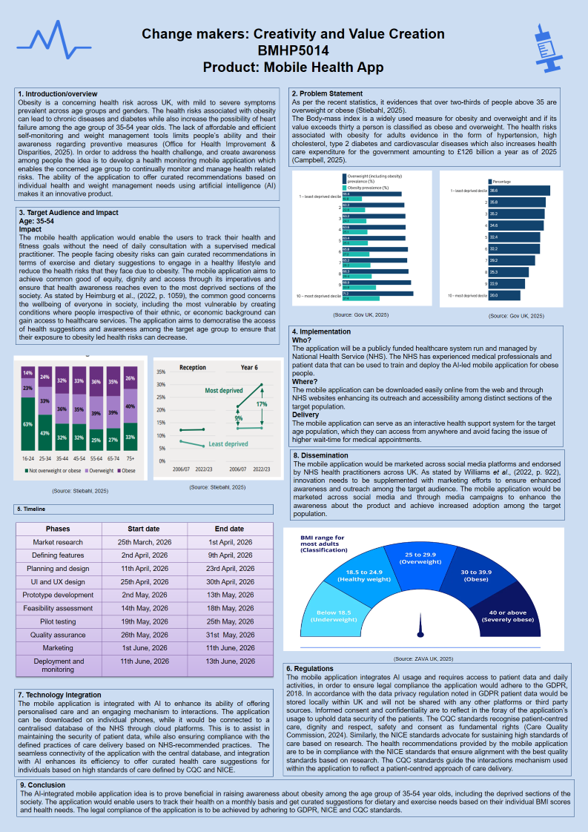
Figure 1: Poster

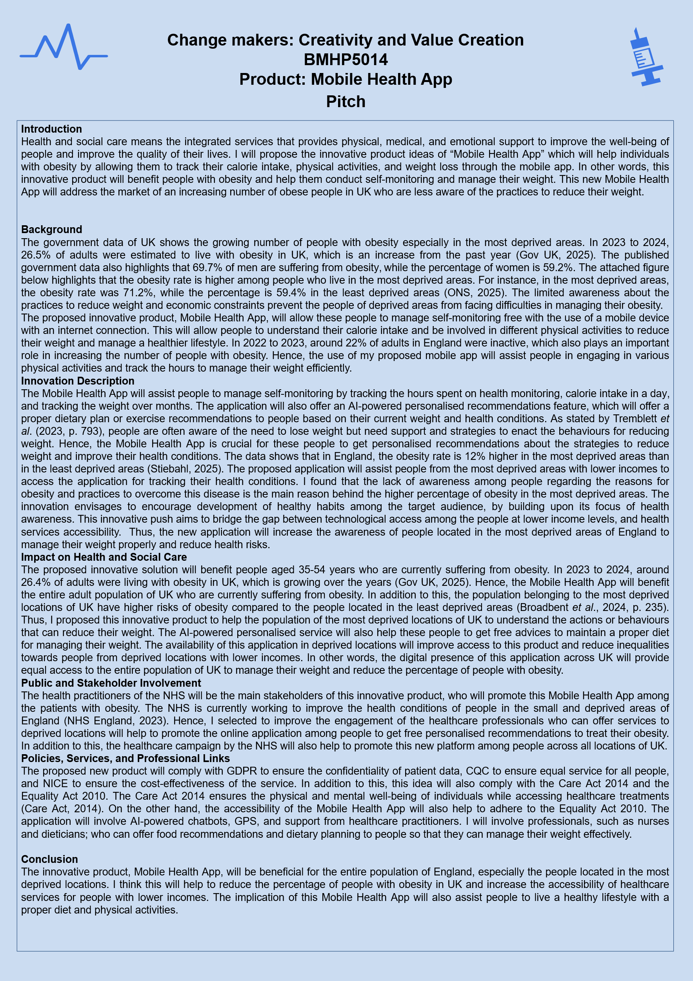
Figure 2: Pitch

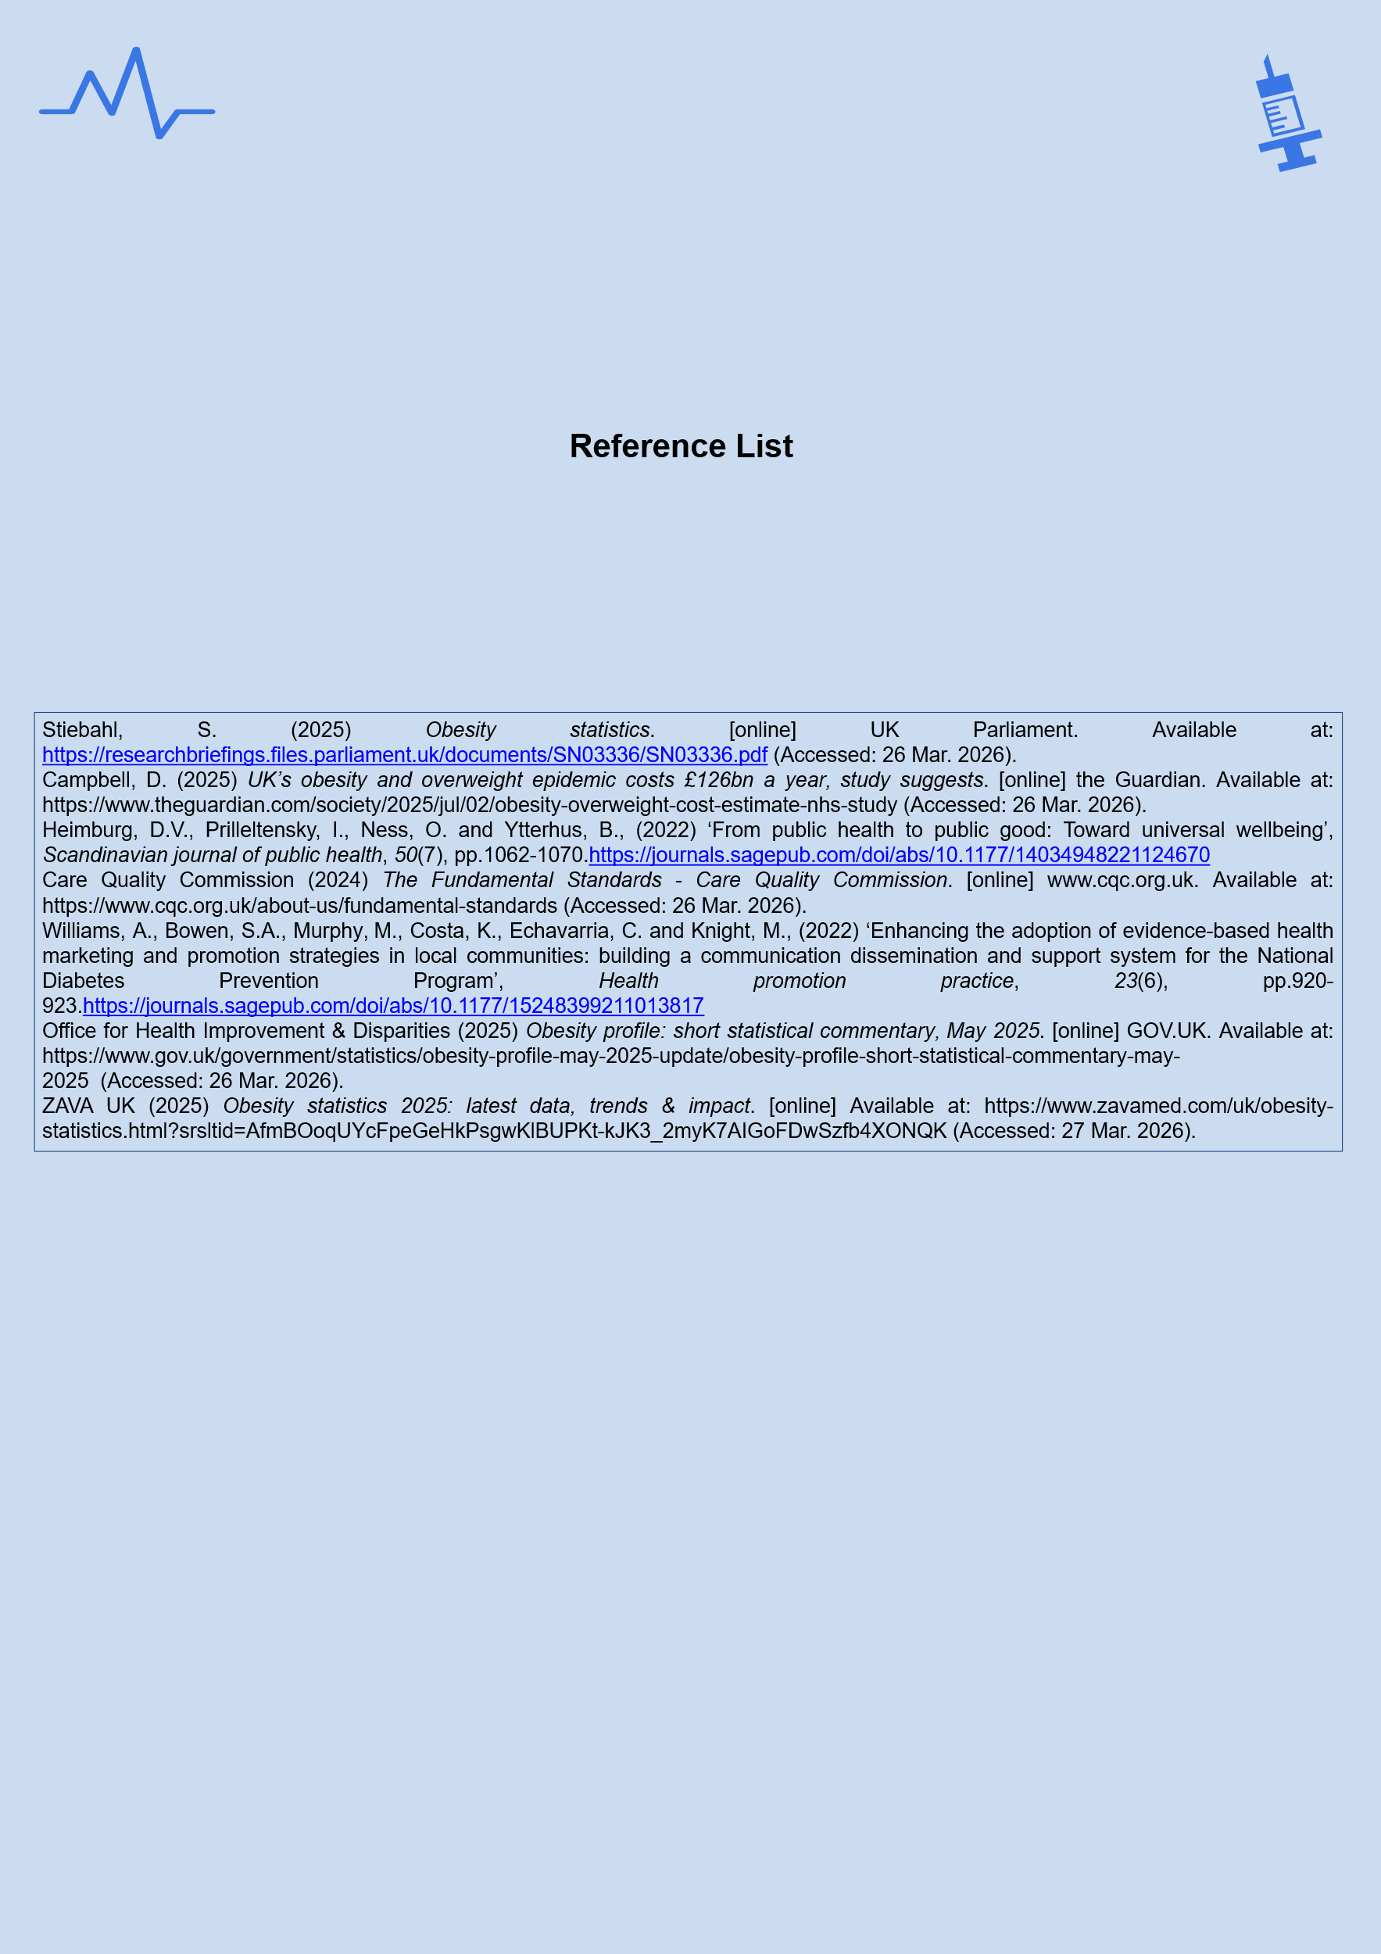
Figure 3: Reference list

