LCMB7001 Assignment 2

Maya Todorova
Student Number: 200985
MBA – LCMB 7002- 25 %
Lecture name: Tushara Balendran

Table of Contents
Abstract...................................................................................................................................4
Introduction.............................................................................................................................4
Analysis environmental marketing for external influence, keys and internal environment and the marketing role in the organisation…………….………......…………….……………….…………………..4
Critical analysis of customer journey and customer touchpoint of the organisation….........11
Conclusion...............................................................................................................................13
Reference................................................................................................................................13
Weblinks..............................................................................................................................…13

Abstract
The information in the below report is describing the usage of various marketing strategies in one of the largest food chains in UK.
Introduction
In the following report I am going to introduce the impressive path of success of one of the leader hypermarkets in UK – Sainsbury’s. Looking back into their history from the starting point in 1869, when John James and Mary Ann open the first shop in London, through some remarkable moment throughout the years such as:
- The pioneer pilot Amy Johnson became the first public figure to be used in Sainsbury’s advert in 1931
- First self-service store in Europe in 1955
- 1st TV advert promoting frozen chicken – 1973
- Own branding clothing line – 1973
- First supermarket to offer Organic food – 1986
- First retail outlet in UK – 2014
- Sainsbury’s has contributed £1M in fight against food waste in 2016
- And they became the first UK store to introduce grocery delivery service by electric cargo bike in 2018
It’s also curious to find out that Sainsbury’s motto is” At Sainsbury’s we will bring an ever improving quality shopping knowledge for our customers with great product at fair prices. We will exceed customer opportunity for healthy, safe, fresh and tasty food making their lives easier every day”. And their success is proving that they are following the above path. We are going to look in the various marketing and branding methods the company used and keep using, and to see how they apply them.
Sainsbury consists of 872 stores, which contain 537 supermarkets and 335 convenience stores, and Sainsbury’s Bank. The food chain is claiming the impressive 19 000 million customers a week.
One of the first point to look is the Environmental Marketing.
Environmental marketing analysis are combining outside influential drivers plus scanning of the inside environment, which are forming the part that the environmental marketing play across the organisation.
When we talk about the external factors it means that we need to think about the macro-environment drivers, such as economic, demographic, technological, political, and legal, and social and cultural factors. We have noticed by the examples of Sainsbury’s achievement, that they managed successfully to implement this by for example hiring first female shop assistant during the First World War, as they were experiencing a staff shortage during that time. This would be considered not only social and demographic issue, they had to face, but also political factor, which they applied cleverly, and brought them a historical place with that move. Also, the funding of £1M regarding the fight against food waste, shows dedication to a social cause, which would have a positive impact not only to the society, but the environment, and helping those, who live in poverty.
Diagram 1: The micro- macro environment

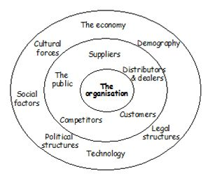

In addition to the above, we are going to look how are Sainsbury’s following the factors from the diagram?
- Political forces – Sainsbury’s is offering banking services, and in general any change on the government policies would have an impact over their taxation and banking policies.
- Economic forces – By opening new stores, hence new vacancies, Sainsbury’s are contributing to the UK economy.
- Social factors –Improving in healthy eating and Fairtrade move.
- Technological factors - progress in new technology and new analytics, and online shopping.
CONCLUSION
The PEST factors are legal problem in the environmental aspect and is creating an issues for many businesses. Now we can say that the political factors are unfavourable, economic are favourable, social are favourable and technological are favourable.
POSTER’S FIVE forces analysis
The Porter fives are measuring the industrial lines applied in the course of development of the business strategy. The following five outlined factors are measuring the productivity of the market.
Diagram 2: Porters 5 Forces

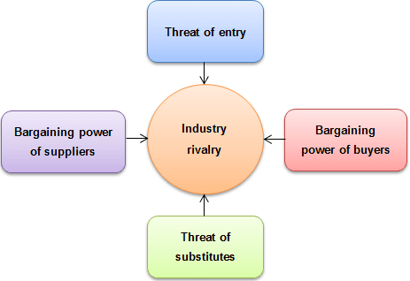

- Threat of new entrants – Regardless of their leadership position for long time, the threat of new entrants is unavoidable, and they would need to search for new strategies and ideas.
- The substitute threat- this is the moment where in order to fight the competitors, a substitute has been created. Sainsbury substitute product cost is high economic cost.
- Bargaining power of suppliers - it brings positive building of quality products.
- Bargaining power of customers - The Sainsbury have been always popular across their client base with the strong choices they make. The company prioritise the health and wellness, and low cost, and they are dedicated to always show improvement.
- Competitive rivalry – the competition is considered healthy for any business as the challenges are the main booster of innovation. But looking from the other side it can also be the reason for ending the business. Sainsbury having a success in food industry, also has an idea of sorting competition issues.
After analysing Porter five model the result is that Sainsbury has adopted and implemented the 5 powers in a way, which allow them to grow the business, beat the competitors and have strong customer’s base.
SWOT Analysis
This is the first step to research, organise and plan by painting any major issues. The purpose of the SWOT analysis is to identify any positive and negative factors, which would eventually have an impact on the business. In the search for success, we should turn what is now considered a deficiency to a strength, and search for opportunities.
Introducing Sainsbury’s business into strengths:
- Reputed brand name – Sainsbury’s has built a reputation on high-quality food, branded over in 3000 products, with matching good price for the customers.
- Recognized business– due to a strong marketing campaign Sainsbury’s developed one of the most successful businesses brands out there.
- Well-established, relationships and popular business- Sainsbury has become one of the most popular and recognizable business operating over 1200 supermarkets and convenience stores.

The below diagram explains Sainsbury’s strategies applied in the business
Diagram3: Segmentation, targeting and positioning

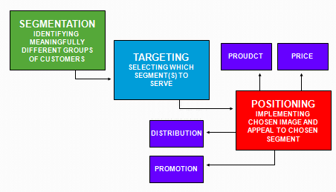

- Marketing Segmentation
This is the area of marketing including the demographic criteria such as age and gender plus the geographic factors such as attitudes and customer’s behaviour. Sainsbury differential advantage arises from one of marketing strategies which are product differentiation.
- Marketing Targeting
In this area we look into targeting to attract certain group of customers with different choice of food and drinks. In Sainsbury’s case they introduced “Free from food” and gluten free bread and bakery.
- Marketing Positioning
Sainsbury has positioned itself at the mid-tier of the market. The positioning is vital from point of view which market the company is occupying. Once we know where we can successfully operate, from there we can decide where we want to place the company in the future, and re-discover various market possibilities.
- Differentiated: Where Sainsbury’s provides a range of products for various groups of customers, based on the criteria of age, occupation, seasons, gender etc. For example, products of pack food for people with busy lifestyles and they don’t have time to cook so they use the ready products of Sainsbury.
- Concentrated: Sainsbury has achieved an impressive market value because of their good knowledge of their customers.
CONCLUSION
From the provided information and the strategies taken by Sainsbury the consumers food products have brought great changes in their food habits.
UMBRELLA BRANDING
The cost of developing a new product in a fast-moving consumer market includes innovating new goods and categories. One of branding strategies is the so called “Umbrella branding” also recognised as Family Branding, where the parent brand and all sub-brands are coming from the same company. Sainsbury umbrella branding is connected to Argos, Tu, Sainsbury Bank, Habitat, Sainsbury’s, J Sainsbury plc, Nectar, Nectar 360.
- Individual Product Branding - Customers providing positive feedback from single brand, from there this leads to increasing of the purchases for this product.
- Product Branding Strategies - Sainsbury offering different quality of food for each different choices of the customer. The shops of Sainsbury work 24/7 this is the main idea to make each customer satisfied with their products and services.
- Creation model - The creation model is the long-term plan for increasing growth through innovation, and offering relevant products and solutions to our customers. Sainsbury use a model for shareholders, customers, and colleagues for now and for the future to keep the quality, value, service, choices. The vision of Sainsbury is to create trust for people where they like to work and shop together.
- Promotions - Sainsbury uses the strategy of ATL (above the line) and BTL (below the line) promotional strategy to build the brand name and get the customers’ attention.
- Sales - Sainsbury uses increasing of the sales with “Nectar reward card “where customer collect points and use for next shopping, and this card help to safe database of the customers.
- Sponsorship - Most of the sponsorships have a commercial objective. Sainsbury became a sponsor for COP26 which takes place in Glasgow. Sainsbury show and bring support to help reducing plastic packaging.
- Direct marketing – Probably the type of marketing mostly known and used, because everything which is relating to TV, newspapers, radio or social media marketing, falls under this category. Sainsbury business uses advertisement channels, such as billboards, television, transports, magazines, newspapers, and social media.
- Extended marketing mix - The marketing mix is an area of subject, which can be controlled by the company. Sainsbury’s is a supermarket chain, which stocks more than 30 000 product in a different range. Collection of fruit and vegetables, fish and meat, dairy, bakery, various drinks, and spirits, etc. The product has value for money and there is a different pricing for different set of products.
- Price mix – Price of the products are driven by the quality the same product offers. For some products Sainsbury went to a price match with Aldi. With other products, they increase the prices because to meet the competitors, and because when the quality is ticking all the boxes, a little price jump is suggesting that would not affect customers’ decision to stay with the brand.
- Promotion mix – The aim of Sainsbury’s is to become the first choice of grocery shopping. That is why they use the strategy of promotional mix. They use many strategies and promotions to bring the best out for their customers.
Introducing the recommendation of strategies going forward
So far Sainsbury’s are showing a distinctive marketing campaign, especially when it comes to their TV adverts and logos around the holiday times. Therefore, we can accept that the company is relying on very original and quirky adverts, pointing the products which we would need mostly on special celebrations.
In Ansoff’s matrix mainly and simply suggests that the marketing of new product on existing market, or discovering and expanding on new markets, is important for business growth. The concept of the matrix is a number of suggested development strategies:
Diagram3: Ansoff matrix
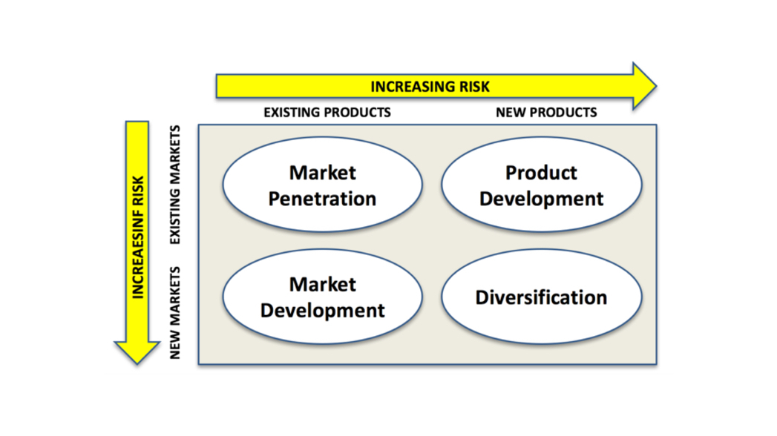

A) Market penetration: This is the stage where the business is focusing on the sale of established product on already existing market. Sainsbury have that strategy for to growth in the industry when Tesco and Asda became a competition.
B) Market development: The growth strategy of the company, where already established products are about to enter new markets. This strategy suggests how the business can strategies in the acceleration of the sales of that product. For Sainsbury market the company should increase banking services, credit cards, insurance.
A range of pricing models to attract various types of customers or develop new market lines.
C) Diversification: A growth strategy where the product is developed to suit the taste of the current market, and it may differ to the same product in a different country (for example), or simply launching new products on established markets. Sainsbury’s started with the groceries but after sometimes start with their own clothing brand, and banking services.
In order the above strategy to be successfully implemented, the company should have a clear vision about the expectations and strong risk assessment. Therefore, if the right balance between risk and return is found, the diversification model can be quite rewarding.
Next diagram of Product Life Cycle Model also plays vital role in the business overall.

Basically the diagram simply explains the life cycle of a product since its beginning and launching to the day when is removed from shelves. The process has four phases —introduction, growth, maturity, and decline. The follow up of this model is a decision from the Management team, which suggest when advertising to be increased or product cutting, or motif re-branding.

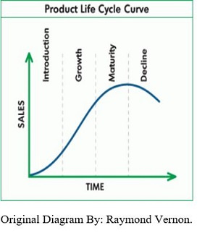

- Introduction -Freshly introduced to the market, this stage can be described mainly by slow rise in the sales, and not that impressive profit margin from direct competitors.
- Grow strategy - In this stage, the product start showing some recognition and demand.
- Maturity - In this stage, the maturity of product is reflected in terms of its capacity face competition. The product must face keen competition which brings pressure on prices.
- Decline – in this stage the product may be replaced by some innovation or change in the consumer behaviour. This is the stage where product is removed from the shelves.
Defence strategies for pioneers in the Growth stage of the PLC

- This is the so-called 'fortress' strategy, where the business builds a fortress around to protect it from competition. One of the steps of doing that is creating a cheaper version of a product, so it can be more accessible to wider range of customers.
- Or the Market expansion strategy, which is also recognised as growth strategy, encouraging the sale of current products in a new market, accepting that the current market has been successfully conquered.

Attack strategies for followers in the Growth stage of the PLC

- One to think about is the Frontal attack strategy where the focus is on the competition and how to match the pricing, quality, marketing etc.
- Flanking attack strategy is strategy used by market leaders, who recognised new entry and try to eclipse their market penetration
- Leap Frog strategy is defined when the marketing team has done a brilliant step forward of mastermind that results in impressive growth, profit margin, and leadership position.

STRATEGIES IN THE MATURITY STAGE OF PLC
- Penetration strategy is resulting in increased sales volume, hence higher profit margin
- An extension strategy is defined by expanding of the market share for a certain product or service.
- Market expansion

CONCLUSION
Sainsbury’s is keeping the leadership role in food supermarkets in UK, because of their mastermind of marketing strategies, build to shape their products around customer preferences and keeping the good quality, diversification, and low cost as main tool to crave that successful leadership role.
REFERENCESS
The Marketing environment by Jim Blythe
Porter five force analysis by Frederic P. Miller, Agnes F. Vandome, McBrewster John
SWOT Analysis by Alan Sarsby
Lifestyle marketing segmentation Art Weinstein, ‎Dennis J. Cahill · 2014
Marketing and promotional strategy by Roddy Mullin
Ansoff Matrix Essentials by Francisco Fortin
Product Lifestyle management- Anti Saaksuvuoru
web links
https://www.accountingtools.com/articles/penetration-strategy-definition-and-examples.html
https://study.com/academy/lesson/growth-market-strategies-for-market-leaders.htmlhttps
https://courses.lumenlearning.com/wm-retailmanagement/chapter/microenvironment-vs-macroenvironment/
https://www.mindtools.com/pages/article/newTMC_08.htm
https://www.tutor2u.net/business/reference/market-segmentation
https://en.wikipedia.org/wiki/Umbrella_brand#:~:text=Umbrella%20branding%20(also%20known%20as,brand%20in%20a%20certain%20marketplace).
http://bikashadhikari1.com.np/business-strategy-ansoff-matrix/?i=1
https://www.investopedia.com/terms/p/product-life-cycle.asp

